**Supplementary Table 1.** Some dominant phytoplanktons in the Dal Lake.

|  |  |  |
| --- | --- | --- |
| **S.No** | **Name of the species** | **Algal member** |
| 1 | *Anacystis* sp. | Cyanophyceae |
| 2 | *Anabena* sp. | Cyanophyceae |
| 3 | *Anthrodesmus* sp. | Chlorophyceae |
| 4 | *Aphanocapsa* sp. | Cyanophyceae |
| 5 | *Chlorella* sp. | Chlorophyceae |
| 6 | *Euglena* acus | Euglenophyceae |
| 7 | *Cladophora* sp | Chlorophyceae |
| 8 | *Euglena rubra* | Euglenophyceae |
| 9 | *Navicula* sp. | Bacillariophyceae |
| 10 | *Phacus* sp. | Euglenophyceae |
| 11 | *Melosira* sp. | Bacillariophyceae |

**Supplementary Table 2.** Mean value of metal concentrations (ppb) at the four stations of Dal Lake

|  |  |  |  |  |  |  |
| --- | --- | --- | --- | --- | --- | --- |
| **S.No.** | **Name of the Metal** | **Permissible concentration (ppb)** | **Hazratbal** | **Habbak** | **Laam** | **Brarinambal** |
| 1 | Molybdenum (Mo) | 0.01 | 2.538 ± 0.002 | 1.703 ± 0.003 | 3.627± 0.004 | 4.787± 0.002 |
| 2 | Chromium (Cr) | 0.005 | ND | ND | ND | ND |
| 3 | Arsenic (Ar) | 0.01 | 2.711 ± 0.029 | 3.098 ± 0.0008 | 0.006 ± 0.0007 | 2.324 ± 004 |
| 4 | Cadmium (Cd) | 0.003 | 0.099 ± 0.001 | 0.494 ± 0.244 | 0.494 ± 0.243 | 0.989 ± 0.002 |
| 5 | Lead (Pb) | 0.01 | 6.828 ± 0.003 | 2.492 ± 0.002 | 5.364 ± 0.004 | 6.292 ± 0.007 |

**Supplementary Table 3.** Annual turnover of PHE water supply schemes for the Years 2020 – 2021

|  |  |  |  |  |  |
| --- | --- | --- | --- | --- | --- |
| **S. No.** | **Revenue/Expenses** | **2020** | | **2021** | |
| **Earning** | **Expenses** | **Earning** | **Expenses** |
| 1 | Total No. of Registered Water Supply Connections | **28000 (Assessed on** March 2021**)** |  | **29979 (**Assessed on 12-11-2021**)** |  |
| 2 | Total number of Souls benefitted | **175000** |  | **185000** |  |
| 3. | Total revenue Generated (Rs) | 7,84,00000 | - | 8,39,41200 |  |
| 4. | Electricity Bill (Rs) |  | 1,50,00000 |  | 1,50,00000 |
| 5. | Maintenance Costs (Rs) |
| 6. | Salaries |
| 7. | Profit | 6,30,00000 | | 68941200 | |

**Source:** Chief Engineer PHE Division Srinagar

**Supplementary Table 4.** Annual turnover of registered hotels around the Dal Lake for the year 2020-2021

|  |  |  |
| --- | --- | --- |
| **Years** | **Number of Hotels** | **2021** |
| Revenue (Rs) | 430  Category A= 87  Category B= 115.  Category C/D=228 | 472500000 |
| Electricity Bill (Rs) | 10,320,000 |
| Water Bill (Rs) | 516000 |
| Salaries (Rs) | 162540000 |
| Maintenance Cost (Rs) | 200000 |
| Profit (Rs) | **298924000** |

**Source:** JK Tourism, Srinagar**.**

**Supplementary Table 5.** Annual turnover of registered house boats in the Dal Lake for the year -2020-2021

|  |  |  |
| --- | --- | --- |
| **Years** | **Number of Houseboats** | **2020-2021** |
| Revenue (Rs) | Total House boats in Dal Lake =900  (Registered= 700  Un Registered = 200) | 75600000 |
| Electricity Bill (Rs) | 8100000 |
| Water Bill (Rs) | 1080000 |
| Salaries (Rs) | Nil |
| Maintenance Cost (Rs) | 100000 |
| Profit (Rs) | **66320000** |

**Supplementary Table 6.** Turnover of Shikaras and Motor boats in Dal Lake

|  |  |  |  |  |  |  |  |  |
| --- | --- | --- | --- | --- | --- | --- | --- | --- |
| **Year** | **Number of Shikaras** | **Revenue Generated** | **Maintenance** | **Profit** | **Number of Motor boats** | **Maintenance** | **Revenue Generated** | **Profit** |
| 2021 | 900 | 32000000 | 900000 | **31,100000** | 30 | **2820000** | **35520000** | **32700000** |

**Supplementary Table 7.** Incidence of water borne diseases in the catchment of Dal Lake and the cost incurred (2020-2021)

|  |  |  |  |  |  |  |
| --- | --- | --- | --- | --- | --- | --- |
| **Year** | **2020** | | | **2021** | | |
| **S. No.** | **Water Borne Disease** | **No. of Cases** | **Cost incurred (in Rs.)** | **Water Borne Disease** | **No. of Cases** | **Cost incurred (in Rs.)** |
| 1. | GIT | 840 | 10,08000 | GIT | 785 | 942000 |
| 2. | Diarrhea | 2645 | 1587000 | Diarrhea | 2665 | 1599000 |
| 3. | Worms | 2700 | 810000 | Worms | 2100 | 630000 |
| 4. | Ascariasis | 1200 | 540000 | Ascariasis | 1085 | 488250 |
|  | **Total** | 10945 | **3945000** | **Total** | 18635 | **3659250** |

**Source: Community Health Officer Srinagar**

**Revenue generated by Vegetable| Floating market in Dal Lake:**

1. **Nadroo (season Sept to March)**

Nadroo production per day=750 chakh

Normal Nadroo 1 chakh =4 gaji

1 gaji=1.5kg

Special (Toiba gaji)= 3kg

Out of 750 (50 are Toiba gaji and 700 are normal gaji)

Rate of Normal Nadroo 1 gaji=200|=

Rate of Toiba gaji=500

Cost of 700 normal chakh per day =4×700×200=560000

Cost of 50 Toiba chakh=50×4×500= 100000

Cost of Normal nadroo per month=560000×30=16800000

Cost of Toiba nadroo per month=100000×30= 3000000

Total cost of Toiba plus normal nadroo per month =16800000+3000000=19800000

Total cost for Nadroo for 7 months= 19800000×7=**138600000**

**2) Trapa (Season March- Oct.)**

Trapa production per day= 35 kg

Rate of Trapa=60|kg

Cost of Trapa sold per day= 35×60=2100

Cost of Trapa sold per month= 2100×30= 63000

Cost of Trapa sold per 8 months= 63000×8= **504000**

1. **Haakh Knol Kohl (Entire year)**

Haakh production per day = 30 Quintal

Rate of Haakh per Quintal in the Floating Garden=1600|=

Cost of Haakh sold per day=1600×30=48000

Cost of Haakh sold per month=48000×30= 1440000

Cost of Haakh sold per year = 1440000× 12= **17280000**

1. **Muji- Gogji (Radish and Turnip) (Sept-March)**

Production of Radish and Turnip= 15 Quintal each per month

Cost of 1Quintal = 1300

Cost of 30 Quintal = 1300× 30= 39000

Cost of Radish and Turnip for 7 Months= 39000×7= **273000**

1. **Carrot (Sept- March)**

Production per month =20 Quintal

Cost of Carrot = 2000| Quintal

Cost of carrot produced per month= 2000×20 = 40000

Cost of carrot produced in seven months= 40000×7=**280000**

1. **Bottle Gourd and Cucumber (May-Oct.)**

Production of Gourd and Cucumber = 5 Quintal |day

Cost of 1 Quintal of Gourd cucumber= 2000| Quintal

Cost of 5 quintals = 2000× 5= 10000| day

Cost of Gourd cucumber sold per month= 10000×30= 300000

Cost of Gourd Cucumber sold for 6 months = 300000×6= **1800000**

1. **Tomato (May –Oct.)**

Production of Tomato = 30 Quintal |month

Cost of 1 Quintal = 1500

Cost of Tomatos produced per month= 15×30= 45000

Cost of Tomatos produced in 6 months=45000×6= **270000**

1. **Brinjal (May-Oct.)**

Production per month= 20 Quintals

Rate per Quintal= 3000

Rate of Brinjal Produced per month= 20×3000= 60000

Rate for 6 months = 60000×6= **360000**

1. **Spinach (yearly)**

Production of Spinach per month = 30 Quintal

Cost per Quintal= 5000

Rate of Spinach produced per month=5000×30= 150000

Rate of Spinach per year =150000×12= **1800000**

1. **Capsicum (June- August**)

Production of Capsicum = 20 Quintal |month

Cost per Quintal = 5000

Cost of production per month= 5000×20= 100000

Cost of production for 3 months= 100000×3= **300000**

1. **Bhindi (May- Oct.)**

Production of Bhindi per month= 9 Quintal

Cost per Quintal = 3000

Cost of Bhindi sold per month= 9×3000= 27000

Cost of Bhindi for 6 months= 27000×6= **162000**

1. **Dhaniya (May- Oct.)**

Production of Dhaniya per month= 6 Quintal

Cost per Quintal = 2500

Cost of Dhaniya produced per month= 2500×6= 15000

Cost of Dhaniya produced for 6 months= 15000×6= **90000**

1. **Spring Onion (March- April)**

Production of Spring Onion= 12 Quintal |month

Cost of Spring Onion= 5000\Quintal

Cost of spring onion produced per month= 5000×12= 60000

Cost of spring onion produced for 2 months= 60000×2= **120000**

**Income Generated by Selling Vegetables Annually= 16,18,39,000**

**Supplementary Figure 1a.** The survey sheet for Travel Cost method (TCM)









**Supplementary Figure 1b.** The survey sheet for Contingent Valuation Method (CVM).















**Supplementary Figure 2a to 2s**

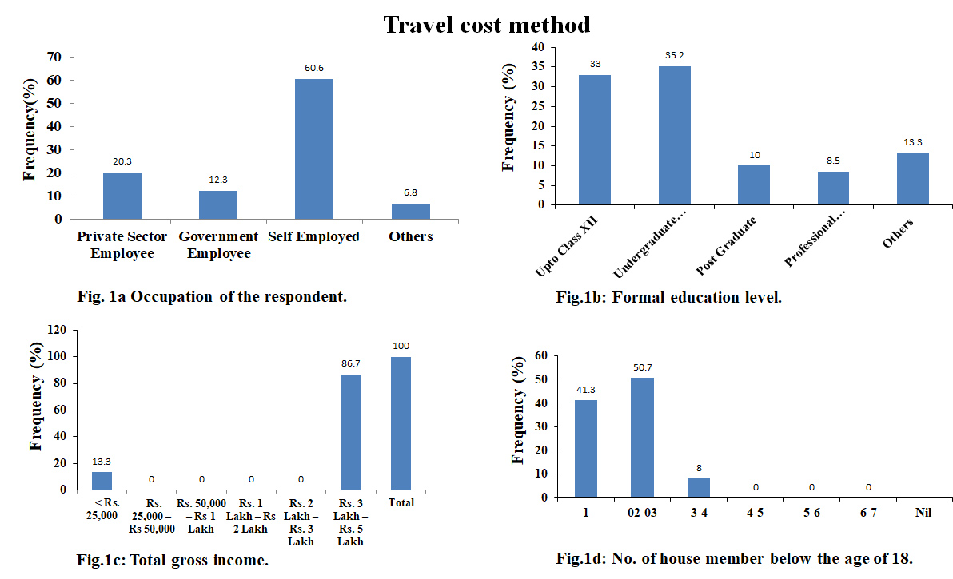

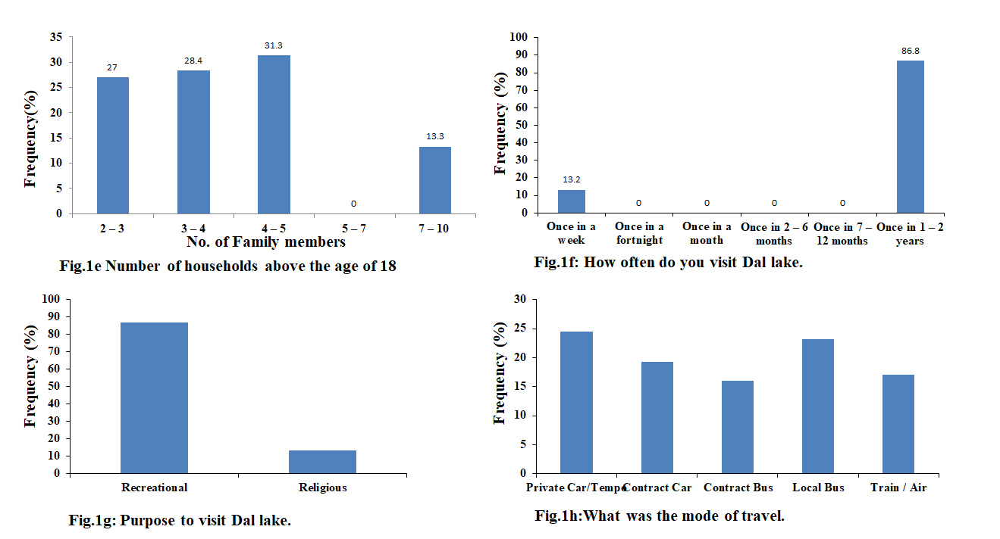

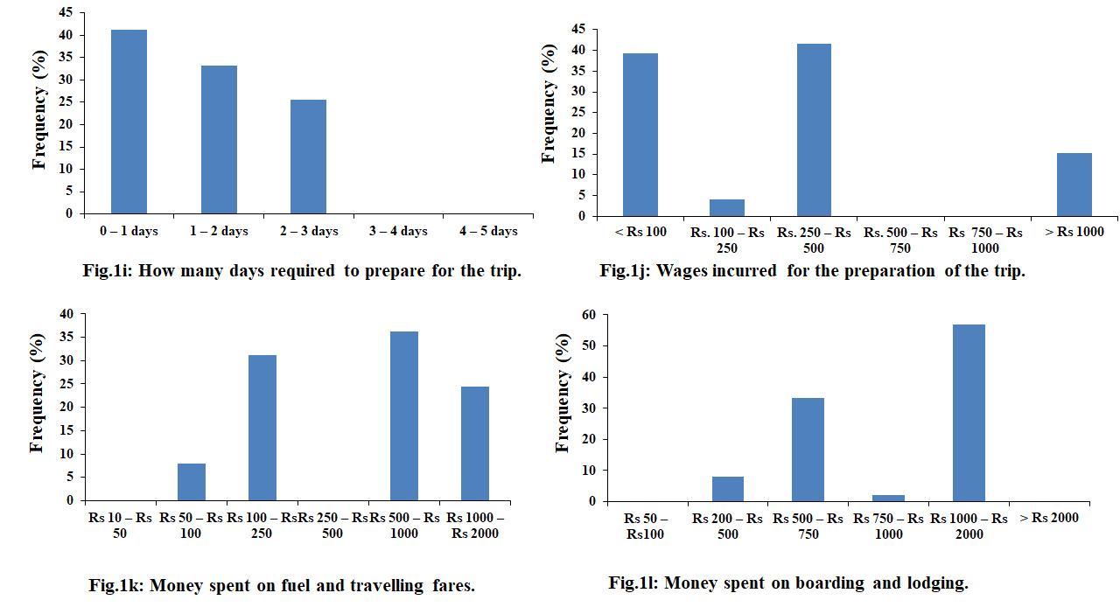

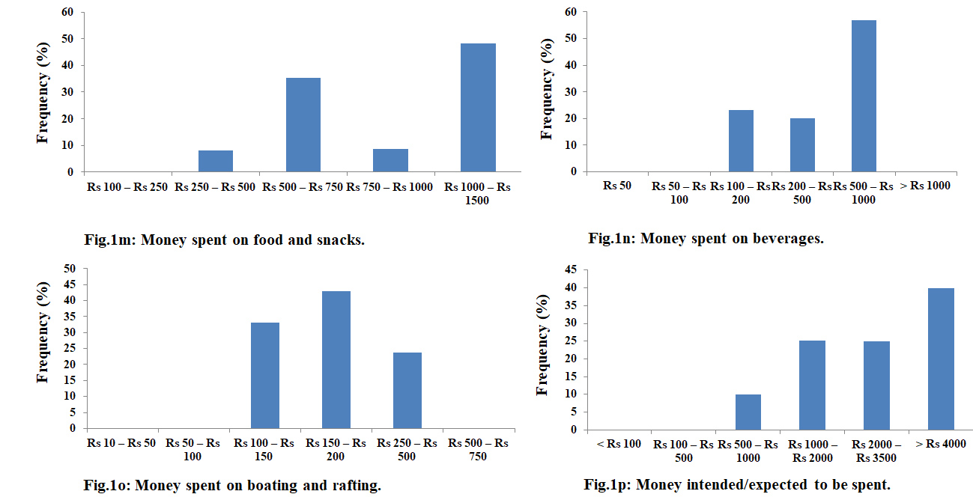

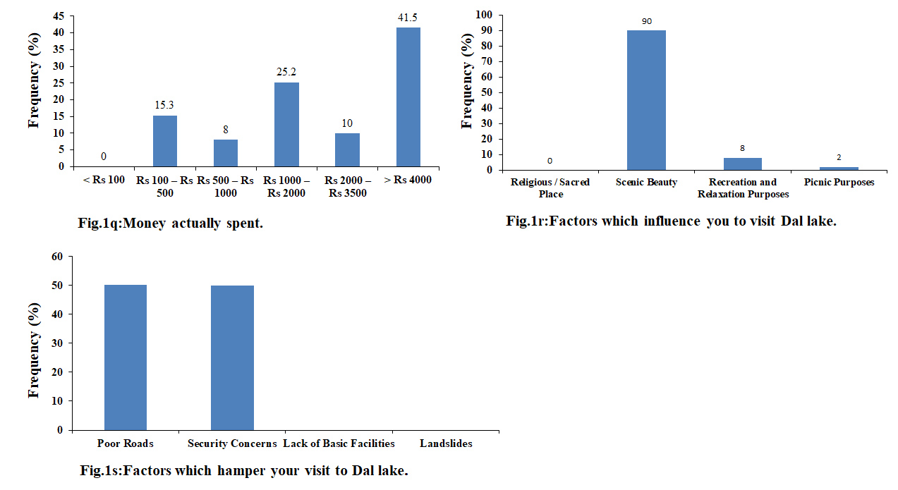

**Supplementary figures 3a to 3m**

