Supplementary Information

Out-of-plane Interface Dipoles and Anti-hysteresis in Graphene-Strontium Titanate Hybrid Transistor

Anindita Sahoo1, Dhani Nafday2, Tathagata Paul1, Roald Ruiter3,Arunesh Roy3, Maxim

Mostovoy3, Tamalika Banerjee3,Tanusri Saha-Dasgupta2,4,5, and Arindam Ghosh1,6

1*Department of Physics, Indian Institute of Science, Bangalore 560 012, India.*

2*Department of Condensed Matter Physics and Materials Science, S.N.Bose National*

*Centre for Basic Sciences, Kolkata 700106, India.*

3*Zernike Institute for Advanced Materials, University of Groningen, Groningen, The Netherlands.*

*4Center for Mathematical, Computational and Data Science, Indian Association for the Cultivation of Science, Kolkata 700032, India*

5*Thematic Unit of Excellence on Computational Materials Science, S.N.Bose National*

*Centre for Basic Sciences, Kolkata 700106, India.*

6*Centre for Nano Science and Engineering, Indian Institute of Science, Bangalore 560 012, India.*

**I. ATOMIC FORCE MICROSCOPY OF TiO2 TERMINATED SrTiO3 (STO) SURFACE**



FIG S1. Atomic force microscopy images of TiO2 terminated surface of different STO substrates showing flat terraces and steps of width $\sim$ 400 nm.

**II. MOBILITY OF GRAPHENE ON STO**

The carrier mobility of graphene FET has been calculated at different temperatures (Fig. S2b) by fitting the resistance of graphene channel with varying back gate voltage, $V_{BG}$ (Fig. S2a) using the following equation 1{Kim, 2009 #21}{Kim, 2009 #21},

$$R_{total}=R_{contact}+R_{channel}=R_{contact}+\frac{L}{Wμ\sqrt{n_{c}^{2}e^{2}+{\left\{\frac{ε_{0}ε_{r}\left(V_{BG}-V_{CNP}\right)}{d}\right\}}^{2} }} ,$$

where $R_{channel}$ is the resistance of the graphene channel between two voltage probes with length, *L* and width, *W*. $R_{contact}$ is the resistance of the metal-graphene contacts. $n_{c}$ is the residual carrier density which is zero for an ideal disorder free graphene channel. *e* is the charge of an electron. $ε_{0}$ is the permittivity of the vacuum, $ε_{r}$ is the dielectric constant of STO and *d* is the thickness of STO back gate dielectric. $V_{CNP}$ is the charge neutrality point with respect to the varying $V_{BG}$.

As shown in Fig. S2b, the mobility of the channel is quite low (*∼* 2000 cm2/Vs) which increases below 50 K and becomes *∼* 7300 cm2/Vs at 7K. Similar result was observed by Couto et al. 2. The carrier mobility in graphene on STO substrate is possibly limited by the resonant scattering mechanism. The short range potential responsible for resonant scattering cannot be screened by the high dielectric constant of STO, which leads to similar conductivity and mobility in graphene on STO as on SiO2 substrate 2.



(a)

(b)

FIG. S2. (a) Transfer characteristics of graphene on STO with varying back gate voltage, *V*BG at different temperatures. *V*CNP is the charge neutrality point. (b) The carrier mobility of the graphene channel on STO with varying temperature.

**III. TEMPERATURE DEPENDENCE OF GRAPHENE RESISTANCE**

We have plotted the resistance of graphene FET on STO with varying temperature in Fig. S3 at different carrier density of the graphene channel, where the temperature-dependence of resistance of graphene (irrespective of carrier density) becomes significantly weaker, and eventually saturates/decreases above ~ 60 – 70 K. This temperature scale is close to, albeit somewhat smaller than cubic to tetragonal structural transition in the STO. In recent report3, the change in resistance behaviour has been attributed to the shift in the dominant phonons (surface optical phonons in the high temperature cubic phase to low energy optical phonons in the low temperature tetragonal phase). The dominant phonon dispersion at the surface of STO is not clear, and this could be further complicated by persistence of tetragonal domains till high temperatures. The negative temperature coefficient of resistance at higher temperatures is thus an unexpected result, and possibly arises from a dominant weak localization effect (over phonon scattering) due to strong substrate induced disorder. At T < 60 K, the surface reconstructs and phonon scattering dominates (the mobility in this regime shows sharp increase, Fig. S2b, which provides further support to this scenario).



FIG. S3. Resistance of graphene channel on STO at different electron and hole carrier density with varying temperature in device D1.

**IV. DIELECTRIC CONSTANT OF STO**

Fitting the locus of charge neutrality points ($V_{TG}^{CNP}$) in ($V_{BG},V_{TG}$) space (Fig. 1g of main text) with Eq. 1, the slope gives the back-gate capacitance ($C_{B}$), hence the dielectric constant of STO ($ε_{r}^{STO}$). We have plotted $ε_{r}^{STO}$ with varying temperature in Fig. S4 estimated by balancing the known capacitance of h-BN top gate with the capacitance of STO back gate in a dual gated single layer graphene (SLG) transistor on STO. As displayed in Fig. S4, $ε_{r}^{STO}$ increases with decreasing temperature following Curie-Weiss law ($ε_{r}^{STO}∝1/(T-T_{m})$) leading to a maximum value of $\sim 3.3×{10}^{4}$ at $T_{m}≈25$ K. Although at the charge neutrality point, the effective electric field ( ${\vec{E}}_{eff}$) applied on graphene is zero, the electric field applied on STO (${\vec{E}}_{STO}$) is finite which may results in a peak in the temperature dependence of $ε_{r}^{STO}$ as discussed in previous reports 4-6. The magnitude of $ε_{r}^{STO}$ obtained in our experiment matches very well with the previously reported values of $ε_{r}^{STO}$ at different temperatures 4, 7-9.



FIG. S4. The temperature dependence of the dielectric constant of STO ($ε_{r}^{STO}$) for device D1 which shows that $ε_{r}^{STO}$ follows Curie-Weiss law till the temperature *T*m where $ε_{r}^{STO}$ is maximum.

**V. TEMPERATURE AND BACK GATE VOLTAGE ($V_{BG}$) SWEEP RANGE DEPENDENCE OF ANTI-HYSTERETIC TRANSFER CHARACTERISTICS**

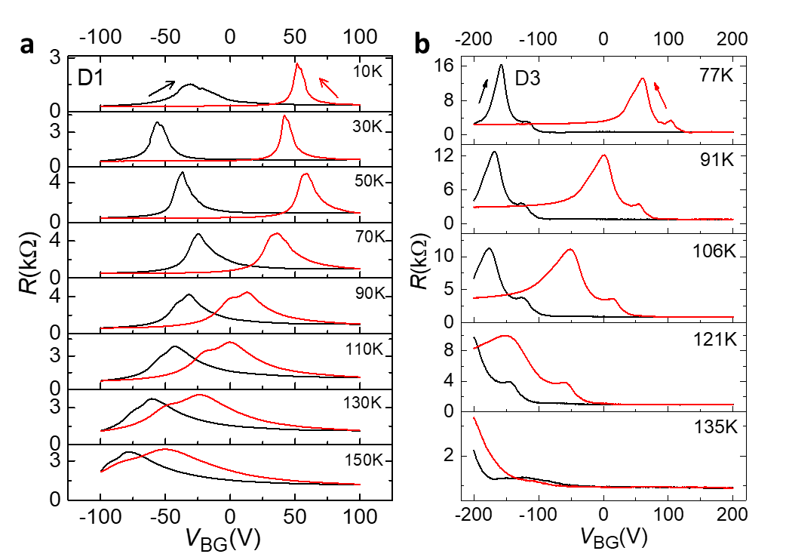

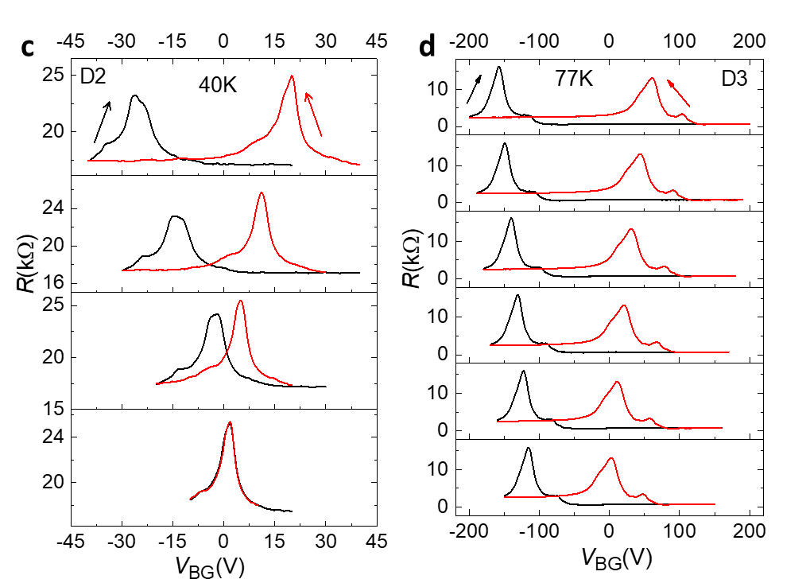

FIG. S5. Anti-hysteresis in transfer characteristics of graphene on STO with varying back gate voltage ($V_{BG}$) at different temperatures for (a) device D1 and (b) device D3. The dependence of the anti-hysteresis on $V_{BG}$ sweep range for (c) device D2 and (d) device D3.

**VI. $V_{BG}$ SWEEP RATE INDEPENDENT ANTI-HYSTERESIS**

The sweep rate of $V_{BG}$ has a negligible effect on the anti-hysteresis of graphene on STO. As the sweep rate is increased, the charge neutrality points ($V_{CNP}$) slightly shift to lower negative VBG for forward sweep and to higher positive $V_{BG}$ for reverse sweep of $V_{BG}$ (Fig. S6a). However, the extent of anti-hysteresis, quantified by the difference between VCNP at forward and reverse sweep direction of $V_{BG}$, remains unchanged for different sweep rates as demonstrated in Fig. S6b. Therefore, surface adsorbates or surface defect mediated trap charges 10 of STO associated with the shifting of $V_{CNP}$ at different ramp rates have very weak effect on the overall anti-hysteresis. (Note: two charge neutrality points in the transfer characteristics may appear due to the dissimilar exposure of PMMA on the h-BN encapsulated and bare regions of the graphene channel during lithography process.)

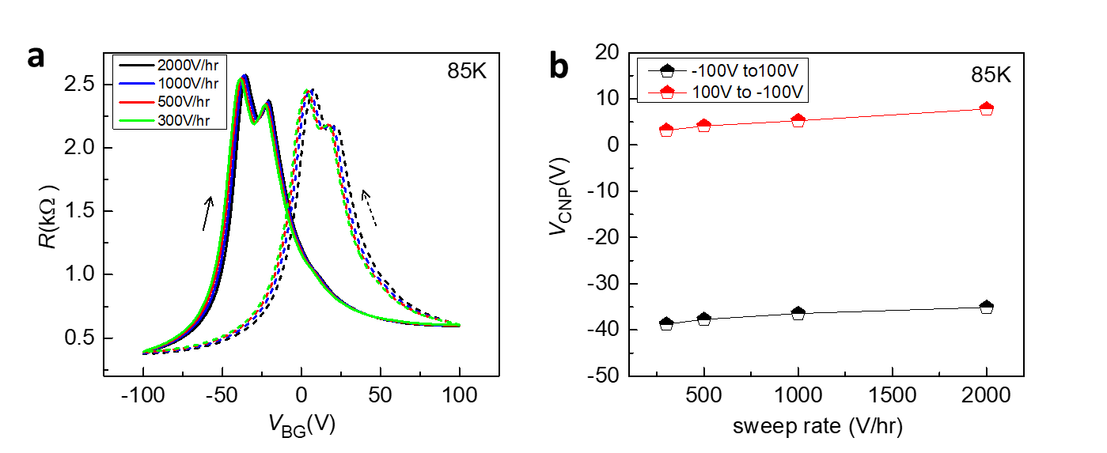

FIG S6. (a) Resistance of graphene transistor on STO with varying back gate voltage ($V_{BG}$) sweeping at the rate from 300 V/hr to 2000 V/hr. The solid and dashed lines represent the resistance of graphene with forward and reverse sweep directions of $V_{BG}$ respectively. (b) The position of $V_{CNP}$ at different sweep rates of $V_{BG}$ obtained from figure (a), showing unchanged anti-hysteresis.

**VII. $1/f$ NOISE WITH VARYING $V_{TG}$**

As a function of $V_{TG}$, the noise magnitude ($〈∆R^{2}〉/R^{2}$) shows a ‘V’ shaped characteristic around the charge neutrality point (Fig. S8). Such $1/f$ noise feature is often observed for conventional graphene transistor on SiO2 substrate due to fluctuating electrostatic environment 11, 12.

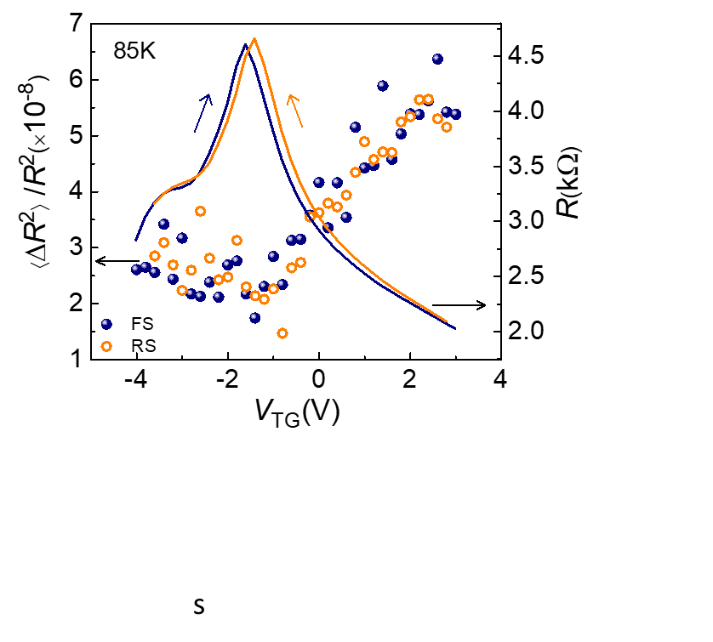

FIG S7. Normalized $1/f$ noise ($〈∆R^{2}〉/R^{2}$) of SLG on STO along with the resistance of the channel with forward sweep (FS) and reverse sweep (RS) of $V_{TG}$ at 85 K.

**VIII. DFT CALCULATIONS**

**A. Method**

DFT calculations of TiO2 terminated STO substrate and graphene/STO (STO+Gr) systems were carried out considering the slab geometries. Imposition of periodic boundary conditions along the [001] direction in slab calculations lead to spurious electric fields being setup within the supercell. The errors introduced due to these spurious fields were eliminated by imposing an external dipole field within the scheme of Neugebauer *et al.* 13.

Relaxation of atomic positions of TiO2 terminated STO substrate and STO+Gr system were carried out within the framework of plane-wave basis set as implemented in VASP 14, 15 with projector-augmented wave (PAW) potential 16, 17. The exchange correlation was treated within generalized gradient approximation (GGA) in the parametrization scheme of Perdew, Burke and Ernzheroff (PBE) 18. The van der Waals corrections were taken into account in the exchange-correlation functional within a DFT-D2 approach of Grimme 19. The plane-wave basis set was expanded with a kinetic energy cutoff of 500 eV. A Monkhorst-Pack k-grid of 4x4x2 was used for all Brillouin zone integrations. Convergence in terms of higher energy cut off as well k-mesh was checked. Electric field was applied along the [001] direction normal to the surface. The systems were considered to be optimized when the maximum force on the atoms became less than 0.01 eV Å-1.

To determine out-of-plane surface polarization $\overline{P}$ we followed the scheme implemented by Vanderbilt *et al*. 20 based on calculating the dipole moment $p^{i}$ on i-th atomic layer. This was done by identifying the nodes $z_{i}$ at which $\int_{-c/2}^{Z_{i}}{\overline{ρ}\left(z\right)dz}$ vanishes where $\overline{ρ}\left(z\right)=\frac{1}{A}\int{ρ\left(x,y,z\right)dxdy; ρ(x,y,z)}$ being the charge density, *c* being the height of the supercell, and *A* being the area of the surface unit cell. The regions enclosed within the nodes are charge neutral and contain exactly one SrO or TiO2 atomic layer. The layer dipole moment $p^{i}$ is given by $p^{i}=\int{\overline{ρ}\left(z\right)dz}$ where the range of integration was restricted to the spacing between two nodes. The dipole moment is largest for the surface layer due to the off-centric displacement of the surface atoms being large. Since the atomic displacements die down rapidly as we move away from the surface layer (Fig. S8) the dipole moment also shows a sharp fall as a function of the layer number. Thus, modification of the surface polarization is primarily contributed to by the unit cell enclosing the surface layers. The net surface dipole moment $p$ was then obtained by summing the individual dipole moments of all the surface layers. Finally, the surface polarization $\overline{P}$ is given by $\overline{P}=\frac{p}{d}$ where $d$ is the inter-layer separation between the two top layers.

For our DFT study, a $2×2×5$ supercell of cubic STO was considered, which was terminated at TiO2 layer along the [001] direction (z-direction). The atomic positions in two bottom layers were kept fixed so as to mimic the substrate effect. Within the periodic set-up of DFT calculations the STO substrate was separated from its periodic image by a vacuum of 12 Å. To establish the convergence of our calculations in terms of vacuum layer thickness, we have carried out additional calculations considering an increased thickness of vacuum layer (30 Å). We found our conclusions to remain unchanged, justifying reliability of our calculations.

To simulate the graphene-STO system in DFT study, modeling is necessary. The modeling was done in two different ways, referred as model-1 and model-2. In model-1, an epitaxial registration between graphene and STO was assumed. Thus, the lattice parameter of 2 x 3 orthorhombic supercell of graphene was matched to that of STO. This resulted in a compressive strain of 7.29 % along lattice parameter *a* and a tensile strain of 6.77 % along *b* in the graphene layer. In model-2, we kept the in-plane lattice parameters of STO substrate fixed. No compressive or tensile strain was applied to the graphene sheet. Structural optimization was carried out in three steps,

(a) For the first step, all the layers of STO were kept fixed and only the graphene sheet was allowed to relax. For the graphene sheet, the relaxation was carried out only in the x-y direction while being restricted in the z-direction. This allowed the in-plane lattice constant the graphene sheet adjust to that of the STO substrate without causing buckling of the sheet.

(b) The second step is similar to the first step except that now the graphene sheet was allowed to be relaxed along the z-direction as well.

(c) Keeping the bottom two layers of the STO substrate fixed to mimic the substrate effect, constrained relaxation of atomic coordinates of both the graphene sheet as well as the STO substrate was carried out.

We found model-2 led to a structure of graphene which is significantly less buckled compared to that of model-1 (an order of magnitude smaller), suggesting primarily van der Waals like interaction between garphene and STO surface. The polarization (${\overline{P}}_{STO+Gr}$)calculated for model-1 and model-2 turned out to be $-34.9 μC cm^{-2}$ and $-24 μC cm^{-2}$, respectively. Thus, the polarization computed from model-2 geometry gives better agreement to experimental value and that obtained from simple phenomenological model.

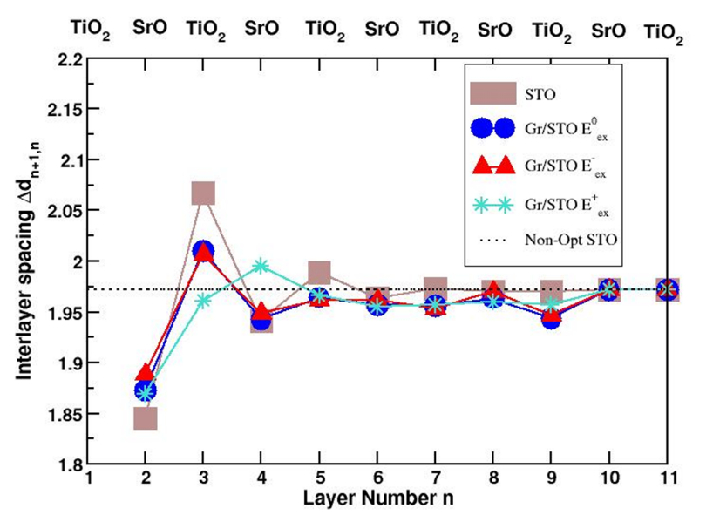

FIG. S8. The interlayer spacing $∆d_{n+1,n}$ plotted against the layer number *n*. We mark the topmost layer as the first layer i.e *n* = 1. Due to the off-centric movement of the atoms, the interlayer separation between the different layers gets modified compared that of the bulk. As can be seen from the figure the modification is largest for the first two layers (identified as the surface layers) but decrease rapidly as one moves away from the surface.

**B. Results**

In our DFT calculations, we observe that even in the absence of graphene, upon relaxation the surface layers of the STO substrate gets somewhat rumpled due to the out-of-plane (*z*) displacements of the Ti and Sr atoms, relative to the unrelaxed or ideal positions (Fig. 3a, 3b of main text). Interestingly, the displacements of Ti and Sr atoms are directed oppositely. The Ti atoms get pushed down towards the interior while the Sr atoms get pulled up towards the surface. The rumpling of the layers decreases in magnitude as one moves down in layers, and finally vanishes at the end layer by construction. This results in formation of dipole moments, oriented along the *z*-direction, *p*z(TiO2) and *p*z(SrO) corresponding to the TiO2 layer and the SrO layer, which point in opposite directions with *p*z(TiO2) > *p*z(SrO). This gives rise to a net surface polarization, directed towards the interior, ${\overline{P}}_{STO}=-13.89 μC cm^{-2}$. This is in good agreement with the result obtained by Vanderbilt *et al*. 20.

The presence of graphene enhances the polarization at the surface of STO substrate, with the magnitude depending on the degree of buckling as discussed in previous section where ${\overline{P}}_{STO+Gr}=-34.90 μC cm^{-2}$ (model-1) and $-24 μC cm^{-2}$ (model-2).

In presence of electric field, a strong asymmetry in atomic displacements and calculated polarization values is observed between positive and negative directions of electric fields, in agreement with experimental observation. We find that the presence of positive electric field, the surface dipole moments, *p*z(TiO2) and *p*z(SrO) at TiO2 and SrO layers are found to be nearly equal in magnitude and oppositely directed, leading to near cancellation. For an electric field of +1 V/Å, the calculated polarization turned out to be tiny, $+2.286 μC cm^{-2}$. Reversing the direction of electric field, leads to greater rumpling of the TiO2 layer due to the larger displacements of the O ions. This causes a significant enhancement of the surface dipole moment *p*z(TiO2) at TiO2 layer. The application of negative electric field, on the other hand, makes the surface dipole moment *p*z(SrO) at SrO layer vanishingly small. Thus, contribution to surface polarization ${\overline{P}}_{STO+Gr}$ dominantly comes from the TiO2 layer and attains a large value of $-66.39 μC cm^{-2}$ for a considered electric field of -1 V/Å. Although this external electric field is almost 105 orders of magnitude higher than our experimental range, the field-tunability of the interface dipoles at this high external electric field provides the possibility of further experimental investigation.

**IX. $1/f$ NOISE MEASUREMENT**

The power spectral density (PSD) of noise is obtained by calculating the Fourier transformation of the auto-correlation function which is expressed as,

$S_{R}\left(f\right)=\lim_{T→∞}\left(\frac{1}{2T}\right){\left(\int_{-T}^{T}{∆R\left(t\right)e^{-i2πft}dt}\right)}^{2},$ (2)

where $T$ is the experimental time period. This PSD shows $1/f^{α}$ dependence with $α\sim 1$ at low frequencies and hence is called ‘ $1/f-$ noise’ or ‘flicker noise’ 21, 22. The resistance fluctuation of graphene as a function of time is measured by a lock-in amplifier (SR830), where the time constant and filter roll-off are set to 10 mS and 24 dB/octave respectively. Since, the noise obtained from the lock-in amplifier contains both the resistance fluctuation of the sample as well as the background fluctuation, it is essential to eliminate the noise coming from external sources. The PSD of the output from the lock-in amplifier is given by,

$S_{R}\left(f,δ\right)≃G_{0}^{2}\left[S_{R}^{0}\left(f_{0}-f\right)+S_{R}\left(f\right)\cos^{2}{δ}\right],$ (3)

where $S_{R}^{0}(f)$ and $S_{R}(f)$ are the PSD due to background fluctuations and resistance fluctuations of the sample, respectively. $G_{0}$ is the gain of lock-in amplifier, $f_{0}$ is the excitation frequency, $f$ is the measurement frequency and $δ$ is the phase angle of the detection of the input voltage to the lock-in amplifier with respect to the bridge current. In case of an in-phase component, $δ=0, { S}_{R}(f,0)/G_{0}^{2}=S_{R}^{0}+S_{R}(f)$, whereas in case of an out-of-phase component, $δ=π/2, { S}_{R}(f,π/2)/G_{0}^{2}=S_{R}^{0}$. Hence subtracting the out-of-phase signal from the in-phase signal gives noise only from the sample. In our case, from lock-in amplifier the fluctuations were digitized by using a 16-bit data acquisition card from National Instrument (NI USB-6210) and stored in the computer for digital signal processing. To eliminate aliasing effects according to the Nyquist theorem, the data were stored at a sampling rate of 1024 Hz and then decimated by a factor of 64 in a three-stage decimation process, which gave the effective sampling rate of 16 Hz (twice the measurement bandwidth $≈$ 8 Hz). The low frequency PSD was then calculated from the decimated time series using Welch's periodogram method 23 and the PSD of only sample was obtained by subtracting the PSD of out-of-phase signal (from the Y channel) of lock-in amplifier from the PSD of in-phase signal (from the X channel).

**References**

1. Kim, S.; Nah, J.; Jo, I.; Shahrjerdi, D.; Colombo, L.; Yao, Z.; Tutuc, E.; Banerjee, S. K. *Appl Phys Lett* **2009,** 94, (6).

2. Couto, N. J. G.; Sacepe, B.; Morpurgo, A. F. *Phys Rev Lett* **2011,** 107, (22).

3. Saha, S.; Kahya, O.; Jaiswal, M.; Srivastava, A.; Annadi, A.; Balakrishnan, J.; Pachoud, A.; Toh, C. T.; Hong, B. H.; Ahn, J. H.; Venkatesan, T.; Ozyilmaz, B. *Sci Rep* **2014,** 4, 6173.

4. Hemberger, J.; Lunkenheimer, P.; Viana, R.; Bohmer, R.; Loidl, A. *Physical Review B* **1995,** 52, (18), 13159-13162.

5. Lemanov, V. V. *Ferroelectrics* **2002,** 265, 1-21.

6. Worlock, J. M.; Fleury, P. A. *Phys Rev Lett* **1967,** 19, (20), 1176.

7. Muller, K. A.; Burkard, H. *Physical Review B* **1979,** 19, (7), 3593-3602.

8. Sakudo, T.; Unoki, H. *Phys Rev Lett* **1971,** 26, (14), 851-853.

9. Tian, J. F.; Chang, C. Z.; Cao, H. L.; He, K.; Ma, X. C.; Xue, Q. K.; Chen, Y. P. *Scientific Reports* **2014,** 4.

10. Wang, H. M.; Wu, Y. H.; Cong, C. X.; Shang, J. Z.; Yu, T. *Acs Nano* **2010,** 4, (12), 7221-7228.

11. Kochat, V.; Sahoo, A.; Pal, A. N.; Eashwer, S.; Ramalingam, G.; Sampathkumar, A.; Tero, R.; Thu, T. V.; Kaushal, S.; Okada, H.; Sandhu, A.; Raghavan, S.; Ghosh, A. *Iet Circuits Devices & Systems* **2015,** 9, (1), 52-58.

12. Pal, A. N.; Ghatak, S.; Kochat, V.; Sneha, E. S.; Sampathkumar, A.; Raghavan, S.; Ghosh, A. *Acs Nano* **2011,** 5, (3), 2075-2081.

13. Neugebauer, J.; Scheffler, M. *Physical Review B* **1992,** 46, (24), 16067-16080.

14. Kresse, G.; Furthmuller, J. *Physical Review B* **1996,** 54, (16), 11169-11186.

15. Kresse, G.; Hafner, J. *Physical Review B* **1993,** 47, (1), 558-561.

16. Blöchl, P. E. *Physical Review B* **1994,** 50, (24), 17953-17979.

17. Kresse, G.; Joubert, D. *Physical Review B* **1999,** 59, (3), 1758-1775.

18. Perdew, J. P.; Burke, K.; Ernzerhof, M. *Phys Rev Lett* **1996,** 77, (18), 3865-3868.

19. Grimme, S. *Journal of Computational Chemistry* **2006,** 27, (15), 1787-1799.

20. Meyer, B.; Vanderbilt, D. *Physical Review B* **2001,** 63, (20).

21. Dutta, P.; Horn, P. M. *Reviews of Modern Physics* **1981,** 53, (3), 497-516.

22. Voss, R. F.; Clarke, J. *Physical Review B* **1976,** 13, (2), 556-573.

23. Welch, P. D. *Ieee Transactions on Audio and Electroacoustics* **1967,** Au15, (2), 70-+.