Title: To a charismatic rescue: Designing a blueprint to steer Fishing Cat conservation for safeguarding Indian wetlands

Supplementary Information

Appendix A: Habitat suitability modelling

Table A1: Presence records of the Fishing Cat in the Indian mainland.xlsx

Table A2: Data sources for environmental variables used in Habitat Suitability Modelling
Environmental variable | Source
Bioclimatic variables | https://www.worldclim.org/data/bioclim.html
Elevation | https://www.ngdc.noaa.gov/mgg/topo/gltiles.html
Land use land cover (2012) | https://globalmaps.github.io/glcnmo.html
Human population density | https://sedac.ciesin.columbia.edu/data/set/gpw-v4-population-density-adjusted-to-2015-unwpp-country-totals-rev11/data-download
Soil water content | https://cgiarcsi.community/data/global-high-resolution-soil-water-balance/

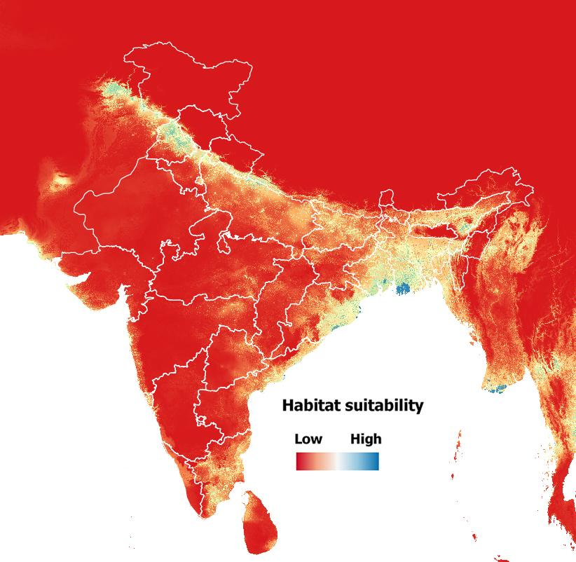
Figure A1: Output raster from the best habitat suitability model
(features - LQP and regularization multiplier - 2)

Table A3: Contribution and importance of environmental predictors obtained from the final MaxEnt model shown in Fig. A1
Variable | Variable Contribution (Mean±SD) | Permutation Importance
Bio17 | 5.02±3.21 | 26.34±8.43
Bio18 | 3.79±3.03 | 1.74±1.24
Bio19 | 1.53±1.03 | 2.2±2.39
Bio02 | 6.86±1.49 | 6.34±1.98
Elevation | 20.82±4.56 | 36.35±4.85
LULC (2012) | 57.29±16.62 | 21.39±6.55
Population density (2020) | 0.24±0.44 | 0.18±0.36
Soil Water Content | 4.45±5.75 | 5.45±5.35

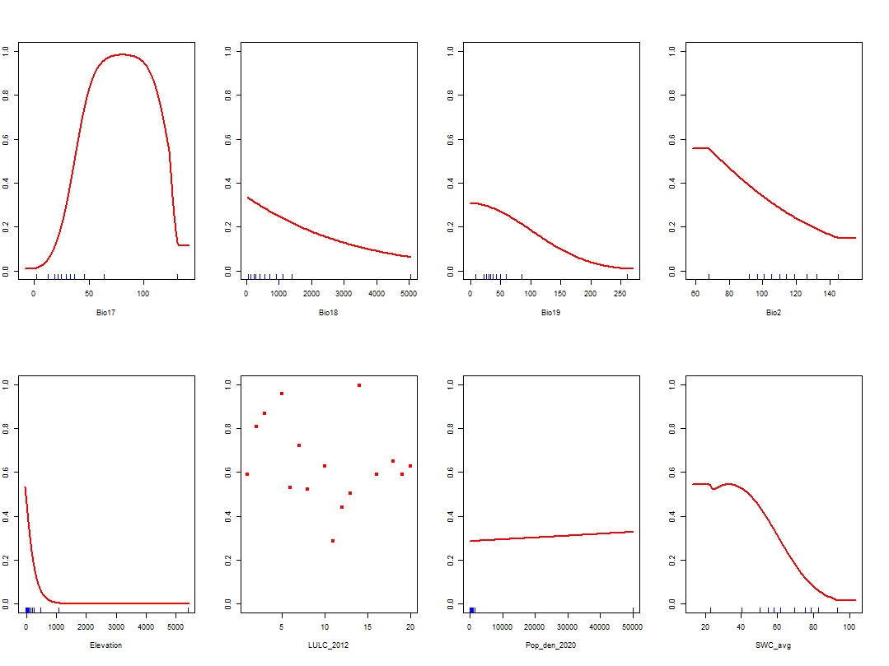
Figure A2: Response curves obtained from the replicate with highest TSS value and lowest omission rates (P10 and ESS thresholds) for the best MaxEnt model

LULC Classification for interpreting the above response curve
Broadleaf Evergreen Forest (1), Broadleaf Deciduous Forest (2), Needleleaf Evergreen Forest (3), Needleleaf Deciduous Forest (4), Mixed Forest (5), Tree Open (6), Shrub (7), Herbaceous (8), Herbaceous with Sparse Tree/Shrub (9), Sparse vegetation (10), Cropland (11), Paddy field (12), Cropland/Other Vegetation Mosaic (13), Mangrove (14), Wetland (15), Bare area (16), consolidated (gravel, rock) (17), Bare area, consolidated(sand) (18), Urban, Snow/Ice (19), Water bodies (20)

Appendix B: Omnidirectional Connectivity analysis

To model connectivity, we first modified the approach detailed by Pelletier et al. (2014). We first applied a buffer (filled with random resistance values) around the resistance raster and created pixel wide current source and sink sites along the edges of this raster. Current was first modelled to flow in the North-South and then along the East-West direction using the software Circuitscape, implemented in R v4.0.5. Values from the two current maps were multiplied and log transformed (after cropping out the buffer) to create an omnidirectional current map, representing landscape level connectivity.

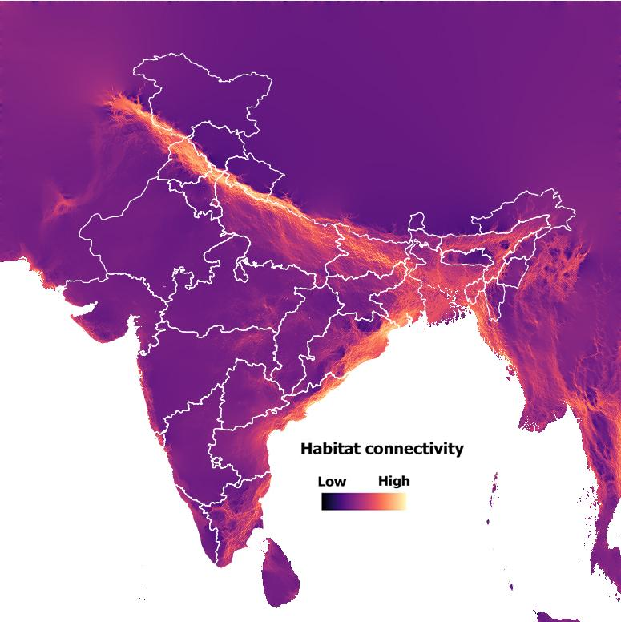
Figure B1: Output raster from the Omnidirectional connectivity model
using the output of habitat suitability modelling

Appendix C: Conservation priority scores

Habitat suitability values where predictive accuracy was high (species 5 times more likely to be present than by chance) were used to calculate Conservation priority scores to minimize false positives in further inferences. Hence, these optimal habitats were identified as areas with habitat suitability scores corresponding to P/E ratio values of 5 or more i.e., 0.44 in this case as shown in Fig. C1.
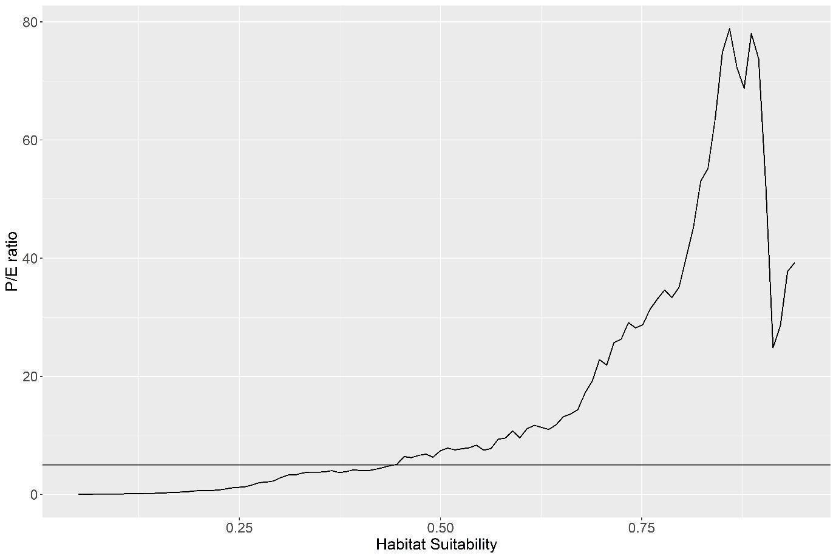
Figure C1: P/E ratio vs Habitat suitability for selected model. Horizontal line represents the 5x cut-off value i.e., habitat suitability score of 0.44

Appendix D: Conservation likelihood scores

Table D1: Data sources for socio-political variables used to estimate Conservation likelihood scores
Socio-political variable | Source
State wise Forest Department budget | https://openbudgetsindia.org/dataset/sector-specific-indicators-of-state-expenditure
Gross Domestic Product (GDP) | https://www.rbi.org.in/Scripts/PublicationsView.aspx?id=19000
State-wise fisher population | https://dof.gov.in/sites/default/files/2021-02/Final_Book.pdf

Appendix E: Conservation Initiative
Table E1: List of ongoing research conservation efforts for the Fishing Cat in India.xlsx

Appendix F: Sensitivity analysis

To understand the effect of selecting various increment values or weights (for Conservation initiatives) and cut-off values (for Conservation priority and likelihood scores), on the resulting classification of districts for our blueprint, we conducted a sensitivity analysis by varying the values of these inputs. The results from our analysis are provided in the table F1 below.

Table F1: Results of sensitivity analysis - The number of districts classified in each tier with different values of weights (for Conservation initiatives) and cut-off values (for Conservation priority and likelihood scores)
Weight | Cut-off (Quantiles) | Number of districts in
 |  | Tier 1 | Tier 2 | Tier 3 | Tier 4
0.5 | 0.25 | 36 | 9 | 12 | 3
0.5 | 0.5 | 16 | 14 | 17 | 13
0.5 | 0.75 | 1 | 14 | 19 | 26
1 | 0.25 | 35 | 10 | 12 | 3
1 | 0.5 | 15 | 15 | 17 | 13
1 | 0.75 | 0 | 15 | 19 | 26
2 | 0.25 | 35 | 10 | 12 | 3
2 | 0.5 | 15 | 15 | 17 | 13
2 | 0.75 | 0 | 15 | 19 | 26

Increasing the weights assigned to Conservation initiatives had no significant impact and only displaced one district from tier 1 to tier 2 (when changed from 0.5 to 1). Increasing cut offs for conservation priority and likelihood scores however significantly affected district classification. Selecting extreme quantiles (1st and 3rd quartile) resulted in extreme shifts in classification, and so we decided to use the median value for district classification and further inference.

Appendix G: District-wise calculated scores of all indices
Table G1: Scores of Conservation priority and Conservation likelihood, presence of Conservation Initiative, and identified survey landscapes

