Supplementary materials:

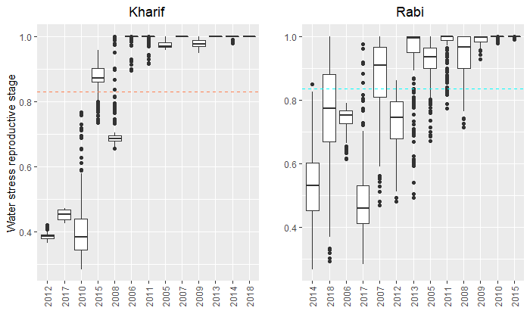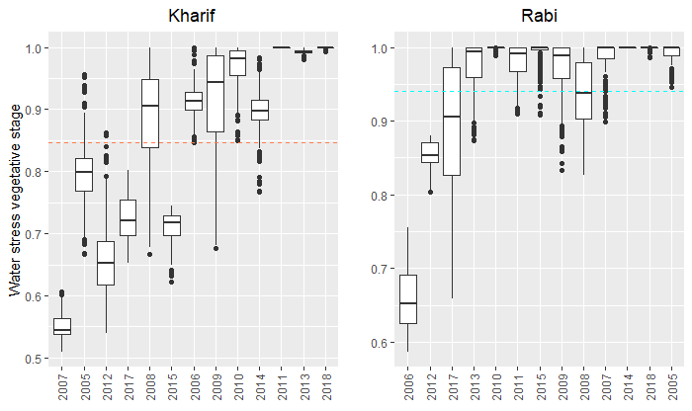
Figure S1: variation of simulated water stresses per year (figures at the top: reproductive water stress, figures at the bottom: vegetative water stress). The years are ordered with respect to the value of “rainfall over cropping season”-“ETP over cropping season”+”Soil water content at sowing”, from lowest to highest values.

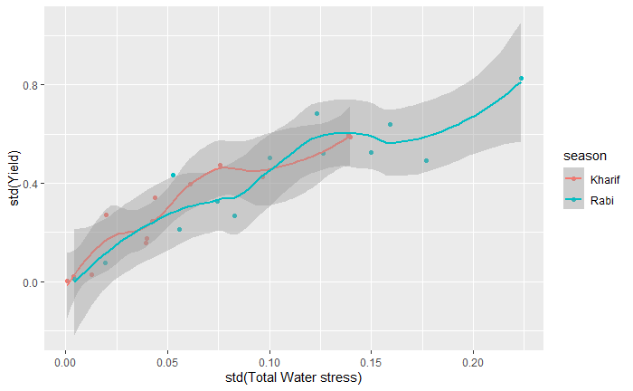
Figure S2: Standard deviation of Yield per year in function of Standard deviation of total water stress (vegetative + reproductive).

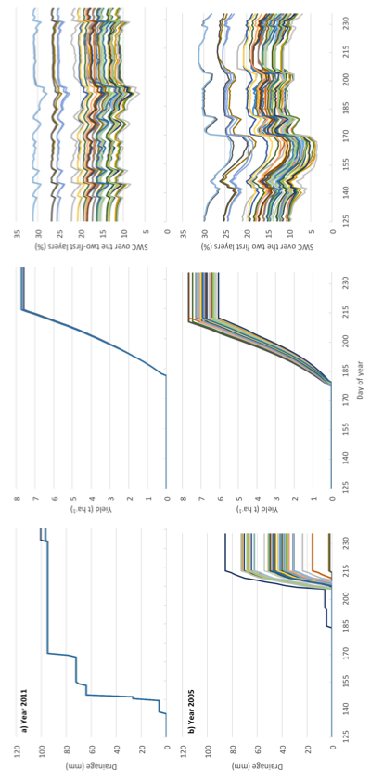
Figure S3: Drainage in mm (left), yield in T/ha (center) and soil moisture in % (right) for the Kharif season of the years 2011 (top) and 2005 (bottom) for different soils (each line represents one soil - for clarity, only soils from 175 to 217 are shown). While the level of P-ETP+resmes(plt) was close for both years (Figure 4), the impact of soil properties on drainage and yield was very different. In 2011, heavy rains occurred at the beginning of the Kharif season, inducing strong episodes of recharge, similar for all types of soils, and filling the soil reservoir, allowing to always achieve the potential yield. To the contrary, in 2005, rains were delayed, and the resulting drought spell induced variable water stress depending to soil properties. Large storm events at the end of the season led to contrasted amount of drainage across soils.

