Supporting Information

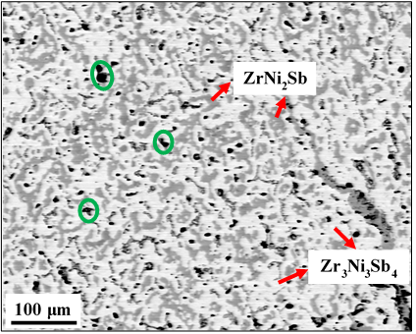
Figure S1: BSE micrograph of Zr deficient ternary Zr_{0.75}NiSb after annealing

BSE micrograph shows binary phase mixture of Zr₃Ni₃Sb₄ (having brighter contrast) and ZrNi₂Sb with darker contrast. Voids can also be seen, as indicated by green circles.

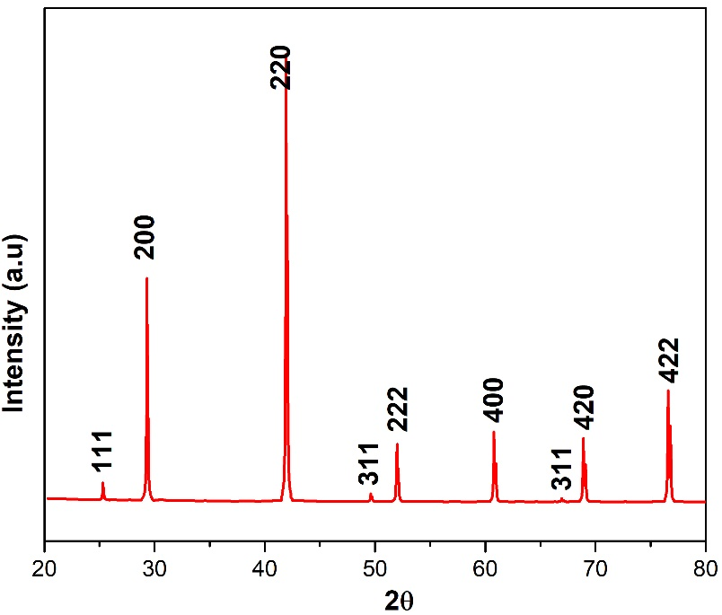

Figure S2: Simulated XRD pattern for ZNFS composition with atomic positions provided in the table below

Elements | Wyckoff position | Occupancy
Zr | 4a | 1
Sb | 4b | 1
Fe | 4c | 0.5
Ni | 4d | 0.5

Partial occupancy of the 4d sites accompanied by voids at the 4c sites yields Cu₂MnAl-type structure (L2₁, space group Fm3m, no 225) with considerable difference between the intensity ratios of the (111) and (200) reflections. Such differences can also be seen in intensity ratios of (311) and (222) reflections. Similar pattern was also observed when Ni was put in 4c and Fe in 4d with same occupancy.

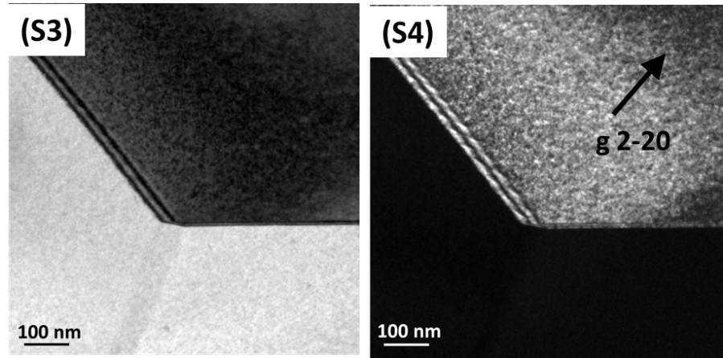
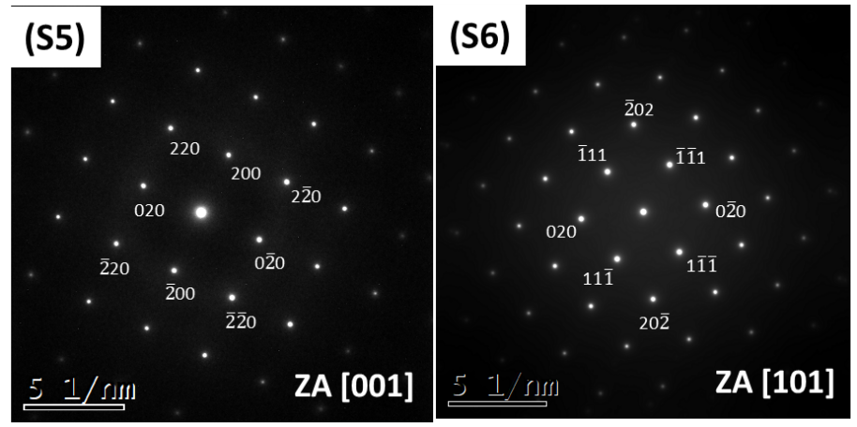
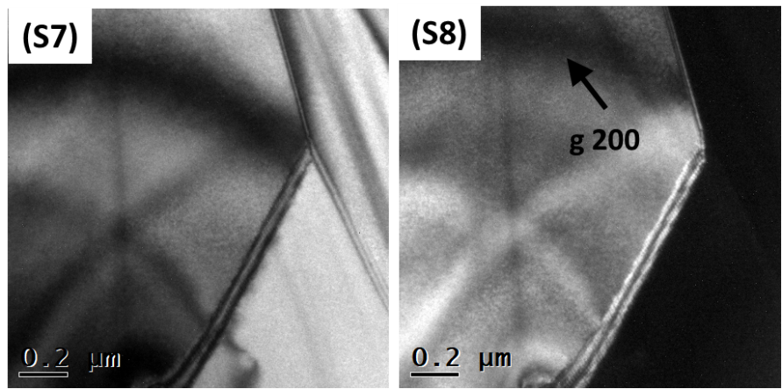
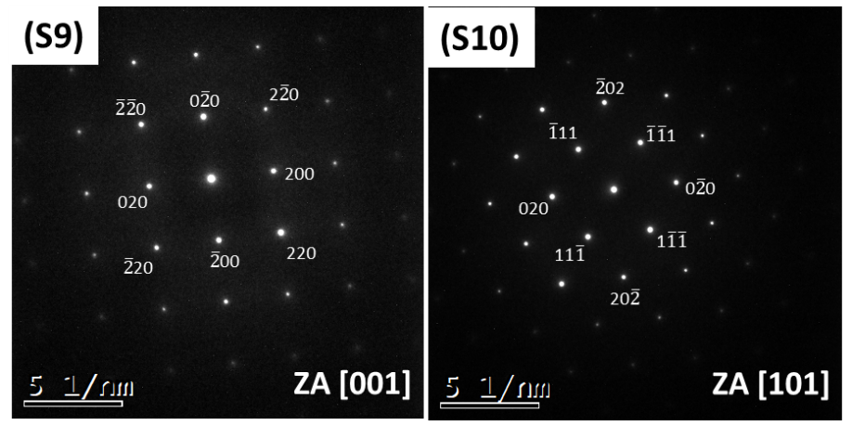
Figure (S3) - (S6): ZrNi_{0.5}Fe_{0.3}Co_{0.2}Sb, (S3) TEM BF image showing grain boundary of hH phase, (S4) DF image formed under two-beam condition using ($\overline{2}20)$ reflection of [001] zone axis direction. Major zone axis patterns indexed to (S5) [001], and (S6) [101]. (S7)-(S10) ZrNiIn_{0.5}Sb_{0.5}, (S7) TEM BF image showing grain boundary of hH phase, (S8) DF image formed under two-beam condition using ($200)$ reflection of [001] zone axis direction. Major zone axis patterns indexed to (S9) [001], and (S10) [101]

