SUPPORTING INFORMATION

**Roost site use by Great** (*Buceros bicornis*) **and Wreathed** (*Rhyticeros undulatus*) **Hornbill****and its implications for seed dispersal**

**Rohit Naniwadekar, Akanksha Rathore, Ushma Shukla** and **Aparajita Datta**

**Study Area:**

The study was carried out in Pakke Tiger Reserve. The elevation of Pakke Tiger Reserve ranges from 100 – 1,800 m a.s.l. The average annual rainfall is 2,500 mm. The temperature varies between 18*°*C to 29*°*C. The intensive study area in Pakke was in the low elevation forests in the south-eastern portion of the Park near the Seijosa town. The vegetation in the area is classified as Assam Valley tropical semi-evergreen forest. Some of the common trees in the area include *Tetrameles nudiflora*, *Ailanthus grandis*, *Polyalthia simiarum*, *Pterospermum acerifolium*, *Chisocheton cumingianus*, *Sterculia alata* and *Duabanga grandiflora*. All the trapping and tagging was conducted between the West Bank and Khari stretch of the park.

**Methods:**

The breeding season of hornbills is between March and August. We tagged three breeding males and two non-breeding males using canopy mounted mist nets following established methods (Keartumsom, Chimchome, Poonswad, Pattanavibool, & Pongpattananurak, 2011; Lenz et al., 2011). Nets were placed in the routes to the fruiting food plants of hornbills. We successfully trapped birds on fruiting fig trees. We only tagged adult male birds as the female birds are incarcerated in tree cavities throughout the entire breeding season, and the tags could interfere with their entry or exit from nest cavities. We did not tag juvenile birds as they can grow in size. Tags were < 3% of the body weight of the birds. Tags were attached as backpacks on birds using Teflon strings. Tags were programmed to take locations at 15-minute intervals throughout the day and turn off at night. We did not use movement information for one Great Hornbill whose tag was programmed to turn on and off at sunrise and sunset respectively. For all the other Great Hornbills and the Wreathed Hornbill, the tag was programmed to shut down at least 45 min after sunset (~ 1900 h IST) and turn on at least two hours before sunrise (~ 0310 h IST). Hornbills arrive at roosts latest by 1700–1800 h (IST) in June when the days are longest (pers. obs).

We used the default “href” function as the smoothing parameter rather than the Least Square Cross Validation (LSCV) method (Watts & Turrin, 2017; Worton, 1995). The LSCV method estimates smaller home ranges than the href method (Hemson et al., 2005). If the roost sites are outside the 50% utilization distributions as estimated by the href method, then they are even less likely to be inside the 50% utilization distributions estimated by the LSCV method.

Estimating seed dispersal distances and proportion of seeds dispersed at roost sites:

For estimating the seed dispersal kernels, we have followed established methods as outlined in multiple studies (Kays, Jansen, Knecht, Vohwinkel, & Wikelski, 2011; Lenz et al., 2011; Naniwadekar, Rathore, Shukla, Chaplod, & Datta, 2019; Westcott, Bentrupperbaumer, Bradford, & McKeown, 2005). We integrated the movement data with the data on visitation data of hornbills on fruiting trees (Naniwadekar et al., 2019), and gut retention (Shukla, Naniwadekar, Rathore, & Datta, 2018). We used the distribution of visitation pattern of hornbills on fruiting trees to draw the random samples of starting points. This way, the random starting points, were more likely to be fruiting trees than just randomly drawing starting points assuming uniform distribution. We obtained gut retention data for 305 seeds of five species of medium and large-seeded plants (Naniwadekar et al., 2019; Shukla et al., 2018). We performed 10 simulations per seed per individual bird (total number of simulations = 3,050 per individual bird). Since the birds have distinct foraging times, in each simulation, we selected the starting point based on the temporal distribution of visitation patterns on fruiting trees of hornbills as presented in another study (Naniwadekar et al., 2019). We determined the straight-line distance of the bird from the starting point at the end of the gut retention time for that particular seed. We also determined the end location of the bird. This end location was assumed to be site where the seed was dispersed. If the end location was within 50 m from the roost site of the bird for that day, the seed was assumed to be dispersed at roost, else it was assumed to be dispersed at non-roost location. We compiled the information from 3,050 simulations to determine the proportion of seeds that were dispersed at roost sites and non-roost sites.

**Table S1.** Breeding status, number of days of roosting data available for the five tagged hornbills (one Wreathed and four Great Hornbills), number of unique roost sites (separated by 200 m distance), and mean (range) number of nights a roost site was used by the different individual hornbills.

|  |  |  |  |  |  |
| --- | --- | --- | --- | --- | --- |
| Hornbill ID | Species | Status | # days data available | # of unique roost sites | Mean (range) number of nights a roost site was used |
| GH3Br | Great Hornbill | Breeding | 38 | 8 | 4.8 (1-17) |
| GH4Br | Great Hornbill | Breeding | 19 | 3 | 6.3 (1-17) |
| GH2NBr | Great Hornbill | Non-breeding | 30 | 11 | 2.7 (1-8) |
| GH5NBr | Great Hornbill | Non-breeding | 55 | 33 | 1.7 (1-11) |
| WH1Br | Wreathed Hornbill | Breeding | 72 | 10 | 7.2 (1-18) |
| Total |  |  | 142 |  |  |

**Table S2.** The average (± *SD* and range) distance (in metres) between roost sites on consecutive days for the different hornbill individuals and the mean (range) number of consecutive days when the birds used the same roost, and the number of days for which roost data from consecutive days was available is also given. * **–** Number of days for which the roost data was available for successive nights. This number is different from the number of days for which the roost data is available (which is summarized in Table 1) since no roost data was available for some nights during the tracking period.

|  |  |  |  |  |
| --- | --- | --- | --- | --- |
| Individual | Mean (± *SD*) distance between roost sites on successive nights (m) | Range (minimum – maximum) distance between roost sites on successive nights (m) | Mean (range) number of successive nights when the bird used the same roost | Number of days for which data was available* |
| GH3Br | 327.9 (234.7) | 17.8 – 709.3 | 3.5 (2 – 5) | 30 |
| GH4Br | 130.3 (199.1) | 3.3 – 601.8 | 5.3 (5 – 6) | 18 |
| GH2NBr | 232.6 (302.0) | 12.6 – 1,183.1 | 4.7 (3 – 7) | 16 |
| GH5NBr | 1,050.6 (1,034.6) | 5.0 – 4,318.7 | 2.6 (2 – 5) | 47 |
| WH1Br | 1,305.2 (1,575.0) | 3.1 – 4,698.7 | 3.8 (2 – 6) | 70 |

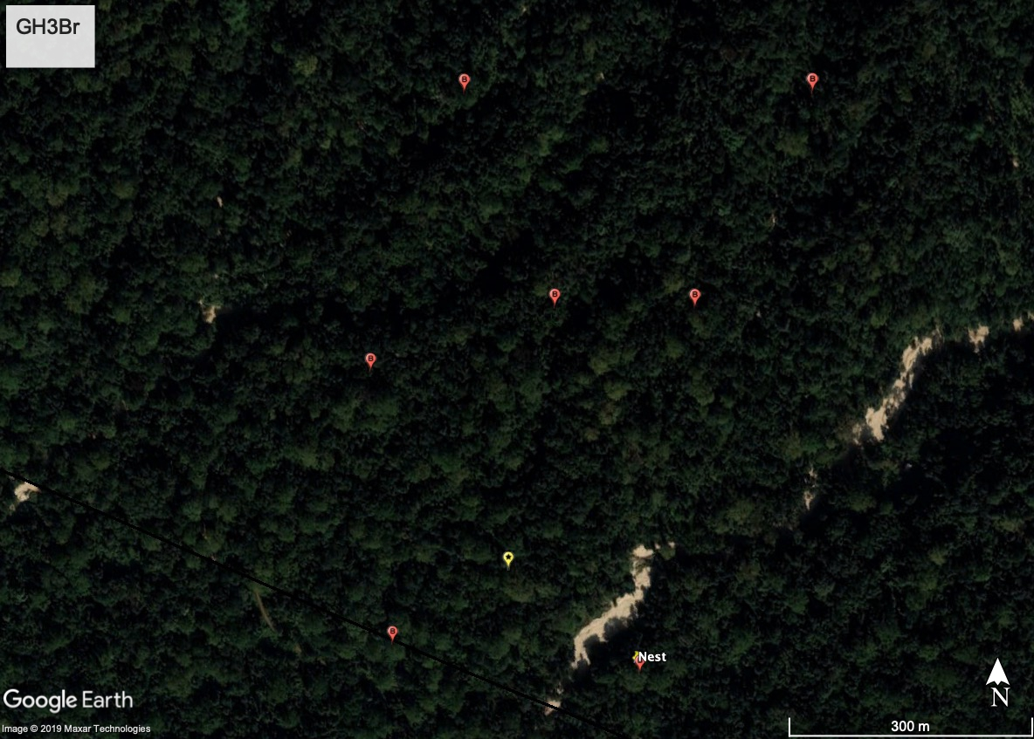

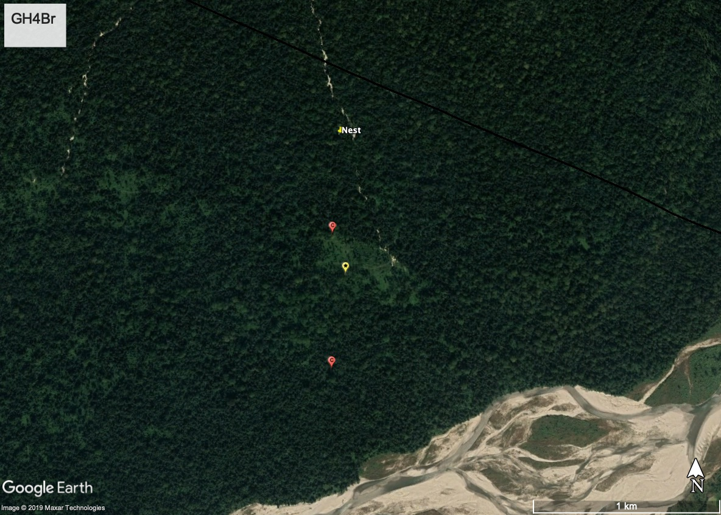

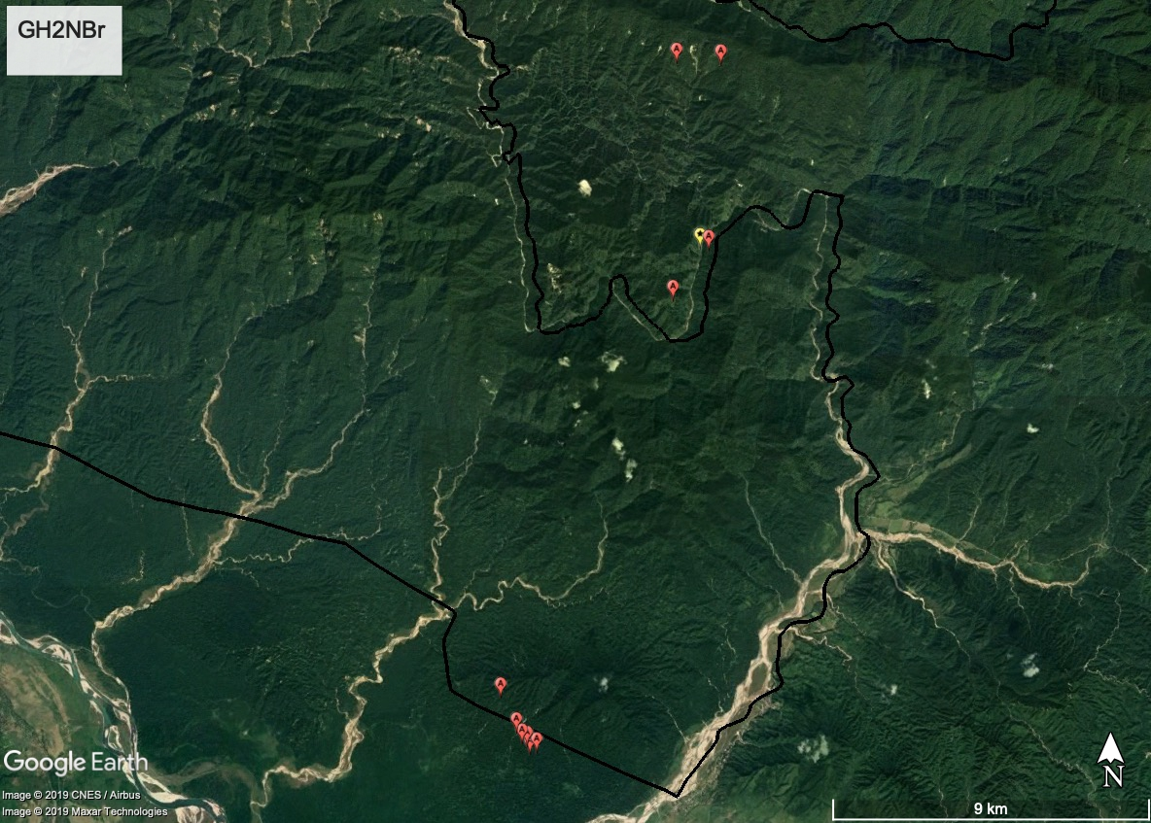

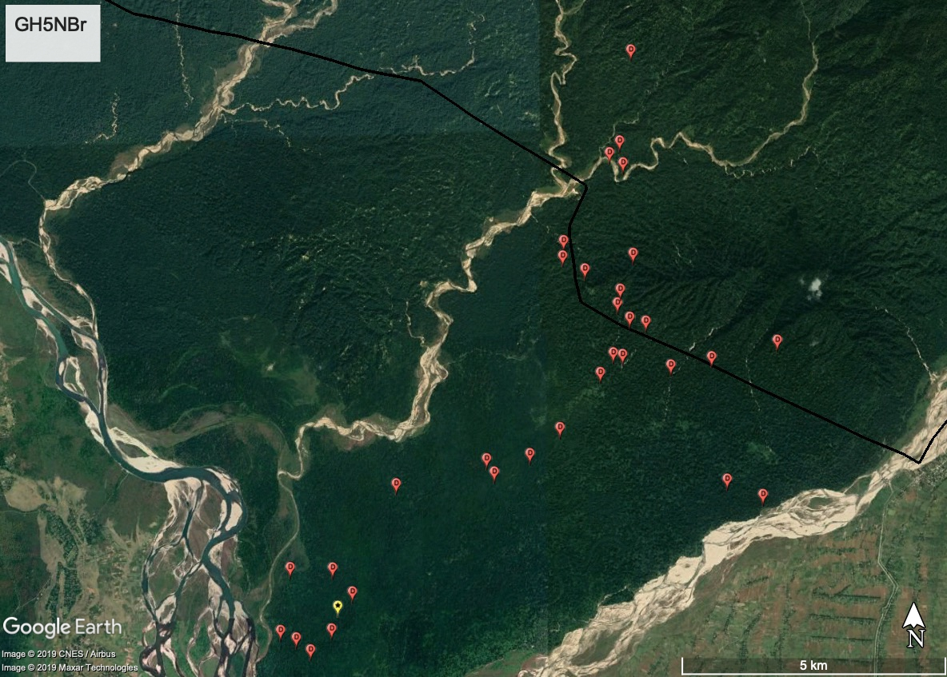

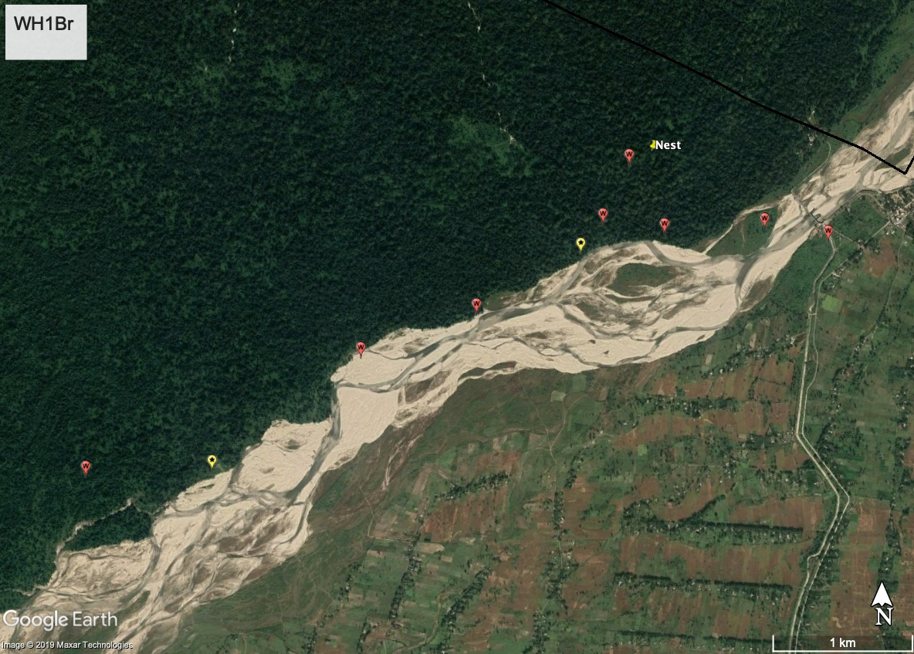

**Figure S1.** Map showing the roost and nest locations of the five individual hornbills (Great Hornbill non-breeding: GH2NBr and GH5NBr; Great Hornbill breeding: GH3Br and GH4Br; Wreathed Hornbill breeding: WH1Br). The roost locations comprise of all roost sites (across different days) within 200 m from each other and were identified using hierarchical cluster analysis. Nest locations have been marked with a yellow pin. The roost sites most used by the different individual birds have been marked with a star. Area north of the black line is the Pakke Tiger Reserve where the study was carried out and south of the black line is the Nameri Tiger Reserve in the adjoining state of Assam. Since the maps contain information on nest and roost sites of individual birds (some of which are still active), geographic coordinates for the maps have not been provided. Three breeding birds are featured first followed by non-breeding birds.

 **Figure S2.** All the roost locations of hornbills (except one roost location for GH4Br) are within the 95% (area enclosed within the black line) kernel density diurnal activity range for the five hornbills but not necessarily within the 50% kernel density activity range (area shown in grey). The locations used for the kernel density diurnal activity range estimation are those between 0500–1700 h for the five hornbills, thereby excluding the roost locations. The black dots are the roost locations of the bird identified using hierarchical cluster analysis. One roost location for GH4Br which was outside the 95% kernel density diurnal activity range is not shown since it was used for only one night and it was far away from its activity range. Coordinates on the map represent the north and east latitudes and longitudes respectively.



**Figure S3.** Mean displacement in a 15-min time interval for the five hornbill individuals. GH3Br and GH4Br are breeding Great Hornbills, GH2NBr and GH5NBr are non-breeding Great Hornbills with the former tagged in November (which is the non-breeding season) and the latter in March (which coincides with the breeding season). WH1Br is the breeding Wreathed Hornbill. There is a spike in the displacement just after and before the bird leaves the roost. It indicated that birds travel a long distance after they leave the roost in the morning and before returning to the roost in the evening.

**LITERATURE CITED**

Hemson, G., Johnson, P., South, A., Kenward, R., Ripley, R., & Macdonald, D. (2005). Are kernels the mustard? Data from global positioning system (GPS) collars suggests problems for kernel home-range analyses with least-squares cross-validation. *Journal of Animal Ecology*, *74*(3), 455–463. https://doi.org/10.1111/j.1365-2656.2005.00944.x

Kays, R., Jansen, P. A., Knecht, E. M. H., Vohwinkel, R., & Wikelski, M. (2011). The effect of feeding time on dispersal of *Virola* seeds by toucans determined from GPS tracking and accelerometers. *Acta Oecologica*, *37*(6), 625–631. https://doi.org/10.1016/j.actao.2011.06.007

Keartumsom, Y., Chimchome, V., Poonswad, P., Pattanavibool, A., & Pongpattananurak, N. (2011). Home range of Great Hornbill (*Buceros bicornis* Linnaeus, 1758) and Wreathed Hornbill (*Rhyticeros undulatus* (Shaw) 1881) in non-breeding season at Khao Yai National Park, Nakhon Ratchasima Province. *Journal of Wildlife in Thailand*, *18*, 47–55.

Lenz, J., Fiedler, W., Caprano, T., Friedrichs, W., Gaese, B. H., Wikelski, M., & Böhning-Gaese, K. (2011). Seed-dispersal distributions by trumpeter hornbills in fragmented landscapes. *Proceedings of the Royal Society B*, *278*(1716), 2257–2264. https://doi.org/10.1098/rspb.2010.2383

Naniwadekar, R., Rathore, A., Shukla, U., Chaplod, S., & Datta, A. (2019). How far do Asian forest hornbills disperse seeds? *Acta Oecologica*, *101*, 103482. https://doi.org/10.1016/j.actao.2019.103482

Shukla, U., Naniwadekar, R., Rathore, A., & Datta, A. (2018). Variability in gut passage times of Asian hornbills for large-seeded tree species. *The Sarawak Museum Journal*, *100*, 167–194.

Watts, B. D., & Turrin, C. (2017). Mapping bald eagle activity shadows around communal roosts. *The Journal of Wildlife Management*, *81*(5), 928–937. https://doi.org/10.1002/jwmg.21263

Westcott, D., Bentrupperbaumer, J., Bradford, M. G., & McKeown, A. (2005). Incorporating patterns of disperser behaviour into models of seed dispersal and its effects on estimated dispersal curves. *Oecologia*, *146*, 57–67. https://doi.org/10.1007/s00442-005-0178-1

Worton, B. J. (1995). Using Monte Carlo simulation to evaluate kernel-based home range estimators. *The Journal of Wildlife Management*, *59*(4), 794–800. JSTOR. https://doi.org/10.2307/3801959