Supplementary Materials

Efficacy of homemade face masks against human coughs: a focus on penetration, atomization and aerosolization of cough droplets.

Authors:
Bal Krishan¹, Dipendra Gupta†¹, Gautham V†¹, Shubham Sharma¹, Dipshikha Chakravortty^{2,4} and Saptarshi Basu*^{1,3}

† Contributed equally * Corresponding author Email: sbasu@iisc.ac.in
Affiliations:
¹Department of Mechanical Engineering, IISc, Bangalore, India
²Department of Microbiology and Cell Biology, IISc, Bangalore, India ³Interdisciplinary Centre for Energy Research (ICER), IISc, Bangalore, India
⁴Center of Biosystems Science and Engineering, IISc, Bangalore, India

This PDF file includes:
Figs. S1-S3
Movies-S1 & S2

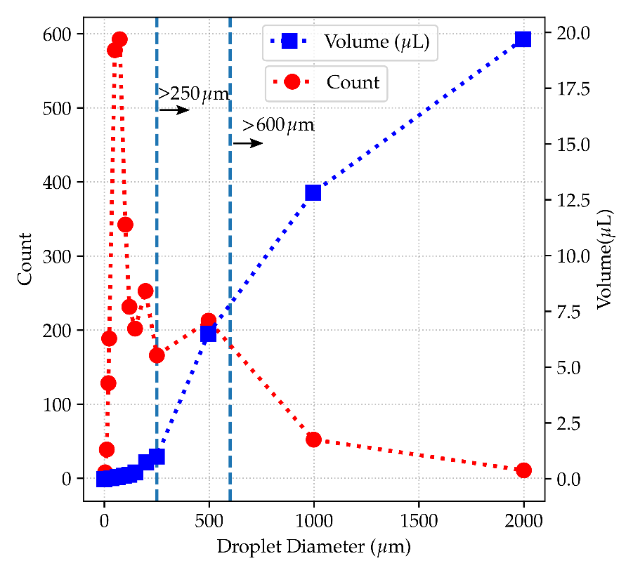
Fig. S1. Size and volume distribution of droplets expelled during coughing. The size distribution is as given in Duguid (1946)¹. Two vertical lines with arrows are used to indicate the sizes greater than 250 mm and 600 mm.

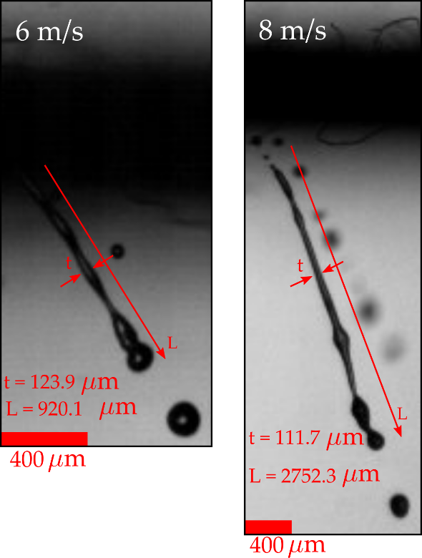
Fig. S2. Stretching of ligament for C-55 sample. The average length and thickness of ligaments shown for C-55 sample for impingement velocity of 6 m/s at 8 m/s just before the ligament breakup.

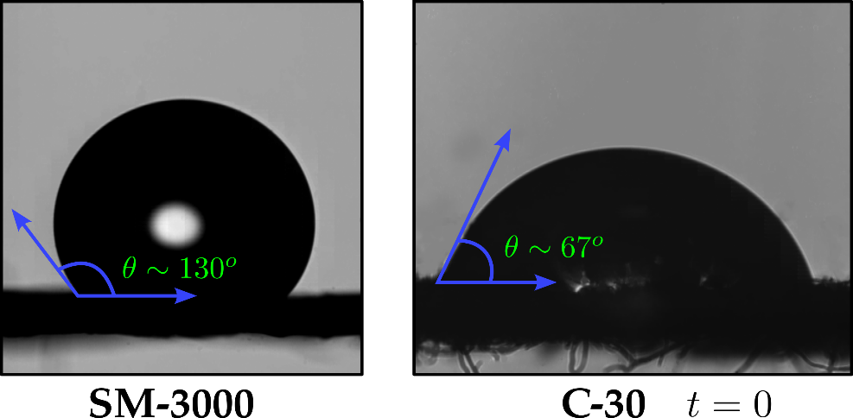
Fig. S3. Contact Angle: The shadowgraphy images of the contact angle for SM-3000 and C-30 sample at t=0.

References
- Duguid, J. P. The size and the duration of air-carriage of respiratory droplets and droplet-nuclei. Journal of Hygiene 44, 471–479 (1946).

