Supporting Information

“Evaluation of spray pyrolysed In: ZnO nanostructures for CO gas sensing at low concentration”
Aninamol Ani¹, Poornesh P^{1*}, K K Nagaraja^{1,2}, E. Kolesnikov², Igor V. Shchetinin², Albin Antony¹, Suresh D Kulkarni³
¹Department of Physics, Manipal Institute of Technology, Manipal Academy of Higher Education, Manipal, Karnataka, 576104, INDIA
²National University of Science and Technology “MISiS“, Leninskiy Pr. 4, Moscow, 119049, Russian Federation
³Department of Atomic and Molecular Physics, Manipal Academy of Higher Education, Manipal, Karnataka, 576104, INDIA
* Corresponding author: Poornesh P (poorneshp@gmail.com, poornesh.p@manipal.edu)

S1. Optical Properties
The UV-VIS spectroscopic analysis was performed to extract the values of transmittance, bandgap and Urbach energy of the films. The undoped and IZO films are highly transparent and showed excellent optical transmittance of 80% to 95% as evident from Fig. S1.1. The transmittance oscillations in the range 450-1100 nm suggests the films have smooth interfaces which further supports our observation on low RMS roughness of the films.
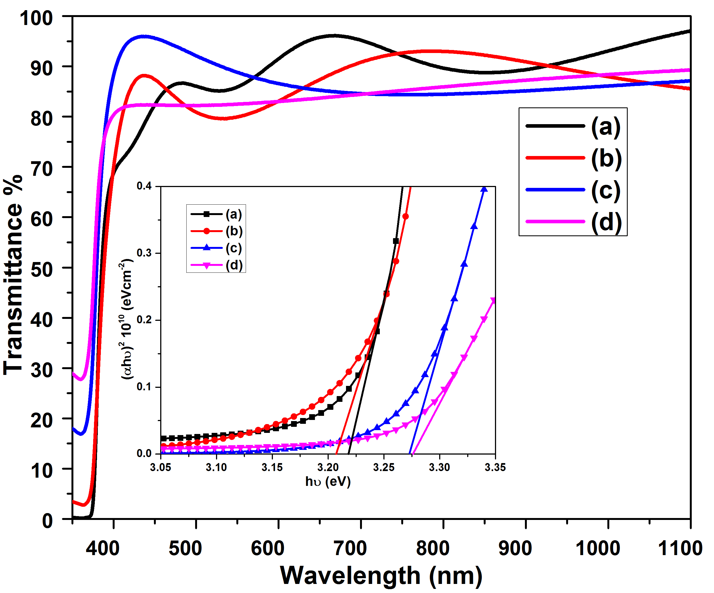
Fig. S1.1: Transmittance spectra of (a) undoped (b) 5 wt% (c) 10 wt% and (d) 15 wt% IZO thin films.
(Inset: Tauc Plot)
The absorption coefficient ($α$ ) was found using the Beer-Lamberts law [42] given by,
$α=\frac{1}{t} ln⁡(\frac{1}{T})$ (1)
Where t is the thickness of the films obtained and T is the transmittance achieved by the films. The bandgap of the films are obtained from Tauc plot which is a function of $(αhυ)$² versus $hυ$ employing Tauc’s relation [1],
$αhυ =A(hυ-E_{g}$)^{m} (2)
where h$υ$describes the photon energy, A is the energy-independent constant different for different transitions and whose value lies between 10⁷ and 10⁸ m⁻¹, E_{g} represents the bandgap energy and m is a constant which decides the type of transitions and is assumed as ½ for direct transitions and 2 for indirect transitions [1]. The inset of figure 5 depicts the Tauc plot of undoped and IZO films. In our case, we have taken it as ½, as ZnO proves as a direct bandgap semiconductor. The bandgap of the undoped and IZO films are well within the range of standard ZnO thin films. To study the spread of disorders in the films, Urbach energy was obtained from the Urbach empirical rule represented by the exponential equation [1],
$α=α_{o} exp⁡(\frac{hυ}{E_{U}})$ (3)
Where $α_{o}$ is considered as a constant and E_{U} represents the Urbach energy of the localized states in bandgap. The graph of ln $α$ versus $hυ$ gives the Urbach tail. The linear portion in the bandgap energy region is plotted and it is linearly fitted to find the slope. The reciprocal of the slope gives the Urbach energy from the straight-line equation. The Urbach energy plot is shown in Fig. S1.2. The energy gap and Urbach energy values are given in Table S1.
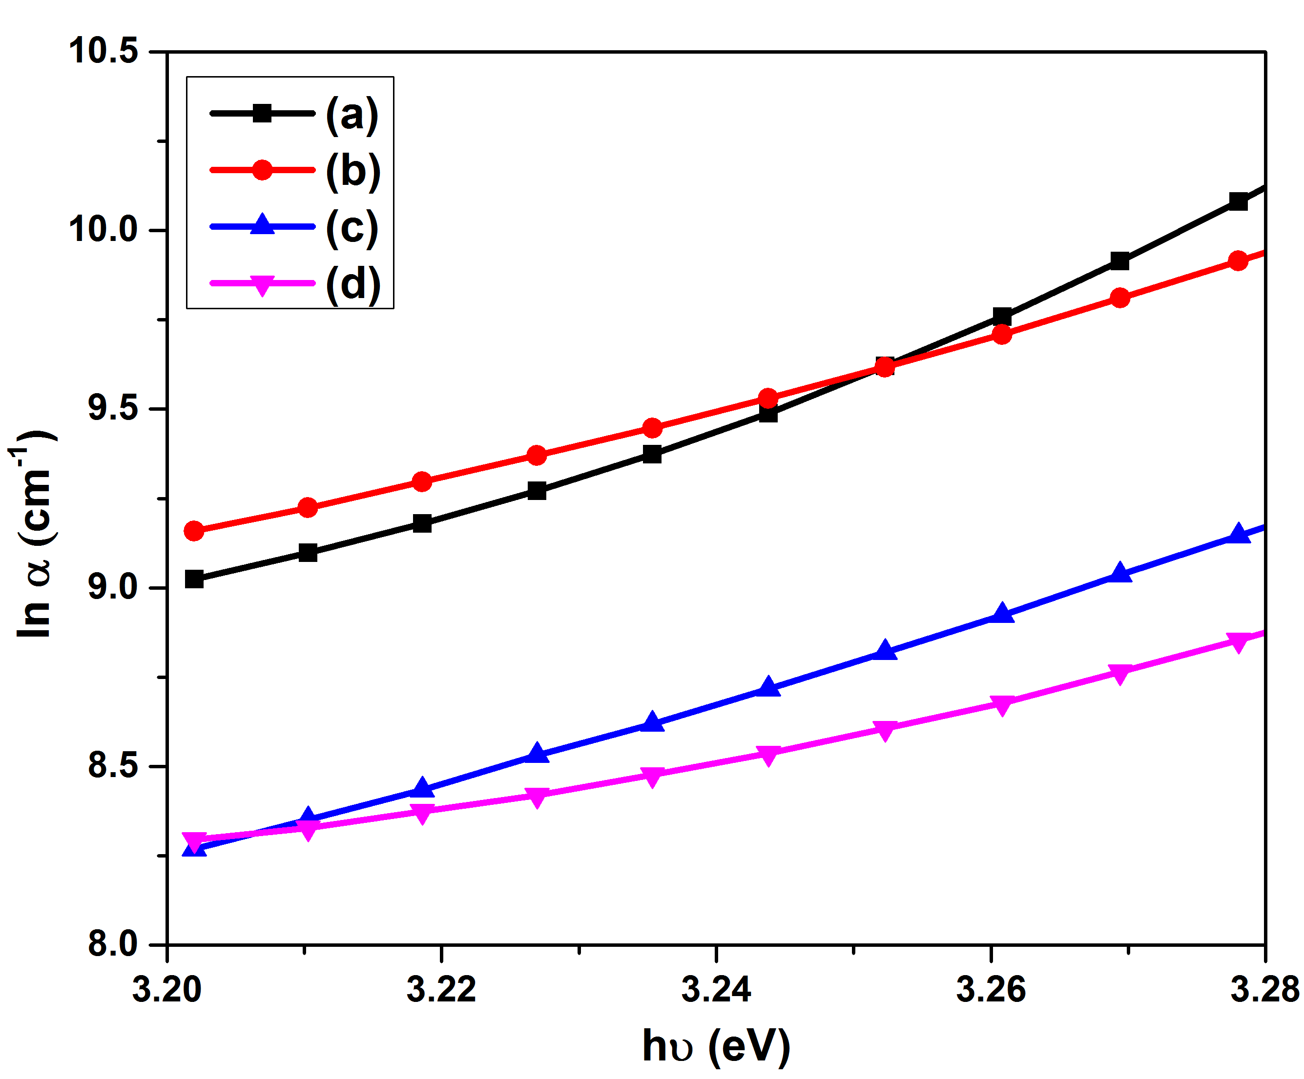
Fig.S1.2: ln $α$ v/s $hυ$plot of (a) undoped (b) 5 wt% (c) 10 wt% and (d) 15 wt% IZO thin films.

Table S1: Band gap and Urbach energy of undoped and IZO thin films.
Doping concentration  (wt% In) | Band gap energy, E_{g}  (eV) | Urbach energy, E_{U}  (eV)
undoped | 3.218 | 0.069
5 | 3.207 | 0.098
10 | 3.272 | 0.085
15 | 3.276 | 0.129

S2. XRD comparison of indium oxide with 15 wt% In: ZnO
The ZnO crystallises in hexagonal wurtzite structure whereas indium oxide (In₂O₃) has cubic structure. The most prominent planes in ZnO are (002) and (101) at around 34.3 and 36.15 respectively whereas In₂O₃ has (222) and (440) as the prominent planes in most cases at 30.8 and 50.3 respectively. The obtained 15 wt% In:ZnO has the standard peaks of ZnO which confirms the structural stability after doping with indium [2, 3]. Table S2 shows the comparison of diffraction peaks of In2O3 and 15 wt% In:ZnO.

Table S2: Comparison of diffraction peaks of In₂O₃ and 15 wt% In:ZnO

 | 2θ (deg.) | (hkl)
In₂O₃  (ICSD-01-088-2160)  [3] | 21.40 | (211)
 | 30.80 | (222)
 | 34.80 | (400)
 | 38.40 | (411)
 | 41.30 | (332)
 | 44.50 | (431)
 | 50.30 | (440)
 | 55.60 | (611)
 | 65.90 | (444)
 | 70.0 | (633)
 | 74.60 | (800)
 | 79.20 | (653)
15 wt% In:ZnO  [2] | 31.73 | (100)
 | 34.31 | (002)
 | 36.15 | (101)
 | 47.52 | (102)
 | 56.55 | (110)
 | 62.81 | (103)
 | 68.0 | (112)

References
- A.S. Hassanien, Alaa A. Akl, Influence of composition on optical and dispersion parameters of thermally evaporated non-crystalline Cd50S50-xSex thin films, Journal of Alloys and Compounds, 648 (2015) 280-290, https://doi.org/10.1016/j.jallcom.2015.06.231
- Baktiyar Soltabayev, Memet Ali Yildirim, Aytunc Ates, Selim Acar, The eﬀect of indium doping concentration on structural, morphological and gas sensing properties of IZO thin ﬁlms deposited SILAR method, Materials Science in Semiconductor Processing, 101 (2019) 28-36, https://doi.org/10.1016/j.mssp.2019.05.026
- Hadeel Salih Mahdi, Azra Parveen, Mawlood Maajal Ali, Ameer Azam, Microstructural and Optical properties of indium oxide nanoparticles, Materials Today: Proceedings 18 (2019) 704–709, https://doi.org/10.1016/j.matpr.2019.06.472

