Supplementary information

Extending cycle-life of the soluble-lead-redox-flow battery with an auxiliary gas-diffusion electrode: A proof-of-concept study

Suman Rathod, M. K. Ravikumar, Nandini Jaiswal, Satish Patil and Ashok Shukla*
Solid State and Structural Chemistry Unit, Indian Institute of Science, Bangalore - 560012

Corresponding author
Ashok Shukla (Email: akshukla2006@gmail.com)

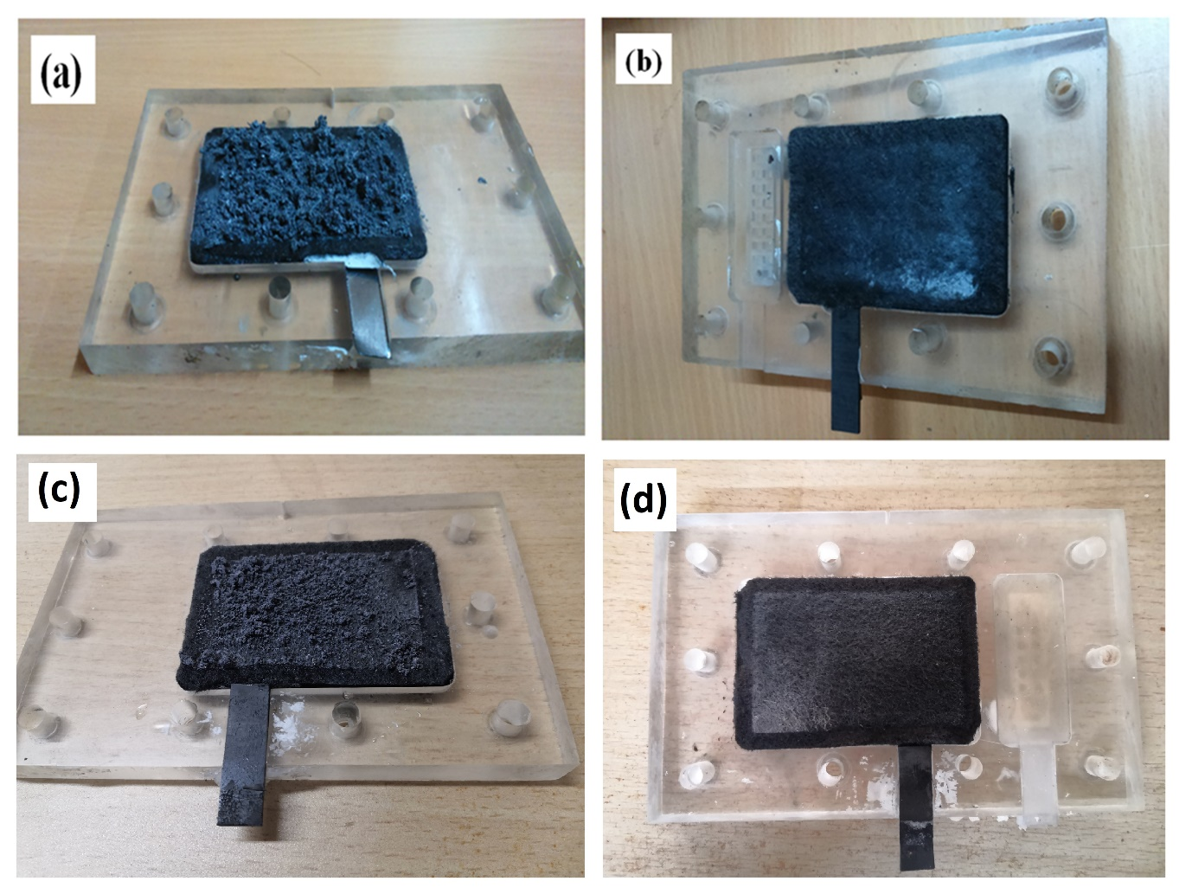

Fig. S1 Photographic image of the (a) anode and (b) cathode of the SLRFB without any additives after 53 charge and discharge cycles at 20 mA/cm² and similarly the images of the (c) anode and (d) cathode of the SLRFB with additives at the end of 76 cycles.

The electrode images in S1(a) show accumulation of Pb dendrites at the anode and S1(b) for cathode with no additives in the electrolyte after 53 cycles. Fig.S1(c) and S1(d) show the images for anode and cathode in presence of SLS and NaF combined additives in the electrolyte after 76 cycles.

Fig. S2 FESEM images for anodes after first charge and discharge curves (a) pure graphite felt, (b) anode after 1h charge at 20 mA/cm² current density, (c) anode after 1hr charge and discharge of the SLRFB cell to 0.8 V at 20 mA/cm² current density and (d) after further discharging anode by auxiliary air electrode (Pb – Air flow cell).

FESEM images of the anode after first cycle charged state, discharged state to 0.8 V and after using the auxiliary electrode to discharge anode and cathode in form of Pb-Air flow cell The FESEM image of the bare graphite felt is also shown for the purpose of comparison.

Fig. S3 FESEM images for cathode after first charge and discharge (a) pure graphite felt, (b) cathode after 1h charge at 20 mA/cm² current density, (c) cathode after 1hr charge and discharge of the SLRFB cell to 0.8 V at 20 mA/cm² current density and (d) after further discharging cathode by auxiliary hydrogen electrode (H₂ – PbO₂ flow cell).

FESEM images of the cathode after first cycle charged state, discharged state to 0.8 V and after using the auxiliary electrode to discharge anode and cathode in form of H₂-PbO₂ flow cells. The FESEM image of the bare graphite felt is also shown for the purpose of comparison.

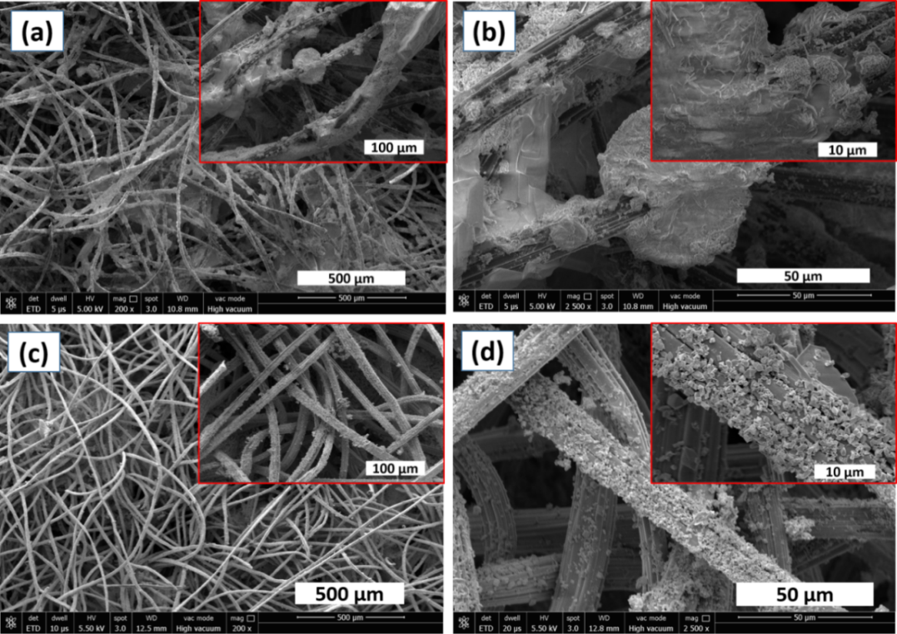

Fig. S4 FESEM images for anodes after 50 charge and discharge cycles (a) and (b) in discharged condition at varying magnifications without discharge using auxiliary air electrode, (c) and (d) after discharge using auxiliary air electrode at various magnifications (as Pb – Air flow cell).

FESEM images of the anode in charged and discharged state after 50 cycles of the SLRFB without performing maintenance using auxiliary electrode and after maintenance using the auxiliary electrode.

Fig. S5 FESEM images for cathodes after 50 charge and discharge cycles (a) and (b) in discharged condition at various magnifications without discharge using auxiliary hydrogen electrode, (c) and (d) after discharge using auxiliary hydrogen electrode (as H₂ – PbO₂ flow cell) at varying magnifications.

FESEM images of the cathode in charged and discharged state after 50 cycles of the SLRFB without performing maintenance using auxiliary electrode and after maintenance using the auxiliary electrode.

