# Supplementary data

|  |  |  |  |
| --- | --- | --- | --- |
| Items | Name | Brand/company | Purposes |
| Chemicals | Ultra-pure HNO3 Acid | Sigma Aldrich | To acidify water samples |
| 35% (w/w) hydrogen peroxide (H2O2) | Sigma Aldrich | To sterilize storage-containers |
| pH, ORP calibration liquide chemicals | Sigma Aldrich | To calibrate pH, and ORP field kits (devices) |
| Amberlite® IRA-400 chlorite resin | Sigma Aldrich | For As speciation |
| Cetyl-trimethylammonium bromide/ sodium dodecyl sulfate (CTAB/SDS) | Qiagen, Germany | Environmental DNA extraction |
| DNeasy Ultraclean microbial kit | Qubit, invitrogen | Environmental DNA purification |
| Agarose | Qubit, invitrogen | Electrophoresis for PCR amplicon detection |
| Phusion® High-Fidelity PCR Master Mix | New England Biolabs | For PCR analsysis |
| Qiagen Gel Extraction Kit | Qiagen, Germany | PCR product purifications |
| NEBNext® UltraTM DNA Library Prep Kit | Qiagen, Germany | For llumina HiSeq sequencing |
| Equipments /materials | pH electrode | SenTix 940, WTW | To measure the pH of water samples |
| Oxygen Reduction Potential (ORP) electrode | SenTix ORP 900, WTW | To measure ORP in the storage system |
| Dissolved Oxygen (DO) electrode | FDO®925, WTW | To measure DO in the storage system |
| 60 ml syringe | Square, Bangladesh | For water sampling |
| IV syringe | Square, Bangladesh | To collect water sample from fixed depth of the storage container |
| VWR 45 µm sysring filter | Sigma Aldrich | To filter water before filling sample vial |
| 15 ml centrifuge tube | Sigma Aldrich | Water sampling for trace element anasysis |
| 250 ml water sampling vial | Square, Bangladesh | Water sampling for anaions analysis |
| ICP-MS | Alanlytik Jena, PlasmaQuant MS | Elemental quantification |
| 75L water containers | GAZI, Bangladesh | For piloting water storage experiments |
| AnoxKaldnes K3 bio-carriers | OSMOSIA, Bangladesh | Providing larger surface area for microbial growth |

**Table 1:** The list of used chemicals, equipments and reagents in the storage experiments.



**Fig. 1.** The generic step-by-step methodological approach and independent and dependent variables in the respective steps of the pilot-scale storage containers experiments.

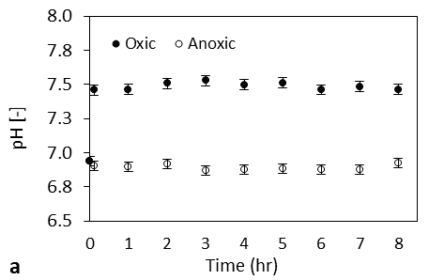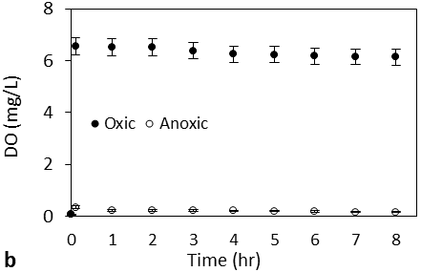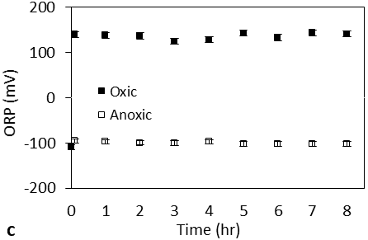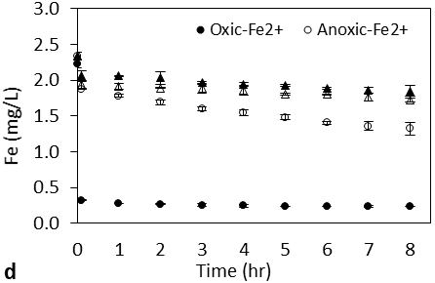

**Fig. 2.** Physicochemical parameters during the first 24 h of the experiment during oxic and anoxic storage containers with bio-carriers (a) pH, (b) DO, (c) ORP changes, and (d) physicochemical parameters as a function of Fe2+ concentration. The error bars represent the standard deviations.

**Fig. 3.** Arsenic speciation during (a) oxic and (b) anoxic storage containers with bio-carriers over a period of 8 h on the first experimental day. The error bars represent the standard deviations.

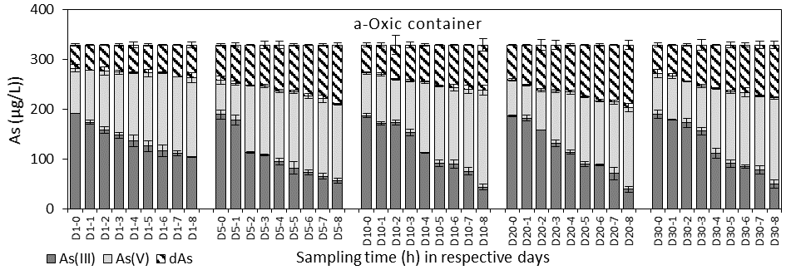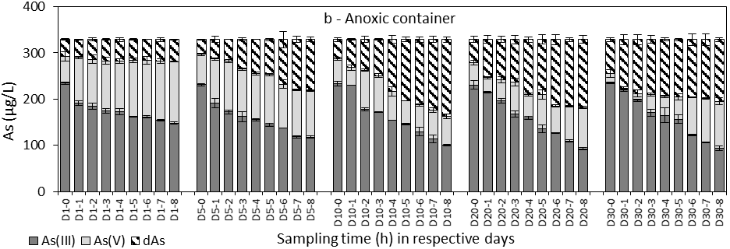

**Fig. 4.** Oxidation of As(III) and removal over the experimental time at respective days for the (a) oxic, and (b) anoxic storage containers with bio-carriers. The error bars represent the standard deviations.

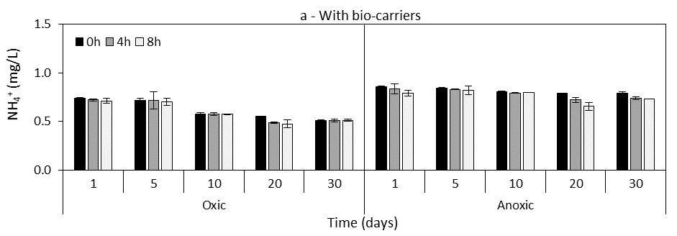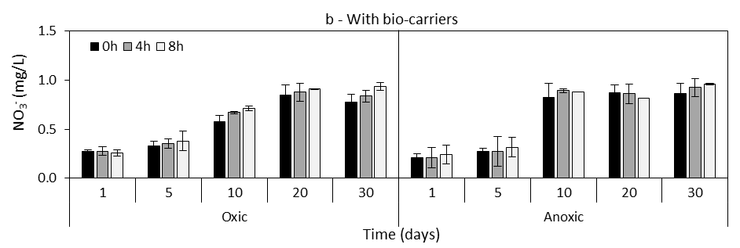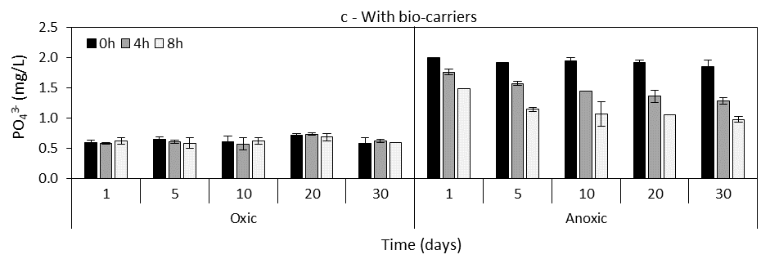

**Fig. 5.** The concentration of (a) NH4+; (b) NO3- and (c) PO43- at different sampling times (1, 4, and 8 h) over the experimental period of 30 days of the oxic and anoxic storage containers in the presence of bio-carriers. The error bars represent the standard deviations.

**Fig. 6.** Relative abundance (% of total OTUs) of the predominant bacterial communities accumulated in the storage containers at the family level.

***Microbial assays in the storage containers biomass:***

The key metabolic functions expressed in various conditions (oxic and anoxic) are described in Table 1. During oxic storage, initially, the increased DO concentration triggers increased chemical Fe2+ oxidation followed by biological oxidation of dissolved Fe minerals such as FeS over 30 days. This involves the rapid Fe sequestering protein siderophores produced by the identified bacterial genus in the biomass of oxic storage, such as *Pseudorhodoferrax, Thiobacter, Sideroxydans, Gallionella, Patulibacter, Pedomicrobium, Tepidicella,* and *Acidibacillu*s (Meijler et al., 2002).

After 30 days of incubation, the endospore-forming Actinobacterial and Firmicute populations like *Geodermatophilaceae, Actinopolysporaceae, Saccharopolyspora, Bacillus, Aeromicrobium, Oceanobacillus* germinates were found in the container walls (Filippidou et al., 2016). This could be due to the sustainable condition or acquiring necessary genes through the high horizontal gene transfers (HGT) as observed in *Sorangium, Bdelovibrio, Hirschia* (Garcia-Vallve et al., 2000). This also triggers ammensalism in some Actinobacterial groups inducing the expression and release of bioactive compounds by *Brevibacterium, Geodermatophila, Saccharopolyspora* (Jakubiec-Krzesniak et al., 2018). Most importantly the oligotrophic waters enriched in thermally mature hydrocarbons flourishes hydrocarbon-degrading groups such as *Taibaiella, Rhodococcus, Sphingomonas, Aerobacterium, Novosphingobium, Methylomonas, Rubirivivax,* and G55 once the carbon sources are exhausted.

**Table 2.** Key functional profiling of microbial communities related to Fe-As cycling based on PICRUSt analysis of metagenomic libraries.

|  |  |  |  |
| --- | --- | --- | --- |
| Sampling container condition | Key functional properties | Participating Microorganism | Inferences |
| Oxic storage containers | * Iron oxidation & precipitation at high rates * S-oxidation | *Pseudorhodoferrax, Patulibacter, Pedomicrobium, Thiobacter, Sideroxydans, Gallionella, Tepidicella, Acidibacillus* | Aeration increased the DO of water triggering increased biological Fe oxidation along with chemical oxidation. Fe sequestering protein. |
| Arsenite oxidation | *Sideroxydans, Gallionella, Hydrogenophaga* | Increase in *aioA* gene expressing bacterial population |
| * Gram-positive predominance * Increase in the spore-forming bacterial population * Bioactive compound synthesis | *Bacillus, Micrococcus, Brachybacterium, Kytococcus, Brevibacterium*  *Geodermatophilaceae, Actinopolysporaceae, Saccharopolyspora, Aeromicrobium, Oceanobacillus* | Due to the high HGT in the container, the tolerant strains can grow in aerobic-low As and Fe conditions.  Spore germination is triggered by the new survivable conditions (low As).  Ammensalism is triggered. |
| High rate of HGT | *Sorangium, Bdelovibrio, Hirschia* | Aerobic oxidation has favored gene exchange, leads to increased diversity and enhanced metabolic function. |
| Aerobic hydrocarbon degradation | *Taibaiella, Rhodococcus, Sphingomonas, Aerobacterium, Novosphingobium, Rubirivivax, and G55* | Aerobic degradation is faster and linked with *aioA* expression. |
| Dissimilatory Iron reduction with Mn oxidation  Thiosulfate oxidation | *Brachybacterium, Rhodoferrax, Acidimicrobiales, CL500_29 marine* | Ferredoxin nitrite reductases-based reduction of oxidized iron as terminal electron acceptor |

|  |  |  |  |
| --- | --- | --- | --- |
| Sampling container condition | Key functional properties | Participating Microorganism | Inferences |
| Anoxic storage containers | * Chemolithotrophic Fe-oxidation * Thiosulfate oxidation * Lowering of pH | *Nitrosomonas, Pseudorhodoferrax, Rhodobacter, Sphingobacterium,*  *Thermithiobacillus, Paucimonas, Thiobacillus, Dyella, Acidibacillus* | The reduction in N-metabolism leads to lowering of pH, facilitating this process along with chemolithotrophic iron oxidation |
| * Fe dependent biofilm/floccule forming * EPS production | *Pseudorhodoferrax, Haliscomenobacter, Pseudorhodoferrax, Sphingobacterium, Tepidicella* | Low/no agitation and increase of surface area in the container wall |
| Degradation of aromatics, aliphatics, PAHs  Methyl oxidation | *Ideonella, Oleiphilus, Rubirivivax, Phenylobacterium, Rubirivivax, Acinetobacter, Novosphingobium, Paucimonas, Dechloromonas, Methylotenera, Mythylospira, Methylomonas* | Anaerobic condition facilitates the slow degradation of terrestrial organic products. |
| Phosphate uptake | *Mesorhizobium, Pledimorphomonas, Pelagibacterium, Rhodopseudomonas*, *Bradyrhizobium* | Phosphate uptake for biomass growth. |

During anoxic storage, the possible slow degradation of aromatics and aliphatic DOC might also sustain the Fe-oxidizing bacterial groups functioning parallel to DO-based (partial) Fe2+ oxidation. Furthermore, the identified bacteria genus in the walls of anoxic storage, such as *Burkholderia, Pseudomonas,* and *Methylomonas,* could also have attributed to the ORP increase in parallel to Fe2+ oxidation (Chistoserdova et al., 2009).

Although no HGT was observed in the anoxic containers, the abundance of Fe dependent biofilm/floccule forming groups such as *Caulobacter, Sediminibacterium,* *Pseudorhodoferrax, Haliscomenobacter, Pseudorhodoferrax, Sphingobacterium, Tepidicella* could be excreted to excreting exopolysaccharides like compounds on the storage walls and bio-carriers surfaces (Lin et al., 2016). Slow hydrocarbon degraders (e.g., *Phenylobacterium, Rubirivivax, Acinetobacter, Novosphingobium, Paucimonas, Dechloromonas, Sulfuritalea, Hydrogenophaga,* G55) could degrade complex carbon compounds in an anaerobic aquifer waters (Quesnell, 2016), such as petroleum hydrocarbons, polyaromatic hydrocarbons (PAHs), aromatic compounds (like- toluene, benzoate, and chlorobenzoate). Along with the methylamine/C1 utilizing Gammaproteobacterial groups such as *Methylotenera*, *Mythylospira* in the anoxic container indicated the complete degradation of hydrocarbon monomer- methane (CH4) and released CO2 (Bacosa and Erdner, 2018).

# References

Bacosa, H.P., Erdner, D.L., 2018. Hydrocarbon degradation and response of seafloor sediment bacterial community in the northern Gulf of Mexico to light Louisiana sweet crude oil. The ISME Journal 2532–2543. https://doi.org/10.1038/s41396-018-0190-1

Chistoserdova, L., Kalyuzhnaya, M.G., Lidstrom, M.E., 2009. The expanding world of methylotrophic metabolism. Annual Review of Microbiology 63, 477–499. https://doi.org/10.1146/annurev.micro.091208.073600

Filippidou, S., Wunderlin, T., Junier, T., Jeanneret, N., Dorador, C., Molina, V., Johnson, D.R., Junier, P., 2016. A Combination of Extreme Environmental Conditions Favr the Prevalence of Endospore-Forming Firmicutes. Frontiers in Microbiology.

Garcia-Vallve, S., Romeu, A., Palau, J., 2000. Horizontal gene transfer in bacterial and archaeal complete genomes. Genome Research 10, 1719–1725. https://doi.org/10.1101/gr.130000

Jakubiec-Krzesniak, K., Rajnisz-Mateusiak, A., Guspiel, A., Ziemska, J., Solecka, J., 2018. Secondary metabolites of actinomycetes and their antibacterial, antifungal and antiviral properties. Polish Journal of Microbiology 67, 259–272. https://doi.org/10.21307/pjm-2018-048

Lin, C.-S., Tsai, Y.-H., Chang, C.-J., Tseng, S.-F., Wu, T.-R., Lu, C.-C., Wu, T.-S., Lu, J.-J., Horng, J.-T., Martel, J., Ojcius, D.M., Lai, H.-C., Young, J.D., 2016. An iron detection system determines bacterial swarming initiation and biofilm formation. Scientific Reports 6, 36747. https://doi.org/10.1038/srep36747

Meijler, M.M., Arad-Yellin, R., Cabantchik, Z.I., Shanzer, A., 2002. Synthesis and Evaluation of Iron Chelators with Masked Hydrophilic Moieties. Journal of the American Chemical Society 124, 12666–12667. https://doi.org/10.1021/ja027013s

Quesnell, K.., 2016. Tracing hydrocarbon contamination through hyperalkaline environments in the calumet region of South-eastern Chicago. Northern Illinois University.