Appendix S1
Supplementary Information
Consequences of migratory coupling of predators and prey when mediated by human actions
Table S1. Golden eagle individual data considered at different steps of the analysis process. Table deals with the number of individuals included at each step of the analyses. Also see Table 1 in the main text.

Step | Migratory coupling | N | Lead analyses | N
1 | Total marked with functioning transmitters | 74 | Total samples analysed for lead | 46
2 | Moved > than 100 Km² | 66 | Total used for survival analyses | 46
3 | Daily and continuous Data available between March to November | 32 | Individuals common with Migratory coupling analyses | 13

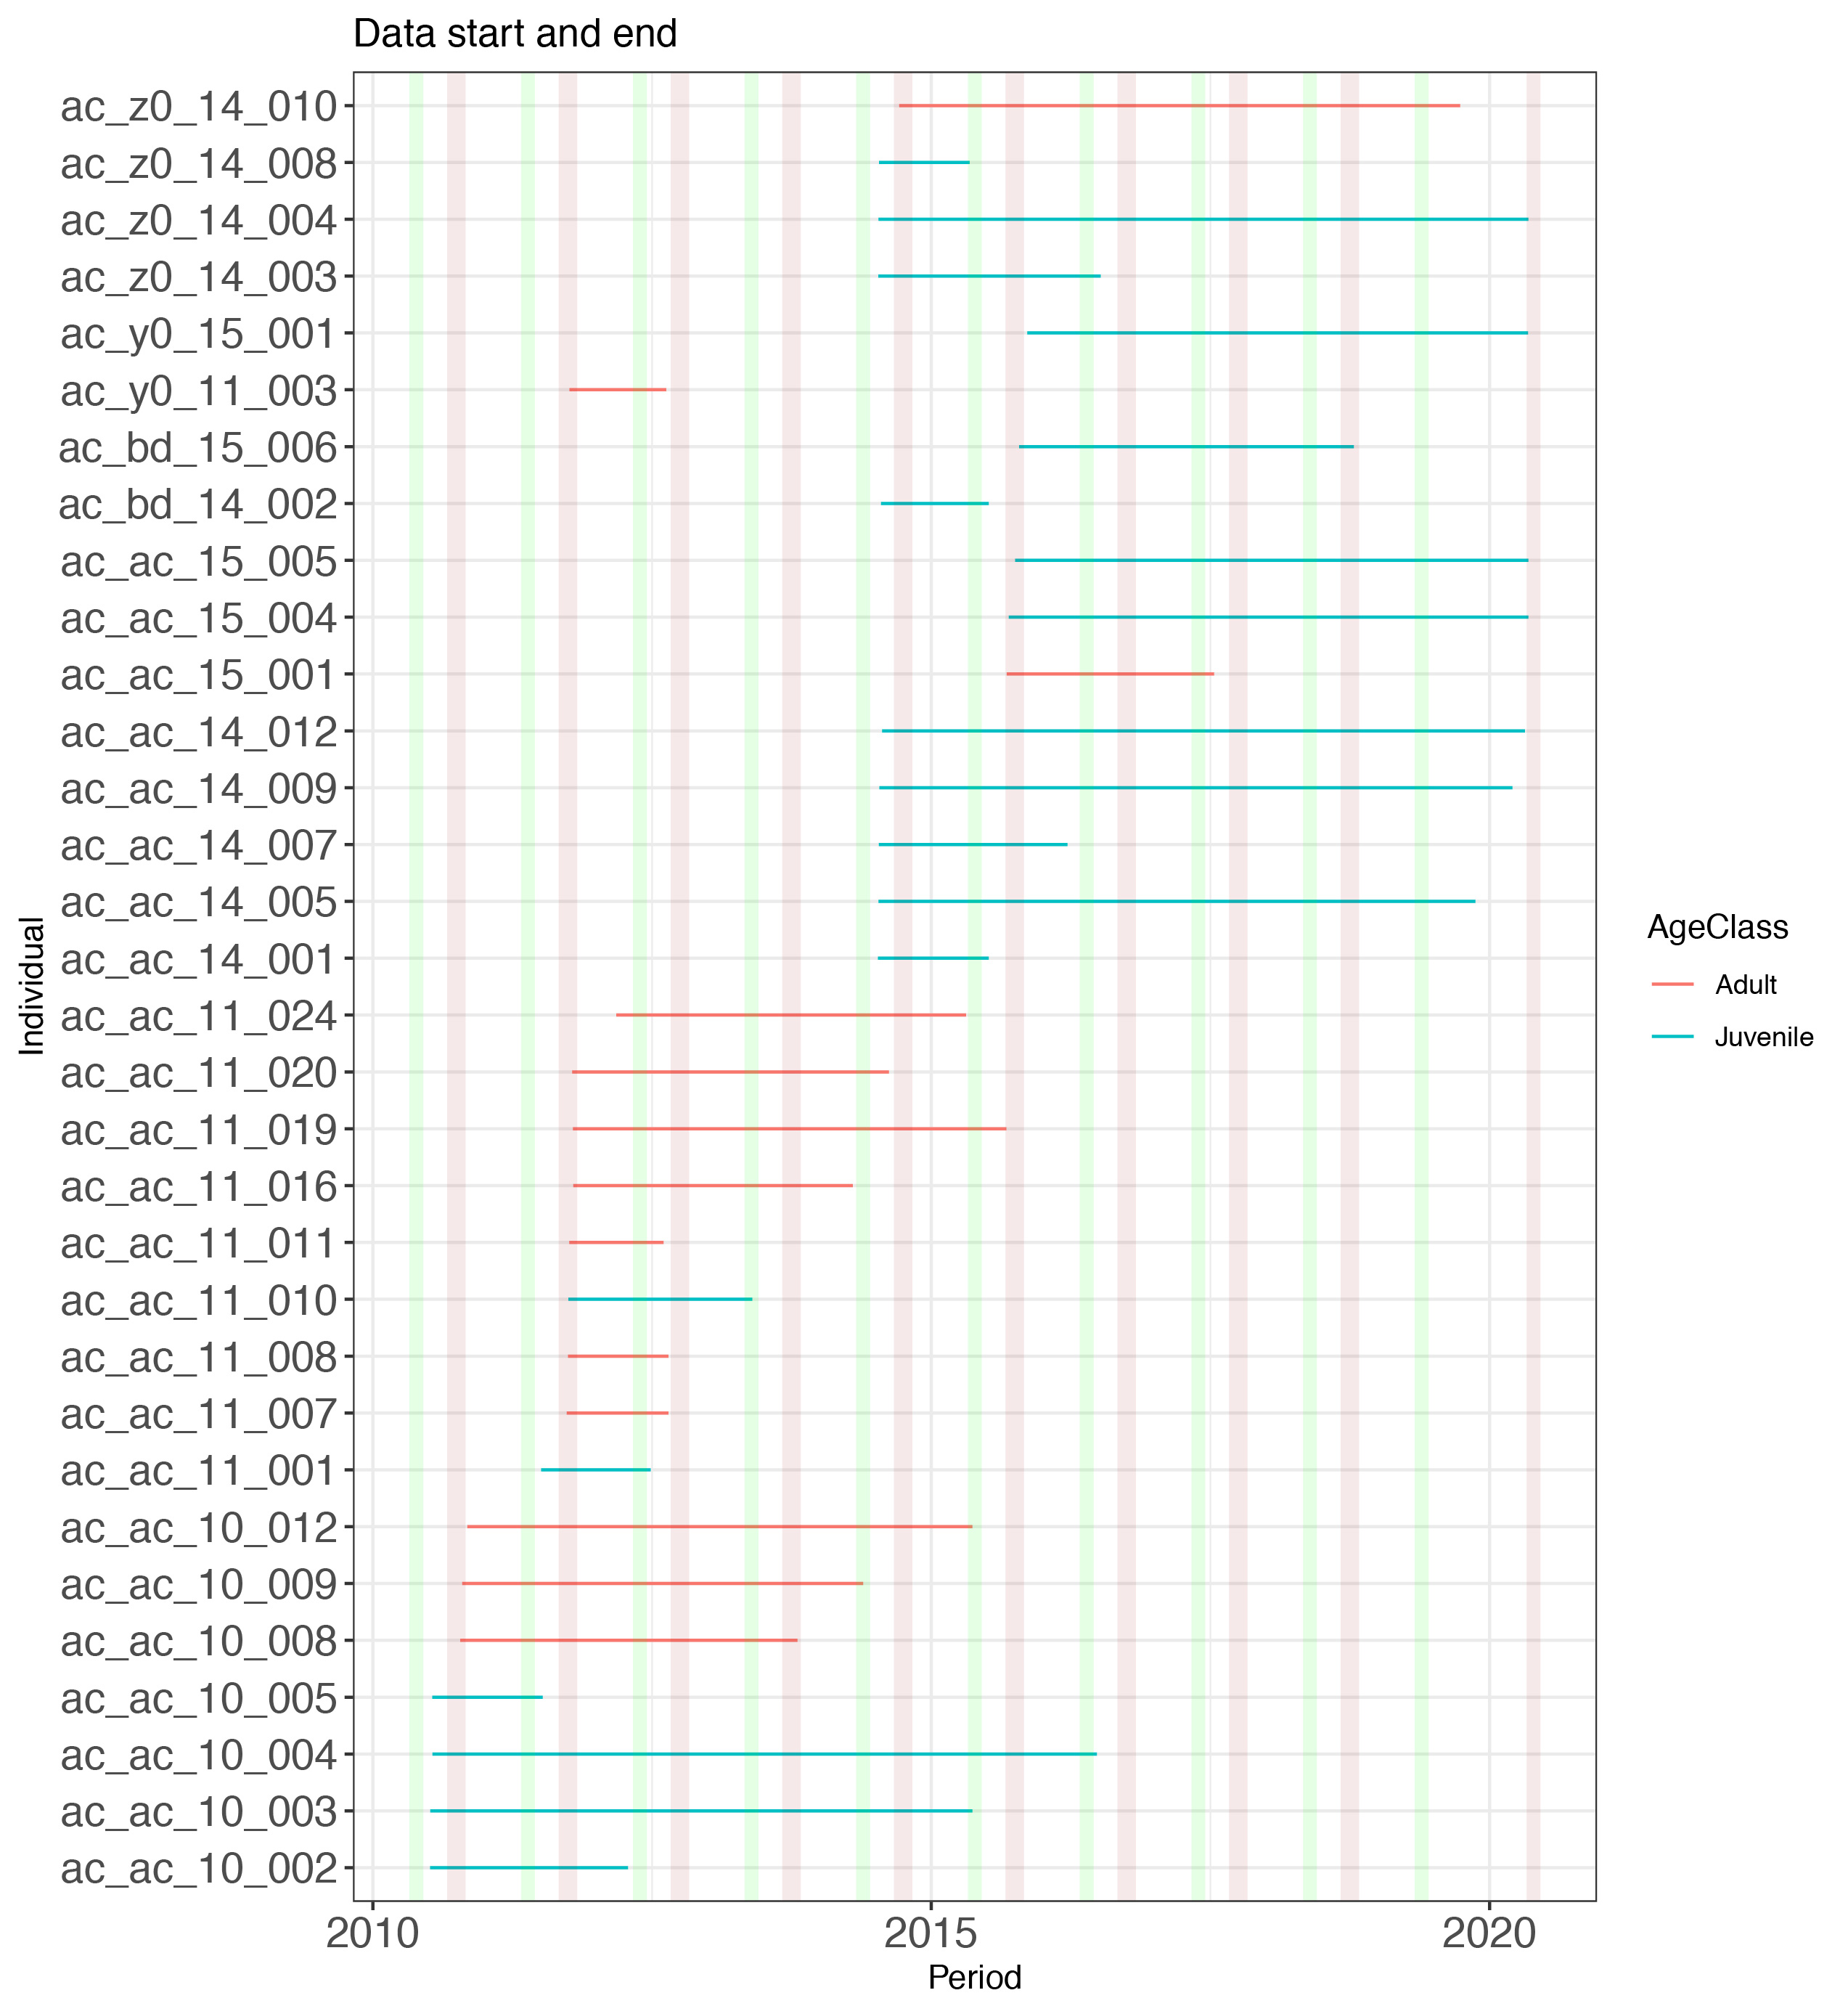
Figure S1. Multiannual data availability for 32 individual Golden Eagles used in this study, showing data availability per individual. Green vertical rectangles represent the reindeer calving period and red-brown rectangles, the moose hunting period.

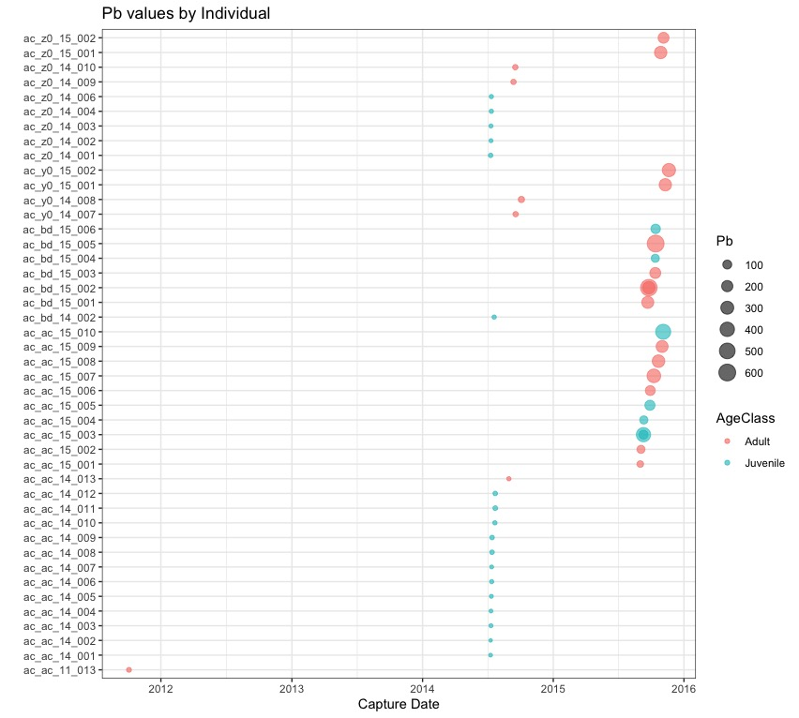

Figure S2. Fourty-six Golden Eagles individuals included in the survival analyses, their capture date and their Blood lead (Pb) concentrations.

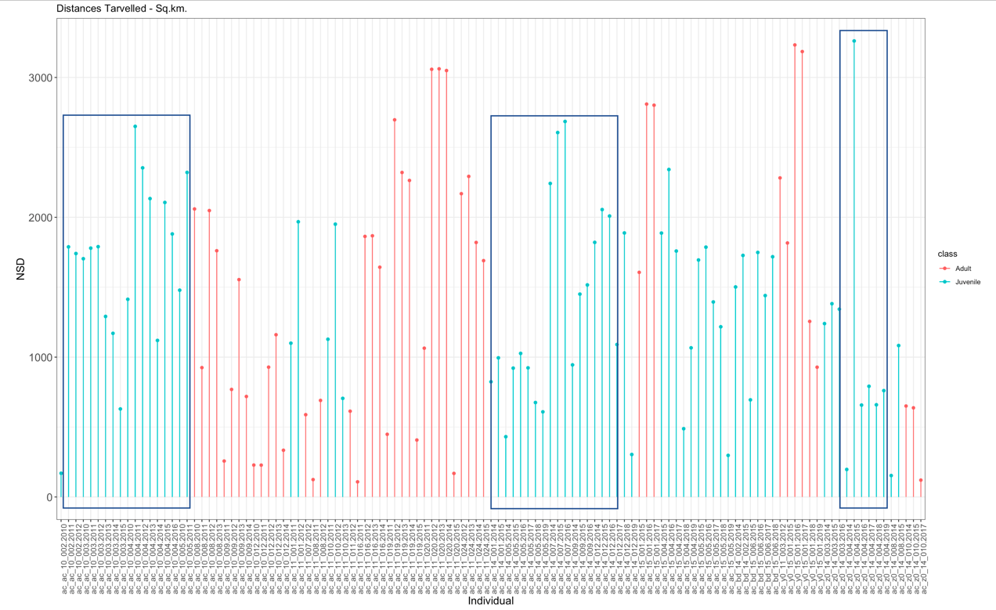

Figure S3. Net Squared Displacement (Km²) of individual eagles during each year of tracking. Boxes enclose juvenile eagles and their changing scales of movements with years.

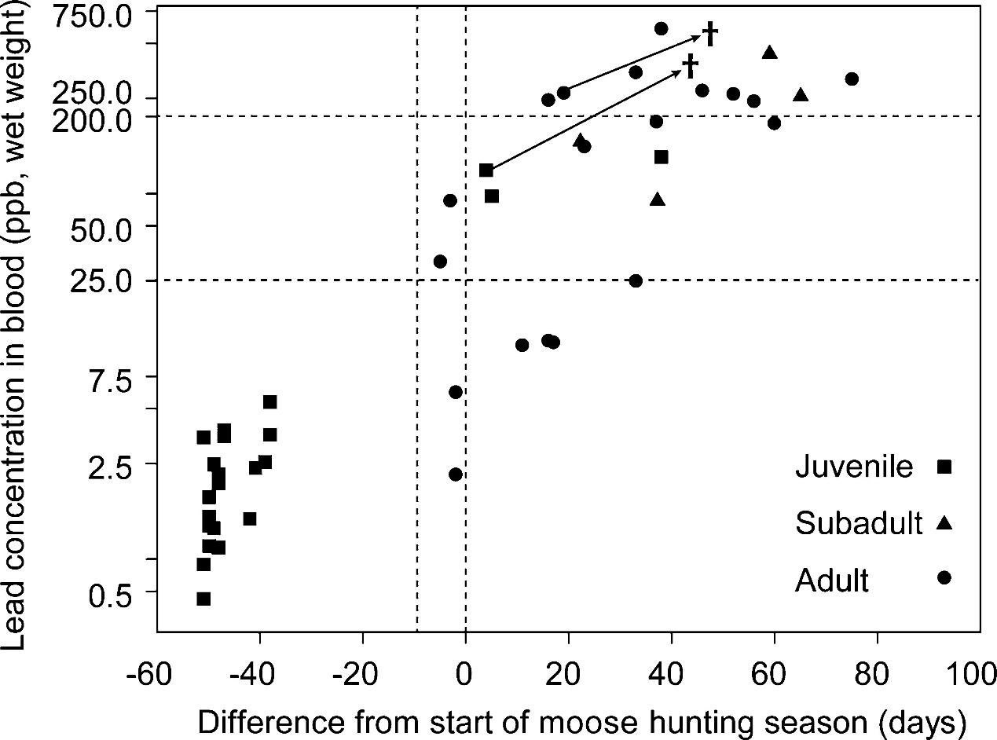

Figure S4. Blood lead (Pb) concentrations in 46 Golden Eagles before and during moose hunting season in Sweden. Squares represent juveniles and circles represent adults. In this study we combined sub adults (1-4 year, represented by triangles) into juveniles as there were only four individuals categorized as subadults. Vertical dotted line on zero represents the onset of moose hunt (adapted from Ecke et al. 2017) and the one before zero represents game bird hunting. Arrows illustrate change in lead concentration in blood from tagging to death of two eagles (cross-marked).
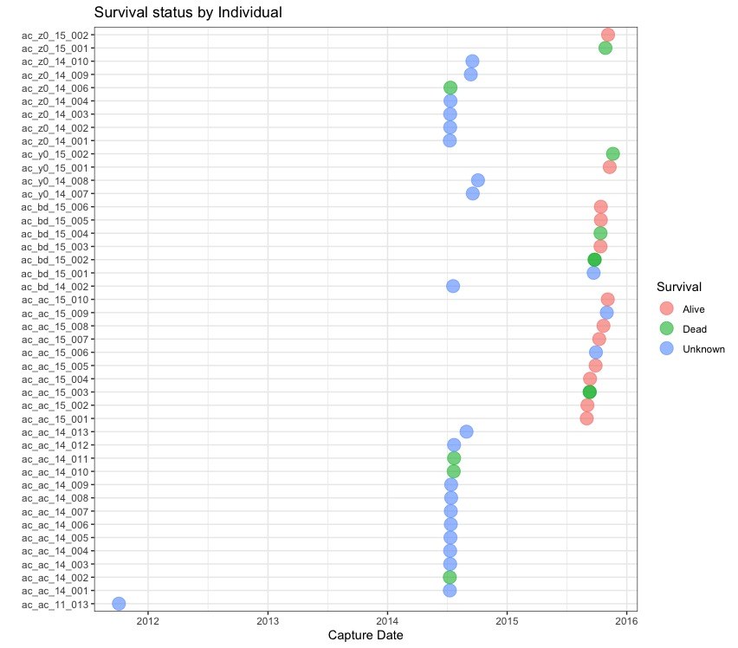
Figure S5. Fourty-six Golden Eagle individuals used for survival analyses with their capture date, IDs and survival status.

