**Supporting Information**

Section S1: Culturing the bacterial strains

Table S1: Magnetic field (Bmax (T)) profile along the axis of the magnet coil;

Table S2: Post hoc Tukey analysis of ANOVA for bacterial viability;

Table S3. Regression analysis for progressive bacterial growth (Control);

Table S4. Regression analysis for progressive bacterial growth (1T);

Table S5. Regression analysis for progressive bacterial growth (1T);

Table S6. Regression analysis for progressive bacterial growth (2T);

Table S7. Regression analysis for progressive bacterial growth (4T);

Table S8. Regression analysis for membrane depolarization (Control);

Table S9. Regression analysis for membrane depolarization (4T);

FigureS1: Plot of total magnetic flux vs Bmax measured for various capacitor voltages and Plot for induced electromotive force measured through pick-up coil experiment

FigureS2: Plot of magnetic field measured through a current transducer and pickup coil setup

FigureS3: Magnetic field and induced electromotive force measured in three different media viz., air, water and bacterial suspension

Figure S4: Plot of peak magnetic field along the axis of the coil

### **S1 Culturing the bacterial strains**

In this study, *E. faecalis* strain (ATCC#29212) was cultured in freshly prepared peptone water broth (PWB) (15g/l) by incubating them for 6h in 37°C and 100rpm in a shaker incubator (SI-300R, Lab Companion, Geumcheon-gu, Seoul, Korea). 100µl of this culture was sub-cultured in 5ml of PWB for 2h in similar condition. An OD of 0.3–1.1 was obtained in the sub-cultured broth, as measured by a biospectrometer (Cat. # 61350000019; Eppendorf, Hamburg, Germany) (sample length = 10mm; λ = 600nm) which was calibrated to 0 for PWB without bacterial culture. The sub-cultured bacterial suspensions were diluted to OD ~ 0.1 for further procedures.

**Table S1** Magnetic field (Bmax (T)) profile along the axis of the magnet coil, where distance is measured from the centre of the coil.

|  |  |
| --- | --- |
| **Distance (10-2 m)** | **Magnetic field, Bmax (T)** |
| 2.1 | 0.4828 |
| 2 | 0.54218 |
| 1.75 | 0.61654 |
| 1.5 | 0.75361 |
| 1.25 | 0.78468 |
| 1 | 0.8929 |
| 0.75 | 0.95228 |
| 0.5 | 0.97669 |
| 0.35 | 0.98557 |
| 0.2 | 0.98779 |
| 0.1 | 0.99279 |
| 0 | 1 |
| -0.1 | 0.99778 |
| -0.2 | 0.99279 |
| -0.35 | 0.98668 |
| 0.5 | 0.97725 |
| -0.75 | 0.9545 |
| -1 | 0.89512 |
| -1.25 | 0.83962 |
| -1.5 | 0.75805 |
| -1.75 | 0.64428 |
| -2 | 0.54495 |
| -2.1 | 0.48113 |

**Table S2** Post hoc Tukey Test for ‘between-the-groups difference’ to analyse progressive bacterial growth for the samples exposed to different magnitudes of the PMF.

|  |  |  |  |  |
| --- | --- | --- | --- | --- |
| **treatments** | **Tukey HSD** | | **Tukey HSD** | **Tukey HSD** |
| **pair** | **Q statistic** | | **p-value** | **inference** |
| Control vs 1T | 16.938 |  | 0.001 | ** p<0.01 |
| Control vs 2T | 3.617 |  | 0.080 | insignificant |
| Control vs 3T | 34.784 |  | 0.001 | ** p<0.01 |
| Control vs 4T | 40.516 |  | 0.001 | ** p<0.01 |
| 1T vs 2T | 20.555 |  | 0.001 | ** p<0.01 |
| 1T vs 3T | 17.846 |  | 0.001 | ** p<0.01 |
| 1T vs 4T | 23.578 |  | 0.001 | ** p<0.01 |
| 2T vs 3T | 38.400 |  | 0.001 | ** p<0.01 |
| 2T vs 4T | 44.134 |  | 0.001 | ** p<0.01 |
| 3T vs 4T | 5.733 |  | 0.001 | ** p<0.01 |

For ANOVA, the *F*-ratio value is 395.180. The *p*-value is <0.00001. The result is significant at *p* < 0.01 and *p* < 0.05.

**Table S3** Regression analysis for progressive bacterial growth through optical density measurement of control (unexposed).

|  |  |  |  |  |  |  |
| --- | --- | --- | --- | --- | --- | --- |
| Best-fit values | | 95% Confidence Intervals | Goodness of Fit (R2) | F (1,11) | Pα=5% | Deviation from horizontal |
| Slope | 3.390×10-4 ± 1.634×10-5 | 3.066×10-4 to 3.715 ×10-4 | 0.8146 | 430.6 | <0.0001 | Significant |
| Y-intercept | 0.122 ± 0.0095 | 0.1035 to 0.1413 |

**Table S4** Regression analysis for progressive bacterial growth through optical density measurement of PMF exposed (1T).

|  |  |  |  |  |  |  |
| --- | --- | --- | --- | --- | --- | --- |
| Best-fit values | | 95% Confidence Intervals | Goodness of Fit (R2) | F (1,11) | Pα=5% | Deviation from horizontal |
| Slope | 2.768 ×10-4 ± 2.906×10-5 | 0.0003 to 0.0003 | 0.9893 | 907.4 | <0.0001 | Significant |
| Y-intercept | 0.0165 ± 0.0017 | 0.0132 to 0.0199 |

**Table S5** Regression analysis for progressive bacterial growth through optical density measurement of PMF exposed (2T).

|  |  |  |  |  |  |  |
| --- | --- | --- | --- | --- | --- | --- |
| Best-fit values | | 95% Confidence Intervals | Goodness of Fit (R2) | F (1,11) | Pα=5% | Deviation from horizontal |
| Slope | 3.650 ×10-4 ± 1.871×10-5 | 0.0003 to 0.0004 | 0.7951 | 380.3 | <0.0001 | Significant |
| Y-intercept | 0.1386 ± 0.0109 | 0.1170 to 0.1603 |

**Table S6** Regression analysis for progressive bacterial growth through optical density measurement of PMF exposed (3T).

|  |  |  |  |  |  |  |
| --- | --- | --- | --- | --- | --- | --- |
| Best-fit values | | 95% Confidence Intervals | Goodness of Fit (R2) | F (1,11) | Pα=5% | Deviation from horizontal |
| Slope | 2.528×10-5 ± 2.920×10-6 | 1.947×10-5to  3.108×10-5 | 0.4333 | 74.95 | <0.0001 | Significant |
| Y-intercept | -0.0010 ± 0.0017 | -0.0044 to 0.0024 |

**Table S7** Regression analysis for progressive bacterial growth through optical density measurement of PMF exposed (4T).

|  |  |  |  |  |  |  |
| --- | --- | --- | --- | --- | --- | --- |
| Best-fit values | | 95% Confidence  Intervals | Goodness of Fit (R2) | F (1,11) | Pα=5% | Deviation from horizontal |
| Slope | -3.490×10-5 ± 3.696×10-6 | -4.225×10-5 to  -2.756×10-5 | 0.4764 | 89.18 | <0.0001 | Significant |
| Y-intercept | -0.0170 ± 0.0022 | -0.0214 to  -0.0128 |

**Table S8** Regression analysis for membrane depolarization assay of control (unexposed)

|  |  |  |  |  |  |  |
| --- | --- | --- | --- | --- | --- | --- |
| Best-fit values | | 95% Confidence Intervals | Goodness of Fit (R2) | F (1,11) | Pα=5% | Deviation from horizontal |
| Slope | 0.018 ± 0.051 | 0.007 to 0.029 | 0.848 | 13.11 | 0.004 | Significant |
| Y-intercept | 65.09 ± 0.36 | 64.30 to 65.89 |

**Table S9** Regression analysis for membrane depolarization assay of PMF exposed (4T)

|  |  |  |  |  |  |  |
| --- | --- | --- | --- | --- | --- | --- |
| Best-fit values | | 95% Confidence Intervals | Goodness of Fit (R2) | F (1,11) | Pα=5% | Deviation from horizontal |
| Slope | 0.031 ± 0.004 | 0.0228 to 0.039 | 0.944 | 65.31 | <0.0001 | Significant |
| Y-intercept | 64.80 ± 0.27 | 64.19 to 65.40 |

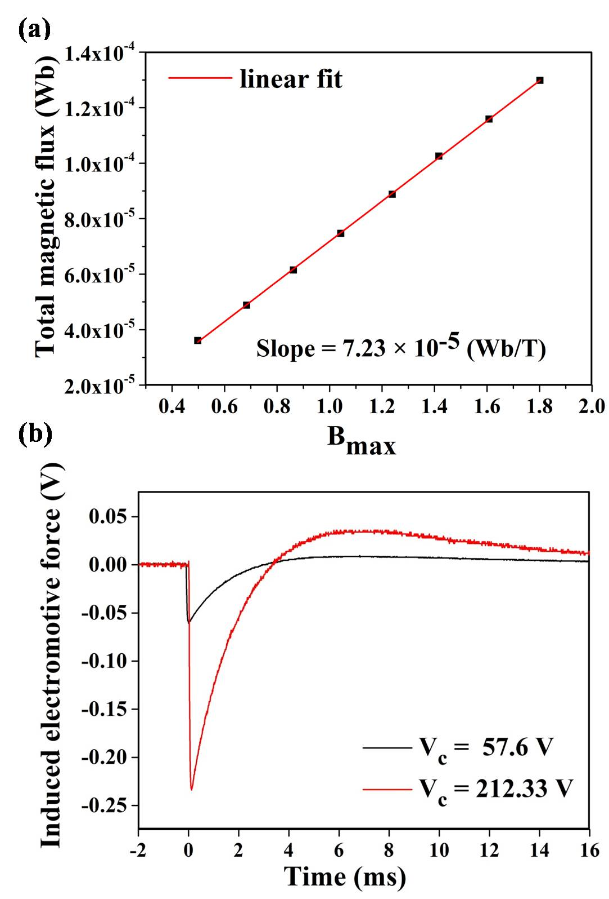

**Fig. S1** (a) Plot of total magnetic flux vs Bmax measured for various capacitor voltages. Area of the coil was found to be, A = 2.411256 × 10-5 m2. (b) Plot of induced elecromotive force at 1T and 4T magnetic fields acquired through a pick up coil set up in real time through oscilloscope and low noise pre-amplifier.

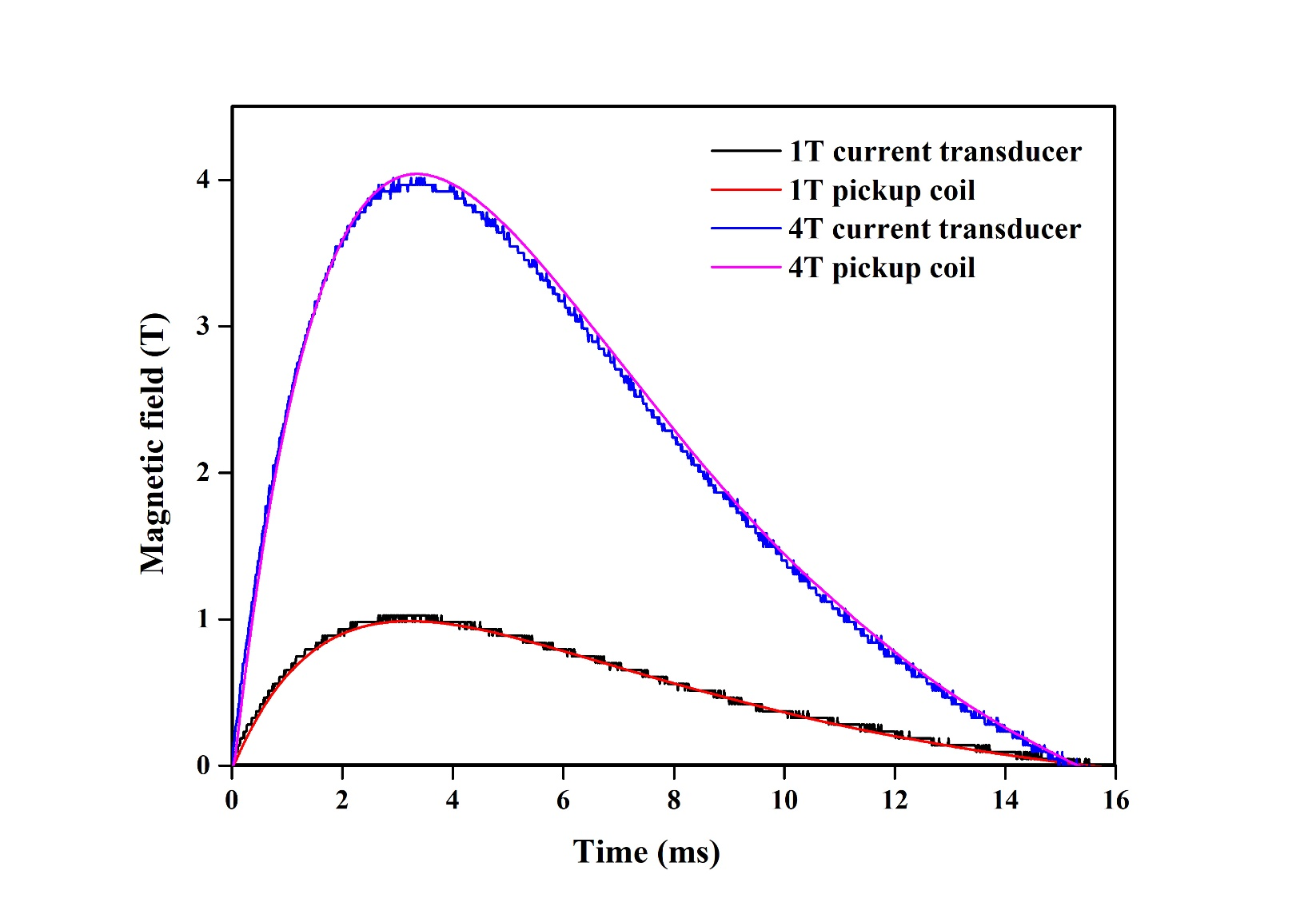

**Fig. S2** The magnetic field measured through a current transducer and pickup coil setup for 1T and 4T magnetic fields, showing a good correlation between two experimental methods with error less than 0.5%.

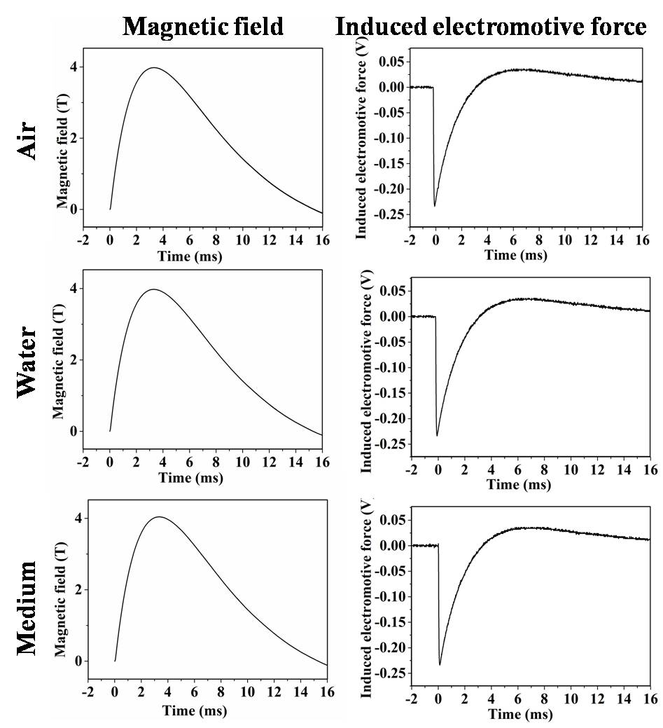

**Fig. S3** Magnetic field and induced electric field measured in three different media viz., air, water and bacterial suspension, revealing the absence of any difference of magnetic field for these media.

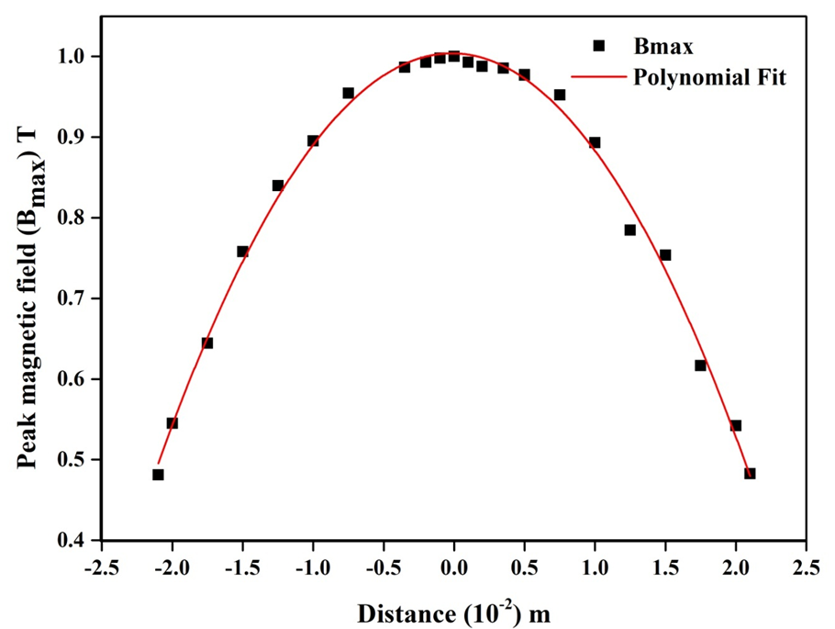

**Fig. S4** Plot of the peak magnetic field (Bmax) at different positions along the axis of the coil, where distance is measured from its centre. Figure depicting typical magnetic field pattern of a air-core solenoid.