Supplementary Materials
InSb nanoparticles dispersion in Yb-filled Co₄Sb₁₂ improves the thermoelectric performance
Sanyukta Ghosh¹, Sahil Tippireddy¹, Gyan Shankar², Anirudha Karati³, Gerda Rogl⁴, Peter Rogl⁴, Ernst Bauer⁵, Sai Rama Krishna Malladi⁶, B. S. Murty⁷, Satyam Suwas², Ramesh Chandra Mallik^{1,*}
¹Thermoelectric Materials and Devices Laboratory, Department of Physics, Indian Institute of Science,
Bangalore 560012, India
²Department of Materials Engineering, Indian Institute of Science, Bangalore 560012, India
³Department of Chemistry, Indian Institute of Technology, Madras, Chennai-600036
⁴Institute of Materials Chemistry, University of Vienna, A-1090 Wien, Austria
⁵Institute of Solid State Physics, TU-Wien, A-1040 Wien, Austria
⁶Department of Materials Science and Metallurgical Engineering, Indian Institute of Technology, Hyderabad, Telangana-502285
⁷Department of Metallurgical and Materials Engineering, Indian Institute of Technology, Madras, Chennai-600036
*Correspondence: rcmallik@iisc.ac.in

- Rietveld refinement analysis of XRD patterns
Figure S1 (a) Rietveld refinement of powder XRD pattern of Yb_{0.2}Co₄Sb₁₂.
Figure S1 (b) Rietveld refinement of powder XRD pattern of (InSb)_{0.2}+Yb_{0.2}Co₄Sb₁₂.
Figure S1 (c) Rietveld refinement of powder XRD pattern of (InSb)_{0.3}+Yb_{0.2}Co₄Sb₁₂.
Figure S1 (d) Rietveld refinement of powder XRD pattern of (InSb)_{0.4}+Yb_{0.2}Co₄Sb₁₂.
Figure S1 (e) Rietveld refinement of powder XRD pattern of ball milled InSb.

- EPMA-WDS elemental mapping
Figure S2 (a) SE micrograph, (b) BSE micrograph of (InSb)_{0.4}+Yb_{0.2}Co₄Sb₁₂, EPMA-WDS elemental mapping of (c) Co, (d) Sb, (e) Yb, (f) In and (g) O.
- Inverse pole figure map
Figure S3 Inverse pole figure (IPF) map of (a) Co₄Sb₁₂, and (b) InSb phases showing grain size and their distribution, normal direction (ND) IPF of (c) Co₄Sb₁₂, and (d) InSb phase of (InSb)_{0.4}+Yb_{0.2}Co₄Sb₁₂.

- X-ray photoelectron spectroscopy
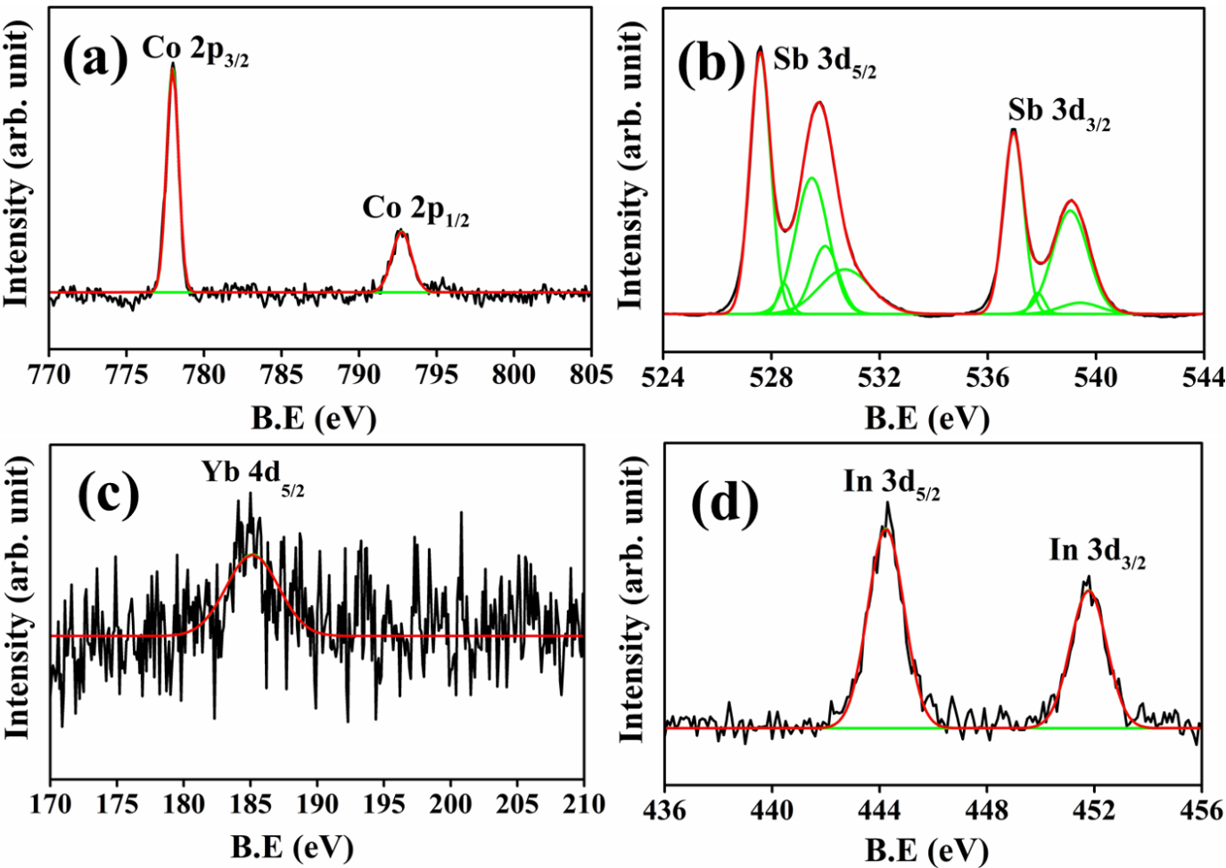
Figure S4 XPS spectra of the (a) Co 2p, (b) Sb 3d, (c) Yb 4d and (d) In 3d energy levels of the (InSb)_{0.2}+Yb_{0.2}Co₄Sb₁₂ composite.
Figs. S4(a-d) present the X-ray photoelectron spectra of Co, Sb, Yb, and In, which helped to identify all the elements' oxidation states and their bonding type. The XPS spectrum of Carbon 1s (at 284.4 eV) was also collected to calibrate the XPS spectra of all the elements, which showed a small shift towards higher binding energies. The XPS spectrum of Co (evaluated using a Gaussian fitting function [Fig. S4(a)]), exhibited peaks at 777.97 eV and 792.75 eV associated with the 2p_{3/2} and 2p_{1/2} energy levels, respectively. No significant shift in the XPS spectrum with respect to elemental Co [NIST XPS database] demonstrated covalent bonding between Co and Sb. A +3 oxidation state of Co was detected in Yb_{0.2}Co₄Sb₁₂, verified from the absence of satellite features in the spectrum. The XPS spectrum of Sb 3d energy levels, shown in Fig. S4(b), reveals that each peak assigned to 3d_{5/2} and 3d_{3/2} energy levels is split into two peaks, mainly due to the two different Sb-Sb bond lengths. This particular characteristic of the XPS spectrum of Sb was observed by several other groups [1-3]. The different bonding states of Sb were demonstrated by deconvoluting the XPS peak associated with Sb 3d_{5/2} and Sb 3d_{3/2} energy levels into sub-peaks, and their percentages were evaluated from the area under the individual peak [3]. The first sub-peak at a binding energy of 527.52 eV with a content of 24.06 % is assigned to the short Sb-Sb bond [3]. A higher electron density at the short Sb-Sb bond generated the peak at a lower binding energy value. The next smallest sub-peak at 528.47 eV of 1.70 % is allotted to the Co-Sb covalent bond [3]. The consecutive two peaks are due to the large Sb-Sb bond, one at 529.49 eV with 19.86 % and another at 529.98 eV with a content of 8.21 %. The total content assigned to the large Sb-Sb bond is 28.07 %. The electron density is smaller at this bond than that of the short Sb-Sb bond. The peak at 530.72 eV with a content of 10.17 % is attributed to the bond perpendicular to the [Sb₄]⁴⁻ ring with the lowest electron density. Yb showed a faint signal associated with the Yb 4d_{5/2} energy level with a peak at 185.15 eV, indicating a +3 oxidation state of Yb [Fig. S4(c)]. Contrary to our observation, Nolas et al. [4] reported a fluctuation in the valence state of Yb between +2 and +3 from magnetic susceptibility measurement. Anno et al. [5] also observed an XPS peak at ~186 eV associated with the +3 oxidation state and a tiny peak at ~182 eV associated with the +2 oxidation state in the XPS spectrum for different content of Yb in Co₄Sb₁₂ voids, which also indicated an intermediate valence state between +2 and +3. However, in our experiment, the peak associated with the +2 oxidation state of Yb at ~182 eV could not be detected, probably due to the weak contribution from Yb. The peaks associated with In 3d_{5/2} and In 3d_{3/2} energy levels were obtained at 444.24 eV and 451.78 eV binding energies, respectively [Fig. S4(d)]. The similar binding energies of In 3d energy levels were reported (444.2 eV and 451.8 eV) for bulk InSb [6]. In conclusion, XPS analysis showed Co-Sb covalent bonding and a +3 oxidation state of Yb, indicating probable charge transfer from Yb to Co₄Sb₁₂ and consequently, a low electrical resistivity of Yb_{0.2}Co₄Sb₁₂.
- Lorenz number
Figure S5 Temperature dependence of Lorenz number of (InSb)_{x} + Yb_{0.2}Co₄Sb₁₂ (where x=0, 0.1, 0.2, 0.3, 0.4).

- Reproducibility of thermoelectric properties
Figure S6 Temperature dependence of the electrical resistivity of (InSb)_{x}+Yb_{0.2}Co₄Sb₁₂ (x=0.1 and 0.3).
Figure S7 Temperature dependence of the Seebeck coefficient of (InSb)_{x}+Yb_{0.2}Co₄Sb₁₂ (x=0.1 and 0.3).
Figure S8 Temperature dependence of the power factor of (InSb)_{x}+Yb_{0.2}Co₄Sb₁₂ (x=0.1 and 0.3).

Supplementary References
[1] J. Leszczyński, W. Szczypka, C. Candolfi, A. Dauscher, B. Lenoir and A. Koleżyński, HPHT synthesis of highly doped In_{x}Co₄Sb₁₂ – Experimental and theoretical study, J. Alloys Compd. 727 (2017) 1178–88.
[2] X. Tang, H. Li, Q. Zhang, M. Niino and T. Goto, Synthesis and thermoelectric properties of double-atom-filled skutterudite compounds Ca_{m}Ce_{n}Fe_{x}Co_{4-x}Sb₁₂, J. Appl. Phys. 100 (2006) 123702.
[3] W. Zhao, P. Wei, Q. Zhang, C. Dong, L. Liu and X. Tang, Enhanced Thermoelectric Performance in Barium and Indium Double-Filled Skutterudite Bulk Materials via Orbital Hybridization Induced by Indium Filler, J. Am. Chem. Soc. 131 (2009) 3713–20.
[4] G. S. Nolas, M. Kaeser, R. T. Littleton IV and T. M. Tritt, High figure of merit in partially filled ytterbium skutterudite materials, Applied Physics Letters, 77 (2012) 1855-1857.
[5] H. Anno, G. S. Nolas, K. Akai, K. Ashida, M. Matsuura and K. Matsubara, Electronic Structure of Yb-filled CoSb₃ Skutterudites Studied by X-ray Photo-ectron Spectroscopy, Proceedings ICT2001. 20th International Conference on Thermoelectrics (Cat. No. 01TH8589). (2001) 61–64.
[6] X. Tang, R. G. Van Welzenis, F. M. Van Setten and A. J. Bosch, Oxidation of the InSb surface at room temperature, Semiconductor science and technology. 1 (1986) 355.

