Supplementary section
Impact of ‘core-shell’ mode of printing on properties of 3D binderjet printed zirconia-alumina based bioceramics
Srimanta Barui^{1*}, Sheetal Chowdhury¹, Rajarshi Samajdar³, Srijan Chakraborty⁴, Meeta Gavade⁵ and Bikramjit Basu^{1,2*}
¹Laboratory for Biomaterials and Translational Center on Biomaterials for Orthopedic and Dental Applications, Materials Research Centre, Indian Institute of Science, Bangalore, India
²Centre for Biosystems Science and Engineering, Indian Institute of Science, Bangalore, India
³Department of Chemical Engineering, Institute of Chemical Technology, Mumbai, India
⁴School of Mechanical Engineering, Kalinga Institute of Industrial Technology, Bhubaneswar, India
⁵BVB College of Engineering and Technology, KLE technological University, Hubli, India
*Joint corresponding author: bikram@iisc.ac.in and btssb.uttaran@gmail.com

Table S1: Acrylic binder physical properties and the dimensionless numbers of fluid physics to endorse ‘binderjet printability’. For an inkjet printable fluid, Oh and Re number should be in the range of 0.1 – 1.0 and 5 – 100 respectively.
Diameter (D) of the printed droplets of binder |  |  | Velocity (v) of printed droplets
D_{min} (µm) | D_{max} (µm) | D_{av} (D_{10,} µm) | v_{min} (m/s) | v_{max} (m/s)
8 - 15 | 70-77 | 42 | 0.1 - 0.5 | 2.5
Fluid physical properties and dimensionless numbers of fluid physics
Surface tension  (mN/m) | Dynamic viscosity  (mPa.s) | Weber number  (We) | Reynolds number  (Re) | Ohnesorge number (Oh)
56 | 16 | 6.44 | 7.5 | 0.34

Figure S1: Innovative approach to prepare smooth bed for zircon-zirconia based bioceramics. An as-deposited layer of cohesive particles without any layer treatment usually creates macroporous bed. A specially designed sprinkler can spray loose powder on the bed and when the next layer will be deposited, it will ensure a smooth layer. The printing follows after that and on the printed pattern, loose powder is sprayed again. The next layer is deposited over the loose powder, distributing it evenly on the shallow pore valleys (if any) and mildly compressing, ensuring the next smooth layer before next printing. These steps were repeated until the complete architectures were built.

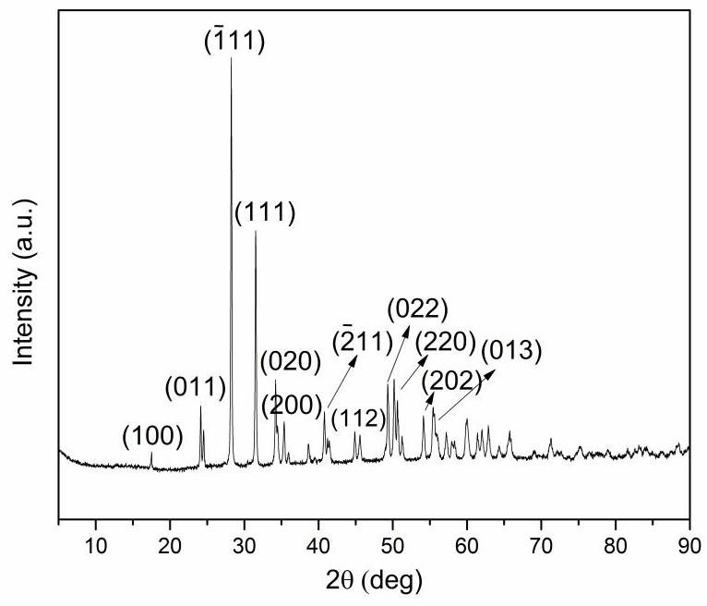
Figure S2: Phase assemblage of monoclinic zirconia transformed from unstabilised tetragonal zirconia (converted from zirconyl chloride octahydrate) by virtue of high temperature sintering and subsequent cooling

Figure S3: Representative stress-strain plots of binderjet printed-sintered microporous zircon-zirconia based cylinders demonstrating progressive failure. The sawtooth nature of the curves arises due to the typical layer by layer failure of the microporous architectures.
Figure S4: Not all powders are binderjet printable. As shown in the above figure, the powder particles should possess cohesive interactions with each other to be binderjet printable. This particular attribute gives rise to an intimate bed packing during powder layers deposition by the spreader roller during printing. A controlled humidification and strategic blending with metallic silicates can contribute in cohesive bed packing and printability.

