**1-Undecene from *P. aeruginosa* is an olfactory signal for flight or fight response in *C. elegans***

Deep Prakash1, Akhil MS1, Buddidhathi Radhika2,Radhika Venkatesan2,3, Sreekanth H. Chalasani4, Varsha Singh1, *

1Department of Molecular Reproduction Development and Genetics, Indian Institute of Science, Bangalore INDIA

2National Center of Biological Sciences, Bangalore, INDIA

3Department of Biological Sciences, Indian Institute of Science Education and Research, Mohanpur, INDIA

4Salk Institute for Biological Studies, La Jolla, USA

* Lead Contact: [varsha@iisc.ac.in](mailto:varsha@iisc.ac.in)

**This file contains:**

**Appendix Figures S1-S4 and legends** (Pages 2-8)

**Appendix Table 1** (pages 9-10)

**Appendix Figure S1 (related to Figure 2)**

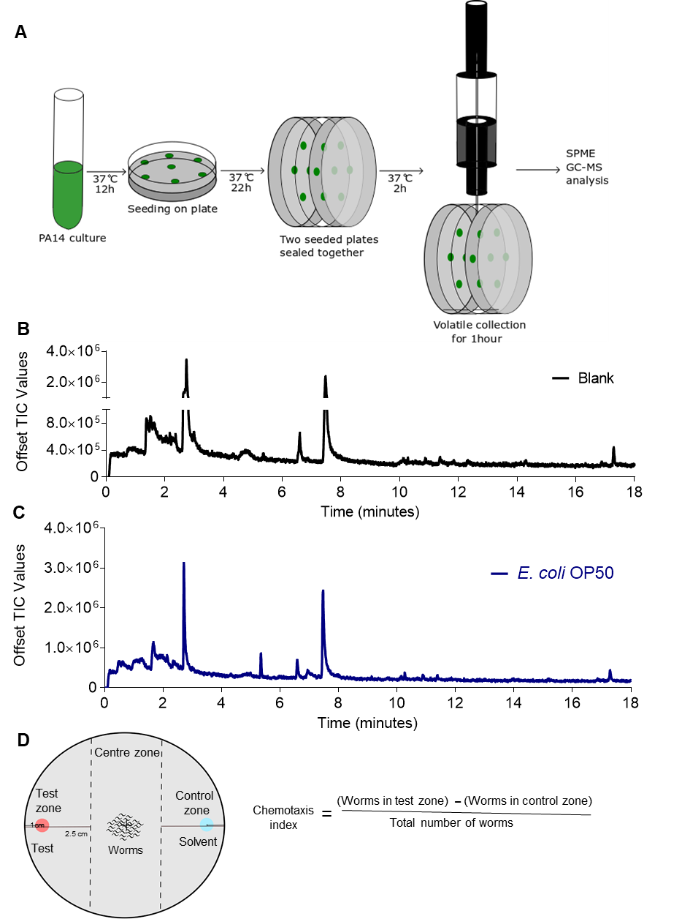**Appendix Figure S1. (Related to figure 2).**

(A) Schematic for preparation of bacterial headspace sample for SPME GC-MS/MS analysis.

(B-C) GC-MS/MS profile of volatiles produced by (B) Blank, media control (C) 24 h old lawn of *E. coli* OP50.

(D) Schematic of chemotaxis assay for attractant and repellent chemical.

**Appendix Figure S2 (related to Figure 2 and 3)**

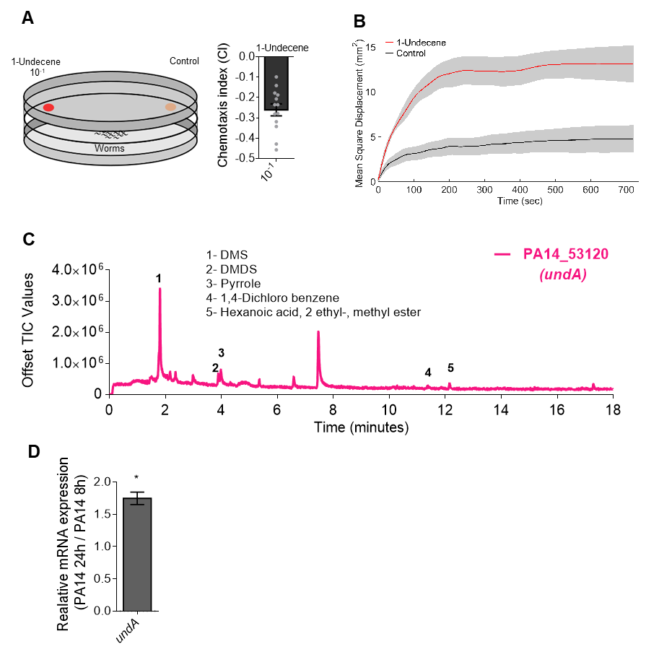

**Appendix Figure S2. 1-Undecene is sensed as a repellent and elicits defense responses in *C. elegans* (Related to Figures 2 and 3).**

1. Chemotaxis response of N2 worms for 1-undecene odor at 1:10 dilution. n ≥ 3 assays. Error bars indicate SEM.
2. Mean square displacement (MSD) of worms under exposure of 1-undecene and control condition. MSD is defined by〈δ*r*2(*t*)〉∝ *tμ*  where δ*r* is displacement of worms in time t and the slope of double logarithm MSD curve is defined by μ. The μ for control is 0.7144 and μ under 1-undecene exposure is 0.9216 (detail in methods).
3. GC-MS/MS profile of volatiles produced by 24 h old lawn of *undA* mutant of *P. aeruginosa*.
4. Real time PCR analysis of *undA* gene in old lawn of PA14 (24 h) over young lawn of PA14 (8h). n ≥ 3 assays. * P ≤ 0.05 as determined by two-tailed unpaired t-test. Error bars indicate SEM.

**Appendix Figure S3** **(related to Figure 3)**



**Fig. S3. 1-Undecene is sensed by AWB odor sensory neurons of *C. elegans*** **(Related to Figure 3).**

Average calcium responses of transgenic worms expressing GCaMP family of indicator in AWA, AWB AWCon and AWCoff neurons recorded for 180 s under 1:100 dilution of 1-undecene.

**Appendix Figure S4** **(related to Figure 4)**

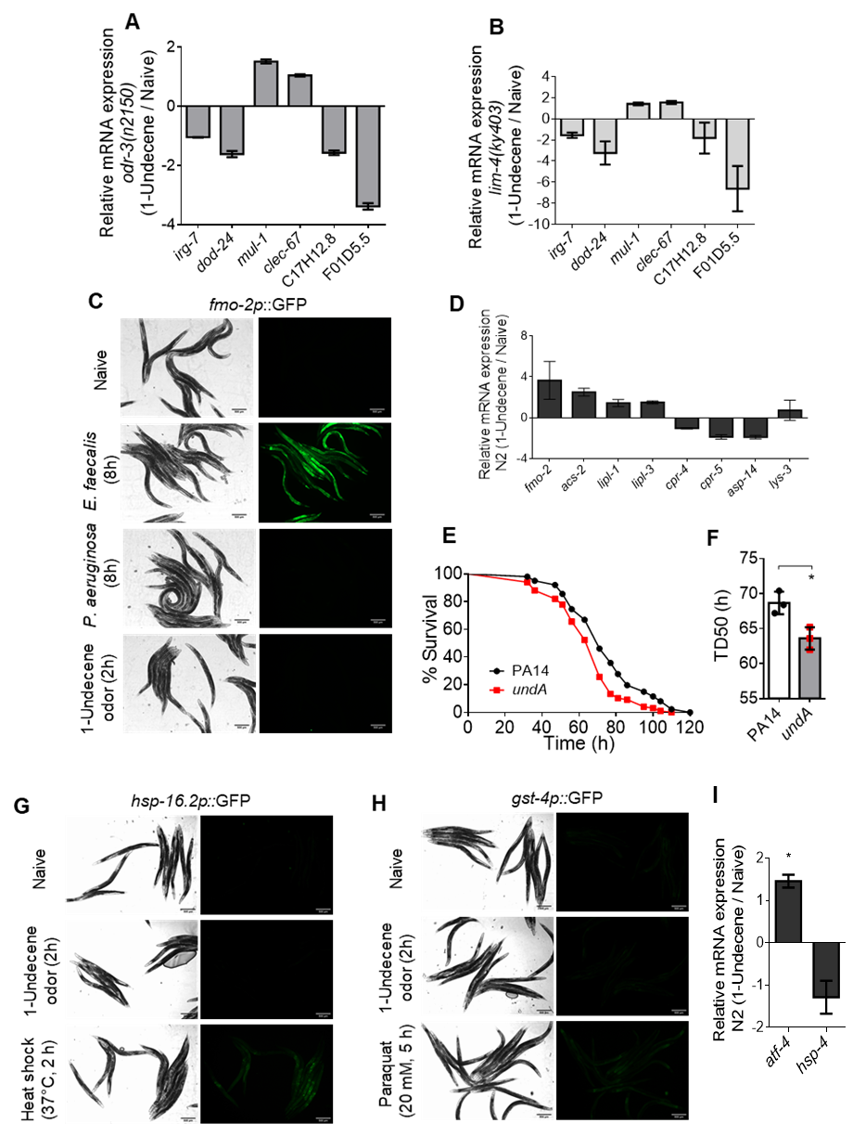

**Appendix Figure S4. 1-Undecene odor induces pathogen-specific immune response in *C. elegans.* (Related to figure 4)**

1. Real time PCR analysis of *P. aeruginosa* specific immune response genes in *odr-3(n2150)* worms exposed to 1-undecene odor upon naive *odr-3(n2150)* worms. n = 3. Error bars indicate SEM.
2. Real time PCR analysis of *P. aeruginosa* specific immune response genes in *lim-4(ky403)* worms exposed to 1-undecene and naive *lim-4(ky403)* worms. n = 3. Error bars indicate SEM.
3. *fmo-2p*::GFP induction in worms exposed to *E. coli* OP50 (naive), *E. faecalis, P. aeruginosa and E. coli* OP50under1-undecene odor exposure. Scale bar = 500 um.
4. Real time PCR analysis of *E. faecalis* specific immune response genes in N2 worms exposed to 1-undecene odor upon naive N2 worms. n = 3. Error bars indicate SEM.
5. Kaplan Meier survival curve of N2 worms on *P. aeruginosa* wild type (PA14) and *undA* mutant. Survival assay was performed at 20°C.
6. Time required for 50% of worms to die (TD50)on *P. aeruginosa* wild type (PA14) and *undA* mutant*.* Each data point indicate replicates with ~100 worms. n = 3 assays. * P ≤ 0.05 as determined by two-tailed unpaired t-test. Error bars indicate SEM.
7. *hsp-16.2*p::GFP induction in worms exposed to *E. coli* OP50 (naive), 1-undecene odor and heat shock. Scale bar = 500 um.
8. *gst-4*p::GFP induction in worms exposed to *E. coli* OP50 (naive), 1-undecene odor and 20mM paraquat. Scale bar = 500 um.
9. Real time PCR analysis of *atf-4* and *hsp-4* genes in N2 worms exposed to 1-undecene odor upon naive N2 worms. n = 3. Error bars indicate SEM.

**Appendix Table S1:** *C. elegans* strains used in this study

|  |  |  |
| --- | --- | --- |
| **Strain Name** | **Genotype** | **Name and Figures** |
| CX2205 | *odr-3(n2150)* | Figures 1A-1F, 3A, 4D, and S4A |
| MT4810 | *odr-3(n2046)* | Figures 1A, 1C-1E, 3B and 4D |
| CX4 | *odr-7(ky4)* | Figure 3B |
| AWA(-) | agEx [odr-10p::TU#813 + odr- 10p::TU#814 + unc-122p::GFP]. AWA ablated | Figure 3B |
| ASH(-) | agEx [sra-6p::TU#813 + del-2p::TU#814 + unc-122p::GFP]. ASH ablated | Figure 3B |
| CX3937 | *lim-4(ky403)* | Figures 3B, 4E and S4B |
| JY359 | *lim-4(yz12)* | Figures 3B and 4E |
| PY7502 | oyIs85 [ceh-36p::TU#813 + ceh 36p::TU#814 + srtx-1p::GFP + unc-122p::DsRed]. AWC ablated | Figure 3B |
| PY6554 | oyEx [gpa-4::GCaMP2.2b, unc-122::dsRed] | AWA; Figure S3A |
| PY7336 | |  | | --- | | oyEx [str-1::GCaMP3, unc-122::dsRed] | | AWB; Figures 3C-3F and S3A |
| CX10536 | |  | | --- | | kyEx2595 [str-2::GCaMP2.2b, unc-122::gfp] | | AWCON; Figure S3A |
| PY6253 | |  | | --- | | pha-1(e2123) III; syEx1238 [srsx-3::GCaMP3, pha-1::pha-1] | | AWCOFF; Figure S3A |
| ERT61 | *zip-2(tm4248)* | Deletion allele, Figure 4B  (Emily Troemel’s lab) |
| AU133 | agIs17 [myo-2p::mCherry + irg-1p::GFP] IV | Figure 4C |
| *fmo*-2GFP | Pfmo-2::GFP | Figure S4C |
| CL2070 | *hsp-16.2p::GFP* | Figure S4G |
| CL2166 | *gst-4p::GFP* | Figure S4H |