Supplementary Material

Matrilineal analysis of mutations in DMD in a multigenerational South Indian cohort using DMD gene panel sequencing

Arun Shastry^{1#}*, Sankaramoorthy Aravind ^{1,3}*, Meeta Sunil²*, Keerthi Ramesh¹, Berty Ashley¹, Nithyanandan T.², Ramprasad VL², Ravi Gupta², Somasekar Seshagiri⁴, Upendra Nongthomba³, Sameer Phalke^{2#}

- Dystrophy Annihilation Research Trust (DART), Bangalore, India
- MedGenome Labs, Bangalore, India
- Indian Institute of Science (IISc), Bangalore, India
- SciGenom Research Foundation, Cochin, India

* Equal Contributions

# Corresponding Authors:

Sameer Phalke: sameer.p@medgenome.com
Arun Shastry: arunshastry@dartindia.in

Figure Legend
Supp. Fig. S1: QC metrics of the sequenced data: (a) Percentage of raw data above Q30, (b) read alignment percentage across the cohort (c) % DMD gene coverage the probands and the other unaffected family members and (d) average depth of DMD gene in the proband and the other family members.
Supp. Fig. S2: Pedigree diagrams of all the 22 families

Table Legend:
Supp. Table S1: List of family, sample, relationship with proband and age of ambulation loss

Supp. Table S2: List of additional 80 genes, along with associated OMIM phenotype, included in the panel
Supp. Table S3: Data quality and processing summary
Supp. Table S4: Comparison of DMD mutation analysis using Illumina True Sight (TRUPNL) and DMD gene panel (MGM DMD Panel)
Supp. Table S5: List of inherited/de-novo DMD mutation

Supp. Fig. S1
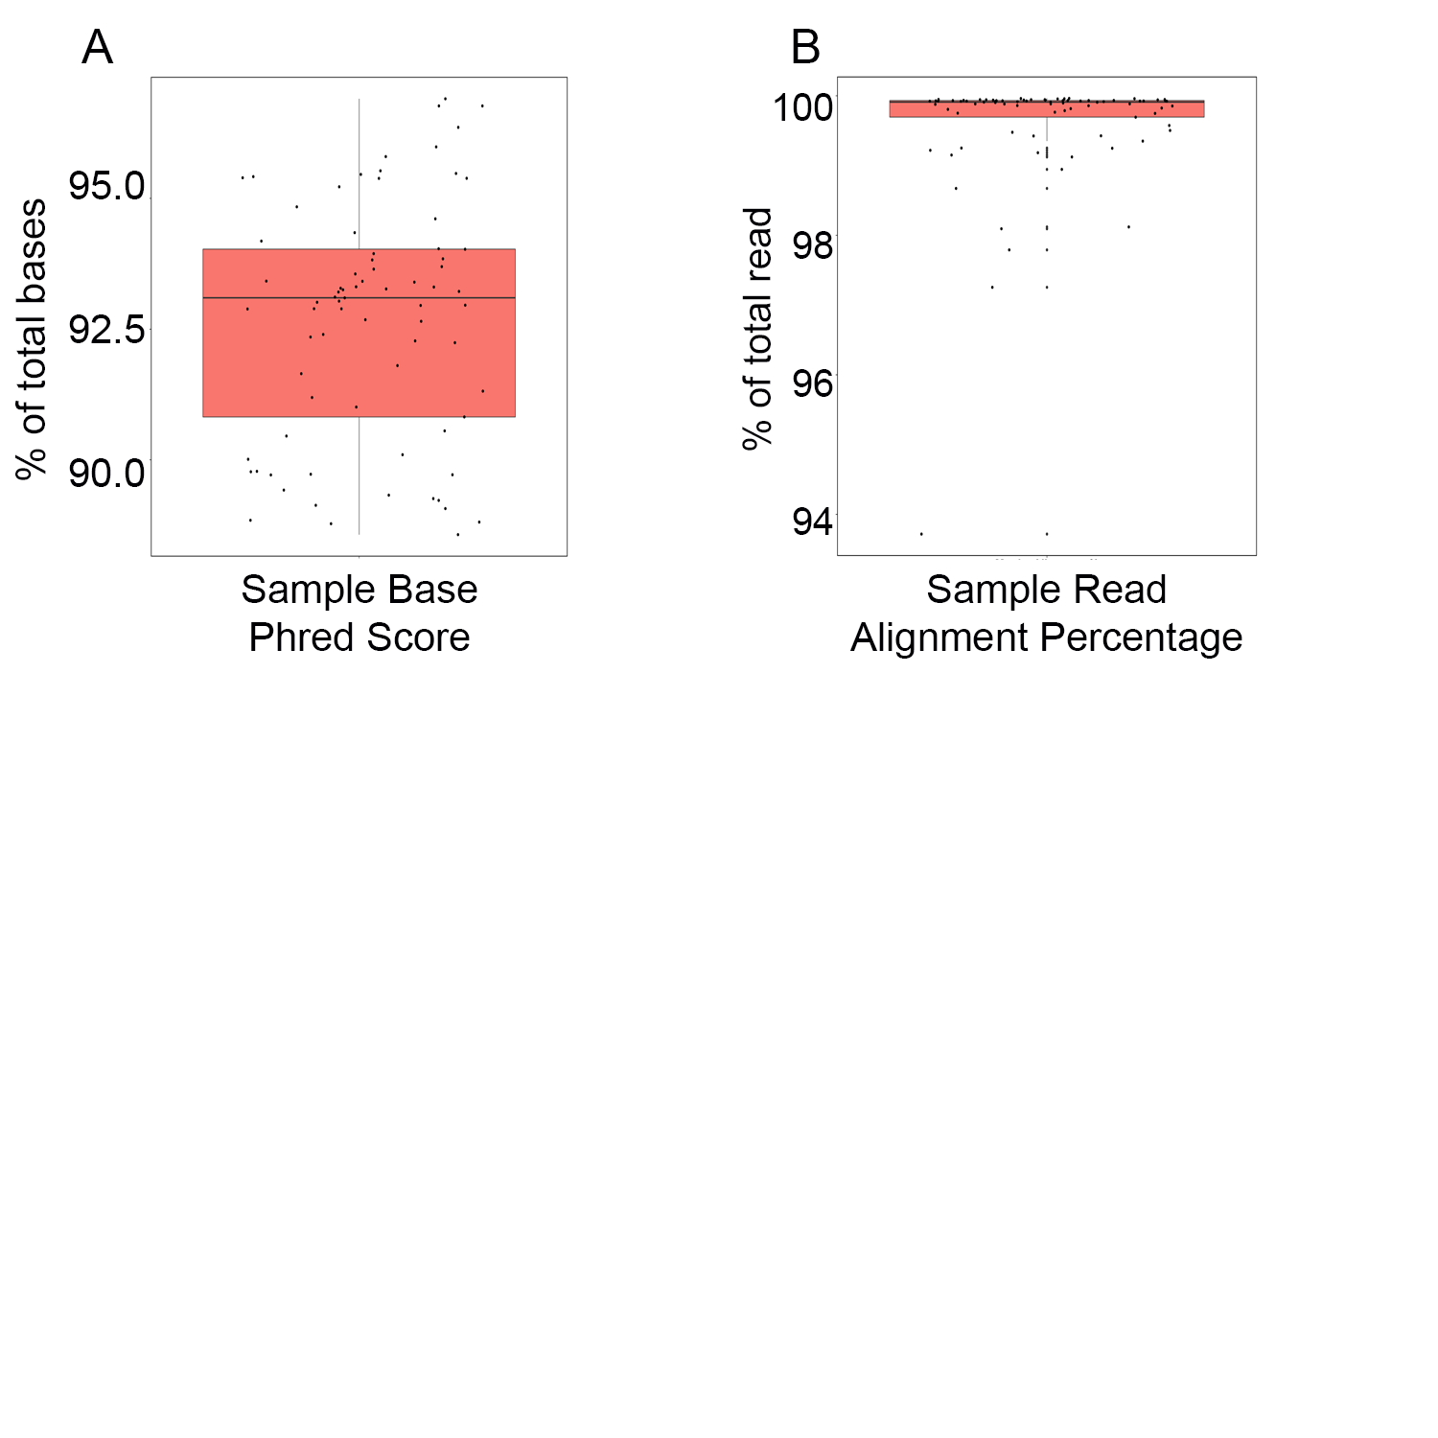
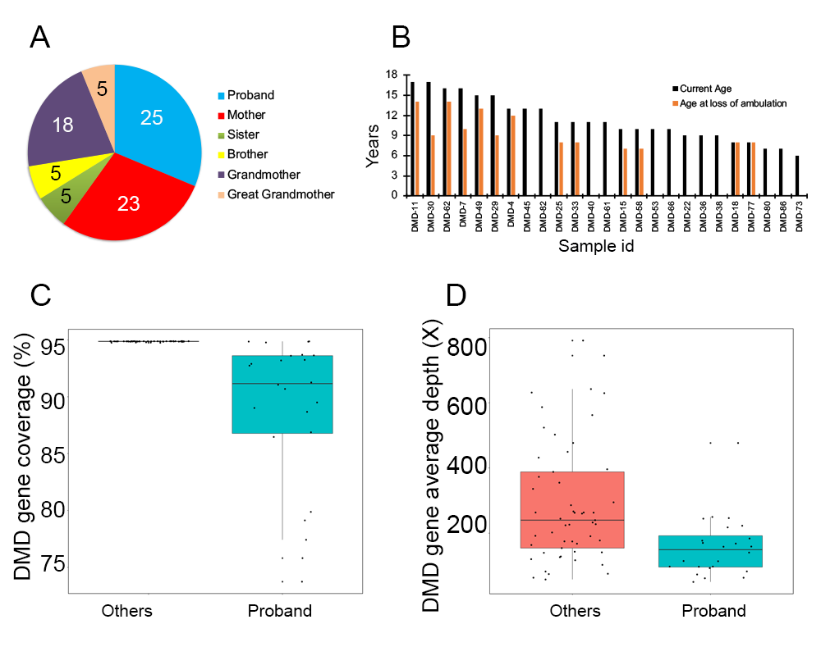
C
a
c
b
d

Supp. Fig. S2
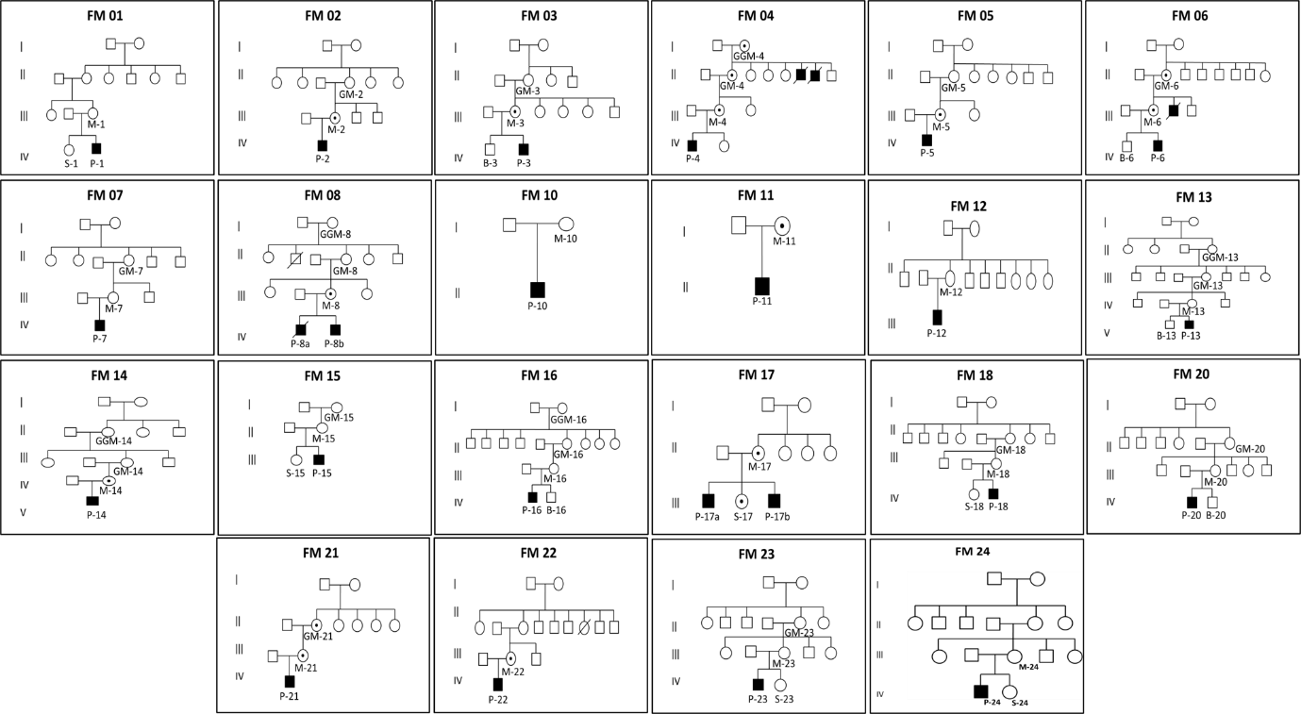

Supp. Table S1
Family ID | Sample ID | Sample Info | Sample Name | Gender | Age | Age at loss of ambulation
FM-1 | M-1 | Mother | DMD2-M | F
FM-1 | S-1 | Sister | DMD2-S | F
FM-1 | P-1 | Proband | DMD2 | M | 13 | 12
FM-2 | GM-2 | GrandMother | DMD22-GM | F
FM-2 | M-2 | Mother | DMD22-M | F
FM-2 | P-2 | Proband | DMD22 | M | 16 | 10
FM-3 | GM-3 | GrandMother | DMD12-GM | F
FM-3 | B-3 | Brother | DMD12-B | M
FM-3 | M-3 | Mother | DMD12-M | F
FM-3 | P-3 | Proband | DMD12 | M | 17 | 14
FM-4 | GGM-4 | Great GrandMother | DMD21-GGM | F
FM-4 | GM-4 | GrandMother | DMD21-GM | F
FM-4 | M-4 | Mother | DMD21-G | F
FM-4 | P-4 | Proband | DMD21 | M | 10 | 7
FM-5 | GM-5 | GrandMother | DMD3-GM | F
FM-5 | M-5 | Mother | DMD3-M | F
FM-5 | P-5 | Proband | DMD3 | M | 8 | 8
FM-6 | GM-6 | GrandMother | DMD1-GM | F
FM-6 | M-6 | Mother | DMD1-M | F
FM-6 | B-6 | Brother | DMD1-B | M
FM-6 | P-6 | Proband | DMD1 | M | 9 | Still Walking
FM-7 | GM-7 | GrandMother | DMD17-GM | F
FM-7 | M-7 | Mother | DMD17-M | F
FM-7 | P-7 | Proband | DMD17 | M | 11 | 8
FM-8 | GGM-8 | Great GrandMother | DMD15-GGM | F
FM-8 | GM-8 | GrandMother | DMD15-GM | F
FM-8 | M-8 | Mother | DMD15-M | F
FM-8 | P-8a | Proband | DMD15 | M | 15 | 9
FM-8 | P-8b | Proband | DMD16 | M | 17 | 9
FM-10 | M-10 | Mother | DMD36-M | F
FM-10 | P-10 | Proband | DMD36 | M | 11 | Walking
FM-11 | M-11 | Mother | DMD38-M | F
FM-11 | P-11 | Proband | DMD38 | M | 11 | Walking
FM-12 | M-12 | Mother | DMD40-M | F
FM-12 | P12 | Proband | DMD40 | M | 13 | Walking
FM-13 | GGM-13 | Great GrandMother | DMD8-GGM | F
FM-13 | GM-13 | GrandMother | DMD8-GM | F
FM-13 | M-13 | Mother | DMD8-M | F
FM-13 | B-13 | Brother | DMD8-B | M
FM-13 | P-13 | Proband | DMD8 | M | 12 | 8
FM-14 | GGM-14 | Great GrandMother | DMD20-GGM | F
FM-14 | GM-14 | GrandMother | DMD20-GM | F
FM-14 | M-14 | Mother | DMD20-M | F
FM-14 | P-14 | Proband | DMD20 | M | 17 | 13
FM-15 | GM-15 | GrandMother | DMD6-GM | F
FM-15 | M-15 | Mother | DMD6-M | F
FM-15 | S-15 | Sister | DMD6-S | F
FM-15 | P-15 | Proband | DMD6 | M | 10 | walking
FM-16 | GGM-16 | Great GrandMother | DMD5-GGM | F
FM-16 | GM-16 | GrandMother | DMD5-GM | F
FM-16 | M-16 | Mother | DMD5-M | F
FM-16 | B-16 | Brother | DMD5-B | M
FM-16 | P-16 | Proband | DMD5 | M | 10 | 7
FM-17 | M-17 | Mother | DMD4-M | F
FM-17 | S17 | Sister | DMD4-S | F
FM-17 | P-17a | Proband | DMD4 | M | 11 | walking
FM-17 | P-17b | Proband | DMD7 | M | 16 | 14
FM-18 | GM-18 | GrandMother | DMD14-GM | F
FM-18 | M-18 | Mother | DMD14-M | F
FM-18 | S-18 | Sister | DMD14-S | F
FM-18 | P-18 | Proband | DMD14 | M | 10 | walking
FM-20 | GM-20 | GrandMother | DMD11-GM | F
FM-20 | M-20 | Mother | DMD11-M | F
FM-20 | P-20 | Proband | DMD11 | M | 6 | walking
FM-21 | GM-21 | GrandMother | DMD9-GM | F
FM-21 | M-21 | Mother | DMD9-M | F
FM-21 | B-21 | Brother | DMD9-B | M
FM-21 | P-21 | Proband | DMD9 | M | 8 | 8
FM-22 | GM-22 | GrandMother | DMD10-GM | F
FM-22 | M-22 | Mother | DMD10-M | F
FM-22 | P-22 | Proband | DMD10 | M | 7 | walking
FM-23 | M-23 | Mother | DMD82-M | F
FM-23 | P-23 | Proband | DMD82 | M | 14 | 11
FM-24 | GM-24 | GrandMother | DMD18-GM | F
FM-24 | M-24 | Mother | DMD18-M | F
FM-24 | S-24 | Sister | DMD18-S | F
FM-24 | P-24 | Proband | DMD18 | M | 7 | NA

Supp. Table S2.
# | Gene | OMIM phenotype
1 | ACTA1 | congenital actin myopathy with cores, congenital actin myopathy with excess of thin myofilaments, autosomal domiant or recessive nemaline myopathy 3, congenital myopathy with fiber-type disproportion 1
2 | ANO5 | Gnathodiaphyseal dysplasia, Miyoshi muscular dystrophy 3, limb-girdle muscular dystrophy-2L
3 | B3GALNT2 | Muscular dystrophy-dystroglycanopathy (congenital with brain and eye anomalies type A 11
4 | B3GNT1 | Muscular dystrophy-dystroglycanopathy (congenital with brain and eye anomalies) type A 13
5 | BAG3 | dilated cardiomyopathy-1HH, myofibrillar myopathy-6
6 | BIN1 | Autosomal recessive centronuclear myopathy-2
7 | BVES | Limb-girdle muscular dystrophy type 2X
8 | CAPN3 | limb-girdle muscular dystrophy-2A
9 | CAV3 | Familial hypertrophic cardiomyopathy, elevated serum creatine phosphokinase, long QT syndrome 9, limb-girdle muscular dystrophy type 1C, Tateyama type distal myopathy, rippling muscle disease
10 | CCDC78 | centronuclear myopathy 4
11 | CFL2 | autosomal recessive nemaline myopathy-7
12 | CHKB | Megaconial type congenital muscular dystrophy
13 | CNTN1 | Compton-North congenital myopathy
14 | COL12A1 | Ullrich congenital muscular dystrophy 2, Bethlem myopathy 2
15 | COL6A1 | Bethlem myopathy, Ullrich congenital muscular dystrophy
16 | COL6A2 | Bethlem myopathy 1, Ullrich congenital muscular dystrophy 1, congenital myosclerosis
17 | COL6A3 | Bethlem myopathy 1, Ullrich congenital muscular dystrophy 1, dystonia 27
18 | CRYAB | dilated cardiomyopathy-1II, multiple types of cataract 16, myofibrillar myopathy-2, fatal infantile hypertonic myofibrillar myopathy
19 | DAG1 | Muscular dystrophy-dystroglycanopathy (congenital with brain and eye anomalies) type A,9, limb-girdle muscular dystrophy-dystroglycanopathy type C9
20 | DES | limb-girdle muscular dystrophy type 2R, dilated cardiomyopathy 1I, myofibrillar myopathy-1, neurogenic scapuloperoneal syndrome type Kaeser
21 | DNAJB6 | limb-girdle muscular dystrophy type 1E
22 | DNM2 | axonal Charcot-Marie-Tooth disease type 2M, dominant intermediate B Charcot-Marie-Tooth disease, lethal congenital contracture syndrome 5, centronuclear myopathy
23 | DYSF | Miyoshi muscular dystrophy 1, distal myopathy with anterior tibial onset, limb-girdle muscular dystrophy type 2B
24 | EMD | X-linked Emery-Dreifuss muscular dystrophy 1
25 | FHL1 | X-linked myopathy with postural muscle atrophy, childhood-onset X-linked reducing body myopathy, severe early-onset X-linked reducing body myopathy, X-linked Emery-Dreifuss muscular dystrophy 6, X-linked dominant scapuloperoneal myopathy
26 | FKRP | congenital muscular dystrophy-dystroglycanopathy with brain and eye anomalies type A5, congenital muscular dystrophy-dystroglycanopathy with or without mental retardation type B5, limb-girdle muscular dystrophy-dystroglycanopathy type C5
27 | FKTN | dilated cardiomyopathy 1X, congenital muscular dystrophy-dystroglycanopathy with brain and eye anomalies type A4, congenital muscular dystrophy-dystroglycanopathy without mental retardation type B4, limb-girdle muscular dystrophy-dystroglycanopathy type C4
28 | FLNC | distal myopathy-4, myofibrillar myopathy-5
29 | GMPPB | Muscular dystrophy-dystroglycanopathy (congenital with brain and eye anomalies) type A 14, muscular dystrophy-dystroglycanopathy (congenital with mental retardation) type B 14, muscular dystrophy-dystroglycanopathy (limb-girdle) type C 14
30 | GNE | autosomal recessive inclusion body myopathy, Nonaka myopathy, Sialuria
31 | HNRNPDL | Limb-girdle muscular dystrophy type 1G
32 | HNRNPA2B1 | Inclusion body myopathy with early-onset Paget disease with or without frontotemporal dementia 2
33 | ISCU | Herediary myopathy with lactic acidosis
34 | ISPD | congenital muscular dystrophy-dystroglycanopathy with brain and eye anomalies type A7, limb-girdle muscular dystrophy-dystroglycanopathy type C7
35 | ITGA7 | congenital muscular dystrophy due to ITGA7 deficiency
36 | KBTBD13 | Autosomal dominant nemaline myopathy-6
37 | KLHL40 | autosomal recessive nemaline myopathy-8
38 | KLHL41 | Nemaline myopathy 9
39 | LAMA2 | Merosin-deficient congenital muscular dystrophy, congenital muscular dystrophy due to partial LAMA2 deficiency
40 | LAMP2 | Danon disease
41 | LARGE | congenital muscular dystrophy-dystroglycanopathy with brain and eye anomalies type A6, congenital muscular dystrophy-dystroglycanopathy with mental retardation type B6
42 | LDB3 | dilated cardiomyopathy 1C with or without LVNC, hypertrophic cardiomyopathy 24, left ventricular noncompaction 3, myofibrillar myopathy-4
43 | LIMS2 | Limb-girdle muscular dystrophy type 2W
44 | LMNA | Dilated cardiomyopathy 1A, Charcot-Marie-Tooth disease type 2B1, Emery-Dreifuss muscular dystrophy 2 AD, Emery-Dreifuss muscular dystrophy 3 AR, Slovenian type heart-hand syndrome, Hutchinson-Gilford progeria syndrome, familial partial lipodystrophy 2, Malouf syndrome, mandibuloacral dysplasia, lethal restrictive dermopathy, limb-girdle muscular dystrophy 1B, congenital muscular dystrophy
45 | LMOD3 | Nemaline myopathy 10
46 | MEGF10 | Early-onset myopathy, areflexia, respiratory distress and dysphagia, early-onset myopathy, areflexia, respiratory distress and dysphagia mild variant
47 | MTM1 | X-linked myotubular myopathy
48 | MYF6 | Centronuclear myopathy 3
49 | MYH2 | Proximal myopathy and ophthalmoplegia
50 | MYH7 | dilated cardiomyopathy-1S, hypertrophic cardiomyopathy-1, Laing distal myopathy, left ventricular noncompaction 5, autosomal dominant myosin storage myopathy, autosomal recessive myosin storage myopathy, myopathic type scapuloperoneal syndrome
51 | MYOT | Limb-girdle muscular dystrophy type 1A, myofibrillar myopathy 3, spheroid body myopathy
52 | NEB | Autosomal recessive nemaline myopathy-2
53 | PABPN1 | Oculopharyngeal muscular dystrophy
54 | PLEC | Epidermolysis bullosa simplex with nail dystrophy, epidermolysis bullosa simplex with pyloric atresia, Ogna type of epidermolysis bullosa simplex, muscular dystrophy with epidermolysis bullosa simplex, limb-girdle muscular dystrophy type 2Q
55 | POMGNT1 | Congenital muscular dystrophy-dystroglycanopathy with brain and eye anomalies type A3, congenital muscular dystrophy-dystroglycanopathy with mental retardation type B3, limb-girdle muscular dystrophy-dystroglycanopathy type C3
56 | POMGNT2 | Muscular dystrophy-dystroglycanopathy (congenital with brain and eye anomalies type A 8
57 | POMK | Muscular dystrophy-dystroglycanopathy (limb-girdle) type C 12, muscular dystrophy-dystroglycanopathy (congenital with brain and eye anomalies) type A 12
58 | POMT1 | congenital muscular dystrophy-dystroglycanopathy with brain and eye anomalies type A1, congenital muscular dystrophy-dystroglycanopathy with mental retardation type B1, limb-girdle muscular dystrophy-dystroglycanopathy type C1
59 | POMT2 | congenital muscular dystrophy-dystroglycanopathy with brain and eye anomalies type A2, congenital muscular dystrophy-dystroglycanopathy with mental retardation type B2, limb-girdle muscular dystrophy-dystroglycanopathy type C2
60 | RYR1 | Central core disease, King-Denborough syndrome, minicore myopathy with external ophthalmoplegia, congenital neuromuscular disease with uniform type 1 fiber, susceptibility to malignant hyperthermia 1
61 | SEPN1 | Rigid spine muscular dystrophy 1, congenital myopathy with fiber-type disproportion
62 | SGCA | limb-girdle muscular dystrophy-2D
63 | SGCB | Limb-girdle muscular dystrophy type 2E
64 | SGCD | dilated cardiomyopathy 1L, limb-girdle muscular dystrophy type 2F
65 | SGCG | limb-girdle muscular dystrophy type 2C
66 | SMCHD1 | digenic fascioscapulohumeral muscular dystrophy 2
67 | SPEG | Centronuclear myopathy 5
68 | SYNE1 | Autosomal dominant Emery-Dreifuss muscular dystrophy 4, autosomal recessive spinocerebellar ataxia 8
69 | SYNE2 | autosomal dominant Emery-Dreifuss muscular dystrophy-5
70 | TCAP | hypertrophic cardiomyopathy 25, limb-girdle muscular dystrophy-2G
71 | TMEM43 | Arrhythmogenic right ventricular dysplasia 5, autosomal dominant Emery-Dreifuss muscular dystrophy 7
72 | TMEM5 | Muscular dystrophy-dystroglycanopathy (congenital with brain and eye anomalies) type A 10
73 | TNNT1 | Amish type nemaline myopathy 5
74 | TNPO3 | limb-girdle muscular dystrophy type 1F
75 | TPM2 | distal arthrogryposis multiplex congenita type 1, distal arthrogryposis type 2B, autosomal dominant nemaline myopathy-4, CAP myopathy-2
76 | TPM3 | Congenital myopathy with fiber-type disproportion, autosomal dominant or recessive nemaline myopathy 1, CAP myopathy 1
77 | TRAPPC11 | Limb-girdle muscular dystrophy type 2S
78 | TRIM32 | Bardet-Biedl syndrome 11, limb-girdle muscular dystrophy type 2H
79 | TTN | Dilated cardiomyopathy-1G, familial hypertrophic cardiomyopathy-9, limb-girdle muscular dystrophy type 2J, early-onset myopathy with fatal cardiomyopathy, proximal myopathy with early respiratory muscle involvement, tardive tibial muscular dystrophy
80 | VCP | amyotrophic lateral sclerosis-14 with or without frontotemporal dementia, inclusion body myopathy with early-onset Paget disease and frontotemporal dementia 1

Supp. Table S3.
Family ID | Sample ID | Sample Name | Total data (Mb) | Raw data >= Q30 (%) | Alignment (%) | Duplicate (%) | DMD Gene Coverage (%) | Average Depth (X)
FM-1 | M-1 | DMD2-M | 616.24 | 95.53 | 99.9594 | 13.8004 | 94.89174205 | 239.9998846
FM-1 | S-1 | DMD2-S | 459.22 | 95.475 | 99.9459 | 10.8242 | 94.88548569 | 174.5052257
FM-1 | P-1 | DMD2 | 579.78 | 95.46 | 99.9415 | 12.104 | 79.8758763 | 140.4494965
FM-2 | GM-2 | DMD22-GM | 622.36 | 95.415 | 99.7512 | 12.1446 | 94.89200273 | 232.7753287
FM-2 | M-2 | DMD22-M | 646.3 | 95.385 | 99.9233 | 13.0104 | 94.885225 | 227.586477
FM-2 | P-2 | DMD22 | 412.16 | 94.61 | 99.9356 | 8.1673 | 73.736882 | 97.36237591
FM-3 | GM-3 | DMD12-GM | 700.8 | 94.84 | 99.9246 | 8.4269 | 94.88646324 | 260.1294977
FM-3 | B-3 | DMD12-B | 588.78 | 95.385 | 99.923 | 10.3766 | 94.88470364 | 167.8053247
FM-3 | M-3 | DMD12-M | 923.72 | 95.8 | 99.9292 | 16.1218 | 94.88587671 | 372.8456717
FM-3 | P-3 | DMD12 | 700.84 | 88.845 | 99.8838 | 8.1542 | 89.01505894 | 176.9567659
FM-4 | GGM-4 | DMD21-GGM | 737.72 | 90.1 | 99.9256 | 10.3212 | 94.89584779 | 285.8800075
FM-4 | GM-4 | DMD21-GM | 688.48 | 89.26 | 99.9281 | 7.5331 | 94.8971512 | 263.5321607
FM-4 | M-4 | DMD21-G | 554.38 | 89.425 | 99.9381 | 9.4969 | 94.79359531 | 226.2813768
FM-4 | P-4 | DMD21 | 273.14 | 89.13 | 99.9241 | 8.9085 | 94.85009811 | 82.71054921
FM-5 | GM-5 | DMD3-GM | 203.54 | 94.185 | 99.9338 | 9.3354 | 94.8799462 | 74.44783983
FM-5 | M-5 | DMD3-M | 332.12 | 93.945 | 99.943 | 6.6558 | 94.88496432 | 117.0340535
FM-5 | P-5 | DMD3 | 199.94 | 93.31 | 99.8247 | 8.7824 | 91.26415747 | 50.30468895
FM-6 | GM-6 | DMD1-GM | 179.6 | 94.345 | 99.9035 | 6.9397 | 94.8755146 | 63.40615874
FM-6 | M-6 | DMD1-M | 472.54 | 89.07 | 99.4265 | 3.9185 | 94.87564494 | 190.5725084
FM-6 | B-6 | DMD1-B | 195.86 | 88.78 | 93.7172 | 3.4731 | 94.82631089 | 57.99058743
FM-6 | P-6 | DMD1 | 269.18 | 95.22 | 99.8841 | 7.9338 | 91.05424335 | 73.30130595
FM-7 | GM-7 | DMD17-GM | 348.06 | 95.395 | 99.3512 | 8.5707 | 94.86632556 | 126.5361295
FM-7 | M-7 | DMD17-M | 236.06 | 91.315 | 99.1837 | 5.255 | 94.86156812 | 75.42283
FM-7 | P-7 | DMD17 | 890.36 | 90.555 | 99.4234 | 5.5233 | 94.77756337 | 249.8065219
FM-8 | GGM-8 | DMD15-GGM | 366.52 | 88.81 | 99.1506 | 1.9999 | 94.77091598 | 141.1786245
FM-8 | GM-8 | DMD15-GM | 332.3 | 88.57 | 99.2502 | 1.8521 | 94.85837477 | 128.5095674
FM-8 | M-8 | DMD15-M | 476.16 | 89.775 | 99.5033 | 2.5347 | 94.8697796 | 177.5589757
FM-8 | P-8a | DMD15 | 328.88 | 89.78 | 99.4766 | 2.7569 | 93.19470268 | 92.72466644
FM-8 | P-8b | DMD16 | 686.08 | 95.985 | 99.9615 | 8.9691 | 93.24266816 | 170.1386039
FM-10 | M-10 | DMD36-M | 242.88 | 93.115 | 97.7913 | 3.9908 | 94.85928715 | 82.43431369
FM-10 | P-10 | DMD36 | 265.84 | 94.03 | 98.6719 | 5.9279 | 89.50064421 | 61.60802952
FM-11 | M-11 | DMD38-M | 536.82 | 91.01 | 98.9455 | 3.7251 | 94.89167688 | 202.1455596
FM-11 | P-11 | DMD38 | 814.46 | 90.455 | 99.2182 | 5.493 | 88.67545556 | 217.8007647
FM-12 | M-12 | DMD40-M | 671.26 | 89.325 | 99.5744 | 3.2374 | 94.88476881 | 263.4188129
FM-12 | P12 | DMD40 | 414.04 | 89.225 | 97.2542 | 3.068 | 75.80923818 | 97.46815021
FM-13 | GGM-13 | DMD8-GGM | 268 | 89.715 | 99.1233 | 1.6169 | 94.88157546 | 102.8710328
FM-13 | GM-13 | DMD8-GM | 2298.56 | 93.285 | 99.932 | 42.2006 | 94.88392159 | 586.7483976
FM-13 | M-13 | DMD8-M | 2882.52 | 93.42 | 99.9287 | 41.2517 | 94.88809251 | 744.8692889
FM-13 | B-13 | DMD8-B | 1017.02 | 92.275 | 99.8533 | 29.6446 | 94.84182146 | 191.8869944
FM-13 | P-13 | DMD8 | 2300.62 | 92.89 | 99.9212 | 32.5248 | 93.63760128 | 476.6825989
FM-14 | GGM-14 | DMD20-GGM | 2122.26 | 93.27 | 99.9239 | 35.268 | 94.88561603 | 631.5439709
FM-14 | GM-14 | DMD20-GM | 353.3 | 89.715 | 98.0939 | 4.1612 | 94.86502215 | 120.2366392
FM-14 | M-14 | DMD20-M | 2602.7 | 93.4 | 99.9478 | 40.7355 | 94.8845733 | 791.0553649
FM-14 | P-14 | DMD20 | 400.46 | 96.77 | 98.1195 | 23.4477 | 94.87401568 | 96.92320375
FM-15 | GM-15 | DMD6-GM | 541.02 | 96.77 | 99.6938 | 23.4708 | 94.87395051 | 163.7359338
FM-15 | M-15 | DMD6-M | 504.2 | 96.905 | 99.7875 | 24.3976 | 94.87590563 | 174.8572473
FM-15 | S-15 | DMD6-S | 1326.12 | 91.195 | 99.9074 | 32.6692 | 94.87740455 | 354.9732697
FM-15 | P-15 | DMD6 | 896.52 | 90.01 | 99.9445 | 29.7042 | 90.69130893 | 158.4958516
FM-16 | GGM-16 | DMD5-GGM | 686.38 | 96.36 | 99.7475 | 20.5906 | 94.75462336 | 244.4608557
FM-16 | GM-16 | DMD5-GM | 1215.46 | 93.305 | 99.8571 | 23.5421 | 94.86645591 | 266.7045607
FM-16 | M-16 | DMD5-M | 1431.2 | 90.82 | 99.9392 | 27.9926 | 94.88555086 | 396.1309614
FM-16 | B-16 | DMD5-B | 781.38 | 93.555 | 99.931 | 26.6641 | 94.85029363 | 154.1912728
FM-16 | P-16 | DMD5 | 1253.76 | 92.955 | 99.9313 | 27.1232 | 92.74268021 | 246.1972222
FM-17 | M-17 | DMD4-M | 479.22 | 93.31 | 99.9169 | 25.518 | 94.86971443 | 143.1185477
FM-17 | S17 | DMD4-S | 1625.94 | 92.68 | 99.9093 | 31.4273 | 94.86678176 | 476.9069828
FM-17 | P-17a | DMD4 | 1109.62 | 92.35 | 99.8595 | 32.5724 | 79.12876188 | 183.6667775
FM-17 | P-17b | DMD7 | 1101.12 | 93.65 | 99.958 | 23.2386 | 77.42331552 | 222.9311989
FM-18 | GM-18 | DMD14-GM | 1987.04 | 93.21 | 99.9093 | 37.5393 | 94.87075716 | 523.8385994
FM-18 | M-18 | DMD14-M | 1941.38 | 94.04 | 99.9627 | 20.911 | 94.86130744 | 642.1905155
FM-18 | S-18 | DMD14-S | 1787.78 | 93.825 | 99.9549 | 23.6956 | 94.84899022 | 562.3562968
FM-18 | P-18 | DMD14 | 1420.56 | 92.65 | 99.8817 | 35.4337 | 93.61088139 | 244.4519977
FM-20 | GM-20 | DMD11-GM | 1267.4 | 92.24 | 99.9436 | 29.1402 | 94.8845733 | 388.1242944
FM-20 | M-20 | DMD11-M | 1515.16 | 92.96 | 99.9327 | 29.7981 | 94.88691944 | 449.6148587
FM-20 | P-20 | DMD11 | 596.06 | 93.22 | 99.8052 | 24.8723 | 86.46695824 | 113.9391594
FM-21 | GM-21 | DMD9-GM | 1000.28 | 93.845 | 99.9385 | 31.9625 | 94.76922155 | 294.7718401
FM-21 | M-21 | DMD9-M | 974.06 | 91.805 | 99.7647 | 20.6374 | 94.88151029 | 262.560777
FM-21 | B-21 | DMD9-B | 691.16 | 93.695 | 99.8847 | 26.0988 | 94.75410199 | 139.820325
FM-21 | P-21 | DMD9 | 930.62 | 93.035 | 99.9251 | 25.0032 | 93.69723227 | 168.1326676
FM-22 | GM-22 | DMD10-GM | 1138.82 | 93.015 | 99.9209 | 32.2722 | 94.87310329 | 335.8623274
FM-22 | M-22 | DMD10-M | 926.9 | 93.415 | 99.915 | 24.2284 | 94.87584045 | 263.0187274
FM-22 | P-22 | DMD10 | 262 | 89.725 | 99.2486 | 9.6864 | 92.89693875 | 63.23886872
FM-23 | M-23 | DMD82-M | 983.64 | 93.255 | 99.8779 | 24.3421 | 94.87681801 | 224.1856792
FM-23 | P-23 | DMD82 | 628.5 | 92.89 | 99.897 | 29.2968 | 86.87740194 | 114.6860621
FM-24 | GM-24 | DMD18-GM | 1665.36 | 93.1 | 99.9256 | 30.924 | 94.88085858 | 502.396346
FM-24 | M-24 | DMD18-M | 1913.72 | 91.65 | 99.9445 | 26.9243 | 94.86704244 | 629.6313136
FM-24 | S-24 | DMD18-S | 1405.34 | 92.4 | 99.9318 | 29.2779 | 94.88131478 | 431.6946509
FM-24 | P-24 | DMD18 | 807.64 | 92.885 | 99.8153 | 26.5219 | 94.8572017 | 159.086839

Supp. Table S3
Fam ID | Sam ID | Sam Name | Align % |  | DMD CaptureRegionSize (bp) |  | Exons affected |  |  | DEL Start |  |  | DEL End |  |  | DEL Len (bp) |  | Tool for DEL prediction
 |  |  | TRUPNL | MGM DMD Panel | TRUPNL | MGM DMD Panel | TRUPNL | MGM DMD Panel | Exon coords for ENST00000357033 | TRUPNL | MGM DMD Panel | Brkpt in Exon / Intron | TRUPNL | MGM DMD Panel | Brkpt in Exon / Intron | TRUPNL | MGM DMD Panel | TRUPNL | MGM DMD Panel
FM-1 | P-1 | DMD2 | 99.87% | 99.93% | 15622 (0.69 %) | 1534437 (68.44 %) | 46-55 | 46-55 | 31645790-31950344 | 31645790 | 31588767 | Intron | 31950344 | 31954409 | Intron | 304555 | 365643 | BEDTools | SoftSV
FM-2 | P-2 | DMD22 | 99.81% | 99.93% | 15622 (0.69 %) | 1534437 (68.44 %) | 33-45 | 33-45 | 31986456-32404582 | 31951085 | 31951085 | Intron | 32404576 | 32404576 | Exon | 453492 | 453492 | SoftSV | SoftSV
FM-5 | P-5 | DMD3 | 99.87% | 99.81% | 15622 (0.69 %) | 1534437 (68.44 %) | 46-48 | 46-48 | 31893305-31950344 | 31893308 | 31877001 | Intron | 31950344 | 31982603 | Intron | 57037 | 105603 | BEDTools | SoftSV
FM-6 | P-6 | DMD1 | 99.83% | 99.87% | 15622 (0.69 %) | 1534437 (68.44 %) | 46-49 | 46-49 | 31854835-31950344 | 31854835 | 31847041 | Intron | 31950344 | 31963099 | Intron | 95510 | 116059 | BEDTools | SoftSV
FM-7 | P-7 | DMD17 | 99.80% | 99.39% | 15622 (0.69 %) | 1534437 (68.44 %) | SNV
FM-8 | P-8a | DMD18 | 99.72% | 99.46% | 15622 (0.69 %) | 1534437 (68.44 %) | 51 | 51 | 31792077-31792309 | 31792077 | 31789297 | Intron | 31792309 | 31826726 | Intron | 233 | 37430 | BEDTools | SoftSV
FM-13 | P-13 | DMD19 | 99.81% | 99.88% | 15622 (0.69 %) | 1534437 (68.44 %) | 46-47 | 46-47 | 31947713-31950344 | 31947713 | 31940865 | Intron | 31950344 | 31979547 | Intron | 2632 | 38683 | BEDTools | ExomeDepth
FM-14 | P-14 | DMD20 | 99.81% | 97.56% | 15622 (0.69 %) | 1534437 (68.44 %) | SNV
FM-15 | P-15 | DMD21 | 99.82% | 99.92% | 15622 (0.69 %) | 1534437 (68.44 %) | 18-29 | 18-29 | 32456358-32536248 | 32456358 | 32446399 | Intron | 32536248 | 32542070 | Intron | 79891 | 95672 | BEDTools | ExomeDepth
FM-17 | P-17a | DMD22 | 99.84% | 99.79% | 15622 (0.69 %) | 1534437 (68.44 %) | 45-52 | 45-52 | 31747748-31986631 | 31747748 | 31728909 | Intron | 31986631 | 32130344 | Intron | 238884 | 401436 | BEDTools | ExomeDepth
FM-18 | P-18 | DMD23 | 99.84% | 99.82% | 15622 (0.69 %) | 1534437 (68.44 %) | 51 | 51 | 31792077-31792309 | 31792077 | 31778073 | Intron | 31792309 | 31813704 | Intron | 233 | 35631 | BEDTools | ExomeDepth
FM-20 | P-20 | DMD24 | 99.74% | 99.74% | 15622 (0.69 %) | 1534437 (68.44 %) | 48-52 | 48-52 | 31747748-31893490 | 31747748 | 31743342 | Intron | 31893490 | 31944322 | Intron | 145743 | 200980 | BEDTools | ExomeDepth
FM-21 | P-21 | DMD25 | 99.68% | 99.90% | 15622 (0.69 %) | 1534437 (68.44 %) | 49-50 | 49-50 | 31838092-31854936 | 31838092 | 31834919 | Intron | 31854939 | 31864242 | Intron | 16848 | 29323 | BEDTools | ExomeDepth
FM-22 | P-22 | DMD26 | 99.77% | 99.17% | 15622 (0.69 %) | 1534437 (68.44 %) | 49-50 | 49-50 | 31838092-31854936 | 31838092 | 31807504 | Intron | 31854939 | 31856691 | Intron | 16848 | 49187 | BEDTools | ExomeDepth

Supp. Table S4
Family ID | Sample ID | Sample Name | MLPA | mPCR | Exons | Variant Caller | Mutation | Zygosity | Inherited/ De novo | Reported in Databases
FM-2 | GM-2 | DMD22-GM
FM-2 | M-2 | DMD22-M |  |  | 33-45 | SoftSV | chrX:31951084-32404576 | Heterozygous
FM-2 | P-2 | DMD22 | 33-45 | Not Done | 33-45 | SoftSV | chrX:31951084-32404576 | Hemizygous | Inherited | No
FM-3 | GM-3 | DMD12-GM
FM-3 | B-3 | DMD12-B
FM-3 | M-3 | DMD12-M |  |  | 46-50 | SoftSV | chrX:31798830- 31950822 | Heterozygous
FM-3 | P-3 | DMD12 | 46-50 | Not Done | 46-50 | SoftSV | chrX:31798830- 31950822 | Hemizygous | Inherited | Yes
FM-4 | GGM-4 | DMD21-GGM |  |  | 7 | HC | chrX:32827676G>A (p.Arg195Ter) | Heterozygous
FM-4 | GM-4 | DMD21-GM |  |  | 7 | HC | chrX:32827676G>A (p.Arg195Ter) | Heterozygous
FM-4 | M-4 | DMD21-G |  |  | 7 | HC | chrX:32827676G>A (p.Arg195Ter) | Heterozygous
FM-4 | P-4 | DMD21 | Negative | Not Done | 7 | HC | chrX:32827676G>A (p.Arg195Ter) | Hemizygous | Inherited | Yes
FM-5 | GM-5 | DMD3-GM
FM-5 | M-5 | DMD3-M |  |  | 46-48 | SoftSV | chrX:31877000-31982603 | Heterozygous
FM-5 | P-5 | DMD3 | 46-48 | Not Done | 46-48 | SoftSV | chrX:31877000-31982603 | Hemizygous | Inherited | Yes
FM-6 | GM-6 | DMD1-GM |  |  | 46-48 | SoftSV | chrX:31847040-31963099 | Heterozygous
FM-6 | M-6 | DMD1-M |  |  | 46-48 | SoftSV | chrX:31847040-31963099 | Heterozygous
FM-6 | B-6 | DMD1-B
FM-6 | P-6 | DMD1 | 46-49 | Not Done | 46-49 | SoftSV | chrX:31847040-31963099 | Hemizygous | Inherited | Yes
FM-8 | GGM--8 | DMD15-GGM
FM-8 | GM-8 | DMD15-GM
FM-8 | M-8 | DMD15-M |  |  | 51 | SoftSV | chrX:31789296-31826726 | Heterozygous
FM-8 | P-8a | DMD15 | 51 | Positive | 51 | SoftSV | chrX:31789296-31826726 | Hemizygous | Inherited | Yes
FM-8 | P-8b | DMD16 | 51 | Positive | 51 | SoftSV | chrX:31789296-31826726 | Hemizygous | Inherited | Yes
FM-11 | M-11 | DMD38-M |  |  | 45-50 | SoftSV | chrX:31829985-31993786 | Heterozygous
FM-11 | P-11 | DMD38 | 45-50 | Not Done | 45-50 | SoftSV | chrX:31829985-31993786 | Hemizygous | Inherited
FM-17 | M-17 | DMD4-M |  |  | 45-52 | SoftSV | chrX:31728694-32130548 | Heterozygous
FM-17 | S-17 | DMD4-S |  |  |  |  |  | Heterozygous
FM-17 | P-17a | DMD4 |  |  | 45-52 | ED | chrX:31728909-32130344 | Hemizygous | Inherited | Yes
FM-17 | P-17b | DMD7 | 45-52 | Not Done | 45-52 | SoftSV  ED | chrX:31728694-32130548  chrX:31728909-32130344 | Hemizygous | Inherited | Yes
FM-22 | GM-22 | DMD10-GM |  |  | 49-50 | ED | chrX:31807843-31856691 | Heterozygous
FM-22 | M-22 | DMD10-M |  |  | 49-50 | ED | chrX:31810391-31856451 | Heterozygous
FM-22 | P-22 | DMD10 | 49-50 | Not Done | 49-50 | ED | chrX:31807504-31856691 | Hemizygous | Inherited | Yes
FM-23 | M-23 | DMD82-M |  |  | 48-54 | ED | chrX:31662823-31924904 | Heterozygous
FM-23 | P-23 | DMD82 | 48-54 | Not Done | 48-54 | ED | chrX:31662823-31924904 | Hemizygous | Inherited | Yes
FM-14 | GGM-14 | DMD20-GGM
FM-14 | GM-14 | DMD20-GM
FM-14 | M-14 | DMD20-M |  |  | 51 | HC | chrX:31792270_31792271insC (p.Val2327GlyfsTer3) | Heterozygous
FM-14 | P-14 | DMD20 | Negative | Not Done | 51 | HC | chrX:31792270_31792271insC (p.Val2327GlyfsTer3) | Hemizygous | Inherited | Yes
FM-1 | M-1 | DMD2-M
FM-1 | S-1 | DMD2-S
FM-1 | P-1 | DMD2 | 46-55 | Not Done | 46-55 | SoftSV | chrX:31588766-31954409 | Hemizygous | De novo
FM-7 | GM-7 | DMD17-GM
FM-7 | M-7 | DMD17-M
FM-7 | P-7 | DMD17 | Positive | Not Done | 21 | HC | chrX:32503176delG (p.Glu765AsnfsTer3) | Hemizygous | De novo | No
FM-10 | M-10 | DMD36-M
FM-10 | P-10 | DMD36 | 1 | Not Done | 1 | SoftSV | chrX:33122034-33245415 | Hemizygous | De novo
FM-12 | M-12 | DMD40-M
FM-12 | P-12 | DMD40 | 35-45 | Not Done | 35-45 | SoftSV | chrX:31959962-32394772 | Hemizygous | De novo
FM-13 | GGM-13 | DMD8-GGM
FM-13 | GM-13 | DMD8-GM
FM-13 | M-13 | DMD8-M
FM-13 | B-13 | DMD8-B
FM-13 | P-13 | DMD8 | 46-47 | Not Done | 46-47 | ED | chrX:31940865-31979547 | Hemizygous | De novo | Yes
FM-15 | GM-15 | DMD6-GM
FM-15 | M-15 | DMD6-M
FM-15 | S-15 | DMD6-S
FM-15 | P-15 | DMD6 | 18-29 | Not Done | 18-29 | ED | chrX:32446399-32542070 | Hemizygous | De novo | No
FM-16 | GGM-16 | DMD5-GGM
FM-16 | GM-16 | DMD5-GM
FM-16 | M-16 | DMD5-M
FM-16 | B-16 | DMD5-B
FM-16 | P-16 | DMD5 | 8-9 | Not Done | 8-9 | ED | chrX:32675098-32721781 | Hemizygous | De novo | No
FM-18 | GM-18 | DMD14-GM
FM-18 | M-18 | DMD14-M
FM-18 | S-18 | DMD14-S
FM-18 | P-18 | DMD14 | 51 | Not Done | 51 | ED | chrX:31778073-31813704 | Hemizygous | De novo | Yes
FM-20 | GM-20 | DMD11-GM
FM-20 | M-20 | DMD11-M
FM-20 | P-20 | DMD11 | 48-52 | Not Done | 48-52 | ED | chrX:31743342-31944322 | Hemizygous | De novo | Yes
FM-21 | GM-21 | DMD9-GM
FM-21 | M-21 | DMD9-M
FM-21 | B-21 | DMD9-B
FM-21 | P-21 | DMD9 | 49-50 | Not Done | 49-50 | ED | chrX:31834919-31864242 | Hemizygous | De novo | Yes
FM-24 | GM-24 | DMD18-GM
FM-24 | M-24 | DMD18-M
FM-24 | S-24 | DMD18-S
FM-24 | P-24 | DMD18 | Positive | Not Done | 46 | HC | chrX:31950337C>A (p.Glu2200Ter) | Hemizygous | De novo | Yes

