Influence of environmental factors on autotrophic, soil and ecosystem respirations in Canadian boreal forest
Soumendra N. Bhanja^{1*}, Junye Wang²
¹Interdisciplinery Centre for Water Research, Indian Institute of Science, CV Raman Rd, Bangalore, Karnataka 560012, India
²Athabasca River Basin Research Institute (ARBRI), Athabasca University, 1 University Drive, Athabasca, Alberta T9S 3A3, Canada
Correspondence to: Soumendra N. Bhanja (soumendrabhanja@gmail.com)

S1 Vertical oxygen transport
Dispersion through connected pores were modelled to simulate a dynamic oxygen concentration. It is a challenging task as the process seldom follows orderly straightforward steps, rather there are variable pathways. Oxygen dispersion can take place through different processes such as, branching, around the grains, around the areas of high conductivity, through fractures etc. (Bethke, 2007). Vertical O₂ transport through pores within unsaturated soil were simulated in our model adopting the Fick’s law (Bethke, 2007; Fan et al., 2014):
$$\frac{dC_{O_{2}}}{dt}= D_{s }\frac{d^{2}C_{O_{2}}}{dz^{2}}-S (1)$$
Where, concentration of O₂ in soil layer: C_{O2} (mol m⁻³); diffusion co-efficient of O₂ in soil layer: D_{s} (m² s⁻¹) and time: t (s), respectively. O₂ consumption rate is represented as S (mol m⁻³ s⁻¹) and depth: z (m). D_{s} is computed following
$$D_{s}= D_{air}. τ_{a} (2)$$
Where, diffusion co-efficient of O₂ in air: D_{air} (2 × 10⁻⁵ m² s⁻¹; Hillel (1998); Fan et al. (2014)) and tortuosity: $τ_{a}$.
Moldrup model (Moldrup et al., 1997) is found to be the best for estimating tortuosity (Moldrup et al., 2000; Pingintha et al., 2010). Tortuosity can be obtained following
$$τ_{a}=0.66 ε {\left(\frac{ε}{φ}\right)}^{\frac{12-m}{3}} (3)$$
Where, total air content of soil: ε (m³ m⁻³) and soil porosity: φ (m³ m⁻³), respectively. For undisturbed soil, the constant m is set to 3 (Moldrup et al., 1997; 2000).
Fick’s 1st law is followed to obtain O₂ concentration gradient (Fan et al., 2014):
$$q= -D_{s} \frac{dC_{O_{2}}}{dz} (4)$$
Where, oxygen flux density: q (mol m⁻² s⁻¹) and O₂ concentration gradient in the medium is $\frac{dC_{O_{2}}}{dz}$. Equation 4 is made simplified following finite difference approximation (Bethke, 2007):
$$q= -D_{s} \frac{\left(C_{{O_{2}}^{1}}- C_{{O_{2}}^{2}}\right)}{z^{'}} (5)$$
Where, O₂ concentration (mol m⁻³) is represented as$C_{{O_{2}}^{1}}$ and $C_{{O_{2}}^{2}}$ in soil layers 1 and 2, respectively and the depth difference between the two layers is represented as z’ (m).
Hodgson and Macleod (1989) method is followed to obtain oxygen flux density (g m⁻² d⁻¹):
$q= 1137 \left[\left(AF-0.145\right)+ \sqrt{{(AF-0.145)}^{2}}\right]$ (6)
Where, air fraction at the soil: AF.
Soil undergoes freeze-thaw process in cold region and sometimes subjected to sub-zero temperature, when water molecules are converted to ice and thus accounts for ~9% expansion within soil (Chamberlain and Gow, 1979; MacKay, 1997). As a result, soil compactness increases with net reduction of effective pore space restricting gas dispersion. Therefore, oxygen transport is not considered in sub-zero temperatures.
Oxygen concentration in water-filled pore space within the top soil is simulated following Henry’s law (Henry, 1803; Sander, 2015). Henry’s solubility is represented as (Sander, 2015):
$$H^{cp}= \frac{{[O]}_{w}}{p} (7)$$
Where, Henry’s solubility coefficient: H^{cp} (mol m⁻³ Pa⁻¹). Oxygen concentration in water-filled pore space is represented as [O]_{w} (mol dm⁻³). Partial pressure of Oxygen: p (Pa).
$$H^{cc}= \frac{{[O]}_{w}}{{[O]}_{g}} (8)$$
Where, dimensionless Henry’s solubility coefficient: H^{cc}. Oxygen concentration in air-filled pore space: [O]_{g} (mol dm⁻³). H^{cc} is derived from H^{cp} following (Sander, 2015).
$$H^{cc}= H^{cp} ×RT (9)$$
Where, universal gas constant: R (8.314 J mol⁻¹ K⁻¹) and soil temperature: T (K).
S2 Chemical processes linked to re-oxygenation
The model system can become aerobic in a re-oxygenation process. This event can lead to a sudden change in the chemical environment, i.e. the reduced species will be oxidized again on the basis of favorable thermodynamic conditions (Stumm and Morgan, 1996; Kirk, 2004; Reddy and DeLaune, 2008). For instance, if methane is detectable at the system with completely reducing condition, a re-oxygenation process can lead to methane oxidation first due to its thermodynamic feasibility than other chemical reactions (Table S3). Major chemical reactions are considered for simulating this chemical environmental change and are provided in Table S3 (Stumm and Morgan, 1996; Kirk, 2004; Reddy and DeLaune, 2008). The SWAT-MKT model was improved following integration of oxidizing chemistry along with the reduction chemistry adopted in Bhanja et al. (2019a; 2019b). The reaction quotients for the re-oxygenation reactions are provided in Table S4.
S3 Derivations related to litter transformation and respiration
C_{AC} and C_{PA} values are estimated following Fujita et al. (2014) after assuming C_{AC} = 2 x C_{b} = 1.74 g C kg⁻¹ soil and C_{PA} = C_{T} - C_{AC} - C_{b} = 43.39 g C kg⁻¹ soil, respectively.
$k_{AC,C}$ and $k_{PA,C}$ are estimated using soil properties as (Fujita et al., 2014):
$k_{AC,C}= 0.02 ×\left(1.4 . {Tex}^{2}- 3.6 .Tex+2.3\right)×f\left(T\right)×f(WFPS)$ (10)
$k_{PA,C}= 2.557 × {10}^{-4} ×\left(1 - 0.00867 . Clay\right)×f\left(T\right)×f(WFPS)$ (11)
Where, Tex and Clay represents soil silt + clay fraction and soil clay fractions, respectively. f(T) and f(WFPS) are the functions of temperature and water-filled pore space (WFPS) respectively. f(T) is estimated as $f\left(T\right)= 0.08 e^{0.095 SoilT}$. SoilT is the soil temperature in ⁰C (Fujita et al., 2014).
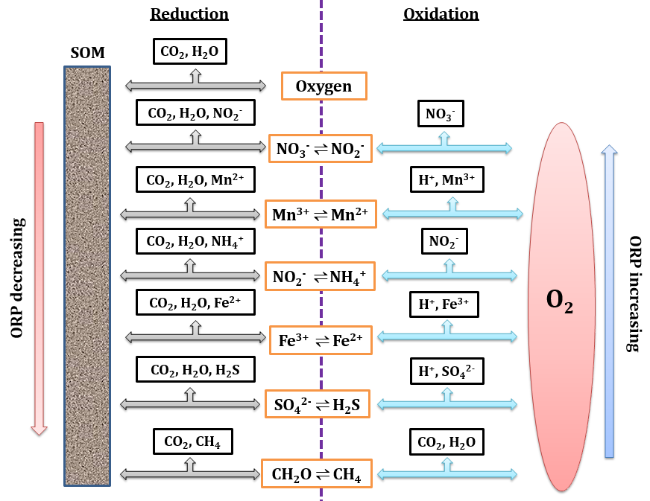
Figure S1: Chemical processes modelled in the new version of SWAT-MKT model

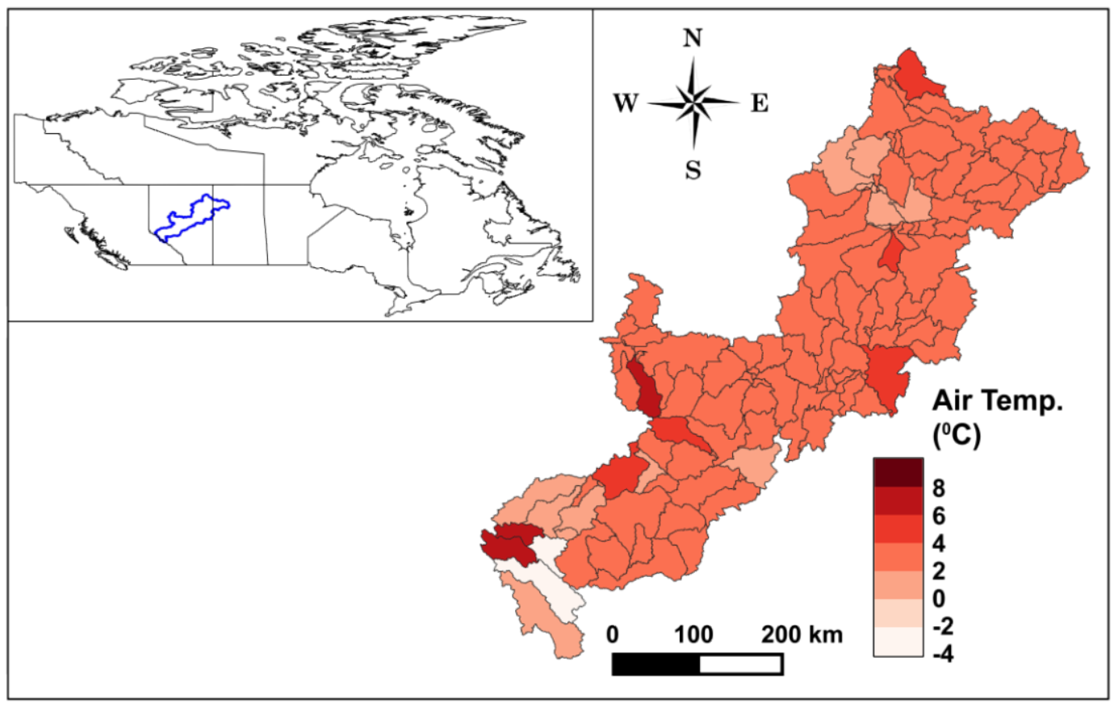
Figure S2: Mean annual air temperature at Athabasca River basin (ARB) in 2000-2013. Location of ARB within Canada is shown in inset.
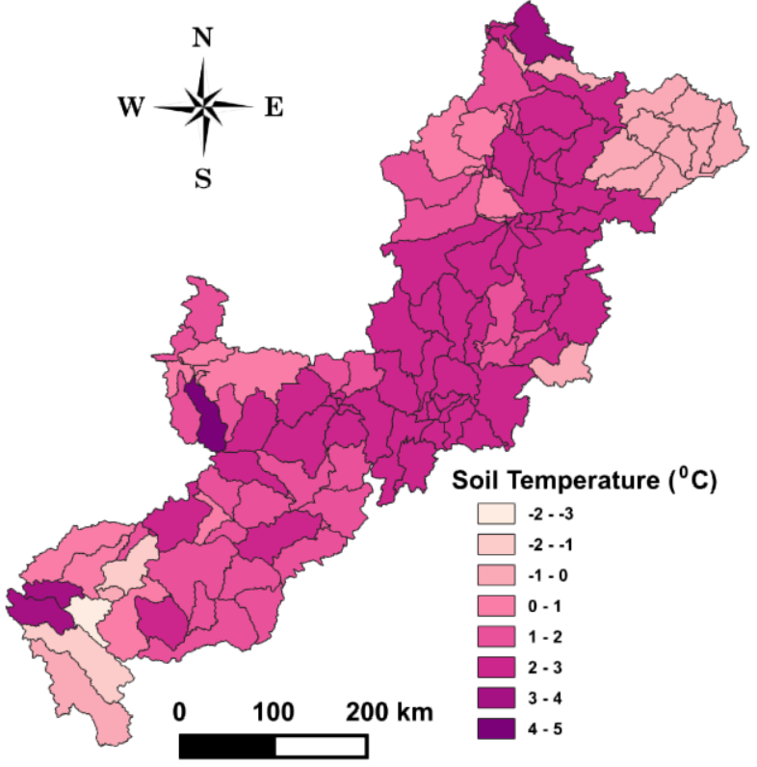
Figure S3: Mean annual soil temperature at Athabasca River basin (ARB) in 2000-2013
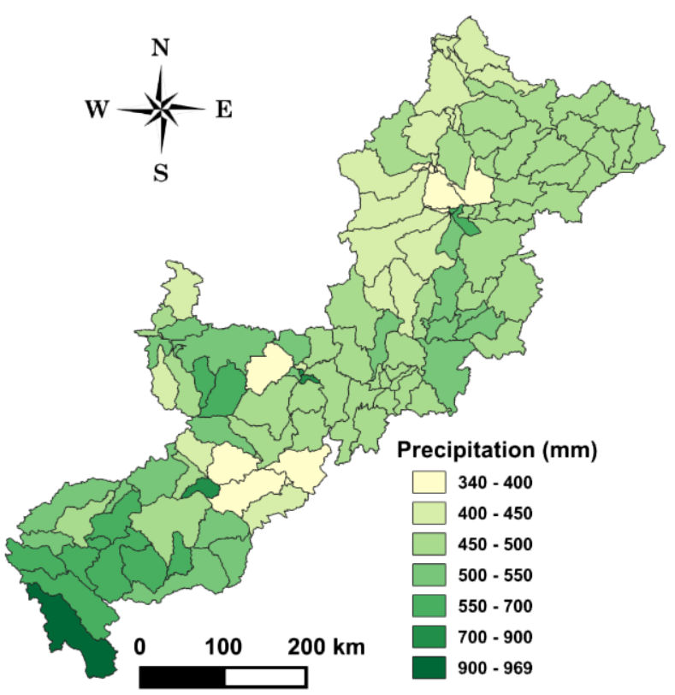
Figure S4: Mean annual precipitation at Athabasca River basin (ARB) in 2000-2013

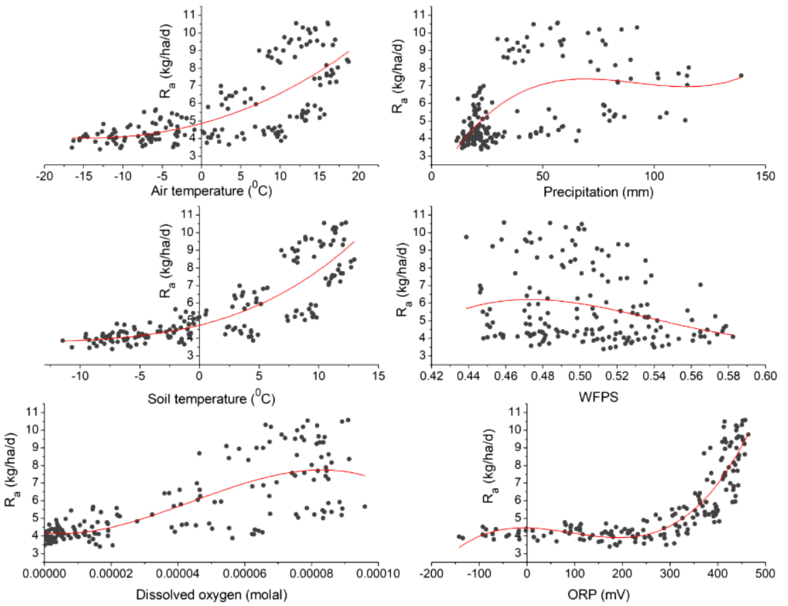
Figure S5: Basin averaged, monthly scatters of autotrophic respiration (R_{a}) and the environmental factors
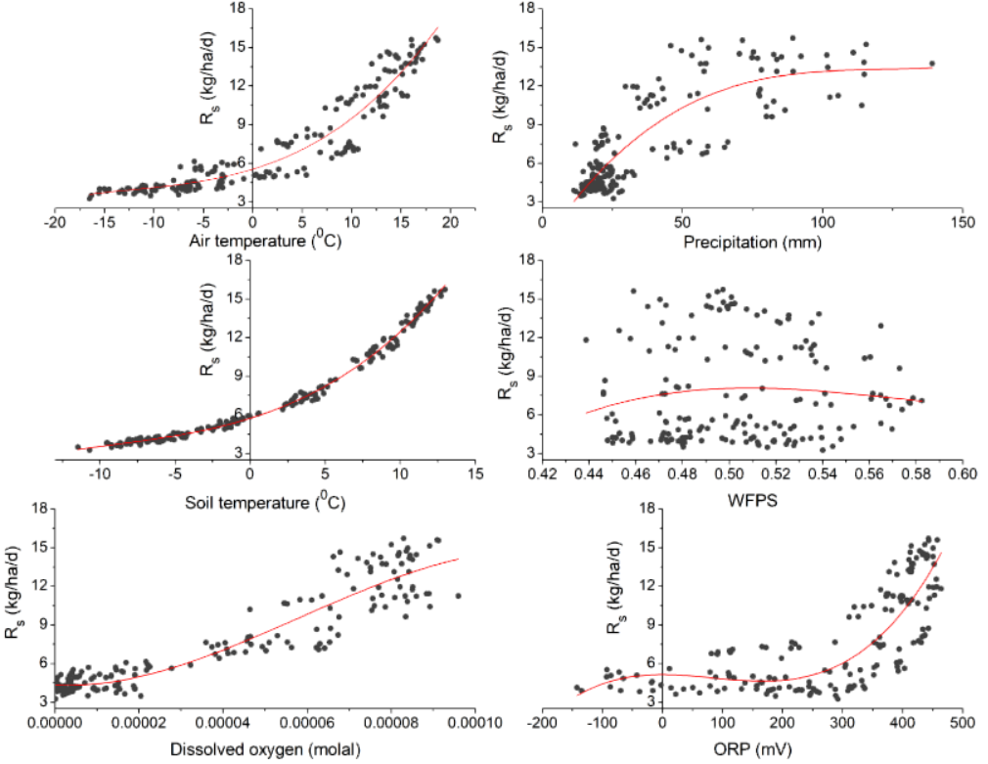
Figure S6: Basin averaged, monthly scatters of soil respiration (R_{s}) and the environmental factors

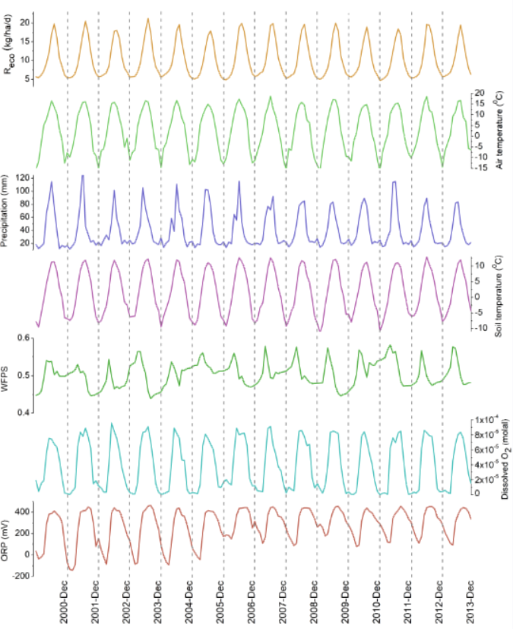
Figure S7: Time-series of basin averaged ecosystem respiration (R_{eco}), air temperature (AirT), precipitation, soil temperature, water filled pore space (WFPS), dissolved oxygen and oxidation reduction potential (ORP) for 168 months in 2000-2013

Table S1: Comparison between subbasin averaged, annual mean modelled R_{eco} (kg ha⁻¹ yr⁻¹) and the nighttime respiration data from Canadian boreal sites retrieved from FLUXNET2015 database (Pastorello et al., 2017)
Site location | Saskatchewan | Saskatchewan | Saskatchewan | Saskatchewan | Simulated data range
Site number | CA-SF1 | CA-SF3 | CA-OAS | CA-OBS
Latitude (⁰W) | 54.485 | 54.092 | 53.629 | 53.987
Longitude (⁰N) | 105.818 | 106.005 | 106.198 | 105.118
1996 |  |  | 9999 |  | 1308-8486*
1997 |  |  | 10620 |  | 1308-8486*
1998 |  |  | 10606 |  | 1308-8486*
1999 |  |  | 10181 | 8115 | 1308-8486*
2000 |  |  | 9398 | 7716 | 1726-7174
2001 |  |  | 9492 | 8005 | 1647-7766
2002 |  | 6617 | 8182 | 6978 | 1570-7559
2003 | 11201 | 4966 | 8769 | 7177 | 1720-7749
2004 | 8177 | 4193 | 8896 | 7332 | 1498-7452
2005 | 10680 | 6010 | 9855 | 8099 | 1472-7501
2006 | 12682 | 5207 | 11431 | 7616 | 1698-7997
2007 |  |  | 10652 | 8231 | 1694-7863
2008 |  |  | 10065 | 8674 | 1541-7874
2009 |  |  | 9837 | 9027 | 1550-7629
2010 |  |  | 10686 | 9546 | 1356-8210
*Range of values between 2000-2013
Table S2: Comparison between subbasin averaged, annual mean model simulated R_{s} data and the data from Canadian boreal, natural sites (only non manipulated sites are taken) retrieved from the SRDB database (Bond-Lamberty and Thomson, 2010)
Site location | Latitude (⁰W) | Longitude (⁰N) | Measurement year | R_{s}  (kg ha⁻¹ yr⁻¹) | Simulated data range  (kg ha⁻¹ yr⁻¹)
Manitoba | 55.910 | 98.520 | 2001 | 5400 | 1305-5102
Manitoba | 55.880 | 98.480 | 2001 | 3750 | 1305-5102
Manitoba | 55.910 | 98.510 | 2001 | 3380 | 1305-5102
Manitoba | 55.880 | 98.480 | 2001 | 3750 | 1305-5102
Quebec | 49.158 | 78.825 | 2007 | 10510 | 1342-5135
Quebec | 49.158 | 78.825 | 2007 | 14630 | 1342-5135
Quebec | 49.158 | 78.825 | 2007 | 13690 | 1342-5135
Quebec | 49.693 | 74.432 | 2005 | 7100 | 1204-5024
Saskatchewan | 53.990 | 105.120 | 1998 | 5640 | 1111-5464*
Saskatchewan | 53.990 | 105.120 | 1998 | 3190 | 1111-5464*
Saskatchewan | 53.990 | 105.120 | 1999 | 5920 | 1111-5464*
Saskatchewan | 53.920 | 104.690 | 1994 | 3380 | 1111-5464*
Saskatchewan | 53.630 | 106.200 | 1994 | 9050 | 1111-5464*
Saskatchewan | 53.990 | 105.120 | 1994 | 5640 | 1111-5464*
Saskatchewan | 53.630 | 106.200 | 1994 | 9050 | 1111-5464*
Saskatchewan | 53.920 | 104.690 | 1999 | 3200 | 1111-5464*
Saskatchewan | 54.000 | 105.100 | 2004 | 6110 | 1200-5464
*Range of values between 2000-2013
Table S3: Major reoxygenation reactions, standard redox potentials (mV) at pH = 7 and T = 25⁰ C (following Bratsch, 1989; Stumm and Morgan, 1996; Kirk, 2004; Reddy and DeLaune, 2008) and the electrons transferred. Other major chemical reactions used in SWAT-MKT model can be obtained from Bhanja et al. (2019a; 2019b) and Bhanja and Wang (2020)
Reactions | E⁰  mV | E⁰ total  mV | Electrons transferred
$$2O_{2 }\left(g\right)+{8H}^{+}\left(aq\right)+{8e}^{-}⇌ 4H_{2}O\left(l\right)$$  $${CH}_{4} (g)+2H_{2}O\left(l\right) ⇌{CO}_{2} (g)+{8H}^{+}\left(aq\right)+{8e}^{-}$$  $${CH}_{4} \left(g\right)+ {2O}_{2}\left(g\right)⇌ {CO}_{2} \left(g\right)+2H_{2}O\left(l\right)$$ | 810  -(-250) | 1060 | 8
$$2O_{2 }\left(g\right)+{8H}^{+}\left(aq\right)+{8e}^{-}⇌ 4H_{2}O\left(l\right)$$  $$H_{2}S (g)+4H_{2}O\left(l\right) ⇌{{SO}_{4}}^{2-} (aq)+{10H}^{+}\left(aq\right)+{8e}^{-}$$  $$H_{2}S (g)+ {2O}_{2}\left(g\right)⇌ {{SO}_{4}}^{2-} (aq)+{2H}^{+}\left(aq\right)$$ | 810  -(-80) | 890 | 8
$$O_{2 }\left(g\right)+{4H}^{+}\left(aq\right)+{4e}^{-}⇌ 2H_{2}O\left(l\right)$$  $${4Fe}^{2+}\left(aq\right)+12H_{2}O\left(l\right) ⇌ {4Fe(OH)}_{3} \left(aq\right) +{12H}^{+}\left(aq\right)+{4e}^{-}$$  $${4Fe}^{2+}\left(aq\right)+10H_{2}O\left(l\right)+ O_{2}\left(g\right)⇌ {4Fe(OH)}_{3} \left(aq\right) +{8H}^{+}\left(aq\right)$$ | 810  -(380) | 430 | 4
$${3O}_{2 }\left(g\right)+{12H}^{+}\left(aq\right)+{12e}^{-}⇌ 6H_{2}O\left(l\right)$$  $${{2NH_{4}^{+}\left(aq\right)+4H_{2}O\left(l\right) ⇌ 2NO}_{2}}^{-}\left(aq\right)+{16H}^{+}\left(aq\right)+{12e}^{-}$$  $$2NH_{4}^{+}\left(aq\right)+{3O}_{2 }\left(g\right)⇌ {{2NO}_{2}}^{-}\left(aq\right)+{4H}^{+}\left(aq\right)+2H_{2}O\left(l\right)$$ | 810  -(470) | 340 | 12
$$O_{2 }\left(g\right)+{4H}^{+}\left(aq\right)+{4e}^{-}⇌ 2H_{2}O\left(l\right)$$  $${{2NO}_{2}}^{-}\left(aq\right)+2H_{2}O\left(l\right)⇌ {{2NO}_{3}}^{-}\left(aq\right)+{4H}^{+}\left(aq\right)+{4e}^{-}$$  $${{{2NO}_{2}}^{-}\left(aq\right)+ O}_{2 }\left(g\right)⇌ {{2NO}_{3}}^{-}\left(aq\right)$$ | 810  -(410) | 400 | 4
$$O_{2 }\left(g\right)+{4H}^{+}\left(aq\right)+{4e}^{-}⇌ 2H_{2}O\left(l\right)$$  $${2Mn}^{2+}\left(aq\right)+4H_{2}O\left(l\right) ⇌ {2MnO}_{2} \left(aq\right) +{8H}^{+}\left(aq\right)+{4e}^{-}$$  $${2Mn}^{2+}\left(aq\right)+2H_{2}O\left(l\right)+ O_{2}\left(g\right)⇌ {2MnO}_{2} \left(aq\right) +{4H}^{+}\left(aq\right)$$ | 810  -(870) | -60 | 4

Table S4: Reaction quotients (Q) for the oxidizing reactions
S. N. | Reaction name | Reaction quotients (Q)
1. | Methane oxidation | $$\frac{{pCO}_{2} }{{pCH}_{4} . {pO_{2}}^{2}}$$
2. | Sulphide oxidation | $$\frac{\left[{{SO}_{4}}^{2-}\right] . {[H^{+}]}^{2} }{{{pO}_{2}}^{2} . [H_{2}S] } × \frac{[γ_{{{SO}_{4}}^{2-}}] }{1}$$
3. | Iron oxidation | $$\frac{ {\left[{Fe(OH)}_{3}\right]}^{4}}{{pO}_{2} .{[{Fe}^{2+}]}^{4} . {[H^{+}]}^{4}} × \frac{1 }{{[γ_{{Fe}^{2+}}]}^{4}}$$
4. | Ammonium oxidation | $$\frac{{[{{NO}_{2}}^{-}]}^{2}. {[H^{+}]}^{4} }{{\left[{{NH}_{4}}^{+}\right]}^{2}. {pO_{2}}^{3}} × \frac{{[γ_{{{NO}_{2}}^{-}}]}^{2} }{{[γ_{{{NH}_{4}}^{+}}]}^{2}}$$
5. | Nitrite oxidation | $$\frac{ {[{{NO}_{3}}^{-}]}^{2}}{{pO}_{2} . {[{{NO}_{2}}^{-}]}^{2} } × \frac{{[γ_{{{NO}_{3}}^{-}}]}^{2} }{{[γ_{{{NO}_{2}}^{-}}]}^{2}}$$

References:
Amadi, C.C., Van Rees, K.C.J., Farrell, R.E., 2016. Soil–atmosphere exchange of carbon dioxide, methane and nitrous oxide in shelterbelts compared with adjacent cropped fields. Agric. Ecosyst. Environ. 223, 123–134.
Arnold, J.G., Kiniry, J.R., Srinivasan, R., Williams, J.R., Haney, E.B. and Neitsch, S.L., 2013. SWAT 2012 input/output documentation. Texas Water Resources Institute.
Bond-Lamberty, B., and A.M. Thomson. 2010. A global database of soil respiration measurements. Biogeosciences. 7:1321-1344. https://doi.org/10.5194/bgd-7-1321-2010.
CFSR, 2016. In: Global Weather Data for SWAT (Ed.), Climate Forecast System Reanalysis http://globalweather.tamu.edu/.
GoC, 2016. Environment and Natural Resources; Weather, Climate and Hazard. http://climate.weather.gc.ca/, G.o.C.
Frank, R.A., Roy, J.W., Bickerton, G., Rowland, S.J., Headley, J.V., Scarlett, A.G., West, C.E., Peru, K.M., Parrott, J.L., Conly, F.M. and Hewitt, L.M., 2014. Profiling oil sands mixtures from industrial developments and natural groundwaters for source identification. Environmental science & technology, 48(5), 2660-2670.
Jarvis, A., Reuter, H.I., Nelson, A., Guevara, E., 2008. Hole-filled SRTM for the Globe Version 4, Available from the CGIAR-CSI SRTM90m Database. CGIAR http://srtm.csi.cgiar.org.
Loveland, T.R., Reed, B.C., Brown, J.F., Ohlen, D.O., Zhu, Z., Yang, L.W.M.J. and Merchant, J.W., 2000. Development of a global land cover characteristics database and IGBP DISCover from 1 km AVHRR data. International Journal of Remote Sensing, 21(6-7), 1303-1330.
Mukherjee, A. and Fryar, A.E., 2008. Deeper groundwater chemistry and geochemical modeling of the arsenic affected western Bengal basin, West Bengal, India. Applied Geochemistry, 23(4), 863-894.
Pastorello, G., Papale, D., Chu, H., Trotta, C., Agarwal, D., Canfora, E., Baldocchi, D. and Torn, M., 2017. A new data set to keep a sharper eye on land-air exchanges. Eos, Transactions American Geophysical Union (Online), 98(8).
RAMP (Regional Aquatics Monitoring Program) database: http://www.ramp-alberta.org/data/Water/waterquality/default.aspx accessed on September 7, 2017.
Reddy, K.R. and DeLaune, R.D., 2008. Biogeochemistry of wetlands: science and applications. CRC press.
Shrestha, N.K., Du, X. and Wang, J., 2017. Assessing climate change impacts on fresh water resources of the Athabasca River Basin, Canada. Science of the Total Environment, 601, 425-440.
SLC, 2010. In: Agriculture and Agri-Food Canada (Ed.), Soil Landscapes of Canada Version 3.2 http://sis.agr.gc.ca/cansis/nsdb/slc/v3.2/index.html.

