Performance of high resolution (400 m) PM_{2.5} forecast over Delhi

Chinmay Jena^{1*}, Sachin D. Ghude^{1*}, Rajesh Kumar², Sreyashi Debnath^{1,3}, Gaurav Govardhan^{1,7} , Vijay K. Soni⁴, Santosh H. Kulkarni⁵, G. Beig¹, Ravi S. Nanjundiah^{1,6}, M. Rajeevan⁸

¹Indian Institute of Tropical Meteorology, Ministry of Earth Sciences, India
²National Center for Atmospheric Research, Boulder, CO, 80301, USA
³Dept. of Atmospheric and Space sciences, Savitribai Phule Pune University, Pune, India
⁴India Meteorological Department, New Delhi, Ministry of Earth Sciences, India
⁵Centre for Development of Advanced Computing, Pune 411 008, India
⁶Centre for Atmospheric and Oceanic Sciences, Indian Institute of Science, Bengaluru 560 012, India
⁷National Center for Medium Range Weather Forecasting, Ministry of Earth Sciences, Noida, UP, India
⁸Ministry of Earth Sciences, Prithvi Bhavan, Lodhi Road, New Delhi 110003, India

*email: chinmayjena@tropmet.res.in and sachinghude@tropmet.res.in

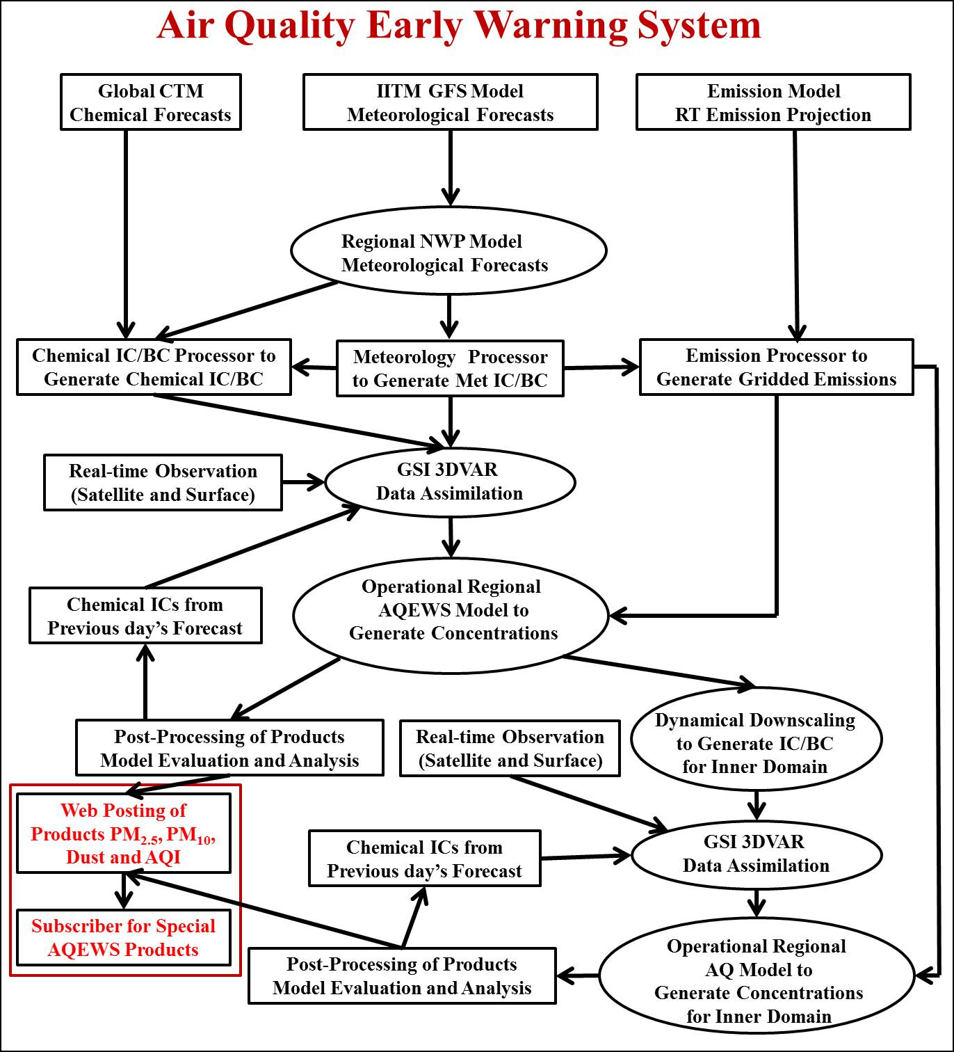

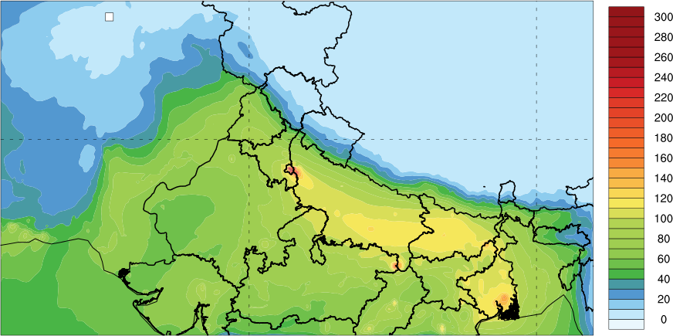
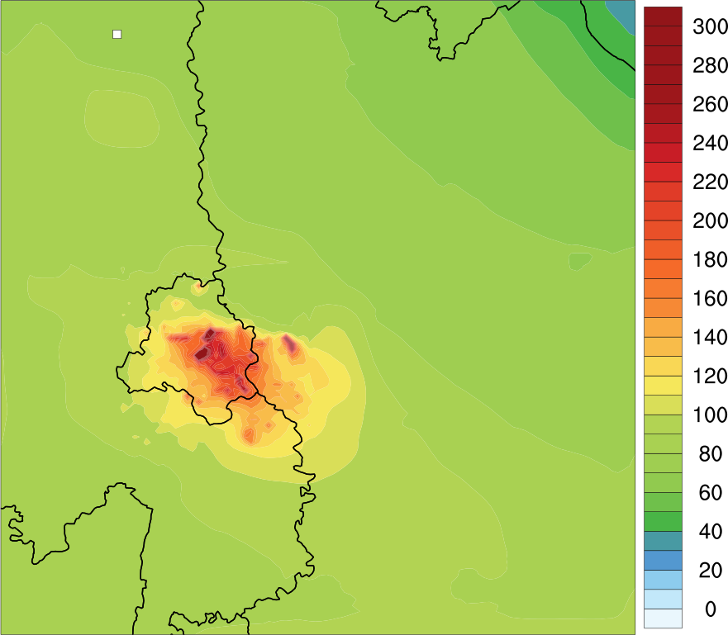
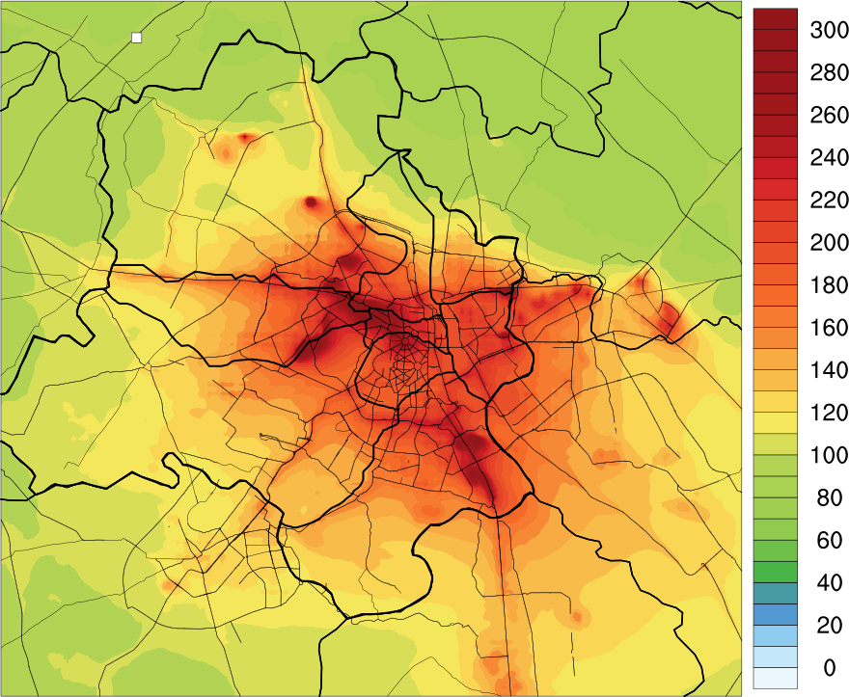
D1
D2
D3

Figure S1: Architecture of the very-high resolution air quality early warning system.

D1
D2
D3

Figure S2: Map of model simulation domain (D1: 10 km horizontal grid spacing, D2: 2 km horizontal grid spacing and D3: 400 meter horizontal grid spacing). We have used ncl/6.6.2 software to create the images (https://www.ncl.ucar.edu/).

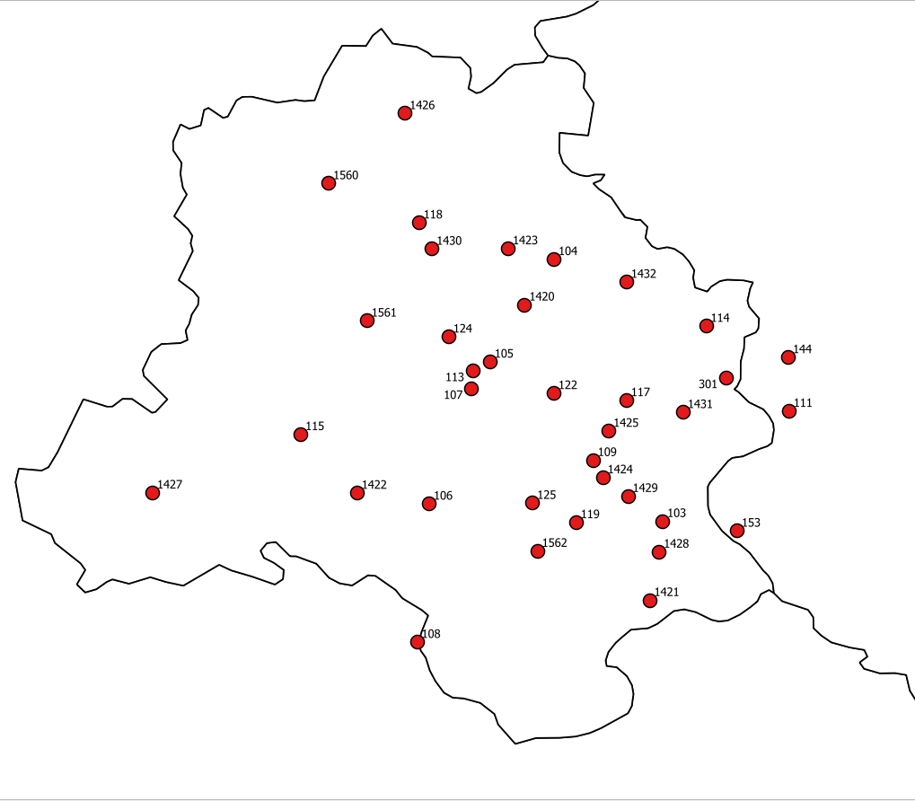

Figure S3: Geographical locations of 37 air quality monitoring stations (stations names associated with the numbers are provided in Table ST2)

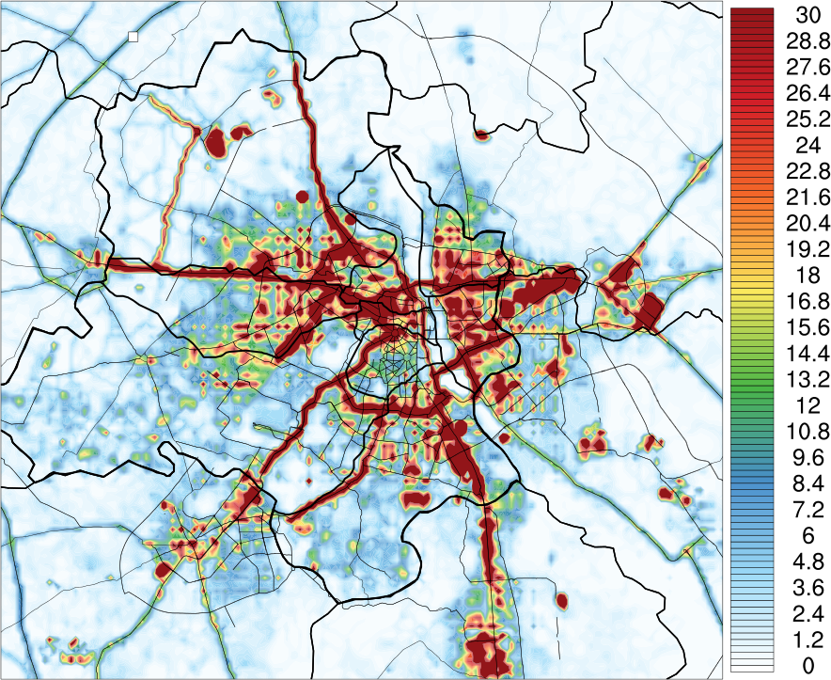

Figure S4: Spatial distribution of High-resolution Delhi Emission Inventory (HrDEI) of PM_{2.5} anthropogenic emissions (unit: 10¹⁰ kg/m²/s) at 400 m horizontal resolution. We have used ncl/6.6.2 software to create the image (https://www.ncl.ucar.edu/).

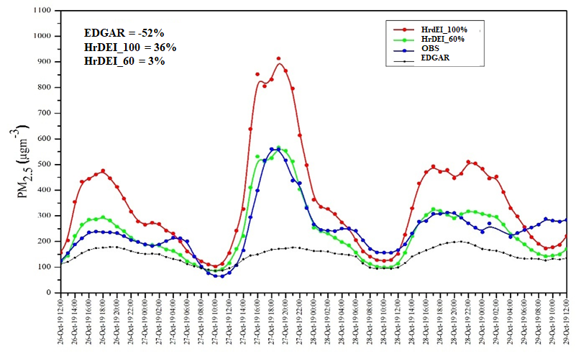

Figure S5: Sensitivity simulations for different emission inventory over Delhi.
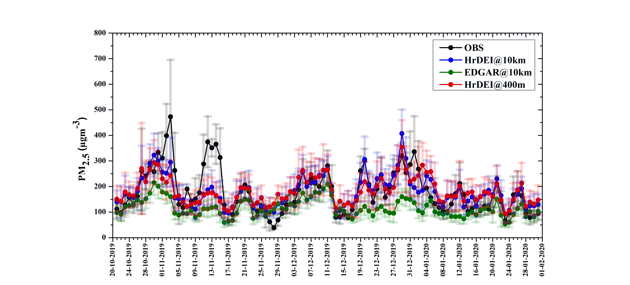

Figure S6: Time-series of daily surface-level PM_{2.5} concentrations from a) observations (black line) (average of 37 stations across Delhi) b) model simulations with EDGAR emissions inventory and with 10 km x 10 km grid-spacing (green line) c) model simulations with High-resolution Delhi Emission Inventory (HrDEI) and with 10 km x 10 km grid-spacing (blue line) and d) model simulations with HrDEI emissions’ inventory and with 400 m x 400 m grid-spacing (red line) of 1st day forecast.

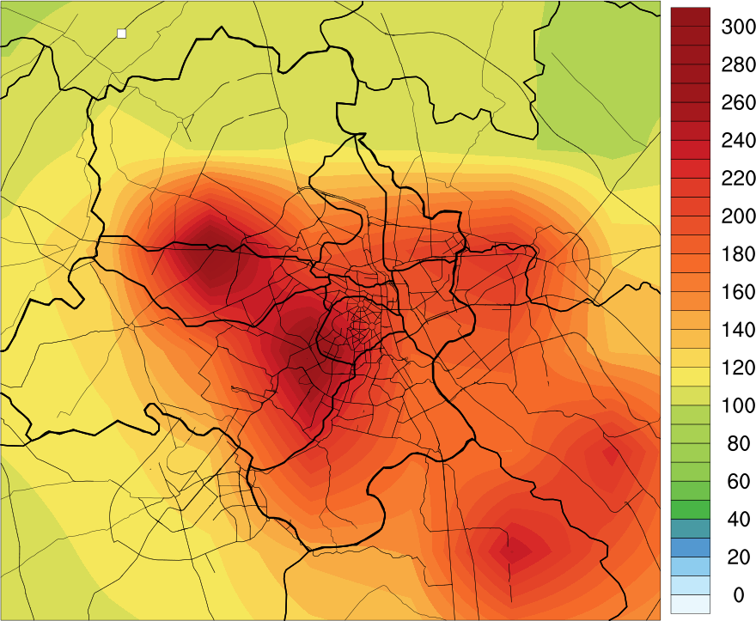
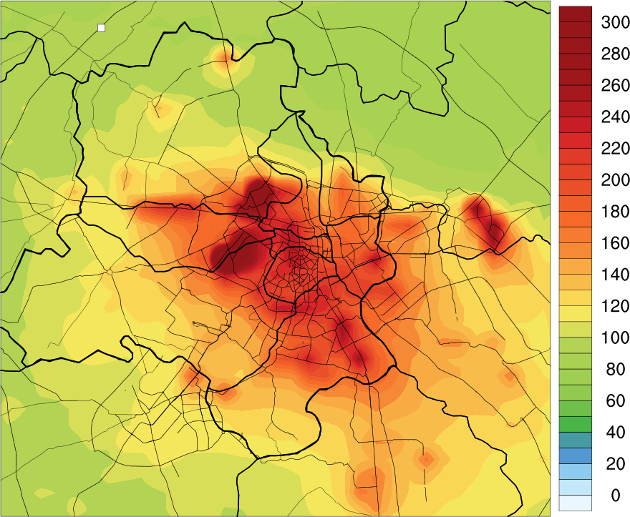
10KM
2KM

Figure S7: Spatial distribution of average PM_{2.5} of 1st day forecast for 400 meter grid spacing during 21 October 2019 to 01 February 2020 at 10 km grid spacing (left) and 2 Km Horizontal grid spacing (right). We have used ncl/6.6.2 software to create the images (https://www.ncl.ucar.edu/).

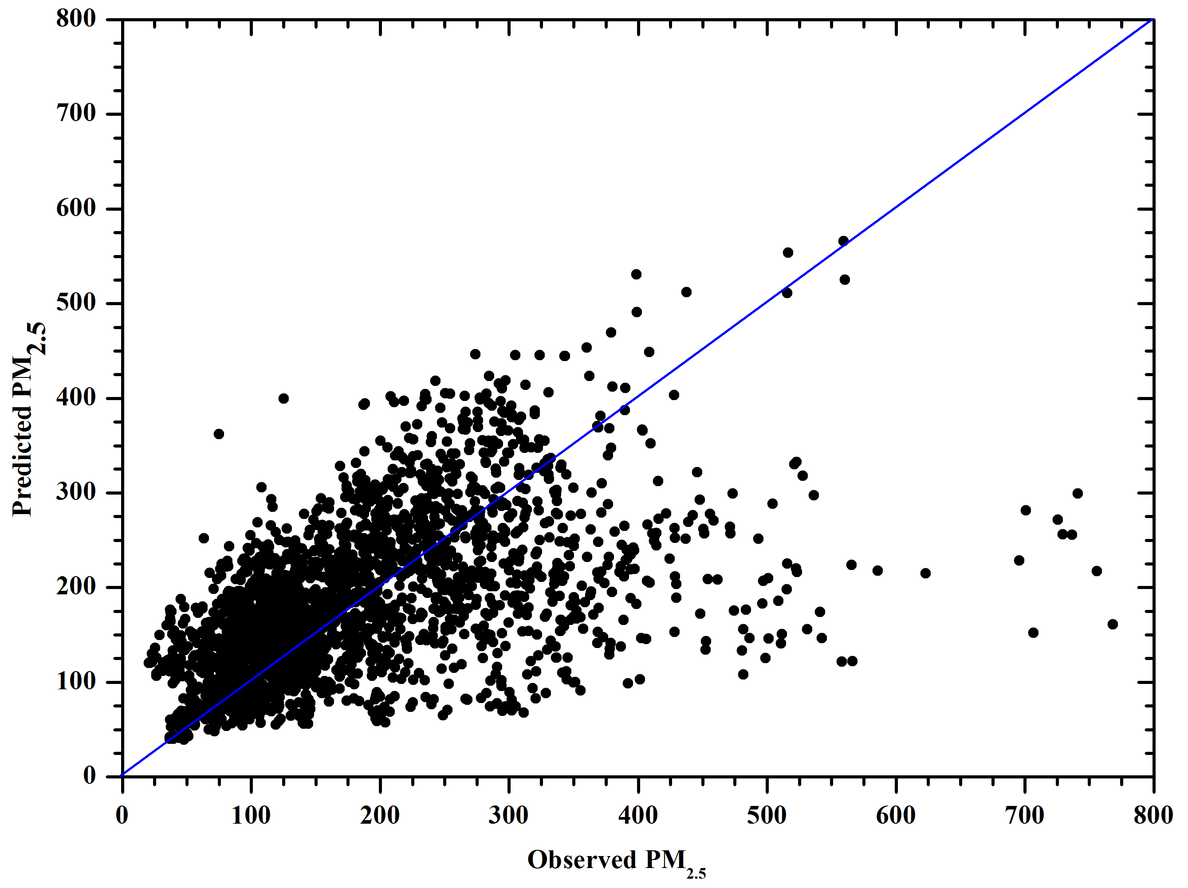

Figure S8: Correlation between hourly mean observed and predicted PM_{2.5} in Delhi.

Table ST1: Selected atmospheric physical and chemical parameterizations

Atmospheric Process | Parameterization
Cloud Microphysics | WRF Single-Moment 6-class scheme (WSM6)¹
Short- and Long-wave radiation | Rapid Radiative Transfer Model for GCMs²
Surface Layer | Monin-Obukhov (Janjic Eta)Scheme^{3,4}
Land Surface model | Unified Noah Land-surface model⁵
Planetary Boundary Layer | MYNN2.5⁶
Cumulus | Grell-Freitas ensemble scheme⁷
Gas-phase Chemistry | Model for Ozone and Related Tracers⁸
Aerosol Processes | Goddard Global Ozone Chemistry Aerosol Radiation and Transport (GOCART)⁹

Table ST2: Performance statistics for mean PM2.5 forecast for different emission inventory and different grid spacing of 1st day forecast over Delhi.

State  Variables | Emission Variables | MB | NMFB (%) | NMFE (%) | r
PM25_hourly | EDGAR@10km | -63.1 | -42.6 | 51.1 | 0.5
PM25_hourly | HrDEI@10km | -0.3 | -0.2 | 33.1 | 0.6
PM25_hourly | HrDEI@400m | 2.5 | 1.3 | 36.3 | 0.5
PM25_daily | EDGAR@10km | -64.9 | -43.8 | 47.8 | 0.5
PM25_daily | HrDEI@10km | -1.0 | -0.5 | 23.2 | 0.7
PM25_daily | HrDEI@400m | 1.8 | 1.0 | 25.6 | 0.6

Table ST3: Performance statistics for simulated PM_{2.5} at different monitoring sites in Delhi during 21 October 2019 to 01 February 2020 at 400 m horizontal grid-spacing.
State | Station name | Latitude | Longitude | MB | NMB (%) | RMSE | R
Delhi | CRRI Mathura Road (103) | 28.5512005 | 77.2735737 | 158.7 | 87.6 | 249.9 | 0.4
Delhi | Burari Crossing (104) | 28.7256504 | 77.2011573 | -60.2 | -31.0 | 149.5 | 0.3
Delhi | North Campus DU (105) | 28.6573814 | 77.1585447 | 68.4 | 40.8 | 181.6 | 0.3
Delhi | IGI-Airport-T3 (106) | 28.5627763 | 77.1180053 | -12.6 | -8.1 | 106.0 | 0.4
Delhi | Pusa IMD (107) | 28.639645 | 77.146262 | 115.2 | 83.4 | 208.1 | 0.3
Delhi | DTU (118) | 28.7500499 | 77.1112615 | -95.6 | - 45.6 | 161.2 | 0.3
Delhi | R K Puram (124) | 28.674045 | 77.131023 | 59.4 | 37.2 | 154.0 | 0.4
Delhi | Shadipur (113) | 28.6514781 | 77.1473105 | 104.4 | 65.5 | 177.0 | 0.6
Delhi | NSIT Dwarka (115) | 28.60909 | 77.0325413 | -36.1 | - 20.7 | 92.4 | 0.5
Delhi | Mandir Marg (122) | 28.636429 | 77.201067 | 52.2 | 29.1 | 174.3 | 0.2
Delhi | Punjabi Bagh (125) | 28.563262 | 77.186937 | -0.5 | - 0.2 | 122.1 | 0.5
Delhi | Sirifort (119) | 28.5504249 | 77.2159377 | -12.4 | - 6.3 | 120.4 | 0.4
Delhi | Lodhi Road (109) | 28.5918245 | 77.2273074 | 34.4 | 23.3 | 127.8 | 0.3
Delhi | ITO (117) | 28.6316945 | 77.2494387 | 20.0 | 10.7 | 144.4 | 0.3
Delhi | Anand Vihar (301) | 28.646835 | 77.316032 | -52.3 | - 25.0 | 145.2 | 0.5
Delhi | Sector – 62 (111) | 28.6245479 | 77.3577104 | -33.5 | -17.3 | 133.8 | 0.3
Delhi | IHBAS-Dilshad-Garden (114) | 28.6811736 | 77.3025234 | 13.3 | 8.5 | 118.5 | 0.4
Delhi | Aya Nagar (108) | 28.4706914 | 77.1099364 | -23.8 | -15.7 | 110.8 | 0.4
Delhi | Vasundhara (144) | 28.6603346 | 77.3572563 | -31.5 | - 14.0 | 140.5 | 0.4
Delhi | Sector 125 (153) | 28.5447608 | 77.3231257 | -14.9 | - 7.5 | 140.9 | 0.3
Delhi | Ashok_Vihar (1420) | 28.695381 | 77.181665 | 26.1 | 24.3 | 79.0 | 0.2
Delhi | DKSS_Stadium (1421) | 28.498571 | 77.264840 | -48.0 | - 24.5 | 137.8 | 0.3
Delhi | Dwarka Sector8 (1422) | 28.57 | 77.07
Delhi | Jahangirpuri (1423) | 28.732820 | 77.170633 | -81.1 | - 35.9 | 151.5 | 0.3
Delhi | Jawaharlal Nehru Stadium (1424) | 28.580280 | 77.233829 | 3.0 | 1.5 | 116.8 | 0.5
Delhi | MDC National Stadium (1425) | 28.611281 | 77.237738 | 32.7 | 19.2 | 140.0 | 0.3
Delhi | Najafgarh (1427) | 28.570173 | 76.933762 | 46.1 | 85.3 | 59.3 | 0.1
Delhi | Narela (1426) | 28.822836 | 77.101981 | -49.4 | - 38.8 | 66.8 | 0.1
Delhi | Nehru Nagar (1429) | 28.567890 | 77.250515 | -9.2 | - 3.8 | 145.3 | 0.5
Delhi | Okhla Phase2 (1428) | 28.530785 | 77.271255 | 17.4 | 14.7 | 77.6 | 0.2
Delhi | Patparganj (1431) | 28.623748 | 77.287205 | 28.7 | 16.0 | 122.5 | 0.4
Delhi | Rohini (1430) | 28.732528 | 77.119920 | -88.6 | - 39.1 | 163.0 | 0.4
Delhi | Sonia Vihar (1432) | 28.710508 | 77.249485 | -44.6 | - 25.8 | 114.3 | 0.3
Delhi | Sri_Aurbindo_Marg (1562) | 28.531346 | 77.190156 | 2.6 | 3.1 | 53.5 | 0.1
Delhi | Mundak (1561) | 28.684678 | 77.076574 | 19.0 | 18.8 | 50.8 | 0.6
Delhi | New_collectorate (1569) | 28.974801 | 77.213357 | -83.3 | - 46.4 | 142.2 | 0.4
Delhi | New_mandi (1550) | 29.4723508 | 77.7194031 | -65.0 | - 44.9 | 109.6 | 0.4
Delhi | Bawana (1560) | 28.776200 | 77.051074 | -92.6 | - 41.9 | 163.4 | 0.4

Table ST4: Model performance goals used to evaluate the model performance for PM_{2.5} (Morris et al., 2005)
Fractional Bias | Fractional Error | Comment
≤ ± 15% | ≤ 35% | A level of model performance that would be considered excellent
≤ ± 30% | ≤ 50% | A level of model performance that would be considered good
≤ ± 60% | ≤ 75% | A level of model performance that would be considered average and hope each PM species could meet for regulatory modeling
> ± 60% | > 75% | At or exceeding this level of performance indicates fundamental problems with the modeling system

Table ST5: AQI category and corresponding break-point concentrations ranges for PM_{2.5} based on National Ambient Air Quality Standard (NAAQS).
AQI Category | AQI | PM_{2.5}  Concentration range
Good | 0 - 50 | 0 - 30
Satisfactory | 51 - 100 | 31 - 60
Moderately | 100 - 200 | 61 - 90
Poor | 201 - 300 | 91 - 120
Very poor | 301 - 400 | 121 - 250
Severe | 401 + | 250+

State | PM₂₅ AQI  Category | Variables | 10km |  |  | 2km |  |  | 400 meter
State | PM₂₅ AQI  Category | Variables | MB | NMFB (%) | NMFE (%) | MB | NMFB (%) | NMFE (%) | MB | NMFB (%) | NMFE (%)
Delhi | Poor  (201-300) | 1st day | 51.1 | 18.4 | 19.3 | 66.2 | 23.2 | 23.3 | 62.9 | 22.1 | 22.3
Delhi | Poor  (201-300) | 2nd day | 30.4 | 11.4 | 20.8 | 56.1 | 20.0 | 22.6 | 53.6 | 19.2 | 22.2
Delhi | Poor  (201-300) | 3rd day | 16.3 | 6.2 | 23.2 | 42.4 | 15.4 | 20.9 | 44.6 | 16.2 | 20.2
Delhi | Very Poor  (301-400) | 1st day | 4.2 | 1.2 | 6.4 | 12.3 | 3.5 | 7.4 | 8.2 | 2.3 | 6.8
Delhi | Very Poor  (301-400) | 2nd day | -17.7 | -5.3 | 9.1 | 0.2 | 0.1 | 6.7 | -2.7 | -0.8 | 6.9
Delhi | Very Poor  (301-400) | 3rd day | -27.5 | -8.3 | 11.4 | -13.7 | -4.0 | 8.9 | -13.4 | -3.9 | 8.7
Delhi | Severe  (401-above) | 1st day | -47.1 | -11.1 | 15.6 | -55.5 | -13.3 | 16.2 | -58.0 | -13.9 | 16.3
Delhi | Severe  (401-above) | 2nd day | -89.0 | -22.1 | 22.2 | -70.2 | -17.1 | 17.5 | -70.8 | -17.2 | 17.8
Delhi | Severe  (401-above) | 3rd day | -105.0 | -26.7 | 26.7 | -86.2 | -21.4 | 21.8 | -83.6 | -20.7 | 20.9

Table ST6: Performance statistics of different PM_{2.5} AQI forecast category

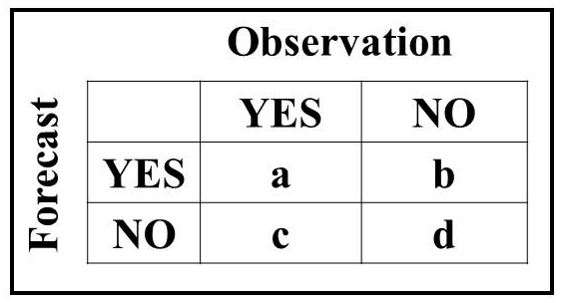
Table ST7: A contingency table and equations used to calculate the different skill score for different category of AQI forecast.

Statistic name | What it measures | Equation | unit | How to interpret
Accuracy (A) | Percent of forecasts that correctly predicted the event or non-event. | A=(a+d)/(a+b+c+d) *100 | % | Higher numbers are better
False Alarm Rate (FAR) | The percent of times a forecast of high pollution did not actually occur. | FAR = (b/(a+b)) *100 | % | Smaller values are best
Probability of Detection  (POD) or Hit rate | Ability to predict high pollution events (i.e., the percentage of forecasted high pollution events that actually occurred). | POD = (a/(a+c)) * 100 | % | Higher numbers are best
Critical Success Index  (CSI), also called Threat  Score | How well the high-pollution events were predicted. Useful for evaluating rarer events like high-pollution days. It is not affected by a large number of correctly forecasted, low pollution events. | CSI = (a/(a+b+c)) * 100 | % | Higher numbers are best

Reference:
- Hong, S.-Y. and Lim, J.-O. J. 2006. The WRF single-moment 6-class microphysics scheme (WSM6). J. Kor. Meteorol. Soc. 42, 129-151.
- Iacono M.J., J.S. Delamere, E.J. Mlawer, M.W. Shephard, S.A. Clough, and W. Collins, Radiative forcing by long-lived greenhouse gases: Calculations with the AER radiate transfer models, J. Geophys. Res., 113, D13103, doi:10.1029/2008JD009944, 2008.
- Janjic, Z. I., 1996: The surface layer in the NCEP Eta Model, Eleventh Conference on Numerical Weather Prediction, Norfolk, VA, 19–23 August;Amer. Meteor. Soc., Boston, MA, 354–355.
- Janjic, Z. I., 2002: Nonsingular Implementation of the Mellor–Yamada Level 2.5 Scheme in the NCEP Meso model, NCEP Office Note, No. 437, 61.
- Tewari, M., Chen, F., Wang, W., Dudhia, J., Lemone, M. A., Mitchell, K. E. (2004). Implementation and verification of the unified Noah land-surface model in the WRF model [presentation]. In 20th Conference on Weather Analysis and Forecasting/16th Conference on Numerical Weather Prediction. American Meteorological Society: Seattle, WA, US.
- Nakanishi, M., and H. Niino, 2006: An improved Mellor–Yamada level-3 model: Its numerical stability and application to a regional prediction of advection fog. Bound. Layer Meteor., 119, 397–407.
- Grell, G. A., & Freitas, S. R. (2014). A scale and aerosol aware stochastic convective parameterization for weather and air quality modelling, Atmospheric Chemistry and Physics, 14, 5233–5250. https://doi.org/10.5194/acp-14-5233-2014
- Emmons, L. K., Walters, S., Hess, P. G., Lamarque, J.-F., Pfister, G. G., Fillmore, D., Granier, C., Guenther, A., Kinnison, D., Laepple, T., Orlando, J., Tie, X., Tyndall, G., Wiedinmyer, C., Baughcum, S. L., and Kloster, S.: Description and evaluation of the Model for Ozone and Related chemical Tracers, version 4 (MOZART-4), Geosci. Model Dev., 3, 43–67, 2010.
- Chin, M., Savoie, D. L., Huebert, B. J., Bandy, A. R., Thornton, D. C., Bates, T. S., Quinn, P. K., Saltzman, E. S., and De Bruyn, W. J.: Atmospheric sulfur cycle simulated in the global model GOCART: Comparison with field observations and regional budgets, J. Geophys. Res.-Atmos., 105, 24689–24712, https://doi.org/10.1029/2000JD900385, 2000.

