Supporting Information
High-sensitivity detection of H₂S by In₂O₃/C composite prepared by inert-ambient sealed-tube pyrolysis
M. Srinidhi Raghavan^{1,2} and S.A. Shivashankar ¹
¹ Centre for Nano Science and Engineering, Indian Institute of Science, Bengaluru-560012, India
² Department of Chemistry, BMS College of Engineering, Bengaluru-560004
*E-mail: rsrinidhi@iisc.ac.in
- Supporting Information Fig.S1
Figure.S1 is a schematic representation of the molecular structure of Indium acetylacetonate, In(acac)₃, used as the precursor material in the STP process, with M=In
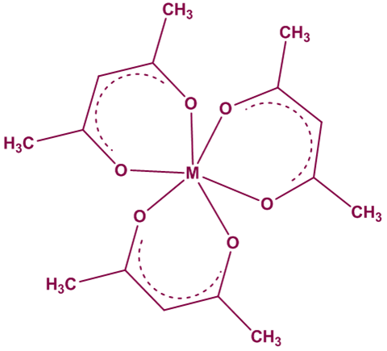

Fig.S1 Molecular structure of indium acetylacetonate
- Supporting Information Fig.S2
The FTIR spectrum of the complex In(acac)₃, embedded in KBR pellet, was recorded in the range of 400 – 4000 cm⁻¹. The complex clearly displays the presence of bands in the chelate carbonyl and M-O regions, indicating the formation of the MO (metal-organic) complex, in this case the acetylaetonate of indium. Peaks corresponding to In(acac)₃ are observed at 455 cm⁻¹ and at 570, 774, 802, 1020 cm⁻¹. By comparing the spectrum with one in the literature, the formation of indium acetylacetonate is confirmed.
Ref. www.sigmaaldrich.com/spectra/ftir/FTIR008202.PDF
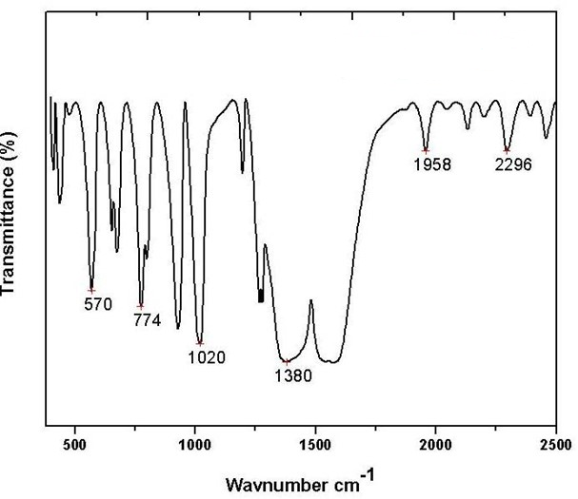

Fig.S2 FTIR Spectrum of In(acac)₃
- Supporting Information Fig. S3:

Electrical characterization of the In₂O₃/C pellet.

Figure S3 shows the variation of electrical resistance of the In₂O₃/C pellet with temperature, in the range of 50–200°C. The data show that the material is semiconducting.
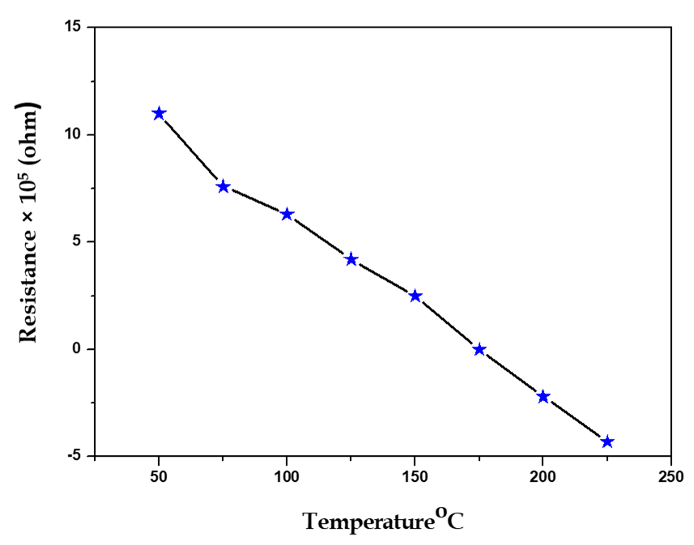

Fig S3 Resistance vs. temperature characteristics of In₂O₃/C

- Supporting Information Fig. S4:
Linear regression equations, regression coefficients and relative standard deviations for Figure 7(B), Figure 8(B) and Figure 9. S = standard deviation.
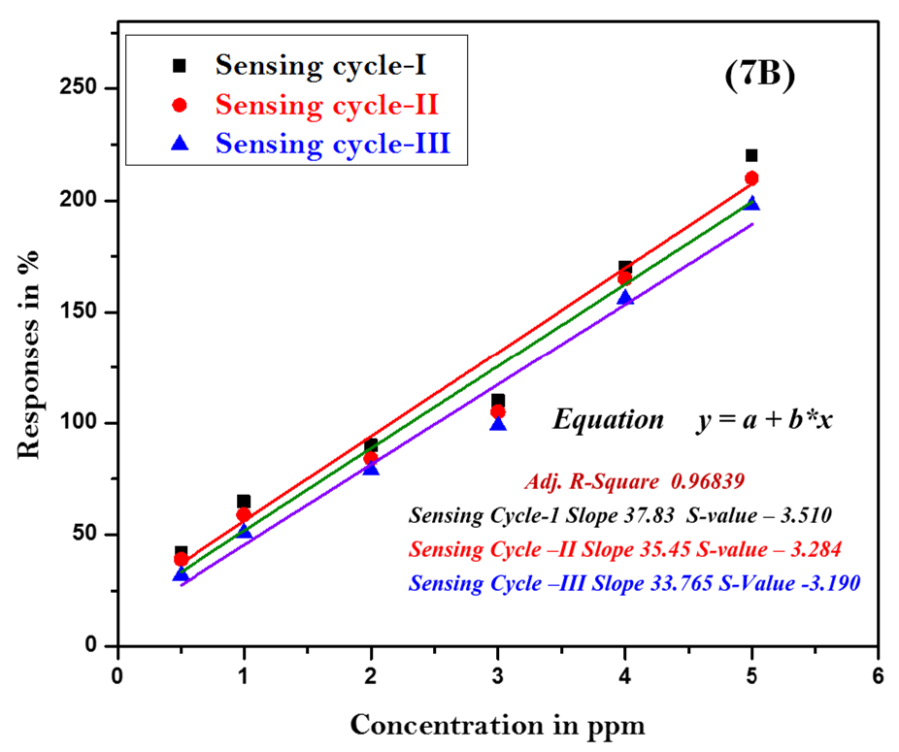

Fig.7B Sensing cycle of In₂O₃/C at operating temperature 250ºC.
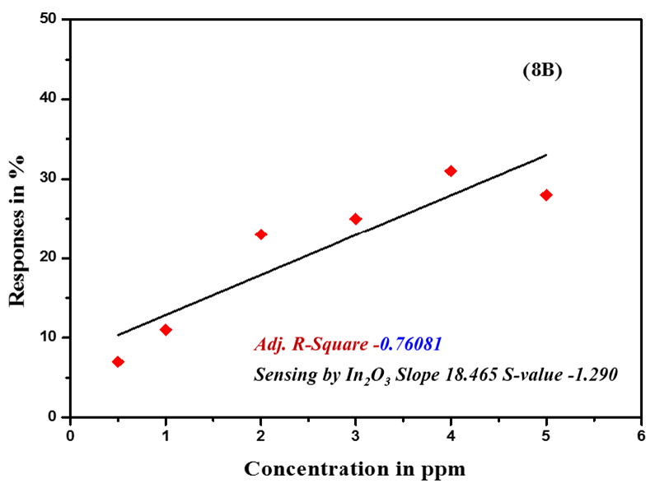

Fig.8B Sensing Cycle of In₂O₃ at operating temperature 250ºC.

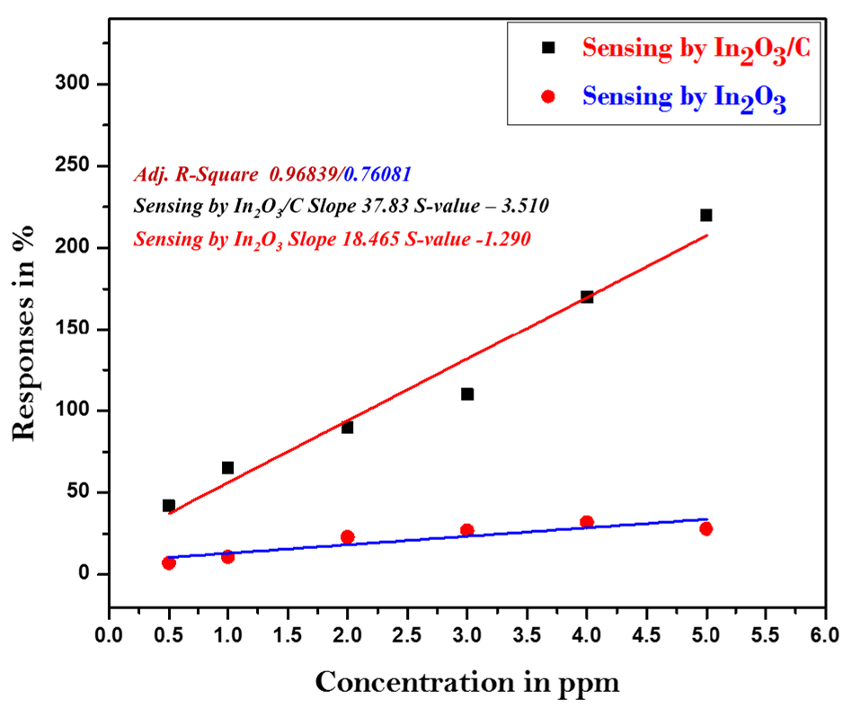

Fig.9 Sensing by In₂O₃ /C and In₂O₃ at operating temperature 250ºC.

- Supporting Information Fig. S5:
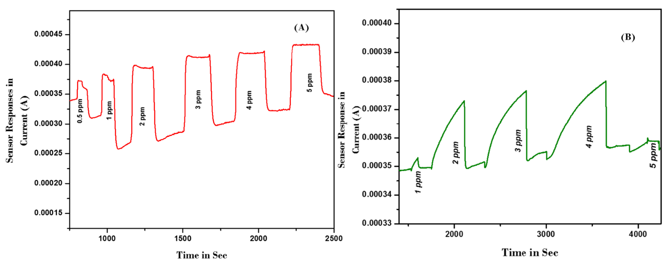
_{H2}S Sensing by In₂O₃/C at operating temperature range of 275ºC and 300ºC

Fig S5.(A) H₂S Sensing of In₂O₃/C at 275ºC (B) H₂S Sensing of In₂O₃/C at 300ºC.

