Supporting Information

Insights on drying and precipitation dynamics of respiratory droplets from the perspective of Covid-19
^{1*}Saptarshi Basu , ¹Prasenjit Kabi, ²Swetaprovo Chaudhuri and ³Abhishek Saha
¹Department of Mechanical Engineering, Indian Institute of Science, Bengaluru, India-560012.
²Institute for Aerospace Studies, University of Toronto, Toronto, Canada-M3H 5T6.
³Department of Mechanical and Aerospace Engineering, University of California San Diego, La Jolla, California, USA-92093.
*Corresponding Author-sbasu@iisc.ac.in

S1: Universal onset of precipitation in salt laden (1 wt%) acoustically levitated droplet

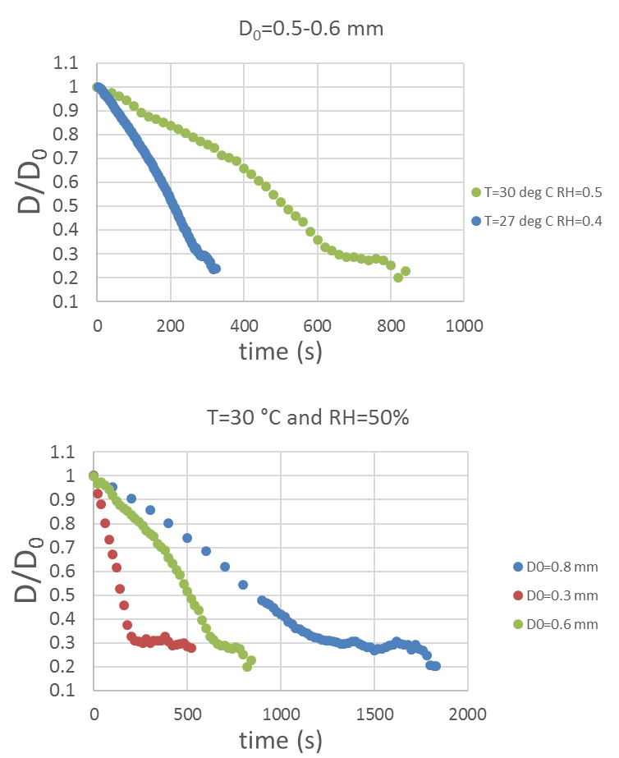

Figure S1: (top panel) plot of normalized droplet diameter reduction (D/D0) vs time where the initial droplet diameter is restricted to 0.5-0.6 mm while the (T, RH) vary from (30°C, 0.5) to (27°C, 0.4). (bottom panel) At the same (T, RH) = (30°C, 0.5), the initial droplet diameter is varied from 0.8 mm to 0.3 mm.
Irrespective of the initial droplet size or the ambient conditions, the diameter reduction always seems to slow down after reducing below 0.3D₀. This has modelled and experimentally verified by Chaudhuri et al¹.
Reference
¹ S. Chaudhuri, S. Basu, P. Kabi, V.R. Unni, and A. Saha, Physics of Fluids 32, 063309 (2020).

