Supporting Information

Chiral Iridium N-Heterocyclic Carbene Complexes for Asymmetric Reduction of Prochiral Ketimines.

Lakshay Kathuria,[a] and Ashoka G. Samuelson*[a]

[a] L. Kathuria, and Prof. Dr. A. G. Samuelson

Inorganic and Physical Chemistry Department

Indian Institute of Science

Bangalore, Karnataka, 560012 (India)

E-mail: [ashoka@iisc.ac.in](mailto:ashoka@iisc.ac.in)

[a] Department of Inorganic and Physical Chemistry, Indian Institute of Science, Bangalore 60012, India; E-mail: [ashoka@iisc.ac.in](mailto:ashoka@iisc.ac.in); Tel.: +91-80-22932663; Fax: +91-80-23601552.

**Synthesis of chiral NHC precursors**:

**General procedures**

**Step 1: Benzylation of amino acid**[1]





In a round bottle flask was added (0.02 mol, 1 equiv.) an amino acid and (0.07 mol, 3.5 equiv.) anhydrous potassium carbonate in ethanol. The reaction mixture was stirred for about 5 minutes on a magnetic stirrer. To this, benzyl bromide (0.066 mol, 3.3 equiv.) was added dropwise using a dropping funnel. The resultant reaction mixture was stirred for 4 days at room temperature and filtered to remove the solid formed. The filtrate part was collected, and the solvent was removed under reduced pressure. The semi-solid obtained was dissolved in ethyl acetate and washed with water, saturated solution of sodium bicarbonate (aq), and finally with brine. The solvent was removed under reduced pressure and an oily compound was obtained. The crude product obtained was used without further purification.

**Step 2: Reduction of benzyl ester to alcohol**[1]





The crude product (0.01 mol, 1 equiv.) obtained from step 1 was dissolved in 20mL dry THF. This solution was added dropwise to a suspension of LiAlH4 (0.011 mol, 1.1 equiv.) in 50mL dry THF maintained at 0 ⁰C. After the addition is over, the reaction mixture was warmed to RT and then allowed to reflux overnight. The reaction progress was monitored by TLC. After the reaction was completed, the reaction mixture was cooled to room temperature, and excess hydrides were quenched by the dropwise addition of acetone. The resultant mixture was stirred for about 6 hours. A white solid formed upon slow addition of 3 N NaOH to the reaction mixture. The reaction mixture was filtered, and the white solid was rinsed with ethyl acetate. All the organic phases were combined, and the solvent was removed under reduced pressure. The compound obtained was used for the next step without any further purifications.

**Step 3: Synthesis of primary and secondary chloride from chiral aminol**





Aminol obtained from the previous step was reacted with methane sulphonyl chloride (MsCl) in the presence of NEt3. MsCl (0.012 mol, 1.2 equiv.) as a solution in dry DCM was added to the reaction mixture containing (0.01 mol, 1 equiv.) an aminol and (0.021 mol, 2.1 equiv.) NEt3. The temperature of the reaction mixture was maintained to 0 °C by using an ice bath. The reaction mixture was warmed to RT and allowed to stir overnight. The mesylate was the expected product, but due to the intramolecular rearrangement that occurred during the reaction, it forms an aziridinium salt. The aziridinium species underwent an attack by the chloride ion present in the reaction mixture, furnishing chloride substituted amines.

**Step 4: Synthesis of N-alkylated benzimidazoles**





To a two-necked round bottom flask charged with benzimidazole (6 mmol, 1 equiv.), was added dry DMF using a glass syringe. The flask was cooled to 0 °C using an ice bath and potassium *tert*-butoxide (9 mmol, 1.5 equiv.) was added to it. After 15 min of stirring at 0 °C, a solution of product obtained from the previous step (6.6 mmol, 1.1 equiv.) as a solution in DMF was added dropwise and stirred for a further period of 15 min. The reaction flask was then transferred to an oil bath and the reaction mixture was heated to 95 °C. The progress of reaction was monitored by TLC. After 24 h of heating, the reaction was complete. DMF was removed under reduced pressure and the solid obtained was dissolved in EtOAc. After washing with water and finally with brine, the organic phases were collected, and the solvent was removed under reduced pressure after drying it with anhydrous Na2SO4. Pure compound was obtained performing column chromatography on the crude compound using ethyl acetate-hexane as a solvent mixture for eluting the desired alkylated benzimidazole.

**Step 5: Synthesis of chiral NHC precursors: benzimidazolium salts**





The purified N-alkylated benzimidazole (2.5 mmol, 1 equiv.) was dissolved in dry-degassed DMF in a two-necked round bottom flask. A solution of methyl iodide or trimethyl benzyl bromide (2.75 mmol, 1.1 equiv.) in DMF was added dropwise to this reaction mixture. After the addition was over, the reaction mixture was heated to 95 °C. The reaction was complete after 2 h of heating in case of methyl iodide, however, it took 12 h in the case of trimethyl benzyl bromide. After the reaction was over, DMF was removed under vacuum. The solid obtained dissolved in EtOAc was washed with water and by brine. The organic phases were collected and dried by anhydrous Na2SO4. The solvent was removed under reduced pressure. The crude product obtained was dissolved in a minimum amount of DCM and the pure compound **L** was precipitated by the addition of n-hexane.

**Synthesis of chiral IrCp*NHC complexes**

**General procedure for complexation**





To compound **L** (0.5 mmol, 1 equiv.) taken in a two-necked round bottom flask, dry-degassed DCM was added. Silver oxide (0.255 mmol, 0.51 equiv.) followed by 4 Å molecular sieves was added to this solution. The reaction flask was immediately wrapped with an aluminum foil. After 24 h of the reaction in dark, the AgNHC complex was formed. The dichlorocyclopentadienyl iridium(III) dimer (0.25 mmol, 0.5 equiv.) was added to the reaction mixture and allowed to stir at room temperature in the dark for another 24 h. The reaction mixture was filtered through celite after 24 h of stirring. The solvent was removed under vacuum to afford the crystalline orange colored pure complex.

**Characterization of the N-alkylated benzimidazole**

Yield: 67%

1H NMR (CDCl3, 400 MHz): δ = 1.07 (3H, d, *J =* 6.8 Hz, CHC**H3**), 1.12 (3H, d, *J =* 6.8 Hz, CHC**H3**), 2.14 (1H, m, C**H**(CH3)2), 2.98 (1H, m, C**H**NBn2), 3.68 (4H, m, N(C**H2**Ph)2), 4.16 (1H, m, NC**H2**CHNBn2), 4.28 (1H, m, NC**H2**CHNBn2), 6.99-7.04 (4H, m, Ar**H**), 7.08-7.17 (7H, m, Ar**H**), 7.23-7.35 (2H, m, Ar**H**), 7.79-7.90 (2H, m, Ar**H**).

Yield: 62%

1H NMR (CDCl3, 400 MHz): δ = 0.84 (3H, d, *J =* 6.3 Hz, CHC**H3**), 0.86 (3H, d, *J =* 6.3 Hz, CHC**H3**), 1.58-1.71 (3H, m, C**H**(CH3)2 and C**H2**CH(CH3)2), 3.10-3.18 (1H, m, C**H**NBn2), 3.52 (2H, d, *J =*14 Hz, N(C**H2**Ph)2), 3.77 (2H, d, *J =*14 Hz, N(C**H2**Ph)2), 4.00-4.07 (1H, m, NC**H2**CHNBn2), 4.19-4.27 (1H, m, NC**H2**CHNBn2), 6.94 (1H, d, *J =* 8.3 Hz, Ar**H**), 7.05-7.12 (10H, m, Ar**H**), 7.18-7.24 (2H, m, Ar**H**), 7.83 (1H, d, *J =* 8.3Hz, Ar**H**), 7.85 (1H, s, Ar**H**).



**4c** could not be obtained in pure form, therefore proceeded with the crude for the next step.



Yield: 83%

1H NMR (CDCl3, 400 MHz): δ = 3.16 (1H, dd, J1= 5.38 Hz, *J2 =* 8.38 Hz, C**H2**NBn2), 3.50 (3H, m, C**H2**NBn2 and N(C**H2**Ph)2), 3.78 (2H, d, *J =* 13.5 Hz, N(C**H2**Ph)2), 5.48 (1H, dd, J1= 5.2 Hz, *J2 =* 5.2 Hz, C**H**Ph), 6.92 (1H, d, *J =* 8.1 Hz, ArH), 7.02-7.09 (3H, m, ArH), 7.10-7.15 (4H, m ArH), 7.17-7.24 (7H, m Ar**H**), 7.25-7.29 (2H, m, Ar**H**), 7.31-7.36 (1H, m, Ar**H**), 7.79 (1H, d, *J =* 8.3Hz, Ar**H**), 7.83 (1H, s, Ar**H**).

* + - 1. **Characterization of the NHC precursors (benzimidazolium salt)**

Yield: 92%

1H NMR (CDCl3, 400 MHz): δ = 1.21 (3H, d, *J =* 7.0 Hz, CHC**H3**), 1.25 (3H, d, *J =* 7.0 Hz, CHC**H3**), 2.37 (1H, sept, C**H**(CH3)2, 2.98-305 (1H, m, C**H**NBn2), 3.58 (2H, d, *J =*13 Hz, N(C**H2**Ph)2), 3.95 (2H, d, *J =* 13 Hz, N(C**H2**Ph)2), 4.07 (3H, s, NC**H3**), 4.41 (1H, dd, *J1 =* 3.4 Hz, *J2 =* 11 Hz, NC**H2**CHNBn2), 4.78 (1H, dd, *J1 =* 3.4 Hz, *J2 =* 11 Hz, NC**H2**CHNBn2), 6.88-6.95 (4H, m, Ar**H**), 7.05-7.10 (6H, m, Ar**H**), 7.23 (1H, d, *J =* 8.3 Hz, Ar**H**), 7.43 (1H, t, *J =* 7.3 Hz, Ar**H**) 7.55-7.65 (2H, m, Ar**H**), 10.03 (1H, s, NC**H**N)

13C NMR (CDCl3, 100 Hz): δ = 20.0, 22.7, 27.1, 33.9, 46.2, 53.5, 61.7, 112.2, 112.9, 126.6, 126.7, 126.8, 127.9, 128.5, 128.6, 130.5, 131.2, 138.4, 141.8.

HRMS (ESI (+), acetonitrile; m/z): calcd for C27H32N3+ [M-I]+: 398.2591. Found: m/z = 398.2599.



Yield: 83%

1H NMR (CDCl3, 400 MHz): δ = 1.15 (3H, d, *J =* 6.8 Hz, CH(C**H3)**2), 1.19 (3H, d, *J =* 6.8 Hz, CH(C**H3)**2), 2.32 (1H, sept, C**H**(CH3)2, 2.35 (3H, s, p-C**H3**Ar), 2.41 (6H, s, o-C**H3**Ar), 3.03-3.09 (1H, m, C**H**NBn2), 3.55 (2H, d, *J =*13.5 Hz, N(C**H2**Ph)2), 3.88 (2H, d, *J =* 13.5 Hz, N(C**H2**Ph)2), 4.45 (1H, dd, *J1 =* 3.4 Hz, *J2 =* 11 Hz, NC**H2**CHNBn2), 5.14 (1H, dd, *J1 =* 3.4 Hz, *J2 =* 11 Hz, NC**H2**CHNBn2), 5.72 (2H, s, NC**H2**Ar), 6.88-6.94 (4H, m, ArH), 6.96-7.04 (8H, m, Ar**H**), 7.11 (1H, d, *J =* 8.5 Hz, Ar**H**), 7.27-7.33 (2H, m, Ar**H**) 7.38-7.44 (1H, m, Ar**H**), 10.47 (1H, s, NC**H**N)

13C NMR (CDCl3, 100 Hz): δ = 19.8, 20.2, 20.9, 22.6, 26.8, 46.6, 46.7, 53.6, 60.6, 112.6, 113.4, 124.7, 126.5, 126.7, 126.8, 127.8, 128.0, 128.4, 128.5, 130.0, 131.1, 131.2, 138.0, 138.6, 138.8, 139.7, 142.4.

HRMS (ESI (+), acetonitrile; m/z): calcd for C36H42N3+ [M-Br]+: 516.3373. Found: m/z = 516.3385.



Yield: 78%

1H NMR (CDCl3, 400 MHz): δ = 0.99 (6H, d, *J =* 6.2 Hz, CH**(CH3)2**), 1.41-1.49 (1H, m, C**H**(CH3)2), 1.71-1.84 (2H, m, C**H2**CH(CH3)2), 3.15-3.25 (1H, m, C**H**NBn2), 3.43 (2H, d, *J =*13.5 Hz, N(C**H2**Ph)2), 3.87 (2H, d, *J =* 13.5 Hz, N(C**H2**Ph)2), 4.11 (3H, s, NCH**3**), 4.40 (1H, dd, *J1 =* 4.5 Hz, *J2 =* 10 Hz, NC**H2**CHNBn2), 4.77 (1H, dd, *J =* 4.5 Hz, *J2 =* 10 Hz, NC**H2**CHNBn2), 6.93-7.00 (4H, m, Ar**H**), 7.06-7.12 (6H, m, Ar**H**), 7.15 (1H, d, *J =* 8.3 Hz, Ar**H**), 7.41 (1H, t, *J =* 7.6 Hz, Ar**H**) 7.59 (1H, t, *J =* 7.6 Hz, Ar**H**), 7.65 (1H, d, *J =* 8.3 Hz, Ar**H**), 10.14 (1H, s, NC**H**N).

13C NMR (CDCl3, 100 Hz): δ = 22.1, 23.6, 25.3, 34.0, 35.3, 48.1, 53.0, 54.5, 112.2, 112.9, 126.7, 126.8, 126.9, 128.0, 128.4, 130.7, 131.3, 138.5, 141.9.

HRMS (ESI (+), acetonitrile; m/z): calcd for C28H34N3+ [M-I]+: 412.2747. Found: m/z = 412.2744.

Yield: 89%

1H NMR (CDCl3, 400 MHz): δ = 1.03 (3H, t, *J =* 7.5 Hz, CH2C**H3)**, 1.20 (3H, d, *J =* 7.0 Hz, CHC**H3**), 1.44-1.52 (1H, m, C**H2**CH3), 1.59-1.65 (1H, m, C**H2**CH3), 2.08-2.18 (1H, m, C**H**CH3), 3.05-3.13 (1H, m, C**H**NBn2), 3.47 (2H, d, *J =*13.5 Hz, N(C**H2**Ph)2), 3.98 (2H, d, *J =*13.5 Hz, N(C**H2**Ph)2), 4.07 (3H, s, NCH**3**), 4.36 (1H, dd, *J1 =* 3.4 Hz, *J2 =* 11 Hz, NC**H2**CHNBn2), 4.87 (1H, dd, *J1 =* 3.4 Hz, *J2 =* 11 Hz, NC**H2**CHNBn2), 6.86-6.92 (4H, m, Ar**H**), 7.03-7.08 (6H, m, Ar**H**), 7.24 (1H, d, *J =* 8.5 Hz, ArH), 7.41-7.47 (1H, m, Ar**H**), 7.56-7.66 (2H, m, Ar**H**), 10.10 (1H, s, NC**H**N).

13C NMR (CDCl3, 100 Hz): δ = 12.0, 16.3, 29.2, 30.1, 32.6, 33.9, 34.0, 45.9, 53.5, 60.4, 112.3, 112.9, 125.3, 126.7, 126.8, 126.9, 128.0, 128.1, 128.5, 130.7, 131.4, 135.5, 138.5, 142.0.

HRMS (ESI (+), acetonitrile; m/z): calcd for C28H34IN3+ [M-I]+: 412.2747 Found: m/z = 412.2759.



Yield: 93%

1H NMR (CDCl3, 400 MHz): δ = 3.43 (1H, dd, *J1 =* 4.5 Hz, *J2 =* 10 Hz, C**H2**NBn2), 3.78 (2H, d, *J =*13.5 Hz, N(C**H2**Ph)2), 3.95 (2H, d, *J =* 13.5 Hz, N(C**H2**Ph)2), 4.136 (1H, dd, *J1 =* 4.5 Hz, *J2 =* 10 Hz, C**H2N**Bn2), 4.28 (3H, s, NC**H3**), 5.33 (1H, dd, *J =* 4.5 Hz, *J2 =* 6.3 Hz, C**H**CH2NBn2), 6.90 (1H, d, *J =* 8.5 Hz, Ar**H**), 7.12-7.17 (10H, m, Ar**H**) 7.29-7.39 (4H, m, Ar**H**), 7.41-7.61 (4H, m, Ar**H**), 11.24 (1H, s, NC**H**N).

13C NMR (CDCl3, 100 Hz): δ = 33.9, 58.9, 60.3, 62.0, 112.4, 113.3, 126.7, 126.8, 127.2, 127.5, 128.3, 128.9, 129.4, 130.5, 131.7, 134.9, 138.6, 141.7.

HRMS (ESI (+), acetonitrile; m/z): calcd for C30H30N3+ [M-I]+: 432.2434. Found: m/z = 432.2458.

* + - 1. **Characterization of the chiral Ir-NHC complexes**

Yield: 86%

1H NMR (CDCl3, 400 MHz): δ = 0.06 (3H, d, *J =* 6.3 Hz, CHC**H3**), 1.05 (3H, d, *J =* 6.3 Hz, CHC**H3**), 1.56 (15H, s, C**H3**Cp*), 2.90-3.03 (1H, m, C**H**(CH3)2), 3.23-3.34 (1H, m, C**H**NBn2), 3.88 (2H, d, *J =*14 Hz, N(C**H2**Ph)2), 4.08-4.22 (5H, m, N(C**H2**Ph)2 and NC**H3**), 5.82-5.93 (1H, m, NC**H2**CHNBn2), 6.35-6.44 (1H, m, NC**H2**CHNBn2), 6.83-6.90 (1H, m, Ar**H**), 7.12-7.19 (1H, m, ArH), 7.26-7.55 (12H, m, Ar**H**).

13C NMR (CDCl3, 100 Hz): δ = 9.0, 19.6, 23.1, 30.2, 35.6, 49.1, 54.6, 58.5, 89.6, 110.0, 111.9, 122.6, 122.7, 126.9, 128.3, 129.0, 134.8, 135.9, 140.5, 169.1.

HRMS (ESI (+), acetonitrile; m/z): calcd for IrC37H47N3+ [M-2Cl+H]+: 726.3399. Found: m/z = 726.3394.



Yield: 79%

1H NMR (CDCl3, 400 MHz): δ = 0.72 (3H, t, *J =* 7.5 Hz, CH2C**H3**), 1.00-1.10 (1H, m, C**H2**CH3), 1.52-1.58 (18H, m, C**H3**Cp* and CHC**H3**), 1.96-2.06 (1H, m, C**H2**CH3), 2.63-2.73 (1H, m, C**H**CH3), 3.34-3.43 (1H, m, C**H**NBn2), 3.79-3.98 (2H, d, *J =* 14.5Hz), N(C**H2**Ph)2), 4.15-4.25 (5H, m, N(C**H2**Ph)2 and NC**H3**), 5.93 (1H, t, *J =* 8.2 Hz, NC**H2**CHNBn2), 6.50 (1H, d, *J =* 8.2 Hz, NC**H2**CHNBn2), 6.89 (1H, t, *J =* 7.5 Hz, ArH), 7.16 (1H, t, *J =* 7.5 Hz, ArH), 7.27-7.52 (12H, m, Ar**H**).

13C NMR (CDCl3, 100 Hz): δ = 9.0, 10.5, 14.5, 26.7, 29.6, 35.6, 36.1, 48.5, 54.7, 56.8, 89.5, 110.0, 111.9, 122.6, 122.7, 126.9, 128.3, 128.9, 129.0, 134.8, 135.9, 140.4, 169.2.

HRMS (ESI (+), acetonitrile; m/z): calcd for IrC38H49N3+ [M-2Cl+H]+: 740.3556 Found: m/z = 740.3561

Yield: 81%

1H NMR (CDCl3, 400 MHz): δ = 0.33 (3H, d, *J =* 6.5 Hz, CH**(CH3)2**), 0.57 (3H, d, *J =* 6.5 Hz, CH**(CH3)2**), 1.05-1.14 (1H, m, CH2C**H**(CH3)2), 1.56 (15H, s, C**H3**Cp*), 1.92-2.01 (1H, m, C**H2**CH(CH3)2), 3.65-3.74 (1H, m, C**H2**CH(CH3)2), 3.76-4.02 (5H, m, N(C**H2**Ph)2 and C**H**NBn2), 4.06-4.15 (1H, m, NC**H2**CHNBn2), 4.17 (3H, s, NC**H3**), 5.65 (1H, t, *J =* 12 Hz, NC**H2**CHNBn2), 6.46 (1H, d, *J =* 8.5 Hz, Ar**H**), 6.86 (1H, t, *J =* 7.5 Hz, Ar**H**), 7.15 (1H, t, *J =* 7.5 Hz, Ar**H**), 7.27-7.51 (11H, m, Ar**H**).

13C NMR (CDCl3, 100 Hz): δ = 9.0, 21.9, 23.2, 24.7, 29.6, 35.5, 35.9, 49.5, 51.0, 54.5, 89.5, 110.0, 111.6, 122.6, 122.9, 126.9, 128.2, 129.0, 134.4, 136.1, 140.8, 169.1.

HRMS (ESI (+), acetonitrile; m/z): calcd for IrC38H48ClN3+ [M-Cl]+: 774.3166. Found: m/z = 774.3166.



Yield: 84%

1H NMR (CDCl3, 400 MHz): δ = 0.25 (3H, d, *J =* 6.3 Hz, CHC**H3**), 1.08 (3H, d, *J =* 6.3 Hz, CHC**H3**), 1.54 (15H, s, C**H3**Cp*), 1.88 (3H, s, p-C**H3**Ar), 2.24 (3H, s, o-C**H3**Ar), 2.44 (3H, s, o-C**H3**Ar), 2.92-3.05 (1H, m, C**H**(CH3)2), 3.22-3.33 (1H, m, C**H**NBn2), 3.92 (2H, d, *J =*14 Hz, N(C**H2**Ph)2), 4.10-4.22 (3H, m, N(C**H2**Ph)2 and NC**H2**CHNBn2), 5.04 (1H, d, *J =* 15 Hz, NC**H2**CHNBn2), 6.03 (1H, t, J= 12 Hz, Ar**H**), 6.37-6.45 (2H, m, NC**H2**Ar), 6.35-6.44 (1H, m, Ar**H**), 6.64 (1H, s, NC**H2**Ph), 6.69-6.82 (2H, m, Ar**H**), 6.88 (1H, s, NC**H2**Ph), 7.26-7.55 (10H, m, Ar**H**).

HRMS (ESI (+), acetonitrile; m/z): calcd for IrC46H57N3+ [M-2Cl+H]+: 844.4182. Found: m/z = 844.4193.



Yield: 89%

1H NMR (CDCl3, 400 MHz): δ = 1.43 (15H, s, C**H3**Cp*), 3.40-3.50 (3H, m, C**H2**NBn2 andN(C**H2**Ph)2), 3.69-3.79 (1H, m, C**H2**NBn2), 4.18 (3H, s, NC**H3**), 4.41 (2H, d, *J =*14.5 Hz, N(C**H2**Ph)2), 6.24 (1H, d, *J =* 8.5 Hz, C**H**Ph), 6.74-6.80 (1H, m, Ar**H**), 7.12-7.35 (17H, m, Ar**H**).

13C NMR (CDCl3, 100 Hz): δ = 9.1, 36.4, 55.6, 58.8, 60.5, 89.7, 110.4, 115.0, 122.2, 122.7, 126.5, 126.8, 127.1, 128.1, 128.3, 128.5, 129.0, 134.2, 136.0, 138.3, 139.6, 170.9.

HRMS (ESI (+), acetonitrile; m/z): calcd for IrC40H44ClN3+ [M-Cl]+: 794.2853. Found: m/z = 794.2850.

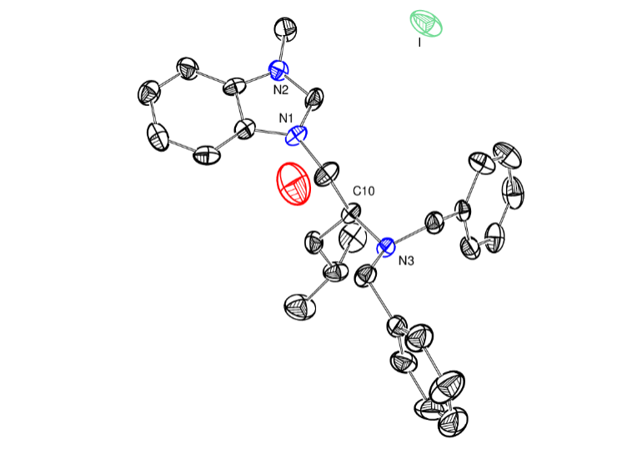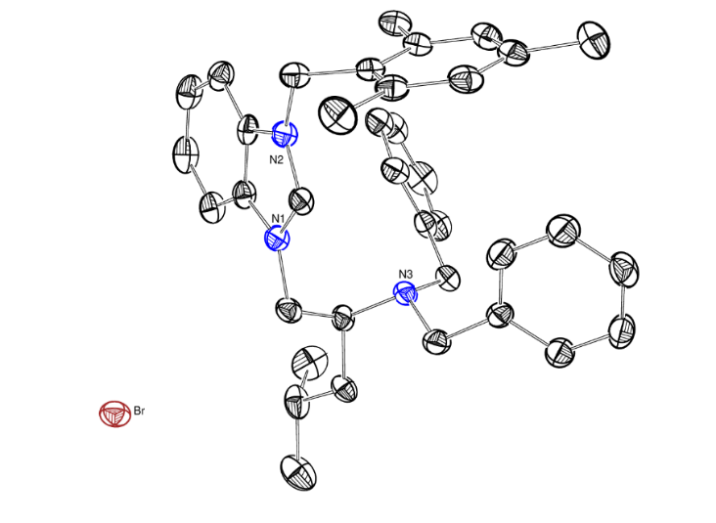**Crystal structure**

**L3 L2**

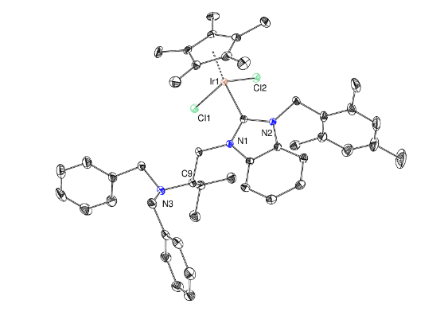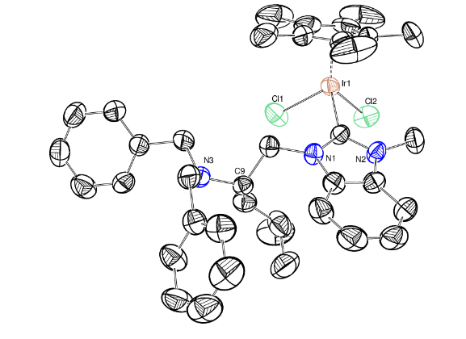

**IrLeuMe IrValMe**

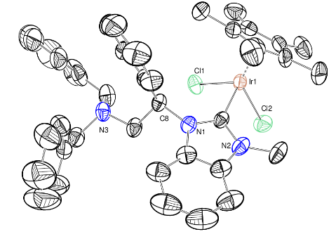

**IrPGMe**

**Figure 10:** ORTEP model representation of chiral ligands **5c, 5d, IrLeuMe, IrValMe, and IrPGMe** depictedwith thermal ellipsoids at 50% probability level. Solvent molecules and hydrogen atoms are omitted for clarity. Colour codes: black = C, blue = N, green = I/Cl, Rust = Br, red = O, and orange = Ir.

**Table S1:** Crystallographic Information and Structure Solution Parameters of chiral NHC precursors **5c** and **5b**.

|  |  |  |
| --- | --- | --- |
| **Identification code** | **L3** | **L2** |
| CCDC No. | 1984312 | 1984309 |
| Empirical Formula | C28 H36 I N3 O | C74 H88 Br2 N6 O |
| Formula Weight | 557.50 | 1237.32 |
| Temperature | 298(2) K | 120(2) K |
| Wavelength | 0.71073 Å | 0.71073 Å |
| Crystal System | Triclinic | Orthorhombic |
| Space Group | P1 | P 21 21 21 |
| Unit Cell Parameters | a = 7.8711(16) Å  b = 9.991(2) Å  c = 18.792(4) Å  α = 98.463(7)°  β = 99.639(7)°  γ = 107.643(6)° | a = 13.3450(7) Å  b = 17.2662(8) Å  c = 28.4764(15) Å  α= 90°  β= 90°  γ = 90° |
| Volume(Å3) | 1357.2(5) | 6561.5(6) |
| Z | 2 | 4 |
| Calculated Density (mg m-3) | 1.364 | 1.253 |
| Absorption coefficient | 1.203 | 1.284 |
| F(000) | 572 | 2608 |
| Crystal Size(mm3) | 0.130 x 0.097 x 0.054 | 0.162 x 0.120 x 0.039 |
| Crystal Habit/Color | Block/orange | Block/orange |
| Theta range for data collection | 3.058 to 27.620° | 1.379 to 27.549° |
| Index ranges | -9<=h<=10,  -12<=k<=12,  -24<=l<=24 | -17<=h<=17,  -22<=k<=22,  -37<=l<=36 |
| Reflections collected/ Independent Unique | 47354/11845  [R(int) = 0.0446] | 148281/15109  [R(int) = 0.0994] |
| Completeness to theta = 25.242° | 99.8% | 100% |
| Refinement method | Full-matrix least-squares on F2 | Full-matrix least-squares on F2 |
| Absorption correction | Semi-empirical from equivalents | Semi-empirical from equivalents |
| Max. and min. transmission | 0.7456 and 0.6142 | 0.7456 and 0.6292 |
| Data / restraints / parameters | 11845 / 87 / 612 | 15109 / 522 / 852 |
| Goodness-of-fit on F2 | 1.067 | 1.016 |
| Final R indices [I>2sigma(I)] | R1 = 0.0500, wR2 = 0.1086 | R1 = 0.0420, wR2 =  0.0831 |
| R indices (all data) | R1 = 0.0684, wR2 = 0.1170 | R1 = 0.0789, wR2 =  0.0956 |
| Absolute structure parameter | 0.013(9) | -0.003(3) |
| Extinction coefficient | n/a | n/a |
| Largest diff. peak and hole | 2.719 and -1.742 e.Å-3 | 0.600 and -0.470 e.Å-3 |

**Table S2:** Crystallographic Information and Structure Solution Parameters of chiral NHC precursors **IrLeuMe, IrValTMB,** and **IrPGMe**.

|  |  |  |  |
| --- | --- | --- | --- |
| **Identification code** | **IrLeuMe** | **IrValTMB** | **IrPGMe** |
| CCDC No. | 1984310 | 1984313 | 1984311 |
| Empirical Formula | C38 H48 Cl2 Ir N3 | C47 H57 Cl5 Ir N3 | C40 H44 Cl2 Ir N3 |
| Formula Weight | 809.89 | 1033.40 | 829.88 |
| Temperature | 297(2) K | 120(2) K | 296(2) K |
| Wavelength | 0.71073 Å | 0.71073 Å | 0.71073 Å |
| Crystal System | Orthorhombic | Monoclinic | Orthorhombic |
| Space Group | P 21 21 21 | P 21 | P 21 21 21 |
| Unit Cell Parameters | a = 8.7213(5) Å  b = 15.2626(8) Å  c = 26.8159(13) Å  α = 90°  β = 90°  γ = 90° | a = 10.2649(5) Å  b = 14.8618(8) Å  c = 14.7326(8) Å  α = 90°  β = 90.836(2)°  γ = 90° | a = 10.7234(8) Å  b = 11.5000(9) Å  c = 29.498(2) Å  α = 90°  β = 90°  γ = 90° |
| Volume(Å3) | 3569.5(3) | 2247.3(2) | 3637.7(5) |
| Z | 4 | 2 | 4 |
| Calculated Density (mg m-3) | 1.507 | 1.527 | 1.515 |
| Absorption coefficient | 3.920 | 3.304 | 3.849 |
| F(000) | 1632 | 1044 | 1664 |
| Crystal Size(mm3) | 0.275 x 0.055 x 0.041 | 0.322 x 0.079 x 0.053 | 0.070 x 0.060 x 0.060 |
| Crystal Habit/Color | Block/orange | Block/orange | Block/orange |
| Theta range for data collection | 1.519 to 29.398° | 1.382 to 30.549° | 1.901 to 30.551° |
| Index ranges | 12<=h<=11,  -20<=k<=21,  -36<=l<=36 | -14<=h<=14,  -21<=k<=21,  -21<=l<=20 | -15<=h<=15,  -16<=k<=16, -42<=l<=42 |
| Reflections collected/ Independent Unique | 186664/9743  [R(int) = 0.0528] | 109004/13770  [R(int) = 0.0371] | 175839/11177  [R(int) = 0.0598] |
| Completeness to theta = 25.242° | 100% | 100% | 100% |
| Refinement method | Full-matrix least-squares on F2 | Full-matrix least-squares on F2 | Full-matrix least-squares on F2 |
| Absorption correction | Semi-empirical from equivalents | Semi-empirical from equivalents | Semi-empirical from equivalents |
| Max. and min. transmission | 0.7458 and 0.5012 | 0.7461 and 0.4795 | 0.7461 and 0.6366 |
| Data / restraints / parameters | 9743 / 0 / 405 | 13770 / 1 / 515 | 11177 / 0 / 421 |
| Goodness-of-fit on F2 | 1.172 | 1.055 | 1.043 |
| Final R indices [I>2sigma(I)] | R1 = 0.0342, wR2 = 0.0617 | R1 = 0.0206, wR2 = 0.0512 | R1 = 0.0232, wR2 = 0.0437 |
| R indices (all data) | R1 = 0.0536, wR2 = 0.0682 | R1 = 0.0211, wR2 = 0.0514 | R1 = 0.0287, wR2 = 0.0454 |
| Absolute structure parameter | 0.002(2) | -0.011(3) | -0.017(2) |
| Extinction coefficient | n/a | n/a | n/a |
| Largest diff. peak and hole | 1.775 and -1.392 e.Å-3 | 0.813 and -0.757 e.Å-3 | 0.559 and -0.691 e.Å-3 |

**Characterization of Ketimines**

1-phenyl-N-(p-tolyl)ethan-1-imine[2]

1H NMR (400 MHz, CDCl3, 298 K): *δ* (ppm) = 8.01-7.95 (m, 2H), 7.49-7.42 (m, 3H), 7.16 (d, 2H, *J* = 8.2 Hz), 6.72 (d, 2H, *J* = 8.2 Hz), 2.36 (s, 3H), 2.25 (s, 3H).

13C NMR (100 MHz, CDCl3, 298 K): *δ* (ppm) =165.4, 148.9, 139.5, 130.2, 129.4, 128.2, 127.0, 119.3, 20.8, 17.2.



1-phenyl-N-(o-tolyl)ethan-1-imine[3]

1H NMR (400 MHz, CDCl3, 298 K): *δ* (ppm) =8.05-7.98 (m, 2H), 7.51-7.42 (m, 3H), 7.23-7.15 (m, 2H), 7.01 (t, 1H, *J* = 7.3 Hz), 6.65 (d, 1H, *J* = 7.8 Hz), 2.17 (s, 3H), 2.11 (s, 3H).

13C NMR (100 MHz, CDCl3, 298 K): *δ* (ppm) =164,.9 150.2, 139.4, 130.4, 130.3, 128.3, 127.1, 126.3, 123.2, 118.4, 17.7, 17.4.



N-(4-methoxyphenyl)-1-phenylethan-1-imine[2]

1H NMR (400 MHz, CDCl3, 298 K): *δ* (ppm) =8.00-7.94 (m,, 2H), 7.48-7.41 (m, 3H), 6.91 (d, 2H, J = 8.5 Hz), 6.76 (d, 2H, J = 8.5 Hz), 3.82 (s, 3H), 2.26 (s, 3H).

13C NMR (100 MHz, CDCl3, 298 K): *δ* (ppm) =165.7, 155.9, 144.8, 139.7, 130.3, 128.3, 127.0, 120.7, 114.2, 55.4, 17.2.



N,1-diphenylethan-1-imine[2]

1H NMR (400 MHz, CDCl3, 298 K): *δ* (ppm) =8.09-7.95 (m,, 2H), 7.57-7.34 (m, 5H), 7.10 (t, 1H, *J* = 8.0 Hz), 6.81 (d, 2H, J = 8 Hz), 2.25 (s, 3H).

13C NMR (100 MHz, CDCl3, 298 K): *δ* (ppm) =165.4, 151.6, 139.4, 130.4, 128.9, 128.3, 127.1, 123.1, 119.3, 17.3.



1-(4-bromophenyl)-N-(4-methoxyphenyl)ethan-1-imine[4]

1H NMR (400 MHz, CDCl3, 298 K): *δ* (ppm) = 7.84 (d, 2H, *J* = 8.3 Hz), 7.56 (d, 2H, *J* = 8.3 Hz), 6.91 (d, 2H, *J* = 8.3 Hz), 6.74 (d, 2H, *J* = 8.3 Hz), 3.82 (s, 3H), 2.23 (s, 3H).

13C NMR (100 MHz, CDCl3, 298 K): *δ* (ppm) =164.4, 156.0, 144.4, 138.5, 131.4, 128.7, 124.8, 120.7, 114.2, 55.4, 17.1.



1-(naphthalen-2-yl)-N-phenylethan-1-imine[2]

1H NMR (400 MHz, CDCl3, 298 K): *δ* (ppm) =8.39 (s, 1H), 8.30 (d, 1H, J = 8.7 Hz), 8.01-7.85 (m, 3H), 7.62-7.52 (m, 2H), 7.43 (t, 2H, *J* = 7.5 Hz), 7.17 (t, 1H, *J* = 7.5 Hz), 6.91 (d, 2H, *J* = 8.2 Hz), 2.39 (s, 3H).

13C NMR (100 MHz, CDCl3, 298 K): *δ* (ppm) =165.1, 151.7, 136.7, 134.3, 132.8, 128.9, 128.8, 127.9, 127.6, 127.5, 127.0, 126.2, 124.1, 123.1, 119.3, 17.2.



1-(4-chlorophenyl)-N-phenylethan-1-imine[2]

1H NMR (400 MHz, CDCl3, 298 K): *δ* (ppm) =7.92 (d, 2H, *J* = 8.7 Hz), 7.41 (d, 2H, *J* = 8.7 Hz), 7.36 (t, 2H, *J* = 8.0 Hz), 7.10 (t, 1H, *J* = 7.5 Hz), 6.79 (d, 2H, *J* = 8.5 Hz), 2.22 (s, 3H).

13C NMR (100 MHz, CDCl3, 298 K): *δ* (ppm) =164.2, 151.2, 137.9, 136.5, 128.9, 128.5, 123.3, 119.2, 17.2.



1-(4-methoxyphenyl)-N-phenylethan-1-imine[2]

1H NMR (400 MHz, CDCl3, 298 K): *δ* (ppm) =7.97-7.92 (m, 2H), 7.34 (t, 2H, *J* = 8.0 Hz), 7.07 (t, 1H, *J* = 7.3 Hz), 6.97-6.92 (m, 2H), 6.79 (d, 2H, *J* = 8.0 Hz), 3.87 (s, 3H), 2.20 (s, 3H).

13C NMR (100 MHz, CDCl3, 298 K): *δ* (ppm) =164.5, 161.4, 151.7, 132.0, 128.8, 128.7, 122.9, 119.5, 113.5, 55.2, 17.0.



N-phenyl-1-(p-tolyl)ethan-1-imine[2]

1H NMR (400 MHz, CDCl3, 298 K): *δ* (ppm) =7.88 (d, 2H, *J* = 7.8 Hz), 7.35 (t, 2H, *J* = 7.8 Hz), 7.25 (d, 2H, *J* = 7.8 Hz), 7.08 (t, 1H, *J* = 7.8 Hz), 6.80 (d, 2H, *J* = 8.0 Hz), 2.42 (s, 3H), 2.22 (s, 3H).

13C NMR (100 MHz, CDCl3, 298 K): *δ* (ppm) =165.2, 151.8, 140.6, 136.8, 129.0, 128.8, 127.1, 123.0, 119.4, 21.3, 17.2.



1-(4-bromophenyl)-N-phenylethan-1-imine[2]

1H NMR (400 MHz, CDCl3, 298 K): *δ* (ppm) =7.86 (d, 2H, *J* = 8.5 Hz), 7.58 (d, 2H, *J* = 8.5 Hz), 7.36 (t, 2H, *J* = 7.8 Hz), 7.10 (t, 1H, *J* = 7.8 Hz), 6.80 (d, 2H, *J* = 8.5 Hz), 2.21 (s, 3H).

13C NMR (100 MHz, CDCl3, 298 K): *δ* (ppm) =164.2, 151.2, 138.2, 131.4, 128.9, 128.7, 125.0, 123.3, 119.2, 17.1.



N-butyl-1-phenylethan-1-imine[5]

1H NMR (400 MHz, CDCl3, 298 K): *δ* (ppm) = 7.78-7.72 (m, 2H), 7.39-7.34 (m, 3H), 3.48 (t, 2H, *J*= 7.2 Hz), 2.23 (s, 3H), 1.76-1.69 (m, 2H), 1.50-1.42 (m, 2H), 0.98 (t, 3H, *J*= 7.2 Hz).

13C NMR (100 MHz, CDCl3, 298 K): *δ* (ppm) =164.6, 141.4, 129.1, 128.1, 126.5, 51.9, 33.0, 20.7, 15.3, 13.9.



N-phenylhexan-2-imine[6]

1H NMR (400 MHz, CDCl3, 298 K): *δ* (ppm) = 0.97 (t, 3H, *J* = 7.5 Hz), 1.39-1.46 (m, 2H), 1.62-1.70 (m, 2H), 2.41 (t, 2H, *J* = 7.5 Hz), 6.68 (d, 2H, *J* = 7.6 Hz), 7.03 (t, 1H, *J* = 6.9 Hz), 7.28 (d, 2H, *J* = 7.7 Hz).



1-(4-fluorophenyl)-1-phenyl-N-(p-tolyl)methanimine[7]

1H NMR (400 MHz, CDCl3, 298 K): *δ* (ppm) = 7.79-7.71 (m, 2H), 7.47-7.39 (m, 1H), 7.32-7.23 (m, 2H), 7.14-7.06 (m, 3H), 7.00- 6.92 (t, 3H, *J* = 7.2 Hz), 6.66-6.59 (d, 2H, *J* = 8.0 Hz), 2.25 (d, 3H, *J* = 8.2 Hz)Hz

.

13C NMR (100 MHz, CDCl3, 298 K): *δ* (ppm) = 166.8, 166.4, 165.6, 163.6, 163.1, 161.2, 148.4, 148.3, 139.7, 136.2, 136.1, 132.7, 132.6, 131.5, 131.4, 131.3, 131.2, 130.7, 129.3, 129.2, 129.0, 128.5, 128.2, 128.0, 120.9, 120.8, 115.2, 114.9, 20.7.

**Characterization of the amines obtained from reduction of ketimines**



4-methyl-N-(1-phenylethyl)aniline[2]

1H NMR (400 MHz, CDCl3, 298 K): *δ* (ppm) =7.39-7.28 (m, 4H), 7.25-7.19 (m, 1H), 6.91 (d, 2H, *J =* 8.0 Hz), 6.44 (d, 2H, *J =* 8.0 Hz), 4.46 (q, 1H, *J =* 6.8 Hz), 2.18 (s, 3H), 1.51 (d, 3H, *J =* 6.8 Hz).

13C NMR (100 MHz, CDCl3, 298 K): *δ* (ppm) =145.3, 144.9, 129.5, 128.5, 126.7, 126.2, 125.7, 113.3, 53.5, 24.9, 20.2.



2-methyl-N-(1-phenylethyl)aniline[3]

1H NMR (400 MHz, CDCl3, 298 K): *δ* (ppm) =7.44-7.30 (m, 4H), 7.29-7.23 (m, 1H), 7.09 (d, 1H, *J =* 7.3 Hz), 7.00 (t, 1H, *J =* 7.8 Hz), 6.66 (t, 1H, *J =* 7.3 Hz), 6.44 (d, 1H, *J =* 7.8 Hz), 4.58 (q, 1H, *J =* 6.8 Hz), 2.27 (s, 3H), 1.61 (d, 3H, *J =* 6.8 Hz).

13C NMR (100 MHz, CDCl3, 298 K): *δ* (ppm) =144.9, 129.9, 128.6, 126.9, 126.8, 125.8, 121.8, 117.0, 111.3, 53.4, 25.0, 17.5.



4-methoxy-N-(1-phenylethyl)aniline[2]

1H NMR (400 MHz, CDCl3, 298 K): *δ* (ppm) =7.41-7.29 (m, 4H), 7.26-7.20 (m, 1H), 6.71 (d, 2H, *J =* 8.8 Hz), 6.49 (d, 2H, *J =* 8.8 Hz), 4.43 (q, 1H, *J =* 6.8 Hz), 3.70 (s, 3H), 1.51 (d, 3H, *J =* 6.8 Hz).

13C NMR (100 MHz, CDCl3, 298 K): *δ* (ppm) =151.8, 145.4, 141.5, 128.5, 126.7, 125.8, 114.7, 114.5, 55.7, 54.2, 25.0.



N-(1-phenylethyl)aniline[2]

1H NMR (400 MHz, CDCl3, 298 K): *δ* (ppm) =7.43-7.31 (m, 4H), 7.27-7.22 (m, 1H), 7.11 (t, 2H, *J =* 7.8 Hz), 6.66 (t, 1H, *J =* 7.3 Hz), 6.53 (d, 2H, *J =* 8.2 Hz), 4.51 (q, 1H, *J =* 6.8 Hz), 1.54 (d, 3H, *J =* 6.8 Hz).

13C NMR (100 MHz, CDCl3, 298 K): *δ* (ppm) =147.2, 145.2, 129.0, 128.6, 126.8, 125.8, 117.2, 113.2, 53.4, 24.8.



N-(1-(4-bromophenyl)ethyl)-4-methoxyaniline[4]

1H NMR (400 MHz, CDCl3, 298 K): *δ* (ppm) =7.43 (d, 2H, *J =* 8.3 Hz), 7.25 (d, 2H, *J =* 8.3 Hz), 6.70 (d, 2H, *J =* 9.0 Hz), 6.46 (d, 2H, *J =* 8.3 Hz), 4.37 (q, 1H, *J =* 6.8 Hz), 3.70 (s, 3H), 1.48 (d, 3H, *J =* 6.8 Hz).

13C NMR (100 MHz, CDCl3, 298 K): *δ* (ppm) =152.2, 144.3, 140.7, 131.6, 127.7, 120.4, 114.8, 114.7, 55.6, 54.0, 24.9.



N-(1-(naphthalen-2-yl)ethyl)aniline[2]

1H NMR (400 MHz, CDCl3, 298 K): *δ* (ppm) =7.98-7.78 (m, 4H), 7.63-7.44 (m, 3H), 7.15 (t, 2H, *J =* 7.3 Hz), 6.72 (t, 1H, *J =* 7.3 Hz), 6.64 (d, 2H, *J =* 8.0 Hz), 4.70 (q, 1H, *J =* 6.8 Hz), 1.65 (d, 3H, *J =* 6.8 Hz).

13C NMR (100 MHz, CDCl3, 298 K): *δ* (ppm) =147.0, 142.5, 133.5, 132.7, 129.0, 128.4, 127.7, 127.6, 125.9, 125.4, 124.3, 124.2, 117.5, 113.5, 53.8, 24.8.



N-(1-(4-chlorophenyl)ethyl)aniline[2]

1H NMR (400 MHz, CDCl3, 298 K): *δ* (ppm) =7.36-7.26 (m, 4H), 7.11 (t, 2H, *J =* 8.5 Hz), 6.68 (t, 1H, *J =* 8.5 Hz), 6.50 (d, 2H, *J =* 8.0 Hz), 4.46 (q, 1H, *J =* 6.8 Hz), 1.51 (d, 3H, *J =* 6.8 Hz).

13C NMR (100 MHz, CDCl3, 298 K): *δ* (ppm) =146.9, 143.8, 132.3, 129.1, 128.7, 127.2, 117.4, 113.2, 52.9, 25.0.



N-(1-(4-methoxyphenyl)ethyl)aniline[2]

1H NMR (400 MHz, CDCl3, 298 K): *δ* (ppm) =7.30 (d, 2H, *J =* 8.5 Hz), 7.11 (t, 2H, *J =* 7.5 Hz), 6.87 (d, 2H, *J =* 8.5 Hz), 6.66 (t, 1H, *J =* 7.5 Hz), 6.53 (d, 2H, *J =* 8.5 Hz), 4.46 (q, 1H, *J =* 6.8 Hz), 3.79 (s, 3H), 1.50 (d, 3H, *J =* 6.8 Hz).

13C NMR (100 MHz, CDCl3, 298 K): *δ* (ppm) =158.4, 147.3, 137.2, 129.0, 126.8, 117.1, 113.9, 113.2, 55.2, 52.7, 24.9.



N-(1-(p-tolyl)ethyl)aniline[2]

1H NMR (400 MHz, CDCl3, 298 K): *δ* (ppm) =7.30 (d, 2H, *J =* 8.0 Hz), 7.20-7.10 (m, 4H), 6.69 (t, 1H, *J =* 7.8 Hz), 6.57 (d, 2H, *J =* 8.0 Hz), 4.51 (q, 1H, *J =* 6.8 Hz), 2.37 (s, 3H), 1.55 (d, 3H, *J =* 6.8 Hz).

13C NMR (100 MHz, CDCl3, 298 K): *δ* (ppm) =147.3, 142.1, 136.3, 129.2, 129.0, 125.7, 117.1, 113.2, 53.1, 24.9, 21.0.



N-(1-(4-bromophenyl)ethyl)aniline[2]

1H NMR (400 MHz, CDCl3, 298 K): *δ* (ppm) =7.44 (d, 2H, *J =* 8.5 Hz), 7.25 (d, 2H, *J =* 8.5 Hz), 7.10 (t, 2H, *J =* 8.0 Hz), 6.67 (t, 1H, *J =* 8.0 Hz), 6.48 (d, 2H, *J =* 8.5 Hz), 4.44 (q, 1H, *J =* 6.8 Hz), 1.50 (d, 3H, *J =* 6.8 Hz).

13C NMR (100 MHz, CDCl3, 298 K): *δ* (ppm) =146.9, 144.3, 131.7, 129.1, 127.6, 120.4, 117.5, 113.2, 53.0, 25.0.



N-((4-fluorophenyl)(phenyl)methyl)-4-methylaniline[8]

1H NMR (400 MHz, CDCl3, 298 K): *δ* (ppm) = 7.35-7.25 (m, 7H), 7.04-6.97 (m, 2H), 6.94 (d, 2H, *J*= 8.2 Hz), 6.46 (d, 2H, *J*= 8.3 Hz), 5.45 (s, 1H), 4.07 (s, 1H, N-H), 2.22 (s, 3H),

13C NMR (100 MHz, CDCl3, 298 K): *δ* (ppm) = 163.2, 160.8, 145.0, 143.0, 138.8, 129.6, 129.0, 128.9, 128.8, 127.8, 127.5, 127.4, 127.0, 115.6, 115.4, 113.6, 62.6, 20.3.

**The chromatographic data for the determination of enantiomeric excess**

**Table 1, Entry 2**

HPLC Conditions:[9] Column: Chiralcel OD‐H, Daicel Chemical Industries, Ltd., Eluent: n-Hexane/IPA (98/2); Flow rate: 0.5 mL/min; Detection: UV 254 nm.



HPLC trace of the isolated product **(Table 1, Entry 2)**

ee = 26% The stereoisomer of amine obtained in excess: *S*

|  |  |  |
| --- | --- | --- |
|  | Retention Time | % Area |
| 1 | 16.822 | 37.06 |
| 2 | 18.862 | 62.94 |

**Table 1, Entry 3**

HPLC Conditions:[10] Column: Chiralcel IB, Daicel Chemical Industries, Ltd., Eluent: n-hexane/IPA (85/15); Flow rate: 0.8 mL/min; Detection: UV 254 nm.



HPLC trace of the isolated product **(Table 1, Entry 3)**

ee = 0 The stereoisomer of amine obtained in excess: none

|  |  |  |
| --- | --- | --- |
|  | Retention Time | % Area |
| 1 | 5.678 | 50.09 |
| 2 | 6.485 | 49.91 |

**Table 1, Entry 4**

HPLC Conditions:[11] Column: Chiralcel OD-H, Daicel Chemical Industries, Ltd., Eluent: n-hexane/IPA (99/1); Flow rate: 0.5 mL/min; Detection: UV 254 nm.



HPLC trace of the isolated product **(Table 1, Entry 4)**

ee = 0 The stereoisomer of amine obtained in excess: none

|  |  |  |
| --- | --- | --- |
|  | Retention Time | % Area |
| 1 | 9.643 | 49.95 |
| 2 | 10.561 | 50.05 |

**Table 2, Entry 1**

HPLC Conditions:[9] Column: Chiralcel OD‐H, Daicel Chemical Industries, Ltd., Eluent: n-Hexane/IPA (98/2); Flow rate: 0.5 mL/min; Detection: UV 254 nm.



HPLC trace of the racemic mixture

|  |  |  |
| --- | --- | --- |
|  | Retention Time | % Area |
| 1 | 16.531 | 49.94 |
| 2 | 18.609 | 50.06 |



**Table 2, Entry 1**

HPLC Conditions:[9] Column: Chiralcel OD‐H, Daicel Chemical Industries, Ltd., Eluent: n-Hexane/IPA (98/2); Flow rate: 0.5 mL/min; Detection: UV 254 nm.



HPLC trace of the isolated product **(Table 2, Entry 1)**

ee = 26% The stereoisomer of amine obtained in excess: *S*

|  |  |  |
| --- | --- | --- |
|  | Retention Time | % Area |
| 1 | 16.822 | 37.06 |
| 2 | 18.862 | 62.94 |

**Table 2, Entry 2**

HPLC Conditions:[9] Column: Chiralcel OD‐H, Daicel Chemical Industries, Ltd., Eluent: n-Hexane/IPA (98/2); Flow rate: 0.5 mL/min; Detection: UV 254 nm.



HPLC trace of the isolated product **(Table 2, Entry 2)**

ee = 11% The stereoisomer of amine obtained in excess: *R*

|  |  |  |
| --- | --- | --- |
|  | Retention Time | % Area |
| 1 | 16.669 | 44.47 |
| 2 | 18.736 | 55.53 |

**Table 2, Entry 3**

HPLC Conditions:[9] Column: Chiralcel OD‐H, Daicel Chemical Industries, Ltd., Eluent: n-Hexane/IPA (98/2); Flow rate: 0.5 mL/min; Detection: UV 254 nm.



HPLC trace of the isolated product **(Table 2, Entry 3)**

ee = 6% The stereoisomer of amine obtained in excess: *S*

|  |  |  |
| --- | --- | --- |
|  | Retention Time | % Area |
| 1 | 16.669 | 47.16 |
| 2 | 18.754 | 52.84 |

**Table 2, Entry 4**

HPLC Conditions:[9] Column: Chiralcel OD‐H, Daicel Chemical Industries, Ltd., Eluent: n-Hexane/IPA (98/2); Flow rate: 0.5 mL/min; Detection: UV 254 nm.



HPLC trace of the isolated product **(Table 2, Entry 3)**

ee = 11% The stereoisomer of amine obtained in excess: *S*

|  |  |  |
| --- | --- | --- |
|  | Retention Time | % Area |
| 1 | 16.669 | 44.49 |
| 2 | 18.801 | 55.51 |

**Table 2, Entry 5**

HPLC Conditions:[9] Column: Chiralcel OD‐H, Daicel Chemical Industries, Ltd., Eluent: n-Hexane/IPA (98/2); Flow rate: 0.5 mL/min; Detection: UV 254 nm.



HPLC trace of the isolated product **(Table 2, Entry 5)**

ee = 0% The stereoisomer of amine obtained in excess: None

|  |  |  |
| --- | --- | --- |
|  | Retention Time | % Area |
| 1 | 16.889 | 49.92 |
| 2 | 18.963 | 50.08 |

 **Table 2, Entry 7**

HPLC Conditions:[9] Column: Chiralcel OD‐H, Daicel Chemical Industries, Ltd., Eluent: n-Hexane/IPA (98/2); Flow rate: 0.5 mL/min; Detection: UV 254 nm.

HPLC trace of the isolated product **(Table 2, Entry 7)**

ee = 9% The stereoisomer of amine

obtained in excess: *R*

|  |  |  |
| --- | --- | --- |
|  | Retention Time | % Area |
| 1 | 16.857 | 54.58 |
| 2 | 18.953 | 45.42 |

**Table 3, Entry 1**

HPLC Conditions:[9] Column: Chiralcel OD‐H, Daicel Chemical Industries, Ltd., Eluent: n-Hexane/IPA (98/2); Flow rate: 0.5 mL/min; Detection: UV 254 nm.

  
HPLC trace of the isolated product **(Table 3, Entry 1)**

ee = 9% The stereoisomer of amine

obtained in excess: *S*

|  |  |  |
| --- | --- | --- |
|  | Retention Time | % Area |
| 1 | 16.712 | 45.50 |
| 2 | 18.736 | 54.50 |

**Table 3, Entry 2**

HPLC Conditions:[9] Column: Chiralcel OD‐H, Daicel Chemical Industries, Ltd., Eluent: n-Hexane/IPA (98/2); Flow rate: 0.5 mL/min; Detection: UV 254 nm.



HPLC trace of the isolated product **(Table 3, Entry 2)**

ee = 26% The stereoisomer of amine

obtained in excess: *S*

|  |  |  |
| --- | --- | --- |
|  | Retention Time | % Area |
| 1 | 16.822 | 37.06 |
| 2 | 18.862 | 62.94 |

**Table 3, Entry 3**

HPLC Conditions:[9] Column: Chiralcel OD‐H, Daicel Chemical Industries, Ltd., Eluent: n-Hexane/IPA (98/2); Flow rate: 0.5 mL/min; Detection: UV 254 nm.



HPLC trace of the isolated product (**Table** 3, Entry 3)

ee = 37% The stereoisomer of amine

obtained in excess: *S*

|  |  |  |
| --- | --- | --- |
|  | Retention Time | % Area |
| 1 | 16.856 | 31.41 |
| 2 | 18.897 | 68.59 |

**Table 3, Entry 4**

HPLC Conditions:[9] Column: Chiralcel OD‐H, Daicel Chemical Industries, Ltd., Eluent: n-Hexane/IPA (98/2); Flow rate: 0.5 mL/min; Detection: UV 254 nm.



HPLC trace of the isolated product **(Table 3, Entry 4)**

ee = 45% The stereoisomer of amine

obtained in excess: *S*

|  |  |  |
| --- | --- | --- |
|  | Retention Time | % Area |
| 1 | 16.733 | 27.48 |
| 2 | 18.771 | 72.52 |

**Table 3, Entry 5**

HPLC Conditions:[9] Column: Chiralcel OD‐H, Daicel Chemical Industries, Ltd., Eluent: n-Hexane/IPA (98/2); Flow rate: 0.5 mL/min; Detection: UV 254 nm.



HPLC trace of the isolated product **(Table 3, Entry 5)**

ee = 39% The stereoisomer of amine

obtained in excess: *S*

|  |  |  |
| --- | --- | --- |
|  | Retention Time | % Area |
| 1 | 16.206 | 30.50 |
| 2 | 18.193 | 69.50 |

**Table 3, Entry 6**

HPLC Conditions:[9] Column: Chiralcel OD‐H, Daicel Chemical Industries, Ltd., Eluent: n-Hexane/IPA (98/2); Flow rate: 0.5 mL/min; Detection: UV 254 nm.



HPLC trace of the isolated product **(Table 3, Entry 6)**

ee = 28% The stereoisomer of amine

obtained in excess: *S*

|  |  |  |
| --- | --- | --- |
|  | Retention Time | % Area |
| 1 | 16.679 | 36.02 |
| 2 | 18.734 | 63.98 |

**Table 3, Entry 7**

HPLC Conditions:[9] Column: Chiralcel OD‐H, Daicel Chemical Industries, Ltd., Eluent: n-Hexane/IPA (98/2); Flow rate: 0.5 mL/min; Detection: UV 254 nm.



HPLC trace of the isolated product **(Table 3, Entry 7)**

ee = 51% The stereoisomer of amine

obtained in excess: *R*

|  |  |  |
| --- | --- | --- |
|  | Retention Time | % Area |
| 1 | 16.683 | 75.47 |
| 2 | 18.828 | 24.53 |

**Table 5, Entry 1**

HPLC Conditions:[9] Column: Chiralcel OD‐H, Daicel Chemical Industries, Ltd., Eluent: n-Hexane/IPA (98/2); Flow rate: 0.5 mL/min; Detection: UV 254 nm.



HPLC trace of the racemic mixture



|  |  |  |
| --- | --- | --- |
|  | Retention Time | % Area |
| 1 | 16.531 | 49.94 |
| 2 | 18.609 | 50.06 |

**Table 5, Entry 1**

HPLC Conditions:[9] Column: Chiralcel OD‐H, Daicel Chemical Industries, Ltd., Eluent: n-Hexane/IPA (98/2); Flow rate: 0.5 mL/min; Detection: UV 254 nm.

When IrPGMe was used as a catalyst. When IrValMe was used as a catalyst. ee = 51% The stereoisomer of amine ee = 45% The stereoisomer of amine obtained in excess: *R* obtained in excess: *S*



|  |  |  |
| --- | --- | --- |
|  | Retention Time | % Area |
| 1 | 16.683 | 75.47 |
| 2 | 18.828 | 24.53 |

|  |  |  |
| --- | --- | --- |
|  | Retention Time | % Area |
| 1 | 16.733 | 27.48 |
| 2 | 18.771 | 72.52 |

**Table 5, Entry 2**

HPLC Conditions:[12] Column: Chiralcel OD‐H, Daicel Chemical Industries, Ltd., Eluent: n-Hexane/IPA (99/1); Flow rate: 1.0 mL/min; Detection: UV 254 nm.



HPLC trace of the racemic mixture



|  |  |  |
| --- | --- | --- |
|  | Retention Time | % Area |
| 1 | 5.312 | 49.94 |
| 2 | 9.154 | 50.06 |

**Table 5, Entry 2**

HPLC Conditions:[12] Column: Chiralcel OD‐H, Daicel Chemical Industries, Ltd., Eluent: n-Hexane/IPA (99/1); Flow rate: 1.0 mL/min; Detection: UV 254 nm.

When IrPGMe was used as a catalyst. When IrValMe was used as a catalyst. ee = 45% The stereoisomer of amine obtained ee = 33% The stereoisomer of amine in excess: *S* obtained in excess: *R*

|  |  |  |
| --- | --- | --- |
|  | Retention Time | % Area |
| 1 | 5.504 | 72.56 |
| 2 | 9.693 | 27.44 |

|  |  |  |
| --- | --- | --- |
|  | Retention Time | % Area |
| 1 | 5.431 | 33.57 |
| 2 | 9.510 | 66.43 |

**Table 5, Entry 3**

HPLC Conditions:[9] Column: Chiralcel OD‐H, Daicel Chemical Industries, Ltd., Eluent: n-Hexane/IPA (97/3); Flow rate: 1.0 mL/min; Detection: UV 254 nm.

HPLC trace of the racemic mixture



|  |  |  |
| --- | --- | --- |
|  | Retention Time | % Area |
| 1 | 8.935 | 50.03 |
| 2 | 9.943 | 49.97 |

**Table 5, Entry 3**

HPLC Conditions:[9] Column: Chiralcel OD‐H, Daicel Chemical Industries, Ltd., Eluent: n-Hexane/IPA (97/3); Flow rate: 1.0 mL/min; Detection: UV 254 nm.

When IrPGMe was used as a catalyst. When IrValMe was used as a catalyst. ee = 50% The stereoisomer of amine obtained ee = 42% The stereoisomer of excess: *R* amine obtained in excess: *S*



|  |  |  |
| --- | --- | --- |
|  | Retention Time | % Area |
| 1 | 8.929 | 74.97 |
| 2 | 9.936 | 25.03 |

|  |  |  |
| --- | --- | --- |
|  | Retention Time | % Area |
| 1 | 8.798 | 29.00 |
| 2 | 9.787 | 71.00 |

**Table 5, Entry 4**

HPLC Conditions:[9] Column: Chiralcel OD‐H, Daicel Chemical Industries, Ltd., Eluent: n-Hexane/IPA (97/3); Flow rate: 1.0 mL/min; Detection: UV 254 nm.



HPLC trace of the racemic mixture



|  |  |  |
| --- | --- | --- |
|  | Retention Time | % Area |
| 1 | 7.717 | 49.96 |
| 2 | 9.108 | 50.04 |

**Table 5, Entry 4**

HPLC Conditions:[9] Column: Chiralcel OD‐H, Daicel Chemical Industries, Ltd., Eluent: n-Hexane/IPA (97/3); Flow rate: 1.0 mL/min; Detection: UV 254 nm.

When IrPGMe was used as a catalyst. When IrValMe was used as a catalyst. ee = 45% The stereoisomer of amine obtained ee = 41% The stereoisomer of in excess: *R*  amine obtained in excess: *S*



|  |  |  |
| --- | --- | --- |
|  | Retention Time | % Area |
| 1 | 7.665 | 70.50 |
| 2 | 9.067 | 29.50 |

|  |  |  |
| --- | --- | --- |
|  | Retention Time | % Area |
| 1 | 7.697 | 27.51 |
| 2 | 9.097 | 72.49 |

**Table** **5, Entry 5**

HPLC Conditions:[11] Column: Chiralcel OD‐H, Daicel Chemical Industries, Ltd., Eluent: n-Hexane/IPA (98/2); Flow rate: 1.0 mL/min; Detection: UV 254 nm.



HPLC trace of the racemic mixture



|  |  |  |
| --- | --- | --- |
|  | Retention Time | % Area |
| 1 | 19.047 | 50.10 |
| 2 | 22.995 | 49.90 |

**Table** **5, Entry 5**

HPLC Conditions:[11] Column: Chiralcel OD‐H, Daicel Chemical Industries, Ltd., Eluent: n-Hexane/IPA (98/2); Flow rate: 1.0 mL/min; Detection: UV 254 nm.

When IrPGMe was used as a catalyst. When IrValMe was used as a catalyst. ee = 47% The stereoisomer of amine ee = 45% The stereoisomer of obtained in excess: *R* amine obtained in excess: *S*



|  |  |  |
| --- | --- | --- |
|  | Retention Time | % Area |
| 1 | 19.241 | 73.57 |
| 2 | 23.243 | 26.43 |

|  |  |  |
| --- | --- | --- |
|  | Retention Time | % Area |
| 1 | 18.751 | 27.54 |
| 2 | 22.596 | 72.46 |

**Table 5, Entry 6**

HPLC Conditions:[13] Column: Chiralcel OD‐H, Daicel Chemical Industries, Ltd., Eluent: n-Hexane/IPA (98/2); Flow rate: 0.5 mL/min; Detection: UV 254 nm.



HPLC trace of the racemic mixture



|  |  |  |
| --- | --- | --- |
|  | Retention Time | % Area |
| 1 | 32.267 | 50.04 |
| 2 | 34.377 | 49.96 |

**Table** **5, Entry 6**

HPLC Conditions:[13] Column: Chiralcel OD‐H, Daicel Chemical Industries, Ltd., Eluent: n-Hexane/IPA (98/2); Flow rate: 0.5 mL/min; Detection: UV 254 nm.

When IrPGMe was used as a catalyst. When IrValMe was used as a catalyst. ee = 63% The stereoisomer of amine obtained ee = 55% The stereoisomer of in excess: *R* amine obtained in excess: *S*



|  |  |  |
| --- | --- | --- |
|  | Retention Time | % Area |
| 1 | 33.425 | 18.48 |
| 2 | 35.289 | 81.52 |

|  |  |  |
| --- | --- | --- |
|  | Retention Time | % Area |
| 1 | 33.170 | 77.49 |
| 2 | 35.225 | 22.51 |

**Table** **5, Entry 7**

HPLC Conditions:[12] Column: Chiralcel OD‐H, Daicel Chemical Industries, Ltd., Eluent: n-Hexane/IPA (95/5); Flow rate: 1.0 mL/min; Detection: UV 254 nm.



HPLC trace of the racemic mixture



|  |  |  |
| --- | --- | --- |
|  | Retention Time | % Area |
| 1 | 7.636 | 50.04 |
| 2 | 8.913 | 49.96 |

**Table 5, Entry 7**

HPLC Conditions:[12] Column: Chiralcel OD‐H, Daicel Chemical Industries, Ltd., Eluent: n-Hexane/IPA (95/5); Flow rate: 1.0 mL/min; Detection: UV 254 nm.

When IrPGMe was used as a catalyst. When IrValMe was used as a catalyst.

ee = 53% The stereoisomer of amine obtained ee = 46% The stereoisomer of in excess: *R* amine obtained in excess: *S*



|  |  |  |
| --- | --- | --- |
|  | Retention Time | % Area |
| 1 | 7.889 | 23.53 |
| 2 | 9.381 | 76.47 |

|  |  |  |
| --- | --- | --- |
|  | Retention Time | % Area |
| 1 | 7.820 | 72.99 |
| 2 | 9.302 | 27.01 |

**Table 5, Entry 8**

HPLC Conditions:[13] Column: Chiralcel OD‐H, Daicel Chemical Industries, Ltd., Eluent: n-Hexane/IPA (90/10); Flow rate: 0.8 mL/min; Detection: UV 254 nm.



HPLC trace of the racemic mixture

|  |  |  |
| --- | --- | --- |
|  | Retention Time | % Area |
| 1 | 9.416 | 50.01 |
| 2 | 10.277 | 49.99 |

**Table 5, Entry 8**

HPLC Conditions:[13] Column: Chiralcel OD‐H, Daicel Chemical Industries, Ltd., Eluent: n-Hexane/IPA (90/10); Flow rate: 0.8 mL/min; Detection: UV 254 nm.

When IrPGMe was used as a catalyst. When IrValMe was used as a catalyst. ee = 50% The stereoisomer of amine obtained ee = 38% The stereoisomer of in excess: *R* amine obtained in excess: *S*



|  |  |  |
| --- | --- | --- |
|  | Retention Time | % Area |
| 1 | 9.500 | 25.00 |
| 2 | 10.352 | 75.00 |

|  |  |  |
| --- | --- | --- |
|  | Retention Time | % Area |
| 1 | 9.574 | 69.07 |
| 2 | 10.445 | 30.93 |

**Table** **5, Entry 9**

HPLC Conditions:[14] Column: Chiralcel OD‐H, Daicel Chemical Industries, Ltd., Eluent: n-Hexane/IPA (99/1); Flow rate: 1.0 mL/min; Detection: UV 254 nm.



HPLC trace of the racemic mixture



|  |  |  |
| --- | --- | --- |
|  | Retention Time | % Area |
| 1 | 8.876 | 50.01 |
| 2 | 9.655 | 49.99 |

**Table 5, Entry 9**

HPLC Conditions:[14] Column: Chiralcel OD‐H, Daicel Chemical Industries, Ltd., Eluent: n-Hexane/IPA (99/1); Flow rate: 1.0 mL/min; Detection: UV 254 nm.

When IrPGMe was used as a catalyst. When IrValMe was used as a catalyst. ee = 53% The stereoisomer of amine obtained ee = 46% The stereoisomer of

in excess: *R* amine obtained in excess: *S*



|  |  |  |
| --- | --- | --- |
|  | Retention Time | % Area |
| 1 | 9.046 | 23.50 |
| 2 | 9.783 | 76.50 |

|  |  |  |
| --- | --- | --- |
|  | Retention Time | % Area |
| 1 | 8.995 | 73.02 |
| 2 | 9.771 | 26.98 |

**Table** **5, Entry 10**

HPLC Conditions:[15] Column: Chiralcel OD‐H, Daicel Chemical Industries, Ltd., Eluent: n-Hexane/IPA (95/5); Flow rate: 1.0 mL/min; Detection: UV 254 nm.

HPLC trace of the racemic mixture



|  |  |  |
| --- | --- | --- |
|  | Retention Time | % Area |
| 1 | 10.372 | 49.99 |
| 2 | 12.150 | 50.01 |

**Table** **5, Entry 10**

HPLC Conditions:[15] Column: Chiralcel OD‐H, Daicel Chemical Industries, Ltd., Eluent: n-Hexane/IPA (95/5); Flow rate: 1.0 mL/min; Detection: UV 254 nm.

When IrPGMe was used as a catalyst. When IrValMe was used as a catalyst. ee = 44% The stereoisomer of amine obtained ee = 44% The stereoisomer of

in excess: *S* amine obtained in excess: *R*



|  |  |  |
| --- | --- | --- |
|  | Retention Time | % Area |
| 1 | 10.467 | 27.99 |
| 2 | 12.219 | 72.01 |

|  |  |  |
| --- | --- | --- |
|  | Retention Time | % Area |
| 1 | 10.386 | 72.07 |
| 2 | 12.183 | 27.93 |

**Table** **5, Entry 11**

HPLC Conditions:[8] Column: Chiralcel OD, Daicel Chemical Industries, Ltd., Eluent: n-Hexane/IPA (98/2); Flow rate: 1.0 mL/min; Detection: UV 254 nm.



HPLC trace of the racemic mixture

|  |  |  |
| --- | --- | --- |
|  | Retention Time | % Area |
| 1 | 6.191 | 50.01 |
| 2 | 6.604 | 49.99 |



**Table** **5, Entry 11**

HPLC Conditions:[8] Column: Chiralcel OD, Daicel Chemical Industries, Ltd., Eluent: n-Hexane/IPA (98/2); Flow rate: 1.0 mL/min; Detection: UV 254 nm.

When IrPGMe was used as a catalyst. When IrValMe was used as a catalyst. ee = 33% ee = 25%

|  |  |  |
| --- | --- | --- |
|  | Retention Time | % Area |
| 1 | 6.522 | 65.00 |
| 2 | 7.151 | 35.00 |

|  |  |  |
| --- | --- | --- |
|  | Retention Time | % Area |
| 1 | 6.417 | 37.50 |
| 2 | 7.042 | 62.50 |



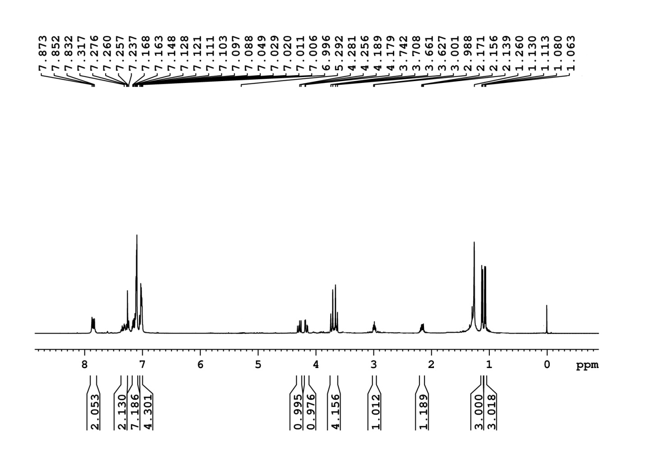

**Figure 1:** 1H NMR recorded in CDCl3



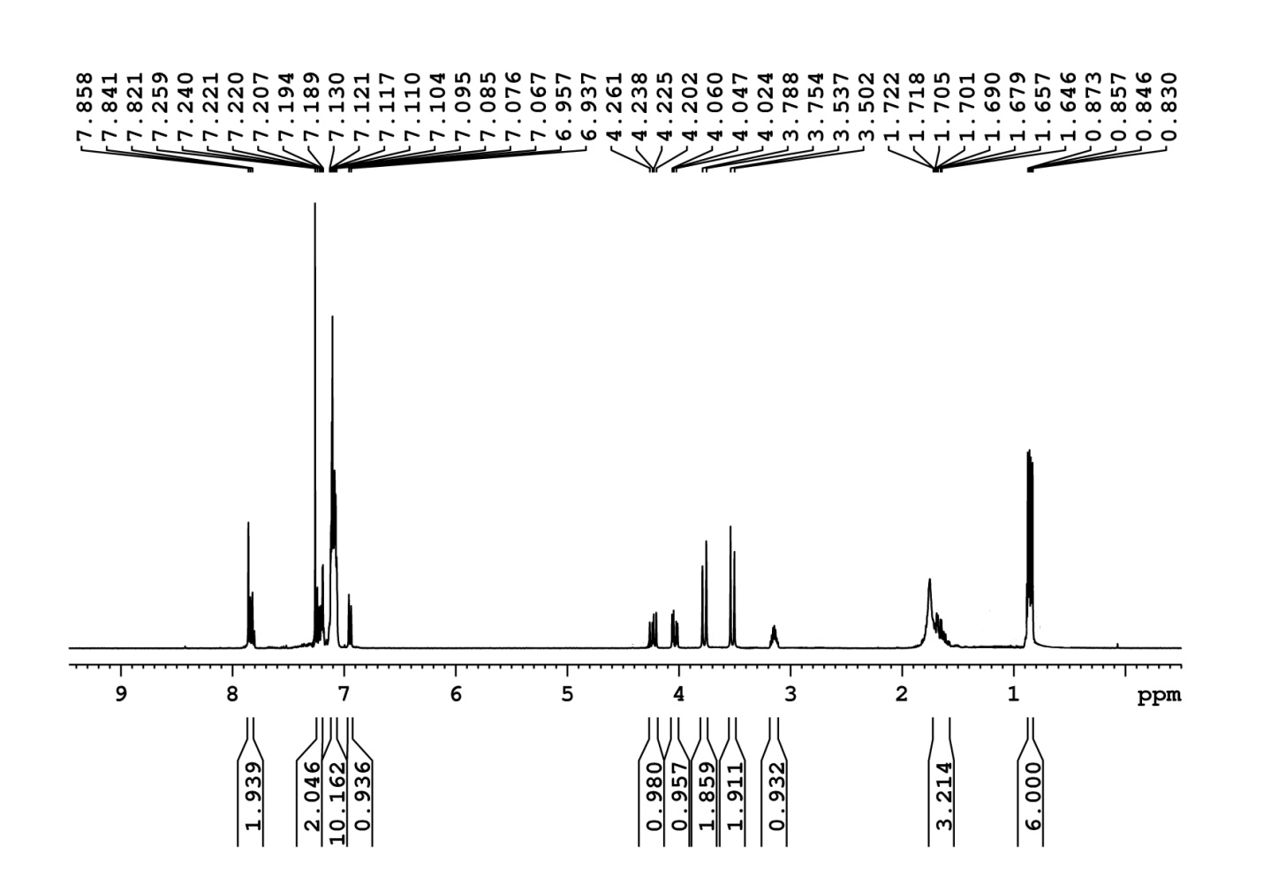

**Figure 2:** 1H NMR recorded in CDCl3



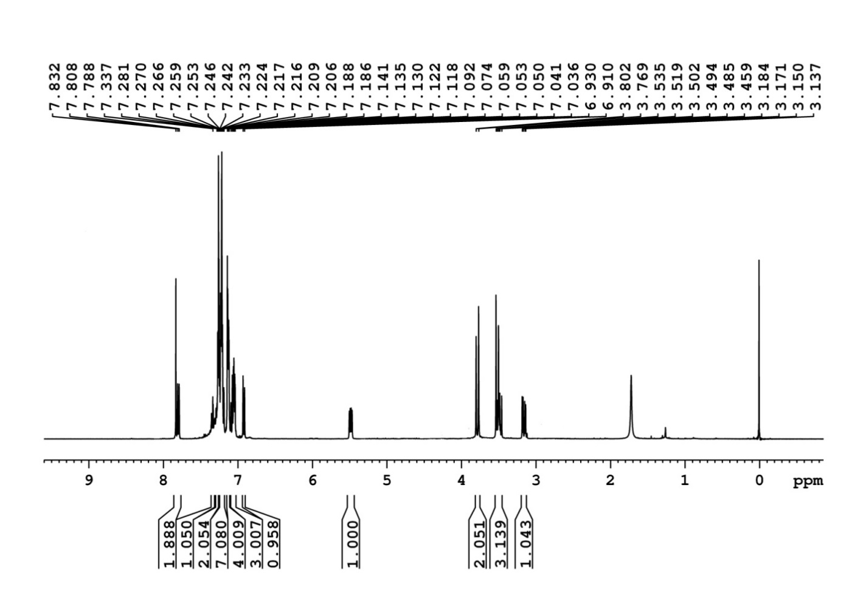

**Figure 3:** 1H NMR recorded in CDCl3



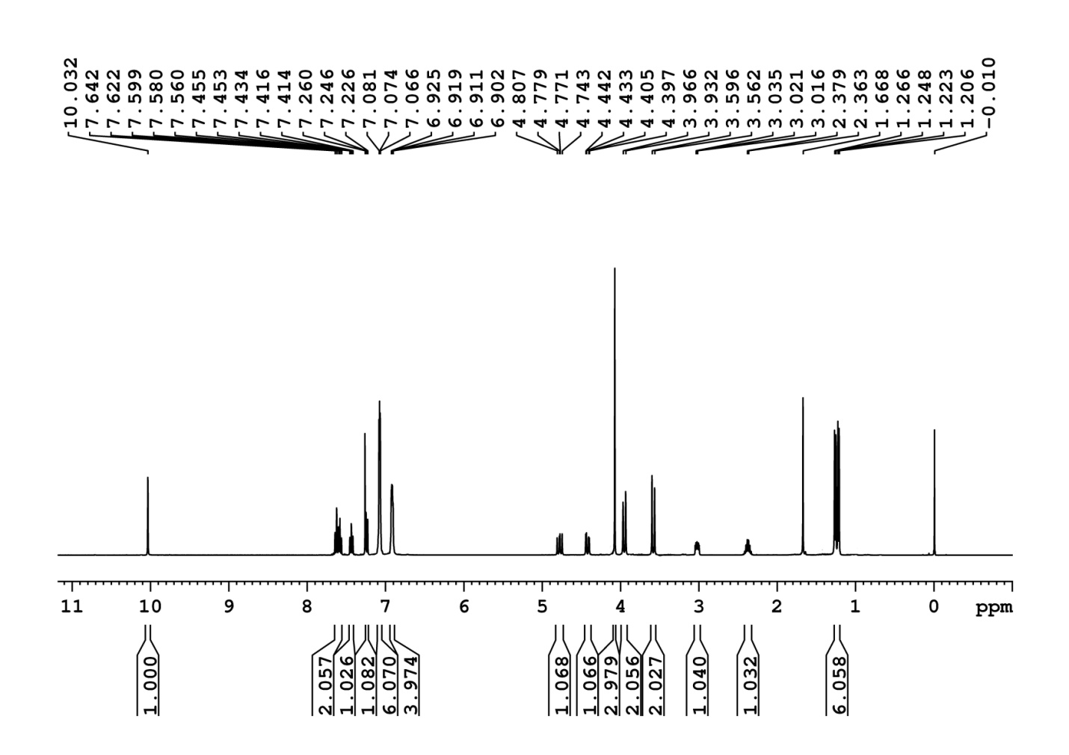

**Figure 4:** 1H NMR recorded in CDCl3



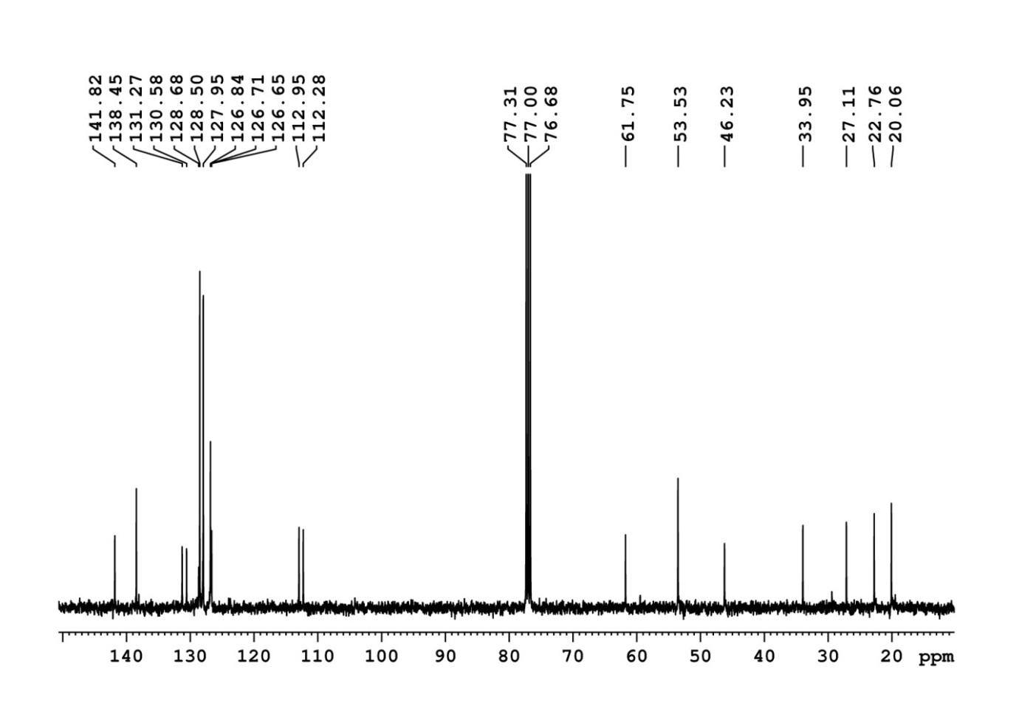

**Figure 5:** 13C NMR recorded in CDCl3



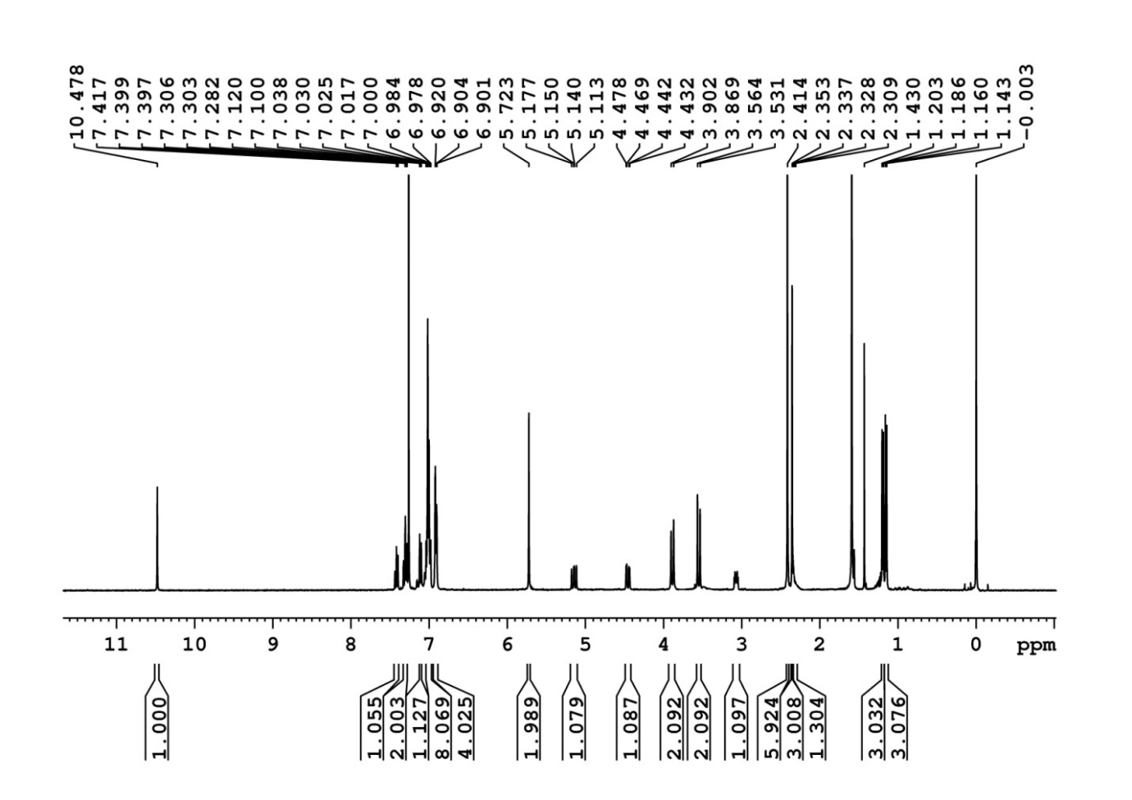

**Figure 6:** 1H NMR recorded in CDCl3



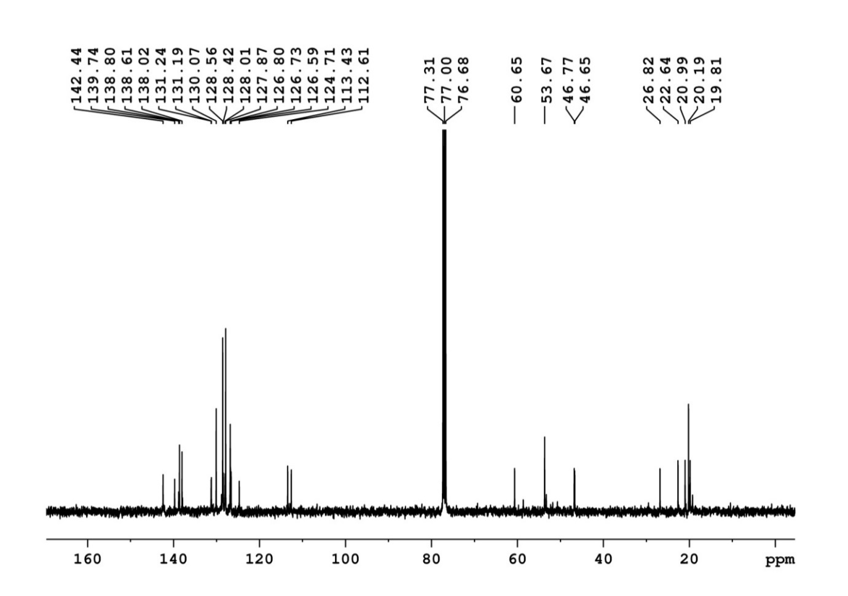

**Figure 7:** 13C NMR recorded in CDCl3



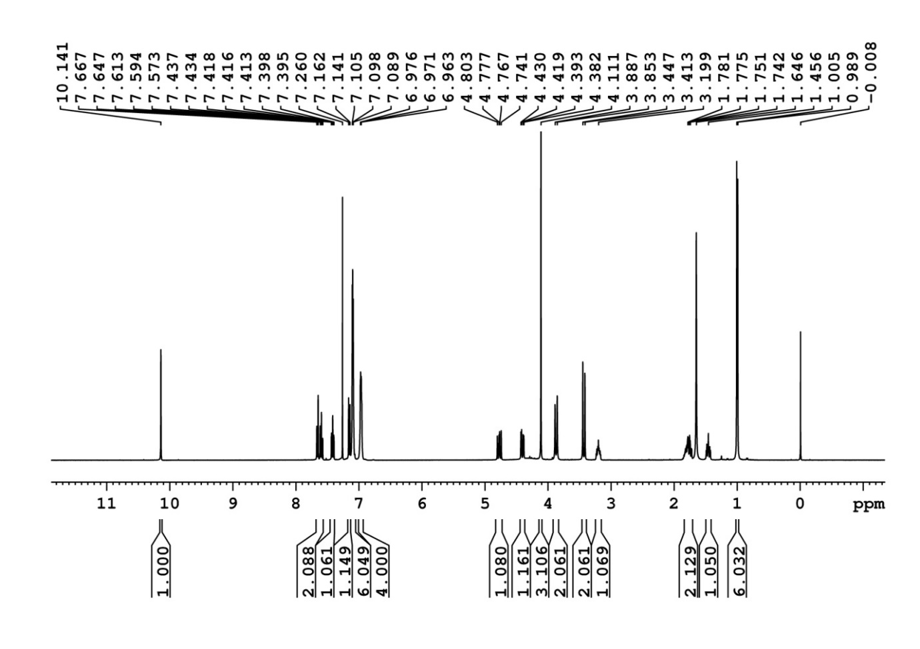

**Figure 8:** 1H NMR recorded in CDCl3



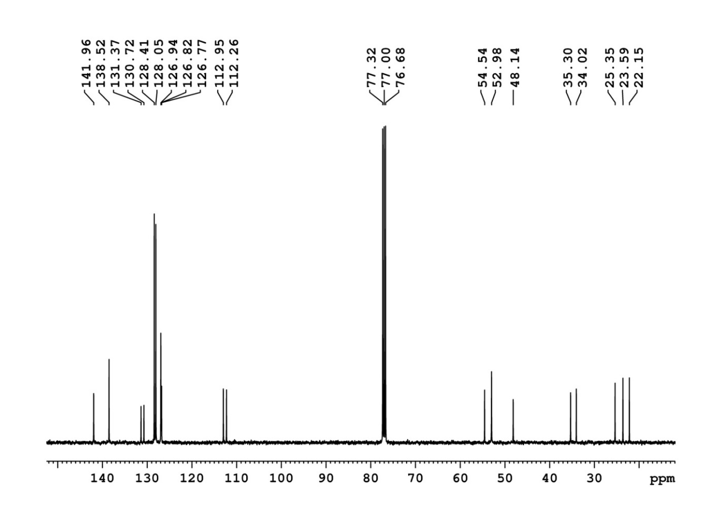

**Figure 9:** 13C NMR recorded in CDCl3



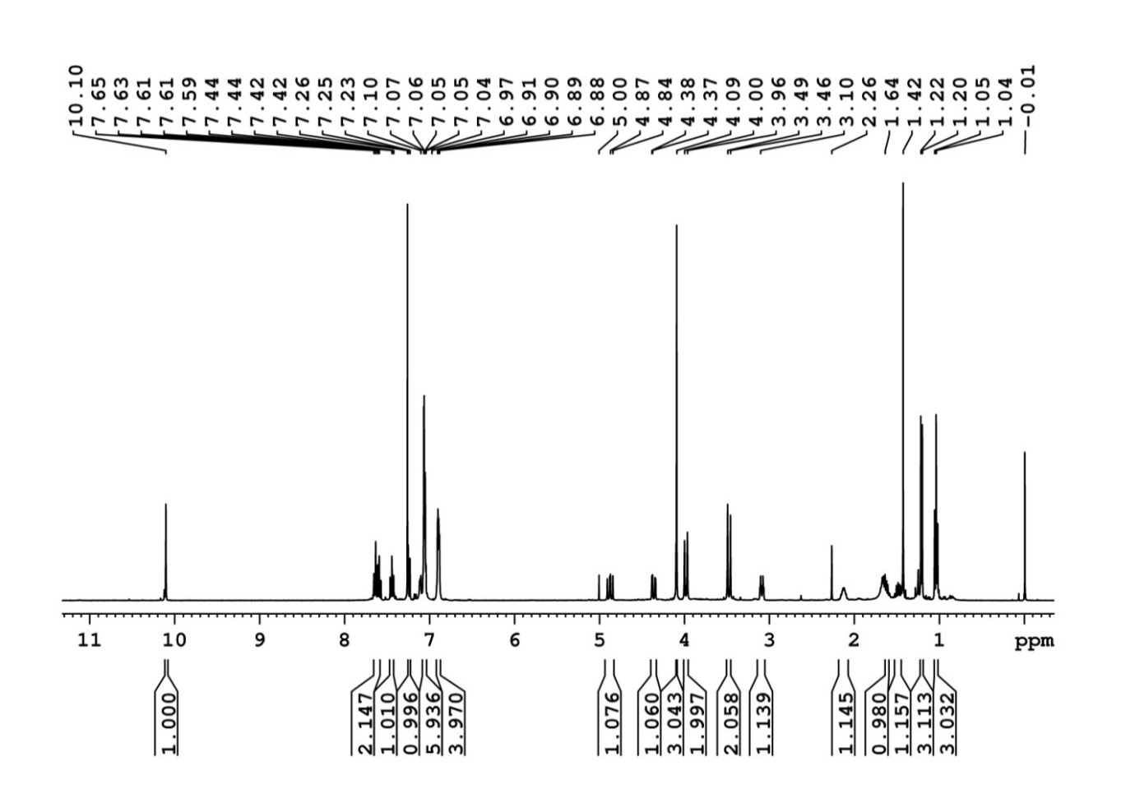

**Figure 10:** 1H NMR recorded in CDCl3



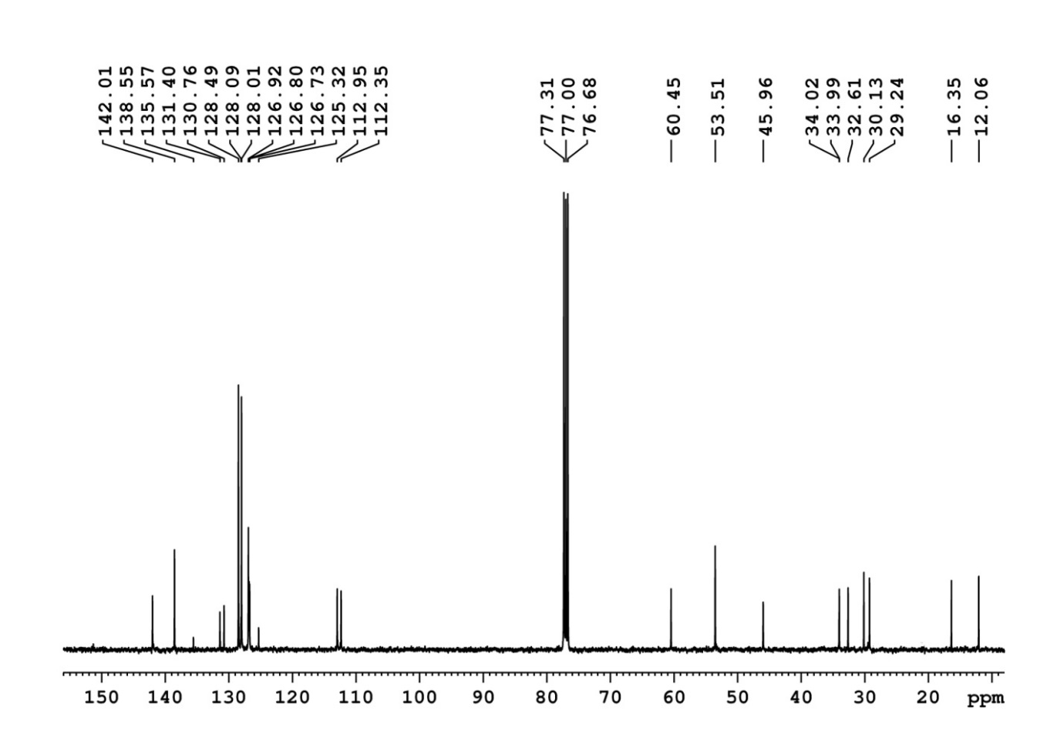

**Figure 11:** 13C NMR recorded in CDCl3



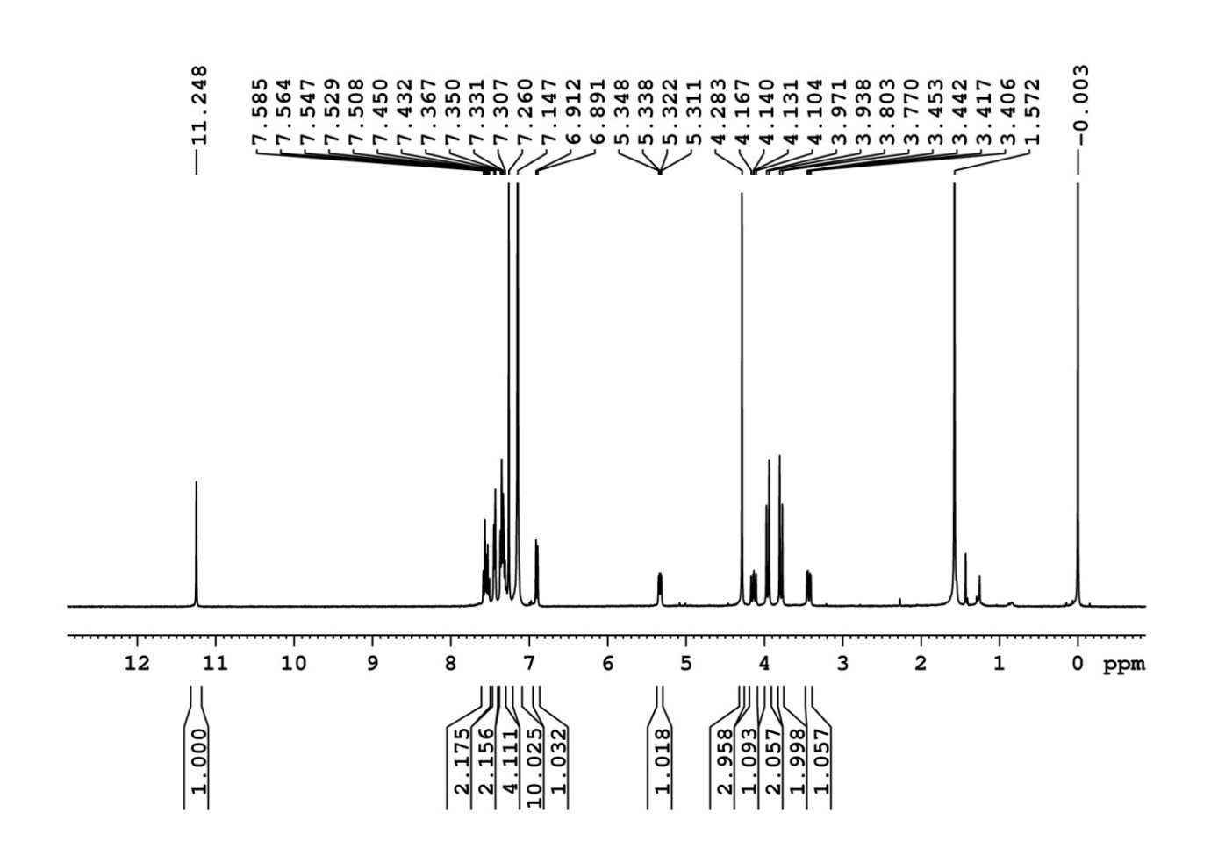

**Figure 12:** 1H NMR recorded in CDCl3



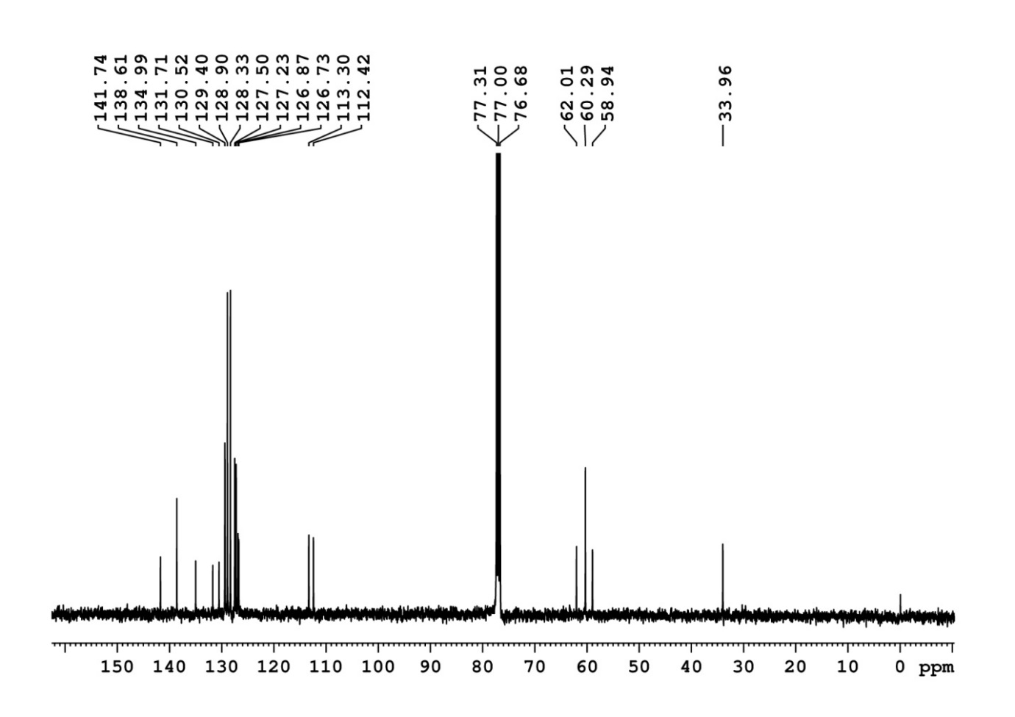

**Figure 13:** 13C NMR recorded in CDCl3



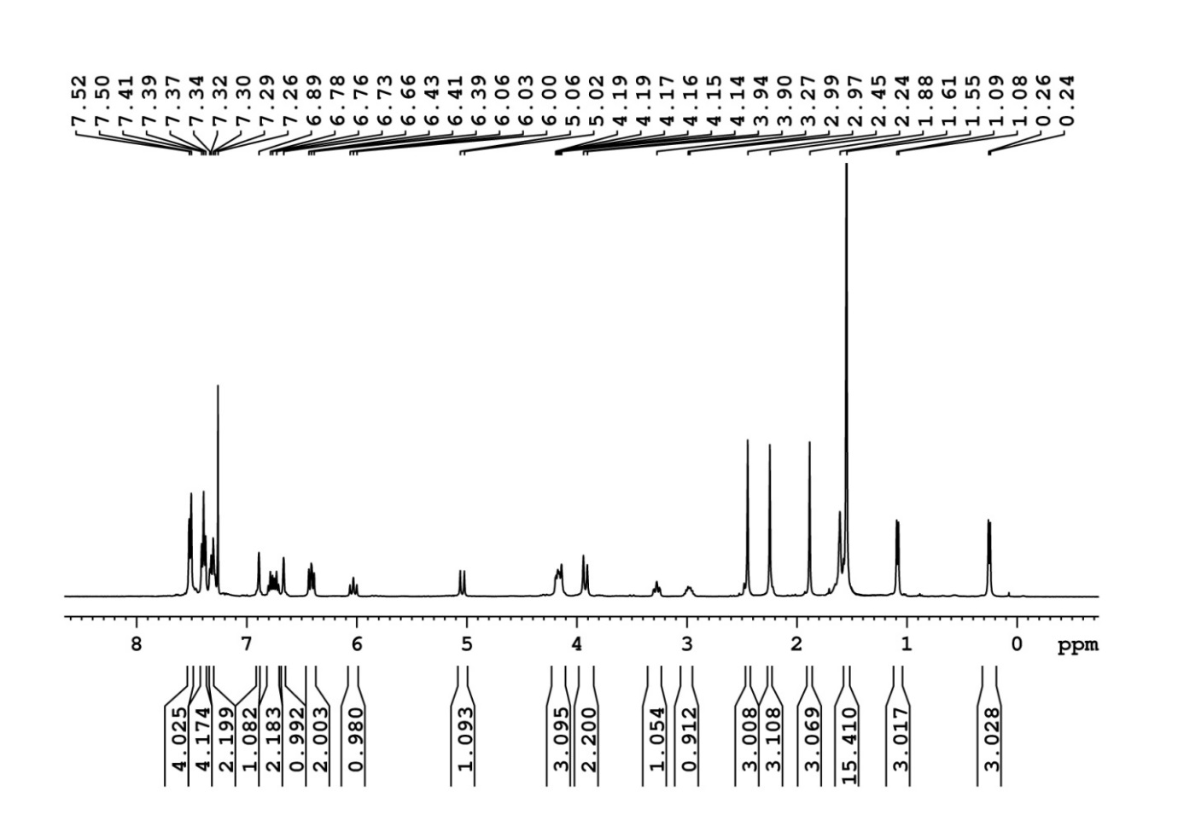

**Figure 14:** 1H NMR recorded in CDCl3



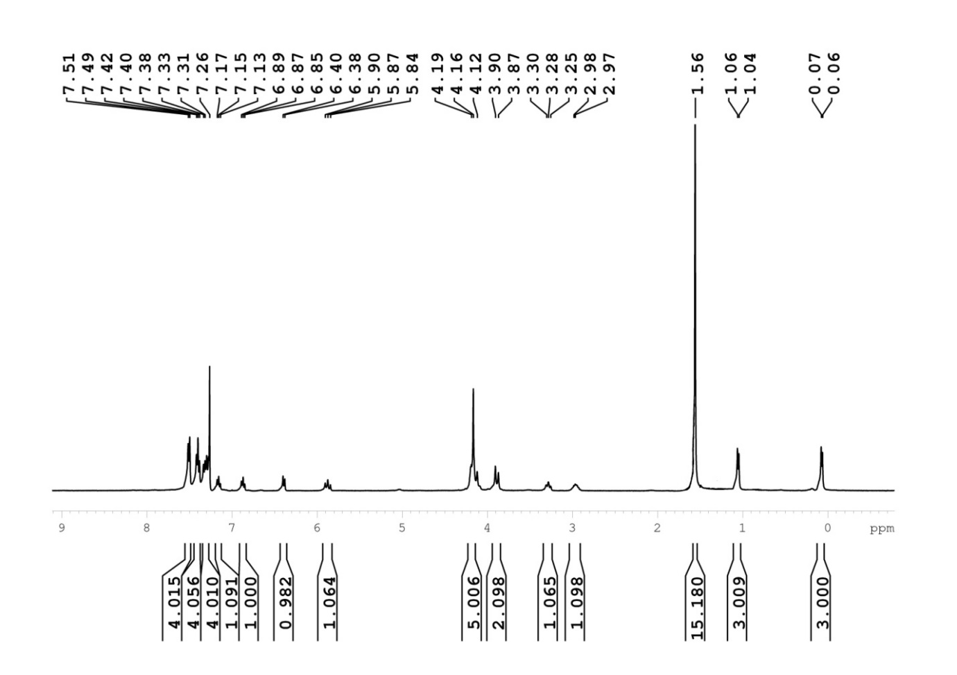

**Figure 15:** 1H NMR recorded in CDCl3



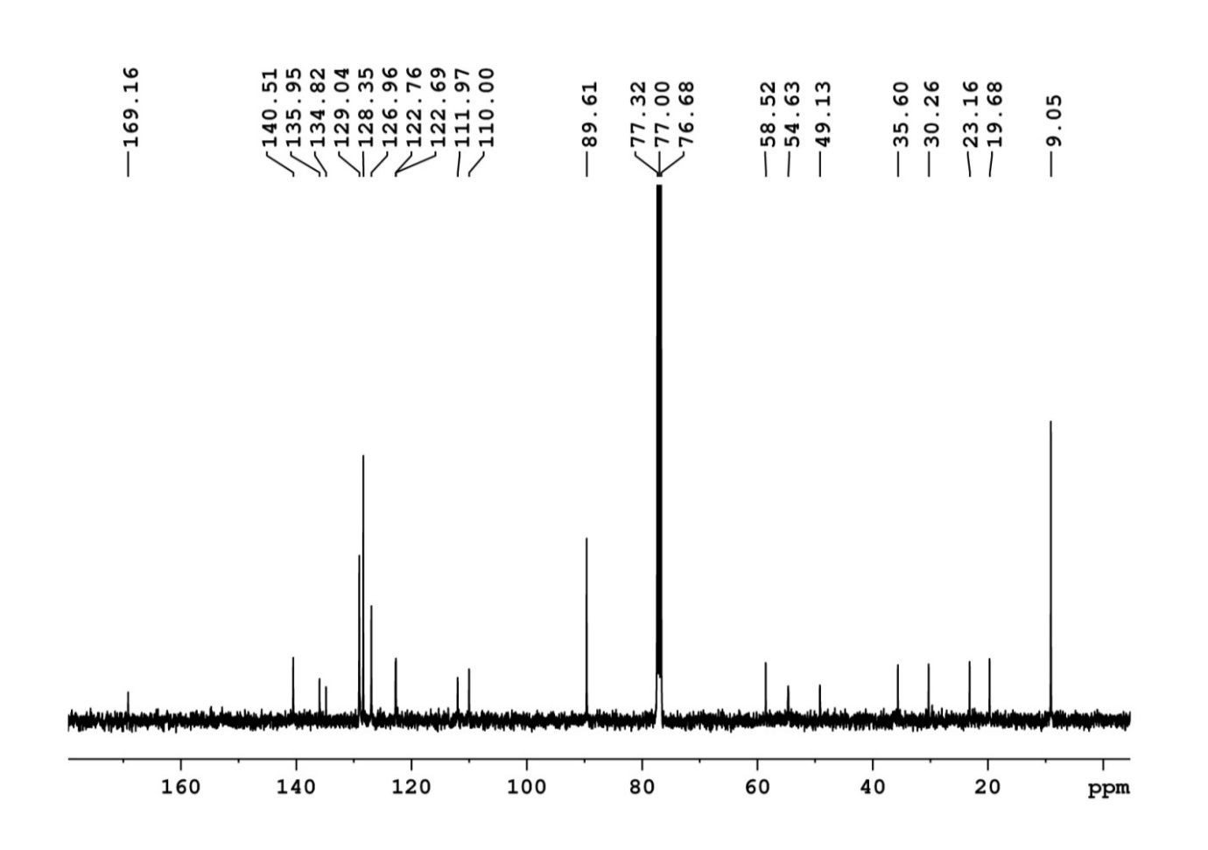

**Figure 16:** 13C NMR recorded in CDCl3



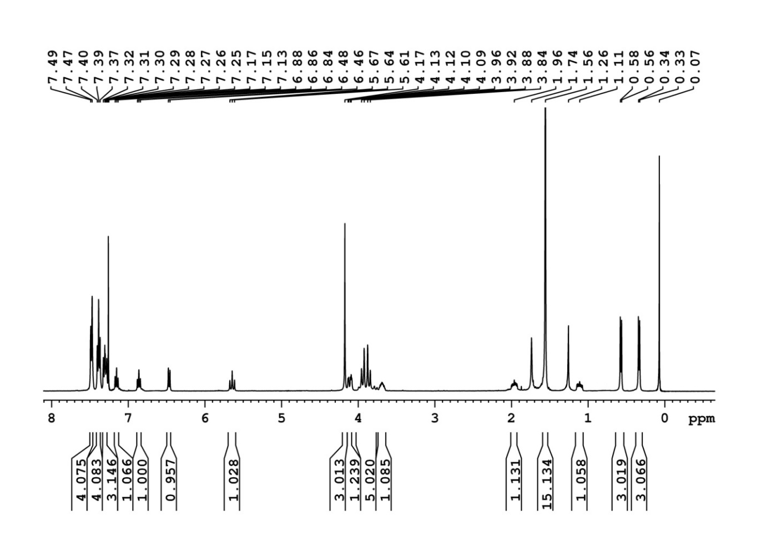

**Figure 17:** 1H NMR recorded in CDCl3



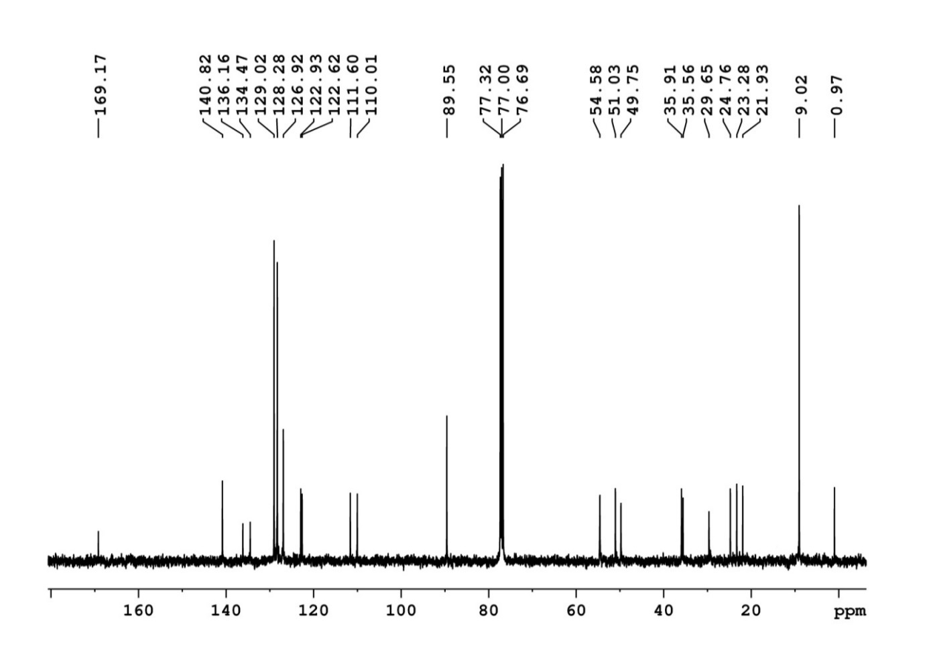

**Figure 18:** 13C NMR recorded in CDCl3



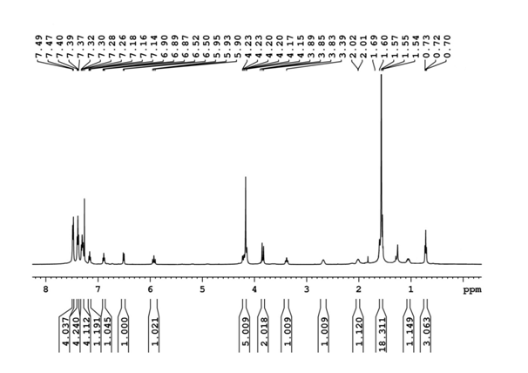

**Figure 19:** 1H NMR recorded in CDCl3



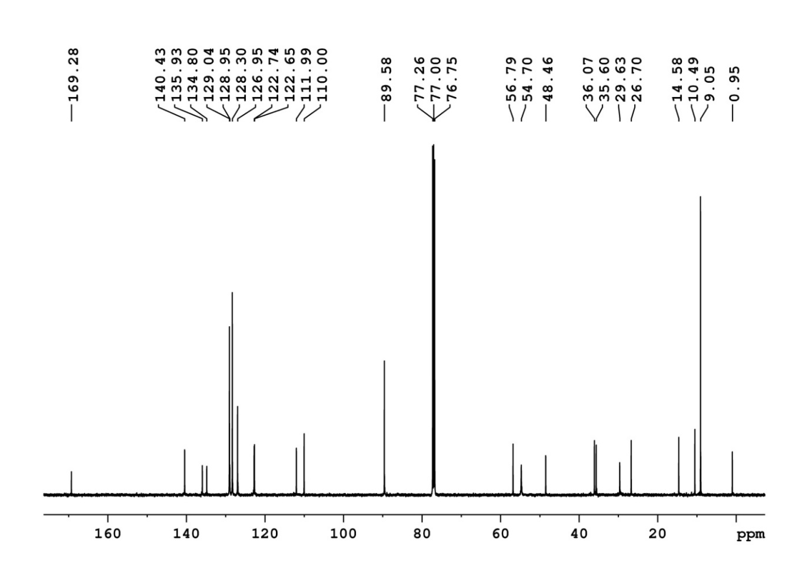

**Figure 20:** 13C NMR recorded in CDCl3



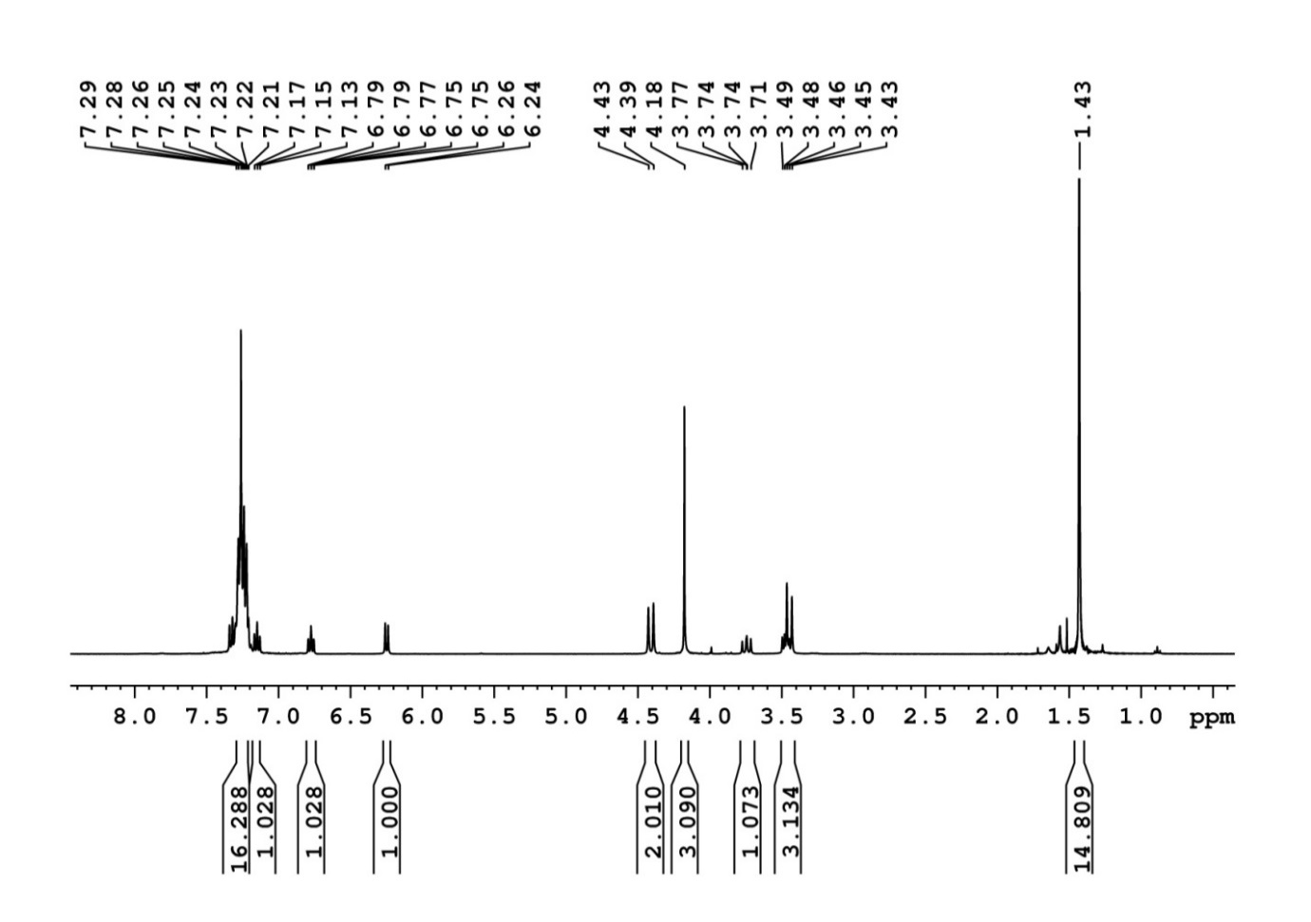

**Figure 21:** 1H NMR recorded in CDCl3



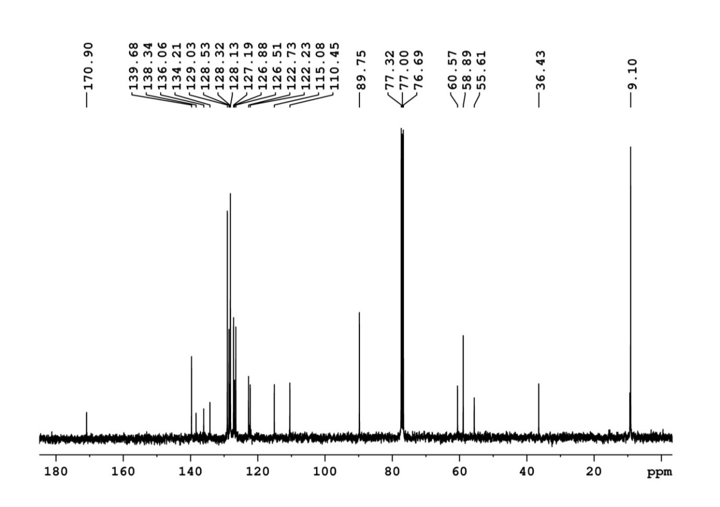

**Figure 22:** 13C NMR recorded in CDCl3

The enantiopurity of the chiral benzimidazolium salt was checked by a method developed by Suryaprakash and co-workers.[16]



**Figure 23:** (a) 1H NMR spectrum of the benzimidazolium salt, 5c. (b) 1H NMR of the mixture of L3 + (*R*-BINOL) + triphenyl borate in the ratio 4:4:1

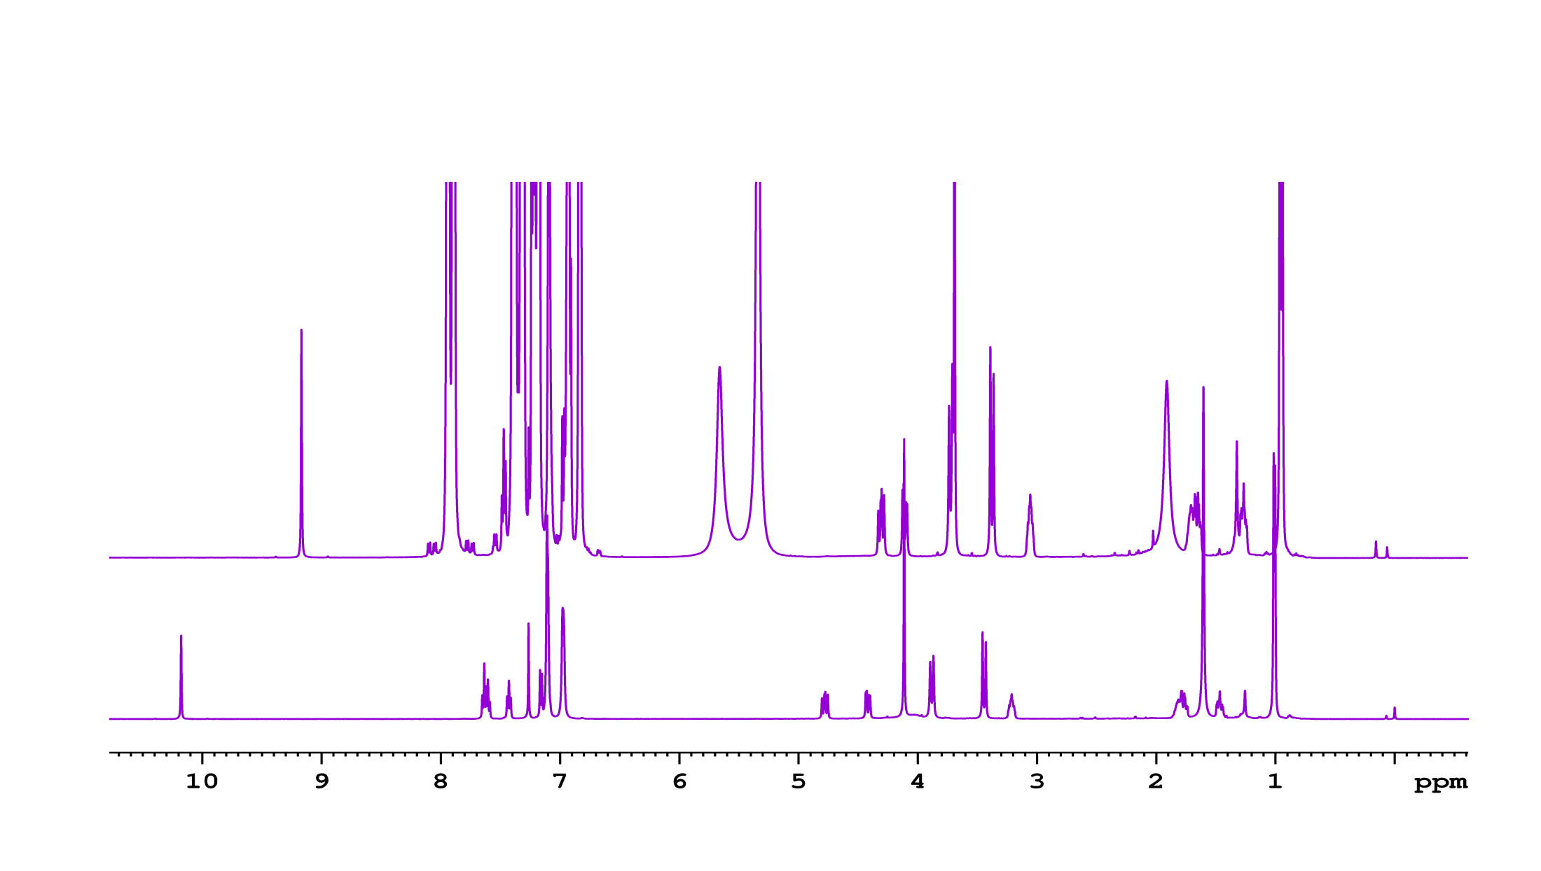

**(a)**

**(b)**

**References:**

[1] P. L. Beaulieu, D. Wernic, *J. Org. Chem.* **1996**, *61*, 3635–3645.

[2] W. Li, G. Hou, M. Chang, X. Zhang, *Adv. Synth. Catal.* **2009**, *351*, 3123–3127.

[3] C. Schmitz, W. Leitner, G. Franciò, *European J. Org. Chem.* **2015**, *2015*, 2889–2901.

[4] A. Chelouan, R. Recio, L. G. Borrego, E. Álvarez, N. Khiar, I. Fernández, *Org. Lett.* **2016**, *18*, 3258–3261.

[5] J. Barluenga, A. Jiménez-Aquino, F. Aznar, C. Valdés, *J. Am. Chem. Soc.* **2009**, *131*, 4031–4041.

[6] W. Iali, F. La Paglia, X. F. Le Goff, D. Sredojevic, M. Pfeffer, J. P. Djukic, *Chem. Commun.* **2012**, *48*, 10310–10312.

[7] M. Amézquita-Valencia, G. A. Suárez-Ortiz, A. Cabrera, *Synth. Commun.* **2013**, *43*, 1947–1954.

[8] M. Amézquita-Valencia, A. Cabrera, *J. Mol. Catal. A Chem.* **2013**, *366*, 17–21.

[9] P. Yang, L. H. Lim, P. Chuanprasit, H. Hirao, J. S. Zhou, *Angew. Chemie - Int. Ed.* **2016**, *55*, 12083–12087.

[10] D. Brenna, R. Porta, E. Massolo, L. Raimondi, M. Benaglia, *ChemCatChem* **2017**, *9*, 941–945.

[11] Y. Zhang, C.-S. Lim, D. S. B. Sim, H.-J. Pan, Y. Zhao, *Angew. Chemie* **2014**, *126*, 1423–1427.

[12] X. Ge, C. Qian, X. Chen, *Tetrahedron Asymmetry* **2014**, *25*, 1450–1455.

[13] X. S. Tu, N. N. Zeng, R. Y. Li, Y. Q. Zhao, D. Z. Xie, Q. Peng, X. C. Wang, *Angew. Chemie - Int. Ed.* **2018**, *57*, 15096–15100.

[14] Q. Wang, J. Chen, X. Feng, H. Du, *Org. Biomol. Chem.* **2018**, *16*, 1448–1451.

[15] W. Pan, Y. Deng, J. B. He, B. Bai, H. J. Zhu, *Tetrahedron* **2013**, *69*, 7253–7257.

[16] S. K. Mishra, S. R. Chaudhari, N. Suryaprakash, *Org. Biomol. Chem.* **2014**, *12*, 495–502.