Endophytic fungus, Chaetomium globosum, associated with marine green alga, a new source of Chrysin
Siya Kamat, Madhuree Kumari, KuttuvanValappilSajna and C. Jayabaskaran*
Department of Biochemistry, Indian Institute of Science, Bangalore-560012, India

*Corresponding author:
Prof. C. Jayabaskaran,
Department of Biochemistry,
Indian Institute of Science, Bangalore-560012,
India,
Tel: +91-80-22932482; Fax: +91-80-23600814;
E-mail: cjb@iisc.ac.in

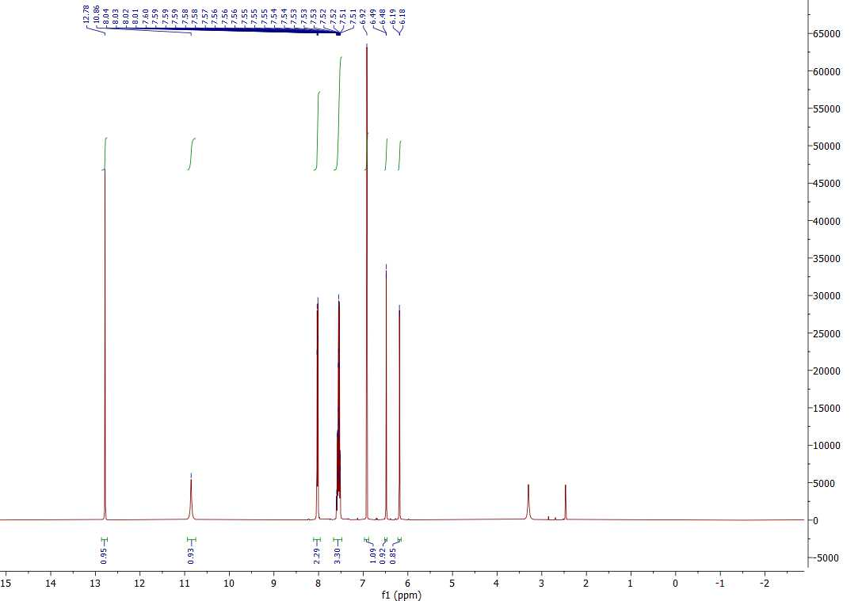
A

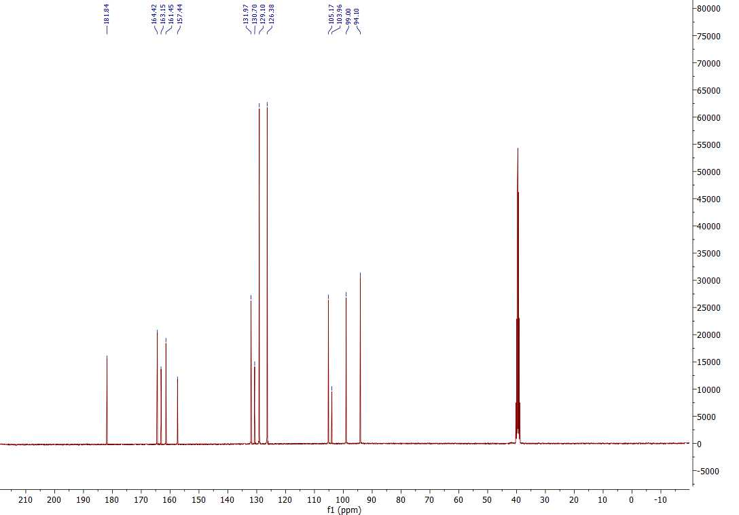
B
Supplementary Figure. ¹H NMR (A) and ¹³C NMR (B) spectra of standard chrysin

SCHR:¹H NMR (400 MHz, DMSO -d6), δ (ppm), 12.78 (1H, s, OH-5), 10.85 (1H, s, OH-7), 8.03 (2H, dd, J = 7.9 Hz and 1.7 Hz, H-2', 6'), 7.55 (3H, m, H-3', 4', 5'), 6.92 (1H, s, H-3), 6.48 (1H, d, J = 2.1 Hz, H-8), 6.19 (1H, d, J = 2.1 Hz, H-6).
¹³C NMR (101 MHz, DMSO-d6), δ (ppm), 163.15 (C-2), 105.17(C-3), 181.84 (C-4), 161.45 (C-5), 99.00 (C-6), 164.42 (C-7), 94.10 (C-8), 157.44 (C-9), 103.96 (C-10), 130.70 (C-1'), 126.38 (C-2', 6'), 129.10 (C-3', 5'), 131.97 (C-4').

References
- Shen CC, Chang YS, Ho LK. Nuclear magnetic resonance studies of 5, 7-dihydroxyflavonoids. Phytochemistry. (1993).
- Chen, L.J., Games, D.E. and Jones, J. Isolation and identification of four flavonoid constituents from the seeds of Oroxylumindicum by high-speed counter-current chromatography. Journal of Chromatography A, 988. 95-105. (2003)

