Endophytic fungus, Chaetomium globosum, associated with marine green alga, a new source of Chrysin
Siya Kamat, Madhuree Kumari, KuttuvanValappilSajna and C. Jayabaskaran*
Department of Biochemistry, Indian Institute of Science, Bangalore-560012, India

*Corresponding author:
Prof. C. Jayabaskaran,
Department of Biochemistry,
Indian Institute of Science, Bangalore-560012,
India,
Tel: +91-80-22932482; Fax: +91-80-23600814;
E-mail: cjb@iisc.ac.in

Supplementary Table 1 (ST1): List of TLC solvent systems used to optimize the best separation of fungal chrysin
Chromatographic system No. | Solvents, ratio
1 | toluene:ethylacetate:formic acid, 36:12:5
2 | cyclohexane:ethylacetate:formic acid, 30:15:5
3 | toluene:ethylacetate:acetic acid, 36:12:5
4 | cyclohexane:ethylacetate:acetic acid, 31:14:5
5 | n-hexane:ethylacetate:formic acid, 31:14:5
6 | toluene:acetone:formic acid, 38:10:5
7 | n-hexane:ethylacetate:acetic acid, 31:14:5
8 | petroleum ether:ethylacetate:formic acid, 30:15:5
9 | carbon tetrachloride:acetone:formic acid, 35:10:5

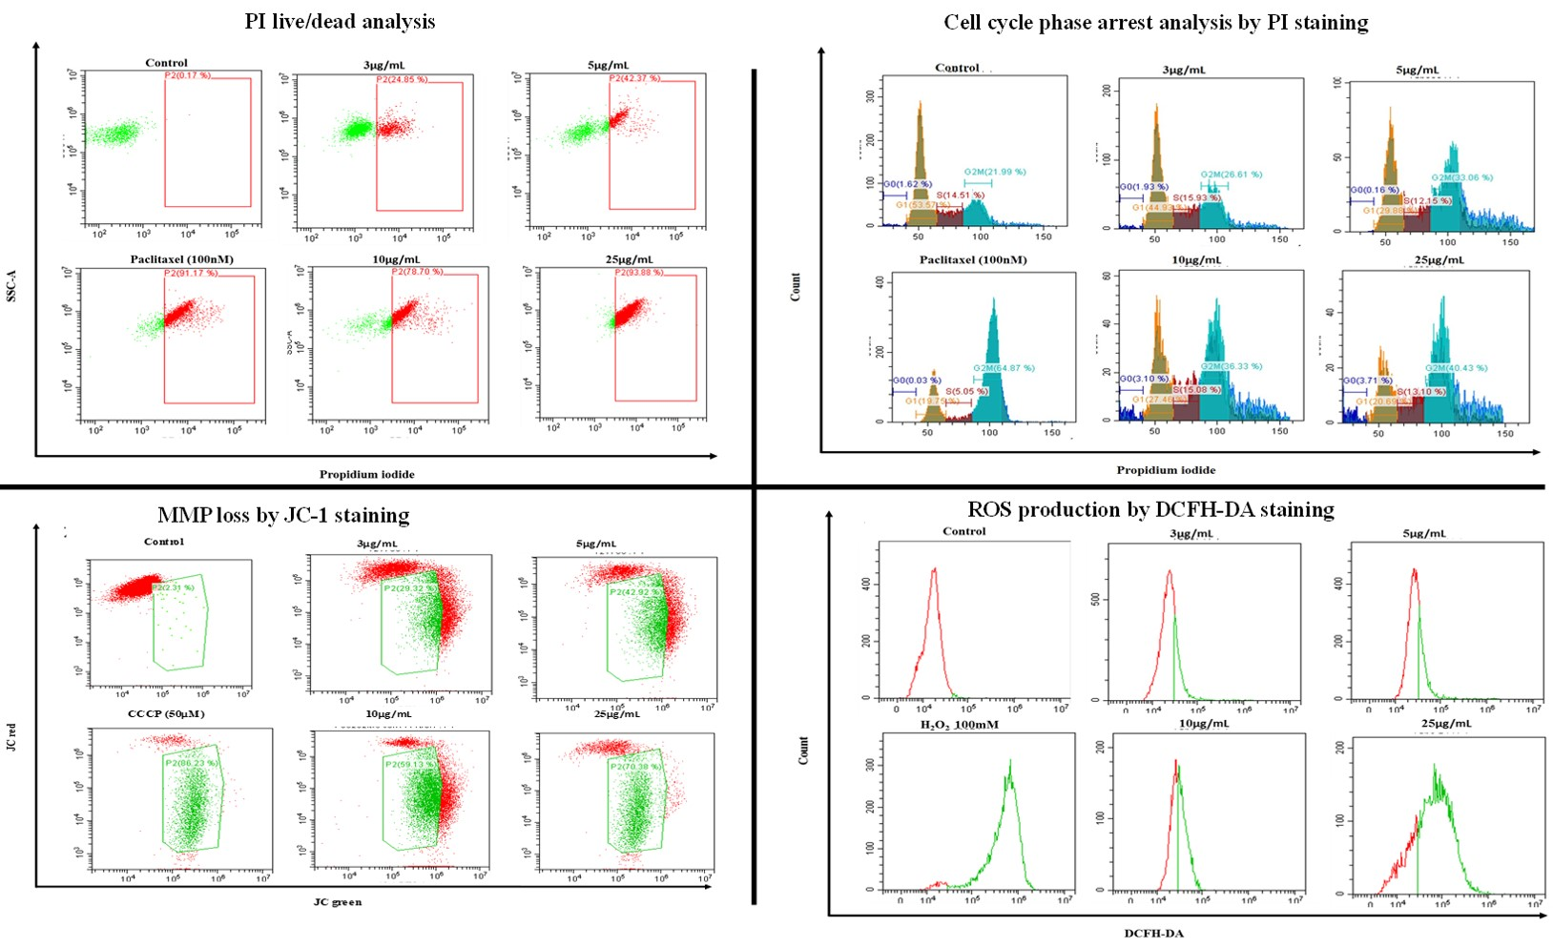
Supplementary Figure 1 (S1): FACS profiles of MCF-7 cells treated with CGEE after 24 h analyzed by PI live/dead assay, distribution of cells in cell cycle phases, loss of MMP and ROS level. Flow cytometry data were quantified using the CytExpert 2.0 software.

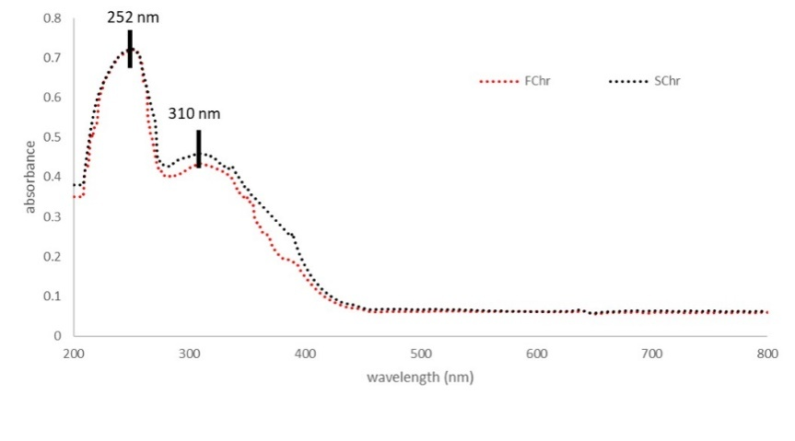
Supplementary Figure 2 (S2): Comparative analysis of UV spectrum of purified compound and SChr. Λmax of 252 nm and 310 nm was observed for both the samples

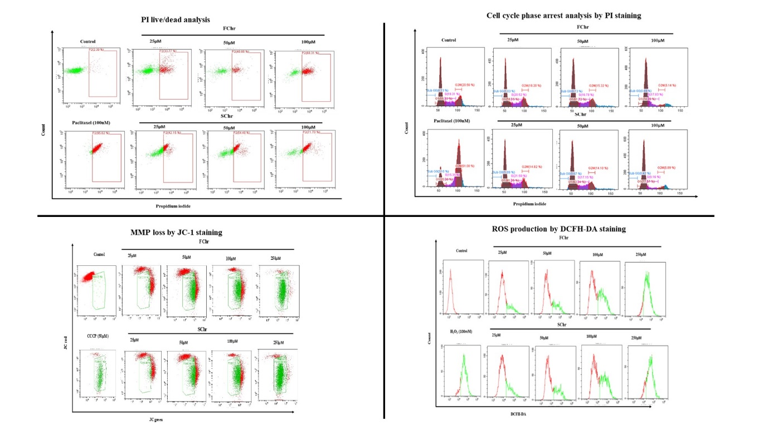

Supplementary Figure 3 (S3): FACS profiles of MCF-7 cells treated with 72 h of FChr and SChr analyzed by PI live/dead assay, distribution of cells in cell cycle phases, loss of MMP and ROS level. Flow cytometry data were quantified using the CytExpert 2.0 software.

