Supporting Information
Redox-active vanadium-based polyoxometalate as an active element in resistive switching based nonvolatile molecular memory
Sterin N. S., Nivedita Basu, Marc Cahay, Satyanarayan M. N., Sib Sankar Mal*, Partha Pratim Das*
Correspondence: malss@nitk.edu.in and daspm@nitk.edu.in

Figure S1: FTIR spectra of sodium decavanadate (Na₆V₁₀O₂₈). The vibrational bands at wavenumbers 988 cm⁻¹ and 956 cm⁻¹ are attributed to V=O bond. The bands at 847 cm⁻¹, 746 cm⁻¹ and 521 cm⁻¹ indicate the V-O-V bond in the SDV.^{[1]}

Figure S2: UV-Visible spectrograph of sodium decavanadate. Bandgap calculated using Tauc equation ^{[2,3]} was found to be 2.7 eV.

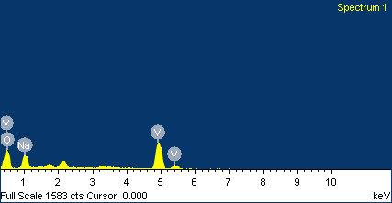

Element | Weight% | Atomic%
O K | 41.29 | 64.42
Na K | 11.44 | 12.42
V K | 47.27 | 23.16
Totals | 100.00

Figure S3: Energy-dispersive X-ray spectroscopy (EDX) showing presence of different elements present in sodium decavanadate crystals.

Figure S4: A typical current-voltage (I-V) plot of our Glass/ITO/ Na₆V₁₀O₂₈/Cr/Au RRAM cell recorded after 12 months. We observed only slight increase in set voltage; rest all switching behavior found to remain same.

Figure S5: Uniform and repetitive current-voltage (I-V) characteristics recorded for 50 cycles.

Figure S6: Cyclic voltammogram of Na₆V₁₀O₂₈ showing only pair of peaks for redox behavior.

References
[1] Han‐Yi Chen, Grace Wee, Rami Al‐Oweini, Jochen Friedl, Kim Soon Tan, Yuxi Wang, Chui Ling Wong, Ulrich Kortz, Ulrich Stimming, and Madhavi Srinivasan, ChemPhysChem. 2014,15, 2162.

[2] Jennifer B. Coulter, Dunbar P. Birnie III Physica Status Solidi (b) 2018, 255, 1700393.
[3] S. Laidoudi, A. Y. Bioud, A Azizi, G. Schmerber, J. Bartringer, S. Barre, A. Dinia Semiconductor Science and Technology. 2013, 28, 115005.

