The Andaman day gecko paradox: an ancient endemic without pronounced phylogeographic structure

Ashwini V. Mohan^{1,2 *}, email id: ashwinivm30@gmail.com
Pablo Orozco-terWengel³, email id: orozco-terwengelpa@cardiff.ac.uk
Kartik Shanker², email id: kshanker@gmail.com
Miguel Vences¹, email id: m.vences@tu-braunschweig.de

Species | Genetic marker | No. of samples | No. of alleles | No. of Median vectors | No. of Private alleles | No. of shared alleles | Maximum uncorrected p distance among alleles
Phelsuma andamanensis | COI | 123 | 25 | 0 | 17 | 8 | 1.6%
Phelsuma andamanensis | 16S | 17 | 6 | 1 | 4 | 2 | 0.9%
Cyrtodactylus rubidus | 16S | 13 | 10 | 5 | 10 | 0 | 1.83%
Gekko verreauxi | 16S | 12 | 4 | 1 | 3 | 1 | 1.16%
Xenochrophis tytleri | 16S | 17 | 7 | 0 | 6 | 1 | 0.71%

Table 1: Summarizing mitochondrial haplotype information from all the four species compared in this study.

Locus | Locus | NA | MA | BA | HA | SA | LA
Pand2 | Pand6 | 1.00 | 1.00 | _ | _ | _ | _
Pand2 | Pand8 | 0.60 | 1.00 | _ | _ | _ | _
Pand6 | Pand8 | 1.00 | 1.00 | _ | _ | 0.02 | _
Pand2 | Pand10 | 1.00 | 1.00 | _ | _ | _ | _
Pand6 | Pand10 | 1.00 | 1.00 | 1.00 | 0.17 | 1.00 | _
Pand8 | Pand10 | 1.00 | 1.00 | _ | _ | _ | _
Pand2 | Pand12 | 1.00 | 1.00 | _ | _ | _ | _
Pand6 | Pand12 | 1.00 | 1.00 | 1.00 | 0.10 | 1.00 | _
Pand8 | Pand12 | 1.00 | 1.00 | _ | _ | 1.00 | _
Pand10 | Pand12 | 1.00 | 1.00 | 1.00 | 0.18 | 1.00 | _
Pand2 | Pand13 | 1.00 | 1.00 | _ | _ | _ | _
Pand6 | Pand13 | 1.00 | 0.30 | _ | 0.11 | 1.00 | _
Pand8 | Pand13 | 1.00 | 1.00 | _ | _ | 1.00 | _
Pand10 | Pand13 | 1.00 | 1.00 | _ | 0.06 | 1.00 | _
Pand12 | Pand13 | 0.29 | 1.00 | _ | 0.11 | 0.03 | _
Pand2 | Pand15 | 1.00 | 1.00 | _ | _ | _ | _
Pand6 | Pand15 | 1.00 | 1.00 | _ | 0.12 | 1.00 | _
Pand8 | Pand15 | 1.00 | 1.00 | _ | _ | 1.00 | _
Pand10 | Pand15 | 1.00 | 1.00 | _ | 0.11 | 1.00 | _
Pand12 | Pand15 | 0.18 | 1.00 | _ | 0.23 | 1.00 | _
Pand13 | Pand15 | 1.00 | 1.00 | _ | 0.08 | 1.00 | _
Pand2 | Pand16 | 0.26 | 0.14 | _ | _ | _ | _
Pand6 | Pand16 | 1.00 | 0.69 | 1.00 | 0.27 | 1.00 | _
Pand8 | Pand16 | 0.14 | 0.50 | _ | _ | 1.00 | _
Pand10 | Pand16 | 1.00 | 1.00 | 1.00 | 0.36 | 1.00 | _
Pand12 | Pand16 | 0.49 | 1.00 | 1.00 | 0.53 | 1.00 | _
Pand13 | Pand16 | 0.16 | 0.05 | _ | 0.19 | 1.00 | 0.29
Pand15 | Pand16 | 1.00 | 1.00 | _ | 0.40 | 1.00 | _
Pand2 | Pand17 | _ | 1.00 | _ | _ | _ | _
Pand6 | Pand17 | 1.00 | 1.00 | _ | 0.09 | _ | _
Pand8 | Pand17 | 1.00 | 1.00 | _ | _ | _ | _
Pand10 | Pand17 | 1.00 | 0.21 | _ | 0.08 | _ | _
Pand12 | Pand17 | 1.00 | 1.00 | _ | 0.09 | _ | _
Pand13 | Pand17 | 1.00 | 1.00 | _ | 0.04 | _ | _
Pand15 | Pand17 | 1.00 | 1.00 | _ | 0.09 | _ | _
Pand16 | Pand17 | 1.00 | 1.00 | _ | 0.17 | _ | _
Pand2 | Pand19 | 1.00 | 1.00 | _ | _ | _ | _
Pand6 | Pand19 | 1.00 | 1.00 | _ | 0.06 | _ | _
Pand8 | Pand19 | 1.00 | 1.00 | _ | _ | _ | _
Pand10 | Pand19 | 1.00 | 1.00 | _ | 0.08 | _ | _
Pand12 | Pand19 | 1.00 | 1.00 | _ | 0.11 | _ | _
Pand13 | Pand19 | 1.00 | 0.65 | _ | 0.04 | _ | _
Pand15 | Pand19 | 1.00 | 1.00 | _ | 0.09 | _ | _
Pand16 | Pand19 | 0.06 | 0.16 | _ | 0.19 | _ | _
Pand17 | Pand19 | 1.00 | 1.00 | _ | 0.04 | _ | _
Pand2 | Pand23 | 1.00 | 1.00 | _ | _ | _ | _
Pand6 | Pand23 | 0.60 | 1.00 | 1.00 | 0.29 | _ | _
Pand8 | Pand23 | 1.00 | 1.00 | _ | _ | _ | _
Pand10 | Pand23 | 1.00 | 0.55 | _ | 0.23 | _ | _
Pand12 | Pand23 | 1.00 | 1.00 | 1.00 | 0.33 | _ | _
Pand13 | Pand23 | 1.00 | 1.00 | _ | 0.09 | _ | _
Pand15 | Pand23 | 1.00 | 1.00 | _ | 0.27 | _ | _
Pand16 | Pand23 | 0.43 | 1.00 | 1.00 | 0.62 | _ | _
Pand17 | Pand23 | 1.00 | 1.00 | _ | 0.11 | _ | _
Pand19 | Pand23 | 1.00 | 1.00 | _ | 0.13 | _ | _
Pand2 | Pand4 | 1.00 | 1.00 | _ | _ | _ | _
Pand6 | Pand4 | 1.00 | 1.00 | _ | _ | _ | _
Pand8 | Pand4 | 1.00 | 1.00 | _ | _ | _ | _
Pand10 | Pand4 | 1.00 | 1.00 | _ | _ | _ | _
Pand12 | Pand4 | 1.00 | 1.00 | _ | _ | _ | _
Pand13 | Pand4 | 1.00 | 1.00 | _ | _ | _ | _
Pand15 | Pand4 | 1.00 | 1.00 | _ | _ | _ | _
Pand16 | Pand4 | 1.00 | 1.00 | _ | _ | _ | _
Pand17 | Pand4 | 1.00 | 1.00 | _ | _ | _ | _
Pand19 | Pand4 | 1.00 | 1.00 | _ | _ | _ | _
Pand23 | Pand4 | 0.00 | 1.00 | _ | _ | _ | _
Pand2 | Pand9 | 1.00 | 1.00 | _ | _ | _ | _
Pand6 | Pand9 | 1.00 | 1.00 | _ | _ | _ | _
Pand8 | Pand9 | 1.00 | 1.00 | _ | _ | _ | _
Pand10 | Pand9 | 1.00 | 1.00 | _ | _ | _ | _
Pand12 | Pand9 | 1.00 | 1.00 | _ | _ | _ | _
Pand13 | Pand9 | 1.00 | 1.00 | _ | _ | _ | _
Pand15 | Pand9 | 1.00 | 1.00 | _ | _ | _ | _
Pand16 | Pand9 | 1.00 | 1.00 | _ | _ | _ | _
Pand17 | Pand9 | 1.00 | 0.16 | _ | _ | _ | _
Pand19 | Pand9 | 1.00 | 0.15 | _ | _ | _ | _
Pand23 | Pand9 | 1.00 | 0.22 | _ | _ | _ | _
Pand4 | Pand9 | 1.00 | 1.00 | _ | _ | _ | _

Table 2: Pairwise microsatellite marker comparison to test presence of Linkage disequilibrium calculated using Genepop implementing Fisher’s method. Columns contain permutated p values for pairwise tests among North Andaman Island (NorA), Middle Andaman (MA), Baratang (BA), Havelock (HA), South Andaman (SA) and Little Andaman (LA) populations. No LD calculations were feasible for small island populations of Long, Interview and Neil islands. Significance of the test inferred using FDR corrected p value (p =₋0.010121). A hyphen is shown for the pairwise comparisons where the linkage could not be estimated.

 | chi^2 | df | Pr(chi^2>) | Pr,exact
Pand2 | 384,2093 | 351 | 1,07E-01 | 0,6806
Pand6 | 134,5354 | 120 | 1,72E-01 | 0,822
Pand8 | 400,2127 | 300 | 9,41E-05 | 0,199
Pand10 | 351,0031 | 325 | 1,54E-01 | 0,415
Pand12 | 497,8007 | 406 | 1,22E-03 | 0,118
Pand13 | 172,4645 | 136 | 1,88E-02 | 0,006
Pand15 | 343,7425 | 325 | 2,27E-01 | 0,025
Pand16 | 117,7154 | 91 | 3,13E-02 | 0,121
Pand17 | 1286,031 | 1176 | 1,34E-02 | 0,01
Pand19 | 105,684 | 136 | 9,75E-01 | 0,81
Pand23 | 234,2445 | 190 | 1,59E-02 | 0,035
Pand4 | 231,2758 | 253 | 8,33E-01 | 0,445
Pand9 | 285,0727 | 171 | 9,99E-08 | 0,002

Table 3: Results from test for Hardy-Weinberg Equilibrium of all the 13 microsatellite markers used in this study; calculated using both χ2-test and exact test using the package pegas in R; highlighted p values after FDR correction with p = 0.015723
 | MA | NorA | SA | HA | LA | BA
Pand2 | 0,275 | 0,792 | 0,082 | 1 | 1 | 1
Pand6 | 0,386 | 0,988 | 0,76 | 0,196 | 0,232 | 0,457
Pand8 | 0,124 | 0,294 | 0,05 | 1 | 1 | 0,787
Pand10 | 0,356 | 0,918 | 0,029 | 0,101 | 1 | 0,564
Pand12 | 0,286 | 0,006 | 0,358 | 0,026 | 0,071 | 0,546
Pand13 | 0,079 | 0,074 | 0,759 | 0,54 | 1 | 0,876
Pand15 | 0,413 | 0,164 | 0,09 | 0,308 | 0,036 | 0,888
Pand16 | 0,281 | 0,166 | 0,191 | 0,04 | 1 | 0,986
Pand17 | 0,005 | 0,12 | 0,443 | 0,02 | 1 | 1
Pand19 | 0,838 | 0,059 | 1 | 0,088 | 0,751 | 0,661
Pand23 | 0,218 | 0,02 | 0,505 | 0,089 | 1 | 0,772
Pand4 | 0,275 | 0,908 | 1 | 0,826 | 0,778 | 0,699
pand9 | 0,041 | 0 | 1 | 1 | 0,589 | 1

Table 4: Results from test for Hardy-Weinberg equilibrium of microsatellite markers from all sampled islands populations of the Andaman Islands, results from PopGenReport package in R, highlighted p values after FDR correction with p = 0.009357

Marker | Frequency of null allele
Pand2 | 0,01
Pand6 | 0,00
Pand8 | 0,02
Pand10 | 0,02
Pand12 | 0,05
Pand13 | 0,03
Pand15 | 0,03
Pand16 | 0,04
Pand17 | 0,03
Pand19 | 0,01
Pand23 | 0,03
Pand4 | 0,04
Pand9 | 0,16

Table 5: Table with estimated null allele frequencies estimated from Summers & Amos, 1997’s method applied in Cervus

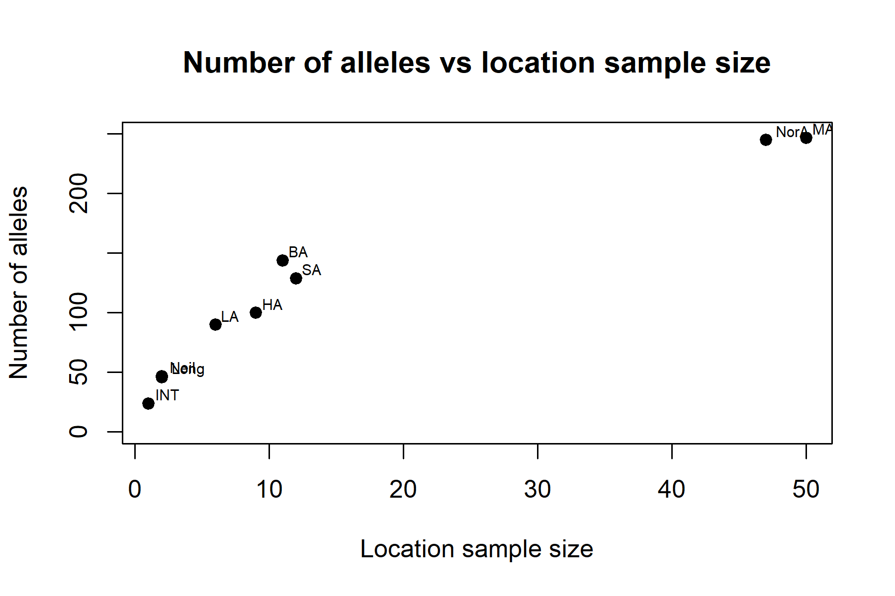

Figure 1: Plot depicting sample size from each island populations versus the number of alleles detected using microsatellite markers

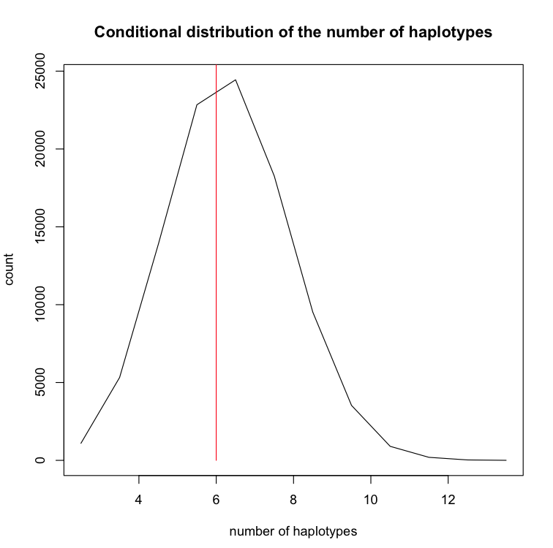

Figure 2: Histogram indicating where the observed 16S results from 17 samples of the Andaman day gecko (Phelsuma andamanensis; red line) falls within the distribution of random samples of 17 COI haplotypes randomly drawn from the set of 123 sequences in this paper’s dataset

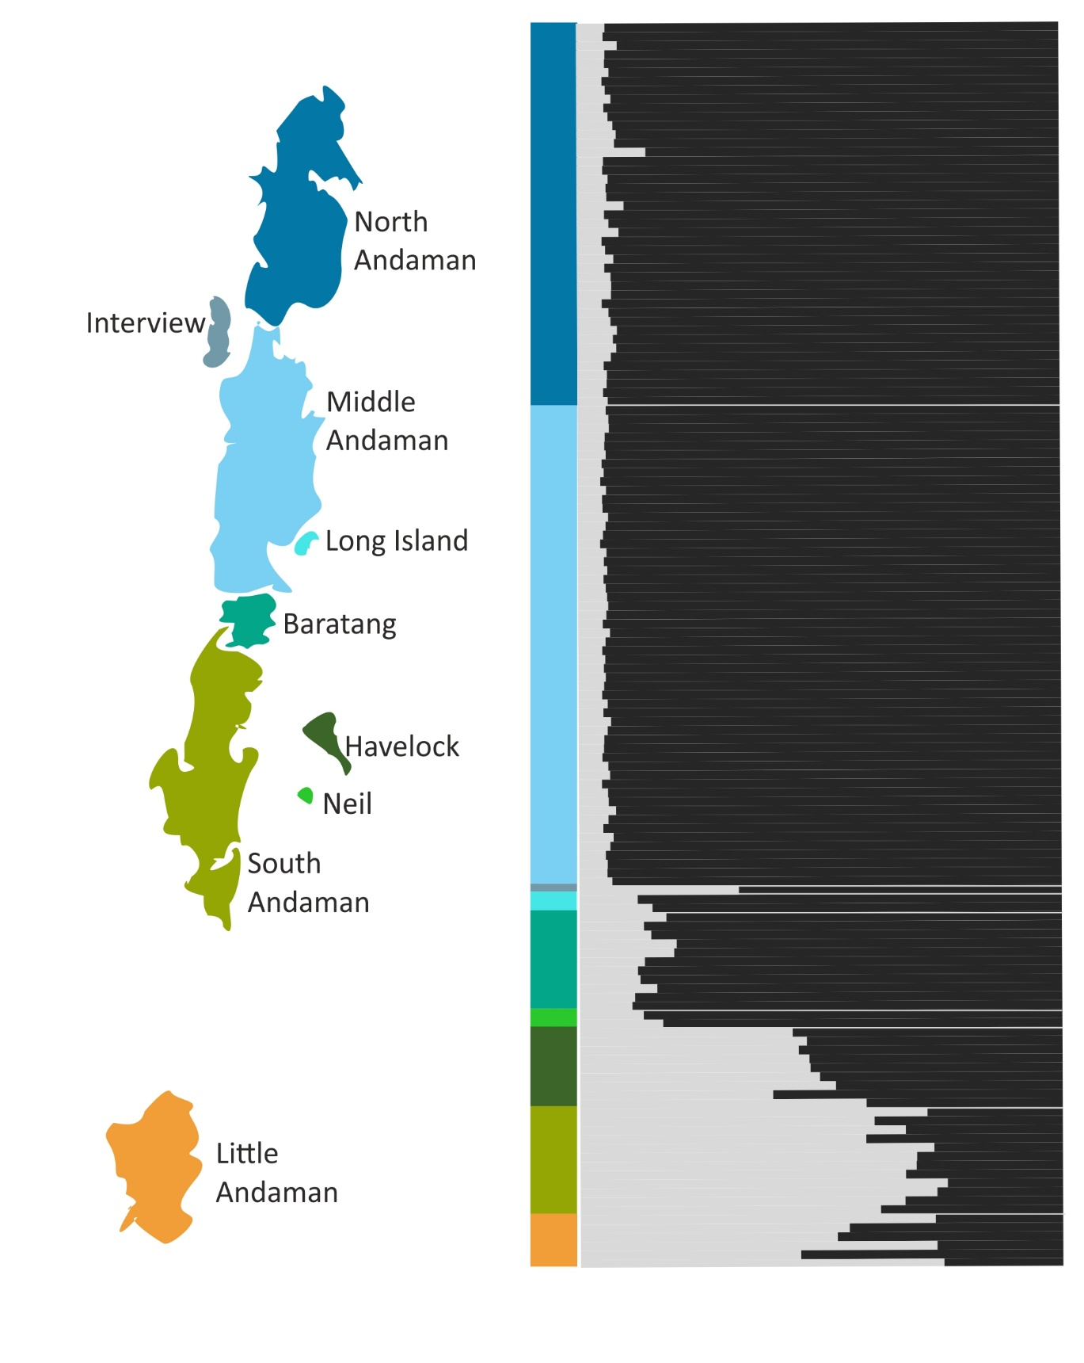
Figure 3: Bar plot generated using the results from the Bayesian clustering algorithm, STRUCTURE using 12 microsatellite markers, after removing marker in which null alleles were detected. White lines separate individuals sampled on different islands and island labels are colour coded in the corresponding blocks.

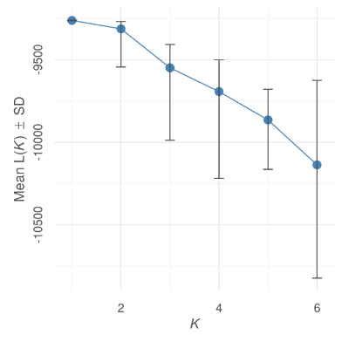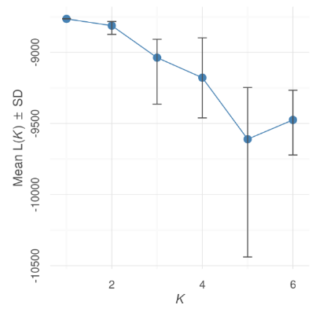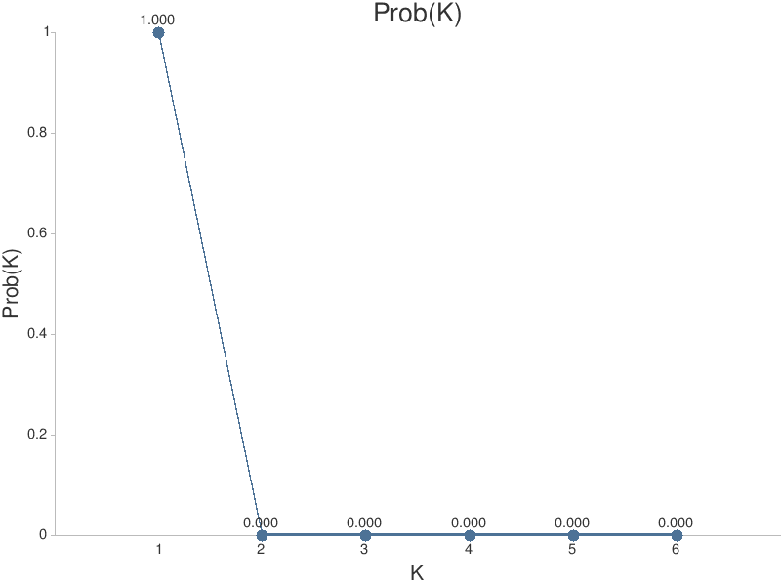

Figure 4: K value graphs from left: Delta K calculated from Structure run with all 13 microsatellite markers; Delta K calculated from Structure run with 12 microsatellite markers excluding a marker which showed presence of null alleles; the likelihood of K for each value of K (Ln Pr(X|K))

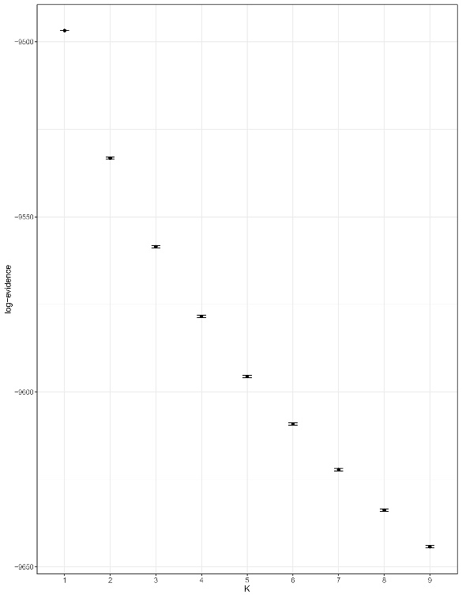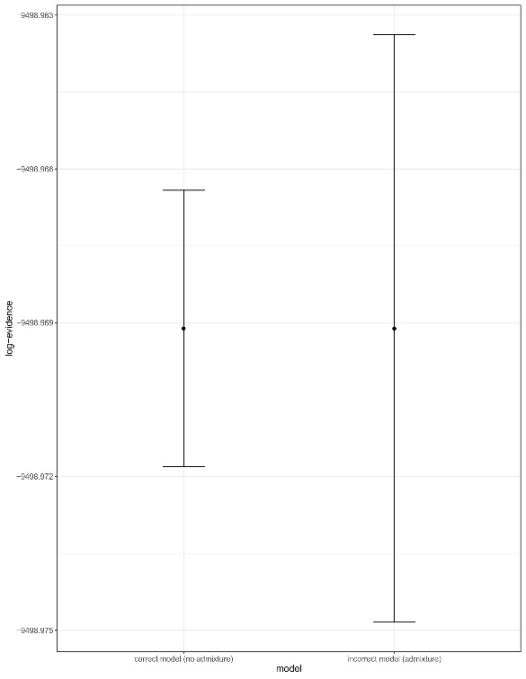
Figure 5: Best K value estimate obtained from rmaverick, run from a no-admixture model; Comparison between admixture and non-admixture model runs in rmaverick shows no clear support for one type.

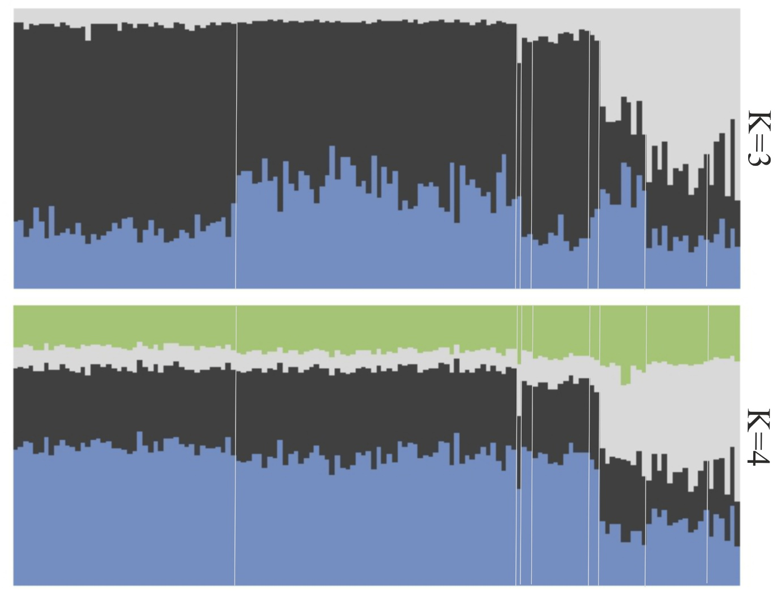
Figure 6: Bar plot generated using the results from the Bayesian clustering algorithm, STRUCTURE using 13 microsatellite markers, K was set to 3 and 4 respectively to show clustering patterns beyond K=2

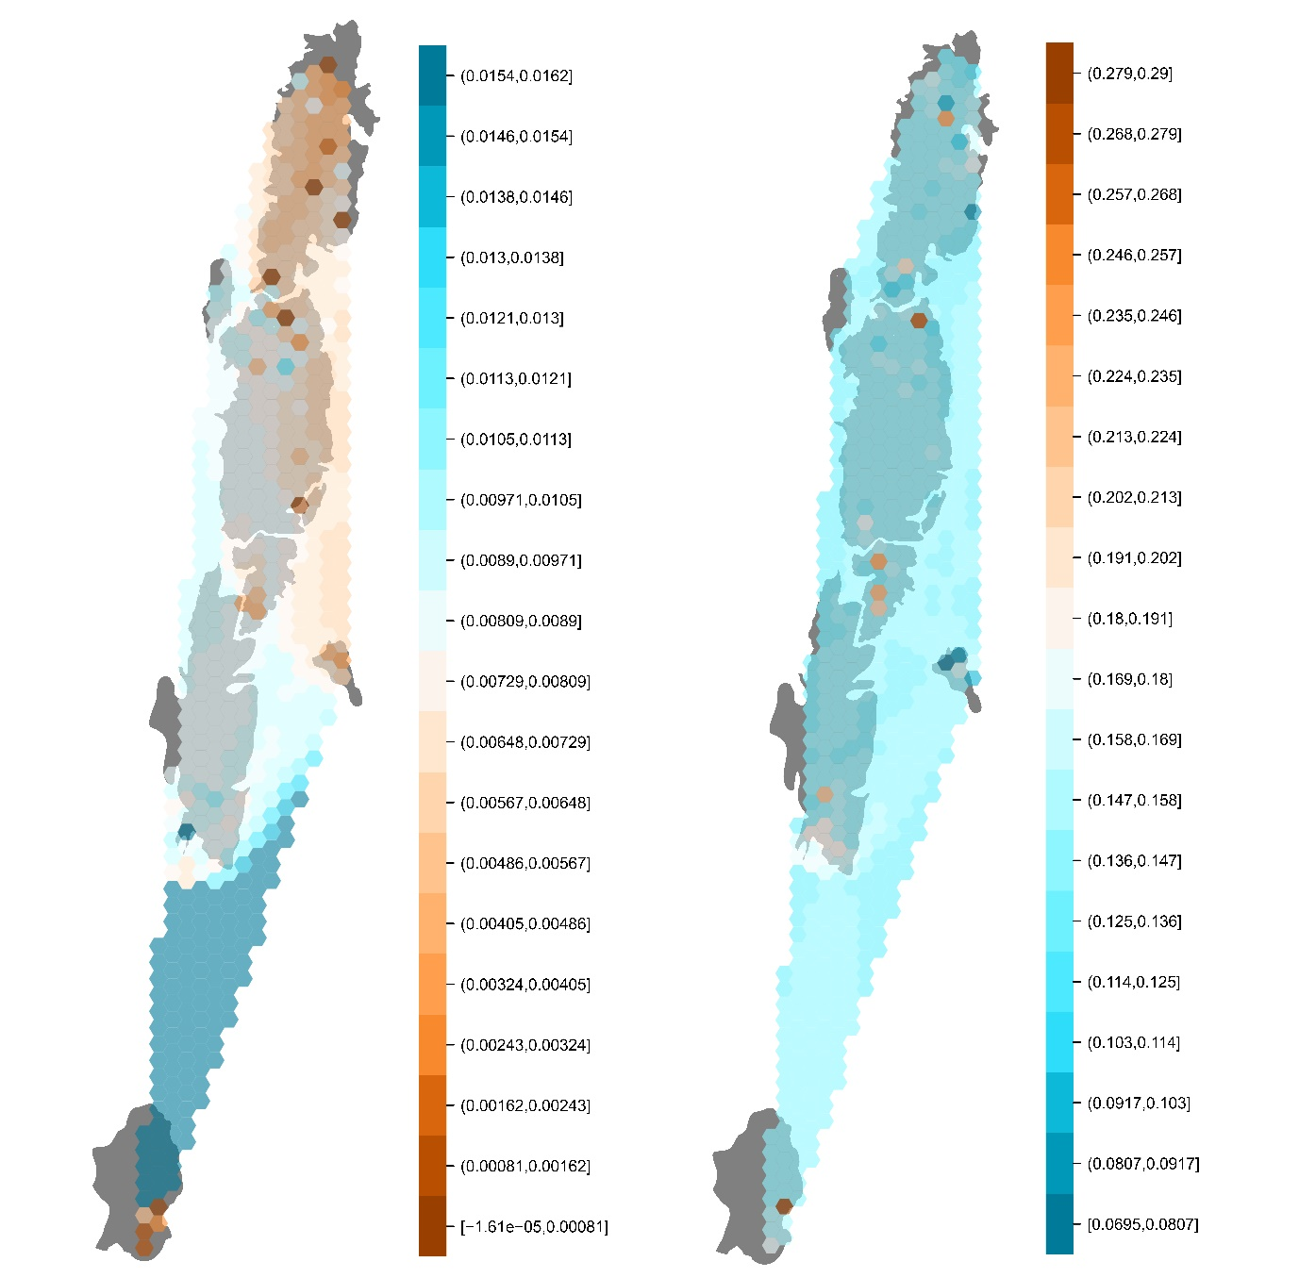
Figure 7: Genetic differentiation measures of microsatellite and mitochondrial data mapped using sampling localities of the Andaman day gecko (Phelsuma andamanensis). a. Microsatellite Allele Sharing Matrix mapped using sampling localities; brown sharing the highest number of alleles and blue the least; b. Genetic pairwise uncorrected p distances mapped on the Andaman Islands; brown being least uncorrected p distance and blue being the highest p distance.

