Single Step Fabrication of ZnO Microflower Thin Films for Highly Efficient and Reusable Photocatalytic Activity
Monoj Kumar Singha*¹, Aniket Patra ², Vineet Rojwal ¹, and Deepa KG ³,
¹Instrumentation and Applied Physics, Indian Institute of Science, Bangalore 560012
²Electrical and Communication Engineering, Indian Institute of Science, Bangalore 560012
³Department of Physics, University of Kerala, Thiruvananthapuram, Kerala 695581

*Corresponding Author: monojsingha@yahoo.co.in, monojsingha@iisc.ac.in

Fig S1. Texture coefficient of varied molarity (0.05 M, 0.1 M and 0.15 M ) of precursor for ZnO thin films with three major planes (inset: the ratio of texture coefficient with molarity)
Fig S2. Bandgap measurement with varied molarity of precursor for ZnO thin films (a) 0.05 M, (b)0.1 M and (c) 0.15 M

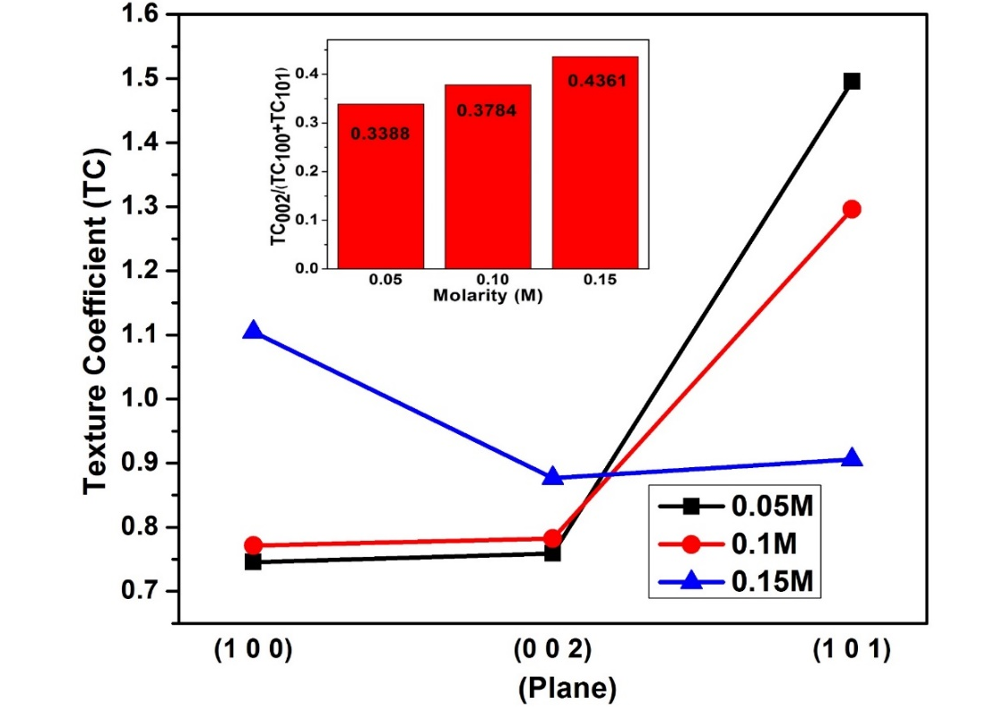
Fig S1.
Fig S2. (a) Fig S2. (b)
Fig S2. (c)

