Supplementary file
Fig. S1. Elemental composition profile across bP-PEO coating thickness for (a) 1 min, (b) 2 min, (c) 4 min, (d) 8 min, and (e) 16 min PEO processing time.
Fig. S2. Elemental composition profile across gP-PEO coating thickness for (a) 1 min, (b) 2 min, (c) 4 min, (d) 8 min, and (e) 16 min PEO processing time.
Fig. S3. Bode-Impedance plot as a function of electrolyte immersion time for bP-PEO treated with (a) 15 s, (b) 30 s, (c) 1 min, (d) 2 min, (e) 4 min, (f) 8 min, and (g) 16 min PEO processing time.

Fig. S4. Bode-Impedance as a function of electrolyte immersion time for gP-PEO treated with (a) 1 min, (b) 2 min, (c) 4 min, (d) 8 min, and (e) 16 min PEO processing time.

Fig. S5. Bode-phase angle plot as a function of electrolyte immersion time for bP-PEO treated with (a) 15 s, (b) 30 s, (c) 1 min, (d) 2 min, (e) 4 min, (f) 8 min, and (g) 16 min PEO processing time.

Fig. S6. Bode-phase angle as a function of electrolyte immersion time for gP-PEO treated with (a) 1 min, (b) 2 min, (c) 4 min, (d) 8 min, and (e) 16 min PEO processing time.

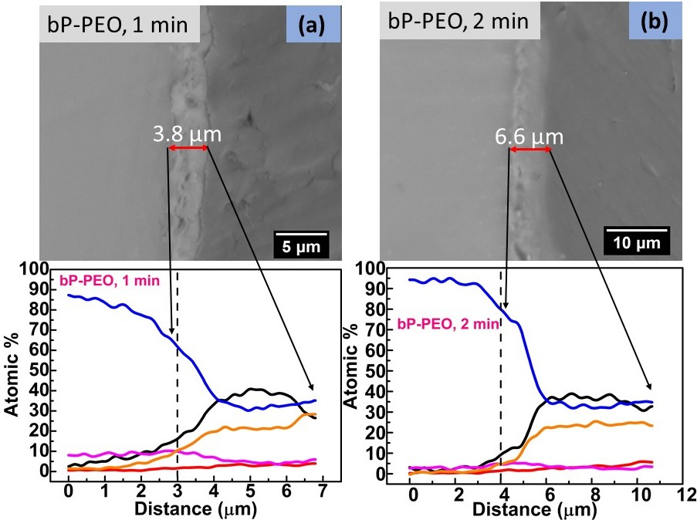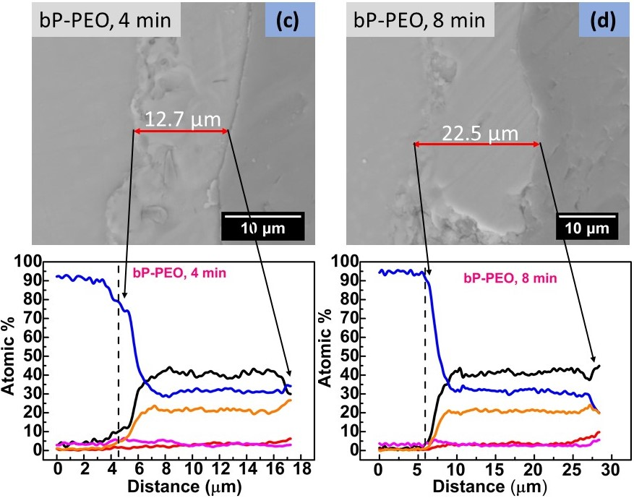
Fig. S1. (a to e)
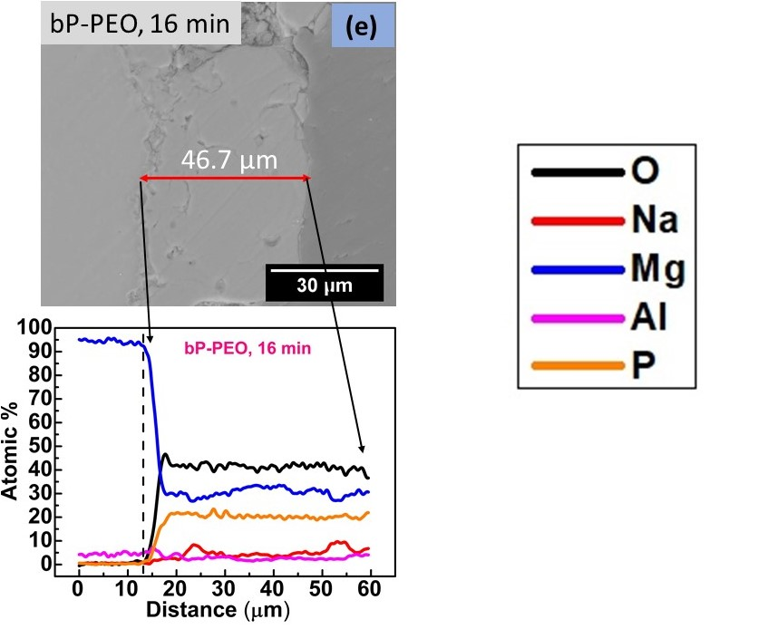
Fig. S1. Continued…

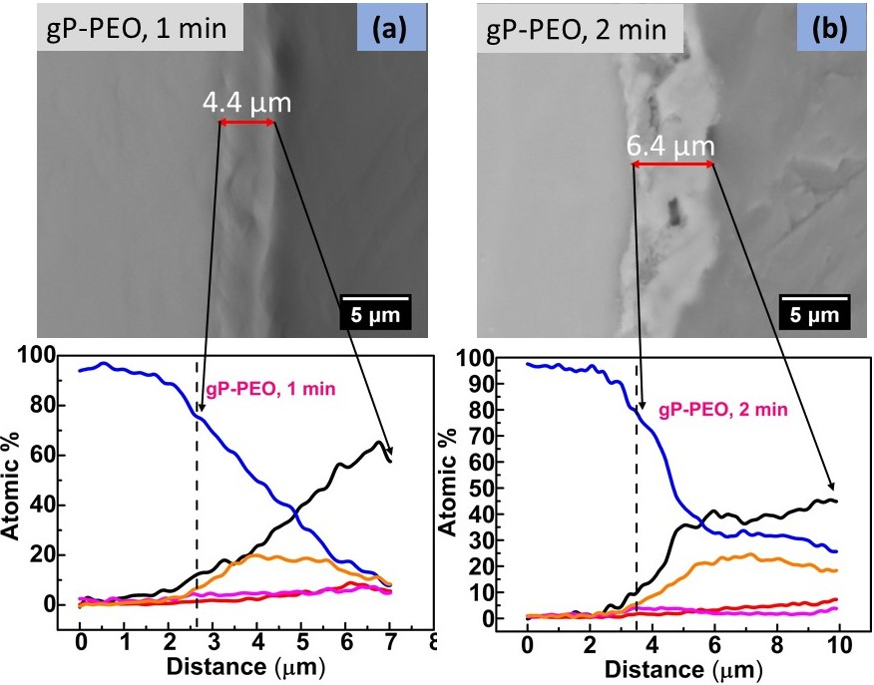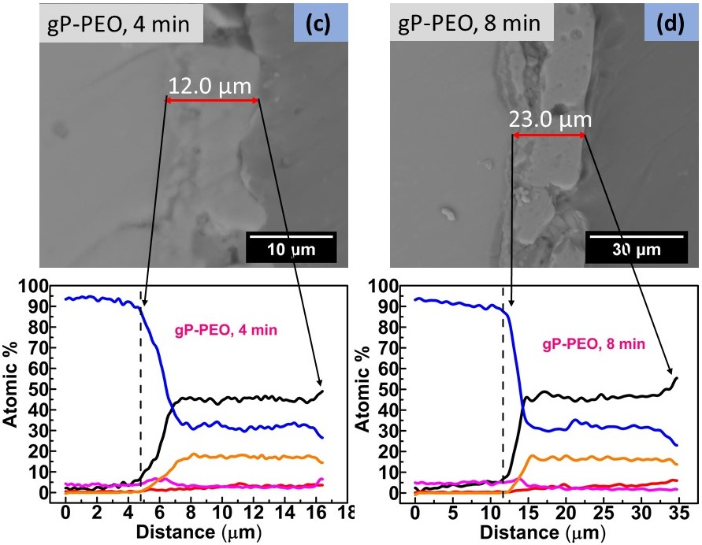
Fig. S2 (a to e)

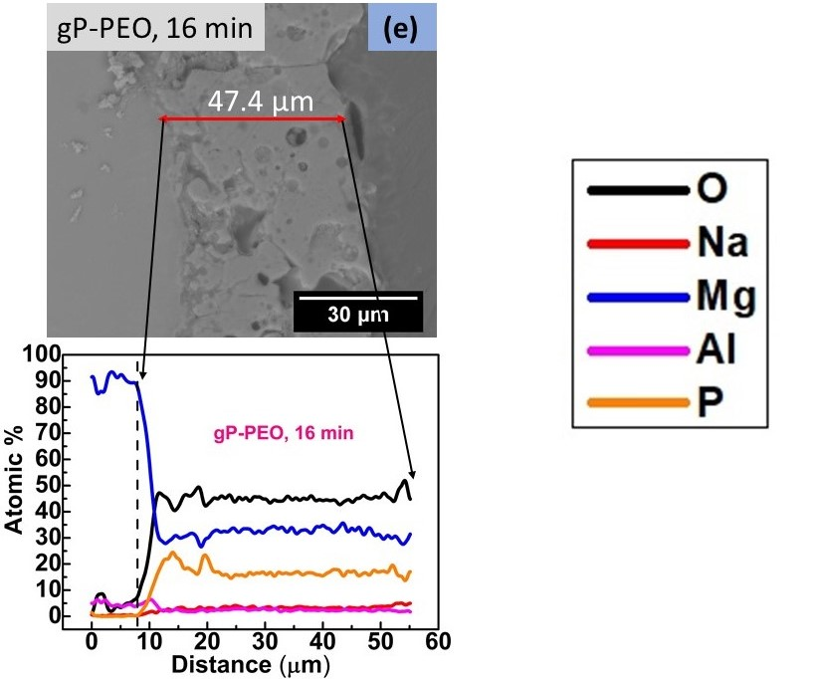
Fig. S2. Continued…

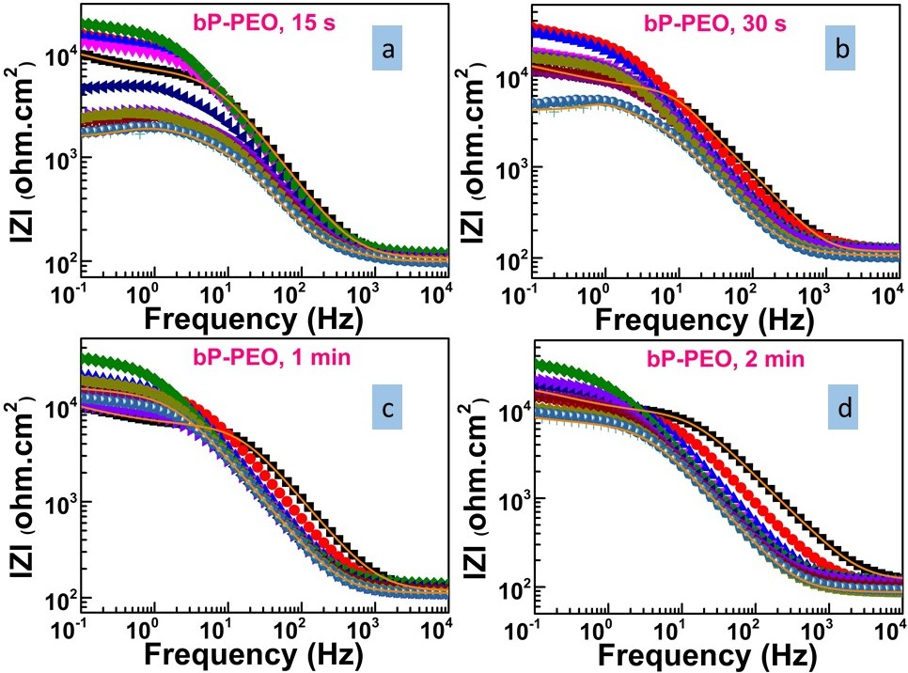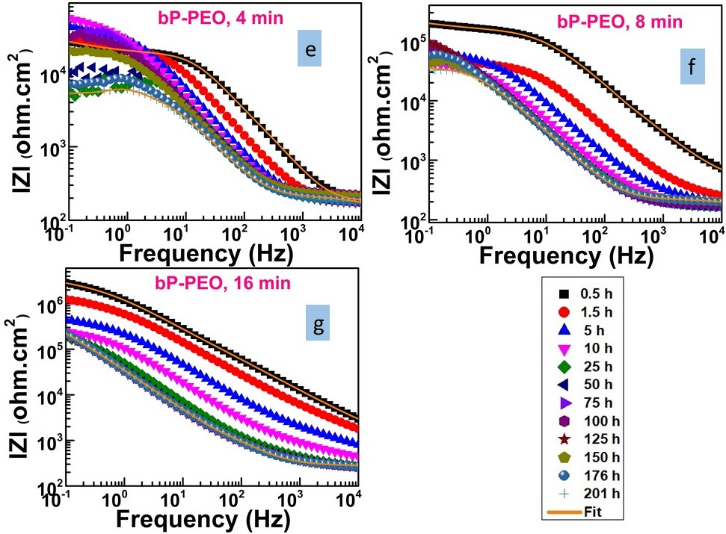
Fig. S3 (a to g)
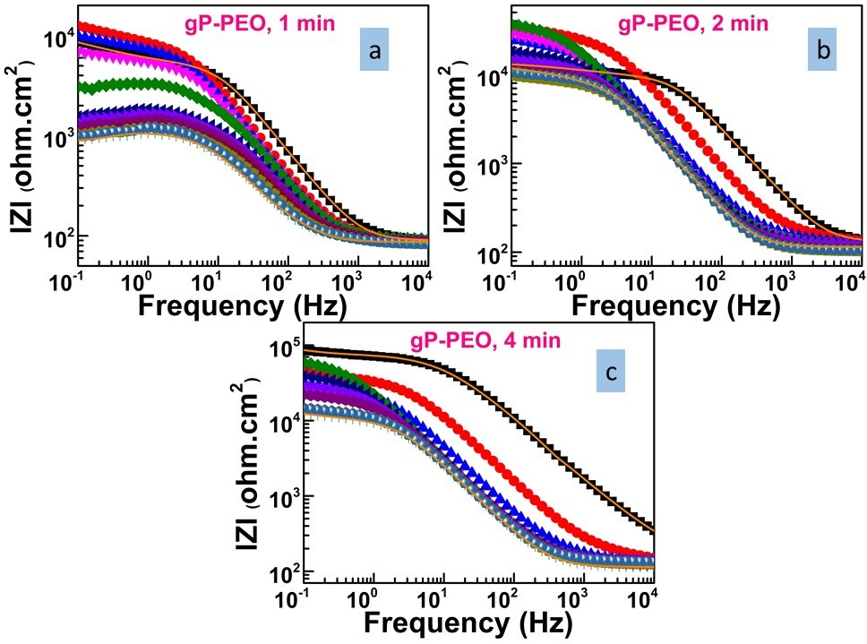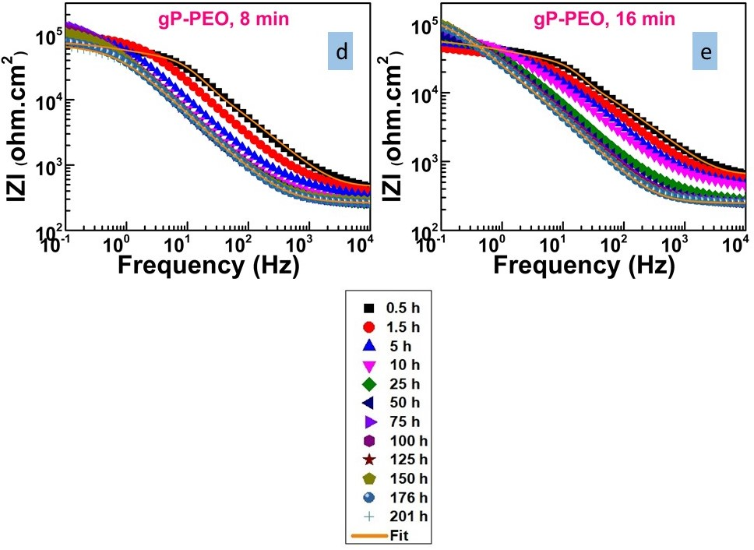
Fig. S4 (a to e)
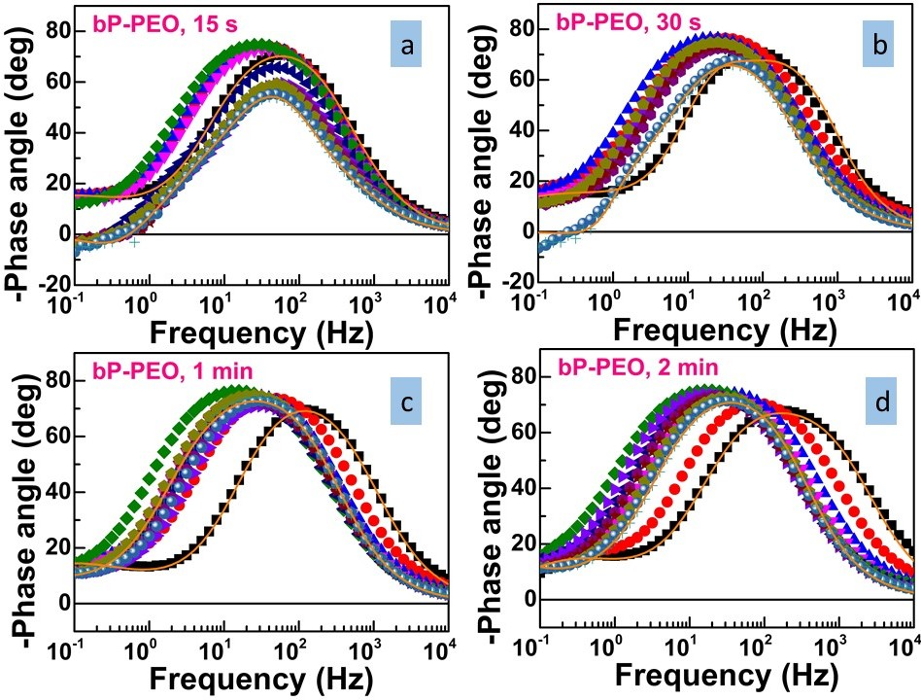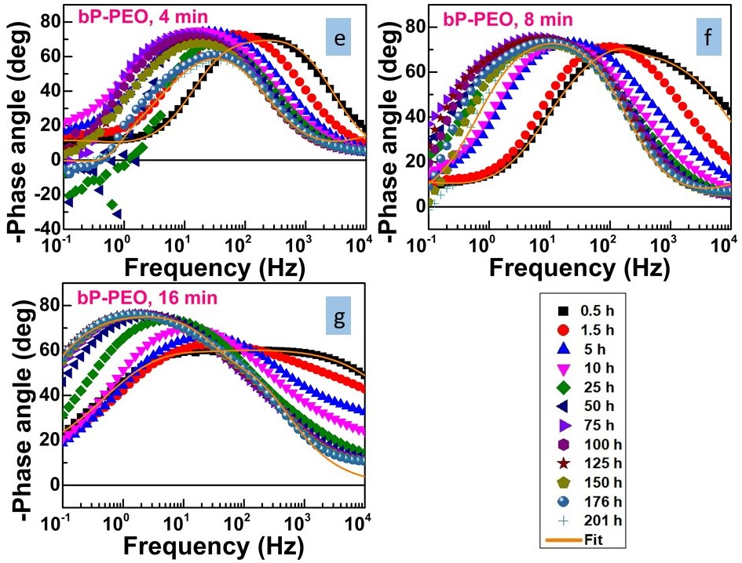
Fig. S5 (a to g)
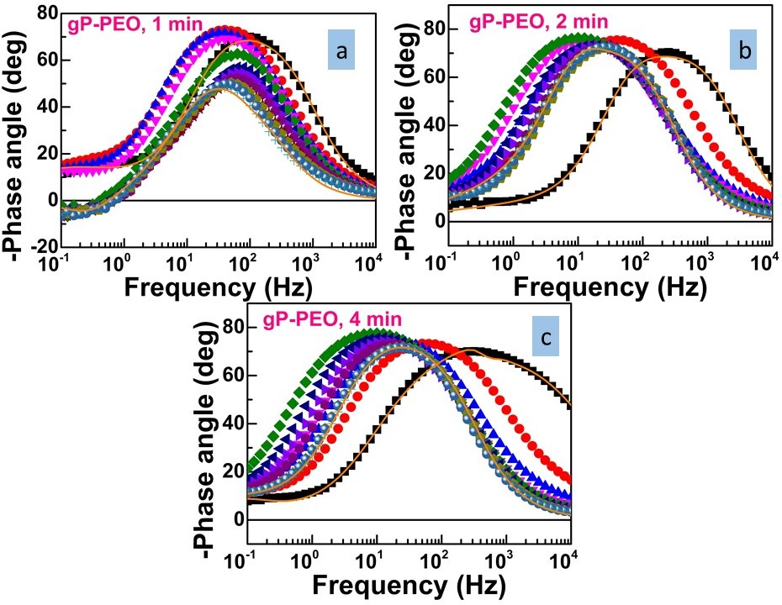
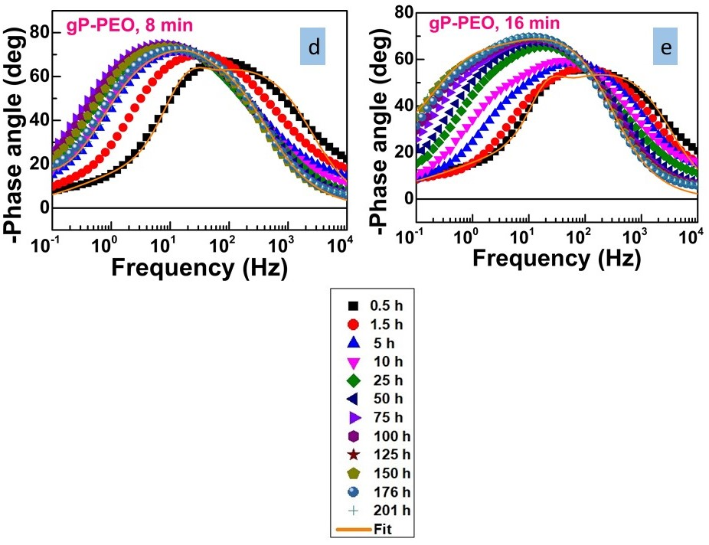
Fig. S6 (a to e)

