Effect of copper concentration on CTS thin films for solar cell absorber layer and photocatalysis applications
Sabina Rahaman^{a,b} , Monoj Kumar Singha*^{c}, M. Anantha Sunil^{d}, Kaustab Ghoshª,
ª School of Electronics Engineering, Vellore Institute of Technology, Chennai campus, Chennai-600127, India.
^{b} Department of Electronics & Communication Engineering, BMS Institute of Technology, Bangalore, India-560064.
^{c} Department of Instrumentation and Applied Physics, Indian Institute of Science, Bangalore-560012, India
^{d} Department of Electronics & Communication Engineering, BMS college of Engineering, Bangalore, India-560019

*corresponding author: monojsingha@yahoo.co.in, monojsingha@iisc.ac.in

TEM and HRTEM studies:
The TEM analysis of the optimized sample CTS3 is carried out using TalosF200S instrument. Sample preparation for TEM characterization is performed as follows: the sample was initially scratched from the CTS thin film using surgical blade and then dispersed in IPA solution. Finally, it drops cast on carbon coated Copper grid.TEM and the high resolution.
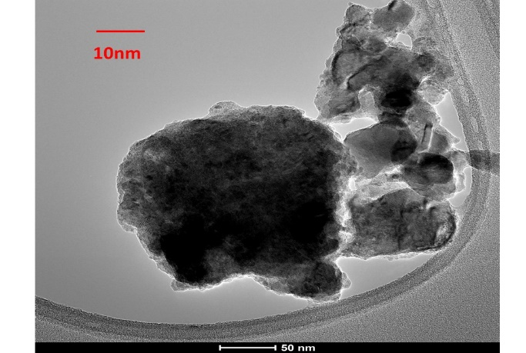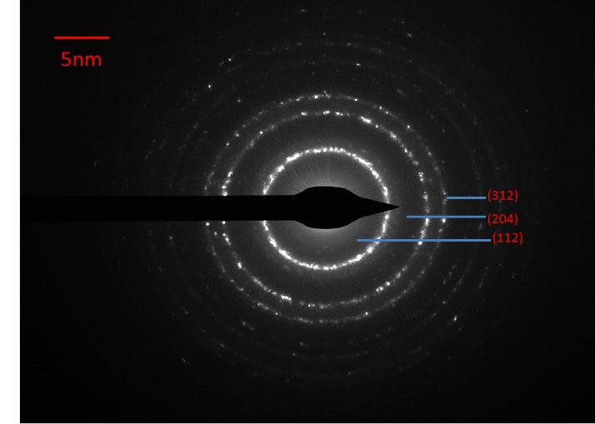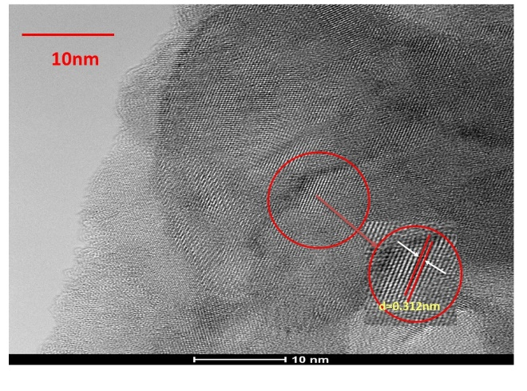
(a)
(b)
(c)

Figure 1 (a,b) TEM and HRTEM images of sample CTS3 and (c) SAED pattern of CTS3
Photoluminescence (PL) studies:
Photoluminescence (PL) spectra of CTS thin films in room temperature are recorded using 685 nm wavelength as excitation source and is shown in figure 2. All the CTS thin films are displayed one asymmetric peak at 1.33eV, which explains that the variation in Cu did not have significant effect on the optical property of the CTS thin films.

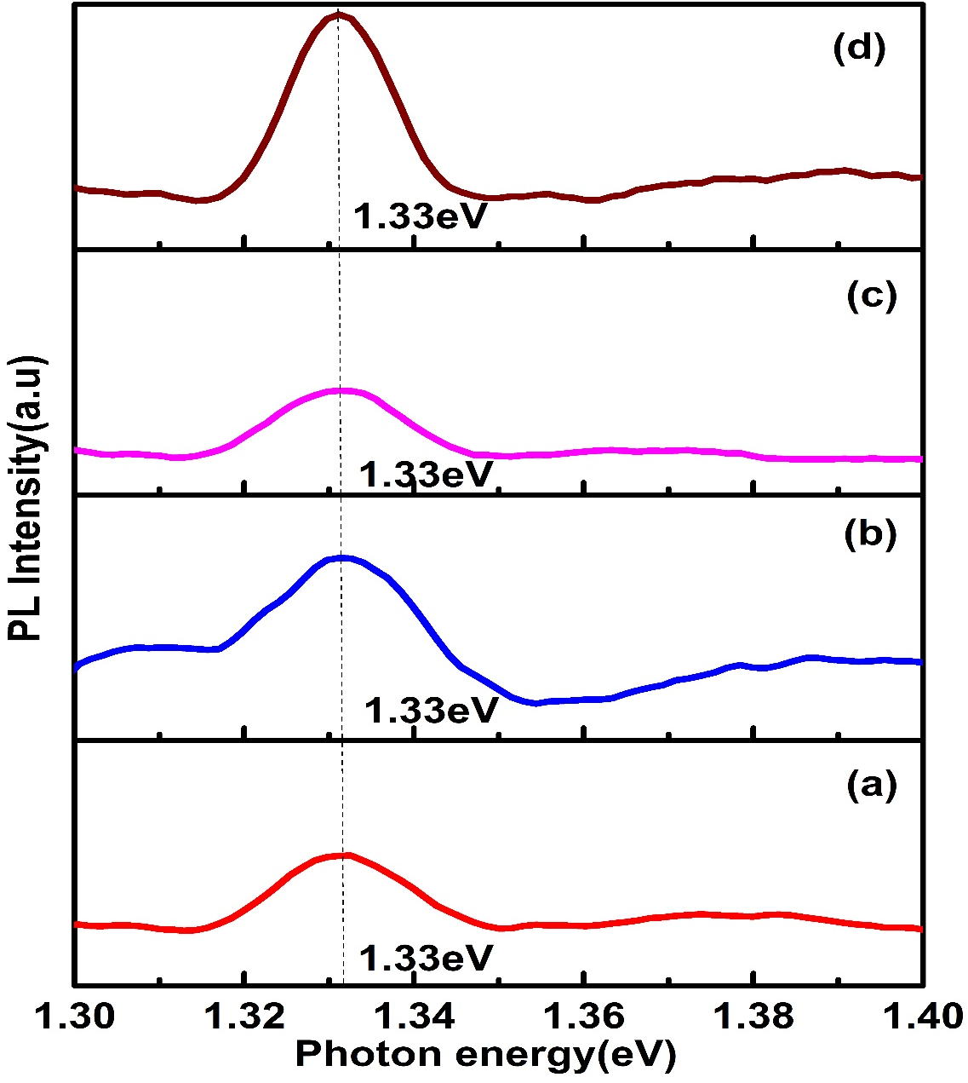

Figure 2: PL spectrum of the CTS thin films at different Cu concentration

