**Enhanced visible light photocatalytic performance of SnO2 nanoparticle co-doped with (Co, Nb) for organic dye degradation**

**S. Jayapandi 1 S. Premkumar 2, V. Ramakrishnan1, D. Lakshmi 3, S.Shanavas4, R. Acevedo5,** **K. Anitha 1\***

*1 School of Physics, Madurai Kamaraj University, Madurai 625021, India*

*2 Department of Inorganic and Physical Chemistry, Indian Institute of Science, Bangalore*

*560012, India*

*3Department of Physics, Bharathiar university, Coimbatore 641043, India*

*4Nano and Hybrid Materials Laboratory, Department of Physics, Periyar University, Salem- 636 011, India.*

*5 Facultad de Ingenieríay Tecnología, Universidad San Sebastián, Bellavista 7, Santiago 8420524, Chile.*

*[*singlecrystalxrd@gmail.com*](mailto:singlecrystalxrd@gmail.com)*,*

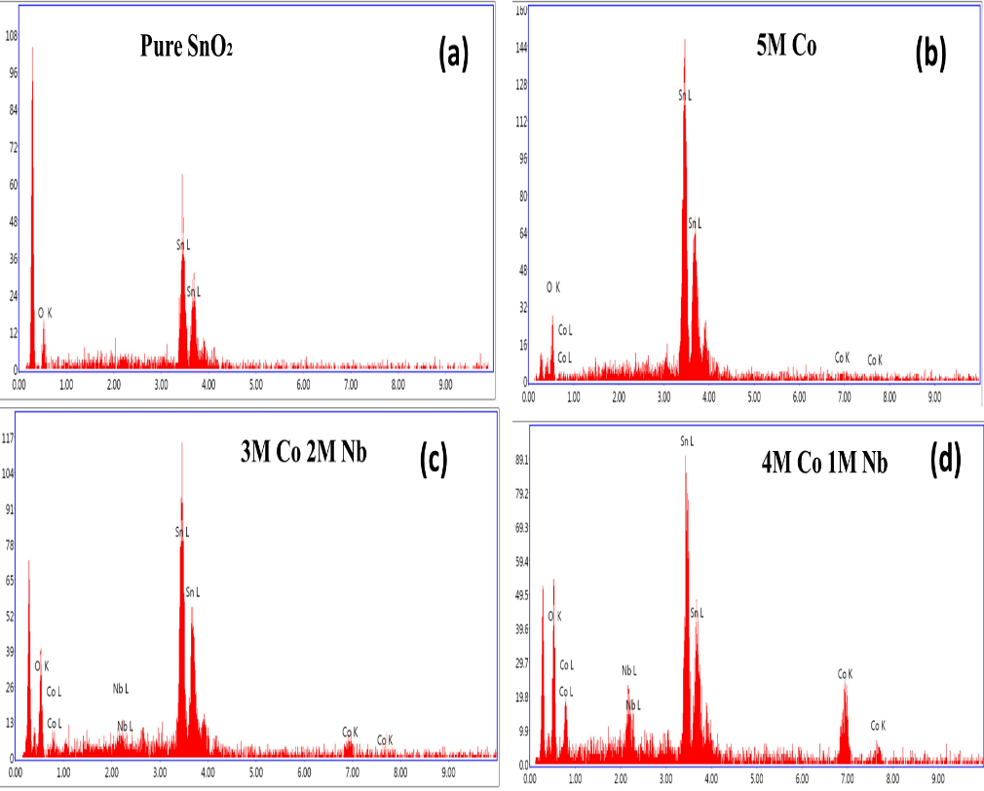

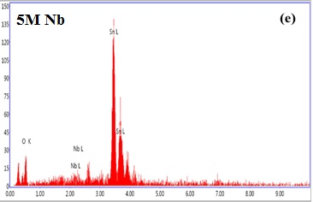

**Figure S1. EDAX spectrum**

|  |  |  |  |  |  |  |  |
| --- | --- | --- | --- | --- | --- | --- | --- |
| **Table S1: Calculated atomic weight percentage of pure and Co,Nb co-doped SnO2 nanoparticles** | | | | | | | |
| **S. No** | **Sample** | **Estimated Composition** | **Observed Atomic Wt. %** | | | | **Observed Elemental Composition** |
| **Nb** | **Co** | **Sn** | **O** |
| 1 | SnO2 | Sn0.1O0.2 | --- |  | 78.76 | 21.24 | Sn0.1O0.2 |
| 2 | 5mol% Co-SnO2 | Co0.005Sn0.095O0.2 | --- | 4.88 | 76.91 | 21.22 | Co0.005Sn0.095 O0.2 |
| 3 | 4mol% Co 1mol% Nb-SnO2 | Nb0.001Co0.004Sn0.095 O.0.2 | 1.58 | 3.52 | 75.12 | 21.28 | Nb0.001Co0.004Sn0.095 O.0.2 |
| 4 | 3mol% Co 2mol% Nb-SnO2 | Nb0.002Co0.003Sn0.095 O.0.2 | 1.92 | 2.68 | 74.30 | 21.02 | Nb0.002Co0.003Sn0.095 O.0.2 |
| 5 | 5mol% Nb-SnO2 | Nb0.005Sn0.095O0.2 | 4.93 |  | 78.28 | 21.10 | Nb0.005Sn0.095 O0.2 |

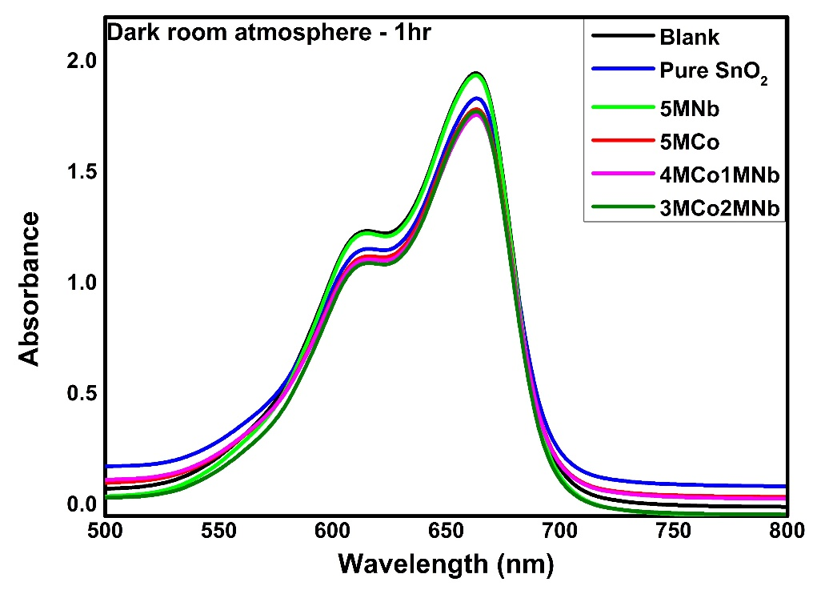

**Figure S2. Photocatalytic performance of prepared catalyst under dark room atmosphere**