Supplementary material
10. Supplementary materials and methods
Inhibition and Akt and NF-κB: The cells were treated with the NF-κB inhibitor (#481412, Sigma) with 50 nM and Akt inhibitor (Akt inhibitor VIII, 124017, Sigma) with 2 µM concentration for 60 and 30 min before the start of infection respectively followed by infection with the different Salmonella strains using the usual protocol as mentioned in materials methods. The inhibitors were maintained in the cell throughout the experimental duration. After the time points as mentioned in the different experiments, the cells were processed either for the confocal microscopy, western blotting or RNA isolation as mentioned in the materials methods.
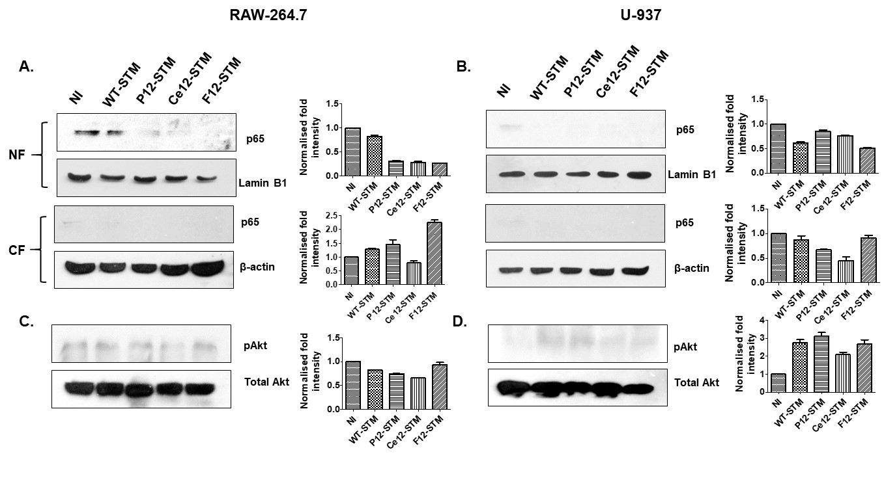
11. Supplementary figures and legends
Fig. S1. Inhibition of infection mediated NF-κB and Akt in Raw-264.7 and U-937 cells using inhibitors. RAW-264.7 and U-937 cells were treated with NF-κB and Akt inhibitor 60 and 30 min before infection respectively and infected with WT-STM, P12-STM, Ce12-STM and F12-STM at 10 MOI for 5 h to monitor the inhibition of infection mediated activation. Inhibitors were maintained during the infection. Western blotting was performed after isolating protein from both nuclear and cytoplasmic fractions for p65 translocalization and whole cell lysate for Akt phosphorylation. p65 in nuclear localization in nuclear and cytoplasmic fractions is shown in RAW-264.7 (A) in U-937 cells (B). pAkt level after treatment with Akt inhibitor is shown in Raw-264.7 (C) and U-937 cells (D) (NF- nuclear fraction, CF- cytoplasmic fraction, pAkt- phosphor Akt)

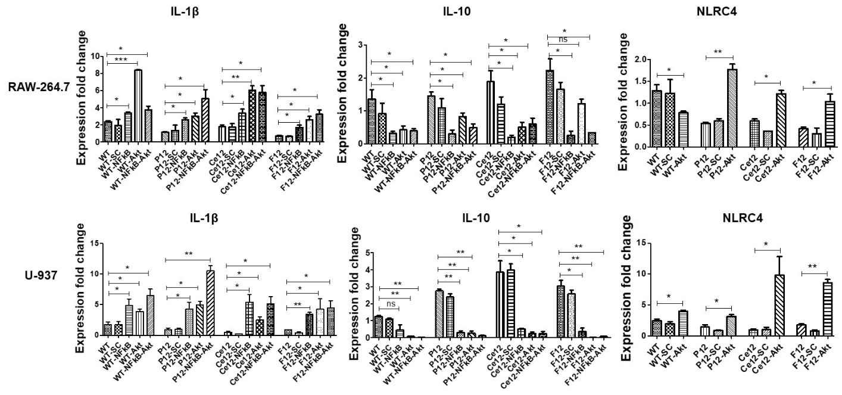
Fig. S2. Quantification of cytokines in macrophages upon NF-κB and Akt inhibition. RAW-264.7 and U-937 cells were treated with NF-κB and Akt inhibitor 60 and 30 min before infection respectively and infected with WT-STM, P12-STM, Ce12-STM and F12-STM at 10 MOI for 5 h to look IL-1β, IL-10 and NLRC4 mRNA expression by qRT-PCR. Inhibitors were maintained during the infection. The relative expression level was shown as fold change after normalizing with the expression of the non-infected control group. Data represent three biological replicates. Values are expressed as Mean ± SEM. *** p < .001, ** p < .005, * p < .05. (WT- WT-STM, P12-P12-STM, Ce12-Ce12-STM, F12-F12-STM, SC-Solvent control, NFκB: anti-NFκB, Akt: anti-Akt, NFκB-Akt: Both the inhibitor together)
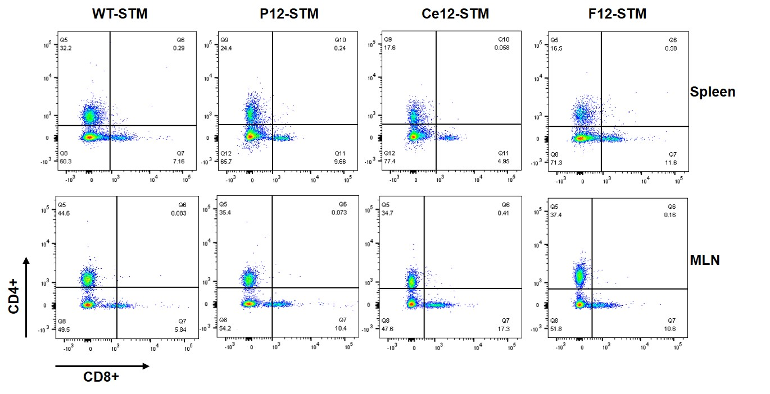
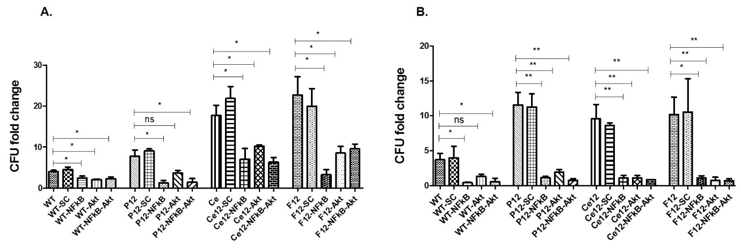
Fig. S3. Representative images of CD4+ and CD8+ T cell population analysis in spleen and MLN of mice. 4-6 week old female mice were orally infected with 10⁷ CFU of WT-STM, P12-STM, Ce12-STM and F12-STM strains (n = 5 for each group). At D7 PI spleen and MLN were processed for the presence of CD4+ and CD8+ T cells by FACS analysis. CD4+ and CD8+ T cells were represented as % positive cells. Samples were acquired in BD FACS Canto II and analyzed by FlowJo software. Representative images from spleen (A) and MLN (B) and the percentage of positive cells are plotted.
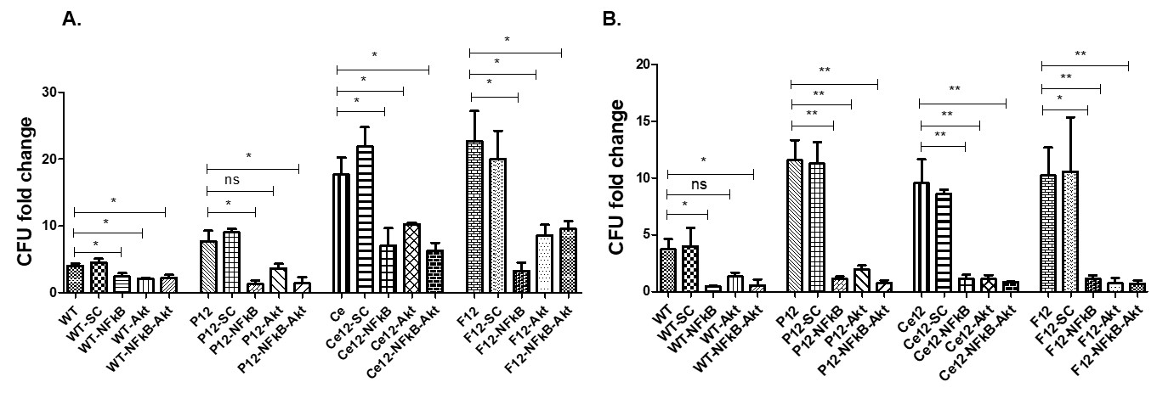

Fig. S4. Bacterial proliferation upon NF-κB and Akt inhibition in macrophage cells. RAW-264.7 and U-937 cells were infected with different bacterial strains at 10 MOI upon treatment with NF-κB and Akt inhibitor and checked for proliferation. NF-κB and Akt inhibitors were added to the cells 60 and 30 min before infection and maintained throughout the infection. (A) CFU fold proliferation at 2 and 16 h PI in RAW-264.7 cells (B) CFU fold proliferation at 2 and 16 h PI in U-937 cells. Data represent three biological replicates. Values are expressed as Mean ± SEM. ** p < .005, * p < .05. (WT- WT-STM, P12-P12-STM, Ce12-Ce12-STM, F12-F12-STM, SC-Solvent control, NFκB: anti-NFκB, Akt: anti-Akt, NFκB-Akt: Both the inhibitor together)
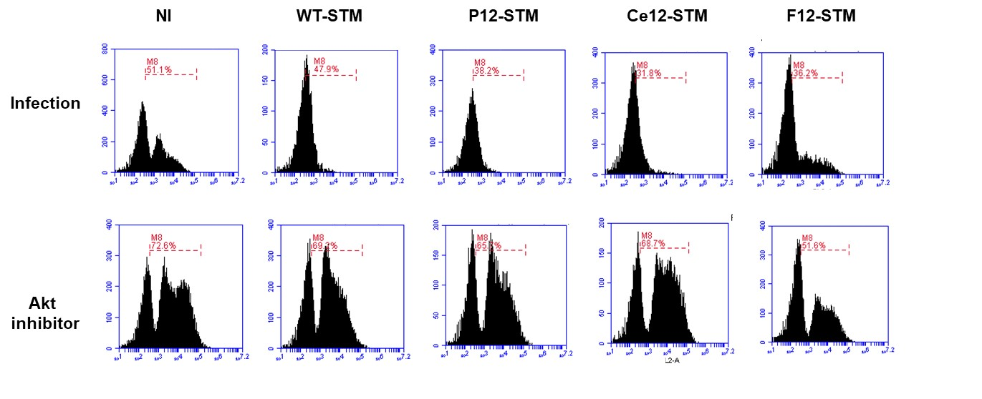
Fig. S5. Lysosomes number estimation upon Akt inhibition in RAW-264.7 cells. RAW-264.7 cells were infected with WT-STM, P12-STM, Ce12-STM, and F12-STM at 10 MOI with and without Akt inhibitor with non-infected control. Akt inhibitor was added at 2 µM concentration 30 min before infection and maintained during the infection. After the infection time, cells were stained with Lysotracker and were acquired in a flow cytometer to check the lysotracker positive cells.
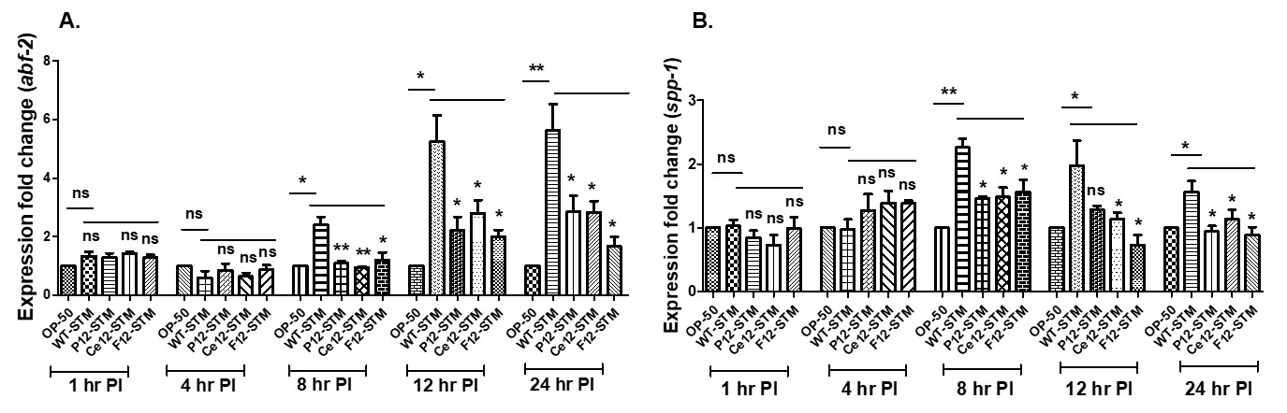

Fig. S6. Antimicrobial response in C. elegans. L4 worms were infected with WT-STM, P12-STM, Ce12-STM, and F12-STM and OP50 fed worms were taken as control. Total RNA was isolated at indicated time points and subjected to qRT-PCR. Relative expression levels are shown as fold difference was done after normalizing to OP50 fed worms. (A) relative expression of abf-2. (B) Relative expression of spp-1. Data represent three biological replicates. Values are expressed as Mean ± SEM. ** p < .005, * p < .05.
Supplementary Table 1. Primers used in the study
Primer | Forward primer (5’-3’) | Reverse primer (5’-3’) | Functions
M-IL-1β | GGGCCTCAAAGGAAAGAATC | TACCAGTTGGGGAACTCTGC | Mouse pro-inflammatory
M-IL-10 | TGCTATGCTGCCTGCTCTTA | TCATTTCCGATAAGGCTTGG | Mouse anti-inflammatory
M-GPDH | GCCTTCCGTGTTCCTACCC | TGCCTGCTTCACCACCTTC | Mouse control
H-IL-1β | GTGATGCCCCAAGCTGAG | CACGGCCTTGCTCTTGTTTT | Human pro-inflammatory
H-IL-10 | GTGATGCCCCAAGCTGAGA | CACGGCCTTGCTCTTGTTTT | Human anti-inflammatory
H-Actin | ATGTACGTTGCTATCCAGGC | TCCTTAATGTCACGCACGA | Human control
H-NLRC4 | TCAGAAGGAGACTTGGACGAT | GGAGGCCATTCAGGGTCAG | Human inflammasome
M-NLRC4 | GAAACACTGTACGATCAGCTCC | CATGTTCTTGAAGCGATGGTTTT | Mouse inflammasome
Crypt-1 | AAGAGACTAAAACTGAGGAGCAGC | GGTGGTCATCAGGCACCAGCATCAGT | Mouse AMP
Crypt-4 | AAGAGACTAAAACTGAGGAGCAGC | AGTGGTCATCAGGCCCCGGCATCAGC | Mouse AMP
Crypt-5 | AAGAGACTAAAACTGAGGAGCAGC | GGTGATCATCAGACCCCAGCATCAGT | Mouse AMP
abf-2 | CCATCGTGGCTGCCGACATCGACTTT | GAGCACCAAGTGGAATATCTCCTCCTC | Worm AMP
spp-1 | CGCATTCTTCCGTGTCTTTT | GCAACAGCATAGTCCAGCAA | Worm AMP
ama-1 | CCCGGAGGAGATTAAACG | CATGTCATGCATCTTCCAC | Worm control
(M- Mouse, H-Human, Crypt- Cryptdine)

