Supplementary Information
Physico-chemical characterization and sink mechanism of atmospheric aerosols over South-west India

Krishnakant B. Budhavant^{1,3*}, Ranjeeta D. Gawhane², Pasumarthi Surya Prakasa Rao², Hari Ram Chandrika Ranjendran Nair⁴, and Pramod D. Safai²
¹The Maldives Climate Observatory-Hanimaadhoo, Maldives Meteorological Services, H. Dh Hanimaadhoo, 2010, Maldives
² Indian Institute of Tropical Meteorology, Pune, 411008, India
³Divecha Centre For Climate Change, Indian Institute of Science, Bangalore, 560012, India
⁴Department of Environmental Science and Analytical Chemistry, Stockholm University, 10691 Stockholm, Sweden

*Corresponding Author
Krishnakant Budhavant
The Maldives Climate Observatory-Hanimaadhoo,
Maldives Meteorological Services,
H. Dh Hanimaadhoo 2020, Maldives
Tel: +960 6520512
Email: kbbudhavant@gmail.com; Krishnakant.Budhavant@aces.su.se
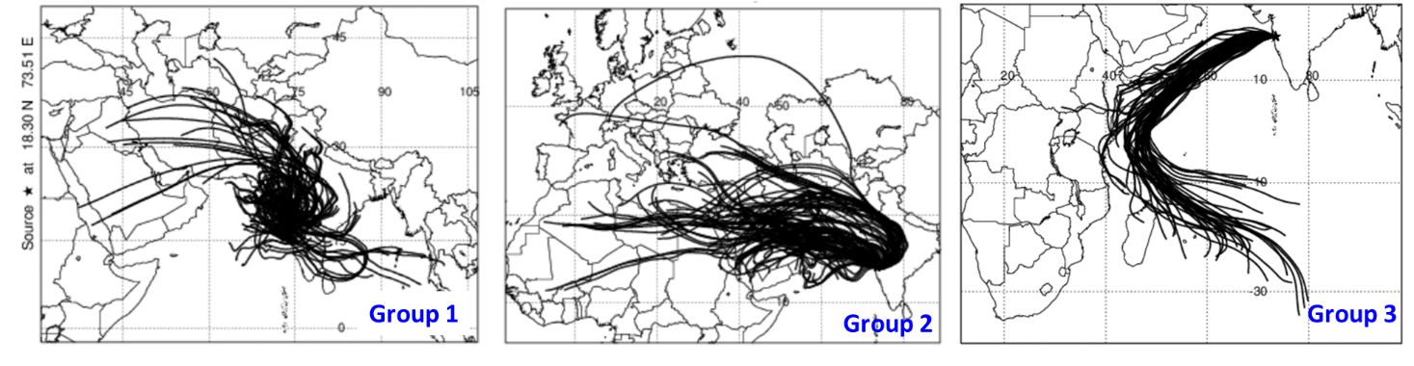
SI figure 1: Clustered 6-hourly, 7-day air mass back trajectories (AMBTs) mean for Pune (total n = 396). The cluster means lines colored in the map indicate three different source regions: Indian Subcontinent (group 1), Arabian Peninsula (group 2) and Indian Ocean (group 3).

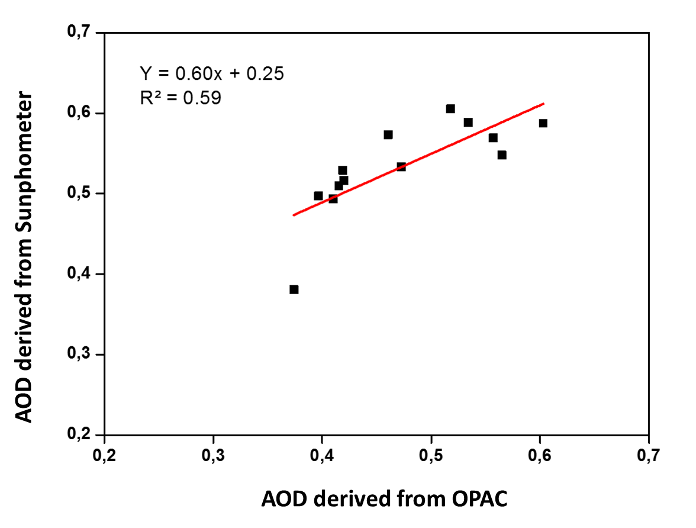
Si figure 2. Monthly aerosol optical depth (AOD) derived from OPAC model Vs. AOD derived from Sun photometer (AERONET network) measured at Pune from January to December 2016.

Radiative forcing of atmospheric components
The acquired data used as input to an aerosol optical model (Optical Properties of Aerosols and Clouds, OPAC 3.1). The model simulates the optical properties of the newly defined aerosol mixture, considering the relative humidity (RH) variations, their vertical distribution and the wavelength of the interaction.
The AOD and SSA derived from the OPAC model was used as input to SBDART (Santa Barbara DISORT Atmospheric Radiative Transfer) (Ricchiazzi et al. 1998). The model uses a discrete ordinate method to numerically integrate the radiative transfer equations (Stamnes et al. 1988). The detailed description of this model and approach is available elsewhere (Ricchiazzi et al. 1998; 2002). The atmospheric heating rate due to aerosol absorption was estimated using the equation given below.
$$\frac{∂T}{∂t}=\frac{g}{C\text{p}}\frac{∆F}{∆P}$$
Where ∂T/ ∂t is the heating rate (Kelvin per day), g is the acceleration due to gravity, Cp is the specific heat capacity of air at constant pressure (1006 J kg⁻¹ K⁻¹), ∆P is the atmospheric pressure difference between the top and bottom layers and ∆F is the atmospheric aerosol radiative forcing. (Satheesh and Ramanathan 2000).

