Supporting information

Microwave Absorption Efficiency of Poly (vinyl-butyral)/Ultra-thin Nickel Coated Fly Ash Cenosphere Composite

Angappan M^{a,b‡}, Pritom J. Bora^{c‡}, K. J. Vinoy^{d}, Kishore^{b}, Praveen C. Ramamurthy ^{b, c *}

ª Aeronautical Development Agency, PB No 1718, Bengaluru-560012, India.
^{b}Department of Materials Engineering, Indian Institute of Science, Bengaluru-560012, India.
^{c.}Interdisciplinary Centre for Energy Research (ICER),Indian Institute of Science, Bengaluru-560012, India.
^{d.}Department of Electrical and Communication Engineering,Indian Institute of Science, Bengaluru-560012, India.
E–Mail: onegroupb203@gmail.com

‡Contribution of both the authors are equal.

Figure S1. (a) Schematic of PVB-Ni-FAC composite preparation. Optical images of PVB-Ni-FAC (S3) composites in (b) Ku-band and (c) X-band sample holders.

Figure S2. (a) Vector network analyser, (b) Schematic of VNA, (c) Schematic of setup for EMI shielding measurements, (d) X-band coaxial to waveguide adaptor.

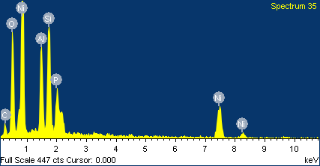

Element | Weight% | Atomic%
C K | 10.55 | 21.89
O K | 24.32 | 37.89
Al K | 9.19 | 8.49
Si K | 13.16 | 11.68
P K | 4.96 | 3.99
Ni K | 37.82 | 16.06
Totals | 100.00

Figure S3. EDX results of 5 min electroless Ni coated FAC

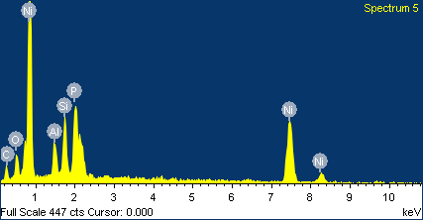

Element | Weight% | Atomic%
C K | 11.89 | 26.57
O K | 18.97 | 31.83
Al K | 5.34 | 5.31
Si K | 8.74 | 8.35
P K | 6.76 | 5.86
Ni K | 48.30 | 22.08
Totals | 100.00

Figure S4. EDX results of 10 min electroless Ni coated FAC.

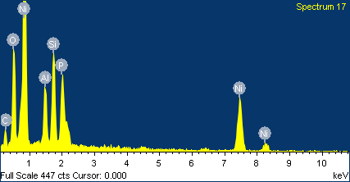

Element | Weight% | Atomic%
C K | 11.03 | 30.73
O K | 5.44 | 11.37
Al K | 3.80 | 4.71
Si K | 6.07 | 7.23
P K | 7.82 | 8.44
Ni K | 65.84 | 37.52
Totals | 100.00

Figure S5. EDX results of 15 min electroless Ni coated FAC.

Figure S6. Thickness dependent RL (dB) of S0 (PVB-FAC).

Figure S7. Thickness dependent RL (dB) of 20 minutes Ni -FAC loaded PVB composite.

