Supplementary information
A critical evaluation of microstructure-texture-mechanical behavior heterogeneity in high pressure torsion processed CoCuFeMnNi high entropy alloy
Reshma Sonkusare, Krishanu Biswas, Nowfal Al-Hamdany, H. G. Brokmeier, R. Kalsar, Norbert Schell, N. P. Gurao
S.I: XRD
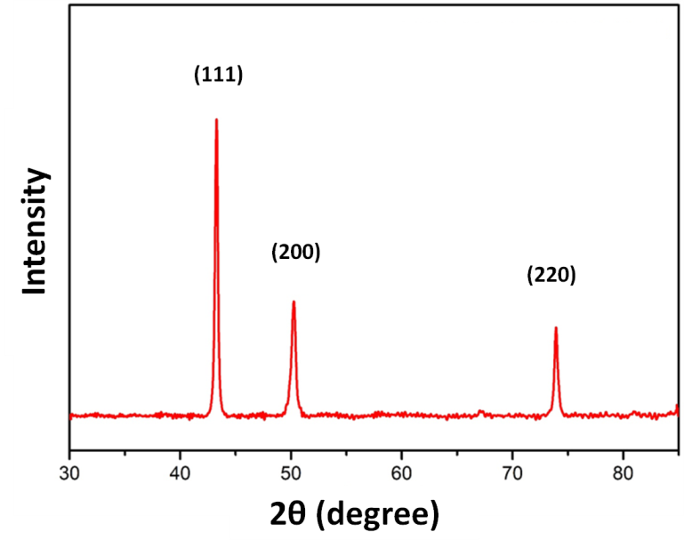
Figure S1: X-ray Diffraction of CoCuFeMnNi HEA [,,3].
Figure S1 shows that the alloy is a single phase FCC (lattice parameter = 0.361 nm).
S.II: Atom Probe Tomography
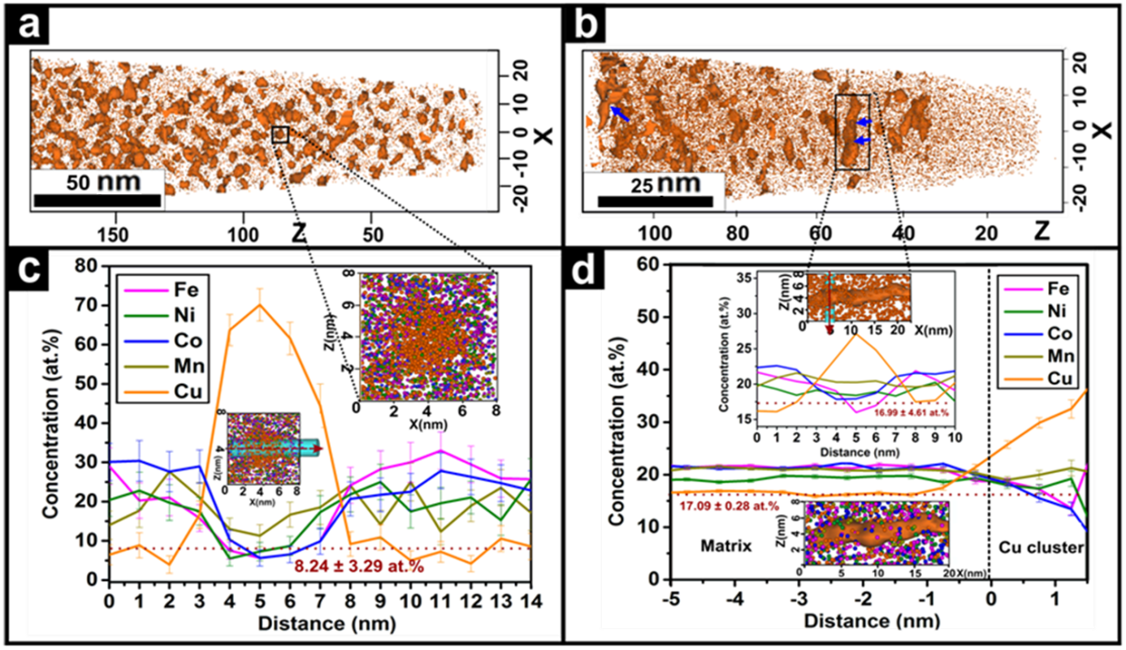
Figure S2: 3D elemental distribution of copper in homogenised alloy (a) and (c) and in five-turn HPT sample (b) and (d).
Table S1: Data from APT.
 | Annealed sample (1273 K, 10 hr) | HPT  (5-turn)
Cluster size (nm) | 2.5 | 1.5
At. % of copper in matrix | 8.24 | 17
Volume fraction of clusters | 0.25 | 0.05

During the APT experiment, 60 $×$60 $×$ 100 nm³ of volume was analyzed and 8.6 million ions were collected. Figure S2 and Table S1 indicates that the copperrich nano-clusters undergo partial dissolution when subjected to HPT. Compositional information obtained in terms of average size of nano-clusters their volume fraction and the atomic percentage of copper in the matrix is statistically significant and reliable.
Earlier investigation by the authors had shown that addition of copper to FeMnNiCo complex concentrated alloy contributes to increase in yield strength due to solid solution strengthening [3]. Hardness and elastic modulus determined from Vickers micro-indentation with load of 100 mN, dwell time of 10 seconds and loading rate of 200 mN/min (Table S2) shows that addition of copper to FeMnNiCo alloy leads to increase in hardness and yield strength but simultaneous decrease in the modulus. This further justifies the claim that the dissolution of copper rich nano-clusters can lead to increase in hardness with simultaneous decrease in modulus.
Table S2: Hardness and modulus of FeMnNiCo and FeMnNiCoCu alloys [].
Alloy | Yield strength (MPa) | Hardness (MPa) | Elastic modulus (GPa)
FeMnNiCo | 215± 20 | 4009±194 | 237± 19
FeMnNiCoCu | 499± 18 | 6914± 605 | 191± 13

S.III: HPT of ten-turn sample
(b)
(a)
Figure S3: 2D contour map of (a) five-turn and (b) ten-turn HPT samples.
Figure S3 shows that the saturation hardness achieved during HPT of CoCuFeMnNi HEA is 1941 MPa.
S.IV: SFE of CoCuFeMnNi HEA
The SFE of the alloy is 22.46 mJ/m², determined using the following Reed and Schramn’s equation [3,].
$γ_{SFE}= \frac{K_{111}ω_{0}G_{111}a_{0}A^{-0.37}{〈ε^{2}〉}_{111}}{π\sqrt{3}α}$ (S1)
Here, ${〈ε^{2}〉}_{111}$ = micro-strain, $G_{111}$= shear modulus on (111) plane, $K_{111}ω_{0}$ = constant (6.6 for FCC materials), $a_{0}$ = lattice parameter, A = Zener anisotropy {${2C_{44}}/{\left(C_{11}-C_{12}\right)}$}, and $α$ = stacking fault probability (SFP). The SFP was calculated using the following formula:
$∆2θ={\left(2θ_{200}-2θ_{111}\right)}_{coldworked}-{\left(2θ_{200}-2θ_{111}\right)}_{annealed}$ (S2)
$∆2θ= -\frac{45\sqrt{3}}{π^{2}}{\left(\tan{θ_{220}}+ \frac{1}{2}\tan{θ_{111}}\right)}_{annealed}α$ (S3)

References [] Reshma Sonkusare, Aditya Swain, M. R. Rahul, Sumanta Samal, N. P. Gurao, Krishanu Biswas, Sudhanshu S. Singh, N. Nayan. Establishing processing-microstructure-property paradigm in complex concentrated equiatomic CoCuFeMnNi alloy. Materials Science and Engineering: A 759 (2019) 415-429. DOI: https://doi.org/10.1016/j.msea.2019.04.096
[] Reshma Sonkusare, P. Divya Janani, N. P. Gurao, S. Sarkar, S. Sen, K. G. Pradeep, Krishanu Biswas. Phase equilibria in equiatomic CoCuFeMnNi high entropy alloy. Materials Chemistry and Physics 210 (2018) 269-278. DOI: https://doi.org/10.1016/j.matchemphys.2017.08.051
[] Rani Agarwal, Reshma Sonkusare, Saumya R. Jha, N. P. Gurao, Krishanu Biswas, Niraj Nayan. Understanding the deformation behavior of CoCuFeMnNi high entropy alloy by investigating mechanical properties of binary ternary and quaternary alloy subsets. Materials & Design 157 (2018) 539-550. DOI: https://doi.org/10.1016/j.matdes.2018.07.046
[] J. E. Jin, Y. K. Lee. Effects of Al on microstructure and tensile properties of C-bearing high Mn TWIP steel. Acta Materialia 60 (2012) 1680-1688. DOI: https://doi.org/10.1016/j.actamat.2011.12.004

