Supporting Information
For
BODIPY based A-D-A molecules: Effect of CF₃ group substitution at meso phenyl group

- Synthesis
The BODIPY subunits are known in literature and the synthesis is similar to known procedures.
General synthetic procedure for Dipyrromethane 2(a,b)
10 mmol of the corresponding 4-substituted benzaldehyde (1a and 1b) was dissolved in 30 ml of distilled pyrrole under nitrogen atmosphere. 1 mmol of trifluoroacetic acid was added to the reaction mixture and stirred at room temperature for 20 mins. The reaction was quenched by adding 50 ml of 1N aqueous solution of NaOH. The mixture was then extracted with 100 ml of ethyl acetate and the organic fraction was washed with distilled water (2×50 ml) and subsequently with brine solution. The organic fraction was dried over anhydrous sodium sulphate and solvent was removed by rotary evaporator under reduced pressure. The crude product was purified by column chromatography over silica gel using 1:10 EtOAc- hexane mixture as the eluent to obtain the purified dipyrromethane. The product obtained was recrystallized from hexane over EtOAc.
2a: white solid. (yield = 73 %). 2b: brownish white solid. (yield = 77 %) ¹H NMR (400 MHz, CDCl₃) δ: 7.97 (s, 2H), 7.57 (d, J = 8.1 Hz, 2H), 7.33 (d, J = 8.1 Hz, 2H), 6.73 (m, 2H), 6.17 (dd, J = 6.0, 2.7 Hz, 2H), 5.89 (m, 2H), 5.54 (s, 1H).
General synthetic procedure for BODIPY 3(a,b)
5 mmol of the dipyrromethane obtained from the previous step was dissolved in dry toluene. DDQ was added to the solution and stirred under nitrogen atmosphere for 1h at room temperature followed by addition of trimethylamine and BF₃.Et₂O. The reaction mixture was stirred at room temperature for another hour and then quenched with 0.1 N NaOH solution in water. The mixture was extracted with dichloromethane. The organic fraction was dried over anhydrous Na₂SO₄ and the solvent removed under reduced pressure. The crude product was then purified by column chromatography using dichloromethane: hexane (1:2) as the eluent over silica. The purified BODIPY was then recrystallized from hexane over dichloromethane.
3a (yield = 87 %): ¹H NMR (500 MHz, CDCl₃) δ 7.93 (s, 2H), 7.47 (d, J = 8.1 Hz, 2H), 7.34 (d, J = 7.9 Hz, 2H), 6.96 (d, J = 4.2 Hz, 2H), 6.54 (d, J = 4.0 Hz, 2H), 2.48 (s, 3H).
3b (yield = 73%): ¹H NMR (400 MHz, CDCl₃) δ 7.98 (s, 2H), 7.81 (d, J = 8.1 Hz, 2H), 7.69 (d, J = 8.0 Hz, 2H), 6.88 (d, J = 4.2 Hz, 2H), 6.57 (d, J = 4.1 Hz, 2H).

General synthetic procedure for monobrominated BODIPY 4(a,b)
BODIPY (3a and 3b) obtained from previous reaction was dissolved in dry dichloromethane: dry DMF mixture (1:1) by stirring under nitrogen atmosphere. 1.5 equivalents of N-bromosuccinamide dissolved in dry DMF was added and the reaction mixture was stirred at room temperature and under nitrogen atmosphere overnight. Dichloromethane was added to the reaction mixture and washed with water to remove DMF. The organic layer was then dried over anhydrous Na₂SO₄ and the solvent removed under reduced pressure. The crude product was then purified by column chromatography using dichloromethane: hexane (1:4) as the eluent over silica. The red coloured compound was then recrystallized from hexane over dichloromethane.
4a (yield = 79%): ¹H NMR (500 MHz, CDCl₃) δ: 7.83 (s, 2H), 7.44 (s, 2H), 7.36 (d, J = 7.9 Hz, 2H), 6.98 (s, 2H), 2.48 (s, 3H).
4b (yield = 66%): ¹H NMR (400 MHz, CDCl₃) δ: 8.05 (s, 1H), 7.82 (d, 3H), 7.69 (d, 2H), 6.95 (d, 1H), 6.83 (s, 1H), 6.63 (d, 1H).
The benzodithiophene compound including all the precursors are also known in literature.
(N,N-diethyl)thiophenecarboxylamide (7) : 3g (23.4 mmol) of thiophene-3-carboxylic acid (1) was added to about 5 ml of dichloromethane taken in a round bottomed flask fitted with CaCl₂ guard tube. The solution was cooled on an ice bath and 11.9 g (93.6 mmol) of oxalyl chloride was added dropwise. The reaction mixture was stirred at room temperature overnight. The excess oxalyl chloride was removed under vacuum and the acyl chloride intermediate (6) was dissolved in 10 ml of dry dichloromethane. The solution of acid chloride was then added dropwise to the solution containing diethylamine 3.4g (46.8 mmol) in 30ml of dry dichloromethane in a two necked round bottomed flask fitted with a CaCl₂ guard tube and cooled on an ice bath. The reaction mixture was stirred for 3 hours at room temperature following which it was washed thoroughly with water. The organic fraction was dried using anhydrous sodium sulphate, concentrated and purified by silica gel column chromatography using ethyl acetate: hexane (3:10) mixture as eluent. 4.2 g (98% yield) of pure product was obtained as an oily liquid.
Benzo[1,2-b:4,5-b']dithiophene-4,8-dione (8): Compound 7 (4.2 g, 22.9 mmol) was dissolved in dry THF under inert atmosphere. The solution was cooled to 0°C on an ice bath. Subsequently 15.8 ml of n-BuLi was added slowly over a period of 30 min while stirring. Stirring was continued for 3 h at RT. The reaction mixture was then poured into ice-water. Yellow coloured precipitate appears instantly. After overnight stirring the precipitate is filtered out using Buchner apparatus. The crude product is purified by repeated washing with water, cold methanol and hexane. The yellow coloured product (1.9 g, 59.3%) is dried under vacuum.
2-(2-ethylhexyl) thiophene (9) : 2 g of thiophene (35.65 mmol) was taken in a two necked RB under inert atmosphere. 20 ml of freshly distilled THF was added and the solution cooled to –78 °C on LN₂:EtOAc bath. n-BuLi (24.5 ml,1.6 M in THF) was added drop wise to the reaction mixture at –78 °C and stirring was continued for 1 h. Following this 2-Ethylhexyl bromide (7 ml, 39.22 mmol) was added to the reaction mixture and overnight. Water was added to quench the reaction and product was extracted with ethyl acetate. The crude product was purified by column chromatography using silica gel and hexane as eluent. The product was obtained as colourless liquid with a yield of 76%. ¹H NMR spectrum (400 MHz, CDCl3) δ: 7.12(d, 1H), 6.9(dd, 1H), 6.8 (d, 1H), 2.6 (d, 2H), 1.56 (d, 1H), 1.29 (m, 8H), 0.91(m, 6H)
4,8-bis(5-(2-ethylhexyl)thiophene-2-yl)benzodithiophene (10): 4.3 g of 2-ethyl hexyl thiophene (22.15 mol) was taken in a three necked RB fitted with a condenser and under dry N₂ flushing. Dry THF (50 ml) was added and the reaction mixture was cooled to 0°C over an ice bath. 15.5 ml of n-BuLi was added to the solution drop wise at the same temperature. The reaction mixture was then heated to 50°C for 1.5 h over an oil bath. 1.2 g of 9 (5.53 mol) was subsequently added to the reaction mixture. The reaction mixture was refluxed for 2 h and cooled down to room temperature. 12.5 g (55.3 mol) of SnCl₂.2H₂O in 10% HCl was added and stirring was continued for 2 h at room temperature. Finally, the product was extracted with diethyl ether and dried over anhydrous Na₂SO₄. The compound was purified by column chromatography over silica gel using hexane as the eluent. The dithienylated-BDT (10) was obtained with a yield of 80% as a fluorescent viscous liquid. ¹H NMR spectrum (400 MHz, CDCl₃) δ: 7.12(d, 1H), 6.9(dd, 1H), 6.8 (d, 1H) 2.6(d, 2H), 1.56 (d, 1H), 1.29 (m, 8H), 0.91(m, 6H).
4,8-bis(5-(2-ethylhexyl)thiophene-2-yl)benzo[1,2-b:4,5-b′]dithiophene-2,6-diyl)bis(trimethylstannane) (11): 1 gram of Benzodithiophene (1.72 mol) was taken in 15 ml dry THF at -78 °C. A 3.2 ml of (n-BuLi) was added to the reaction mixture drop-wise at the same temperature. The temperature of the reaction mixture was maintained and stirred for 30 minutes. SnMe₃Cl (4.3 ml, 1M in THF) was added to the reaction mixture slowly and kept for stirring overnight. Water was added to quench the reaction and the product was extracted with ethyl acetate. The crude was purified thrice by recrystallization to obtain the clean product. (yield =70%) ¹H NMR spectrum (400 MHz, CDCl₃) δ: 7.69 (s, 2H), 7.32 (d, J = 3.5 Hz, 2H), 6.91 (d, J = 3.5 Hz, 2H), 2.89- 2.86 (m, 4H), 1.72-1.68 (m, 2H), 1.46-1.35 (br, 16H), 0.98-0.86 (m, 12H), 0.40 (s, 18H).
Synthesis of S1 and S2:
0.2 mmol of 12 and 0.4 mmol of monobrominated BODIPY(4a or 4b) were taken in a two necked are purged with nitrogen. 6 ml of dry toluene was added to the RB and degassed for 20 mins. Pd₂dba₃ (15 μmol) and P(o-tolyl)₃ (10 μmol) were added to the reaction mixture and degassed for another 10 mins by purging nitrogen gas through the reaction mixture. The reaction mixture was then stirred at 110°C for 15 mins after which 1 ml of 2M potassium carbonate solution (degassed by purging nitrogen) was added. The stirring was continued at the same temperature for 6 h. The reaction mixture was cooled down and dichloromethane (50 ml) was added to it. The solution was dried over anhydrous Na₂SO₄ and solvent removed under vacuum. The crude product was purified by silica gel column chromatography using dishloromethane: hexane (2:3) mixture as eluent to obtain crystalline products S1 (yield = 57.8%) and S2 (yield = 61.3 %) respectively.
¹H NMR of S1 (CDCl₃, 400 MHz) δ (ppm): 8.37 (2H, s), 7.95 (2H, s), 7.65-7.67 (4H, d), 7.55-7.57 (4H, d), 7.49-7.51 (2H, dd), 7.46 (2H,s), 7.39-7.41 (4H,d), 7.16 (2H, s), 6.96-6.97 (2H, d), 6.56-6.57 (2H,dd), 2.52 (6H, s), 1.97-2.02 (4H, m), 1.04-1.12 (12H, m), 0.72-0.76 (6H,t), 0.61 (4H, m). ¹³C NMR of S1 (CDCl₃, 100 MHz) δ (ppm): 150.7, 146.0, 142.6, 141.2, 140.4, 139.3, 130.5, 130.3, 130.1, 129.6, 128.3, 124.2, 123.4, 119.2, 118.6, 54.3, 39.5, 30.43, 28.6, 22.7, 21.6, 20.5, 12.9. ¹¹B NMR of S1 (CDCl₃, 128 MHz) δ (ppm): -0.68 (t). ¹⁹F NMR of S1 (CDCl₃, 376 MHz) δ (ppm): -145.0 (q). ESI-MS m/z: 894.299 (m/z calculated for C₅₇H₅₆B₂F₄N₄ = 894.46)
¹H NMR of S2 (CDCl₃, 400 MHz) δ (ppm): 8.42 (2H, s), 8.00 (2H, s), 7.86-7.88 (4H, d), 7.77-7.79 (4H, d), 7.66-7.68 (2H,d), 7.49-7.51 (2H, dd), 7.46 (2H,s), 7.06 (2H, s), 6.87-6.88 (2H, d), 6.59-6.60 (2H,d), 1.99-2.03 (4H, m), 0.98-1.12 (12H, m), 0.72-0.75 (6H,t), 0.60 (4H, m).¹³C NMR of S2 (CDCl₃, 100 MHz) δ (ppm): 150.8, 143.7, 143.3, 142.6, 139.5, 136.3, 131.8, 130.1, 130.0, 129.7, 124.6, 123.6, 123.5, 119.3, 118.6, 117.9, 54.4, 39.5, 30.5, 28.6, 22.7, 21.5, 12.9. . ¹¹B NMR of S2 (CDCl₃, 128 MHz) δ (ppm): -0.71 (t). ¹⁹F NMR of S1 (CDCl₃, 376 MHz) δ (ppm): -62.9 (m), -144.9 (q) ESI-MS m/z: 1002.381 (m/z calculated for C₅₇H₅₀B₂F₁₀N₄ = 1002.41)
Synthesis of S3 and S4:
0.2 mmol of 11 and 0.4 mmol of monobrominated BODIPY(4a or 4b) were taken in a two necked RB fitted with a condenser and purged with nitrogen. 6 ml of dry toluene was added to the RB and degassed for 20 mins. Pd₂dba₃ (15 μmol) and P(o-tolyl)₃ (10 μmol) were added to the reaction mixture and degassed for another 10 mins by purging nitrogen gas through the reaction mixture. The reaction was then refluxed at 110°C for 6 h. The reaction mixture was cooled down and dichloromethane (50 ml) was added to it. The solution was dried over anhydrous Na₂SO₄ and solvent removed under vacuum. The crude product was purified by silica gel column chromatography using dishloromethane: hexane (2:3) mixture as eluent to obtain crystalline products S3 (yield = 62.1 %) and S4 (yield = 70.6 %) respectively.
¹H NMR of S3 (CDCl₃, 400 MHz) δ (ppm): 8.26 (2H, s), 7.96 (2H, s), 7.63 (4H, s), 7.50-7.51 (4H, d), 7.37-7.38 (4H,d), 7.26-7.27 (2H, d), 6.98-6.99 (2H,d), 6.91-6.92 (2H, s), 6.56-6.57 (2H, dd), 2.88-2.89 (4H,d), 2.50 (6H, s), 2.02-2.05 (2H,m), 1.36 (20H, m), 0.95-0.98 (6H,t), 0.90-0.93 (6H, t). ¹³C NMR of S3 (CDCl₃, 100 MHz) δ (ppm): 146.3, 145.1, 143.6, 142.3, 140.6, 140.2, 137.5, 136.3, 135.8, 135.7, 134.3, 130.9, 129.8, 129.6, 128.4, 128.0, 127.4, 126.8, 124.5, 124.1, 122.4, 117.7, 40.4, 33.3, 31.4, 27.9, 24.7, 22.0, 20.5, 13.1, 9.9. ¹¹B NMR of S3 (CDCl₃, 128 MHz) δ (ppm): -0.77 (t). ¹⁹F NMR of S1 (CDCl₃, 376 MHz) δ (ppm): -145.0 (q) ESI-MS m/z: 1138.241 (m/z calculated for C₆₆H₆₄B₂F₄N₄S₄ = 1138.41)
¹H NMR of S4 (CDCl₃, 400 MHz) δ (ppm): 8.31 (2H, s), 8.01 (2H, s), 7.83-7.86 (4H, d), 7.71-7.73 (4H, d), 7.65 (2H,s), 7.27 (2H, d), 6.89-6.91 (6H, m), 6.59 – 6.61 (2H,m), 2.87-2.89 (4H, d), 2.02-2.05 (q), 1.67-1.73 (2H,m), 1.33-1.47 (20H, m), 0.94-0.98 (6H, t), 0.88-0.92 (6H,t). ¹³C NMR of S4 (CDCl₃, 100 MHz) δ (ppm): 145.3, 144.8, 143.5, 142.3, 141.5, 137.5, 136.3, 135.9, 135.6, 135.3, 130.7, 129.6, 129.5, 127.9, 126.8, 124.6, 124.5, 124.4, 123.6, 122.6, 118.4, 118.1, 40.4, 33.3, 31.4, 28.7, 24.8, 21.9, 13.0, 9.9. ¹¹B NMR of S1 (CDCl₃, 128 MHz) δ (ppm): -0.68 (t). ¹⁹F NMR of S1 (CDCl₃, 376 MHz) δ (ppm): -62.8 (m), -144.8 (q) ESI-MS m/z: 1246.172 (m/z calculated for C₆₆H₅₈B₂F₁₀N₄S₄ = 1246.36)

- NMR spectra

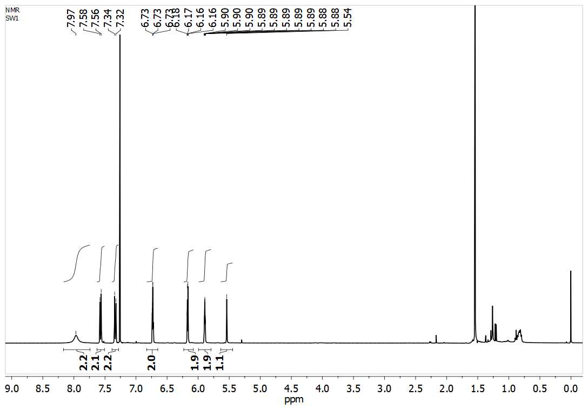
Figure S1: ¹H NMR of 2a in CDCl₃
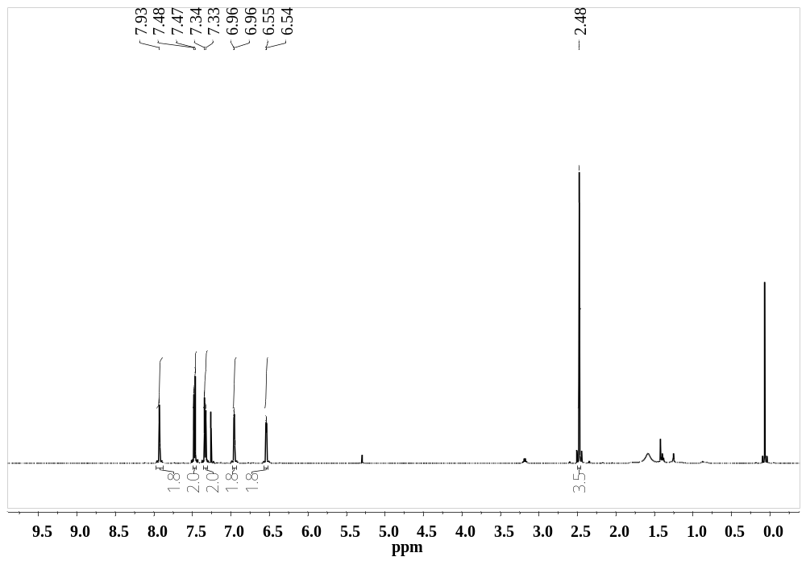
Figure S3: ¹H NMR of MeBDP (3a) in CDCl₃
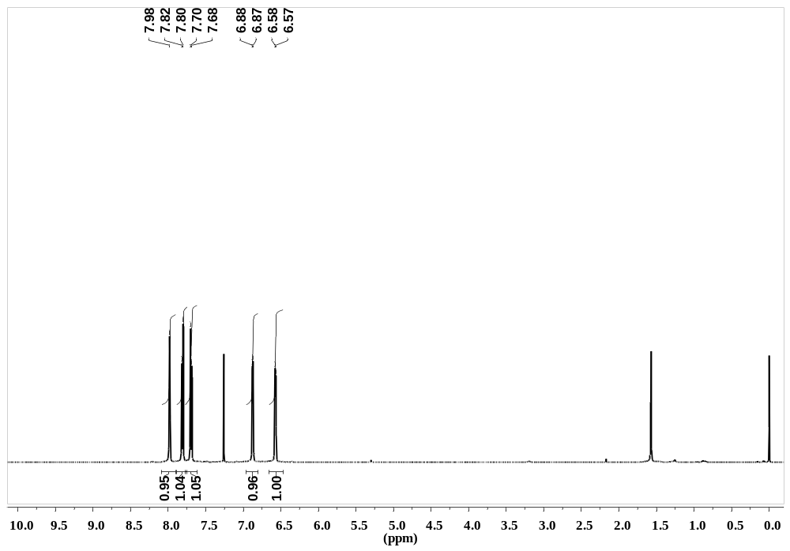
Figure S4: ¹H NMR of CF₃BDP (3b) in CDCl₃
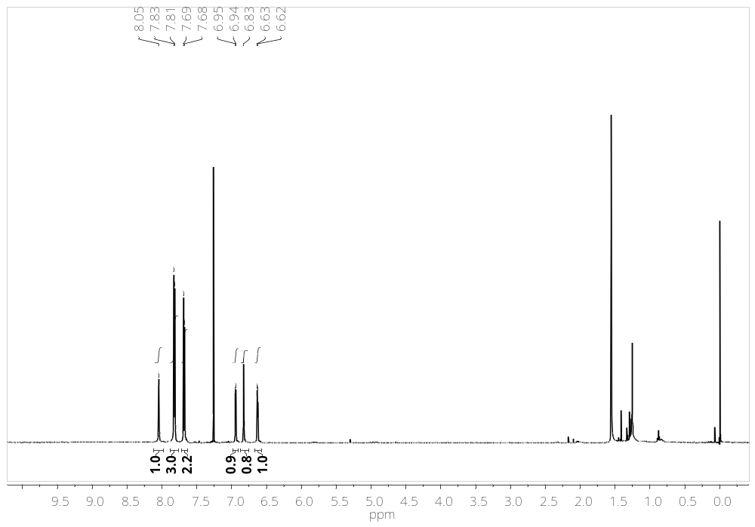
Figure S6: ¹H NMR of 4b in CDCl₃
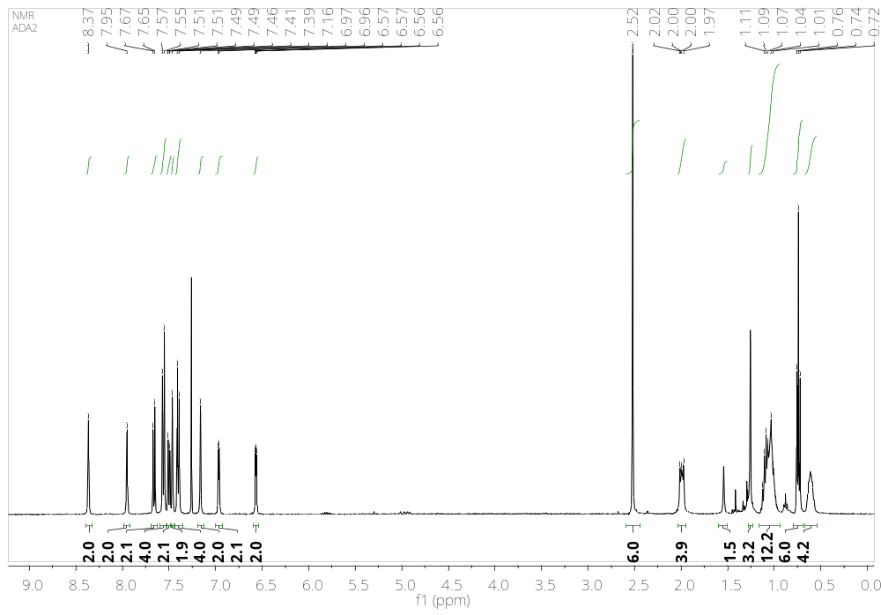
Figure S7: ¹H NMR of S1 in CDCl₃
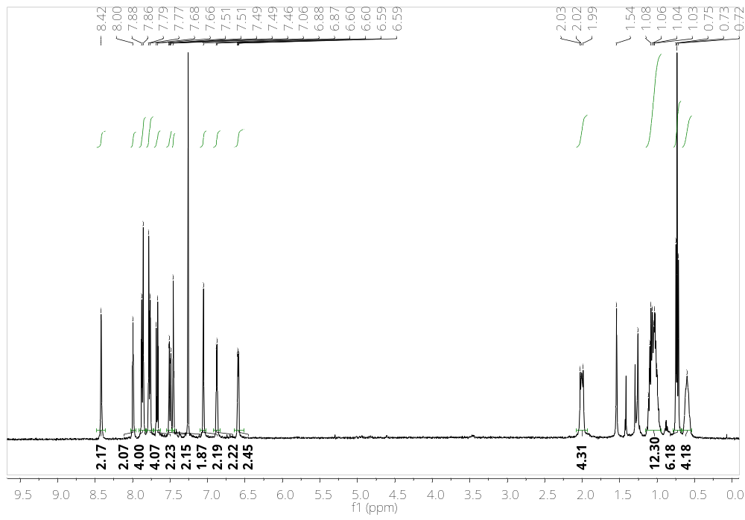
Figure S8: ¹H NMR of S2 in CDCl₃
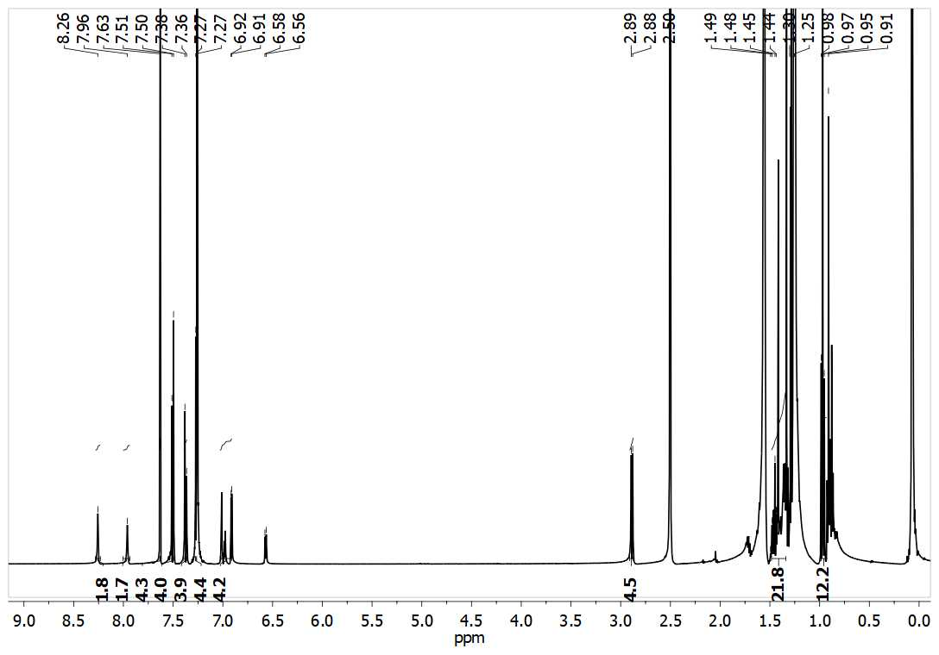
Figure S9: ¹H NMR of S3 in CDCl₃
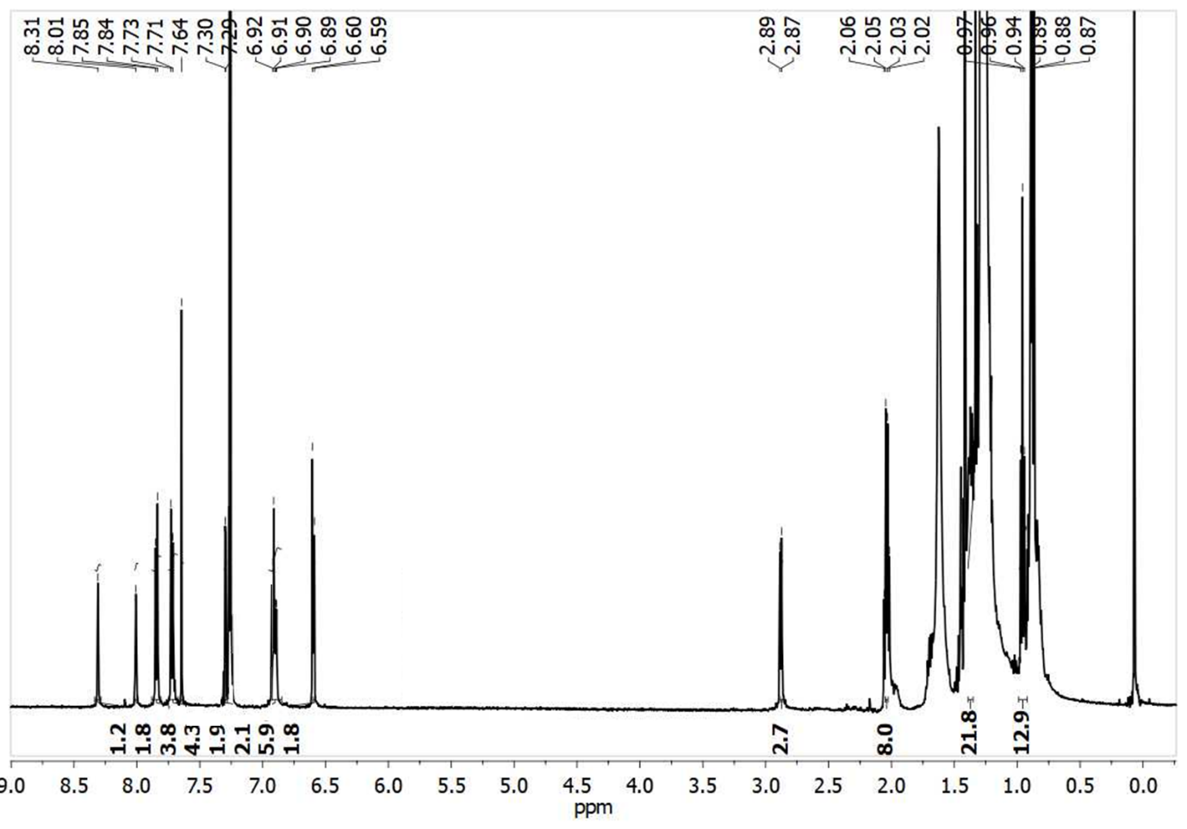
Figure S10: ¹H NMR of S4 in CDCl₃
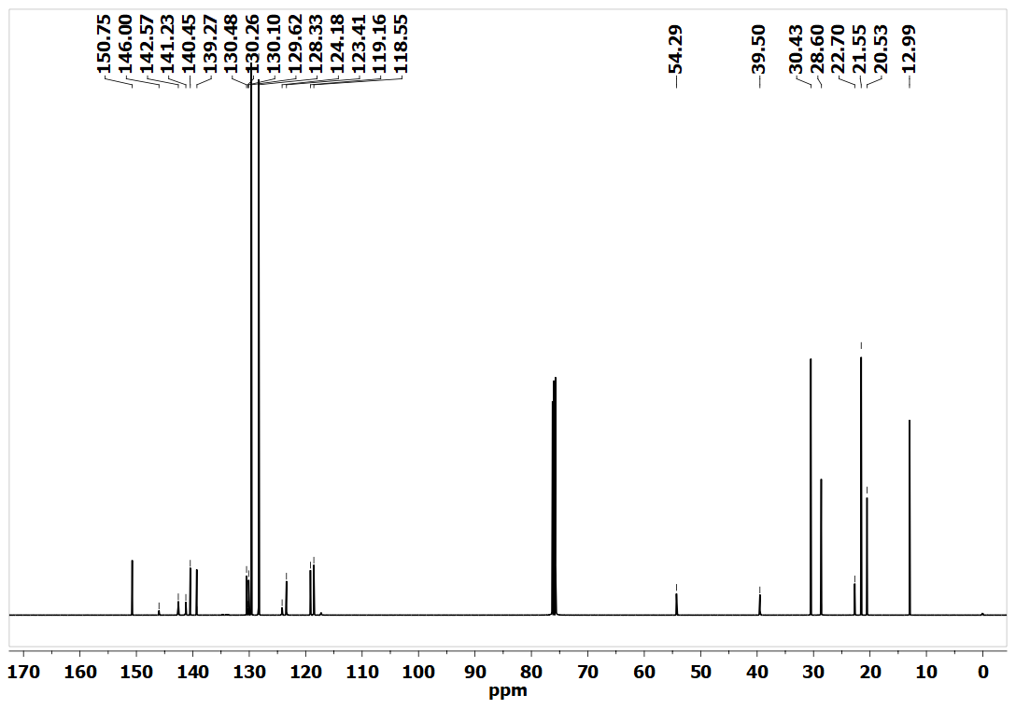
Figure S11: ¹³C NMR of S1 in CDCl₃
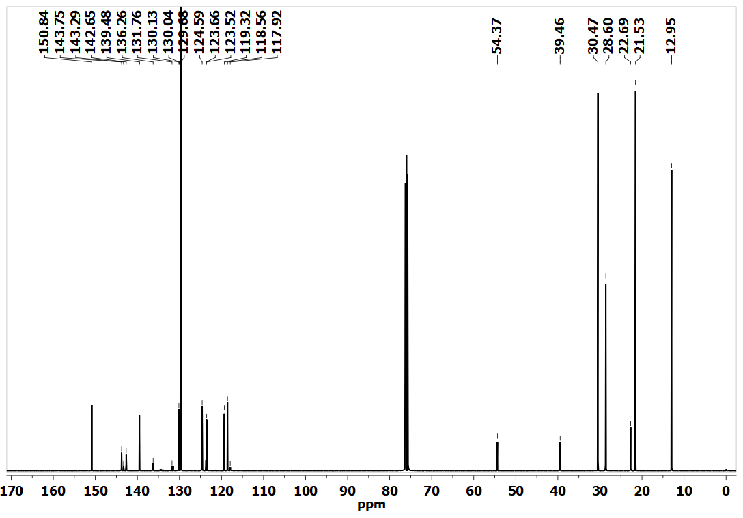
Figure S12: ¹³C NMR of S2 in CDCl₃
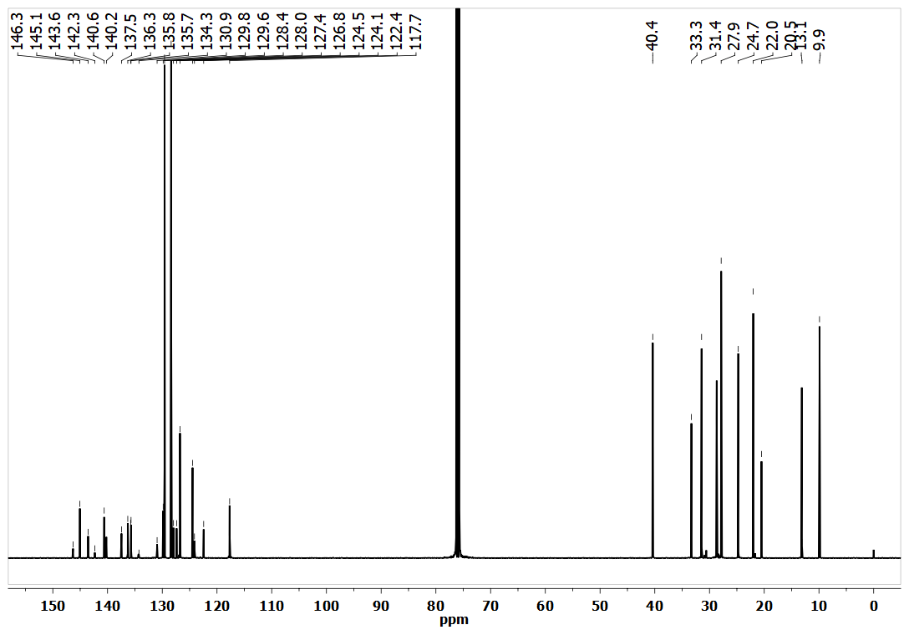
Figure S13: ¹³C NMR of S3 in CDCl₃
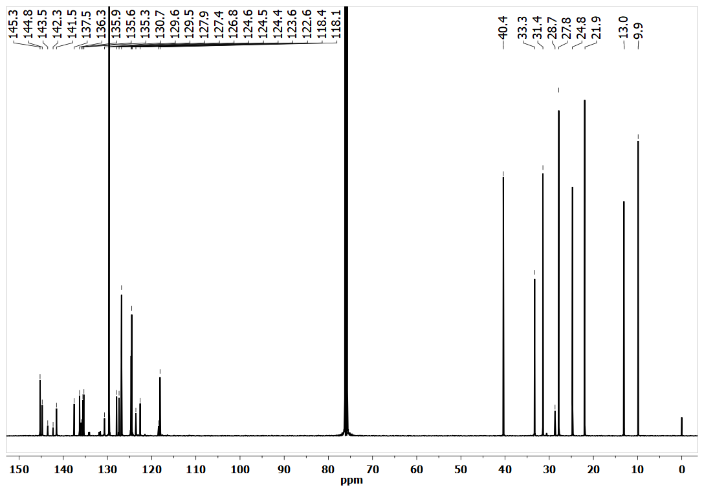
Figure S14: ¹³C NMR of S4 in CDCl₃
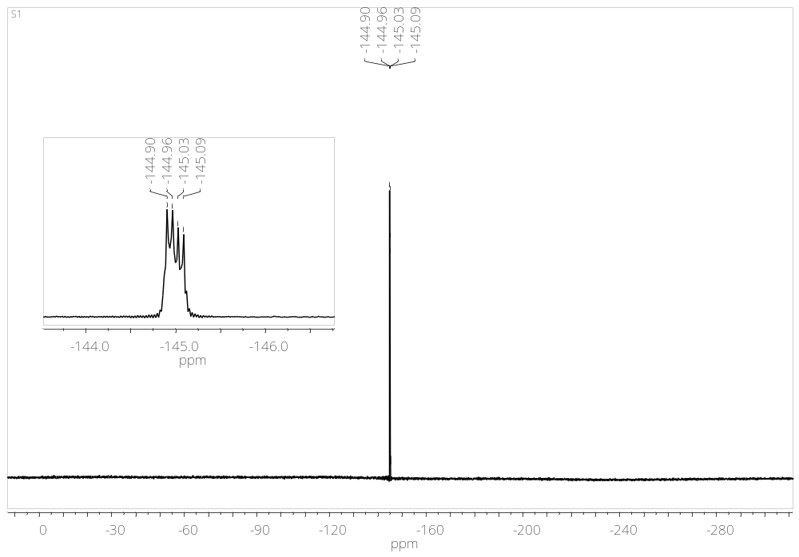
Figure S15: ¹⁹F NMR of S1 in CDCl₃

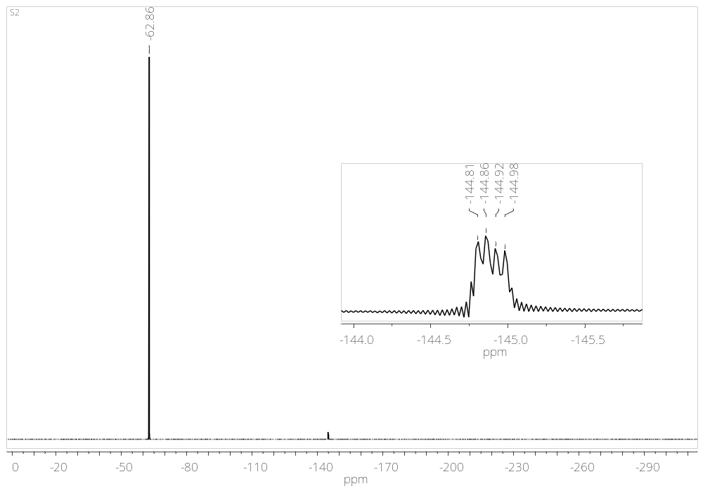
Figure S16: ¹⁹F NMR of S2 in CDCl₃
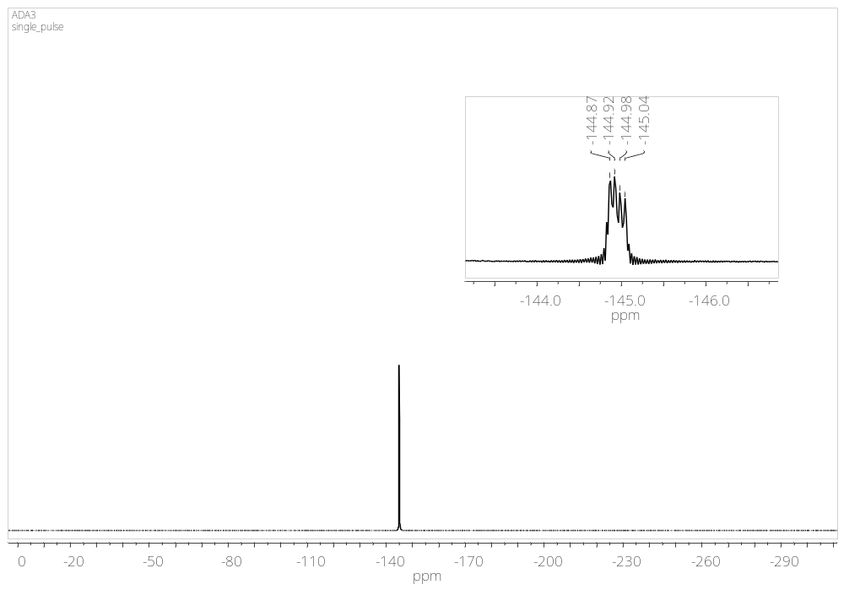
Figure S17: ¹⁹F NMR of S3 in CDCl₃

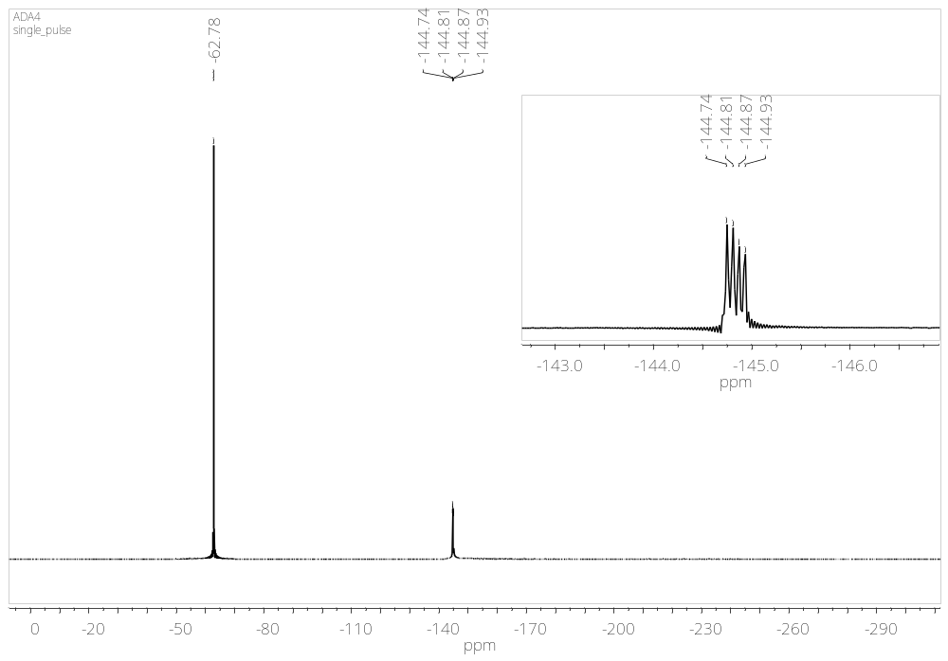
Figure S18: ¹⁹F NMR of S4 in CDCl₃

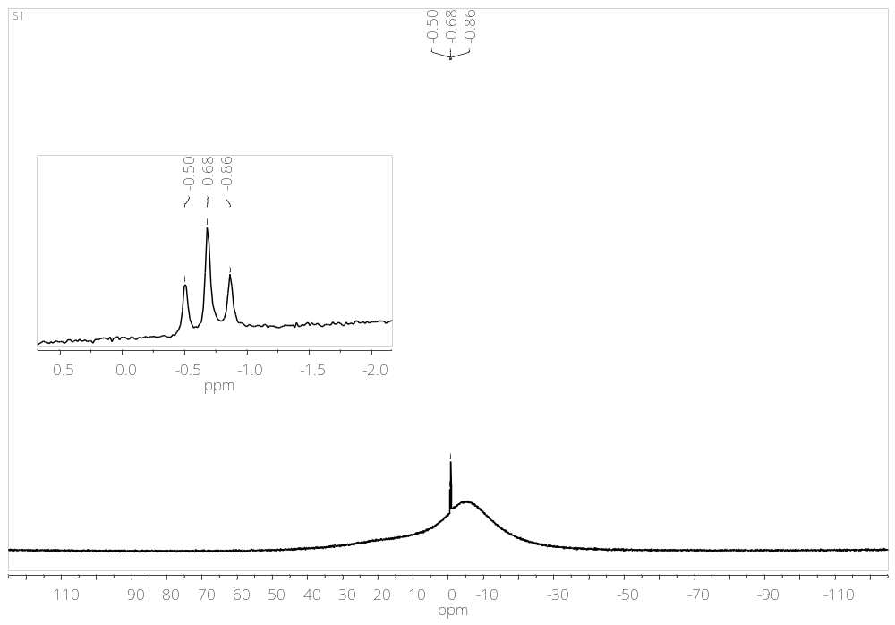
Figure S19: ¹¹B NMR of S1 in CDCl₃

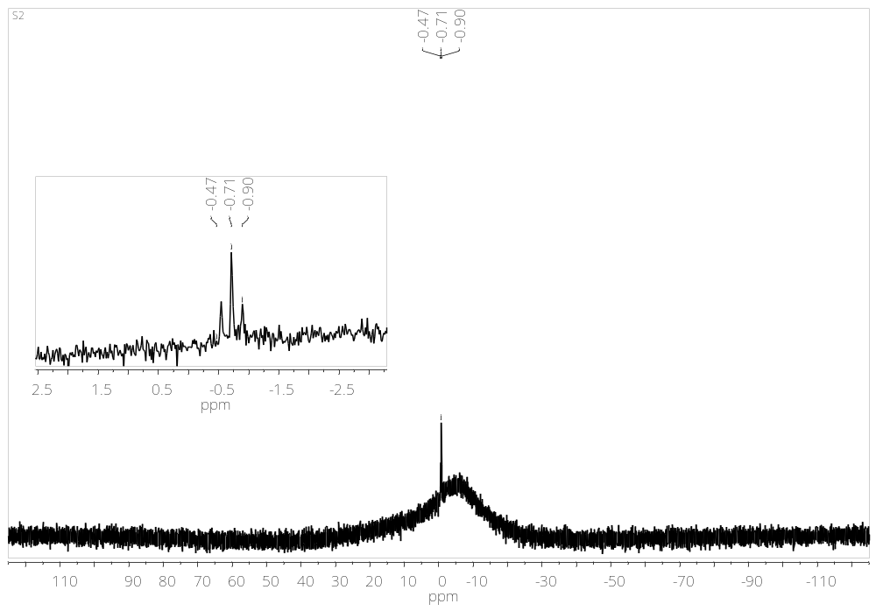
Figure S20: ¹¹B NMR of S2 in CDCl₃

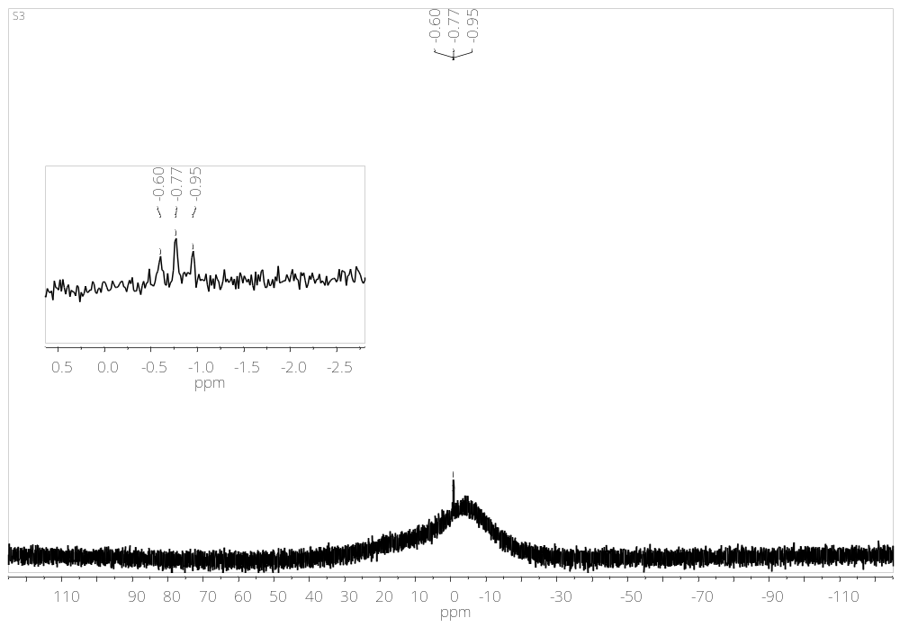
Figure S21: ¹¹B NMR of S3 in CDCl₃

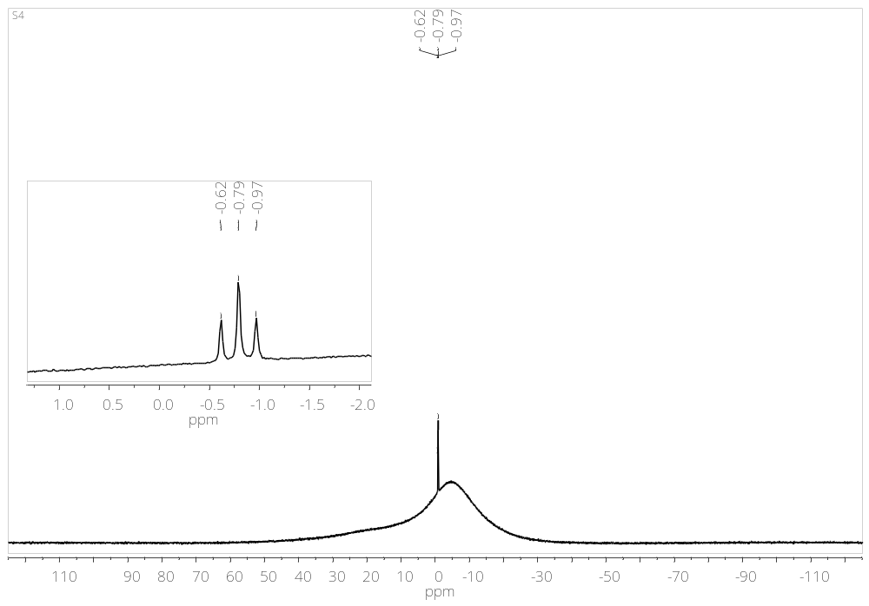
Figure S22: ¹¹B NMR of S4 in CDCl₃

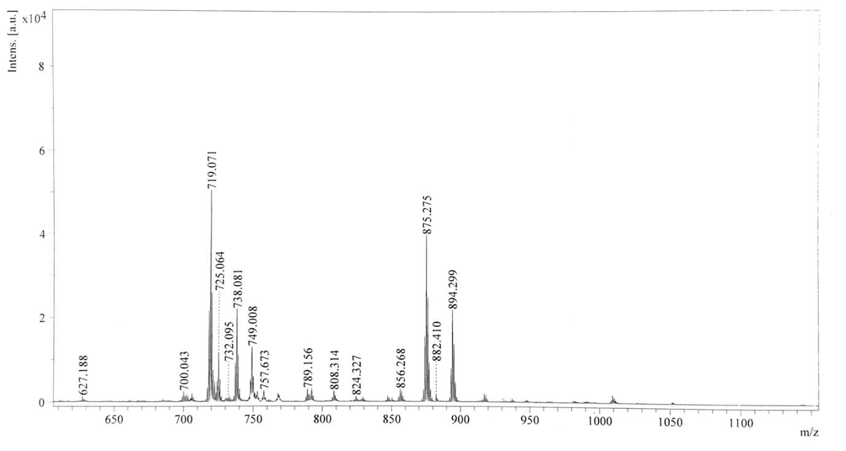
Figure S23: ESI-MS spectra of S1

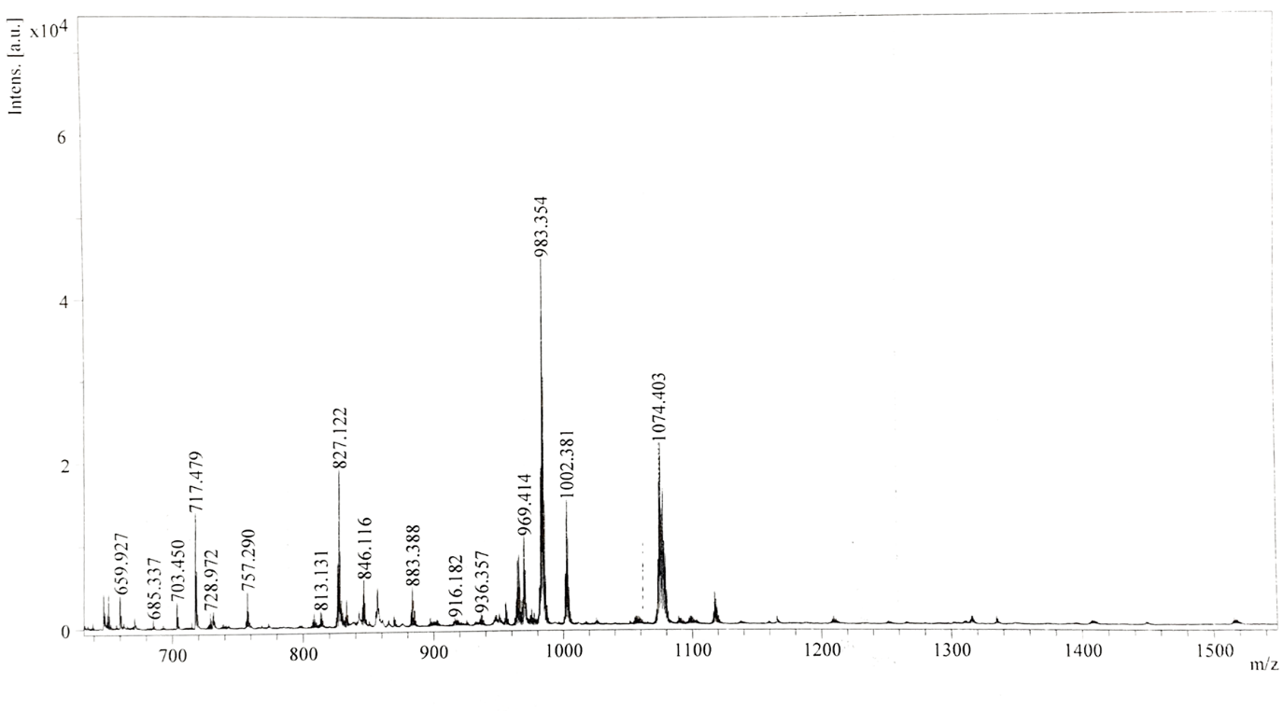
Figure S24: ESI-MS spectra of S2

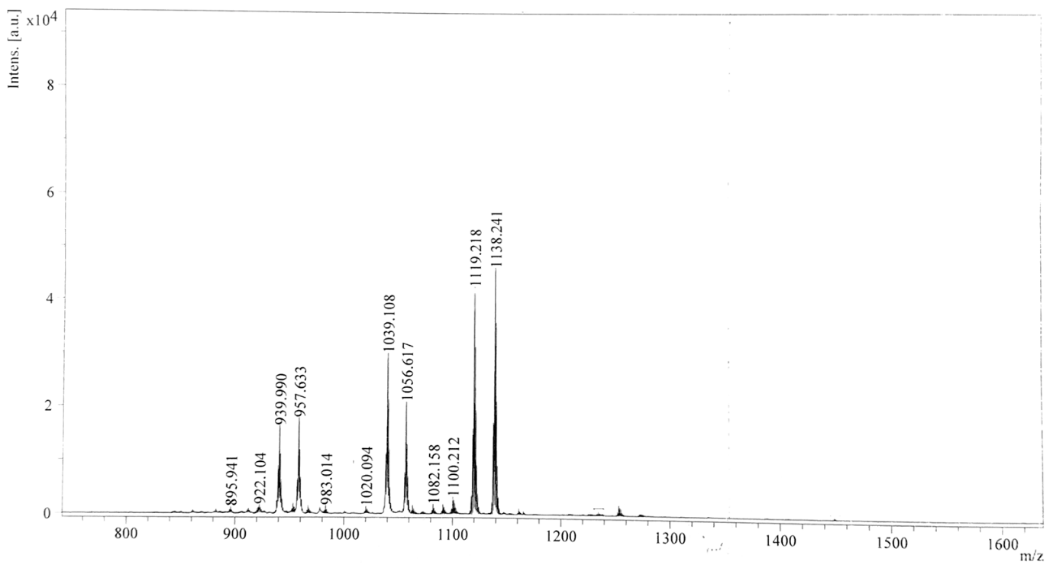

Figure S25: ESI-MS spectra of S3

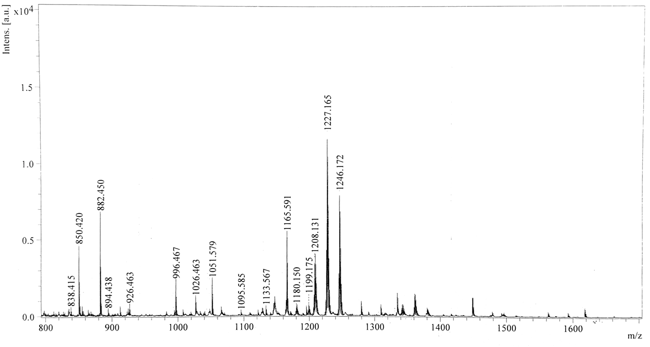
Figure S26: ESI-MS spectra of S4

- Density Functional theory calculations:
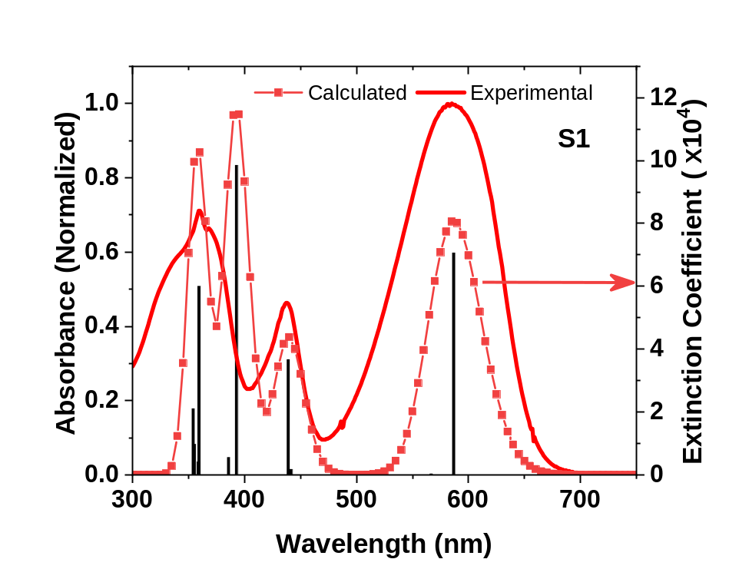
Figure S27: TDDFT calculated absorption spectra of S1
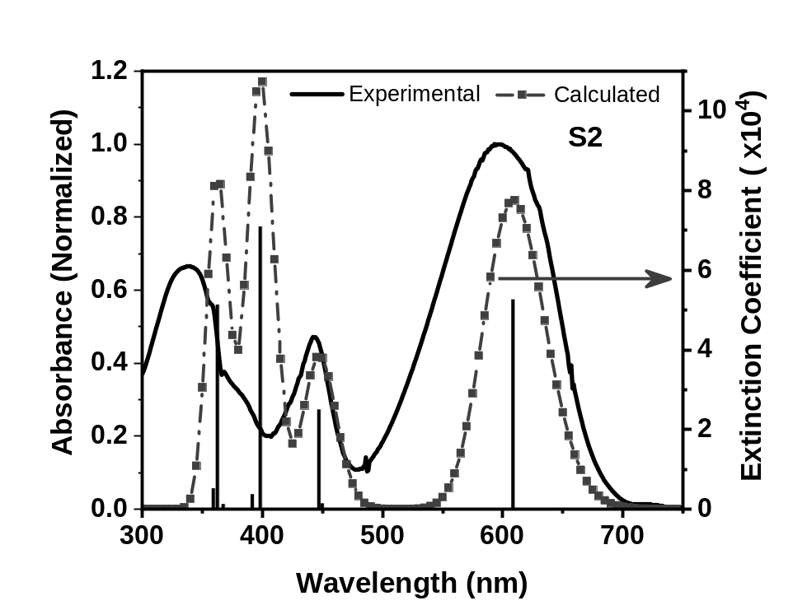
Figure S28: TDDFT calculated absorption spectra of S2
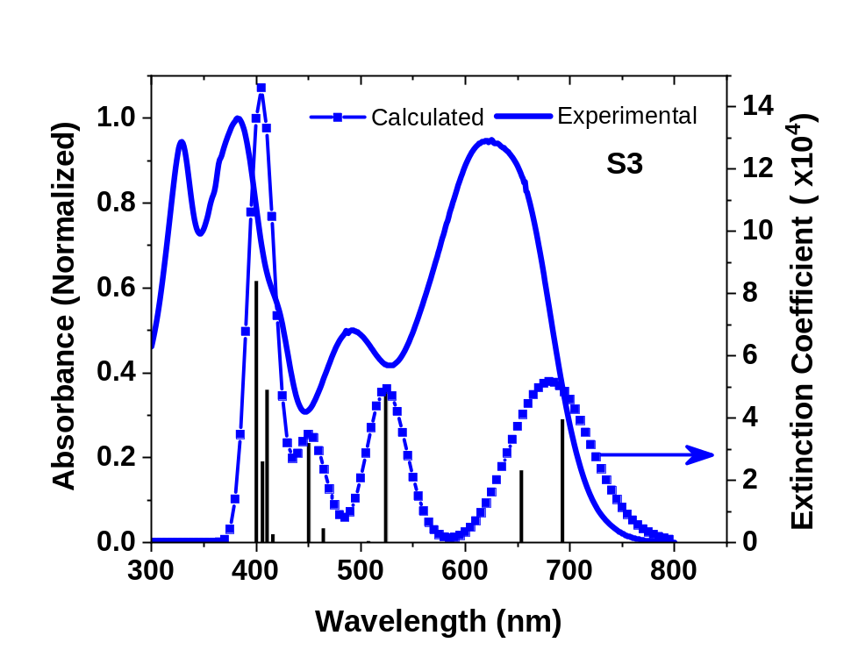
Figure S29: TDDFT calculated absorption spectra of S3
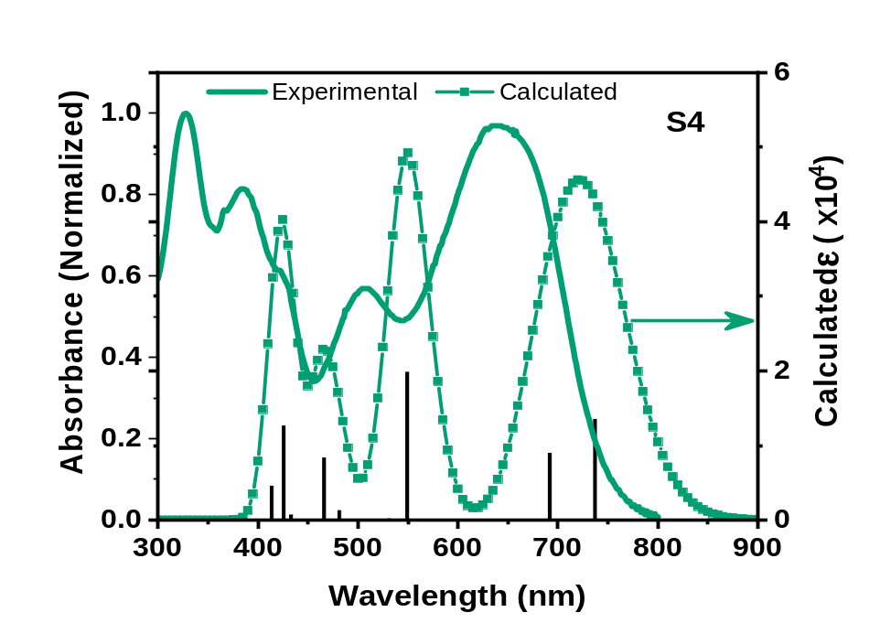
Figure S30: TDDFT calculated absorption spectra of S4

Table S1: TD-DFT calculations for S1
Wavelength (nm) | Oscillator strength | Transition
586.97 | 0.5974 | HOMO → LUMO
439.21 | 0.3103 | HOMO – 1 → LUMO + 1
392.92 | 0.8331 | HOMO – 2 → LUMO, HOMO – 1 → LUMO+1
359.46 | 0.5077 | HOMO – 3 → LUMO + 1;  HOMO – 8 → LUMO

Table S2: TD-DFT calculations for S2
Wavelength (nm) | Oscillator strength | Transition
608.72 | 0.5736 | HOMO → LUMO
447.23 | 0.2720 | HOMO – 1 → LUMO + 1
398.39 | 0.7733 | HOMO – 2 → LUMO, HOMO – 1 → LUMO
362.69 | 0.5594 | HOMO – 4, HOMO – 3, HOMO – 2 → LUMO + 1;  HOMO → LUMO + 2

Table S3: TD-DFT calculations for S3
Wavelength (nm) | Oscillator strength | Transition
693.15 | 0.2894 | HOMO → LUMO
524.17 | 0.3645 | HOMO – 1 → LUMO, HOMO – 1 → LUMO + 1
450.55 | 0.2337 | HOMO – 2 → LUMO + 1, HOMO – 3 → LUMO+1
410.76 | 0.3590 | HOMO – 3→ LUMO + 1;
400.48 | 0.6150 | HOMO → LUMO + 2, HOMO – 4 → LUMO, HOMO – 3, HOMO – 5 → LUMO + 1

Table S4: TD-DFT calculations for S4
Wavelength (nm) | Oscillator strength | Transition
737.43 | 0.2474 | HOMO → LUMO
692.13 | 0.1642 | HOMO → LUMO, LUMO + 1
549.57 | 0.3631 | HOMO – 1 → LUMO, HOMO – 1 → LUMO + 1
466.42 | 0.1528 | HOMO – 2 → LUMO+1, HOMO – 3 → LUMO+1
426.03 | 0.2315 | HOMO – 3 → LUMO+1, HOMO – 4 → LUMO, HOMO → LUMO + 2
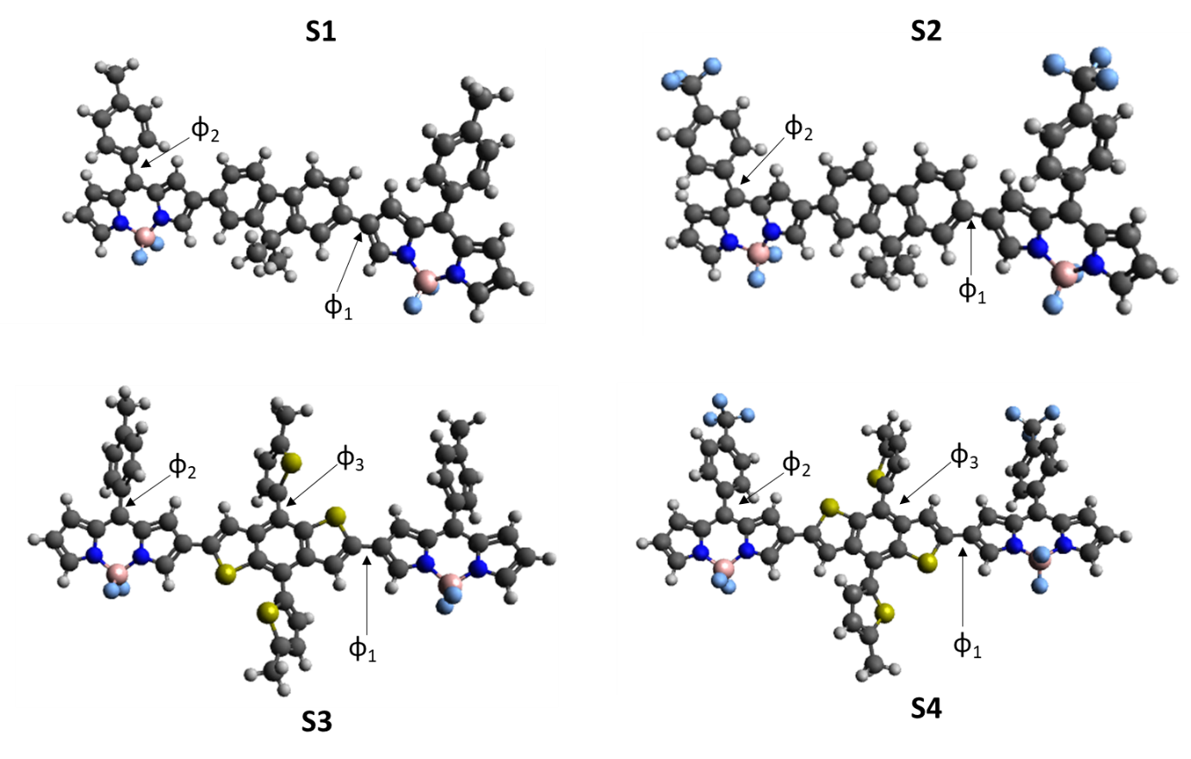
Figure S31: Optimized geometries of the ADA molecules obtained from DFT calculations. φ₁ is the dihedral angle between the donor and acceptor units and φ₂ the dihedral angle between the phenyl ring at meso position and the BODIPY ring. Φ₃ is the dihedral angel the thiophene rings make with the BDT subunits on S3 and S4.

Table S5: Comparison of dihedral angles in the structures optimized using DFT calculations. φ₁ is the dihedral angle between the donor and acceptor units and φ₂ the dihedral angle between the phenyl ring at meso position and the BODIPY ring. Φ₃ is the dihedral angel the thiophene rings make with the BDT subunits on S3 and S4.

A-D-A molecules |  | φ₁ | φ₂ | φ₃
S1 | Neutral | 157.5º | 53.0º | —
S1 | Cation | 178.1º | 52.1º | —
S2 | Neutral | 157.7º | 55.1º | —
S2 | Cation | 179.8º | 55.3º | —
S3 | Neutral | 170.2º | 52.5º | 56.3º
S3 | Cation | 179.1º | 51.9º | 47.2º
S4 | Neutral | 176.5º | 54.6º | 58.0º
S4 | Cation | 173.3º | 55.0º | 47.7º

- Absorption (Films)
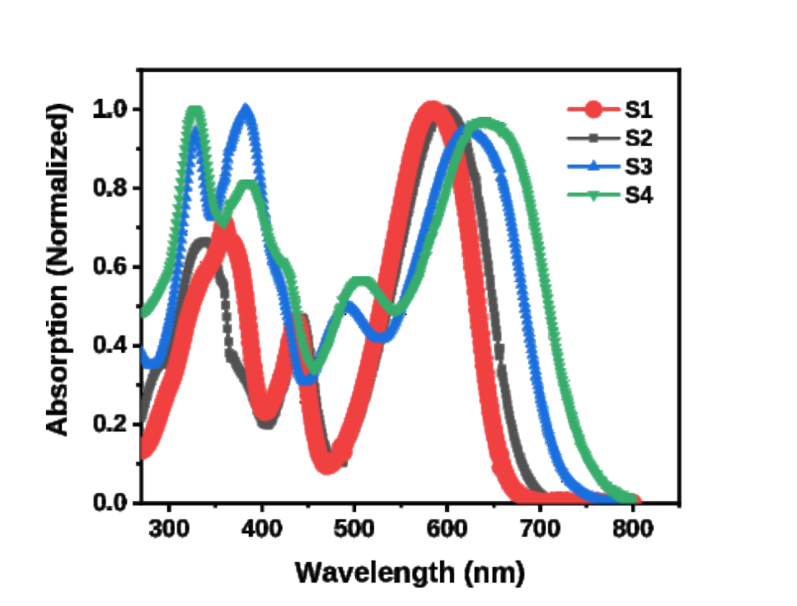
Figure S32: Absorption spectra of films
- Transient Absorption Spectroscopy
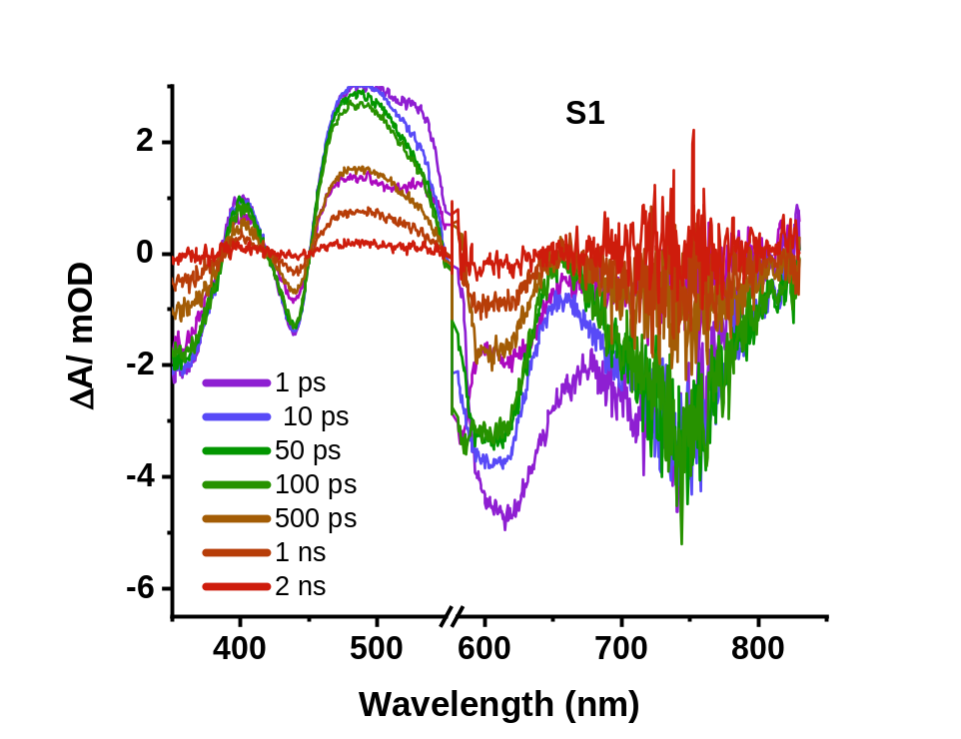
Figure S33: Transients of S1 in chloroform solution
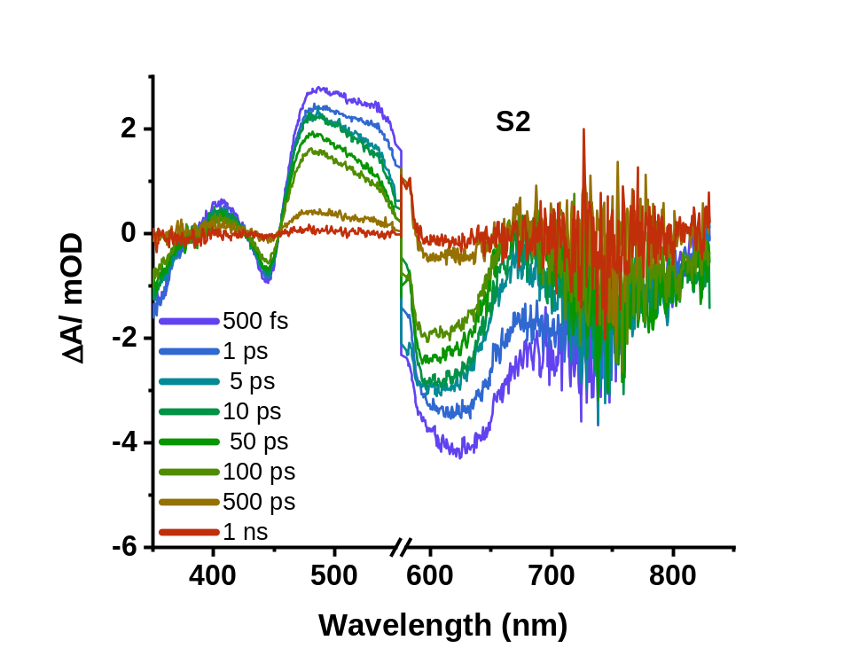
Figure S34: Transients of S2 in chloroform solution

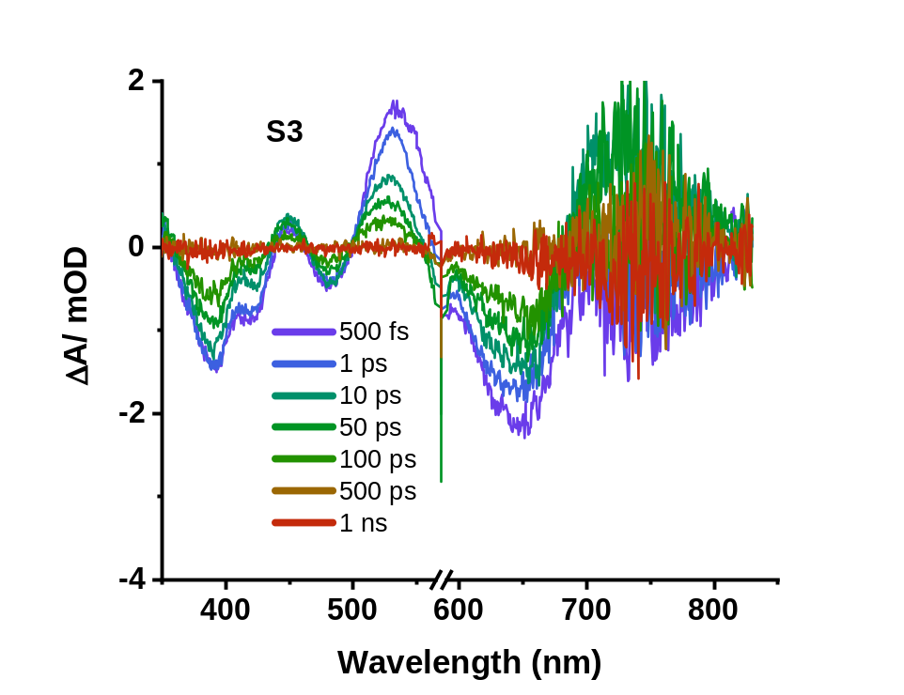
Figure S35: Transients of S3 in chloroform solution
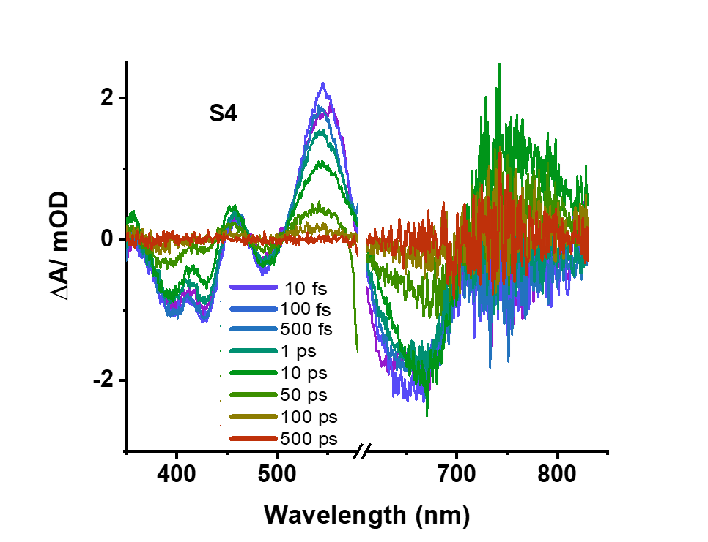

Figure S36: Transients of S4 in chloroform solution

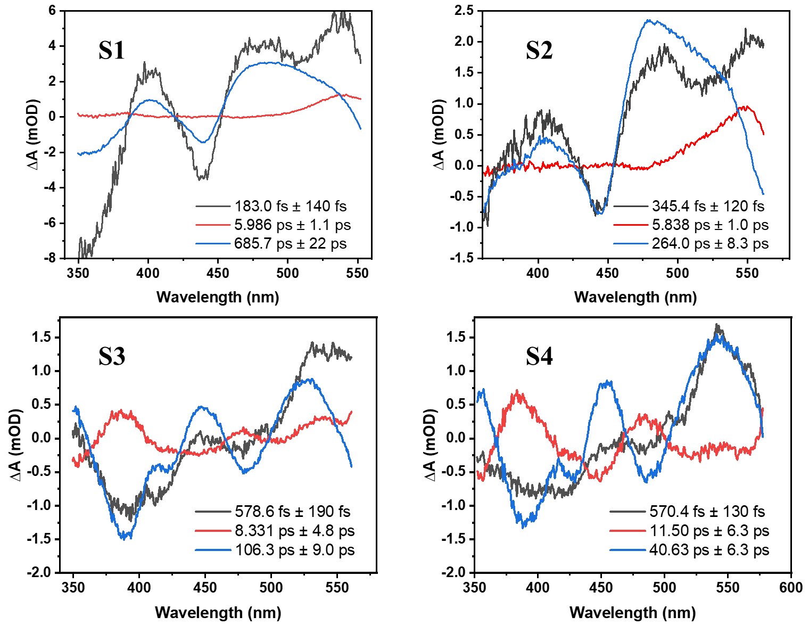
Figure S37: Decay associated spectra obtained from TA measurements for the solution of S1-S4 in chloroform.
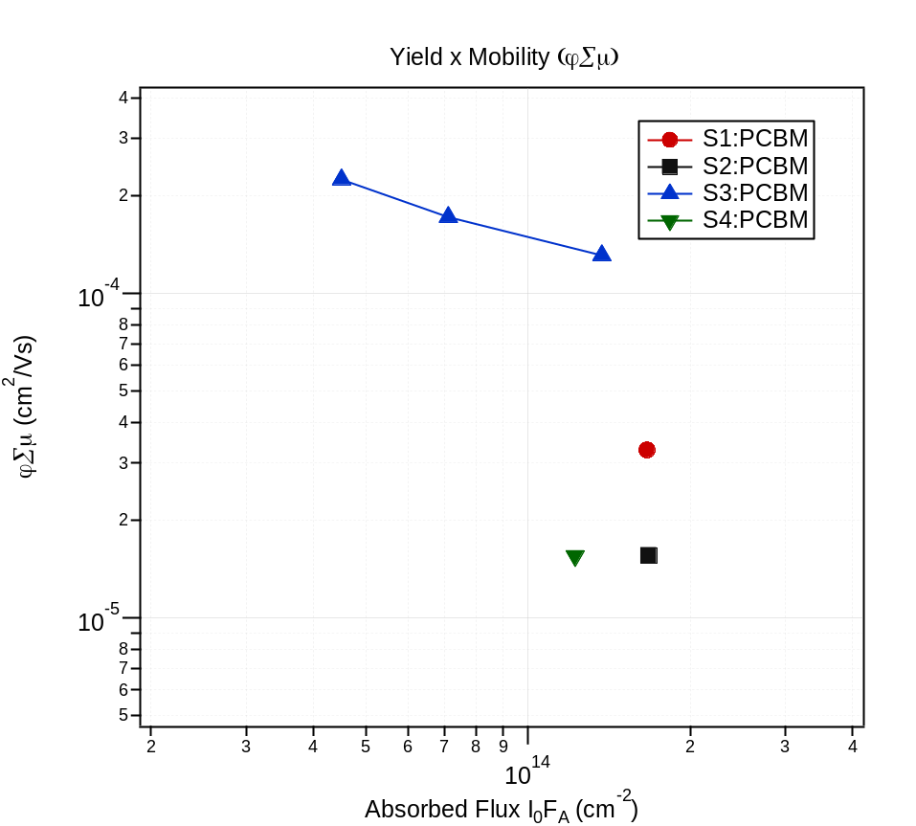
Figure S38: Yield mobility product vs Absorbed Flux obtained from TRMC measurements on blends of the different ADA molecules with PC₆₀BM

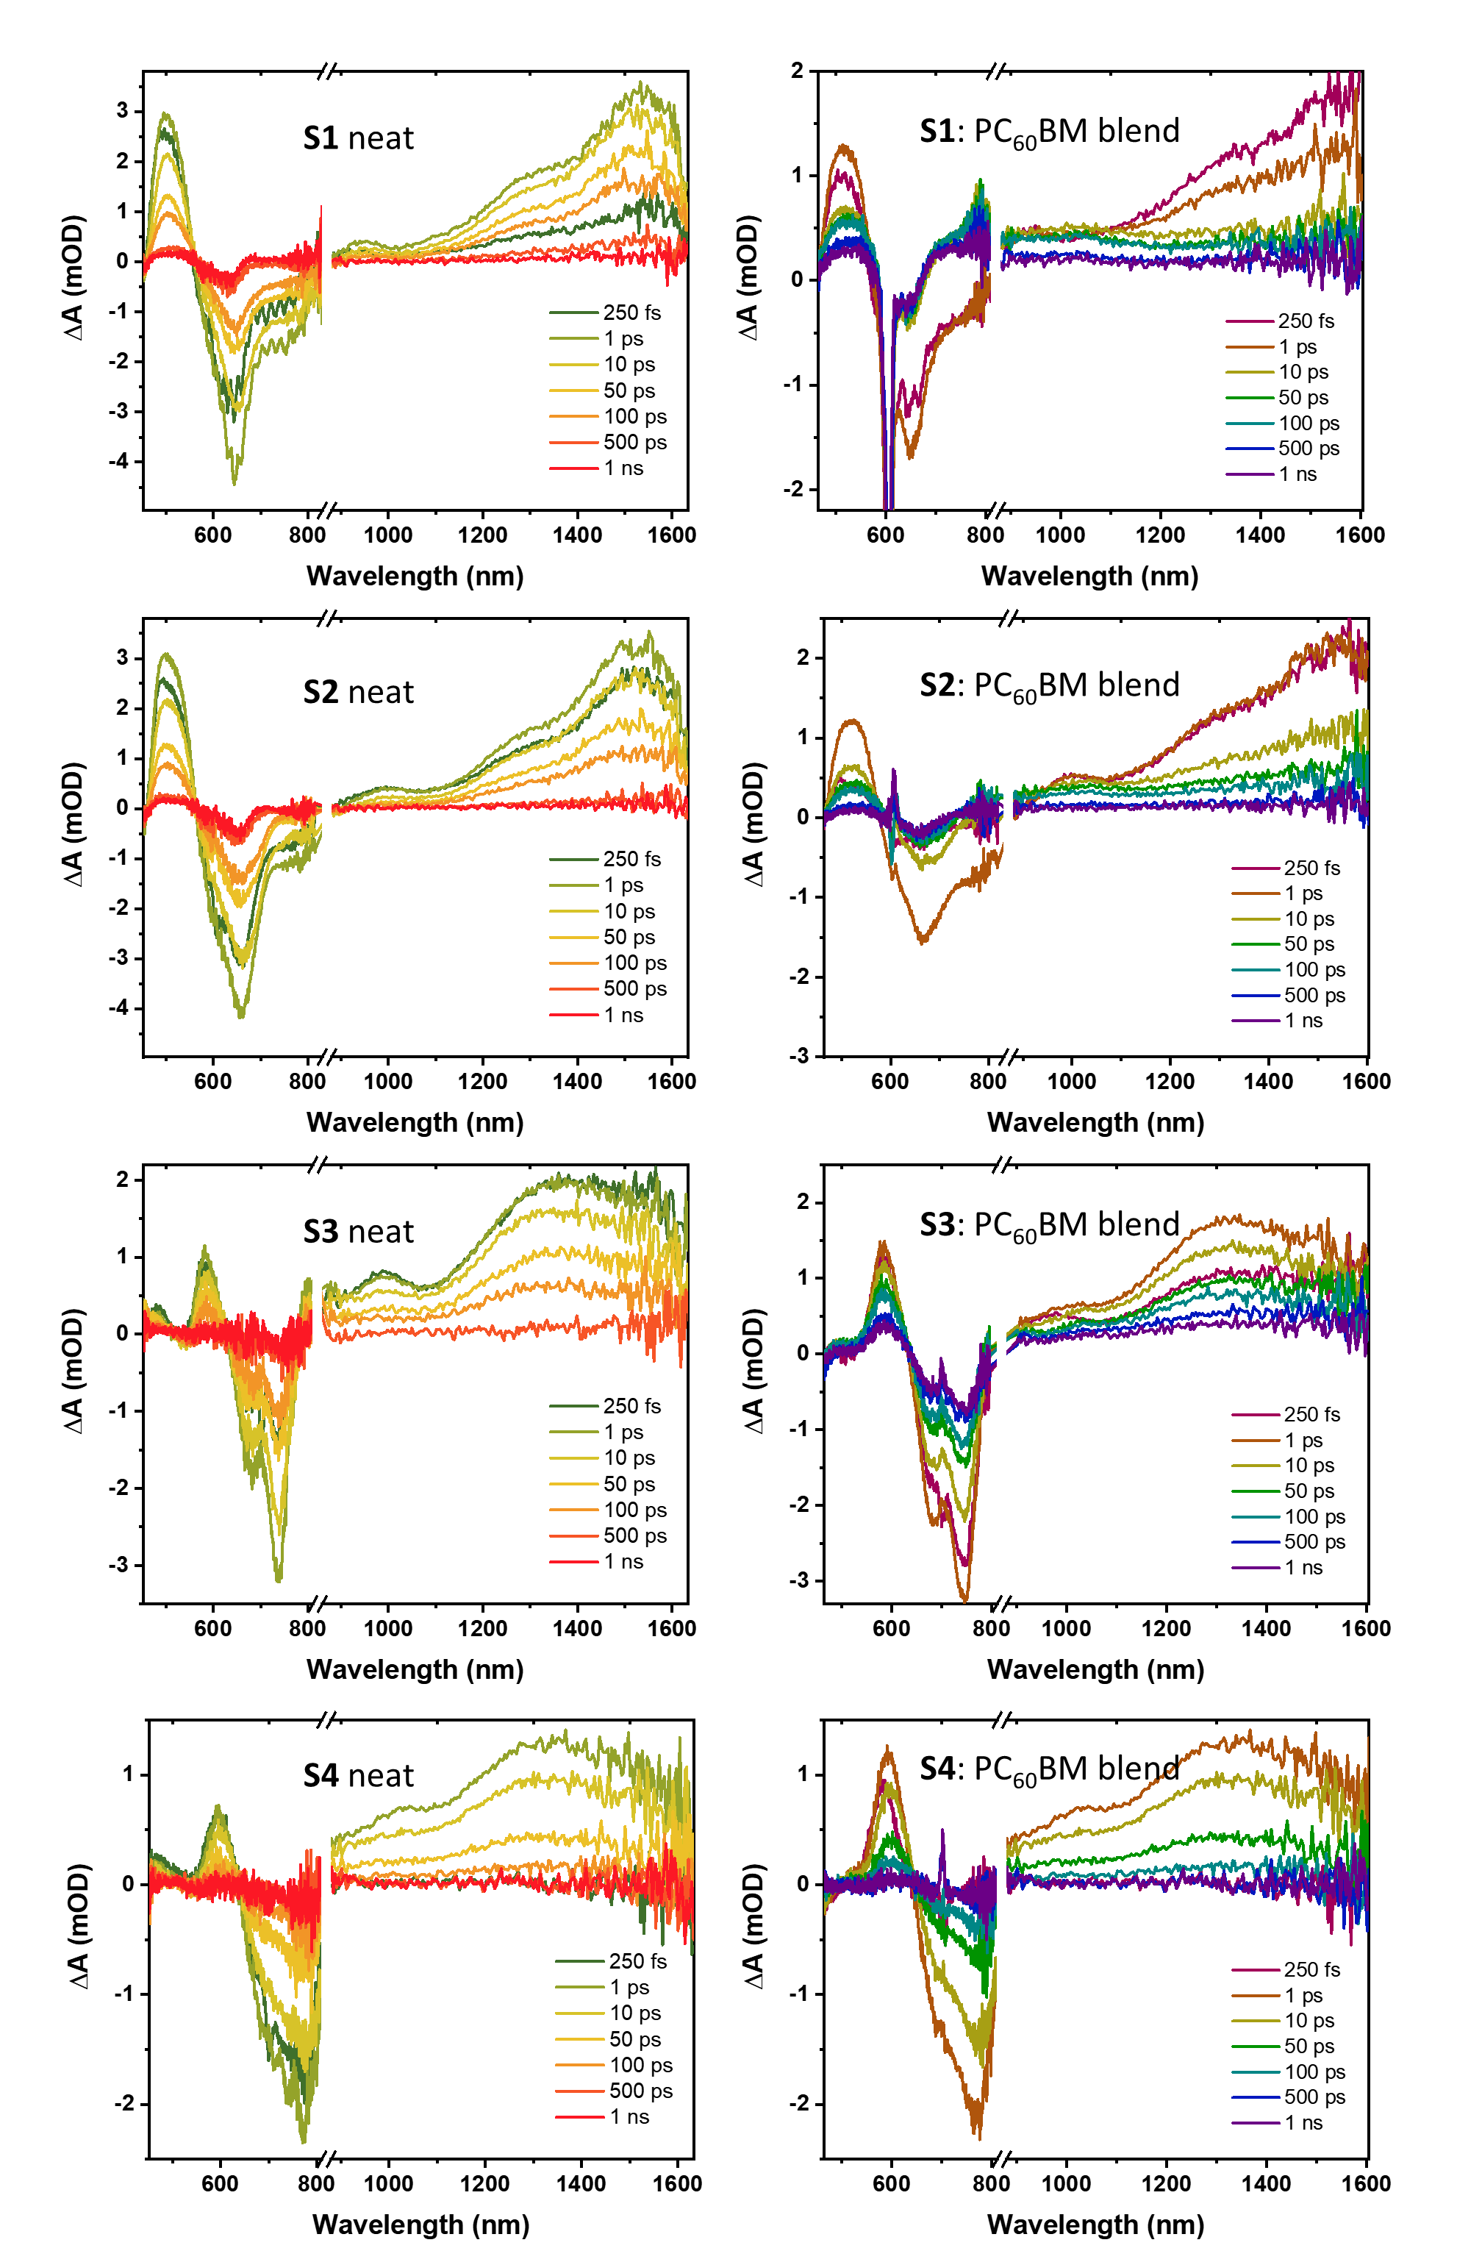
Figure S39: Transient absorption spectral evolution of neat and blend ADA films over 1 ns.

Table S6: Summary of time constants from Transient absorption measurements

 |  | τ (ps) |  |  | τ (ps)
S1 | 500 nm | 7.1 ± 1.2  117 ± 10.7 | S1: PC₆₀BM | 512 nm | 1.6 ± 0.2  279.1±58.8
S1 | 648 nm | 6.7 ± 1.3  126.3 ± 20.9 | S1: PC₆₀BM | 648 nm | 0.7 ± 0.14  5.2 ± 1.2
S1 | 758 nm | 10.6 ± 3.4  125.9 ± 28.3 | S1: PC₆₀BM | 754 nm | 1.3 ± 0.15 (Growth)  > 1 ns (decay)
S1 | 950 nm | 3.4 ± 1.2  94.4 ± 17.3 | S1: PC₆₀BM | 994 nm | 2.0 ± 2.4 (growth)  380.9±60.9 (decay)
S1 | 1307 nm | 29.4 ± 7.6  281 ± 34.9 | S1: PC₆₀BM | 1030 nm | 1.3 ± 1.6 (growth)  594.3 ± 115 (decay)  inf
S1 | 1533 nm | 39.5 ± 17.6  298.6 ± 66.6 | S1: PC₆₀BM | 1366 nm | 1.2 ± 0.2  349±132  inf
S2 | 500 nm | 5.2 ± 0.9  95.9 ± 9.5 | S2: PC₆₀BM | 520 nm | 3.0 ± 0.4  139.9±24.1
S2 | 660 nm | 6.0 ± 1.2  110.6 ± 13.5 | S2: PC₆₀BM | 672 nm | 2.0 ± 0.3  38.7 ± 8.3
S2 | 766 nm | 1.9 ± 1.1  35.4 ± 9.1 | S2: PC₆₀BM | 777 nm | 2.9 ± 0.9 (growth)  > 1 ns (decay)
S2 | 987 nm | 2.8 ± 0.6  79.5 ± 14.5 | S2: PC₆₀BM | 1030 nm | 2.2 ± 1.7  219.8 ± 31.5  inf
S2 | 1290 nm | 4.5 ± 1.1  106.2 ± 9.4 | S2: PC₆₀BM | 1318 nm | 3.2 ± 0.4  128.9 ± 23  inf
S2 | 1530 nm | 8.5 ± 3.8  120.3 ± 18.6 | S2: PC₆₀BM | 1530 nm | 3.4 ± 0.9  121.7± 49.3
S3 | 480 nm | 85.3 ± 25.1 | S3:PC₆₀BM | 585 nm | 7.8 ± 3.7  178.6 ± 45.3
S3 | 585 nm | 4.9 ± 3.0  104.2 ± 25.6 | S3:PC₆₀BM | 683 nm | 3.9 ± 08  77.7 ± 14.3
S3 | 737 nm | 4.0 ± 1.7  91.3 ± 12.4 | S3:PC₆₀BM | 744 nm | 1.9 ± 0.6  19.4 ± 7.8  161.7 ± 61
S3 | 987 nm | 2.6 ± 0.8  89.6 ± 12.3 | S3:PC₆₀BM | 1030 nm | 12.2 ± 4.7  285.1 ± 80.1  inf
S3 | 1360 nm | 12.9 ± 5.8  138.6 ± 20.4 | S3:PC₆₀BM | 1360 nm | 2.7 ± 1.0  136.9 ± 29.1  inf
S4 | 480 nm | 9.0 ± 4.1 | S4:PC₆₀BM
S4 | 598 nm | 39.6 ± 7.0 | S4:PC₆₀BM | 598 nm | 40.9 ± 3.4
S4 | 768 nm | 32.6 ± 5.0 | S4:PC₆₀BM | 768 nm | 24.8 ± 4.1
S4 | 1010 nm | 40.4 ± 4.0 | S4:PC₆₀BM | 1010 nm | 33.7 ± 3.3
S4 | 1328 nm | 42.4 ± 3.6 | S4:PC₆₀BM | 1328 nm | 35.2 ± 2.9
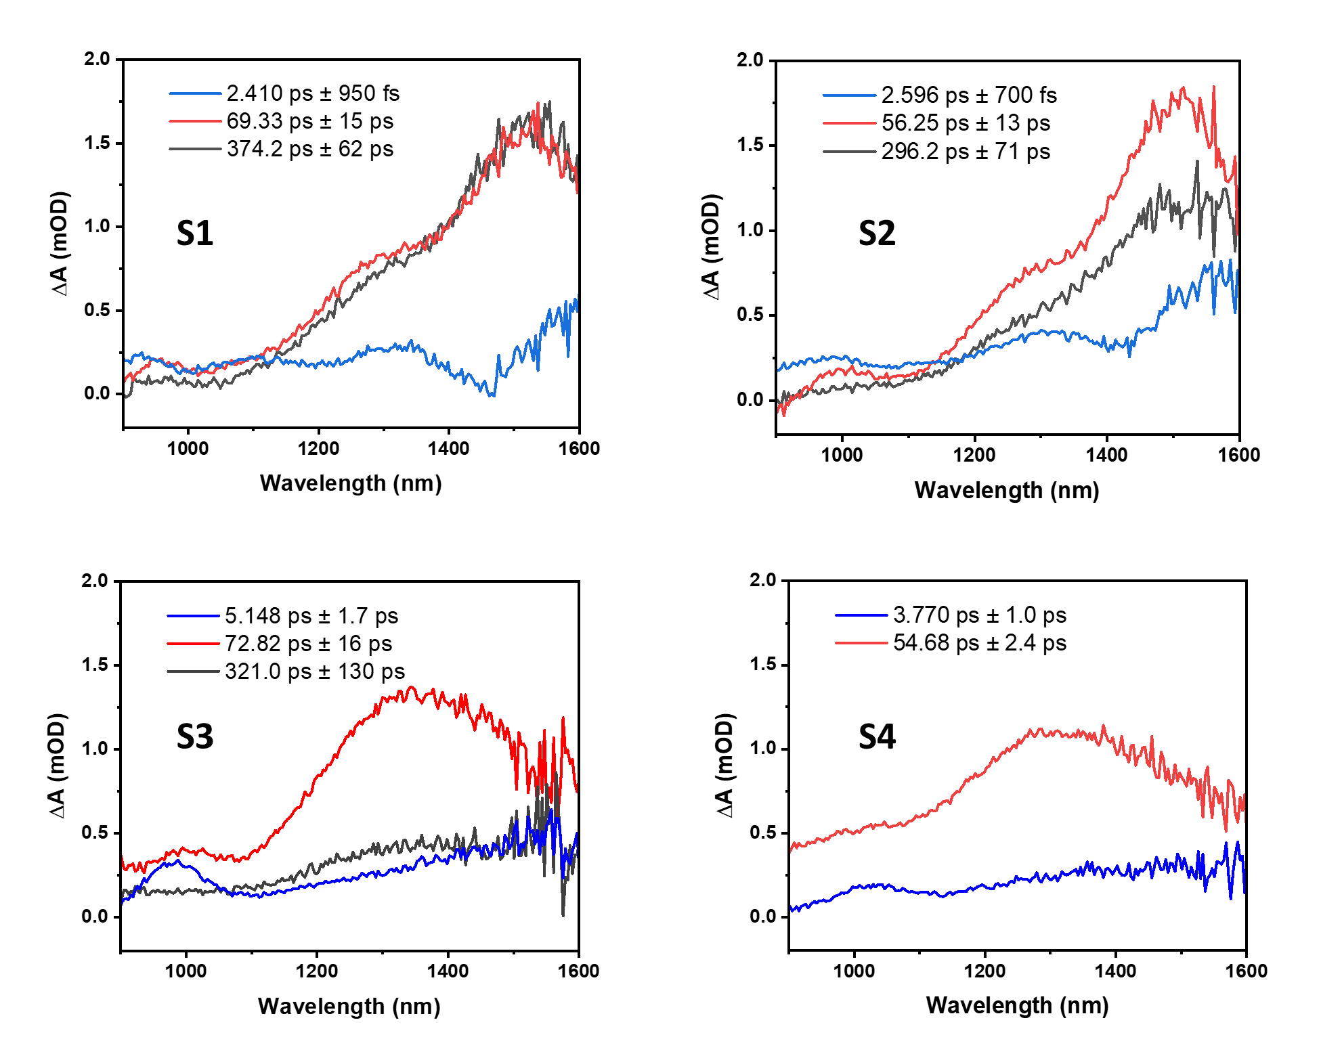
Figure S40: Global analysis DADS of transient absorption measurements for neat films of the ADA molecules

- DFT data

S1 optimized structure
Energy: -1556960.7247369
C -1.18546 -0.82652 -0.02977
C -0.73401 0.41851 -0.51316
C -2.54214 -1.09461 0.06619
C -1.65644 1.39306 -0.90211
C -3.48649 -0.12338 -0.32763
C -3.01755 1.11446 -0.81053
C -0.00623 -1.72875 0.33692
C 1.17642 -0.82531 -0.01544
C 0.72967 0.41915 -0.50443
C 2.53227 -1.09175 0.09718
C 3.48006 -0.11943 -0.28521
C 1.65573 1.39467 -0.88242
C 3.01594 1.11794 -0.77403
C 4.91920 -0.39004 -0.17889
C 5.53092 -1.67168 -0.16061
C 5.97298 0.52436 -0.09300
N 6.85931 -1.56690 -0.06090
C 7.18125 -0.21009 -0.00594
B 7.87678 -2.75749 -0.17738
N 9.28188 -2.10761 0.05267
C 8.52002 0.21042 0.10012
C 9.55369 -0.74395 0.14683
C 10.43816 -2.77204 0.19820
C 11.50141 -1.86823 0.39125
C 10.94954 -0.59363 0.36679
C -4.92672 -0.39411 -0.23895
C -5.98077 0.52112 -0.16333
C -5.53832 -1.67562 -0.20763
C -7.19104 -0.21265 -0.09768
N -6.86767 -1.56919 -0.12588
C -8.52394 0.21007 0.06292
C -9.54641 -0.74270 0.23349
B -7.88048 -2.76630 -0.08088
N -9.26329 -2.10790 0.24810
C -10.94979 -0.58922 0.39535
C -11.49096 -1.86230 0.52349
C -10.41784 -2.76889 0.42109
C 8.84309 1.65440 0.17431
C 9.77717 2.22682 -0.70512
C 8.23007 2.48533 1.12766
C 10.07670 3.58531 -0.63663
C 8.54711 3.83913 1.19716
C 9.46927 4.41685 0.31337
C -8.84266 1.65675 0.06652
C -8.40883 2.48917 -0.97978
C -9.57765 2.23528 1.11458
C -8.71068 3.84801 -0.97788
C -9.86352 3.59852 1.11346
C -9.44315 4.42924 0.06654
F -7.93869 -3.38442 -1.31651
F -7.51515 -3.65127 0.91490
C -0.00050 -3.02017 -0.51134
C -0.01529 -2.08454 1.84084
F 7.62322 -3.69912 0.80108
F 7.80321 -3.30642 -1.44435
C -9.78698 5.89937 0.04950
C 9.77985 5.89342 0.37012
H -2.88554 -2.04723 0.46186
H -1.32432 2.35549 -1.28321
H -3.73578 1.86053 -1.13855
H 2.87249 -2.04384 0.49701
H 1.32720 2.35653 -1.26805
H 3.73699 1.86478 -1.09400
H 5.06746 -2.64503 -0.25069
H 5.89768 1.60186 -0.07750
H 10.45514 -3.85332 0.16704
H 12.53849 -2.13375 0.54325
H 11.46205 0.34671 0.51065
H -5.90376 1.59747 -0.11105
H -5.07343 -2.65122 -0.25463
H -11.48001 0.35209 0.40531
H -12.53012 -2.12412 0.66750
H -10.42921 -3.85030 0.45152
H 10.25106 1.60489 -1.45829
H 7.52683 2.05719 1.83528
H 10.79478 4.00761 -1.33565
H 8.07363 4.45767 1.95612
H -7.85263 2.05940 -1.80716
H -9.89667 1.61693 1.94788
H -8.37332 4.46859 -1.80490
H -10.41856 4.02576 1.94529
H -0.88725 -3.62774 -0.29704
H 0.00573 -2.78928 -1.58129
H 0.88425 -3.62693 -0.28666
H -0.02029 -1.18175 2.45989
H -0.90194 -2.67753 2.09301
H 0.86944 -2.67556 2.10418
H -9.97129 6.28012 1.05914
H -10.69398 6.08560 -0.54098
H -8.98311 6.49424 -0.39721
H 9.74627 6.27089 1.39763
H 9.05111 6.47295 -0.21225
H 10.77125 6.11092 -0.04019

S1 cation
Energy: -1556818.1780481
C -1.18198 -0.88295 0.03506
C -0.72249 0.46418 0.01413
C -2.52938 -1.16079 0.02496
C -1.64894 1.52675 -0.01483
C -3.47915 -0.10249 -0.00740
C -2.99791 1.23919 -0.02550
C -0.00491 -1.85647 0.06358
C 1.17218 -0.88266 0.04915
C 0.71265 0.46434 0.02300
C 2.51971 -1.16017 0.05584
C 3.46948 -0.10166 0.03421
C 1.63911 1.52716 0.00638
C 2.98820 1.23991 0.01193
C 4.88715 -0.37292 0.02678
C 5.49606 -1.66514 -0.01015
C 5.96481 0.54431 0.03501
N 6.81831 -1.55625 -0.01827
C 7.15122 -0.19421 0.02149
B 7.82021 -2.75301 -0.26134
N 9.23681 -2.11375 -0.07024
C 8.51599 0.21873 0.03403
C 9.52471 -0.74472 0.01023
C 10.38751 -2.78191 0.01634
C 11.47667 -1.88264 0.15580
C 10.94225 -0.61105 0.15911
C -4.89659 -0.37401 -0.02639
C -5.97417 0.54291 -0.05900
C -5.50580 -1.66658 -0.00245
C -7.16045 -0.19598 -0.06687
N -6.82755 -1.55726 -0.02949
C -8.52288 0.22256 -0.00936
C -9.52754 -0.73311 0.14558
B -7.84198 -2.76405 -0.05149
N -9.23293 -2.10091 0.23979
C -10.94876 -0.59191 0.24267
C -11.47574 -1.85469 0.41732
C -10.38166 -2.75838 0.40144
C 8.85425 1.65589 0.08503
C 9.75110 2.21160 -0.84505
C 8.30159 2.49801 1.06688
C 10.07303 3.56460 -0.79601
C 8.64608 3.84517 1.11739
C 9.53035 4.40720 0.18460
C -8.84626 1.66218 -0.08042
C -8.34102 2.45859 -1.12434
C -9.66216 2.27124 0.88994
C -8.66002 3.81086 -1.19996
C -9.95926 3.62854 0.81361
C -9.47405 4.42271 -0.23538
F -7.84960 -3.33397 -1.30457
F -7.50964 -3.66045 0.93633
C 0.00267 -2.76955 -1.18419
C -0.01249 -2.71281 1.35110
F 7.60721 -3.73784 0.67369
F 7.66729 -3.20611 -1.55246
C -9.83572 5.88385 -0.33619
C 9.87034 5.87657 0.22244
H -2.87173 -2.19062 0.03844
H -1.31099 2.55882 -0.03018
H -3.71185 2.05526 -0.04953
H 2.86216 -2.18983 0.07805
H 1.30112 2.55914 -0.01362
H 3.70215 2.05611 -0.00659
H 5.03504 -2.64205 -0.05359
H 5.90757 1.62205 0.04648
H 10.39870 -3.86381 -0.01323
H 12.51535 -2.16343 0.25937
H 11.46951 0.32380 0.28191
H -5.91863 1.62087 -0.05056
H -5.04660 -2.64429 0.04037
H -11.48856 0.34165 0.18133
H -12.51551 -2.12640 0.53346
H -10.39058 -3.83780 0.48145
H 10.17137 1.58389 -1.62487
H 7.63716 2.08304 1.81878
H 10.75819 3.97437 -1.53373
H 8.22835 4.47108 1.90200
H -7.72700 2.00510 -1.89661
H -10.02967 1.68518 1.72664
H -8.27468 4.40214 -2.02687
H -10.57518 4.08133 1.58640
H -0.88163 -3.41571 -1.19252
H 0.00843 -2.18340 -2.10835
H 0.88684 -3.41592 -1.18179
H -0.01857 -2.08593 2.24817
H -0.89668 -3.35863 1.37708
H 0.87216 -3.35747 1.38817
H -10.00611 6.32427 0.65118
H -10.75826 6.01765 -0.91627
H -9.05091 6.45887 -0.83770
H 9.82700 6.27222 1.24201
H 9.16284 6.45775 -0.38371
H 10.87171 6.06691 -0.17612

S2 optimized structure:
Energy: -1930601.4543645
C -1.18848 -1.51928 -0.04144
C -0.73940 -0.28486 -0.55335
C -2.54473 -1.78454 0.06712
C -1.66298 0.68204 -0.95859
C -3.49004 -0.82064 -0.34187
C -3.02357 0.40643 -0.85377
C -0.00790 -2.41384 0.33891
C 1.17292 -1.51812 -0.03785
C 0.72425 -0.28405 -0.55088
C 2.52927 -1.78187 0.07472
C 3.47438 -0.81644 -0.33070
C 1.64796 0.68433 -0.95249
C 3.00858 0.41069 -0.84308
C 4.91396 -1.08338 -0.22271
C 5.52747 -2.36528 -0.18796
C 5.96609 -0.16749 -0.14894
N 6.85516 -2.25871 -0.09145
C 7.17565 -0.90086 -0.05431
B 7.87575 -3.45081 -0.18493
N 9.27897 -2.79554 0.05050
C 8.51281 -0.48189 0.05017
C 9.54874 -1.42991 0.11763
C 10.43624 -3.45411 0.20962
C 11.49844 -2.54409 0.38545
C 10.94509 -1.27180 0.33430
C -4.92975 -1.08753 -0.23699
C -5.98244 -0.17101 -0.17606
C -5.54194 -2.36895 -0.16995
C -7.19245 -0.90383 -0.08086
N -6.86974 -2.26093 -0.07924
C -8.52255 -0.48121 0.08452
C -9.54524 -1.42467 0.28711
B -7.88650 -3.45612 -0.01649
N -9.26470 -2.78998 0.32223
C -10.94538 -1.26327 0.47479
C -11.48637 -2.53161 0.63718
C -10.41689 -3.44362 0.53100
C 8.83524 0.96643 0.10278
C 9.73469 1.52919 -0.81811
C 8.24758 1.79775 1.07034
C 10.03422 2.88800 -0.77616
C 8.55564 3.15467 1.12032
C 9.44737 3.70270 0.19538
C -8.84013 0.96881 0.06205
C -8.45798 1.76290 -1.03216
C -9.51808 1.57363 1.13327
C -8.75400 3.12276 -1.05894
C -9.80569 2.93580 1.11180
C -9.42694 3.71221 0.01414
F -7.95855 -4.07845 -1.24812
F -7.51473 -4.33419 0.98137
C -0.00606 -3.72287 -0.48202
C -0.01004 -2.73701 1.85024
F 7.61345 -4.37936 0.80205
F 7.81553 -4.01162 -1.44626
C -9.79145 5.17263 -0.03961
C 9.82223 5.15911 0.27894
F -9.87542 5.71472 1.19449
F -8.88502 5.88849 -0.74036
F -10.99039 5.36233 -0.63695
F 8.83338 5.90163 0.82189
F 10.09954 5.67470 -0.93848
F 10.92211 5.34406 1.04487
H -2.88628 -2.72828 0.48497
H -1.33236 1.63595 -1.36149
H -3.74279 1.14629 -1.19341
H 2.87150 -2.72531 0.49290
H 1.31744 1.63782 -1.35644
H 3.72801 1.15122 -1.18081
H 5.06379 -3.33990 -0.26222
H 5.88840 0.91010 -0.14460
H 10.45635 -4.53573 0.19767
H 12.53582 -2.80484 0.54290
H 11.45739 -0.32820 0.45742
H -5.90428 0.90643 -0.15256
H -5.07718 -3.34532 -0.19963
H -11.47354 -0.32055 0.48062
H -12.52278 -2.78794 0.80776
H -10.43066 -4.52410 0.58488
H 10.17915 0.90045 -1.58285
H 7.56276 1.37198 1.79653
H 10.71500 3.31744 -1.50370
H 8.10093 3.78784 1.87475
H -7.94358 1.30458 -1.87061
H -9.79575 0.97664 1.99588
H -8.45905 3.72682 -1.91056
H -10.31298 3.39767 1.95218
H -0.89175 -4.32585 -0.25111
H -0.00450 -3.51477 -1.55665
H 0.87947 -4.32508 -0.24846
H -0.01169 -1.82102 2.44956
H -0.89568 -3.32390 2.11942
H 0.87557 -3.32269 2.12215

S2 cation:
Energy: -1930454.0163524
C -1.18668 -1.58333 0.02813
C -0.72678 -0.23611 0.00048
C -2.53444 -1.85991 0.03269
C -1.65226 0.82785 -0.02095
C -3.48295 -0.80028 0.00878
C -3.00115 0.54132 -0.01707
C -0.00976 -2.55734 0.04598
C 1.16735 -1.58375 0.02014
C 0.70776 -0.23637 -0.00380
C 2.51507 -1.86076 0.01675
C 3.46365 -0.80140 -0.01238
C 1.63340 0.82733 -0.02939
C 2.98221 0.54037 -0.03340
C 4.88200 -1.07099 -0.02677
C 5.49389 -2.36207 -0.07441
C 5.95698 -0.15187 -0.01219
N 6.81587 -2.25079 -0.08418
C 7.14524 -0.88868 -0.03460
B 7.82428 -3.44472 -0.32144
N 9.23961 -2.79916 -0.12105
C 8.50699 -0.47475 -0.01552
C 9.52113 -1.42832 -0.04098
C 10.39392 -3.45987 -0.04056
C 11.48023 -2.55379 0.09444
C 10.93999 -1.28595 0.09945
C -4.90138 -1.06948 0.00660
C -5.97610 -0.15024 -0.02357
C -5.51400 -2.36063 0.04808
C -7.16462 -0.88690 -0.01046
N -6.83568 -2.24853 0.03506
C -8.52347 -0.46676 0.05525
C -9.53264 -1.41168 0.22041
B -7.85619 -3.45229 0.01800
N -9.24550 -2.78155 0.31167
C -10.95241 -1.25937 0.33884
C -11.48481 -2.51762 0.52008
C -10.39582 -3.42987 0.48980
C 8.83836 0.96894 0.04671
C 9.68091 1.54468 -0.91949
C 8.31778 1.78132 1.06863
C 9.98895 2.90148 -0.86888
C 8.63916 3.13432 1.12674
C 9.47132 3.69700 0.15587
C -8.84115 0.97927 -0.01993
C -8.38820 1.74760 -1.10648
C -9.58982 1.60427 0.99174
C -8.68910 3.10417 -1.18528
C -9.87760 2.96455 0.91875
C -9.43120 3.71501 -0.17131
F -7.86967 -4.02161 -1.23418
F -7.52749 -4.34676 1.00719
C -0.01404 -3.47063 -1.20180
C -0.00566 -3.41332 1.33384
F 7.60962 -4.42871 0.61252
F 7.68414 -3.89601 -1.61350
C -9.79316 5.17657 -0.28056
C 9.85536 5.15430 0.24444
F -9.93469 5.74321 0.93482
F -8.84974 5.86897 -0.95271
F -10.95867 5.34175 -0.94017
F 8.89500 5.88214 0.85173
F 10.06587 5.68457 -0.97728
F 10.99173 5.31586 0.95435
H -2.87766 -2.88937 0.05105
H -1.31359 1.85952 -0.04125
H -3.71420 1.35825 -0.03416
H 2.85827 -2.89018 0.03851
H 1.29493 1.85909 -0.04865
H 3.69540 1.35696 -0.05937
H 5.03433 -3.33951 -0.12235
H 5.89703 0.92566 0.01236
H 10.41239 -4.54166 -0.07375
H 12.52088 -2.82951 0.19135
H 11.46406 -0.34818 0.21538
H -5.91688 0.92769 -0.02954
H -5.05636 -3.33907 0.09195
H -11.48638 -0.32151 0.28910
H -12.52437 -2.78268 0.65220
H -10.41186 -4.50896 0.57418
H 10.06866 0.93273 -1.72767
H 7.68553 1.34445 1.83513
H 10.62242 3.34355 -1.63052
H 8.24321 3.75365 1.92441
H -7.82457 1.27298 -1.90350
H -9.91801 1.02939 1.85184
H -8.34597 3.68911 -2.03194
H -10.43797 3.44494 1.71363
H -0.89843 -4.11665 -1.20167
H -0.01665 -2.88490 -2.12623
H 0.86985 -4.11730 -1.20718
H -0.00272 -2.78650 2.23095
H -0.88994 -4.05857 1.36815
H 0.87866 -4.05880 1.36241

S3 optimized structure:
Energy: -2675726.6182683
C -1.29515 -0.12991 -0.10133
C -1.12001 -1.54469 -0.06229
C -0.16702 0.72883 -0.11341
C 0.13399 -2.16441 -0.02858
C 1.08592 0.11035 -0.06187
C 1.26056 -1.30433 -0.01652
C -2.68045 0.23659 -0.13436
C -3.54121 -0.82570 -0.14402
S -2.67723 -2.36815 -0.09882
S 2.64580 0.93217 -0.08059
C 3.50792 -0.60918 -0.00212
C 2.64591 -1.67051 0.03040
C -0.33490 2.19080 -0.19595
S 0.29692 3.27628 1.03696
C -1.00010 2.91394 -1.15550
C -0.33961 4.68634 0.22512
C -0.99879 4.32012 -0.91834
C 0.30429 -3.62787 -0.02620
S -0.40454 -4.65177 1.21664
C 1.02595 -4.39643 -0.90702
C 0.27832 -6.09891 0.51581
C 1.00724 -5.78883 -0.60179
C -4.99237 -0.79872 -0.17612
C -5.83351 0.31129 -0.02990
C -5.85544 -1.90788 -0.37913
C -7.16776 -0.14547 -0.12887
N -7.13415 -1.52310 -0.35385
C -8.39509 0.54176 -0.04044
C -9.60404 -0.16309 -0.17958
B -8.36341 -2.42512 -0.73520
N -9.61580 -1.53101 -0.44783
C -10.95112 0.25473 0.00196
C -11.75499 -0.86416 -0.16933
C -10.89091 -1.94453 -0.44074
C 4.95776 -0.63112 0.02380
C 5.76486 -1.78992 0.18694
C 5.85286 0.43548 -0.11036
N 7.05955 -1.46998 0.16274
C 7.16399 -0.08795 -0.01199
B 8.24880 -2.49886 0.12267
N 9.53887 -1.61861 0.19165
C 8.42401 0.53731 -0.07107
C 9.59587 -0.23303 0.05203
C 10.78910 -2.06948 0.37483
C 11.70284 -0.99751 0.35992
C 10.95740 0.15829 0.16393
C -8.41538 1.99993 0.21841
C -7.71932 2.55278 1.30687
C -9.14050 2.86620 -0.61714
C -7.75360 3.92350 1.54839
C -9.15684 4.23740 -0.37483
C -8.46490 4.79272 0.70988
C 8.52065 2.00509 -0.24393
C 9.31575 2.55471 -1.26439
C 7.82267 2.88318 0.60187
C 9.39910 3.93391 -1.43392
C 7.92443 4.26174 0.43271
C 8.71172 4.81379 -0.58643
C -0.13330 6.06440 0.78075
C 0.03665 -7.44737 1.12670
F -8.39297 -3.55499 0.05657
F -8.30089 -2.74081 -2.07965
F 8.20658 -3.19719 -1.07016
F 8.18587 -3.34354 1.21258
C 8.83573 6.30931 -0.75294
C -8.46542 6.28267 0.95410
H -3.01296 1.26700 -0.15859
H 2.97434 -2.70109 0.08411
H -1.46062 2.44754 -2.01994
H -1.46567 5.04138 -1.58209
H 1.53905 -3.97363 -1.76430
H 1.51380 -6.54112 -1.19832
H -5.53178 1.33509 0.13487
H -5.59812 -2.94348 -0.55965
H -11.26545 1.25724 0.25438
H -12.83231 -0.91852 -0.09505
H -11.12898 -2.98462 -0.61951
H 5.45758 -2.81985 0.30830
H 5.60377 1.47427 -0.27291
H 10.97395 -3.12614 0.51523
H 12.77292 -1.07575 0.49382
H 11.32041 1.17541 0.12828
H -7.17761 1.89841 1.98279
H -9.67298 2.46108 -1.47217
H -7.22217 4.32459 2.40823
H -9.71631 4.88841 -1.04254
H 9.84350 1.89251 -1.94385
H 7.21791 2.48095 1.40872
H 10.00518 4.33420 -2.24338
H 7.38271 4.92102 1.10680
H -0.56893 6.17446 1.78150
H 0.93051 6.32066 0.85749
H -0.60868 6.80145 0.12572
H 0.40677 -7.50359 2.15767
H -1.02988 -7.70257 1.14679
H 0.55433 -8.21485 0.54275
H 9.71944 6.69339 -0.22604
H 8.94103 6.58781 -1.80686
H 7.96275 6.83161 -0.34852
H -8.37727 6.51435 2.02066
H -7.62037 6.76581 0.44559
H -9.38107 6.75082 0.57833

S3 cation:
Energy: -2675840.6342476
C 1.31137 -0.14047 0.11364
C 1.12366 -1.55811 0.07114
C 0.17881 0.74869 0.15661
C -0.12733 -2.16950 0.04747
C -1.07099 0.14031 0.10026
C -1.25802 -1.27721 0.03528
C 2.67585 0.21707 0.10861
C 3.54910 -0.86628 0.10994
S 2.67983 -2.38916 0.09439
S -2.63132 0.96886 0.13738
C -3.49533 -0.54999 0.01101
C -2.61979 -1.63163 -0.04139
C 0.37794 2.19506 0.26238
S -0.44114 3.34365 -0.78933
C 1.19501 2.87015 1.14552
C 0.32538 4.70593 -0.01524
C 1.15757 4.28149 0.99119
C -0.32902 -3.61724 0.04197
S 0.54824 -4.69347 -1.03914
C -1.19118 -4.35078 0.83351
C -0.25705 -6.10294 -0.40259
C -1.14279 -5.74692 0.58595
C 4.98212 -0.82762 0.12245
C 5.81996 0.30753 0.01810
C 5.85673 -1.94014 0.26103
C 7.14258 -0.14466 0.07537
N 7.12305 -1.53474 0.23953
C 8.37975 0.55902 -0.00745
C 9.57971 -0.14743 0.07419
B 8.36740 -2.44060 0.59227
N 9.60475 -1.53176 0.28419
C 10.92926 0.28085 -0.13145
C 11.73371 -0.83646 -0.03374
C 10.87442 -1.93569 0.21961
C -4.92620 -0.59407 -0.02525
C -5.70856 -1.77808 -0.14045
C -5.85212 0.46967 0.06068
N -7.00241 -1.47532 -0.13289
C -7.13419 -0.08581 -0.01872
B -8.17308 -2.53088 -0.03331
N -9.47701 -1.67538 -0.16472
C -8.42386 0.52119 0.00904
C -9.56242 -0.27966 -0.08598
C -10.70989 -2.15427 -0.34034
C -11.65316 -1.09645 -0.38285
C -10.94071 0.07584 -0.23088
C 8.38802 2.02441 -0.19988
C 7.66065 2.62398 -1.24353
C 9.14213 2.85221 0.65090
C 7.69884 4.00254 -1.43075
C 9.15791 4.23139 0.46483
C 8.44016 4.83359 -0.57833
C -8.55025 1.98867 0.12476
C -9.37684 2.55732 1.11107
C -7.85737 2.84951 -0.74464
C -9.49585 3.93879 1.22389
C -7.99960 4.22978 -0.63407
C -8.81767 4.80173 0.35052
C 0.04906 6.10912 -0.46500
C 0.04217 -7.47166 -0.93493
F 8.37886 -3.55697 -0.21001
F 8.32467 -2.75185 1.93354
F -8.11869 -3.13905 1.20175
F -8.08168 -3.43165 -1.06822
C -8.98452 6.29763 0.45462
C 8.44941 6.33093 -0.76508
H 3.02248 1.24183 0.10679
H -2.96088 -2.65330 -0.14127
H 1.77266 2.36572 1.91241
H 1.72419 4.96863 1.61083
H -1.80709 -3.90034 1.60418
H -1.74082 -6.47393 1.12508
H 5.51117 1.33609 -0.09368
H 5.61632 -2.98639 0.39878
H 11.23386 1.29314 -0.35411
H 12.80749 -0.88926 -0.14636
H 11.12492 -2.98112 0.34469
H -5.38645 -2.80803 -0.21077
H -5.62714 1.51991 0.17715
H -10.87668 -3.21912 -0.43854
H -12.71845 -1.20805 -0.52834
H -11.32477 1.08541 -0.24752
H 7.10279 2.00118 -1.93622
H 9.69470 2.41123 1.47494
H 7.15142 4.44102 -2.26146
H 9.73920 4.85196 1.14216
H -9.89646 1.91082 1.81165
H -7.23629 2.43308 -1.53187
H -10.12415 4.35531 2.00720
H -7.46991 4.87585 -1.32964
H 0.30778 6.25835 -1.51987
H -1.00816 6.37363 -0.34508
H 0.64085 6.81085 0.12992
H -0.17140 -7.54675 -2.00761
H 1.09426 -7.74280 -0.78868
H -0.57287 -8.21227 -0.41585
H -9.89706 6.62597 -0.05996
H -9.06857 6.61956 1.49780
H -8.14329 6.82895 -0.00092
H 8.30062 6.60550 -1.81414
H 7.64483 6.80364 -0.18620
H 9.39282 6.77131 -0.42738

S4 optimized structure:

Energy: -3049042.3868401
C -1.31440 -0.73223 -0.13101
C -1.14411 -2.14757 -0.08881
C -0.18461 0.12463 -0.12678
C 0.10730 -2.77096 -0.03581
C 1.06525 -0.49770 -0.05483
C 1.23520 -1.91302 -0.00627
C -2.69776 -0.36177 -0.18239
C -3.56104 -1.42191 -0.20281
S -2.70271 -2.96694 -0.14707
S 2.62711 0.32036 -0.04806
C 3.48283 -1.22279 0.04800
C 2.61828 -2.28271 0.06535
C -0.34813 1.58670 -0.21239
S 0.27371 2.67236 1.02511
C -1.00231 2.30983 -1.17975
C -0.35213 4.08263 0.20513
C -1.00054 3.71617 -0.94449
C 0.27401 -4.23470 -0.02980
S -0.45661 -5.25606 1.20234
C 1.00755 -5.00545 -0.89893
C 0.23358 -6.70519 0.51299
C 0.98067 -6.39756 -0.59329
C -5.01145 -1.38934 -0.25186
C -5.84976 -0.27557 -0.12968
C -5.87718 -2.49964 -0.44727
C -7.18520 -0.73038 -0.23614
N -7.15421 -2.11136 -0.44073
C -8.41086 -0.04271 -0.16579
C -9.62216 -0.74204 -0.29535
B -8.38634 -3.01655 -0.81144
N -9.63767 -2.11531 -0.53422
C -10.96912 -0.31378 -0.13188
C -11.77589 -1.43260 -0.28276
C -10.91427 -2.52272 -0.52618
C 4.93140 -1.24884 0.10632
C 5.73164 -2.41453 0.26588
C 5.83232 -0.18484 0.00575
N 7.02715 -2.10052 0.27036
C 7.14027 -0.71745 0.11287
B 8.21457 -3.12034 0.42950
N 9.50630 -2.27539 0.16273
C 8.40232 -0.10695 0.01104
C 9.57093 -0.88837 0.03659
C 10.76115 -2.74953 0.16292
C 11.68509 -1.69266 0.03880
C 10.94289 -0.52127 -0.03133
C -8.42702 1.42332 0.06650
C -7.76668 1.98325 1.17310
C -9.10986 2.27532 -0.81709
C -7.78859 3.35796 1.38994
C -9.12269 3.65174 -0.60694
C -8.46294 4.19533 0.49752
C 8.49572 1.36648 -0.14235
C 9.19830 1.93253 -1.21938
C 7.87587 2.22016 0.78502
C 9.27905 3.31438 -1.36481
C 7.96539 3.60267 0.64619
C 8.66592 4.15228 -0.42983
C -0.14936 5.46074 0.76180
C -0.02066 -8.05260 1.12109
F -8.41697 -4.13512 -0.00575
F -8.32533 -3.34536 -2.15178
F 8.08987 -4.12620 -0.50699
F 8.23574 -3.61712 1.71800
C 8.80962 5.64634 -0.55524
C -8.42795 5.68768 0.69830
H -3.02612 0.66990 -0.20966
H 2.94248 -3.31415 0.12793
H -1.45431 1.84360 -2.04884
H -1.45956 4.43762 -1.61332
H 1.53456 -4.58447 -1.74868
H 1.49445 -7.15152 -1.18143
H -5.54576 0.74926 0.02523
H -5.62106 -3.53902 -0.60686
H -11.28225 0.69542 0.09475
H -12.85379 -1.48105 -0.21426
H -11.15658 -3.56482 -0.68667
H 5.41711 -3.44389 0.37241
H 5.59075 0.85635 -0.15421
H 10.94473 -3.81128 0.26040
H 12.76130 -1.79235 0.01126
H 11.31877 0.48853 -0.11355
H -7.25768 1.33363 1.87771
H -9.61427 1.85572 -1.68150
H -7.29165 3.77904 2.25765
H -9.64759 4.30237 -1.29826
H 9.65848 1.28364 -1.95741
H 7.33889 1.79565 1.62711
H 9.80730 3.74188 -2.21062
H 7.48754 4.25353 1.37061
H -0.59333 5.57118 1.75871
H 0.91397 5.71600 0.84690
H -0.61905 6.19764 0.10274
H 0.33301 -8.10859 2.15780
H -1.08792 -8.30536 1.12450
H 0.50446 -8.82170 0.54605
F 9.93822 6.08696 0.04704
F 8.87619 6.03524 -1.84722
F 7.77576 6.30063 0.01636
F -8.39171 6.01547 2.00821
F -7.33287 6.23774 0.12446
F -9.50541 6.29330 0.15430

S4 cation:
Energy: -3049477.4282300
C 1.34300 -0.75909 0.15291
C 1.16322 -2.17658 0.10719
C 0.20584 0.12621 0.18139
C -0.08551 -2.79456 0.06539
C -1.04097 -0.48914 0.10228
C -1.22022 -1.90634 0.03372
C 2.70600 -0.39445 0.16143
C 3.58412 -1.47284 0.17209
S 2.72348 -2.99906 0.14994
S -2.60474 0.33175 0.11126
C -3.45940 -1.18911 -0.03568
C -2.57956 -2.26691 -0.07071
C 0.39808 1.57101 0.29384
S -0.43460 2.72438 -0.74247
C 1.21772 2.24466 1.17799
C 0.33042 4.08388 0.03708
C 1.17157 3.65572 1.03569
C -0.28127 -4.24162 0.05803
S 0.63390 -5.31980 -0.98962
C -1.16502 -4.97592 0.82650
C -0.18534 -6.72907 -0.37180
C -1.10297 -6.37214 0.58781
C 5.01826 -1.42370 0.19588
C 5.84381 -0.28126 0.09555
C 5.90344 -2.52743 0.34025
C 7.17174 -0.72032 0.16365
N 7.16634 -2.10961 0.32706
C 8.39920 -0.00497 0.08806
C 9.60848 -0.68961 0.17269
B 8.42276 -3.00442 0.66904
N 9.65127 -2.07555 0.37066
C 10.95443 -0.23745 -0.01105
C 11.77350 -1.34306 0.08464
C 10.92715 -2.45855 0.31785
C -4.89045 -1.23473 -0.11031
C -5.67040 -2.41737 -0.25477
C -5.81636 -0.17204 -0.03618
N -6.96421 -2.11371 -0.27662
C -7.09791 -0.72775 -0.14301
B -8.14165 -3.14778 -0.46166
N -9.43527 -2.32653 -0.12009
C -8.38466 -0.12907 -0.04138
C -9.52324 -0.93103 -0.02530
C -10.67275 -2.81995 -0.06046
C -11.62189 -1.77326 0.07317
C -10.91003 -0.59186 0.08266
C 8.38298 1.46572 -0.10127
C 7.69400 2.04146 -1.18293
C 9.06245 2.30460 0.79753
C 7.68602 3.42150 -1.36006
C 9.04091 3.68690 0.62797
C 8.35279 4.24667 -0.45029
C -8.49353 1.34448 0.07903
C -9.18420 1.92799 1.15474
C -7.89895 2.17971 -0.88226
C -9.27767 3.31247 1.26599
C -8.00571 3.56362 -0.77779
C -8.69228 4.13186 0.29790
C 0.04626 5.48881 -0.40123
C 0.13397 -8.09869 -0.88937
F 8.44824 -4.10965 -0.14660
F 8.38726 -3.32933 2.00631
F -7.97864 -4.18960 0.42054
F -8.18568 -3.56380 -1.77270
C -8.84605 5.63044 0.38815
C 8.27602 5.74519 -0.60717
H 3.04712 0.63204 0.15959
H -2.91445 -3.28952 -0.18104
H 1.80077 1.73797 1.93921
H 1.73846 4.34136 1.65658
H -1.80494 -4.52476 1.57681
H -1.71398 -7.09942 1.11173
H 5.52490 0.74375 -0.02193
H 5.67264 -3.57650 0.47309
H 11.24756 0.78220 -0.21596
H 12.84935 -1.37888 -0.01380
H 11.19364 -3.50055 0.43917
H -5.34666 -3.44570 -0.33951
H -5.59464 0.87586 0.10746
H -10.84299 -3.88677 -0.12771
H -12.69309 -1.89965 0.14358
H -11.30426 0.41161 0.15314
H 7.19411 1.40237 -1.90383
H 9.58722 1.87251 1.64364
H 7.17357 3.85760 -2.21114
H 9.56134 4.32881 1.33050
H -9.62044 1.29471 1.92055
H -7.37703 1.74125 -1.72691
H -9.79464 3.75593 2.11029
H -7.55375 4.20200 -1.52933
H 0.29542 5.64469 -1.45736
H -1.01076 5.74883 -0.27060
H 0.64129 6.18852 0.19256
H -0.05003 -8.17901 -1.96714
H 1.18291 -8.36428 -0.71356
H -0.49175 -8.83975 -0.38398
F -9.97300 6.04364 -0.22873
F -8.91559 6.04405 1.67012
F -7.81112 6.27034 -0.19648
F 8.24020 6.10555 -1.90656
F 7.15580 6.23538 -0.02804
F 9.32672 6.36310 -0.03341

- Morphology of films
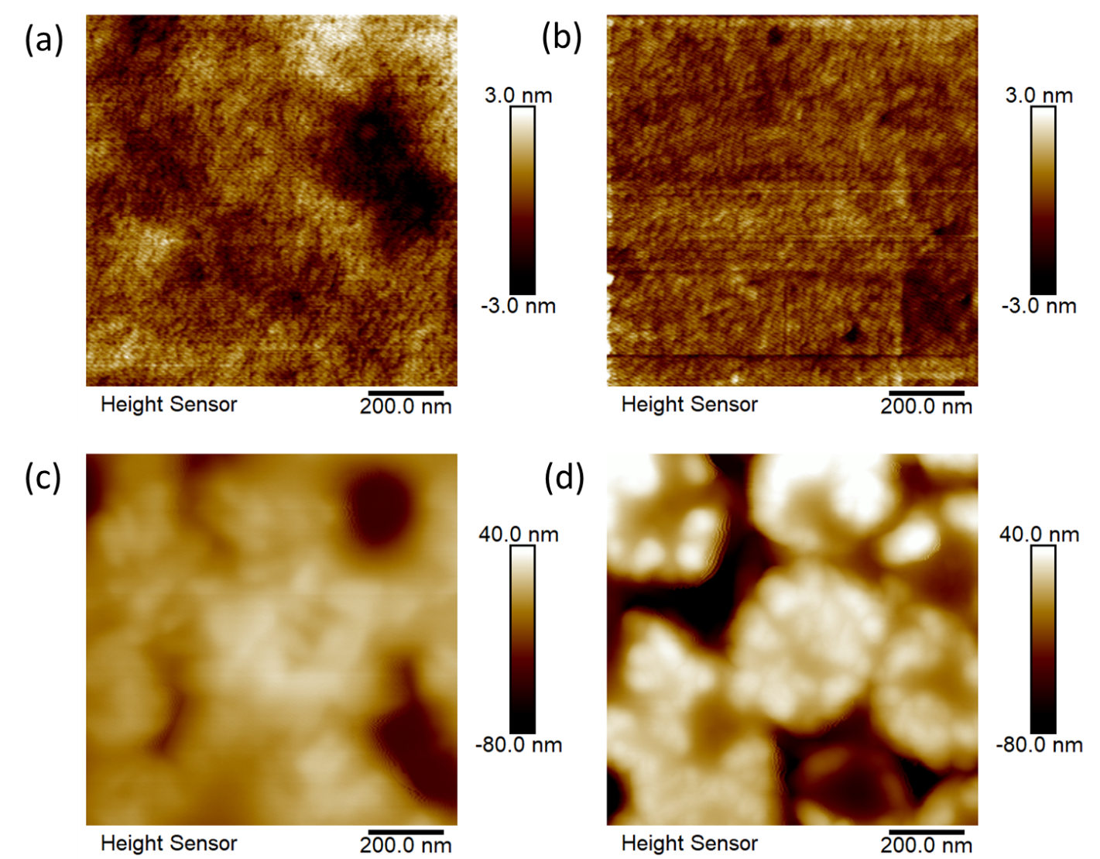
Figure S41: AFM images for films spin-coated from 1:1 solutions of PC₆₀BM with (a) S1 (b) S2 (c) S3 and (d) S4 on quartz substrates.

References:

[2] Melanson JA, Smithen DA, Cameron TS, Thompson A. Microwave-assisted reduction of F-BODIPYs and dipyrrins to generate dipyrromethanes. Can J Chem 2013;92:688–94. https://doi.org/10.1139/cjc-2013-0341.
[3] Yu J, Zhao B, Nie X, Zhou B, Li Y, Hai J, et al. Correlation of structure and photovoltaic performance of benzo[1,2-b:4,5-b′]dithiophene copolymers alternating with different acceptors. New J Chem 2015;39:2248–55. https://doi.org/10.1039/C4NJ02192D.

