Electronic Supplementary Information (ESI)

Effect of Fe alloying on the thermoelectric performance of Cu₂Te
Shriparna Mukherjeeª, Rajasekar Parasuraman^{b}, Arun M. Umarji^{b}, Gerda Rogl^{c}, Peter Rogl^{c}, and Kamanio Chattopadhyay^{a,d *}

ª Interdisciplinary Centre for Energy Research, Indian Institute of Science, Bangalore, 560012, India
^{b} Materials Research Centre, Indian Institute of Science, Bangalore, 560012, India
^{c} Christian Doppler Laboratory for Thermoelectricity at Institute of Materials Chemistry, University of Vienna, Währingerstrasse 42, A-1090 Wien, Austria, and at Institute of Solid State Physics, TU-Wien, Wiedner Hauptstrasse 8-10, A1040 Wien
^{d} Department of Materials Engineering, Indian Institute of Science, Bangalore, 560012, India
* Corresponding author: kamanio@iisc.ac.in

MICROSTRUCTURAL ANALYSIS:
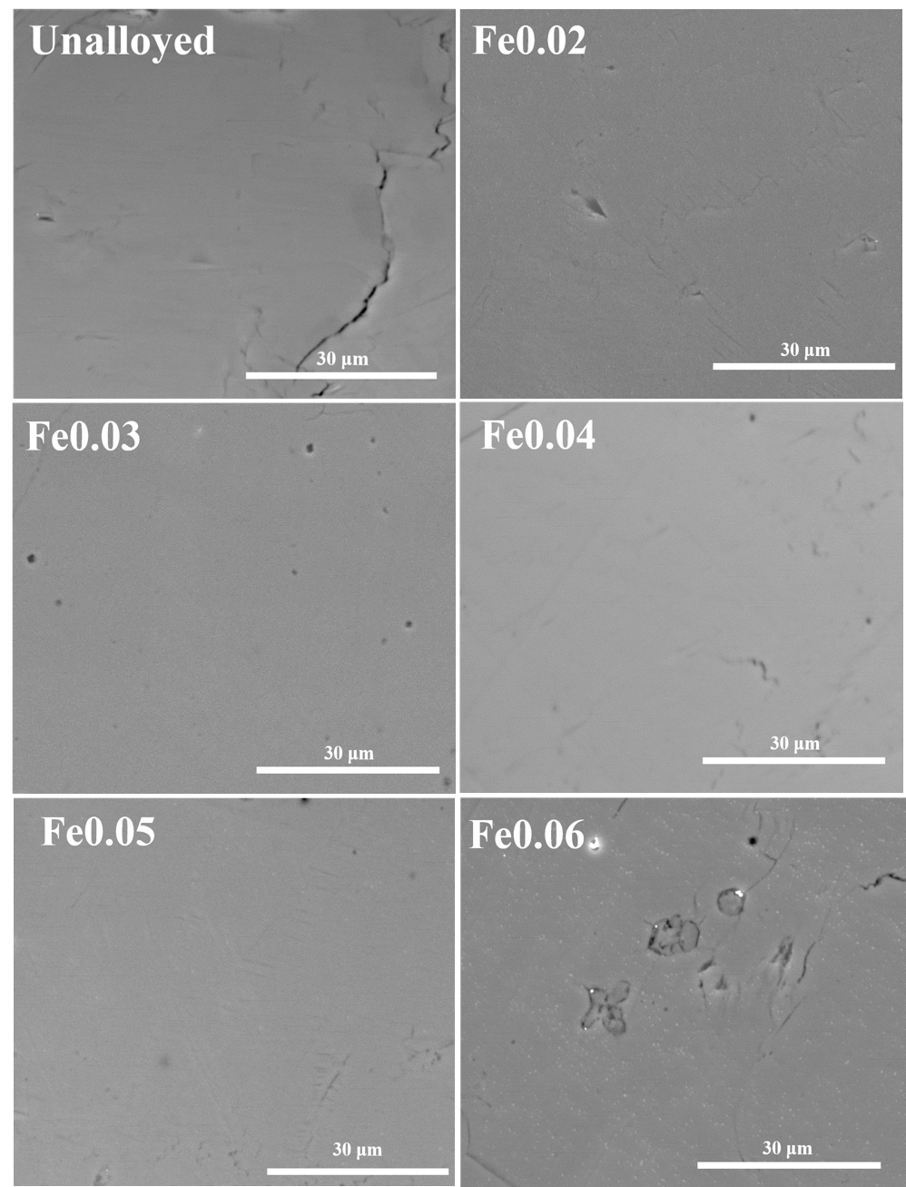
Fig S1. Secondary electron (SE) images for all samples

SPECTROSCOPIC ANALYSIS:
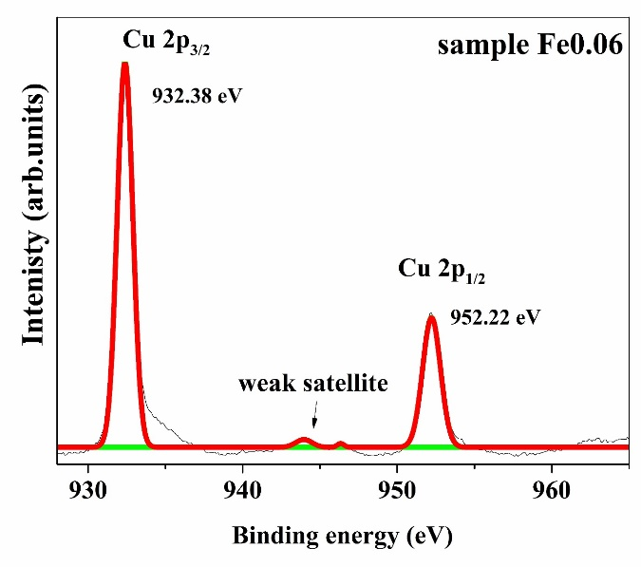 | 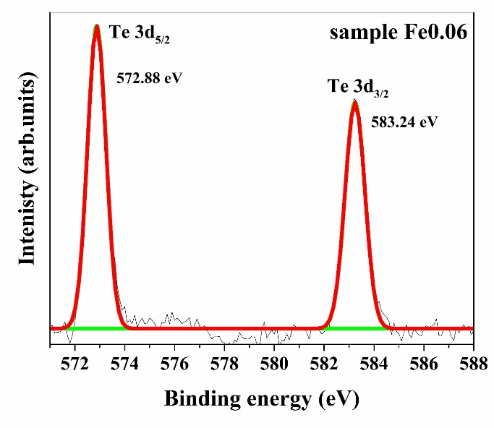
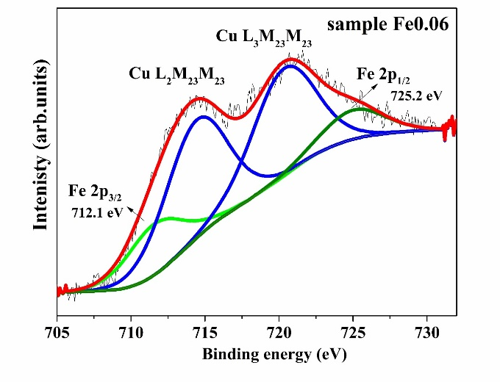
Fig S2. X-ray photoelectron spectra for the sample Fe0.06 showing valence state of Cu as +1, Te as -2 and Fe as +3

THERMAL STABILITY:

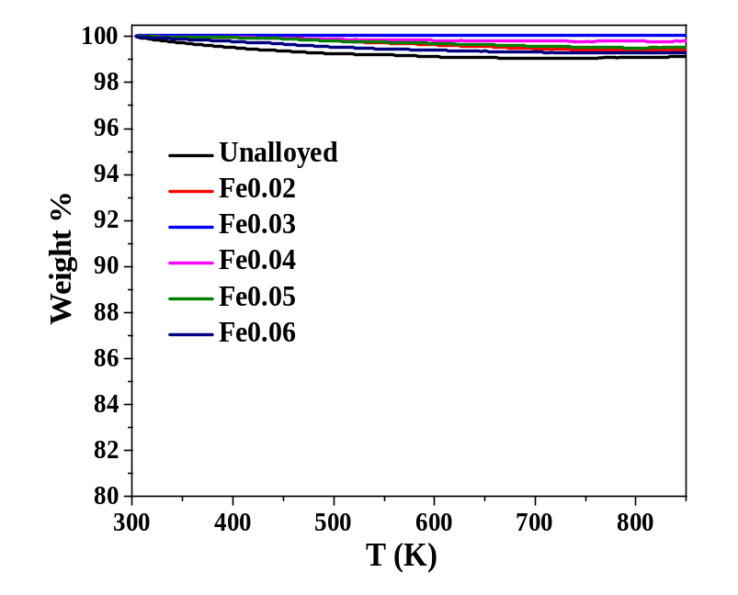
Fig S4. Thermogravimetric analysis data for all samples showing no significant weight loss till 850 K
In order to make sure that our isothermal Seebeck measurement is not affected by weight loss, we have also carried out an isotherm measurement for the sample Fe0.03 (since it had the highest zT) at 673 K for 24 hours. We did not observe more than 0.1% loss of weight in the sample.
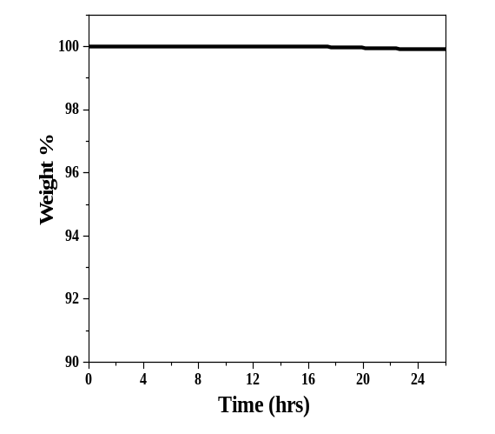
Fig S5: Isothermal TGA for the sample Fe0.03 at 673 K for 24 hours
TRANSPORT PROPERTIES:
We carried out the resistivity measurement at a constant temperature of 673 K for a duration of 16 hrs and the plot is as follows. The measurement shows that the data of resistivity do not vary much during the 16 hrs.
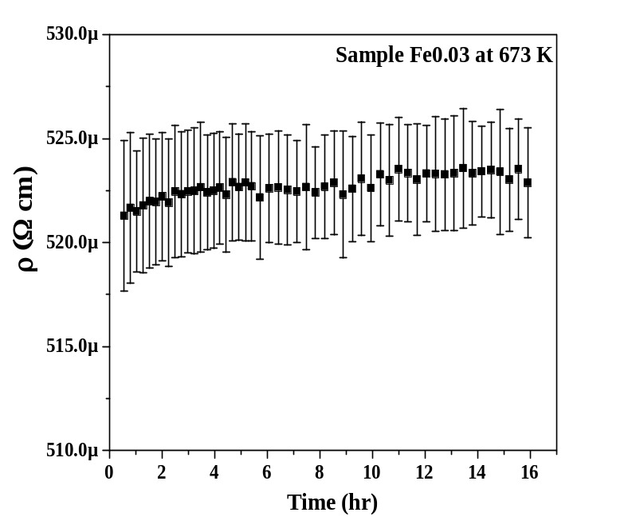
Fig S6. Variation in resistivity with time for the sample Fe0.03 held at 673 K
Calculation of Lorenz Number:
As the total thermal conductivity is comprised of two parts, i.e. κ=κ_{e}+κ_{ph}, the separated contributions were evaluated. The electronic part of thermal conductivity can be obtained via the Wiedemann Franz relation as follows[38],
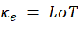
The Lorenz number (L) was obtained (figure S7) assuming single parabolic band approximation (SPB) via the following set of equations involving the Seebeck coefficients (obtained from the transport measurements) and the reduced chemical potential[2,39].
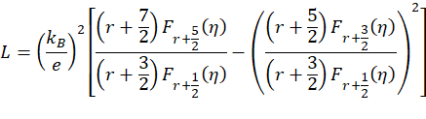
For acoustic phonon scattering, the scattering parameter (r) is taken as -1/2. η (= E_{F}/k_{B}T) is the reduced Fermi energy, and F_{n}(η) is the n-th order Fermi integral given by 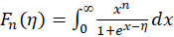. The reduced Fermi energy η can be obtained by fitting the Seebeck coefficient to the equation,
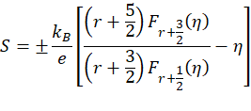
where k_{B} is the Boltzmann constant, e is the electron charge.
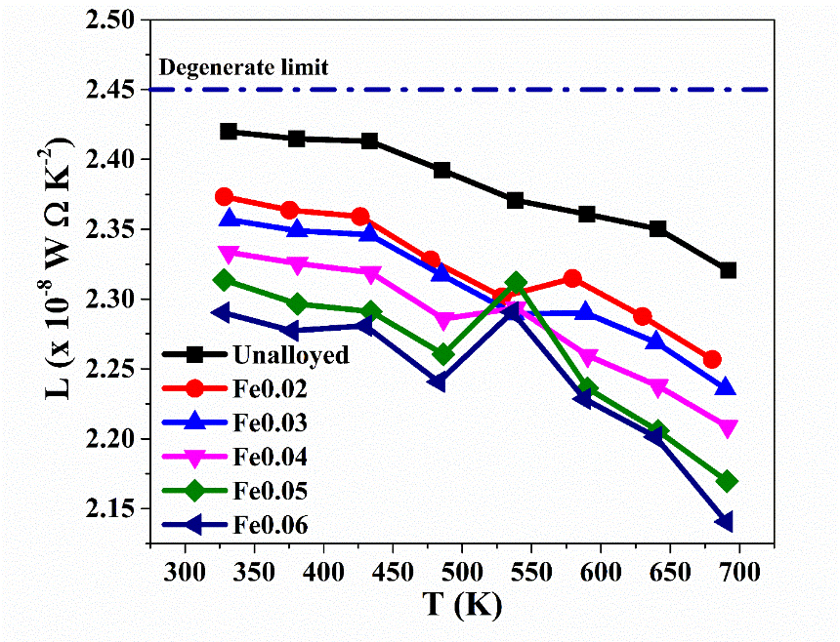
Fig S7. Variation in Lorenz number with temperature; the Lorenz number has been calculated using SPB-APS model

Isothermal measurement of electrical conductivity:
In order to check if Fe alloying obstructs the movement of the Cu ions, we have carried out isothermal heating at 673 K for both the unalloyed and the Fe0.03 sample for 16 hours under helium atmosphere in an ULVAC ZEM-3 system. The samples were subjected to a flow of current and a temperature gradient during this time. After this, we repeated the measurement of electrical resistivity from room temperature to 700 K for both samples. Herein we plot the temperature dependent electrical conductivity for the unalloyed and the Fe0.03 sample.
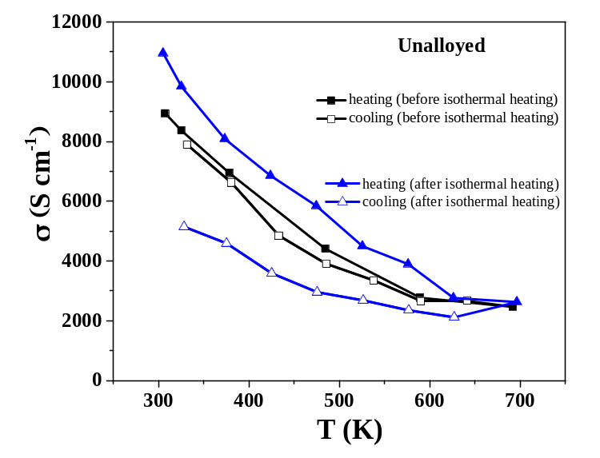
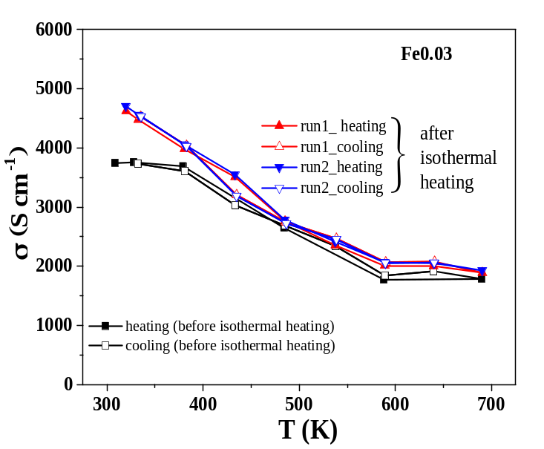
Fig S8. The measurement of electrical conductivity for the unalloyed and Fe0.03 samples before and after isothermal heating
While there was repeatability in the electrical conductivity for the Fe0.03 sample, this was not the case for the unalloyed sample. In the unalloyed sample, the copper ions migrate towards the electrode opposite to the micro heater, under the presence of the current flow and temperature gradient. Due to this irreversible migration of Cu ions, a hysteresis is observed in the measurement of the electrical conductivity. However, even after repeated measurements, no such hysteresis was observed in the sample Fe0.03. This might be a signature that the ionic diffusion has been controlled in the Fe alloyed sample.

