**Supporting information:**

**A terpyridine luminophore: synthesis, photophysics and selective metal ion –mediated hydrogelation**

Aditya Kumar Purohita, Santosh Kumar Beherab and Pravin Kumar Kara*

a Department of Chemistry, Veer Surendra Sai University of Technology, Burla, Sambalpur 768018, Odisha, India

b Department of Inorganic and Physical Chemistry, Indian Institute of Science, Bangalore 560012, India

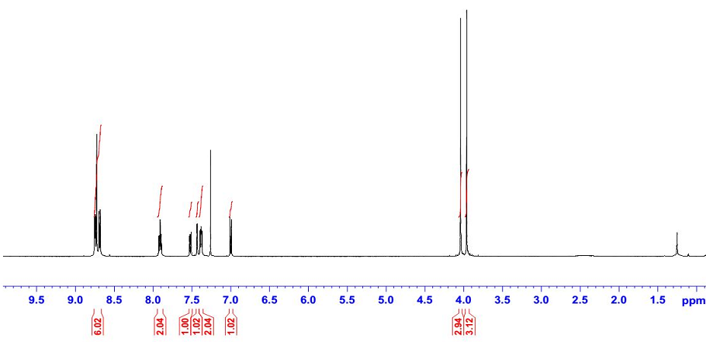

Fig. S1. 1H NMR spectra for terpyridine ligand (DMPTP).

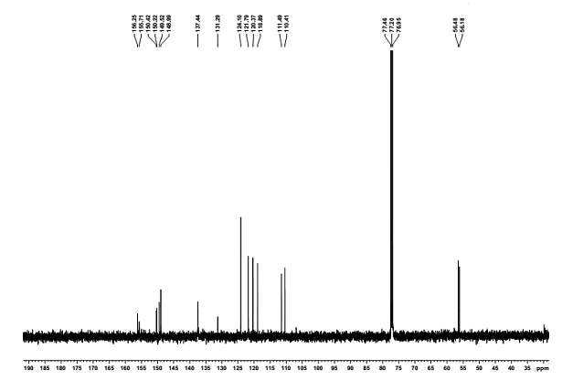

Fig. S2. 13C NMR spectra for terpyridine ligand (DMPTP)**.**

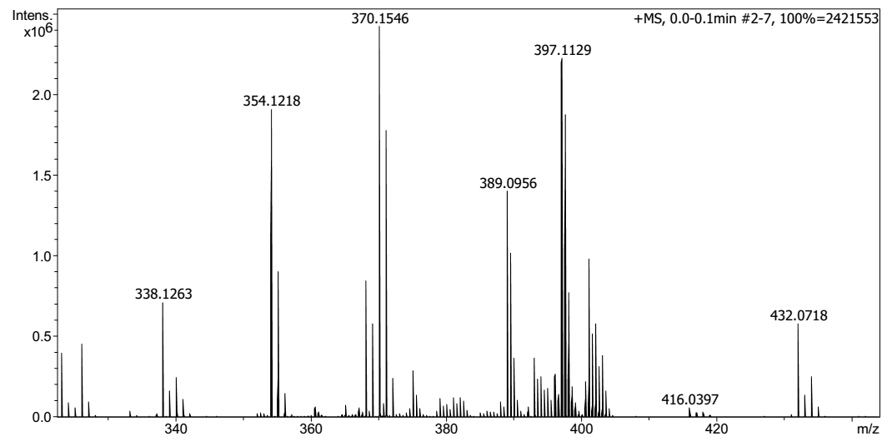

Fig. S3. HRMS data for terpyridine ligand (DMPTP)**.**



Fig. S4. Terpyridine (DMPTP) ligand, in different solvents (a) in naked eye (b) under UV lamp at 365 nm.



Fig. S5. Fluorescence decay of DMPTP in hexane and DMSO.



Fig. S6. TGA plots for Cu2+: terpyridine gel and Zn2+: terpyridine gel.