Cone snail analogs of the pituitary hormones oxytocin/ vasopressin and their carrier protein neurophysin. Proteomic and transcriptomic identification of conopressins and conophysins.
Sanjeev Kumar¹, M.Vijayasarathy¹, M.A.Venkatesha¹, P.Sunita² and P.Balaram^{1,2,†}
¹National Centre for Biological Sciences, Tata Institute of Fundamental Research, Bangalore-560065, India.²Molecular Biophysics Unit, Indian Institute of Science, Bangalore-560012, India.

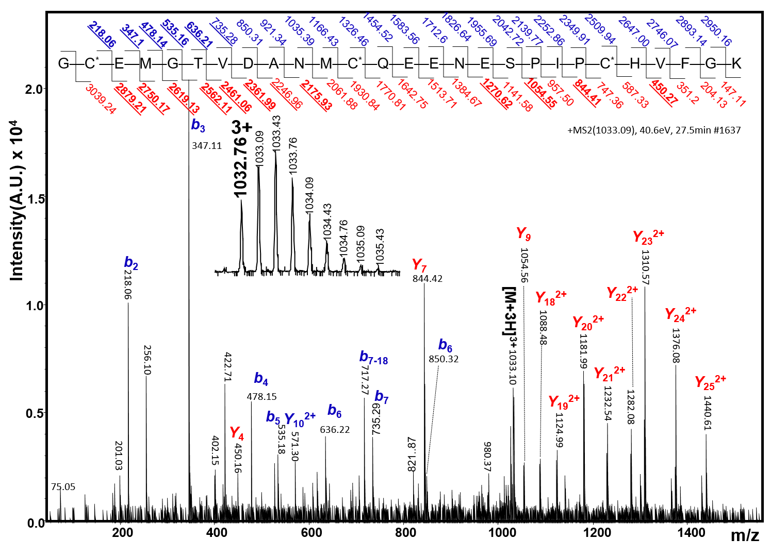
Supplementary information

Supplementary Figure S1. MS/MS spectrum of the C. monile conophysin 3 isoform peptide (M=3,095.28 Da), derived from in-gel trypsin digestion. Inset shows the 3⁺ charge state (m/z 1032.76), which has been subjected to collision induced dissociation (CID). The b and y ions identified are marked on the spectrum and are highlighted against the sequence shown. C*, S-carboxamidomethyl cysteine, residue mass 160 Da.
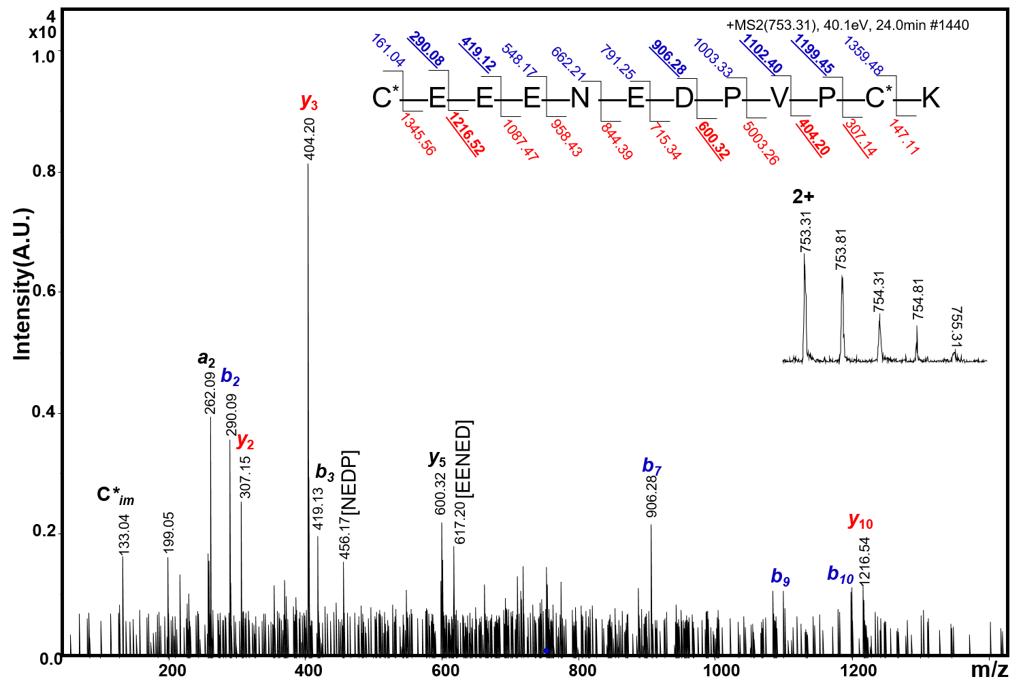
Supplementary Figure S2. MS/MS spectrum of the C. monile conophysin 1 isoform peptide (M=1,504.6 Da), derived from in-gel trypsin digestion. Charge state 2⁺ (m/z 753.31) was subjected to collision induced dissociation (CID). The product ions identified are marked on the spectrum and are highlighted on the sequence shown. C* , indicate S-carboxamidomethyl cysteine, residue mass 160 Da.

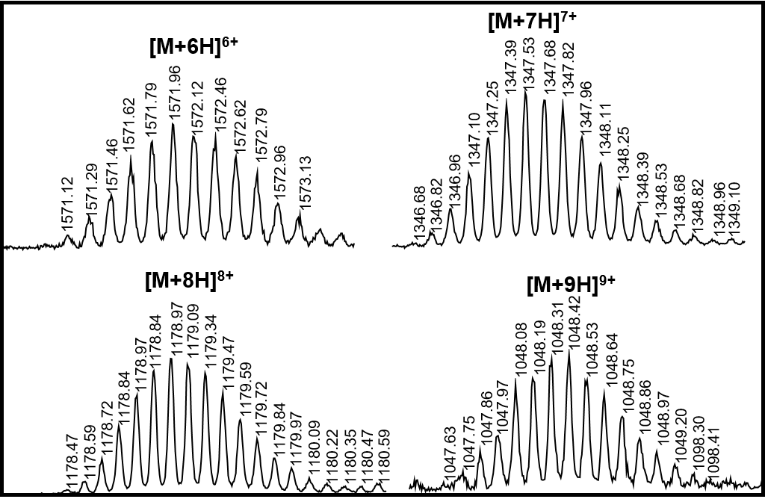
Supplementary Figure S3. ESI-MS of C. monile conophysin 3 isoform. Spectrum shows isotopic distribution of [M+6H]⁶⁺, [M+7H]⁷⁺, [M+8H]⁸⁺ and [M+9H]⁹⁺ charge states. The M_{obs} of 9419.76 Da is in agreement with the M_{calc} of 9419.87 Da.

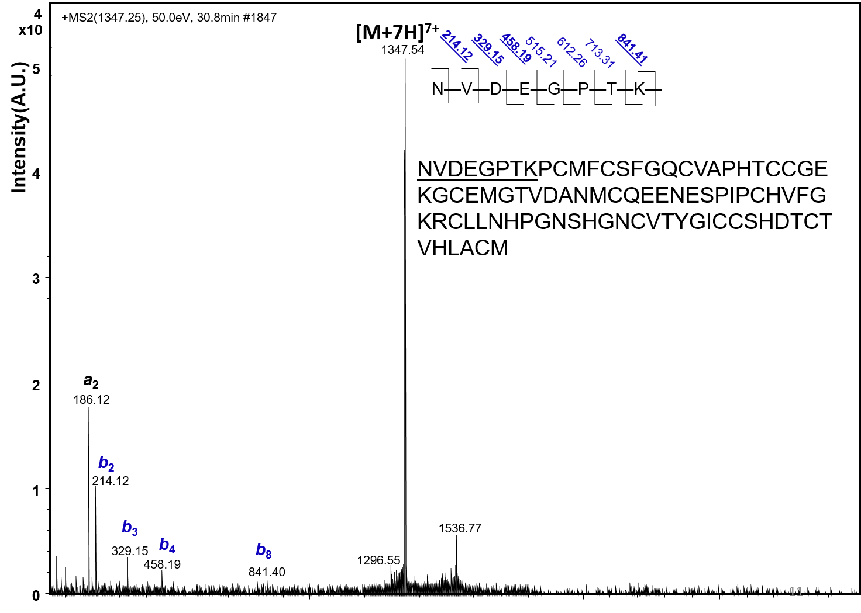

Supplementary Figure S4. MS/MS spectrum of disulfide bonded C. monile conophysin 3 isoform (M= 9,419.8 Da). The 7⁺ charge state was subjected to fragmentation under CID conditions. The identified product ions (a₂, b₂, b₃, b₄ and b₈) that permit the identification of N-terminus are marked.

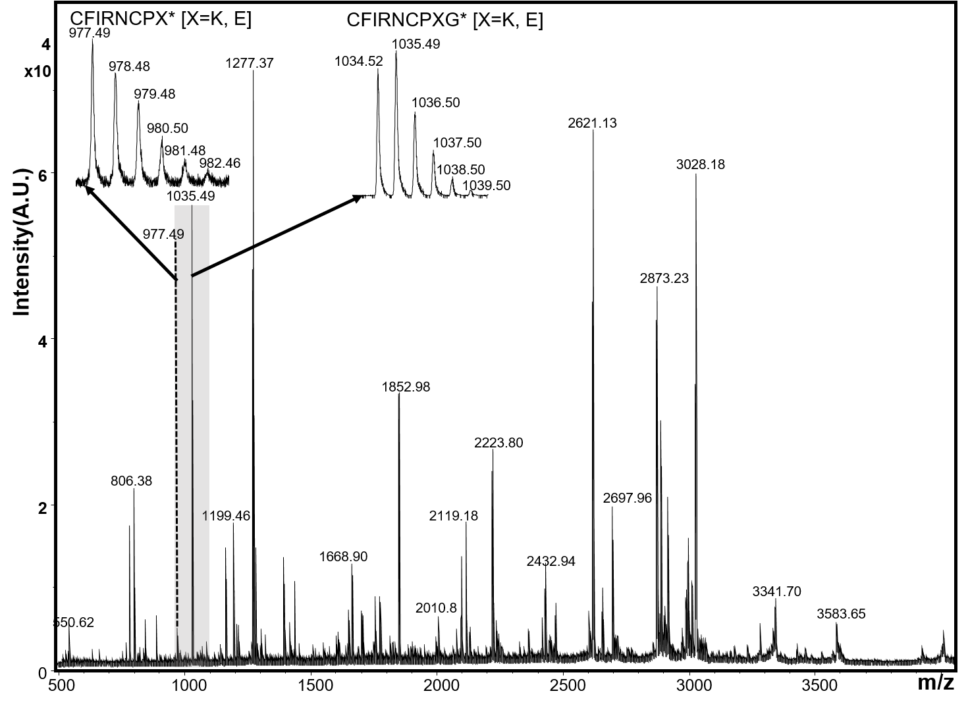

Supplementary Figure S5. MALDI-MS spectrum of aqueous extracts of C. monile venom duct. The intense peak at m/z of 1,035.49 corresponds to the mass of conopressin CFIRNCPKG*/ CFIRNCPEG*. The expanded isotopic multiplet shows a peak at m/z 1034.49 (CFIRNCPKG*) and a higher intensity peak at 1035.42 (CFIRNCPEG*) A less abundant component at m/z 977.5 corresponds to the C-terminal Gly deleted conopressin variants CFIRNCPK*/ CFIRNCPE*.

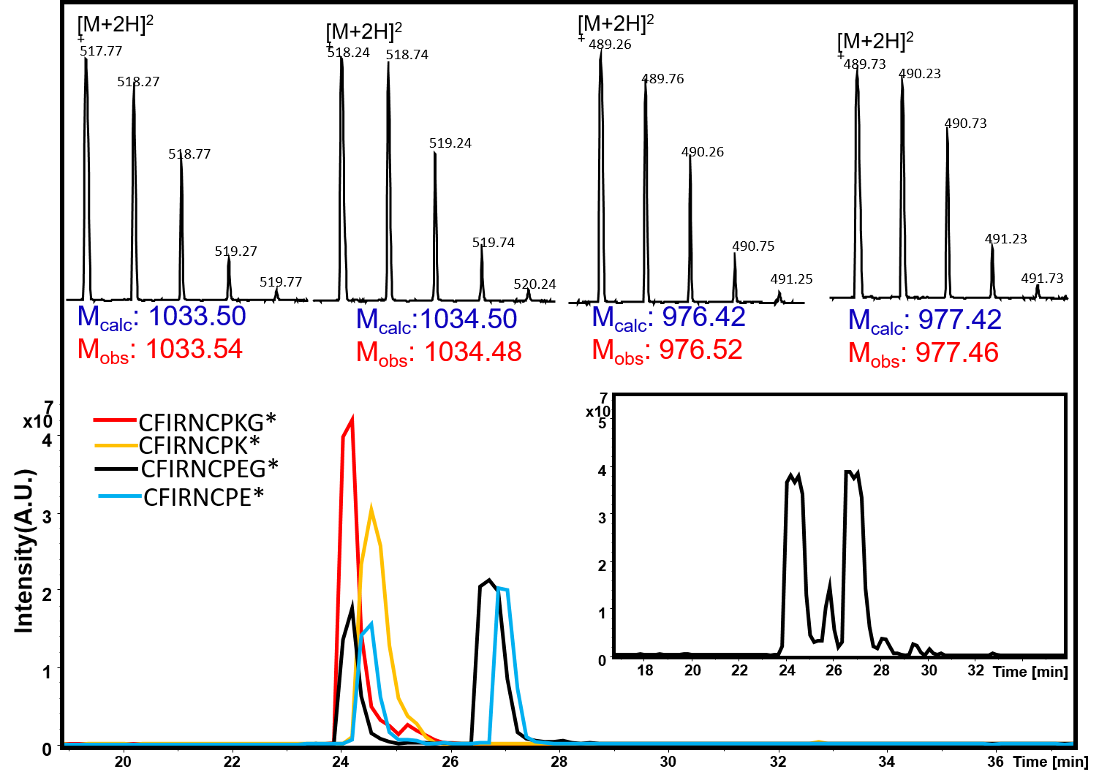

Supplementary Figure S6. (Top panel) Mass spectra of 2⁺ charge state of four chemically synthesised conopressin peptides CFIRNCPKG*(M=1033.5), CFIRNCPEG*(M=1034.5), CFIRNCPK*(M= 976.5) and CFIRNCPE* (M=977.5 Da) (Bottom panel) The extracted ion chromatogram (EIC) of a mixture of four synthetic peptides obtained using the four detected masses. Inset shows the mass detected LC-profile (total ion chromatogram) of the mixture of four chemically synthesised conopressin peptides. The position of elution of four conopressin are similar to that observed for the conopressin peptides from the crude venom.

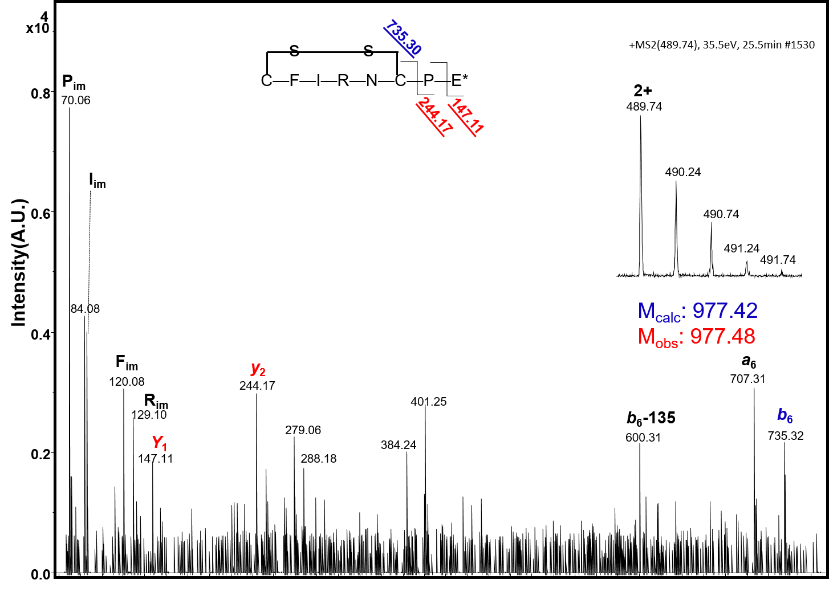

Supplementary Figure S7. MS/MS spectrum of the disulfide linked conopressin anaogue CFIRNCPE* (M=977.5). The 2⁺ charge state was chosen for fragmentation under CID conditions. Selected fragments ions have been assigned.

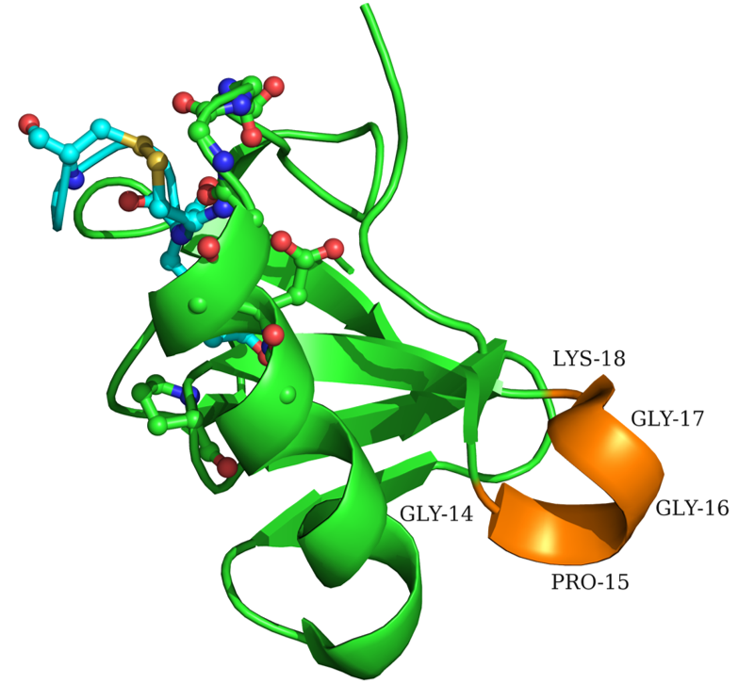

Supplementary Figure S8. A Partial view of the bovine neurophysin II structure (PDB id: 1JK4) showing the loop residues 14-18. This loop is deleted in C. monile isofoms 1 and 3 and is present only in the C. monile 2 isoform.

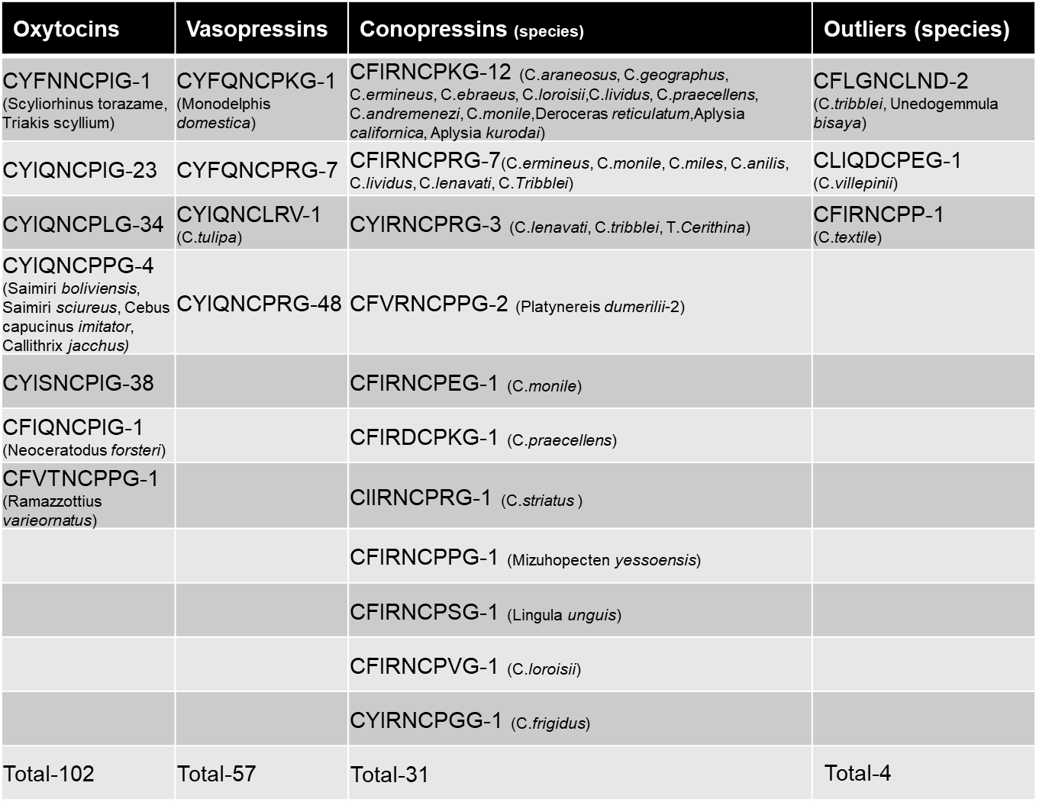

Supplementary Table 1 Classification of oxytocins, vasopressins and conopressins sequences.

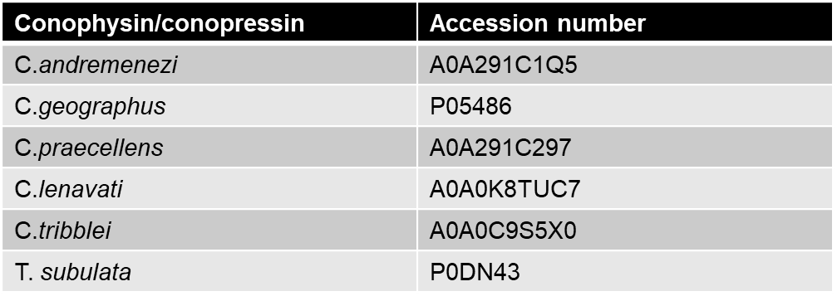

Supplementary Table 2 Accession number for sequences used in Figure 1.The conophysin/conopressin sequences reported in this study are submitted to NCBI with accession no. KY982965-KY982973

