Journal of Geophysical Research: Atmospheres
Supporting Information for
Enhanced light-absorption of black carbon in rainwater compared with aerosols over the northern Indian Ocean
Krishnakant Budhavant^{1,2,3}, August Andersson¹, Henry Holmstrand¹, Poonam Bikkina^{1,4}, Srinivas Bikkina¹, S. K. Satheesh³, Örjan Gustafsson^{1*}
¹Department of Environmental Science and Analytical Chemistry, and the Bolin Centre for Climate Research, Stockholm University, 10691 Stockholm, Sweden
²Maldives Climate Observatory at Hanimaadhoo, H. Dh. Hanimaadhoo, 02020, the Maldives
³Centre for Atmospheric and Oceanic Sciences and Divecha Centre for Climate Change, Indian Institute of Sciences (IISC), Bangalore 560012, India.
⁴National Institute of Oceanography, Visakhapatnam, 530017, India.

*Correspondence to: Örjan Gustafsson (orjan.gustafsson@aces.su.se)
1 A correction scheme for measuring light-absorption through heavily loaded filters
Most existing filter loading corrections for measuring light transmission are developed for low-loading scenarios. However, for some situations heavier loadings are analyzed through comparably thick filters. Here, we develop a filter correction for heavy loading cases using a diffusive light model. That is, the multiple scattering among particles and filter media and the corresponding ‘loading effects’ are approximated as a radiative transfer diffusion process.
Diffusion processes can be described by the diffusion equation, here expressed for light:
$0=D∙\frac{d^{2}I(z)}{dz^{2}}+S-K∙I(z)$ (1)
Where, D is the diffusion constant, I is light intensity, z is a spatial dimension (filter depth), S is the source flux and K is the sink rate. Equation (1) is the time-independent diffusion equation, since we assume steady-state. In terms of light-absorption of particles on a filter, S is the light that shines onto the filter surface. Since S may be considered a point source, and thus is independent of z, we for simplicity ignore this term. The sink for the light is the absorption of light by the particles. The solution to Eq (1) is given by:
$I\left(z\right)=A∙e^{-λ∙z}+B∙e^{λ∙z}$ (2)
Where A and B are constants and:
$λ=\sqrt{\frac{K}{2∙D}}$ (3)
The first and second terms ($A∙e^{-λ∙z}$ resp. $B∙e^{λ∙z}$) corresponds to the situations of the light coming into and moving out of the filter. Since we are only interested in the light moving into the filter we may set B = 0. The sink is the absorption coefficient (μ_{a}, m⁻¹) of the particles in the filter (which is defined in terms of the density in the filter) times the speed of light (c):
$K=μ_{a}∙c$ (4)
The diffusion coefficient of light is given by [Letokhov, 1968]:
$D=\frac{c}{3∙\left(μ_{s}+μ_{a}\right)}≈\frac{c}{3∙μ_{s}}$ (5)
Where, μ_{s} is the scattering coefficient (m⁻¹) of the filter and the particles. This term is typically much larger than μ_{a}, and we therefore approximate μ_{a} + μ_{s} ≈ μ_{s}.
Combining Eqs (3) to (5) we have:
$λ=\sqrt{1.5∙μ_{a}∙μ_{s}}$ (6)
Normalizing to the initial (zero loading) transmission (I₀), we have:
$\frac{I}{I_{0}}=e^{-\sqrt{k∙μ_{a}∙μ_{s}}∙z}$ (7)
For comparison, the analogous expression for light-extinction in the commonly used Lambert-Beer-Bouguer limit is:
$\frac{I}{I_{0}}=e^{-\left(μ_{s}+μ_{a}\right)∙z}$ (8)
We note that z is the filter thickness, which is independent of the filter loading. We assume that μ_{s} is dominated by the filter scattering and set: k’ = 1.5·μ_{s}·z (unitless). Defining the light attenuation, ATN = -log(I/I₀), and rearranging Eq (7):
$ATN=\sqrt{k'∙μ_{a}∙z}$ (9)
The absorption coefficient for matter in the filter is given by:
$μ_{a}=ρ_{a}∙σ_{a}=\frac{m_{a}∙σ_{a}}{z∙A}=\frac{V∙C_{a}∙σ_{a}}{z∙A}=\frac{V∙C_{a}∙k_{a}∙MAC}{z∙A}=\frac{V∙k_{a}∙b_{abs}}{z∙A}$ (10)
Where ρ_{a} is the density (kg/m³) of the absorbing materials in the filter and σ_{a} is the mass absorption cross section (m²/kg) in the filter. The density of the materials is the mass (m_{a}, kg) divided by the volume of the filter, which is the area (A, m²) times z. The mass of absorbing materials in the filter is the concentration in air (C_{a}, kg/m³) times the volume of air sampled (V, m³). The mass absorption cross-section of particles in the air (MAC) is proportional (via the constant k_{a}, unitless) to σ_{a}. The absorption coefficient (b_{abs}, m^{.1}) in the air equals the concentration in air times the MAC.
Equation (10) includes the simplifying assumptions that particles are evenly distributed throughout the filter, and that the density of the absorbing materials (or the mass absorption cross-section) is independent of the filter medium. Combining Equations (9) and (10) (where k = k’·k_{a}):
$$b_{abs}=\frac{{ATN}^{2}∙A}{k∙V}$$
The MAC is defined as the ratio of the light-absorption coefficient and the BC mass loading – elemental carbon (EC):
$MAC=\frac{{ATN}^{2}∙A}{EC∙V∙MS}=\frac{{ATN}^{2}}{{EC}_{loading}∙MS}$ (11)
Following common nomenclature, k is set to MS, which is a heuristic multiple scattering correction factor implemented in most filter loading correction schemes, ranging between ~ 2 to 6, depending on mixing/coating of the BC and filter type [e.g., Weingartner et al., 2003; Arnott et al., 2005; Schmid et al., 2006]. Here, the MS relates to μ_{s}, z, and σ_{a}/MAC. EC_{loading} is the loading of EC on the filter in units mass per surface area.

2 Non-sea salt contribution
The non-sea-salt (nss) concentrations of K⁺, Mg²⁺, Ca²⁺, and SO₄²⁻ were calculated using Na⁺ as the sea-salt tracer. Nss SO₄²⁻ is computed as follows:
$${nss SO}_{4}^{2-}= \left[{SO}_{4}^{2-}\right]-\left[{\left(\frac{\left[{SO}_{4}^{2-}\right]}{\left[Na\right]}\right)}_{sea }X \left[{Na}^{+}\right]\right]$$
where ([SO₄²⁻]/ [Na⁺]) sea is the standard ratio of the concentrations of SO₄²⁻ and Na⁺ which is obtained from seawater composition [Keene et al., 1986].
Table S1. A matrix of correlation coefficients (r) for components measured in rainwater. Correlations higher than 0.5 are highlighted in italics.
 | EC | WIOC | NO₃⁻ | NH₄⁺ | nss-K⁺ | nss-SO₄²⁻ | nss-Ca²⁺ | Na⁺ | Cl⁻ | Mg²⁺
EC | 1 | 0.87 | 0.41 | 0.45 | 0.34 | 0.31 | 0.05 | -0.07 | 0.01 | -0.01
WIOC | 0.87 | 1 | 0.23 | 0.30 | 0.44 | 0.03 | 0.08 | -0.07 | -0.11 | -0.19
NO₃⁻ | 0.41 | 0.23 | 1 | 0.66 | -0.10 | 0.70 | 0.12 | 0.24 | 0.21 | 0.17
NH₄⁺ | 0.45 | 0.30 | 0.66 | 1 | 0.51 | 0.66 | 0.27 | 0.35 | 0.40 | 0.32
nss-K⁺ | 0.34 | 0.44 | -0.10 | 0.51 | 1 | -0.03 | -0.01 | 0.02 | 0.00 | -0.09
nss-SO₄²⁻ | 0.31 | 0.03 | 0.70 | 0.66 | -0.03 | 1 | 0.30 | 0.54 | 0.61 | 0.41
nss-Ca²⁺ | 0.05 | 0.08 | 0.12 | 0.27 | -0.01 | 0.30 | 1 | 0.34 | 0.39 | 0.51
Na⁺ | -0.07 | -0.07 | 0.24 | 0.35 | 0.02 | 0.54 | 0.34 | 1 | 0.98 | 0.82
Cl⁻ | 0.01 | -0.11 | 0.21 | 0.40 | 0.00 | 0.61 | 0.39 | 0.98 | 1 | 0.83
Mg²⁺ | -0.01 | -0.19 | 0.17 | 0.32 | -0.09 | 0.41 | 0.51 | 0.82 | 0.83 | 1

Table S2. Matrix of correlation coefficients (r) for components measured in PM₁₀. Correlations higher than 0.5 are highlighted in italics
 | EC | WIOC | NO₃⁻ | NH₄⁺ | nss-K⁺ | nss-SO₄²⁻ | nss-Ca²⁺ | Na⁺ | Cl⁻ | Mg²⁺
EC | 1 | 0.89 | 0.18 | 0.51 | 0.94 | 0.22 | -0.29 | 0.54 | 0.16 | 0.60
WIOC | 0.89 | 1 | 0.16 | 0.46 | 0.89 | 0.24 | -0.19 | 0.54 | 0.29 | 0.64
NO₃⁻ | 0.18 | 0.16 | 1 | 0.89 | 0.23 | 0.21 | -0.11 | 0.17 | 0.03 | 0.27
NH₄⁺ | 0.51 | 0.46 | -0.03 | 1 | 0.57 | 0.25 | -0.34 | -0.06 | -0.18 | 0.02
nss-K⁺ | 0.94 | 0.89 | 0.23 | 0.57 | 1 | 0.22 | -0.25 | 0.52 | 0.22 | 0.66
nss-SO₄²⁻ | 0.22 | 0.24 | 0.21 | 0.25 | 0.22 | 1 | -0.36 | -0.01 | -0.03 | 0.02
nss-Ca²⁺ | -0.29 | -0.19 | -0.11 | -0.34 | -0.25 | -0.36 | 1 | 0.17 | 0.29 | 0.05
Na⁺ | 0.54 | 0.54 | 0.17 | -0.06 | 0.52 | -0.01 | 0.17 | 1 | 0.89 | 0.95
Cl⁻ | 0.16 | 0.29 | 0.03 | -0.18 | 0.22 | -0.03 | 0.29 | 0.89 | 1 | 0.81
Mg²⁺ | 0.60 | 0.64 | 0.27 | 0.02 | 0.66 | 0.02 | 0.05 | 0.95 | 0.81 | 1

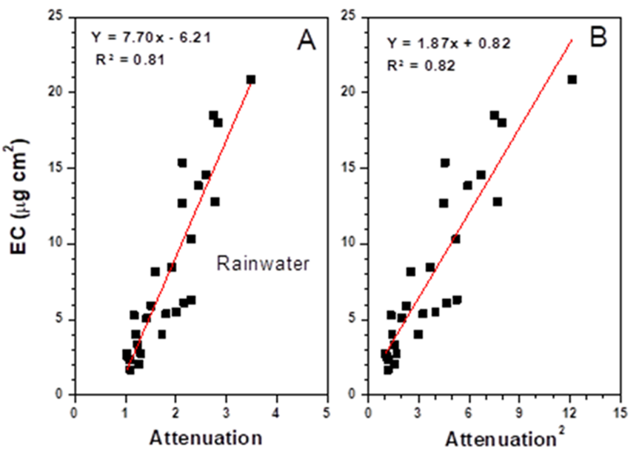
Figure S1. Relations between filter loadings and filter light absorption for filtered rain samples Panel A. Linear relationship between optical-attenuation (ATN) and EC filter loading. Panel B. Linear relationship between ATN square and EC filter loading. Note that the ATN is typically outside (>1) the range of the most common filter loading corrections schemes and that the ATN² relation gives a ~ zero intercept.
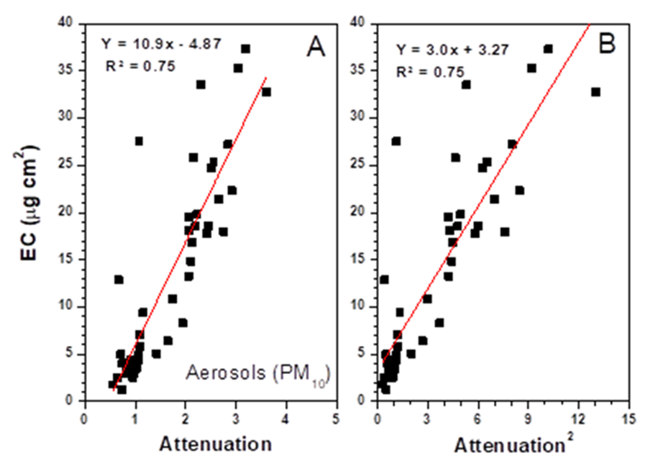
Figure S2. Relations between filter loadings and filter light absorption for ambient PM₁₀ samples. Panel A. Linear relationship between optical-attenuation (ATN) and EC filter loading. Panel B. Linear relationship between ATN square and EC filter loading. Note that the ATN is typically outside (>1) the range of the most common filter loading corrections schemes and that the ATN² relation gives a ~ zero intercept.
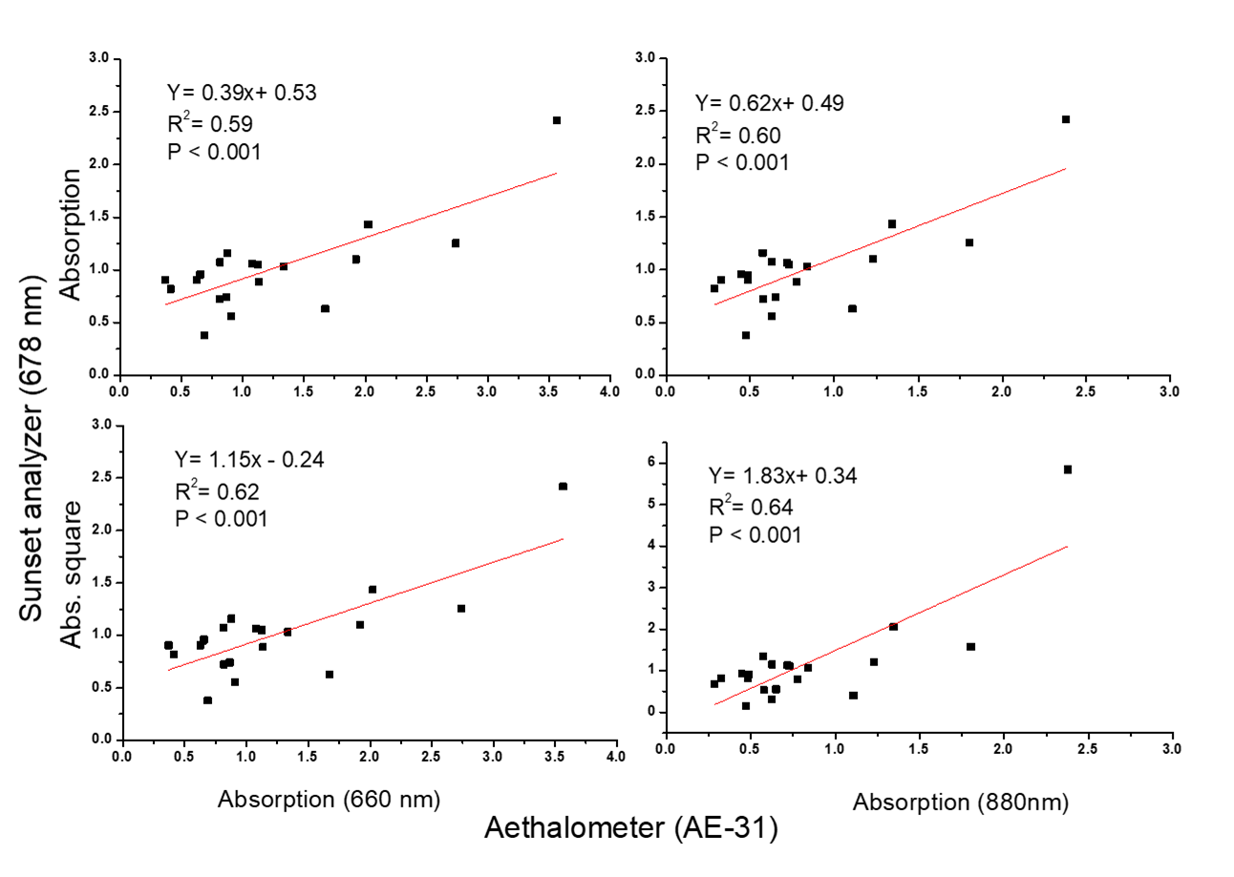
Figure S3: Comparison of absorption coefficient derived from Sunset Carbon analyser and Aethalometer.
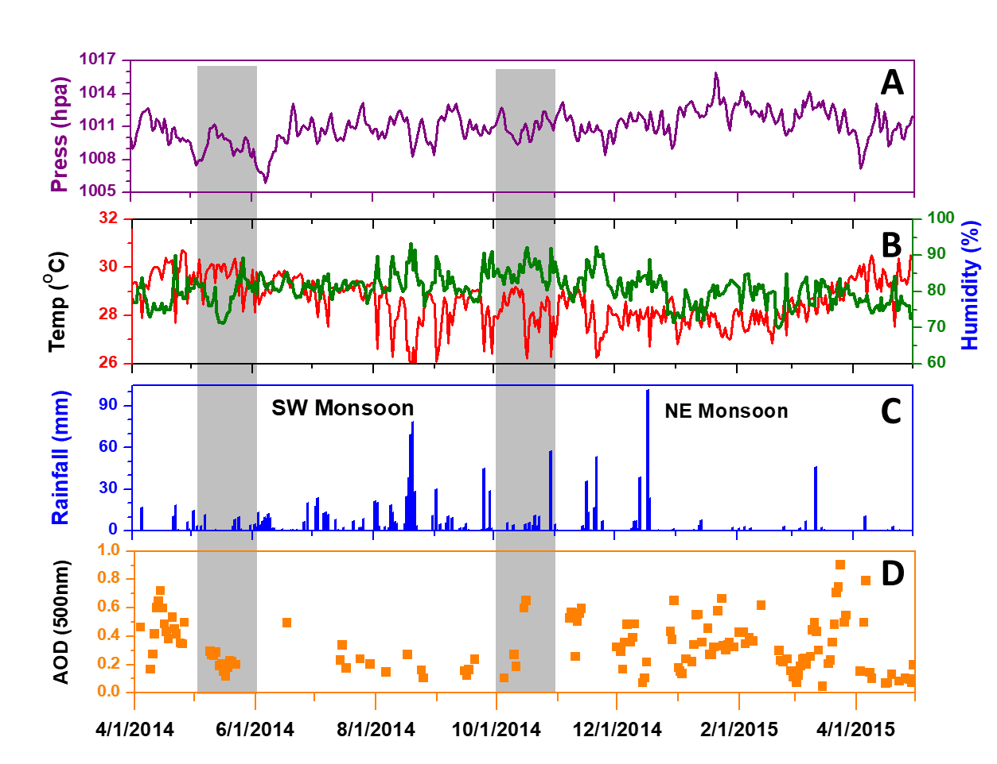
Figure S4. Weather parameters measured at MCOH. Panel A. Atmospheric pressure, B. temperature and relative humidity, C. rainfall and D. Columnar aerosol optical depth (AOD) from Sun photometer (AERONET network), (top to bottom) during April 2014 to April 2015.
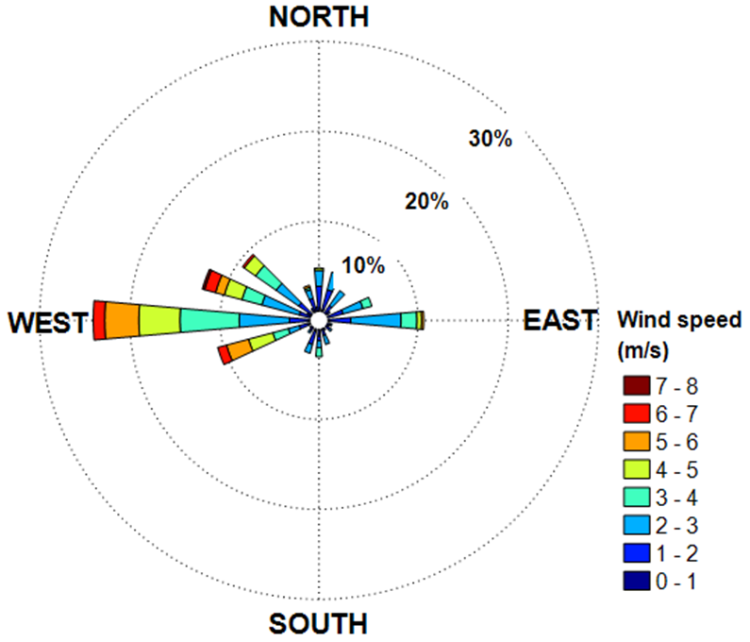
Figure S5. Distribution of wind speed and wind direction measured at the Maldives Climate Observatory-Hanimaadhoo (MCOH) from April 2014 to April 2015.
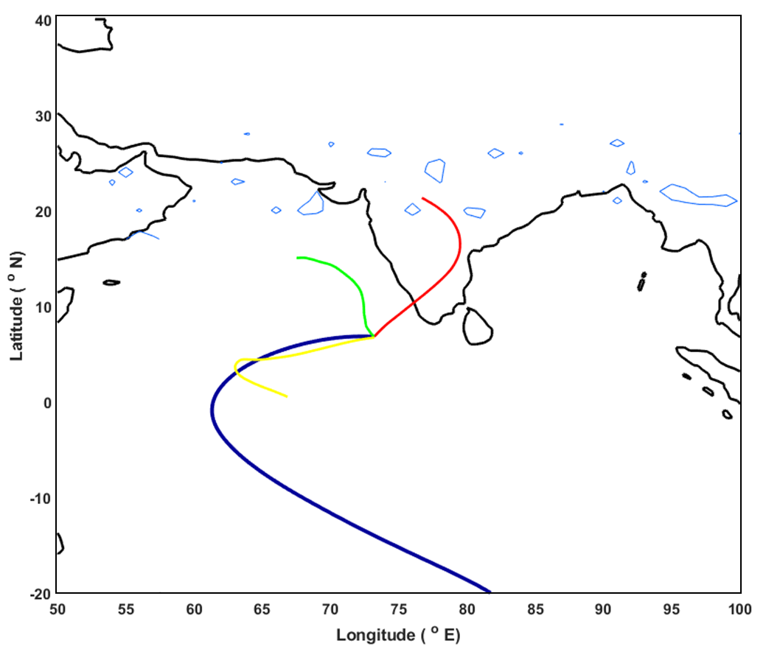
Figure S6. Clustered 6-hourly, 10-day air mass back trajectories’ (AMBTs) mean for MCOH. The color lines represent the seasonal cluster, classified as NE monsoon (red), SW monsoon (dark blue), Pre-transition period (green) and post-transition period (yellow).
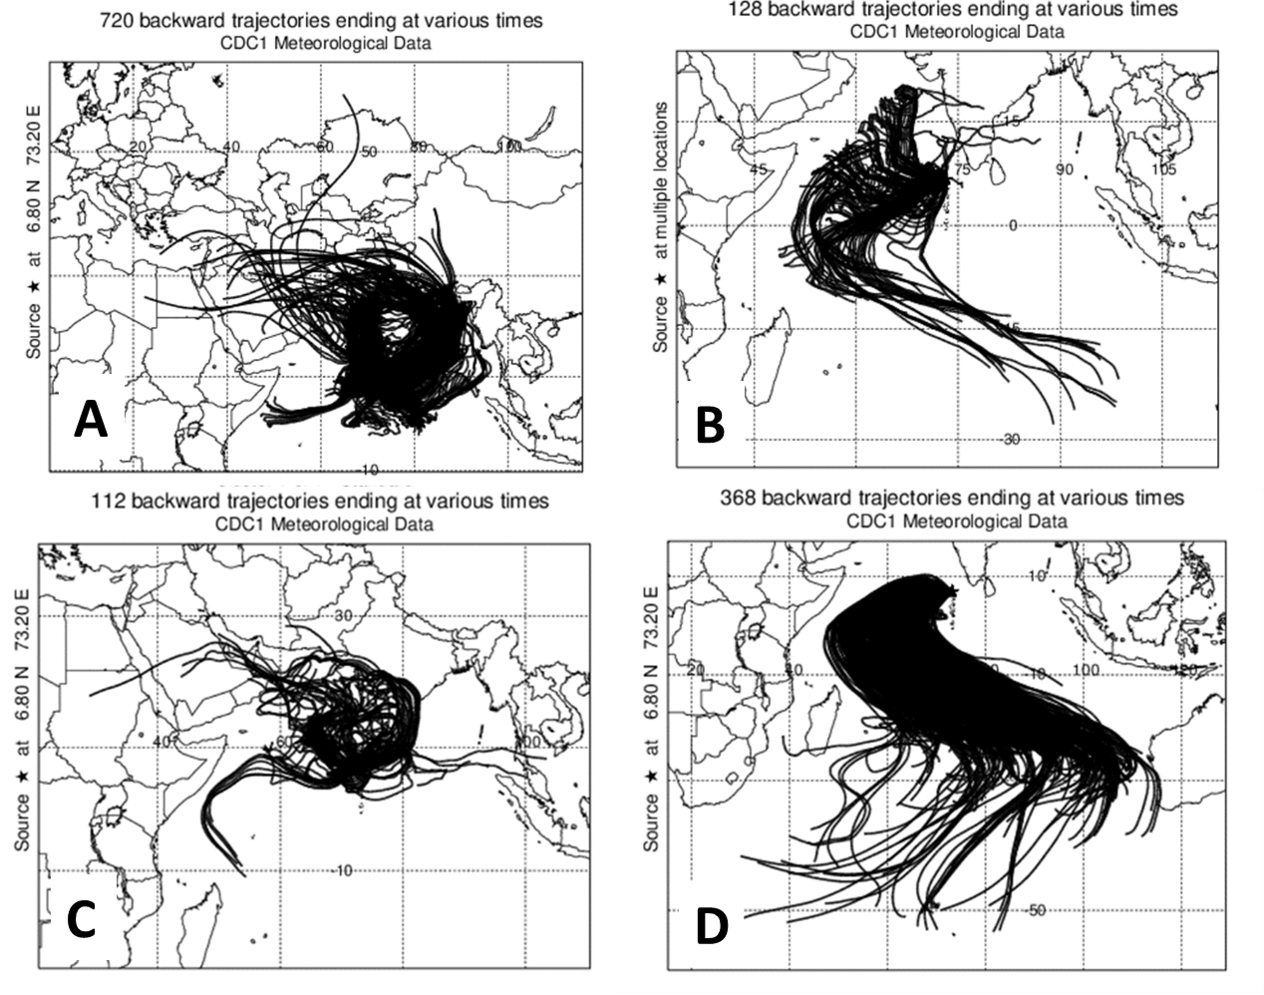
Figure S7. Ten days air-mass back trajectories (100m) ending at Maldives Climate Observatory-Hanimaadhoo (MCOH) from May 2014 to April 2015, classified as A. NE monsoon, B. Pre-transition period, C. Post-transition, and D. SW monsoon
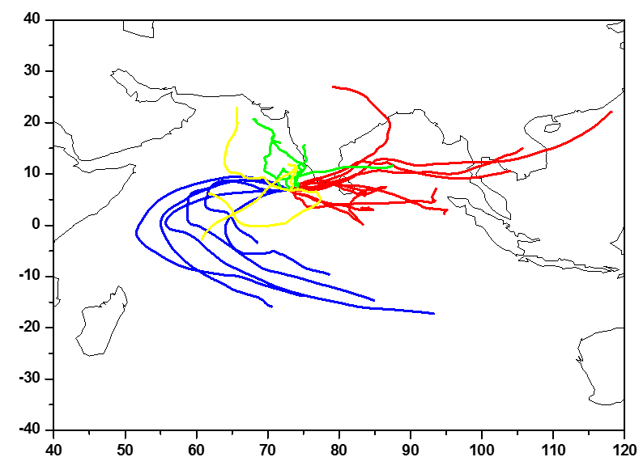
Figure S8. Ten days air mass back trajectories (2000m) ending at MCOH from April 2014 to May 2015, NE monsoon (Red color), SW monsoon (Blue) Pre-transition period (Green) and Post-transition with (yellow) during the April 2014 to April 2015.

References
Arnott, W., K. Hamasha, H. Moosmüller, P. J. Sheridan, and J. A. Ogren (2005), Towards aerosol light-absorption measurements with a 7-wavelength aethalometer: Evaluation with a photoacoustic instrument and 3-wavelength nephelometer, Aerosol Sci. Tech., 39, 17–29.
Lethokov, V. S. (1968), Generation of Light by a Scattering Medium with Negative Resonance Absorption, Soviet Physics JETP 26, 835-840
Ram, K., and M. M. Sarin (2009), Absorption coefficient and sites specific mass absorption efficiency of elemental carbon in aerosols over urban, rural, and high-altitude sites in India, Environ. Sci. Technol., 43,8233–8239, doi:10.1021/es9011542.
Schmid, O., P. Artaxo, W. P. Arnott, D. Chand, L. V. Gatti, G. P. Frank, A. Hoffer, M. Schnaiter, and M. O. Andreae (2006), Spectral light absorption by ambient aerosols influenced by biomass burning in the Amazon Basin, I: Comparison and field calibration of absorption measurement techniques, Atmos. Chem. Phys., 6, 3443–3462, https://doi.org/10.5194/acp-6-3443-2006, 2006.
Weingartner, E., H. Saathoff, M. Schnaiter, N. Streit, B. Bitnar, and U. Baltensperger (2003), Absorption of light by soot particles: determination of the absorption coefficient by means of aethalometers, J. Aerosol Sci., 34, 1445–1463.

