Structural elucidation, theoretical insights and thermal properties of three novel multicomponent molecular forms of gallic acid with hydroxypyridines

Jyothi K. L^{a,b}, Karthik Kumaraª, Hema M. K.ª, Maheshaª, Raj Gautam^{c}, Guru Row T. N.^{c} and Lokanath N. K.^{a*}

ª Department of Studies in Physics, Manasagangotri, University of Mysore, Mysuru 570006, India.
^{b} Department of Physics, Government First Grade College and PG Centre, Chintamani 563125, India.
^{c} Solid State and Structural Chemistry Unit, Indian Institute of Science, Bengaluru 560012, India.

Supplementary information

Table S1. FTIR major bands (in cm⁻¹) assignment of starting and multicomponent compounds.

Sample | νO-H  (Alcohol) | νO-H  (Acid) | νC=O  (Acid) | νC-O  (Acid) | ν N-H  (Bending) | νN-H  (Stretching)
GA | 3345.27 | 3273.45 | 1700.25 | 1239.40 | -- | --
2HP | 3070.15 | -- | -- | -- | 1638.19 | --
3HP | 3062.56 | -- | -- | -- | 1590.35 | --
4HP | 3421.39 | -- | -- | -- | 1638.27 | --
GA-2HP | 3258.06 | 2984.27 | 1742.15 | 1299.92 | 1645.94 | 3413.61
GA-3HP | 3072.92 | 2521.67 | 1336.94 |  | 1617.95 | 3510.35
GA-4HP | 3091.49 | 2982.89 | 1700.00 | 1341.66 | 1635.45 | 3462.38

Table S2. Interatomic distances (Å), bond angles ($°$) and symmetry codes of inter/intra molecular hydrogen bonds.
GA-2HP cocrystal
D-H...A | D-H | H...A | D...A | D-H...A | Symmetry Code
O9-H9…O19 | 0.82 | 1.77 | 2.582(2) | 172 | -1/2+x,1/2-y,1/2+z
O10-H10…O19 | 0.82 | 1.85 | 2.652(2) | 168 | 5/2-x,-1/2+y,1/2-z
O11-H11…O10 (intra) | 0.82 | 2.26 | 2.698(2) | 114
O11-H11…O8 | 0.82 | 2.14 | 2.805(2) | 138 | 1/2+x,1/2-y,-1/2+z
O12-H12…O11 (intra) | 0.82 | 2.41 | 2.724(2) | 103
O12-H12…O8 | 0.82 | 2.18 | 2.967(2) | 160 | -1/2+x,1/2-y,-1/2+z
N18-H18…O8 | 0.86 | 2.15 | 2.961(2) | 156 | 1/2+x,1/2-y,-1/2+z
C17–H17…O12 | 0.93 | 2.68 | 3.606(2) | 172
GA-3HP molecular salt
D-H...A | D-H | H...A | D...A | D-H...A | Symmetry Code
O10-H10…O11 (intra) | 0.82 | 2.28 | 2.715(2) | 114
O10-H10…O19 | 0.82 | 2.38 | 3.012(2) | 135 | 1/2-x,1/2+y,3/2-z
O11-H11…O12 (intra) | 0.82 | 2.37 | 2.727(2) | 108
O11-H11…O8 | 0.82 | 1.90 | 2.703(2) | 165 | 3/2-x,1/2+y,3/2-z
O12-H12…O9 | 0.82 | 1.85 | 2.655(2) | 169 | 1/2+x,1/2-y,1/2+z
N18-H18…O9 | 0.98 | 1.67 | 2.642(2) | 179 | 1-x,-y,1-z
O19-H19…O8 | 0.82 | 1.75 | 2.566(2) | 172 | -1/2+x,1/2-y,1/2+z
C7-H7…O9 | 0.93 | 2.55 | 3.204(2) | 128 | 1/2+x,1/2-y,1/2+z
GA-4HP cocrystal hydrate
D-H...A | D-H | H...A | D...A | D-H...A | Symmetry Code
O9-H9…O8 | 0.98 | 1.64 | 2.620(2) | 178 | 1-x,2-y,-z
O10-H10…O19 | 0.82 | 1.86 | 2.652(3) | 163 | -x,1-y,-z
O11-H11…O20 | 0.82 | 1.85 | 2.668(3) | 174 | -1+x,1/2-y,-1/2+z
O12-H12…O11 (intra) | 0.82 | 2.28 | 2.720(2) | 114
O12-H12…O11 | 0.82 | 2.11 | 2.827(2) | 145 | -x,-y,-z
N18-H18…O20 | 0.92 | 2.08 | 2.882(3) | 145
N18-H18…O10 | 0.92 | 2.37 | 2.979(3) | 123 | 1+x,1/2-y,1/2+z
O20-H20A…O19 | 0.85 | 1.91 | 2.744(3) | 165 | 1-x,1/2+y,1/2-z
O20-H20B…O19 | 0.85 | 1.86 | 2.706(3) | 176 | 1+x,y,z
C14-H14…O12 | 0.93 | 2.56 | 3.469(3) | 166
C17-H17…O8 | 0.93 | 2.29 | 3.053(3) | 139 | 1-x,-1/2+y,1/2-z

Table S3. Comparison of experimental (XRD) and theoritical (DFT) parameters of intermolecular interactions responsible for the formation of multicomponent compounds.
 | Bond lenghts (Å) |  |  |  |  |  | Bond angles (°) |  | Torsion angles (°)
 | XRD | DFT | XRD | DFT | XRD | DFT | XRD | DFT | XRD | DFT
GA-2HP | C17-H17…O12 |  | C17-H17 |  | H17…O12 |  | C17-H17…O12 |  | N18-C17-H17…O12
 | 3.606 | 3.927 | 0.93 | 1.082 | 2.682 | 3.914 | 172.65 | 82.73 | 146.22 | 6.24
 |  |  |  |  |  |  |  |  | C16-C17-H17…O12
 |  |  |  |  |  |  |  |  | -33.75 | -173.82
GA-4HP | C14-H14…O12 |  | C14-H14 |  | H14…O12 |  | C14-H14…O12 |  | C15-C14-H14…O12
 | 3.469 | 3.468 | 0.93 | 0.93 | 2.558 | 2.559 | 166.05 | 166.06 | -76.01 | -76.11
 |  |  |  |  |  |  |  |  | C13-C14-H14…O12
 |  |  |  |  |  |  |  |  | 103.93 | 103.83
 | N18-H18…O20 |  | N18-H18 |  | H18…O20 |  | N18-H18…O20 |  | C13-N18-H18…O20
 | 2.882 | 2.882 | 0.917 | 0.917 | 2.080 | 2.079 | 145.36 | 145.41 | 104.10 | 103.79
 |  |  |  |  |  |  |  |  | C17-N18-H18…O20
 |  |  |  |  |  |  |  |  | -74.03 | -74.34
GA-3HP | π-π interactions |  | Cg(1)-Cg(2) distance in Å
 |  |  | XRD |  |  |  | DFT
 |  |  | 3.828 |  |  |  | 3.574

Table S4. Lone pair…π interactions in GA-2HP (Å, $°$).

Y-X...Cg(π) | X...Cg | Y-X...Cg | Y-X...Cg | Symmetry code
C15-H15...Cg(1) | 2.97 | 3.731(2) | 140 | 2-x,1- y,1-z
C13-O19...Cg(1) | 3.439(18) | 3.512(2) | 82.68(12) | 3/2-x,1/2+y, 1/2-z

Table S5. π-π interactions.
Cg(I) - Cg(J) | Cg...Cg in Å | $$α$$ | $$β$$ | $$γ$$ | CgI-Perp | CgJ-Perp | Symmetry code
GA-2HP cocrystal
Cg(1) - Cg(1) | 5.5486(14) | 0 | 56.9 | 56.9 | 3.0333(8) | -3.0332(8) | -1+x, y, z
Cg(1) - Cg(2) | 5.8335(13) | 75.16(10) | 44.8 | 62.5 | 2.6916(8) | 4.1369(9) | x, y, z
Cg(1) - Cg(2) | 4.0924(12) | 3.09(10) | 36.3 | 34.3 | 3.3792(8) | -3.2840(9) | 3/2-x, -1/2+y, 1/2-z
Cg(1) - Cg(2) | 4.9509(13) | 75.16(10) | 13.8 | 82.5 | 0.6472(8) | 4.8088(9) | 2-x, 1-y, 1-z
Cg(2) - Cg(2) | 5.5486(14) | 0 | 58.4 | 58.4 | 2.9037(9) | -2.9037(9) | -1+x,y,z
Cg(2) - Cg(2) | 4.1012(13) | 0 | 35.5 | 35.5 | 3.3389(9) | -3.3388(9)
GA-3HP molecular salt
Cg(1) - Cg(1) | 5.7181(12) | 69 | 54.3 | 38.6 | 4.4694(8) | -3.3375(8) | 3/2-x,-1/2+y,3/2-z
Cg(1) - Cg(1) | 4.5004(11) | 0 | 41.5 | 41.5 | 3.3682(8) | 3.3682(8) | 1-x,1-y,1-z
Cg(1) - Cg(2) | 3.8277(13) | 6.97(10) | 18.2 | 11.6 | 3.7493(8) | -3.6352(9) | x,y,z
Cg(1) - Cg(2) | 5.8022(14) | 75.58(10) | 44.0 | 80.9 | 0.9132(8) | 4.1752(9) | 3/2-x,1/2+y,3/2-z
Cg(2) - Cg(2) | 4.0034(13) | 0 | 26.2 | 26.2 | -3.5915(9) | -3.5914(9) | 1-x, -y, 2-z
GA-4HP cocrystal hydrate
Cg(1) - Cg(1) | 3.5070(14) | 0 | 13.9 | 13.9 | -3.4042(10) | -3.4042(10) | -x,1-y,-z
Cg(1) - Cg(1) | 5.5399(14) | 0 | 57.0 | 57.0 | 3.0142(10) | 3.0142(10) | 1-x,1-y,-z
Cg(2) - Cg(2) | 3.6360(18) | 2 | 8.0 | 10.2 | -3.5780(12) | 3.6005(12) | 1-x,1/2+y,1/2-z

Where, α is the dihedral angle between planes I and J, β is the angle between the Cg(I)→Cg(J) vector and the normal to the plane I, γ is the angle between the Cg(I)→Cg(J) vector and the normal to the plane J, CgI-Perp is the perpendicular distance of CgI from ring J and CgJ-Perp is the perpendicular distance of CgJ from ring I.

Table S6. Summary of the percentage contribution of various intermolecular contacts to the Hirshfeld surface.
 | O…H | H…H | C…H | C…C | O…C | C…N | O…O | N…H | N…N
GA-2HP | 37.1 | 29.2 | 18.1 | 4.1 | 6.5 | 0.5 | 2.3 | 1.5 | 0.0
GA-3HP | 46.2 | 33.7 | 10.5 | 3.3 | 3.9 | 0.1 | 1.1 | 1.0 | 0.0
GA-4HP | 41.9 | 31.3 | 12.3 | 7.3 | 3.3 | 2.3 | 1.4 | 0.1 | 0.0

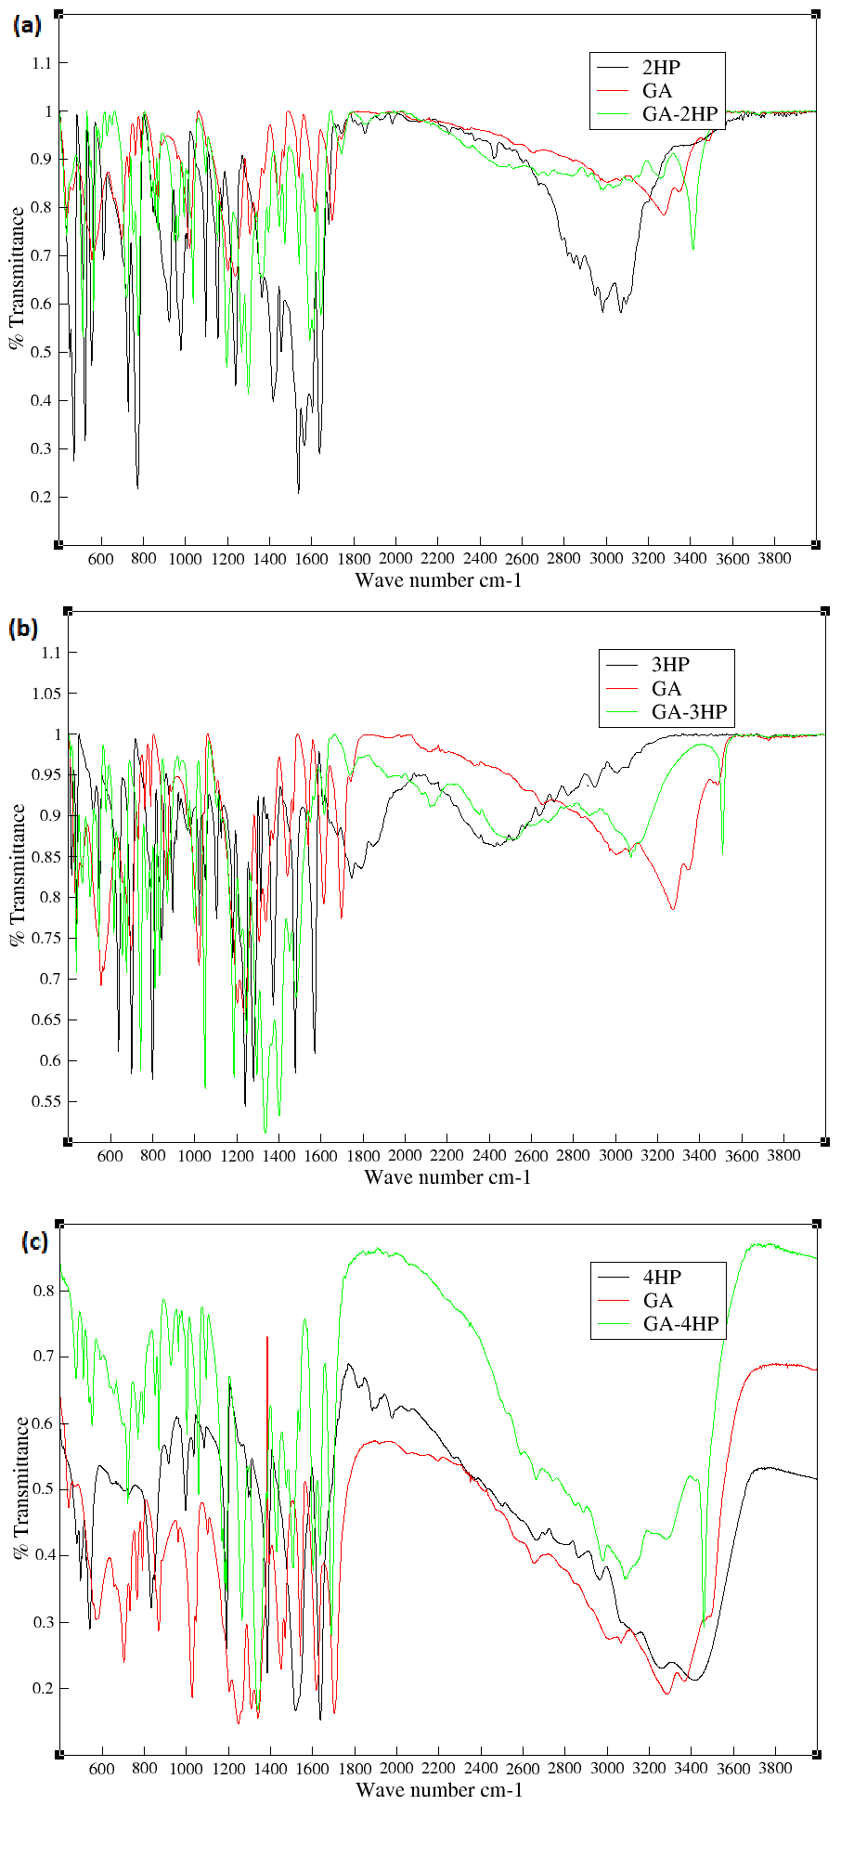
Figure S1: FTIR spectrum of starting components and ground materials of (a) GA-2HP cocrystal, (b) GA-3HP molecular salt and (c) GA-4HP monohydrate cocrystal.

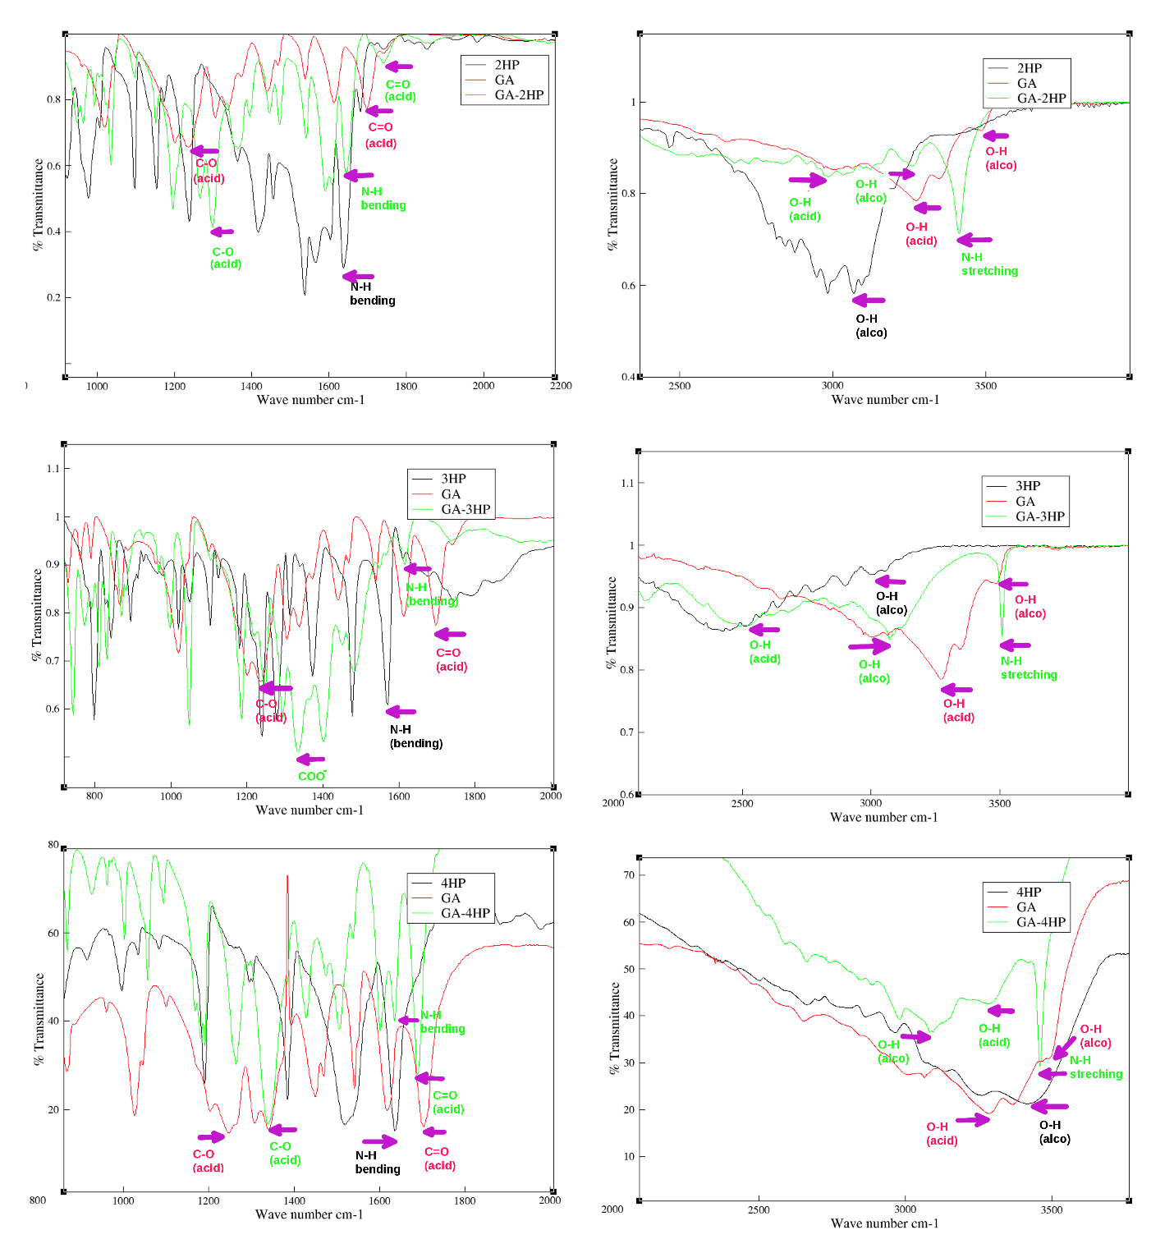
Figure S2: IR frequency assignment of the functional groups.

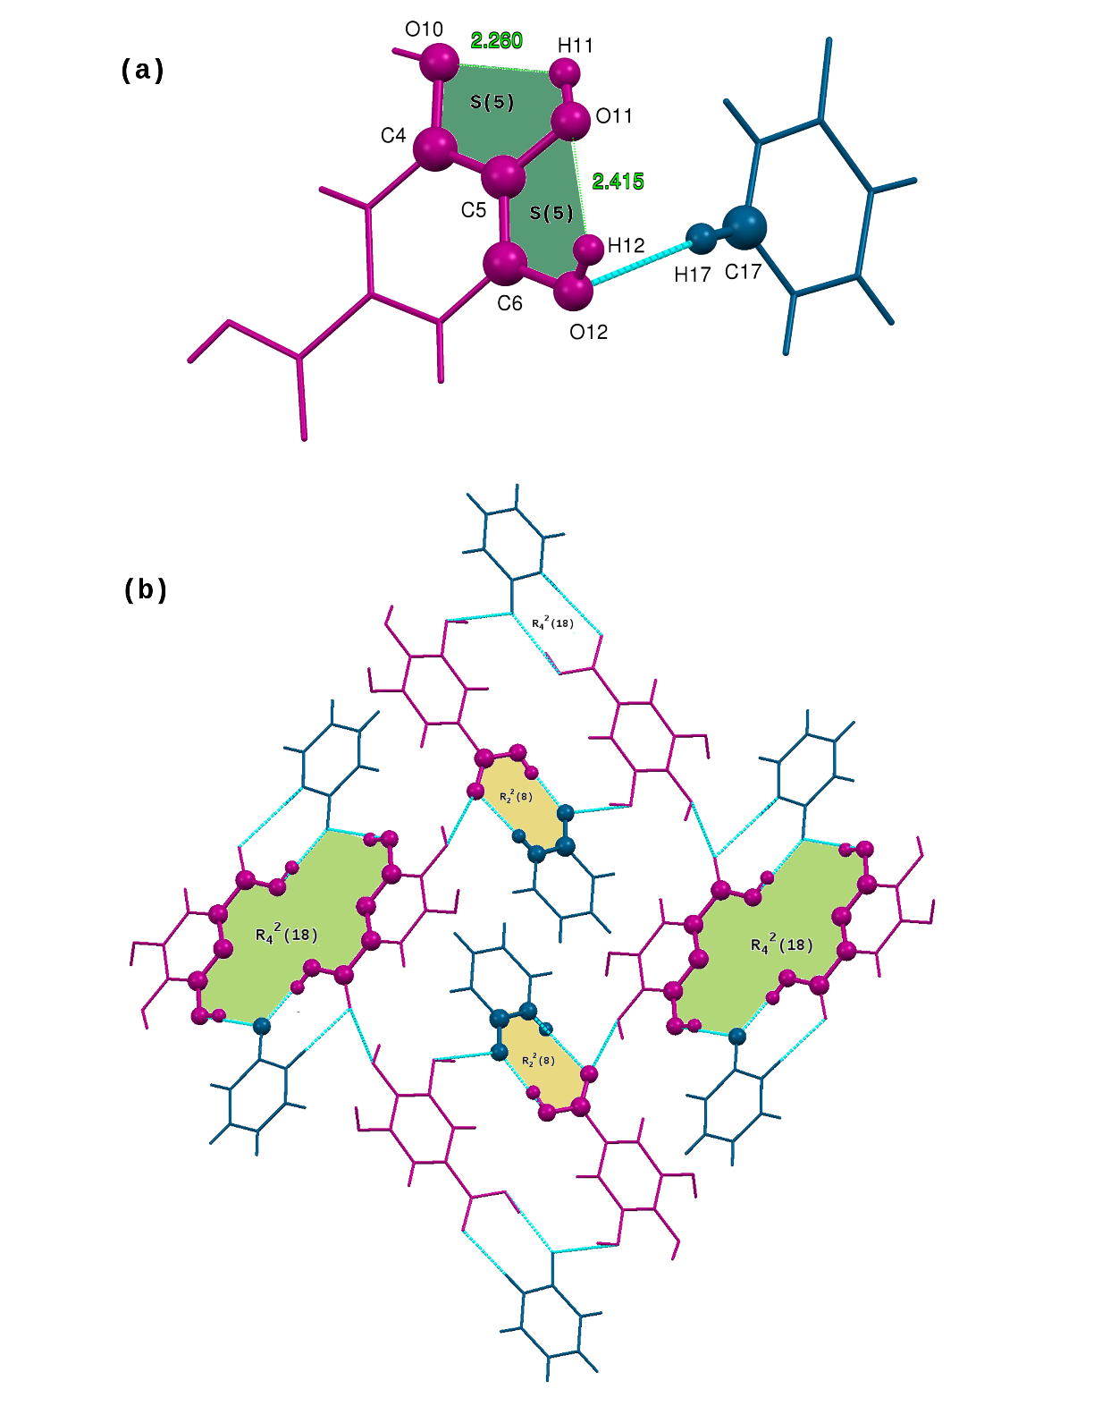
Figure S3: (a) Assymetric unit of 1:1GA-2HP molecular salt showing S(5) patterns and (b) the presence of $R_{2}^{2}\left(8\right)$ and $R_{4}^{2}\left(18\right)$ ring motifs.

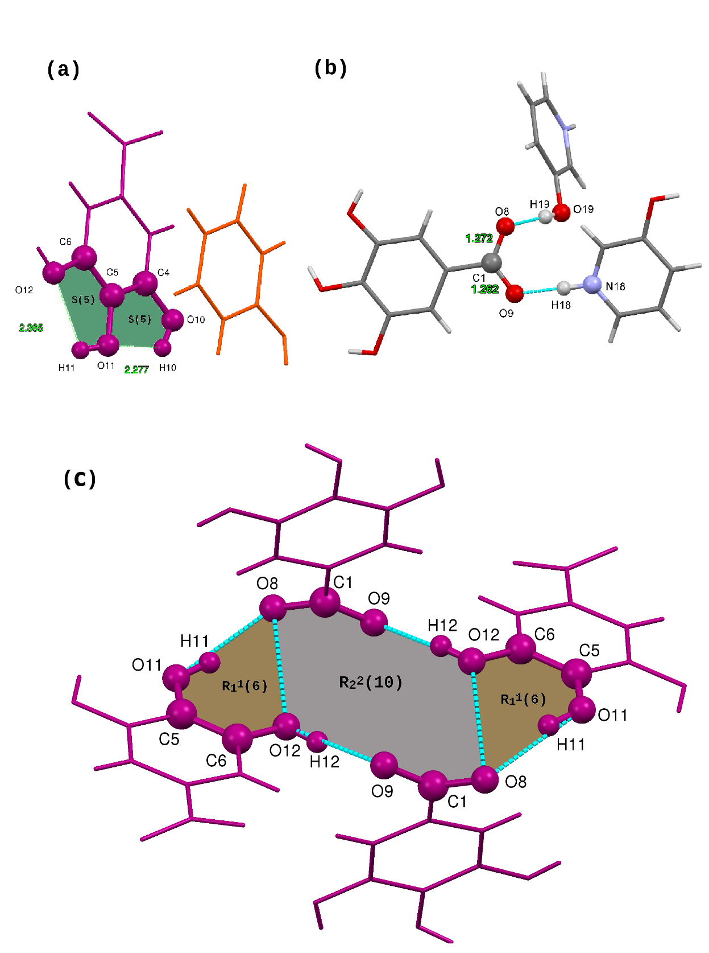
Figure.S4: (a) Assymetric unit of 1:1 GA-3HP molecular salt showing S(5) patterns, (b) highlighting the C-O bond lengths confirming the proton transfer from GA to 3HP and (c) the presence of $R_{1}^{1}\left(6\right)$ and $R_{2}^{2}\left(10\right)$ ring motifs.

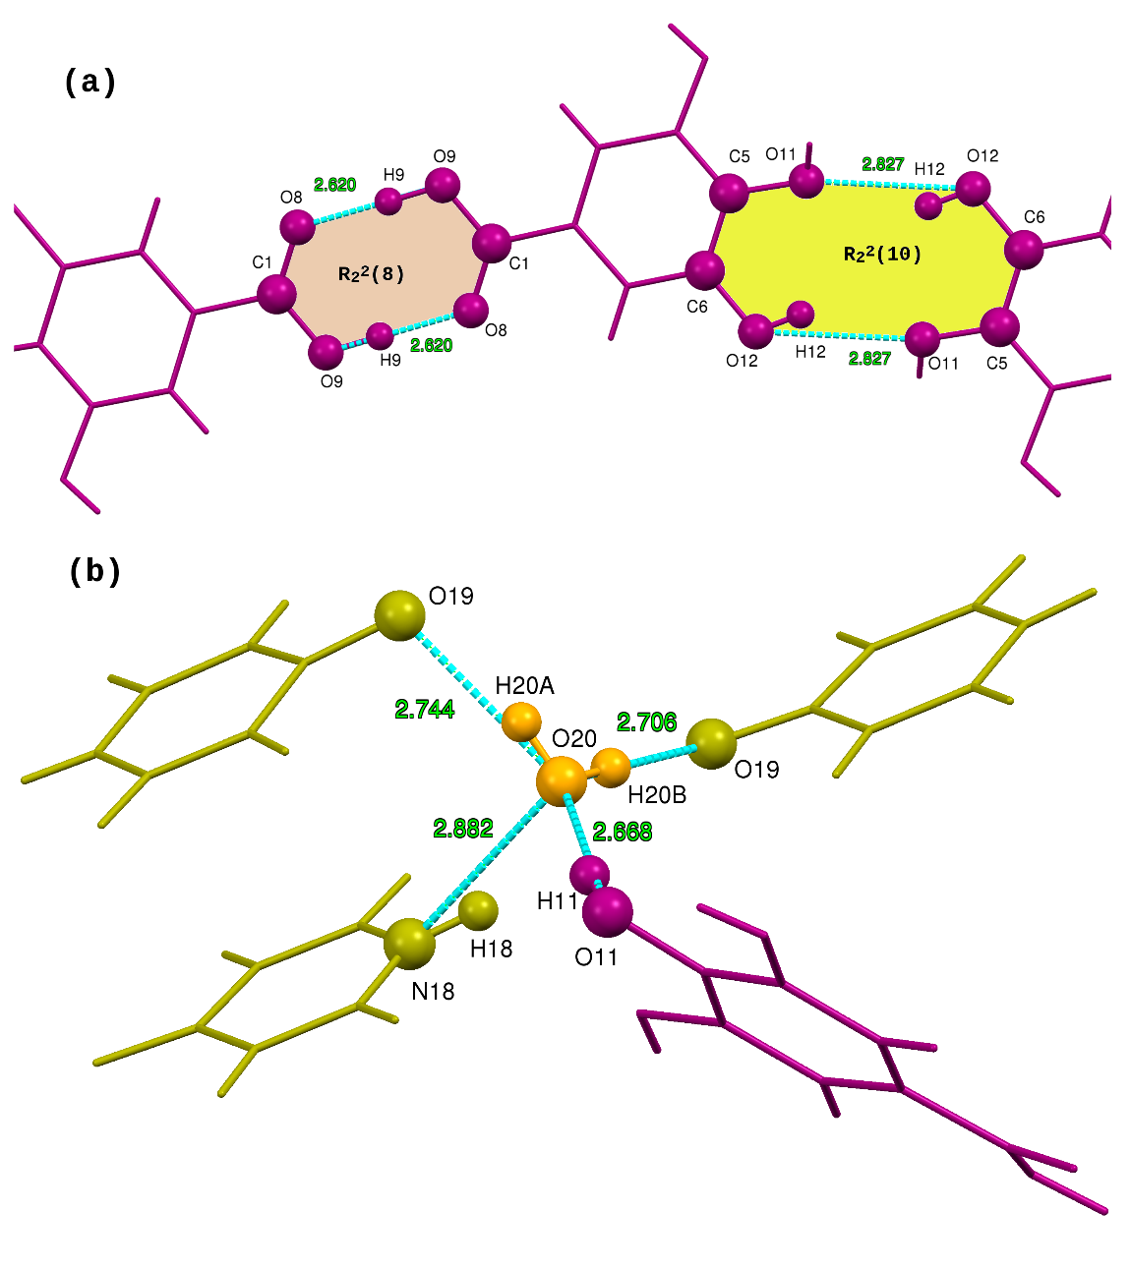
Figure S5: (a) The presence of $R_{2}^{2}\left(8\right)$ and $R_{2}^{2}\left(10\right)$ ring motifs in GA-4HP cocrystal monohydrate and (b) strong hydrogen bond DDAA environment of the water molecule.

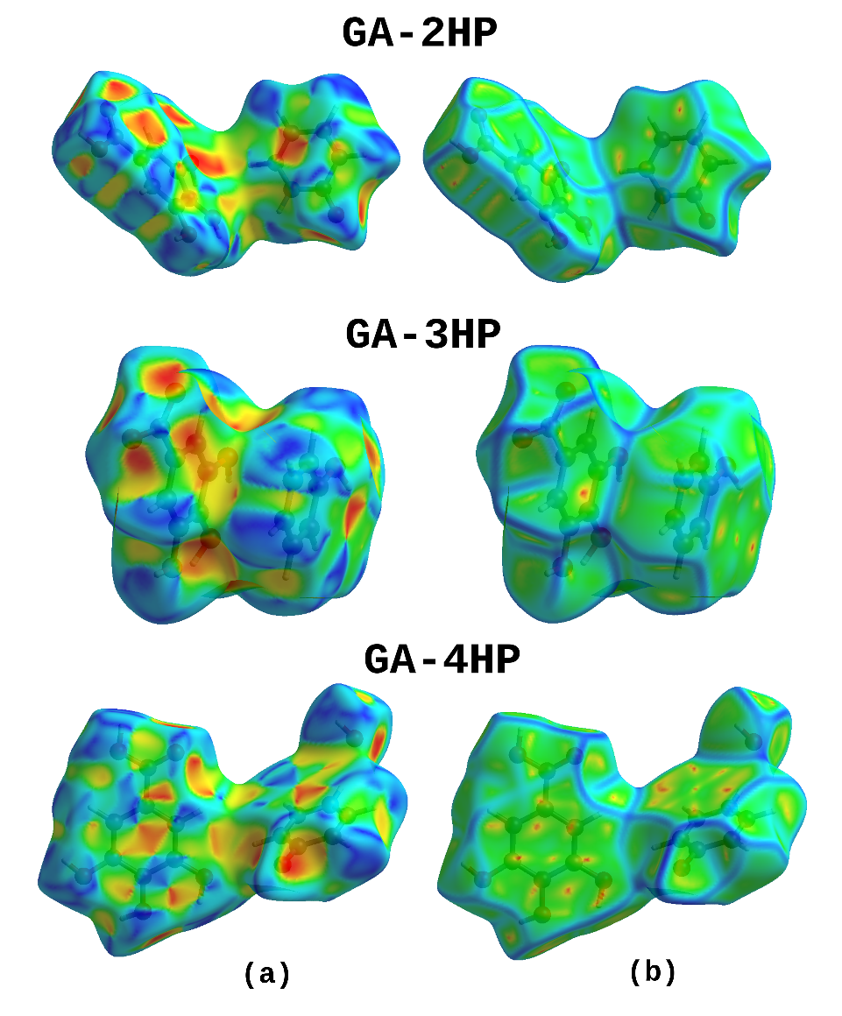
Figure S6: Views of the Hirshfeld surfaces mapped with shape index and curvedness of the three reported multicomponent crystals.
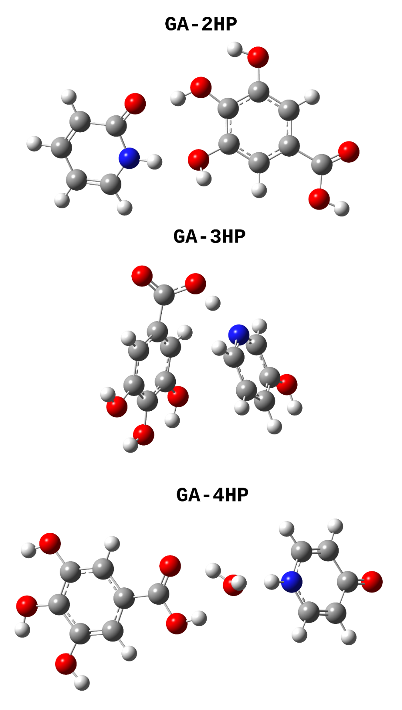
Figure S7: DFT optimized structures of (a) GA-2HP cocrystal, (b) GA-3HP molecular salt and (c) GA-4HP monohydrate cocrystal.

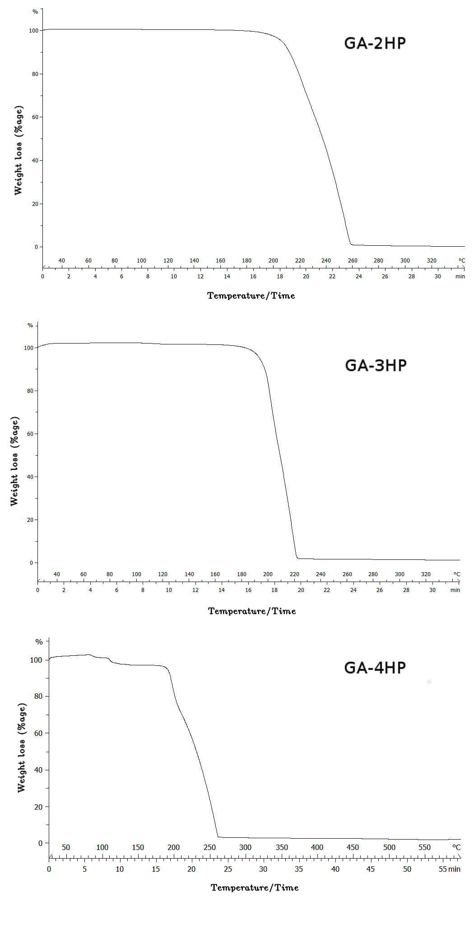
Figure S8: TGA thermograms of (a) 1:1 GA-2HP shows that the cocrystal melts at 210$°$C and decomposes at 260$°$C, (b) 1:1 GA-3HP shows that the molecular salt melts at 195$°$C and decomposes at 220$°$C and (c) 1:1 GA-4HP monohydrate cocrystal shows a weight loss of 6.36% at 100$°$C which indicates the removal of one molecule of water, it melts at 190$°$C and decomposes at 260$°$C.

