Supplementary information

Microwave irradiation assisted rapid growth of ZnO nanorods over metal coated/electrically conducting substrate
Sanjaya Brahma^{a*} S. A. Shivashankar^{a *}
ªMaterials Research Centre, Indian Institute of Science, Bangalore, 560012-India

Details about microwave irradiation experiment.

The microwave irradiation experiment is carried out in a domestic microwave oven, in other words a kitchen oven (2.45 GHz frequency, power variable from 160–800 W, time varies from few seconds to several minutes, multimode), usually used to bake food. The schematic diagram (Fig. S1) of the apparatus used in the process for the deposition of ZnO coatings is shown below. The microwave synthesis system is equipped with a reflux system placed outside the microwave oven. The precursor-surfactant solution mixture is taken in the round bottomed flask and a substrate is dipped in it. The microwave irradiation at a certain power and time yield precipitate in the solution and a coating on a substrate.
In the present experiment, Zn(II) acetylacetonate (C₁₀H₁₄O₄Zn), commonly called as Zn(acac)₂ is used as precursor that has a metal-oxygen (Zn-O) bond in the complex making it a suitable precursor for the synthesis of ZnO. In the present procedure, 1.31 g of Zn(acac)₂ is taken in a round-bottomed flask and dissolved in 40 ml of ethanol (99⋅9%, HPLC grade), and stirred for 15 min. A solution of the surfactant cetyltrimethylammonium bromide in double-distilled water is prepared (~0.728 g in 40 ml distilled water) which was then mixed with Zn(acac)₂ solution and stirred for 15 min. Then microwave is irradiated (power = 100 W) on the solution mixture for 5 min leading to the formation of precipitate in the solution and a coating on the substrate. The substrate was gently removed from the solution and washed with distilled water and acetone.
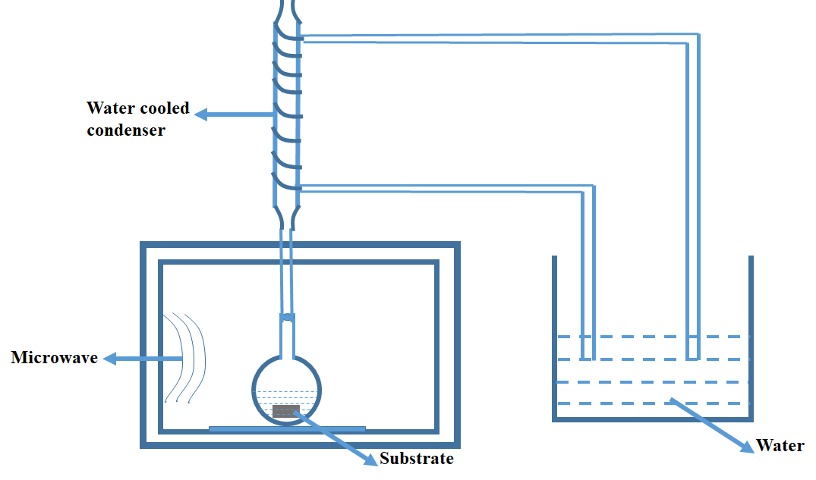

Fig. S1: Schematic diagram of the microwave reactor
Growth of ZnO nanorods over ITO/glass substrate with CTAB as the surfactant
The XRD pattern (Fig. S2) confirms the oriented growth of ZnO on ITO/glass substrate with CTAB as surfactant. However, the data obtained by using PVP as the surfactant is provided to convince that the oriented growth is possible on a conducting substrate irrespective of the surfactants used. This makes the growth process more versatile and usable.

Fig. S2: XRD pattern of ZnO nanorods grown on ITO/glass substrate (CTAB as surfactant)

