International Journal of Climatology

Supplementary Material for Review
Article Title: Regionalization of Reference Evapotranspiration using Fuzzy Dynamic Clustering Approach. Part 1: formation of Regions in India
Running Head: Regionalization of Evapotranspiration using Fuzzy Dynamic Clustering
Authors' names: Swapan Kumar Masanta¹, V. V. Srinivas^{1,2,*}
¹Department of Civil Engineering, Indian Institute of Science, Bangalore 560 012, India
²Interdisciplinary Center for Water Research (ICWaR), Indian Institute of Science,
Bangalore 560 012, India
¹Contributing author: Swapan Kumar Masanta (swapanm@iisc.ac.in)
*Corresponding author: V. V. Srinivas (vvs@iisc.ac.in); Telephone: +91-8022932641

Contents of this file
The supplementary material contains six Figures (S1 to S6).
Figure S1. Spatial variation of mean annual ET₀ (cm/year) in India.
Figure S2: Spatial variation of monthly ET₀ in India.
Figure S3. Inter-site (inter-grid) cross-correlation of monthly ET₀ for Agro-ecological regions.
Figure S4. Inter-site (inter-grid) correlation of monthly ET₀ for regions delineated using GFCM clustering methodology.
Figure S5. Monthly variation of climate variables in 18 homogeneous ET₀ regions formed using fuzzy dynamic clustering (MTFC) methodology.
Figure S6. Monthly variation of actual evapotranspiration (ET_{a}) in 30 homogeneous ET_{a} regions of India formed using fuzzy dynamic clustering (MTFC) method.

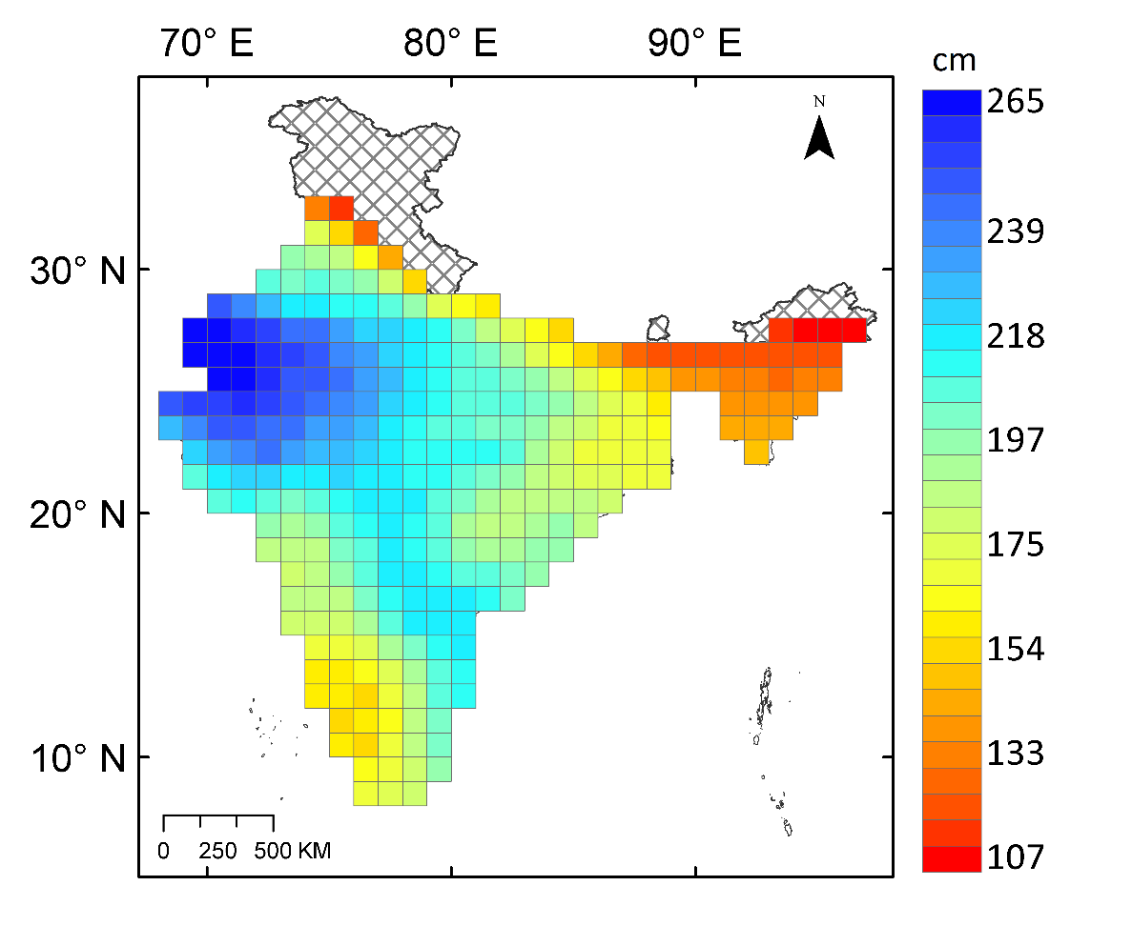

Figure S1. Spatial variation of mean annual ET₀ (cm/year) in India.

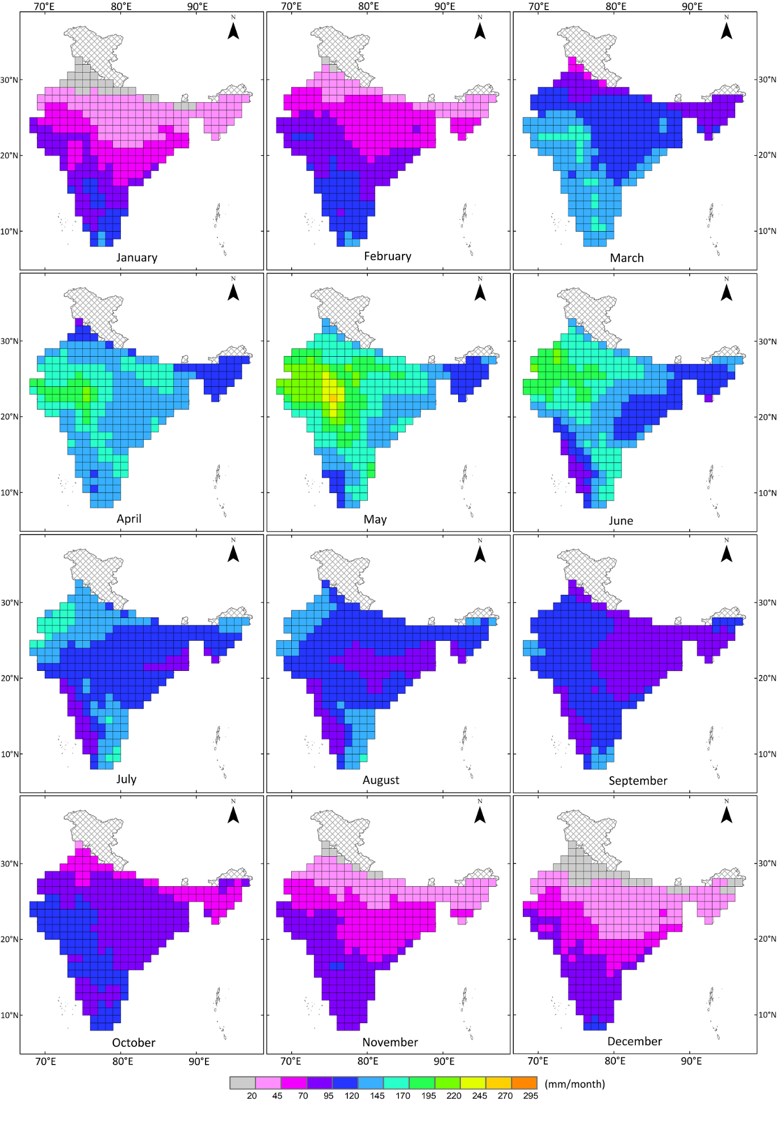
Figure S2: Spatial variation of monthly ET₀ in India.
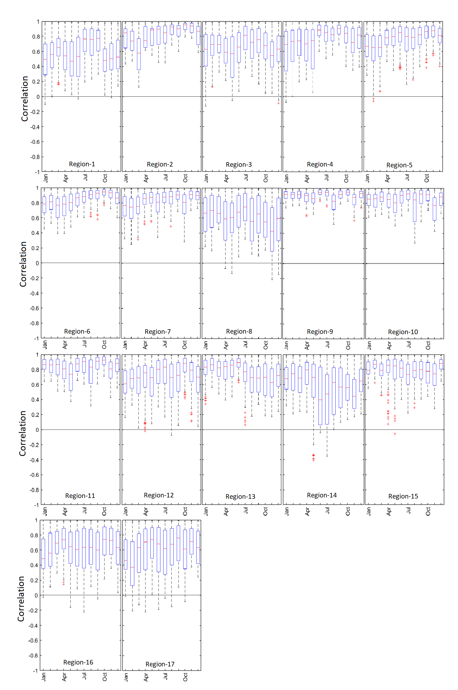Figure S3. Inter-site (inter-grid) cross-correlation of monthly ET₀ for Agro-ecological regions.

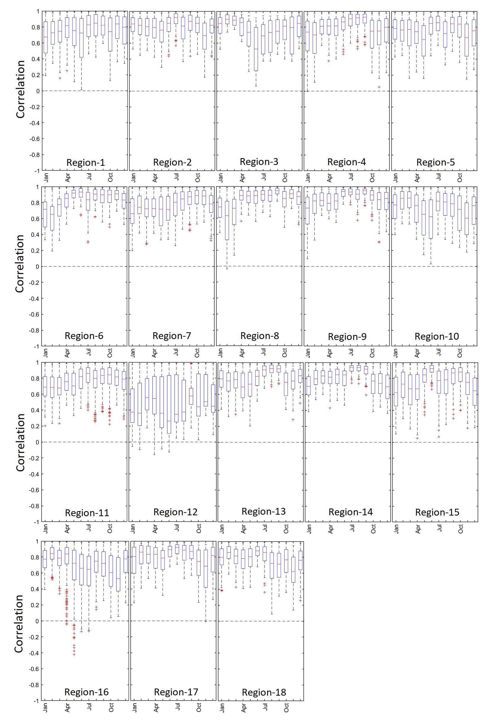Figure S4. Inter-site (inter-grid) correlation of monthly ET₀ for regions delineated using GFCM clustering methodology.

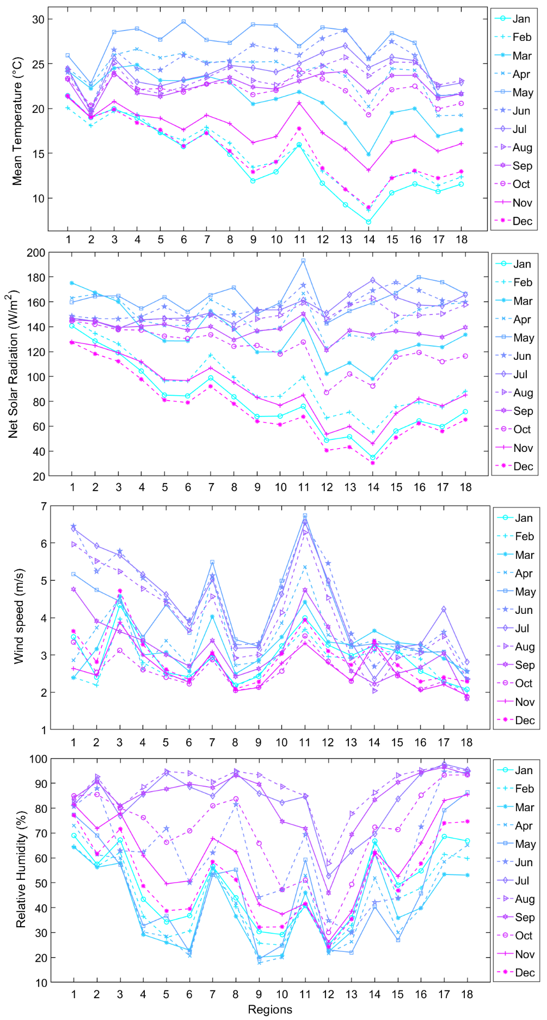
Figure S5. Monthly variation of climate variables in 18 homogeneous ET₀ regions formed using fuzzy dynamic clustering (MTFC) methodology.

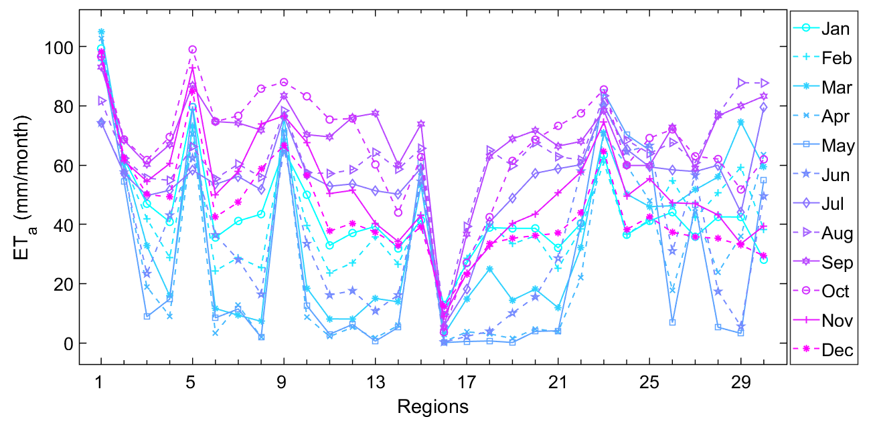
Figure S6. Monthly variation of actual evapotranspiration (ET_{a}) in 30 homogeneous ET_{a} regions of India formed using fuzzy dynamic clustering (MTFC) method.

