Supplementary Materials for

Nanoforest of 3C-SiC/graphene by laser chemical vapor deposition with high electrochemical performance
Qingyun SUN¹, Rong TU¹, Qingfang XU¹, Jun LI², Hitoshi OHMORI³, Marina KOSINOVA⁴, Bikramjit BASU⁵, Jiasheng YAN⁶, Shusen LI⁶, Song ZHANG^{1,}*, Takashi GOTO¹, Lianmeng ZHANG¹
¹ State Key Laboratory of Advanced Technology for Materials Synthesis and
Processing, Wuhan University of Technology, 122 Luoshi Road, Wuhan 430070, China
² National Key Laboratory for Shock Wave and Detonation Physics, Institute of Fluid
Physics, P.O. Box 919-102, Minyan, 621900, China
³ Institute of Physical and Chemical Research, 2-1 Hirosawa, Wako, Saitama
351-0198, Japan
⁴ Nikolaev Institute of Inorganic Chemistry, Russian Academy of Sciences Siberian
Branch, 3 Acad. Lavrerntiev Pr. Novosibirsk, 630090, Russia
⁵ Centre for BioSystems Science and Engineering, Indian Institute of Science, Bangalore 560012, Karnataka, India
⁶ Tech Semiconductors, LTD., No.162 Shengli Street, Xiangyan, 441021, China
*Corresponding author, Song ZHANG: Tel/Fax: +86-27-87499409;
E-mail: kobe@whut.edu.cn

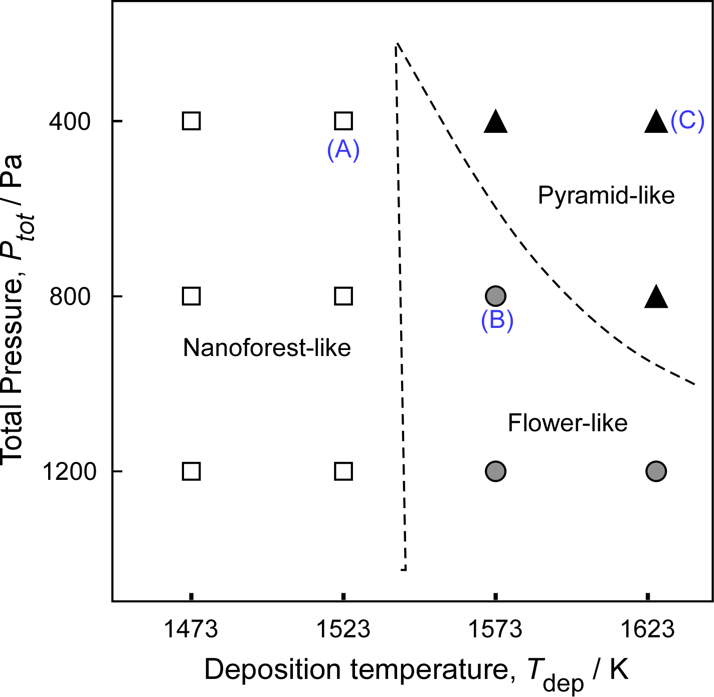
Fig. S1. Effects of T_{dep} and P_{tot} on the morphologies of films prepared by LCVD.
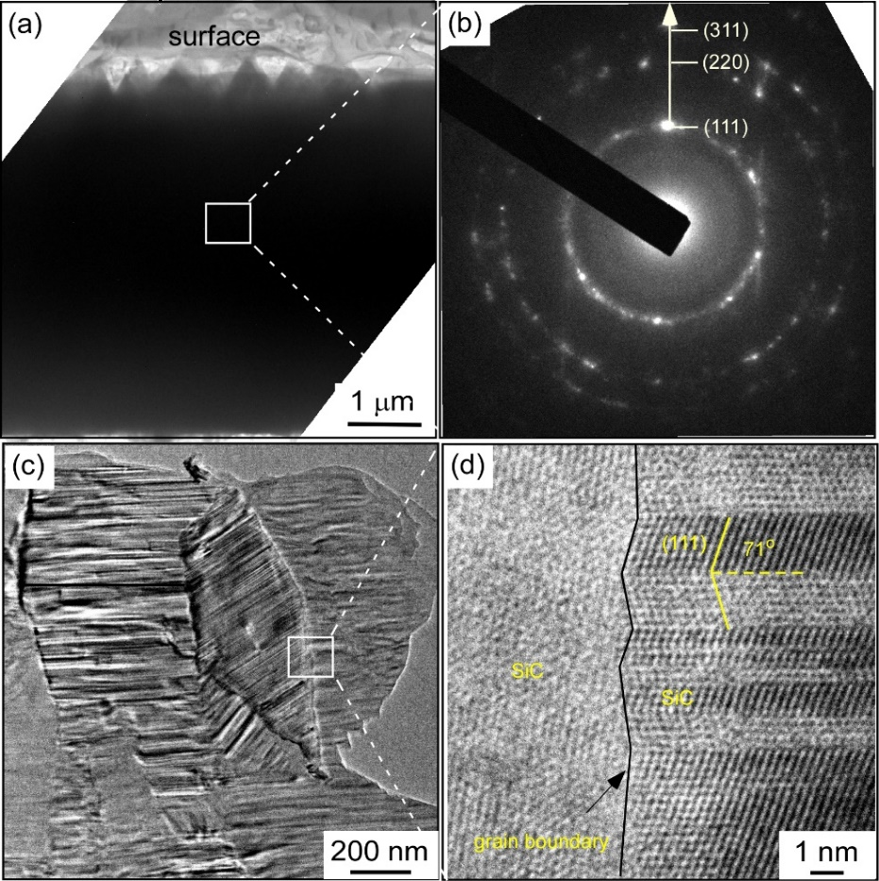
Fig. S2. TEM observations of the pyramid-like 3C-SiC films deposited at T_{dep} = 1623 K and P_{tot} = 400 Pa.
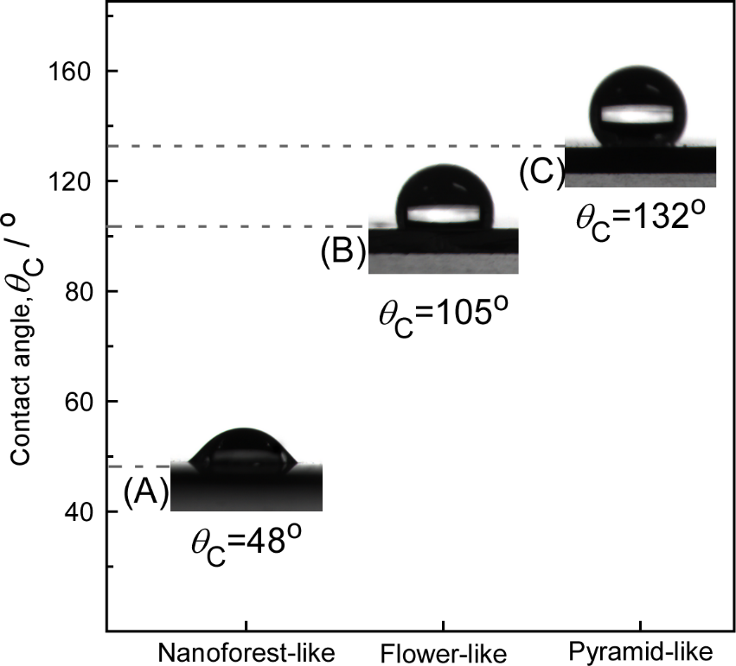
Fig. S3. Wettability of the films with different morphologies deposited at different T_{dep} and P_{tot}. (A): Nanoforest-like films deposited at T_{dep} = 1523 K and P_{tot} = 400 Pa. (B): Flower-like films deposited at T_{dep} = 1573 K and P_{tot} = 800 Pa. (C): Pyramid-like films deposited at T_{dep} = 1623 K and P_{tot} = 400 Pa.

