Supporting Information

**Transferrin conjugates of antitubercular drug isoniazid: Synthesis and in Vitro efficacy**

*Yogesh B. Sutar1, Jaishree K. Mali1, Vikas N. Telvekar1*, Raju S. Rajmani2, Amit Singh2*

1 Department of Pharmaceutical Sciences and Technology, Institute of Chemical Technology, Mumbai 400 019, India.

2 Biosafety Level-3 Laboratory, Centre for Infectious Disease Research, Indian Institute of Science, Bangalore 560 012, India

**\*Corresponding author:** Vikas N. Telvekar**,** Pharmaceutical Technology Research Lab,Department of Pharmaceutical Sciences and Technology, Institute of Chemical Technology, Mumbai 400 019, India. Email: [vikastelvekar@rediffmail.com](mailto:vikastelvekar@rediffmail.com).

Contents

1. General information 2
2. Spectroscopic data 2
3. Reference 2
4. FTIR, 1H, 13C NMR spectra, Calibration curve (TNBS assay), and

mass spectra 3-7

**1. GENERAL INFORMATION:**

FTIR spectroscopy of INH, IH, IG, Tf-IH, and Tf-IG was recorded on FTIR spectrophotometer (Perkin Elmer FT-IR, Spectrum Two L160000A). For that, the samples were mixed with 200 mg of previously dried KBr powder and pelleted into a KBr disc using hydraulic pressure. Further, the analysis was performed between 4000 and 500 cm-1.

NMR spectra were recorded at Department of Pharmaceutical Sciences and Technology, Institute of Chemical Technology, Mumbai. NMR 1H and 13C spectra were recorded at 400 MHz and 101 MHz Agilent Technology NMR spectrometer respectively. The chemical shifts are expressed in ppm relative to tetramethylsilane (TMS) as internal reference. Chemical shifts are expressed in ppm (δ-scale) and coupling constants (*J*) in Hz. Splitting patterns are described as singlet (s), doublet (d), triplet (t), quartet (q), and multiplet (m).

MALDI-TOF was recorded at Biosciences & Bioengineering, Indian Institute of Technology Bombay.

**2. SPECTROSCOPIC DATA**

**Isonicotinoylhydrazonoacetic acid (2)**1



White solid; Yield: 92%; 1H NMR (400 MHz, DMSO) δ 12.38 (s, 1H), 8.73 (d, *J* = 36.5 Hz, 2H), 7.74 (d, *J* = 25.3 Hz, 2H), 7.39 (s, 1H), 5.72 (s, 1H); 13C NMR (101 MHz, DMSO) δ 164.89 (s), 162.93 (s), 150.88 (s), 140.45 (s), 140.05 (s), 122.02 (s). HRMS-ESI calculated 193.1; found 193.1

**Isonicotinoylhydrazinyl-5-oxopentanoic acid (3)**



White solid; Yield: 90%;1H NMR (400 MHz, DMSO) δ 12.03 (s, 1H), 10.58 (s, 1H), 9.96 (s, 1H), 8.73 (d, *J* = 5.1 Hz, 2H), 7.73 (d, *J* = 5.6 Hz, 2H), 2.28-2.19 (dt, *J* = 23.3, 7.2 Hz, 4H), 1.78 – 1.70 (m, 2H); 13C NMR (101 MHz, DMSO) δ 174.55 (s), 171.52 (s), 164.38 (s), 150.83 (s), 139.87 (s), 121.71 (s), 33.18 (s), 32.77 (s), 20.87 (s). HRMS-ESI calculated 251.09; found 251.09

**3. REFERENCE**

Kata H., Gábor M., Nóra S.,Ferenc H., Szilvia B. (2009) Peptide conjugates of therapeutically used antitubercular isoniazid-design, synthesis and antimycobacterial effect. *J. Pept. Sci.* *15 (5)*, 385–391.

**4. FTIR, 1H, 13C NMR SPECTRA, CALIBRATION CURVE (TNBS ASSAY), AND MASS SPECTRA**

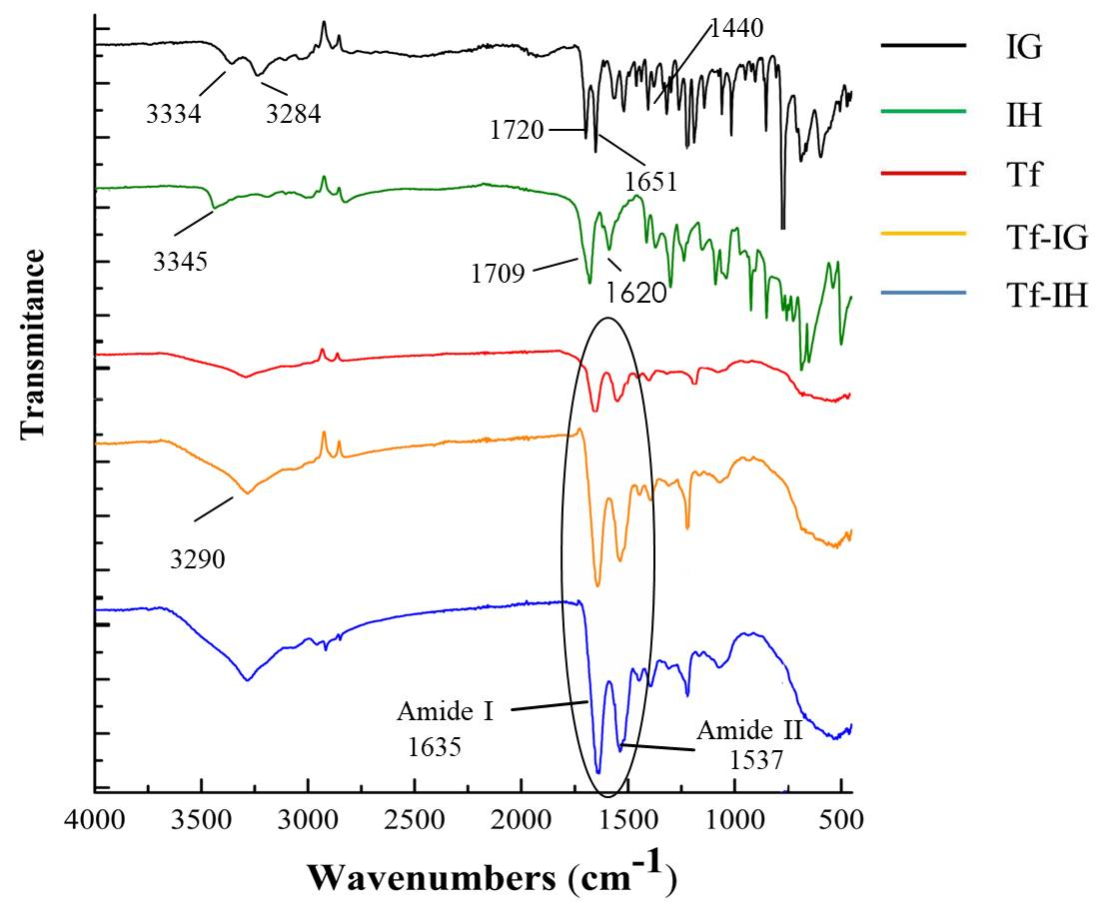

Figure S1: FTIR spectra of IG, IH, Tf, Tf-IG, and Tf-IH

D:\Yogesh\Ph.D\Thesis\curcumin\tb\work\manuscript\NMR\IH 1H.tif

Figure S2. 1H NMR of Isonicotinoylhydrazono acetic acid (2) (400 MHz, DMSO)

D:\Yogesh\Ph.D\Thesis\curcumin\tb\work\manuscript\NMR\IH 13C.tif

Figure S3. 13C NMR of Isonicotinoylhydrazono acetic acid (2) (101 MHz, DMSO)

D:\Yogesh\Ph.D\Thesis\curcumin\tb\work\manuscript\NMR\IG 1H.tif

Figure S4. 1H NMR of 5-(2-isonicotinoylhydrazinyl)-5-oxopentanoic acid (3) (400 MHz, DMSO)

D:\Yogesh\Ph.D\Thesis\curcumin\tb\work\manuscript\NMR\IG 13C.tif

Figure S5. 13C NMR of 5-(2-isonicotinoylhydrazinyl)-5-oxopentanoic acid (3) (101 MHz, DMSO)

**CALIBRATION CURVE OF L-LYSINE (TNBS ASSAY):**

The standard calibration curve was plotted using various concentrations of L-lysine on a UV/Vis spectrophotometer (Shimadzu UV-2600) and showed linearity in the concentration range of 1–10 µg/mL.

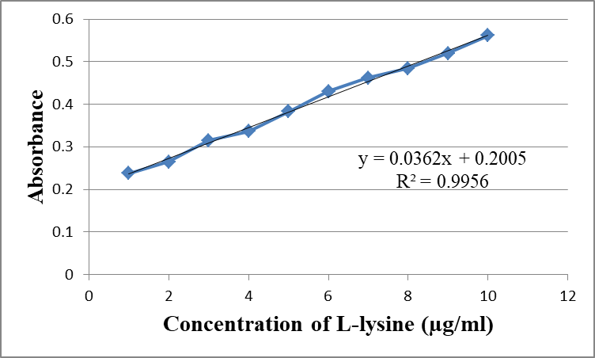

Figure S6. Calibration curve of L-lysine (TNBS assay)

**MALDI-TOF MASS SPECTRA**

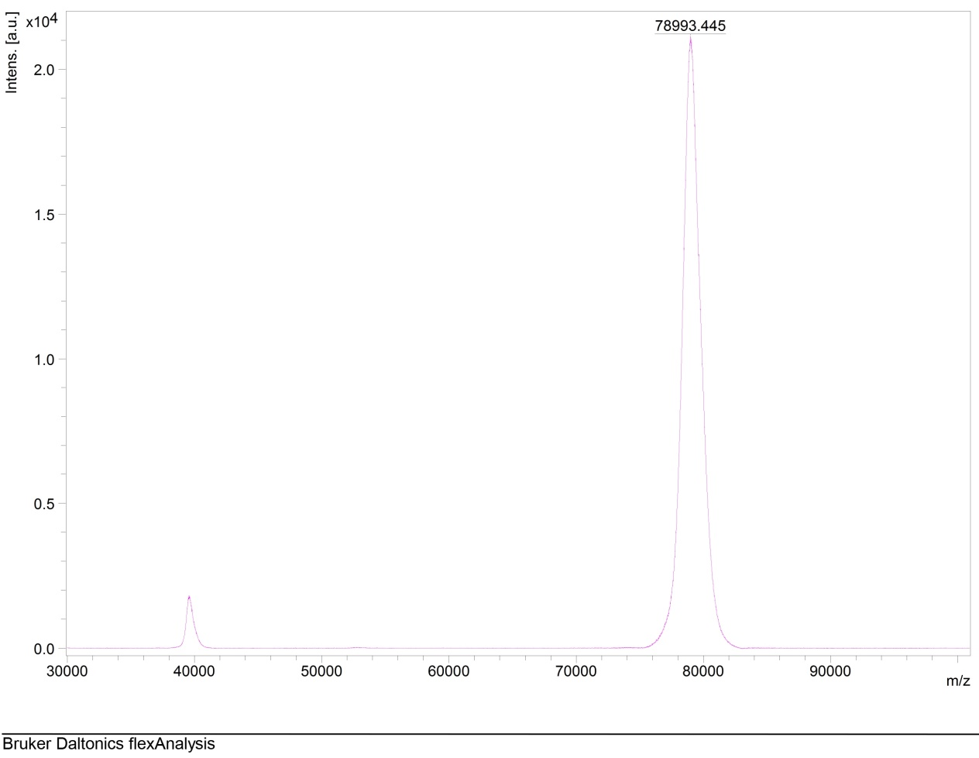

Figure S7. MALDI-TOF mass spectrum of transferrin (Tf)

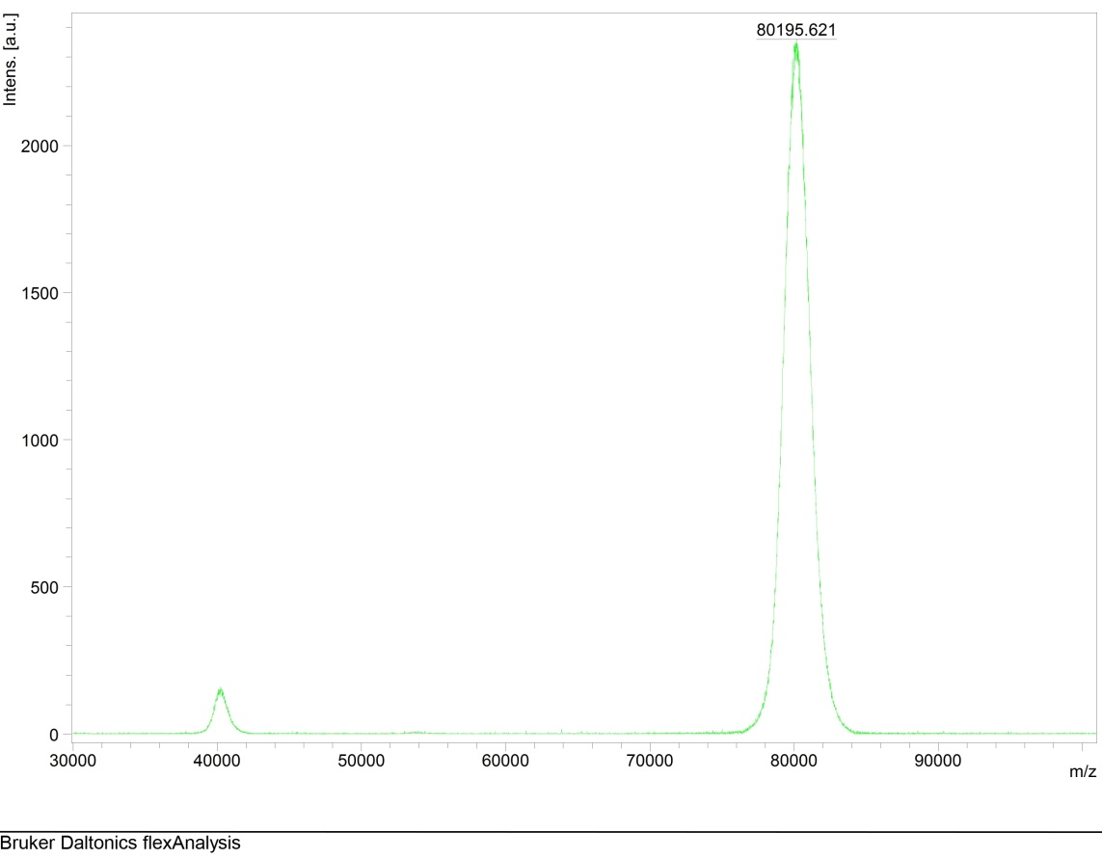

Figure S8. MALDI-TOF mass spectrum of transferrin-isonicotinoylhydrazonoacetic acid conjugate (Tf-IH) (T3)

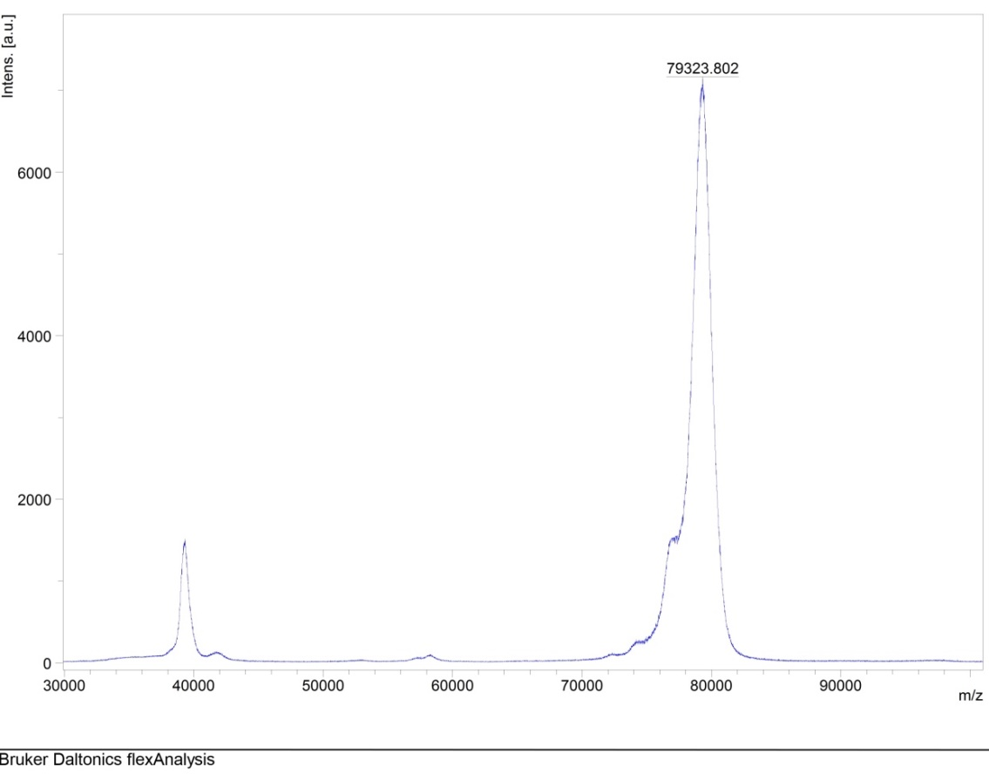

Figure S9. MALDI-TOF mass spectrum of transferrin-isonicotinoylhydrazinyl-5-oxopentanoic acid conjugate (Tf-IG) (T3)