Supporting Information: Structural determination of Enzyme-Graphene Nanocomposite Sensor Material
Durgesh K. Rai^{1*}, Manickam Gurusaran², Volker Urban^{3#}, Kiana Aran⁴, Lulu Ma⁵, Pingzuo Li⁶, Shuo Qian³, Tharangattu N. Narayanan⁷, Pulickel M. Ajayan⁵, Dorian Liepmann⁴, Kanagaraj Sekar⁸, María-Efigenia Álvarez-Cao⁹, Juan-José Escuder-Rodríguez⁹, María-Esperanza Cerdán⁹, María-Isabel González-Siso⁹, Sowmya Viswanathan¹⁰, Ramasamy Paulmurugan¹¹, Venkatesan Renugopalakrishnan^{6,12,‡}

¹Cornell High Energy Synchrotron Source, Cornell University, Ithaca, New York-14853, USA
²Institute for Cell and Molecular Biosciences, Newcastle University, Newcastle upon Tyne-NE1 7RU, UK
³Neutron Scattering Division, Oak Ridge National Laboratory, Oak Ridge, Tennessee-37831, USA
⁴Department of Bioengineering, University of California, Berkeley, Berkeley, California-94709, USA
⁵Department of Mechanical Engineering and Materials Science, Rice University, Houston, Texas-77005, USA
⁶Center for Life Sciences, Boston Children’s Hospital, Harvard Medical School, Boston, Massachusetts-02115, USA
⁷Tata Institute of Fundamental Research – Center for Interdisciplinary Sciences, Hyderabad-500107, India
⁸Department of Computational and Data Sciences, Indian Institute of Science, Bangalore-560012, India
⁹Universidade da Coruña, Grupo EXPRELA, F. Ciencias & Centro de Investigacións Científicas Avanzadas (CICA) & Instituto de Investigación Biomédica A Coruña (INIBIC). A Coruña-15011, Spain
¹⁰Newton Wellesley Hospital / Partners Healthcare System, Newton, Massachusetts-02462, USA
¹¹Cellular Pathway Imaging Laboratory (CPIL), Dept. of Radiology, Stanford University School of Medicine, 3155 Porter Drive, Suite 2236, Palo Alto, California-94304, USA
¹²Department of Chemistry and Chemical Biology, Northeastern University, Boston, Massachusetts-02115, USA

*Email: dkr42@cornell.edu
#Email: urbanvs@ornl.gov
‡Email: v.renugopalakrishnan@northeastern.edu
Inspired by Varun, Suraj

Supporting Figures:

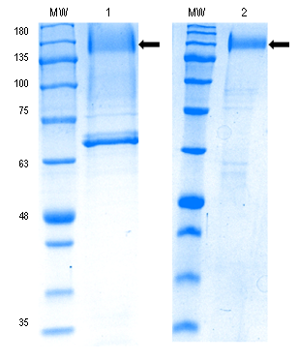

Figure S1: Coomassie blue stained SDS-PAGE analysis of the Aspergillus niger glucose oxidase. Protein is highly glycosylated and migrates as a broad band indicated by an arrow. Lane 1, Medium Grade Recombinant GOx (produced by Klyuveromyces marxianus); lane 2, High Grade Recombinant GOx (Produced by Klyuveromyces marxianus); MW, molecular-weight size marker. Each lane contains 3µg of total protein.

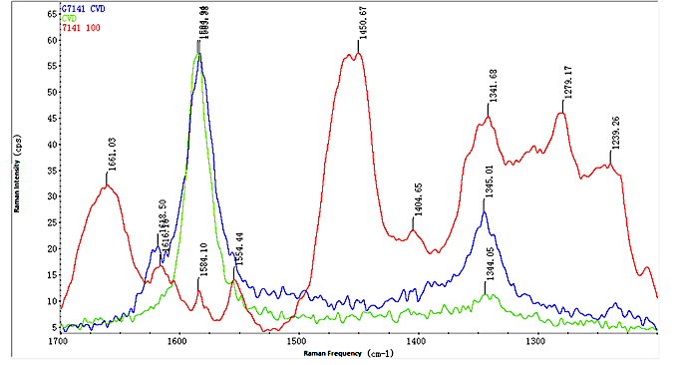

Figure S2: Raman spectrum of GOx immobilized on single layer graphene (SLG, GT141 CVD) collected at ~ pH 7 (blue), after subtraction of SLG (CVD).

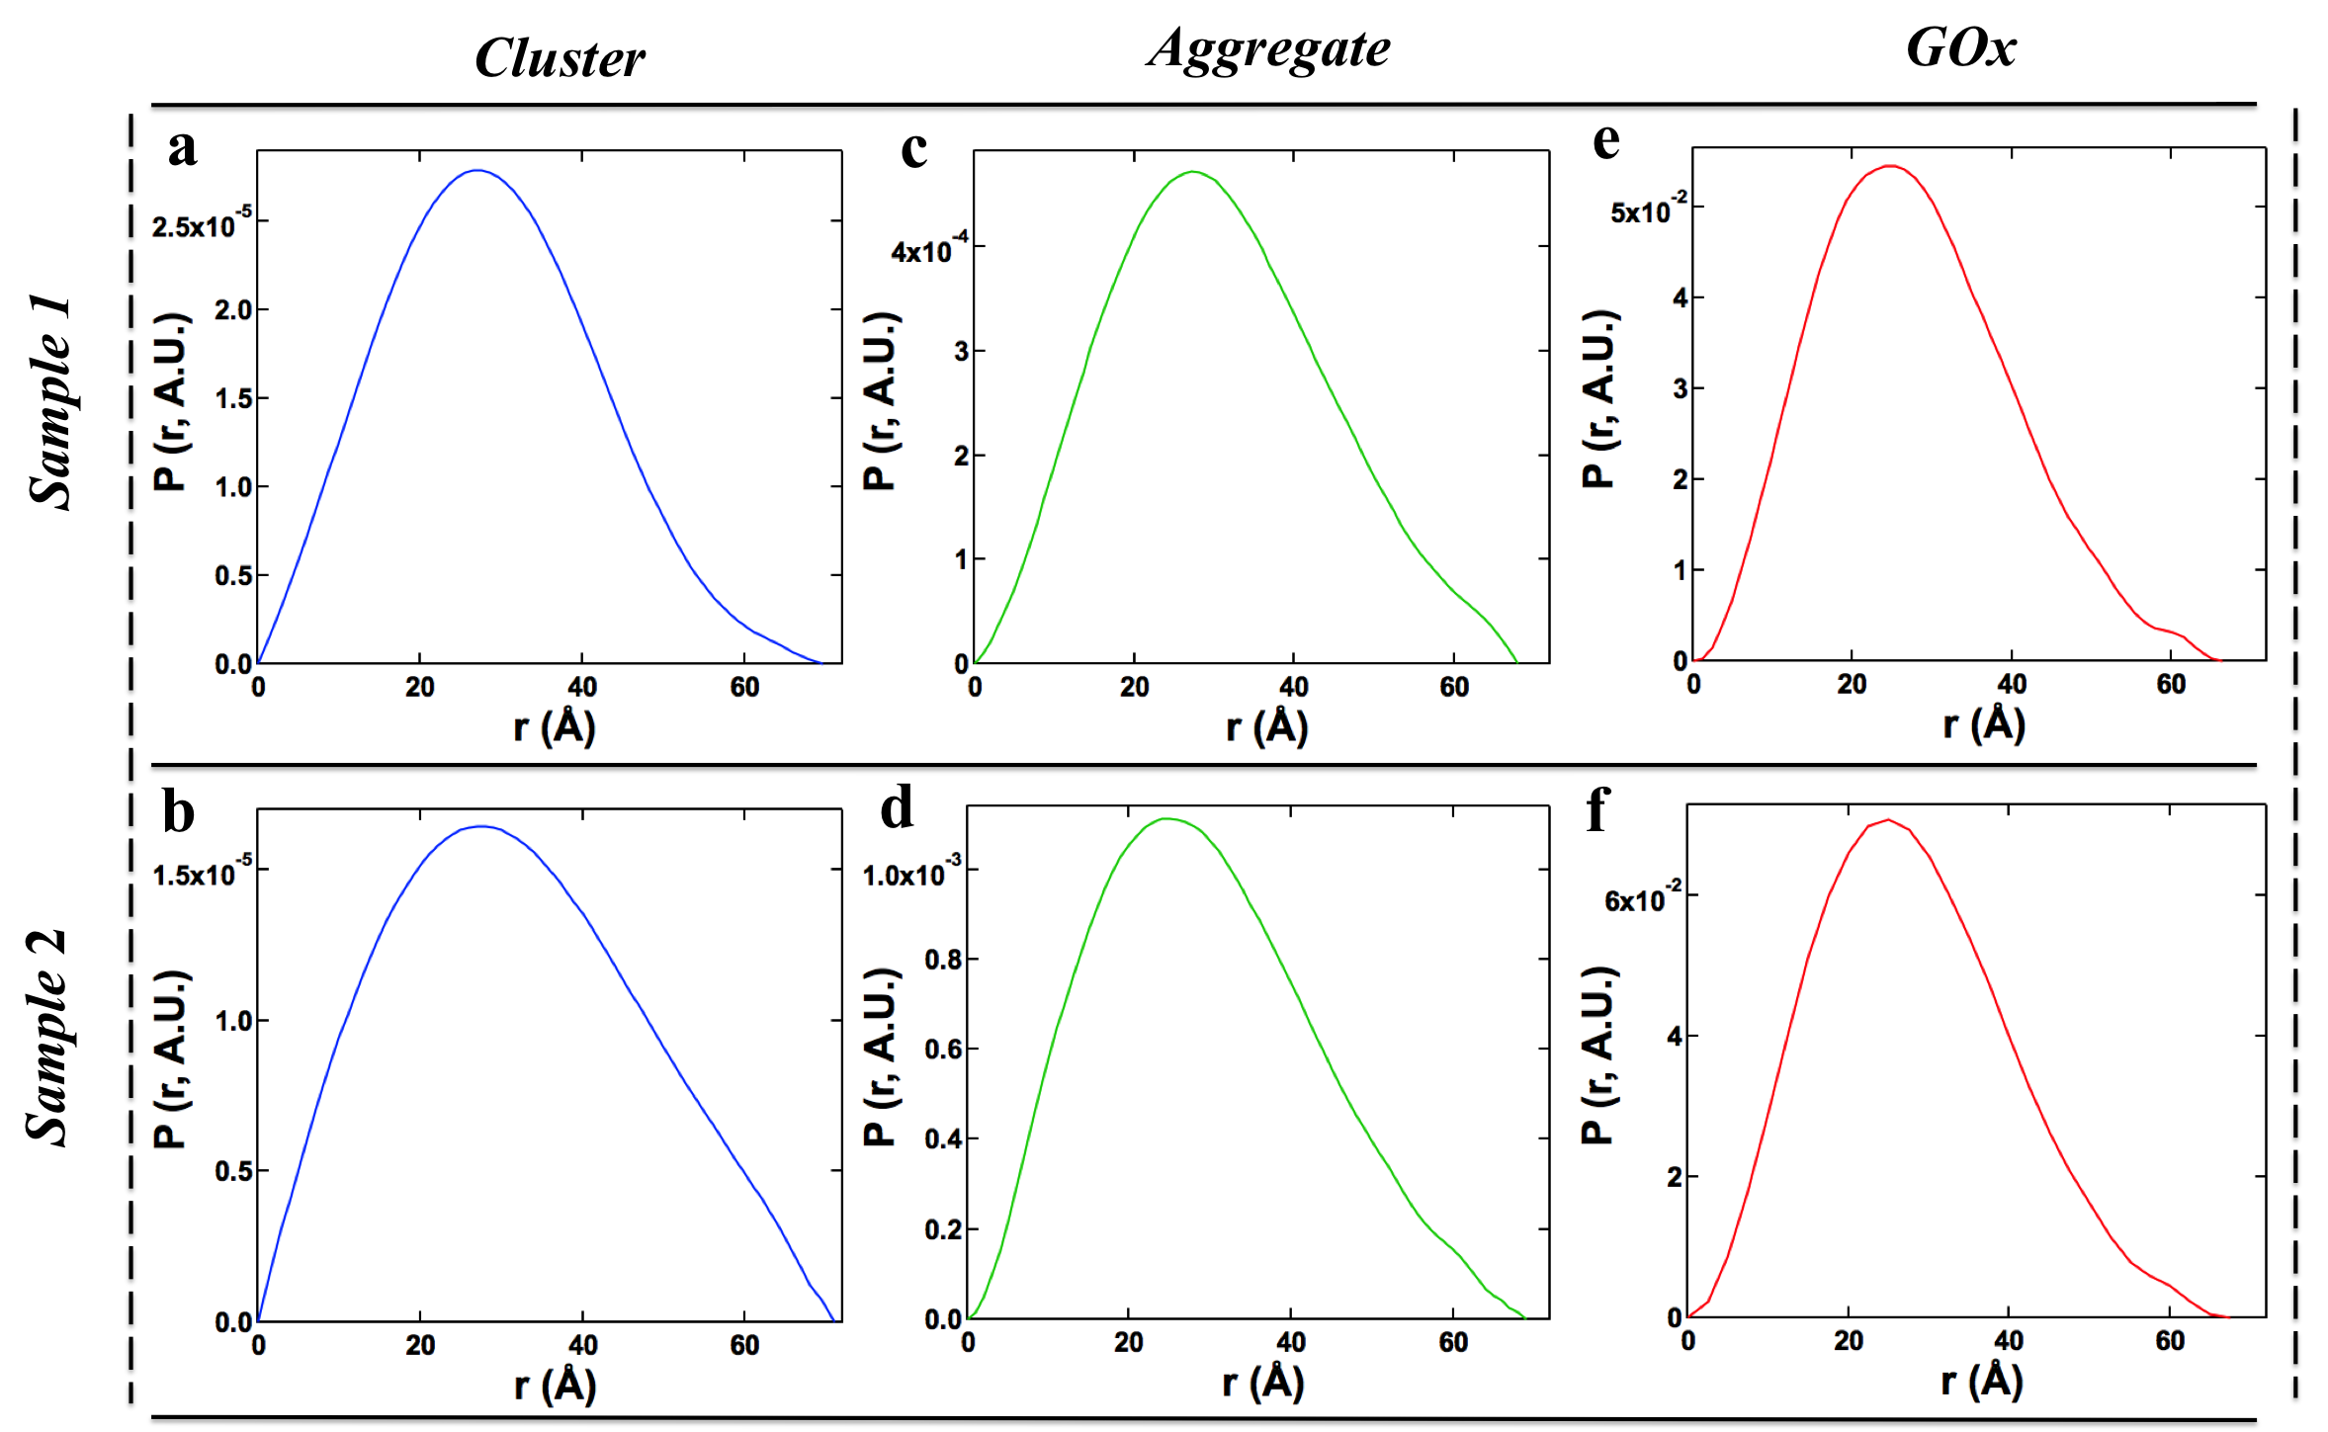

Figure S3: Probability distribution, P(r), plots using equation (12) for (a) sample 1 and (b) sample 2 GOx dimers; (c) sample 1 and (d) sample 2 aggregates and (e) sample 1 and (f) sample 2 clusters.

Table S1: Statistical details of the ab-initio modeling using ATSAS package.
Sample | Level | NSD*  (Std Deviation) | Reconstructions included by DAMAVER | Dmax (GNOM, Å) | Dmax (DAMAVER, Å)
1 | GOx | 0.58  (±0.06) | 18/20 | 69.6 | 69.2
 | Aggregate | 0.69  (±0.06) | 19/20 | 68 | 71.6
 | Cluster | 0.480  (±0.007) | 19/20 | 66.5 | 76.3
2 | GOx | 0.66  (±0.12) | 18/20 | 71 | 72.7
 | Aggregate | 0.87  (±0.04) | 18/20 | 69 | 75.7
 | Cluster | 0.488  (±0.007) | 20/20 | 67.5 | 78.7
*Normalized spatial discrepancy (NSD)

