- XRD result

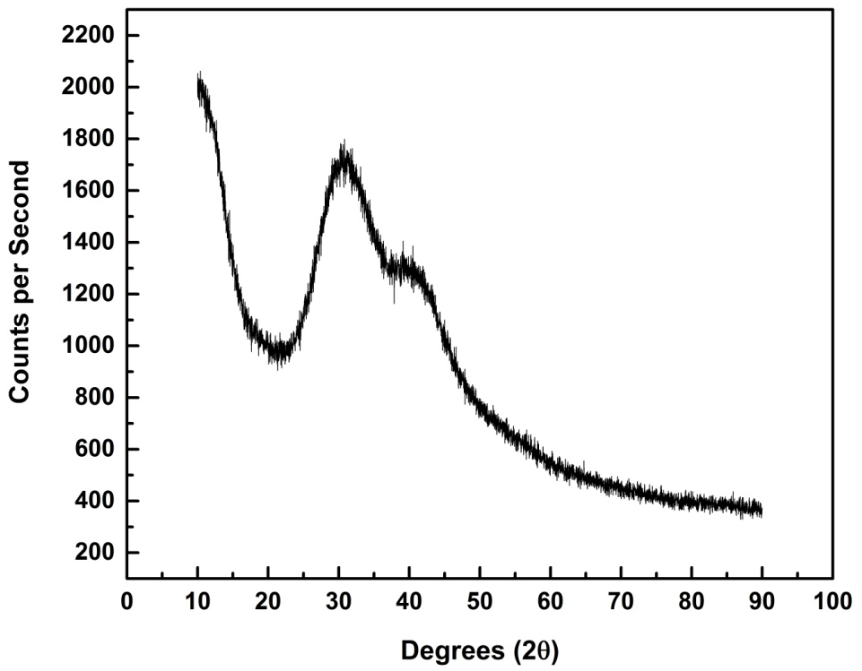

Supplementary Figure 1: XRD plot for a representative sample, S5 - (AgI)₅₀(Ag₂O)₂₅(MoO₃)₂₅

- Electrode contacts

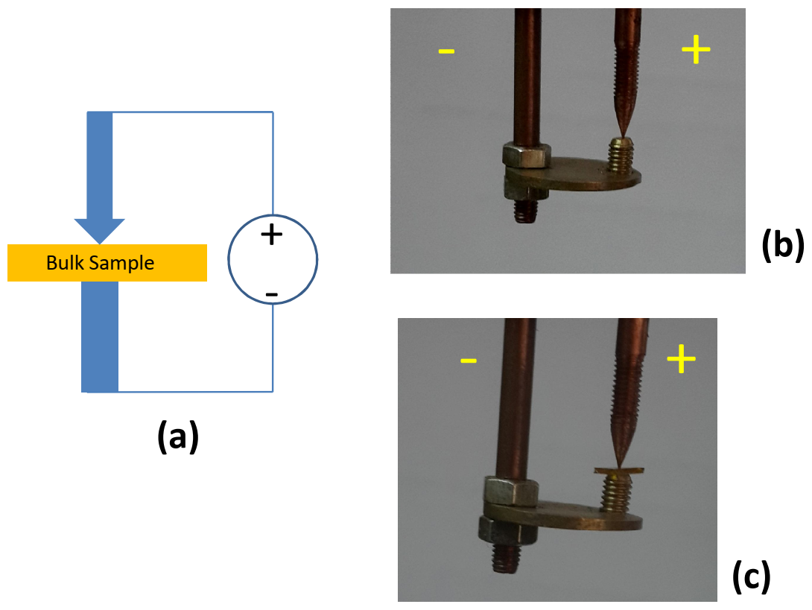

Supplementary Figure 2: (a) A schematic for electrode contacts (b) Photograph of the electrode contacts, without sample (c) Photograph of the electrode contacts with a sample in between

- EDS Result
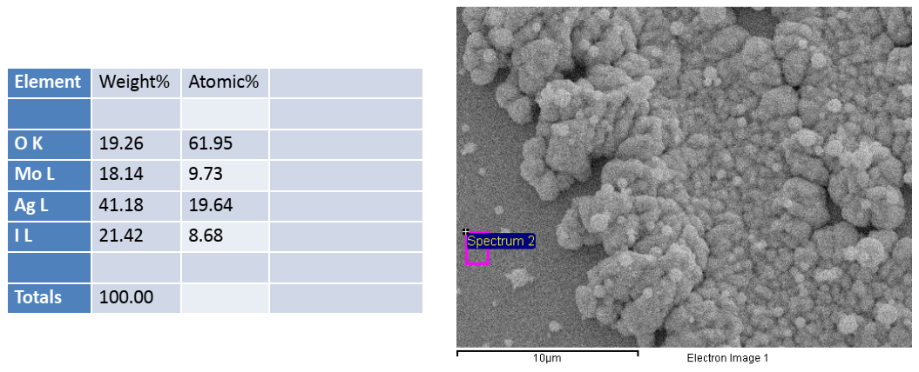
Supplementary Figure 3: EDS result for a region outside the switched part show the presence of all the constituent atoms, Ag, Mo, I and O.
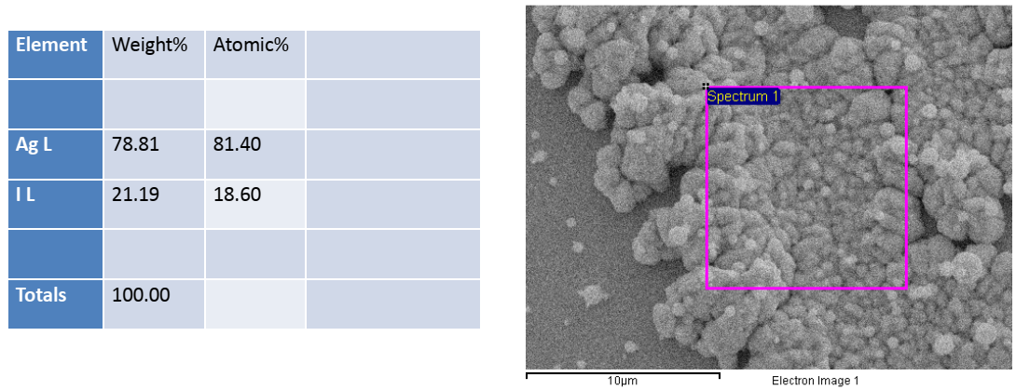
Supplementary Figure 4: EDS result for a region inside the switched part show the presence of only Ag and I

