Emerging Technologies for Antibiotic Susceptibility Testing

Bhagaban Behera¹, Anil Vishnu G K^{1,} ², Suman Chatterjee¹, V S N Sitaramgupta V¹, Niranjana Sreekumar¹, Apoorva Nagabhushan¹, Nirmala Rajendran³, Prathik B H⁴, and Hardik J Pandya^{1,*}
¹Biomedical and Electronic (10⁻⁶-10⁻⁹) Engineering Systems Laboratory,
Department of Electronic Systems Engineering,
Indian Institute of Science, Bangalore, India
²Center for BioSystems Science and Engineering,
Indian Institute of Science, Bangalore, India
³IISc Medical Center, Indian Institute of Science, Bangalore, India
⁴Indira Gandhi Institute of Child Health, Bangalore, India
*Corresponding author: E-mail: hjpandya@iisc.ac.in

Electronic Supplementary Information (ESI)

I. Statistics about recent publications
As is clear from the table, 3000+ articles on an average have been published on the topic of antibiotic or antimicrobial susceptibility testing in the last five years. This number is approximately 25-30% of the total number of publications on these topics. Among these almost 50% of the articles on phenotypic AST methods have been published in the last five years. The same is the case with “phenotypic rapid antibiotic susceptibility testing”. When it comes to microfluidics-based AST techniques almost 90% of the literature has been published in the last five years. Same is the case with “engineering technologies” for AST. These statistics are also graphically potrayed in Figures S1-S8 which show the list of publications for different search key words from year 2000 to 2019. This shows the dynamic nature of this field and the merit for a review article on emerging technologies for AST profiling with focus on phenotypic methods and rapid systems. Majority of the research articles related to AST are from journals such as Biosensor and Bioelectronics, Lab on Chip, Analytical chemistry, and PLoS One.
Keywords searched | Number of publications in different databases
 | PubMed (*) | Web of Science (*)
antibiotic susceptibility testing | 11217 (3624) | 14508 (3228)
antimicrobial susceptibility testing | 14208 (4598) | 8710 (3228)
genotypic antibiotic susceptibility testing | 1114 (524) | 458 (205)
phenotypic antibiotic susceptibility testing | 949 (508) | 1,105 (537)
emerging antibiotic susceptibility testing | 482 (238) | 843 (335)
engineering technologies antibiotic susceptibility testing | 73 (66) | 3 (2)
rapid antibiotic susceptibility testing | 1494 (555) | 1228 (488)
phenotypic rapid antibiotic susceptibility testing | 263 (148) | 192 (111)
genotypic rapid antibiotic susceptibility testing | 205 (107) | 54 (27)
microfluidic antibiotic susceptibility testing | 54 (42) | 43 (38)
* The number of publications in last five years

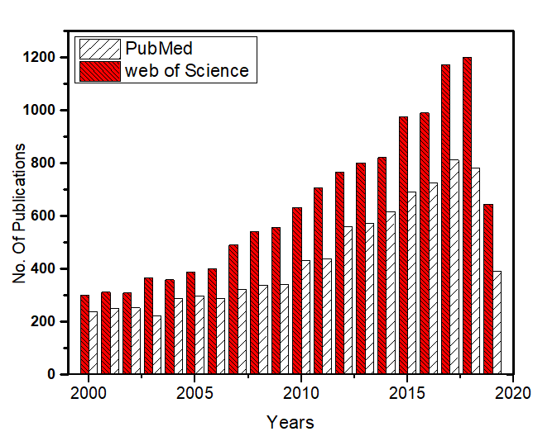
Keywords searched: antibiotic susceptibility testing
Figure-S1: Trend showing the number of publications from 2000-2019 for the key word “antibiotic susceptibility testing”

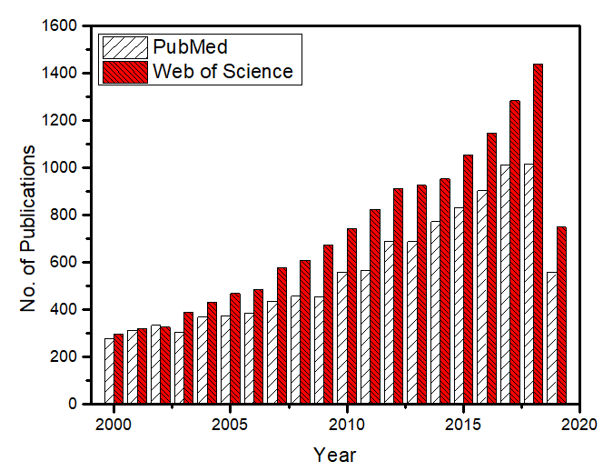
Keywords searched: antimicrobial susceptibility testing

Figure-S2: Trend showing the number of publications from 2000-2019 for the key word “antimicrobial susceptibility testing”
”

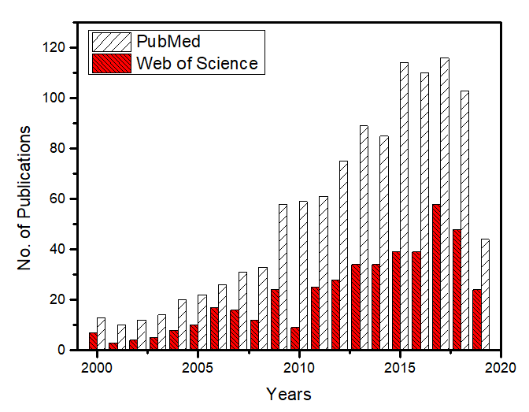
Figure-S3: Trend showing the number of publications from 2000-2019 for the key word “genotypic antibiotic susceptibility testing”

Keywords searched: genotypic antibiotic susceptibility testing

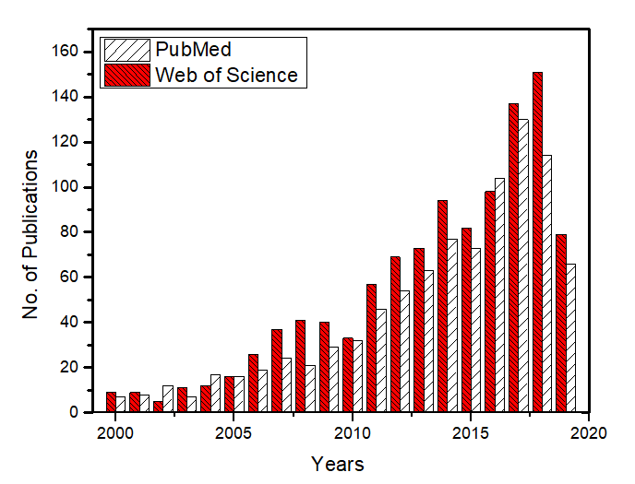
Keywords searched: phenotypic antibiotic susceptibility testing

Figure-S4: Trend showing the number of publications from 2000-2019 for the key word “phenotypic antibiotic susceptibility testing”

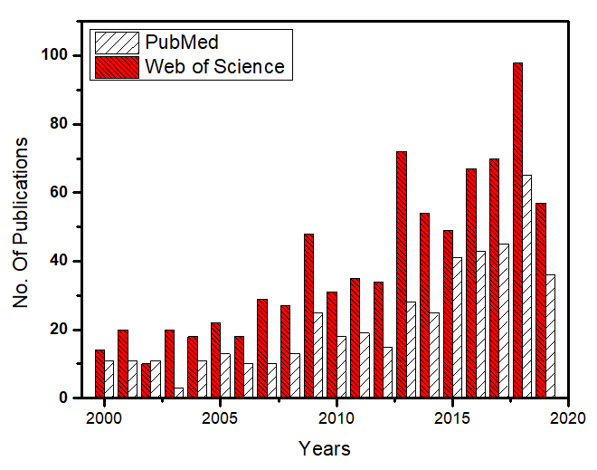
Keywords searched: emerging antibiotic susceptibility testing
Figure-S5: Trend showing the number of publications from 2000-2019 for the key word “emerging antibiotic susceptibility testing”

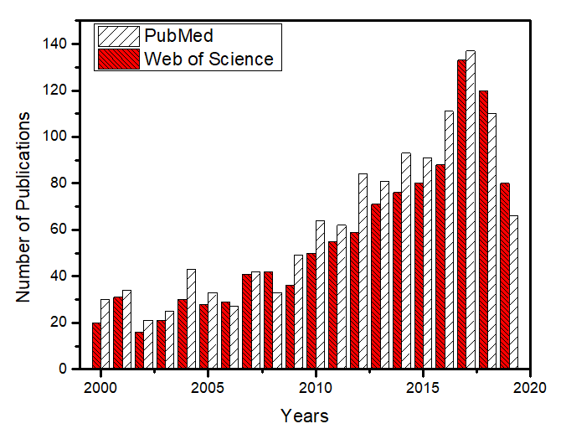
Keywords searched: rapid antibiotic susceptibility testing

Figure-S6: Trend showing the number of publications from 2000-2019 for the key word “rapid antibiotic susceptibility testing”

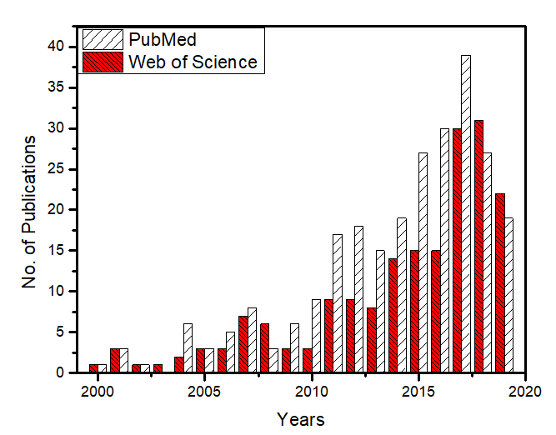
Figure-S7: Trend showing the number of publications from 2000-2019 for the key word “phenotypic rapid antibiotic susceptibility testing”

Keywords searched: phenotypic rapid antibiotic susceptibility testing

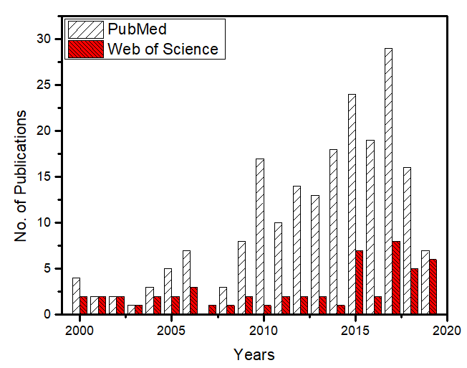

Keywords searched: genotypic rapid antibiotic susceptibility testing

Figure-S8: Trend showing the number of publications from 2000-2019 for the key word “genotypic rapid antibiotic susceptibility testing”

II. Past, present and future trends of AST
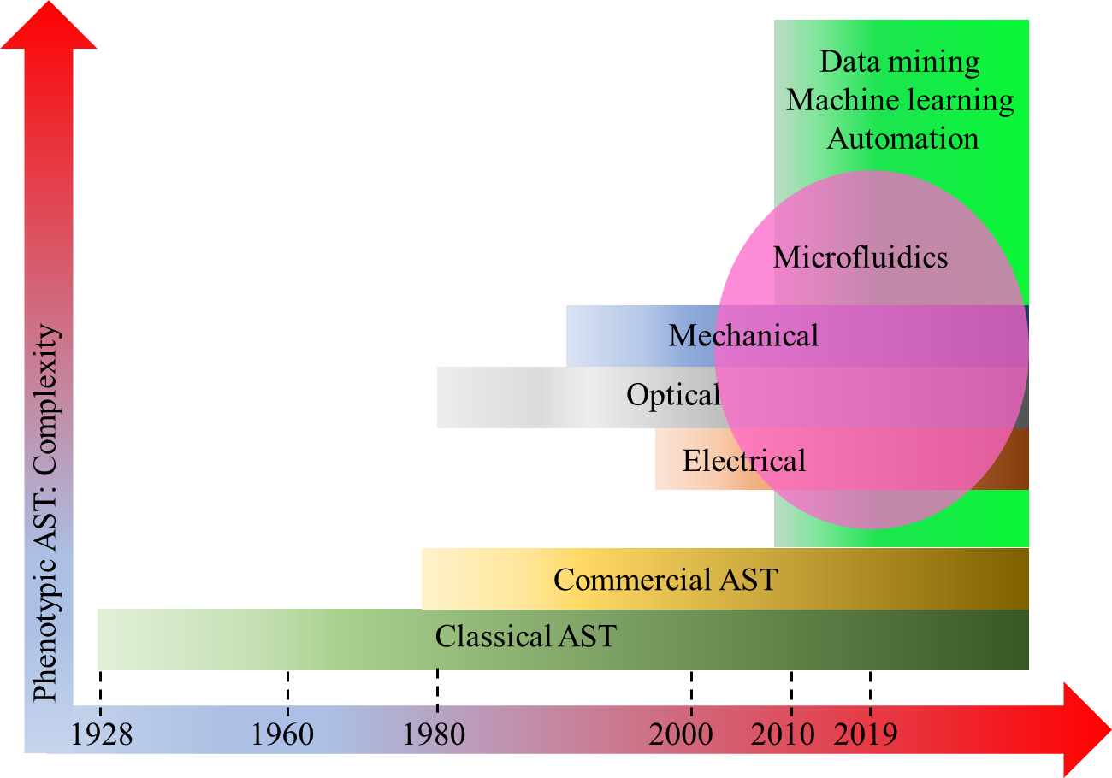
Figure- S9: Past, present and future trends of different modalities for AST profiling.

