**Water Soluble Thioglycosylated BODIPYs for Mitochondria Targeted Cytotoxicity**

Praseetha E. Kesavan,a Vijayalakshmi Pandey,a Md Kausar Raza,b Shigeki Moric and Iti Gupta*a

aIndian Institute of Technology Gandhinagar, Palaj Campus, Gandhinagar, Gujarat-382355, India.

bDepartment of Inorganic and Physical Chemistry, Indian Institute of Science, Bangalore-560012, India

cIntegrated Centre for Sciences, Ehime University, Matsuyama 790-8577, Japan

*Corresponding author, e-mail: [iti@iitgn.ac.in](mailto:iti@iitgn.ac.in)

|  |  |  |
| --- | --- | --- |
| Serial No | List of Figures | Page No. |
| 1 | **Figure 1.** Normalized absorption and emission spectra of (a) **6** and (b) **7** in methanol. | S2 |
| 2 | **Figure 2**. Flow cytometry data and DCFDA study of BODIPYs **6-9** | S2 |
| 3 | **Figure 3.** 1H NMR of **1** in CDCl3 | S3 |
| 4 | **Figure 4.** ESI-MS of **4** | S3 |
| 5 | **Figure 5.** 1H NMR of **4** in CDCl3 | S4 |
| 6 | **Figure 6.** 13C NMR of **4** in CDCl3 | S4 |
| 7 | **Figure 7.** HRMS of **5** | S4 |
| 8 | **Figure 8.** 1H NMR of **5** in CDCl3 | S5 |
| 9 | **Figure 9.** 13C NMR of **5** in CDCl3 | S5 |
| 10 | **Figure 10.** HRMS of **6** | S5 |
| 11 | **Figure 11.** 1H NMR of **6** in CDCl3 | S6 |
| 12 | **Figure 12.** 13C NMR of **6** in CDCl3. | S6 |
| 13 | **Figure 13.** 11B NMR of **6** in CDCl3 | S7 |
| 14 | **Figure 14.** 19F NMR of **6** in CDCl3 | S7 |
| 15 | **Figure 15.** COSY **N**MR of **6** in CDCl3 | S8 |
| 16 | **Figure 16.** HRMS of **7** | S8 |
| 17 | **Figure 17.** 1H NMR of **7** in CDCl3 | S9 |
| 18 | **Figure 18.** 13C NMR of **7** in CDCl3 | S9 |
| 19 | **Figure 19.** 11B NMR of **7** in CDCl3 | S10 |
| 20 | **Figure 20.** 19F NMR of **7** in CDCl3 | S10 |
| 21 | **Figure 21.** COSY NMR of **7** in CDCl3 | S11 |
| 22 | **Figure 22.** HRMS of **8** | S12 |
| 23 | **Figure 23.** ESI-MS of **9** | S12 |
| 24 | **Figure 24.** IR spectra of (a) **4** and (b) **5** | S13 |
| 25 | **Figure 25.** IR spectra of (a) **6** and (b) **8** | S13 |
| 26 | **Figure 26.** IR spectra of (a) **7** and(b) **9** | S14 |



**Figure 1.** Normalized absorption and emission spectra of (a) **6** and (b) **7** in methanol.



**Figure 2**. DCFDA of BODIPYs **6-9**; quantitative analysis by flow cytometry on incubation with HaCaT cells. Shift in the band position of BODIPYs (**6-9**) in dark with colour code: black, cells only, green, cells + DCFDA; purple, cells + DCFDA + **6**; light blue, cells + DCFDA + **7**; navy blue, cells + DCFDA + **8**; red, cells + DCFDA + **9.**

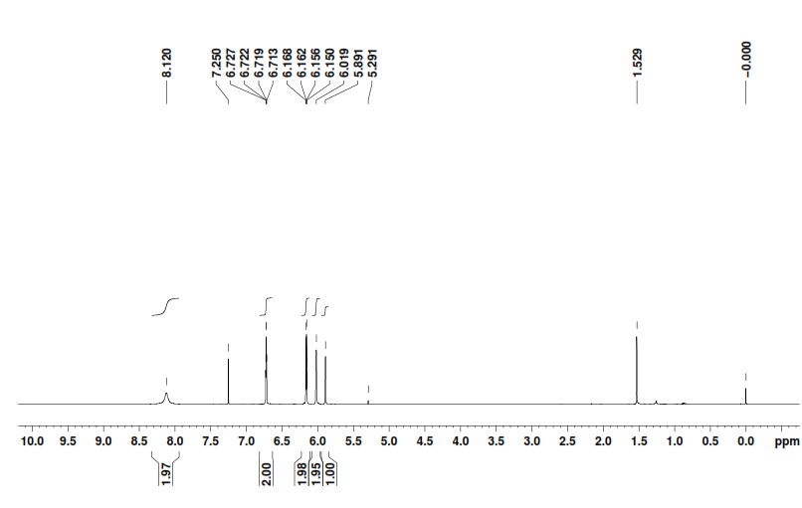

**Figure 3.** 1H NMR of **1** in CDCl3.

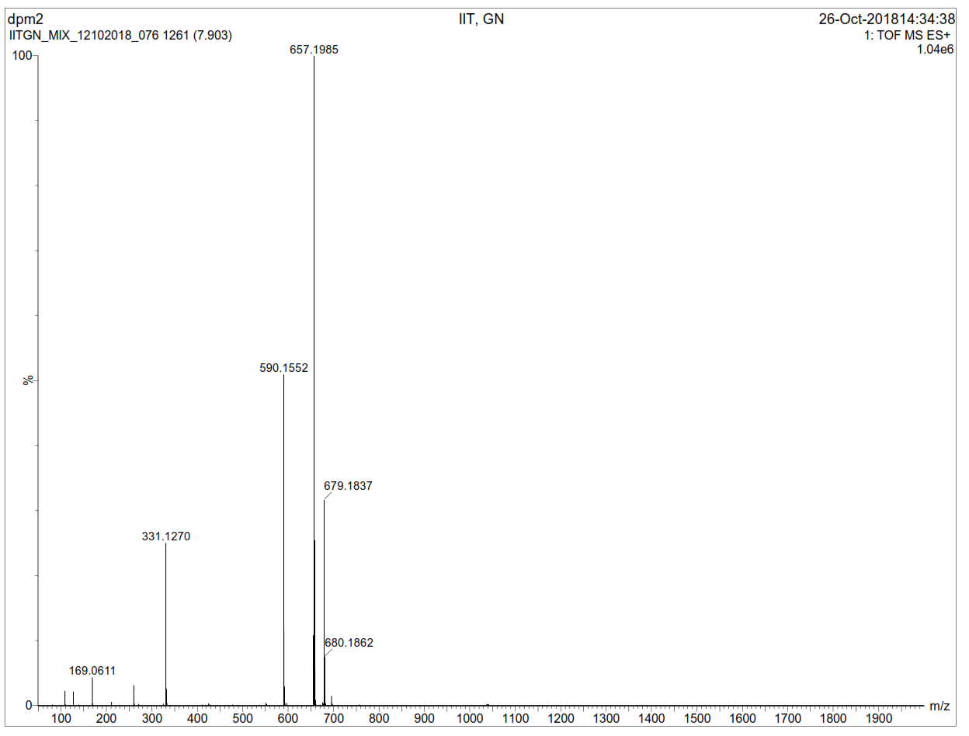  
**Figure 4.** ESI-MS of **4.**

\\10.0.58.230\iitg\data\IITGN\nmr\praseetha\Praseetha\Glycosylated bodipy\gal DPM 1H.tif

**Figure 5.** 1H NMR of **4** in CDCl3.

\\10.0.58.230\iitg\data\IITGN\nmr\praseetha\Praseetha\Glycosylated bodipy\GAL DPM 13 C.tif

**Figure 6.** 13C NMR of **4** in CDCl3.

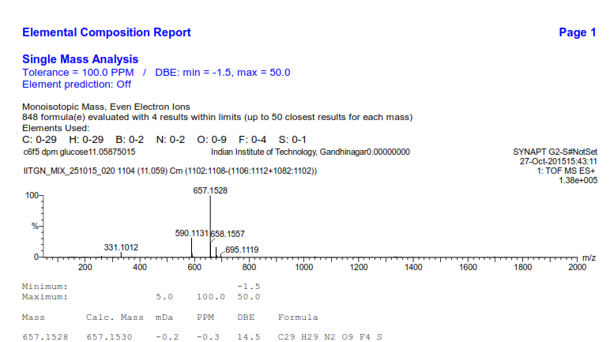

**Figure 7.** HRMS of **5.**

\\10.0.58.230\iitg\data\IITGN\nmr\praseetha\Praseetha\Glycosylated bodipy\GLU DPM 1h.tif

**Figure 8.** 1H NMR of **4** in CDCl3.   
\\10.0.58.230\iitg\data\IITGN\nmr\praseetha\Praseetha\Glycosylated bodipy\GLU DPM 13 C.tif

**Figure 9.** 13C NMR of **5** in CDCl3.

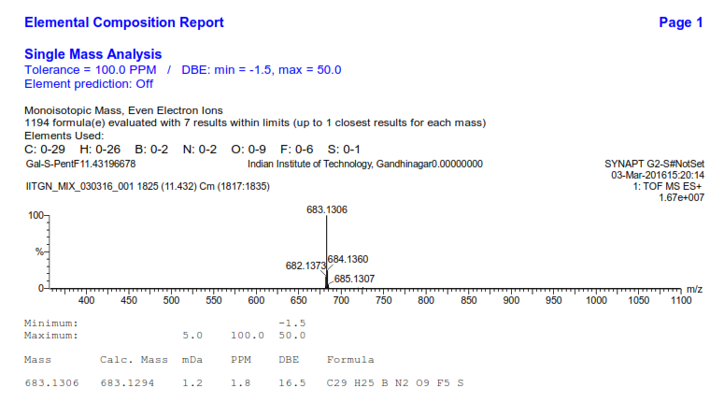

**Figure 10.** HRMS of **6**.

\\10.0.58.230\iitg\data\IITGN\nmr\praseetha\Praseetha\Glycosylated bodipy\Galactose BODIPY 1H 1.tif

**Figure 11.** 1H NMR of **6** in CDCl3.

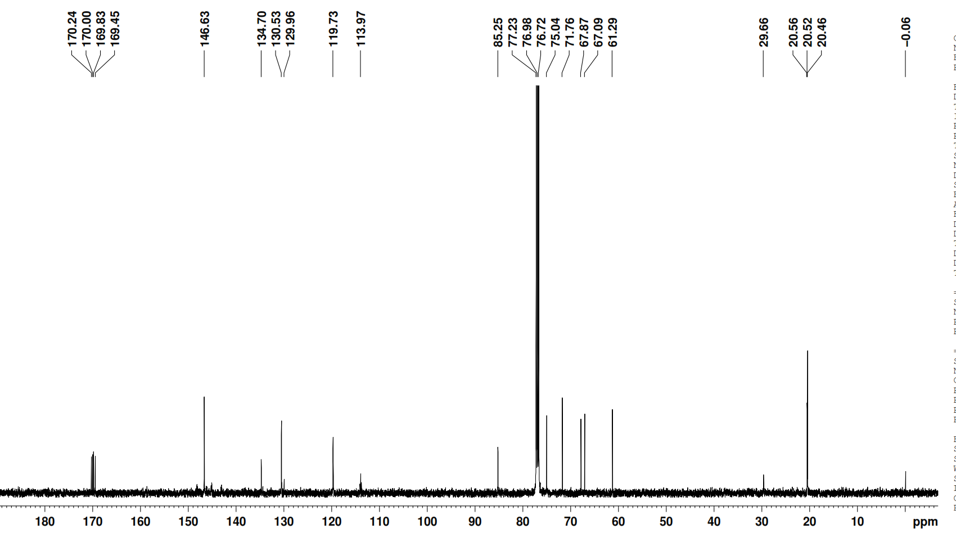

**Figure 12.** 13C NMR of **6** in CDCl3.

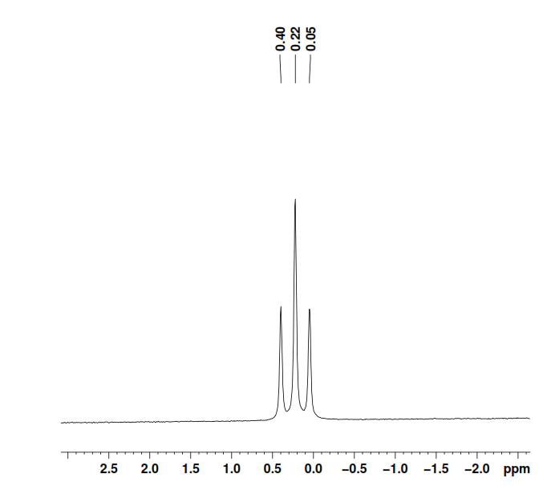

**Figure 13.** 11B NMR of **6** in CDCl3.

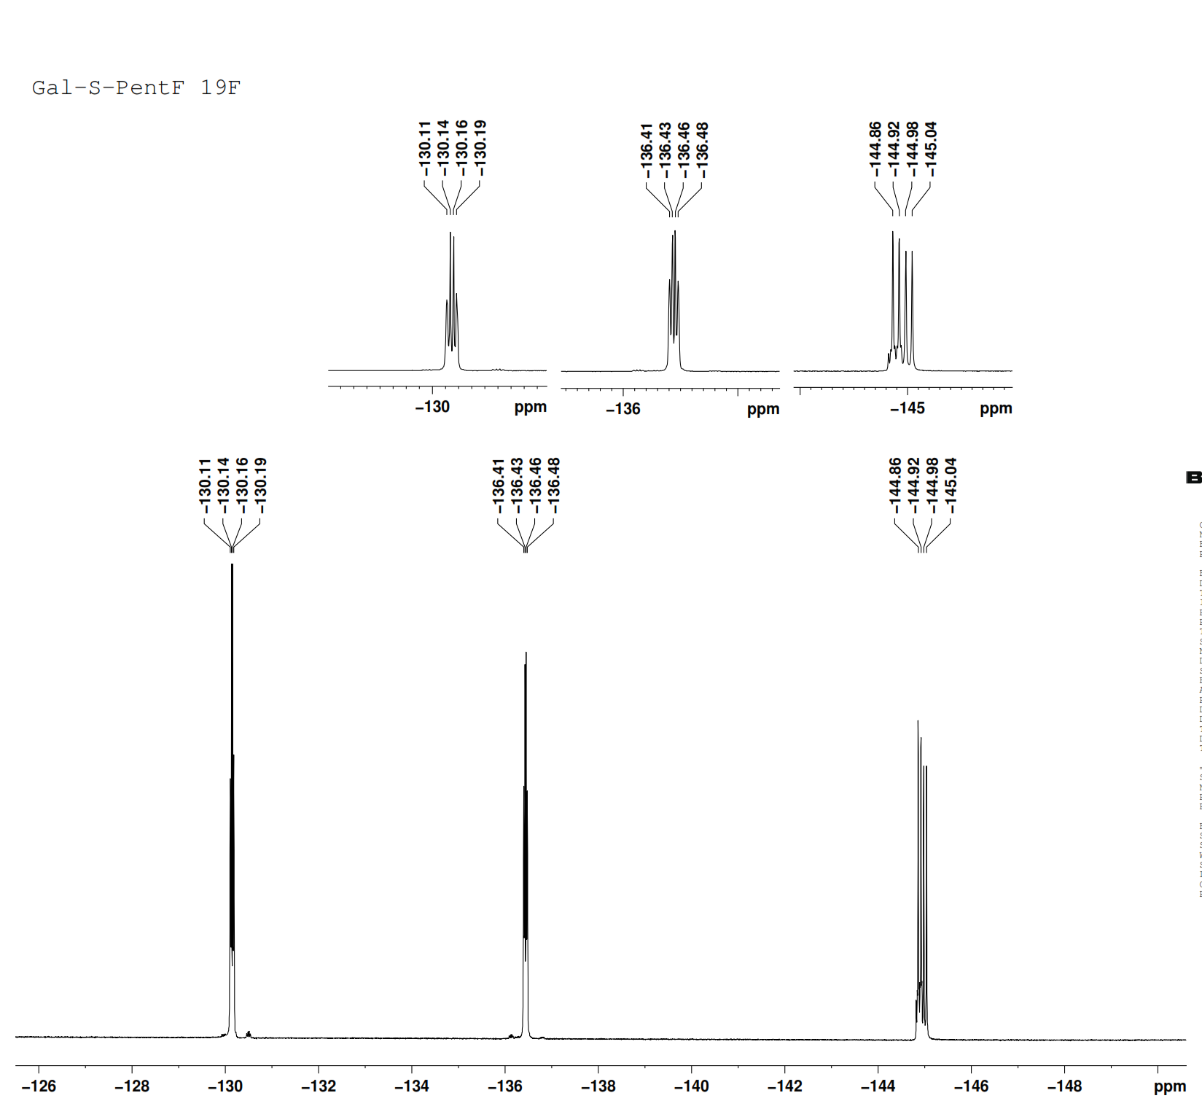

**Figure 14.** 19F NMR of **6** in CDCl3.

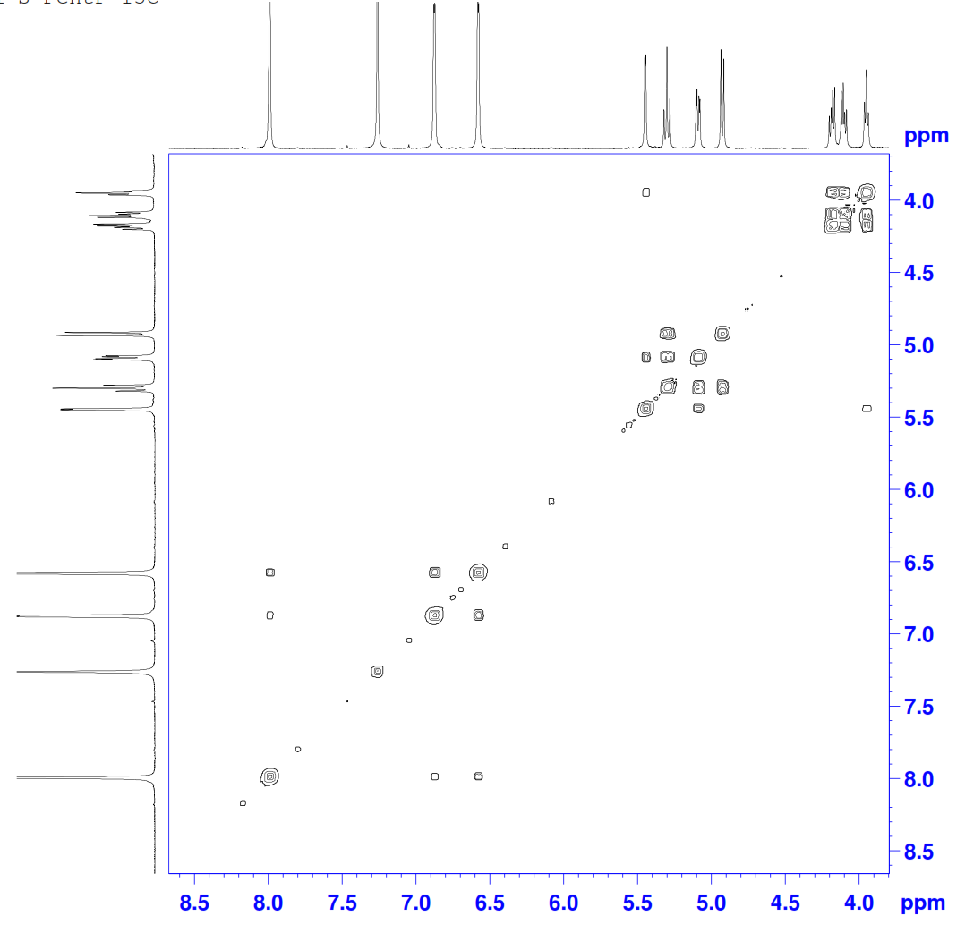

**Figure 15.** COSY NMR of **6** in CDCl3.

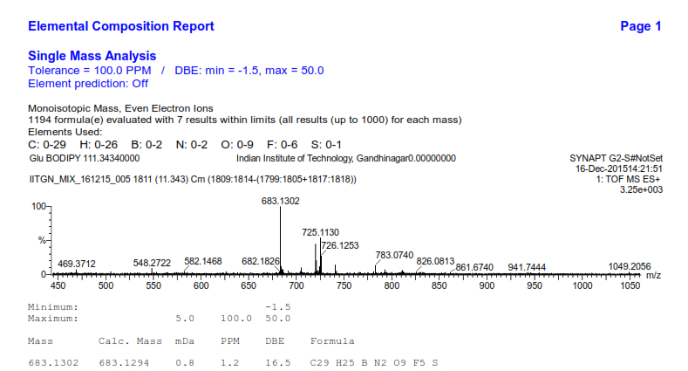

**Figure 16.** HRMS of **7**.

\\10.0.58.230\iitg\data\IITGN\nmr\praseetha\Praseetha\Glycosylated bodipy\Glu 1h.tif

**Figure 17.** 1H NMR of **7** in CDCl3.

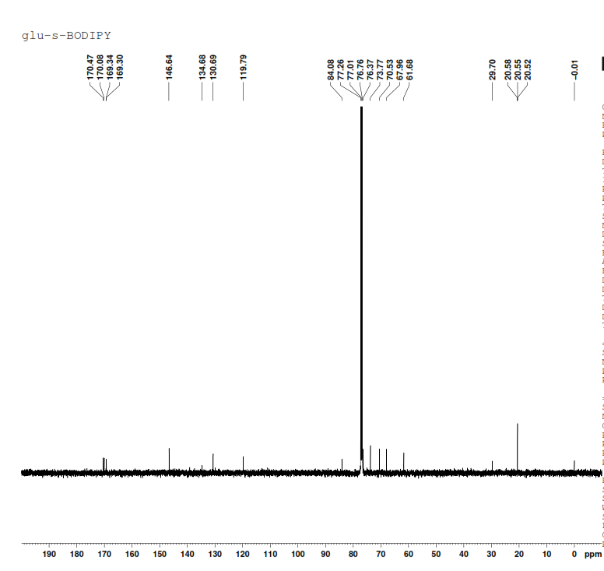

**Figure 18.** 13C NMR of **7** in CDCl3.

\\10.0.58.230\iitg\data\IITGN\nmr\praseetha\Praseetha\Glycosylated bodipy\Glu 11B.tif

**Figure 19.** 11B NMR of **7** in CDCl3.

\\10.0.58.230\iitg\data\IITGN\nmr\praseetha\Praseetha\Glycosylated bodipy\Glu 19f.tif

**Figure 20.** 19F NMR of **7** in CDCl3.

C:\Users\admin\Desktop\GLU C6F5 BODIPY cosy.tif

**9,9’**

**7,7’ 8, 8’**



**Figure 21.** 1H-1HCOSY **N**MR of **7** in CDCl3.

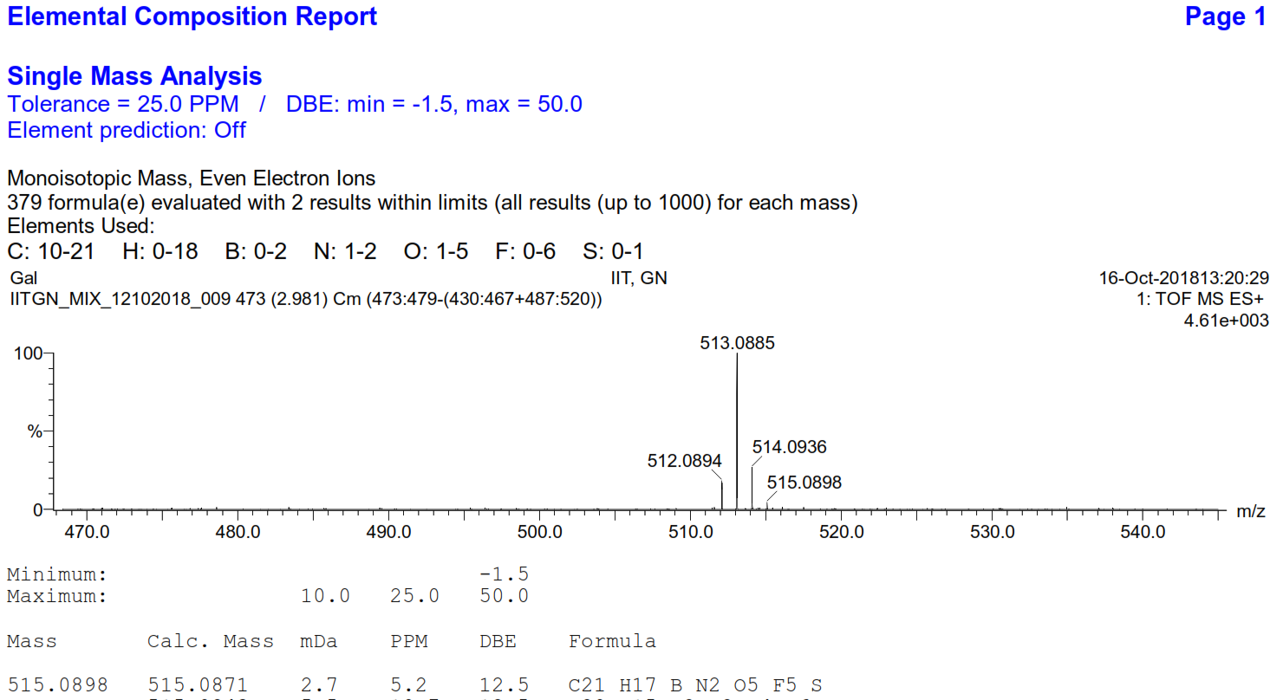

**Figure 22.** HRMS of **8**

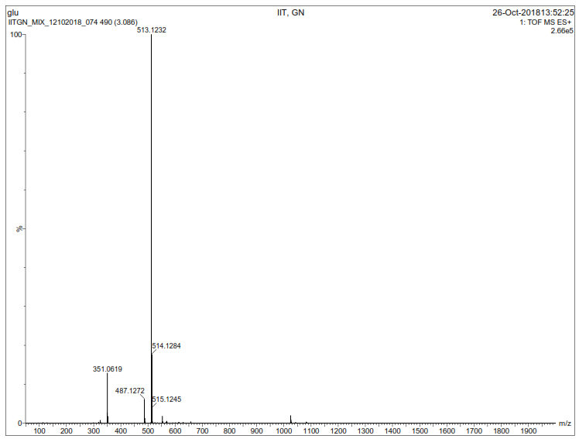

**Figure 23.** ESI-MS of **9**



**Figure 24.** TheIR spectra of (a) **4** and (b) **5**



**Figure 25.** Comparison ofIR spectra of (a) **6** and (b) **8.**



**Figure 26.** Comparison ofIR spectra of (a) **7** and (b) **9.**

********************************