Supplementary Information
Crystallization properties of arsenic doped GST alloys
Vinod E. Madhavan^{1*}, Marcelo Carignano¹, Ali Kachmar^{1*}, K. S. Sangunni²
¹Qatar Environment and Energy Research Institute, Hamad Bin Khalifa University, Qatar Foundation, P. O. Box 34110, Doha, Qatar
²Department of Physics, Indian Institute of Science, Bangalore 560012, India

*Corresponding authors (vmadhavan@hbku.edu.qa, akachmar@hbku.edu.qa)
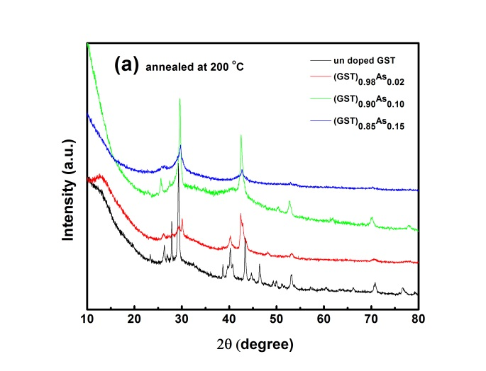
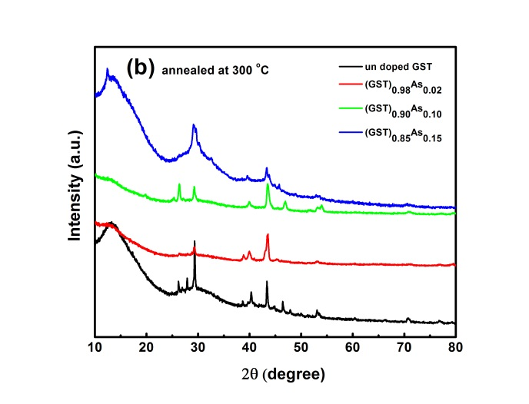
Figure S1: XRD of the (Ge₂Sb₂Te₅)_{1-x}As_{x} samples annealed (a) 200 ºC and (b) 300 ºC. The films annealed at 200 ºC are crystallized (Fi.g S1(a)). However, GST and As 0.02 at.% samples show a hexagonal structure formation whereas 0.10, 0.15 at.% arsenic doped sample show FCC structure. This is distinguishable by the absence of diffraction peak at 40.3 degree. This shows higher content of As suppresses the hexagonal formation. The arsenic suppresses the grain growth by sitting at the grain boundaries. At 300 ºC (Fig. S1(b)) all the samples are crystalline and hexagonal in structure.
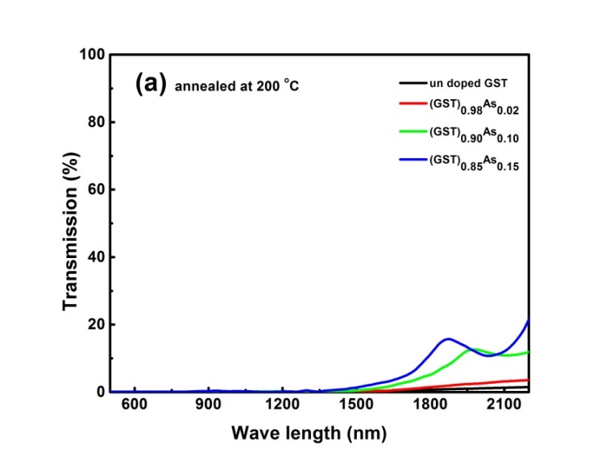
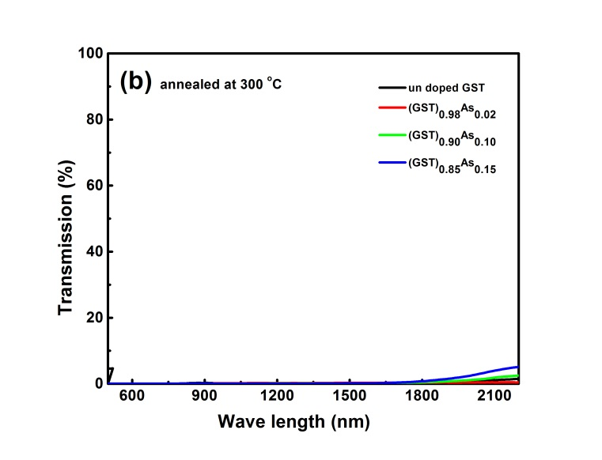
Figure S2: The VIS-NIR transmission spectra of the (Ge₂Sb₂Te₅)_{1-x}As_{x} samples annealed (a) 200 ºC and (b) 300 ºC. The maximum transmission is reduced as a result of crystallization in these samples.

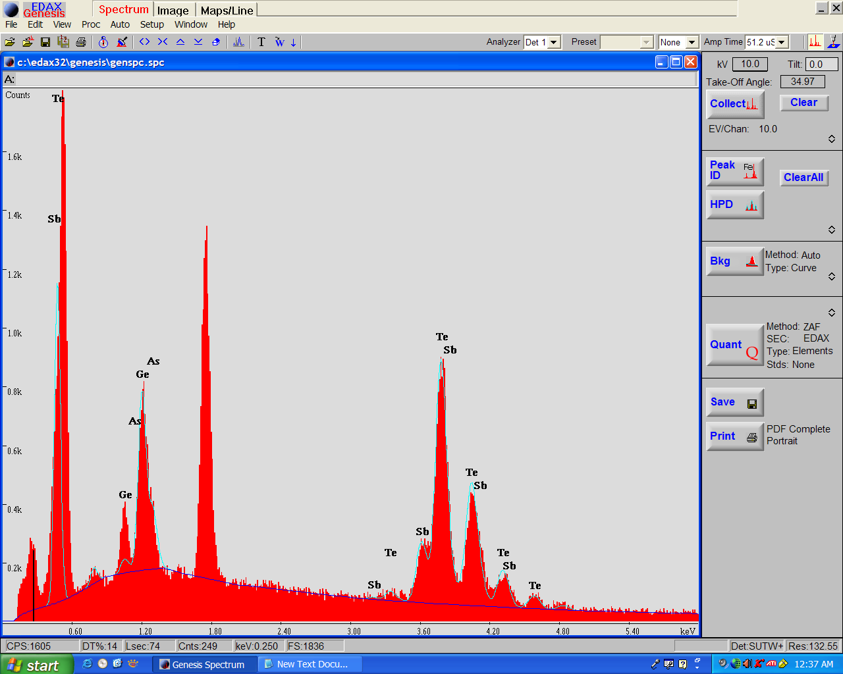

Figure S3: EDAX spectra of (GST)₉₀As₁₀ alloy.

Elements | Ge | Sb | Te | As
At% observed | 20.01 | 13.55 | 60.69 | 5.75
At% Expected | 20 | 20 | 50 | 10

Table S1: Quantification table of (GST)₉₀As₁₀ table from EDAX analysis.

