**Supplementary Material:**

# Non-linearity in dipolar solvation dynamics in water-ethanol mixture: Composition dependence of free energy landscape

**Milan K. Hazra and Biman Bagchi\***

**Solid State and Structural Chemistry Unit, Indian Institute of Science**

**Bangalore-560012**

**Email-** [**bbagchi@iisc.ac.in**](mailto:bbagchi@iisc.ac.in)**; profbiman@gmail.com**

1. **Force field parameters for ethanol**

**Table.SI.1. Charge and mass of atoms in ethanol**

|  |  |  |  |  |
| --- | --- | --- | --- | --- |
| Atom type | O | H | CH2 | CH3 |
| Mass(amu) | 15.9994 | 1.0080 | 14.0270 | 15.0350 |
| C61/2 | 0.04756 | 0.0 | 0.08642 | 0.09805 |
| C121/2 | 1.227 | 0.0 | 5.828 | 5.162 |
| Q(e) | -0.760 | 0.423 | 0.337 | 0.0 |

**Table.SI.2. Force field parameters for bonds**

|  |  |  |
| --- | --- | --- |
| Bond | Length (nm) | Kb[106 kJmol-1nm-4] |
| H-O | 0.100 | 15.7 |
| O-CH2 | 0.143 | 8.18 |
| CH2-CH3 | 0.153 | 7.15 |

**Table.SI.3. Force field parameters for angles**

|  |  |  |
| --- | --- | --- |
| Angle | Value | Kθ [kJmol-1] |
| H-O-CH2 | 109.5° | 450 |
| O-CH2-CH3 | 111.0° | 530 |

**Table.SI.4. Force field parameters for dihedrals**

|  |  |  |  |
| --- | --- | --- | --- |
| Dihedral | Kϕ [kJmol-1] | Cos(δ) | multiplicity |
| H-O-CH2-CH3 | 1.26 | 1.0 | 3 |

1. **Force field parameters for indole:**

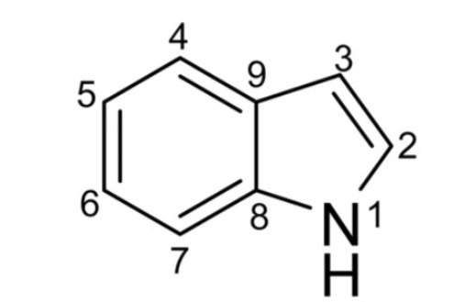

**Figure.SI.1. Structure of indole.**

**Table.SI.5. Atomic charge and masses of indole**

|  |  |  |  |
| --- | --- | --- | --- |
| **Atom type** | **Charge distribution in ground state (e)** | **Charge distribution in excited state (e)** | **Mass (amu)** |
| H1 | 0.359 | 0.373 | 1.0080 |
| N1 | -0.447 | -0.358 | 14.0067 |
| C8 | 0.262 | 0.315 | 12.0110 |
| C7 | -0.326 | -0.485 | 12.0110 |
| H7 | 0.167 | 0.161 | 1.0080 |
| C6 | -0.128 | -0.071 | 12.0110 |
| H6 | 0.132 | 0.118 | 1.0080 |
| C9 | 0.282 | 0.150 | 12.0110 |
| C4 | -0.304 | -0.385 | 12.0110 |
| H4 | 0.169 | 0.153 | 1.0080 |
| C5 | -0.164 | -0.191 | 12.0110 |
| H5 | 0.135 | 0.135 | 1.0080 |
| C3 | -0.474 | -0.171 | 12.0110 |
| H3 | 0.211 | 0.177 | 1.0080 |
| C2 | -0.037 | -0.075 | 12.0110 |
| H2 | 0.163 | 0.154 | 1.0080 |

**Table.SI.6. Force field parameters for bonds**

|  |  |  |  |
| --- | --- | --- | --- |
| **Atom type** | **Atom type** | **Bond length (nm)** | **Kb[107 kJmol-1nm-4]** |
| H1 | N | 0.0110 | 2.107 |
| N1 | C8 | 0.1380 | 1.100 |
| N1 | C2 | 0.1390 | 0.866 |
| C8 | C7 | 0.1400 | 0.854 |
| C8 | C9 | 0.1430 | 0.818 |
| C7 | H7 | 0.1090 | 1.23 |
| C7 | C6 | 0.1390 | 0.866 |
| C6 | H6 | 0.1090 | 1.23 |
| C6 | C5 | 0.1410 | 0.653 |
| C9 | C4 | 0.1400 | 0.854 |
| C9 | C3 | 0.1435 | 0.610 |
| C4 | H4 | 0.1090 | 1.230 |
| C4 | C5 | 0.1390 | 0.866 |
| C5 | H5 | 0.1090 | 1.230 |
| C3 | H3 | 0.1090 | 1.230 |
| C3 | C2 | 0.1380 | 1.100 |
| C2 | H2 | 0.1090 | 1.230 |

**Table.SI.7. Force field parameters for angles**

|  |  |  |  |  |
| --- | --- | --- | --- | --- |
| **Atom type** | **Atom type** | **Atom type** | **Θ(°)** | **Kθ [kJmol-1]** |
| H1 | N1 | C8 | 123.0 | 415.0 |
| H1 | N1 | C2 | 123.0 | 415.0 |
| C8 | N1 | C2 | 107.0 | 2726.0 |
| N1 | C8 | C7 | 126.0 | 640.0 |
| N1 | C8 | C9 | 108.0 | 465.0 |
| C7 | C8 | C9 | 120.0 | 560.0 |
| C8 | C7 | H7 | 120.0 | 505.0 |
| C8 | C7 | C6 | 120.0 | 560.0 |
| H7 | C7 | C6 | 120.0 | 505.0 |
| C7 | C6 | H6 | 120.0 | 505.0 |
| C7 | C6 | C5 | 120.0 | 560.0 |
| H6 | C6 | C5 | 120.0 | 505.0 |
| C8 | C9 | C4 | 120.0 | 560.0 |
| C8 | C9 | C3 | 109.0 | 520.0 |
| C4 | C9 | C3 | 132.0 | 760.0 |
| C9 | C4 | H4 | 120.0 | 505.0 |
| C9 | C4 | C5 | 120.0 | 560.0 |
| H4 | C4 | C5 | 120.0 | 505.0 |
| C6 | C5 | C4 | 120.0 | 560.0 |
| C6 | C5 | H5 | 120.0 | 505.0 |
| C4 | C5 | H5 | 120.0 | 505.0 |
| C9 | C3 | H3 | 126.0 | 575.0 |
| C9 | C3 | C2 | 109.50 | 520.0 |
| H3 | C3 | C2 | 126.0 | 575.0 |
| N1 | C2 | C3 | 109.5 | 520.0 |
| N1 | C2 | H2 | 120.0 | 505.0 |
| C3 | C2 | H2 | 126.0 | 575.0 |

**Table.SI.8. Force field parameters for improper dihedrals**

|  |  |  |  |  |  |
| --- | --- | --- | --- | --- | --- |
| **Atom type** | **Atom type** | **Atom type** | **Atom type** | **Φ(°)** | **Kϕ [kJmol-1]** |
| N1 | C2 | C8 | H1 | 0.0 | 167.36 |
| C2 | N1 | C3 | H2 | 0.0 | 167.36 |
| C3 | C2 | C9 | H3 | 0.0 | 167.36 |
| C4 | C5 | C9 | H4 | 0.0 | 167.36 |
| C5 | C4 | C6 | H5 | 0.0 | 167.36 |
| C6 | C5 | C7 | H6 | 0.0 | 167.36 |
| C7 | C6 | C8 | H7 | 0.0 | 167.36 |
| C8 | N1 | C7 | C9 | 0.0 | 167.36 |
| C9 | C3 | C4 | C8 | 0.0 | 167.36 |

**Table.SI.9. Force field parameters for dihedrals**

|  |  |  |  |  |  |  |
| --- | --- | --- | --- | --- | --- | --- |
| **Atom type** | **Atom type** | **Atom type** | **Atom type** | **Φ(°)** | **Kϕ [kJmol-1]** | **multiplicity** |
| C2 | N1 | C8 | C9 | 180.00 | 41.80 | 2 |
| C8 | N1 | C2 | C3 | 180.00 | 41.80 | 2 |
| C9 | C8 | C7 | C6 | 180.00 | 41.80 | 2 |
| C7 | C8 | C9 | C4 | 180.00 | 41.80 | 2 |
| C8 | C7 | C6 | C5 | 180.00 | 41.80 | 2 |
| C7 | C6 | C5 | C4 | 180.00 | 41.80 | 2 |
| C8 | C9 | C4 | C5 | 180.00 | 41.80 | 2 |
| C8 | C9 | C3 | C2 | 180.00 | 41.80 | 2 |
| C9 | C4 | C5 | C6 | 180.00 | 41.80 | 2 |
| C9 | C3 | C2 | N1 | 180.00 | 41.80 | 2 |

Bonded and van der Waals parameters were taken from the GROMOS 53A6 parameter set.

1. **Error bars (standard deviation from mean)**

In order to calculate the statistical uncertainties in our data, we have calculated the error bars using the following definition of standard deviation,



For equilibrium simulations, we have data averaged over 10 independent runs and we calculate the standard deviation of each of the independent dataset from the mean value using the above relation of standard deviation.

For non-equilibrium data, we calculate the standard deviation from each of the 200 trajectories (initial conditions are 10ps apart) in a set (There are five such sets; initial conditions are 5ns apart). Thus we obtain 5 sets of standard deviation. We calculate the average standard deviation from the five independent sets. This corresponds to a confidence interval of about 65-70%.

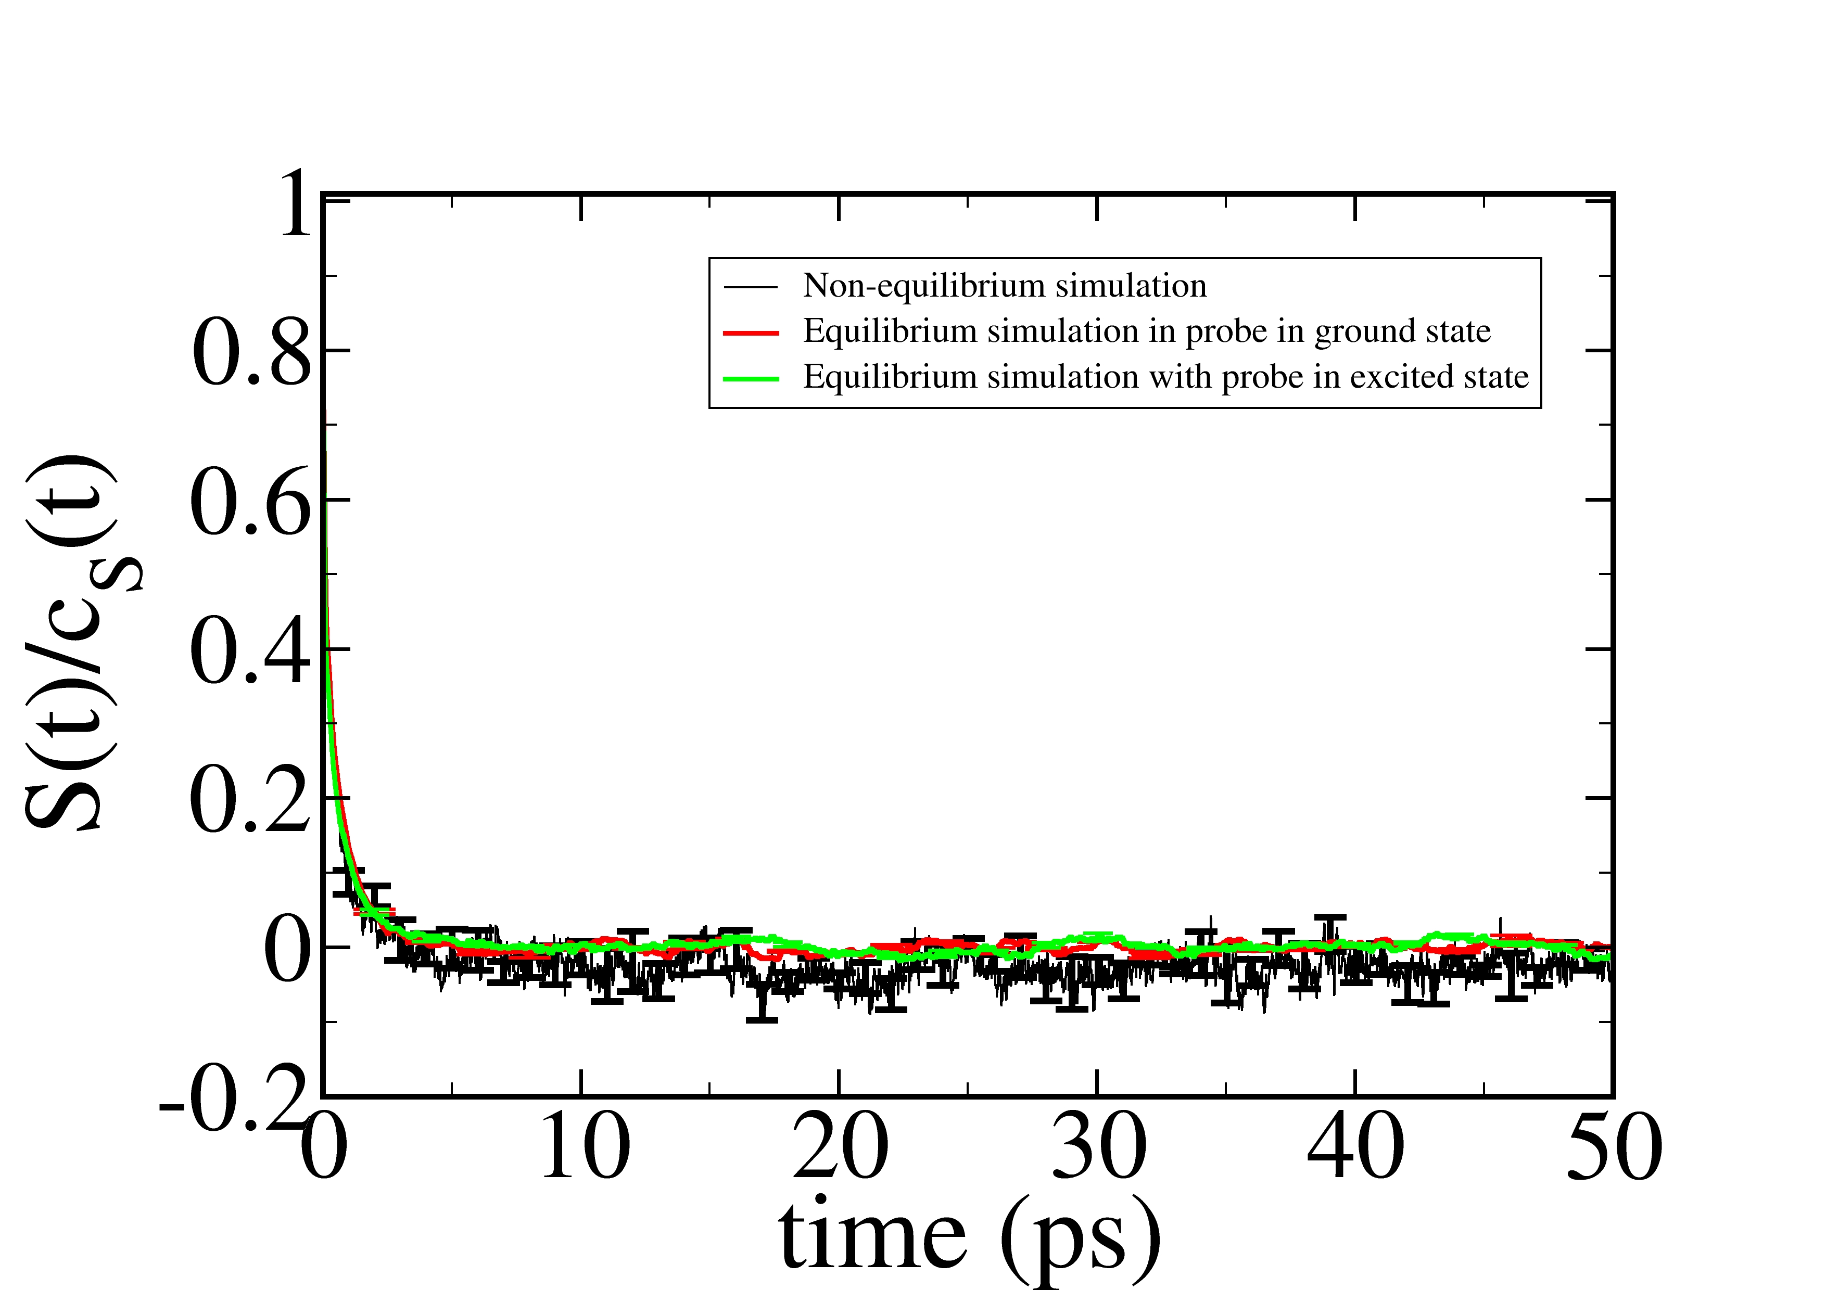

**(a)**

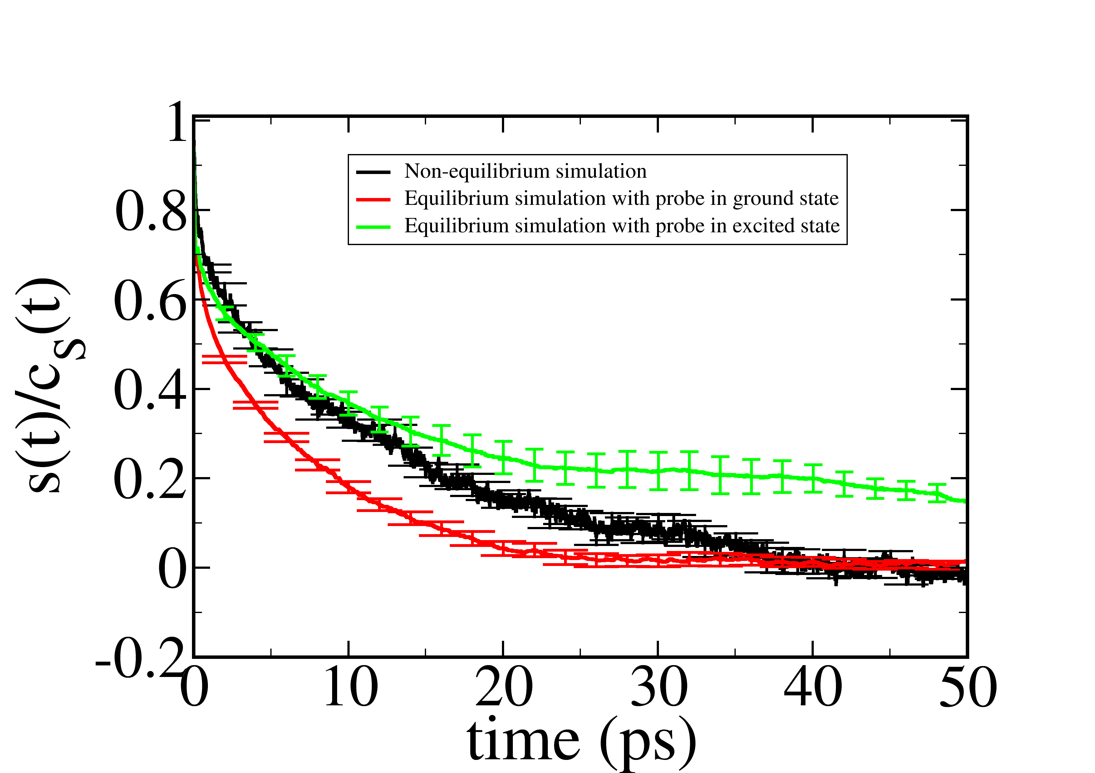

**(b)**

**Figure.SI.2. Error bars for equilibrium (CS(t)) and non-equilibrium (S(t)) solvent response functions for pure solvents (a) pure water (b) pure ethanol. Black curve shows the non-equilibrium solvent response, red curve shows equilibrium solvent response for probe indole in ground state and green curve shows equilibrium solvent response for probe indole in excited state. The errors for equilibrium solvation time correrlation functions for pure water are less than 10%(not visible clearly because of superposition of all the graphs) .**

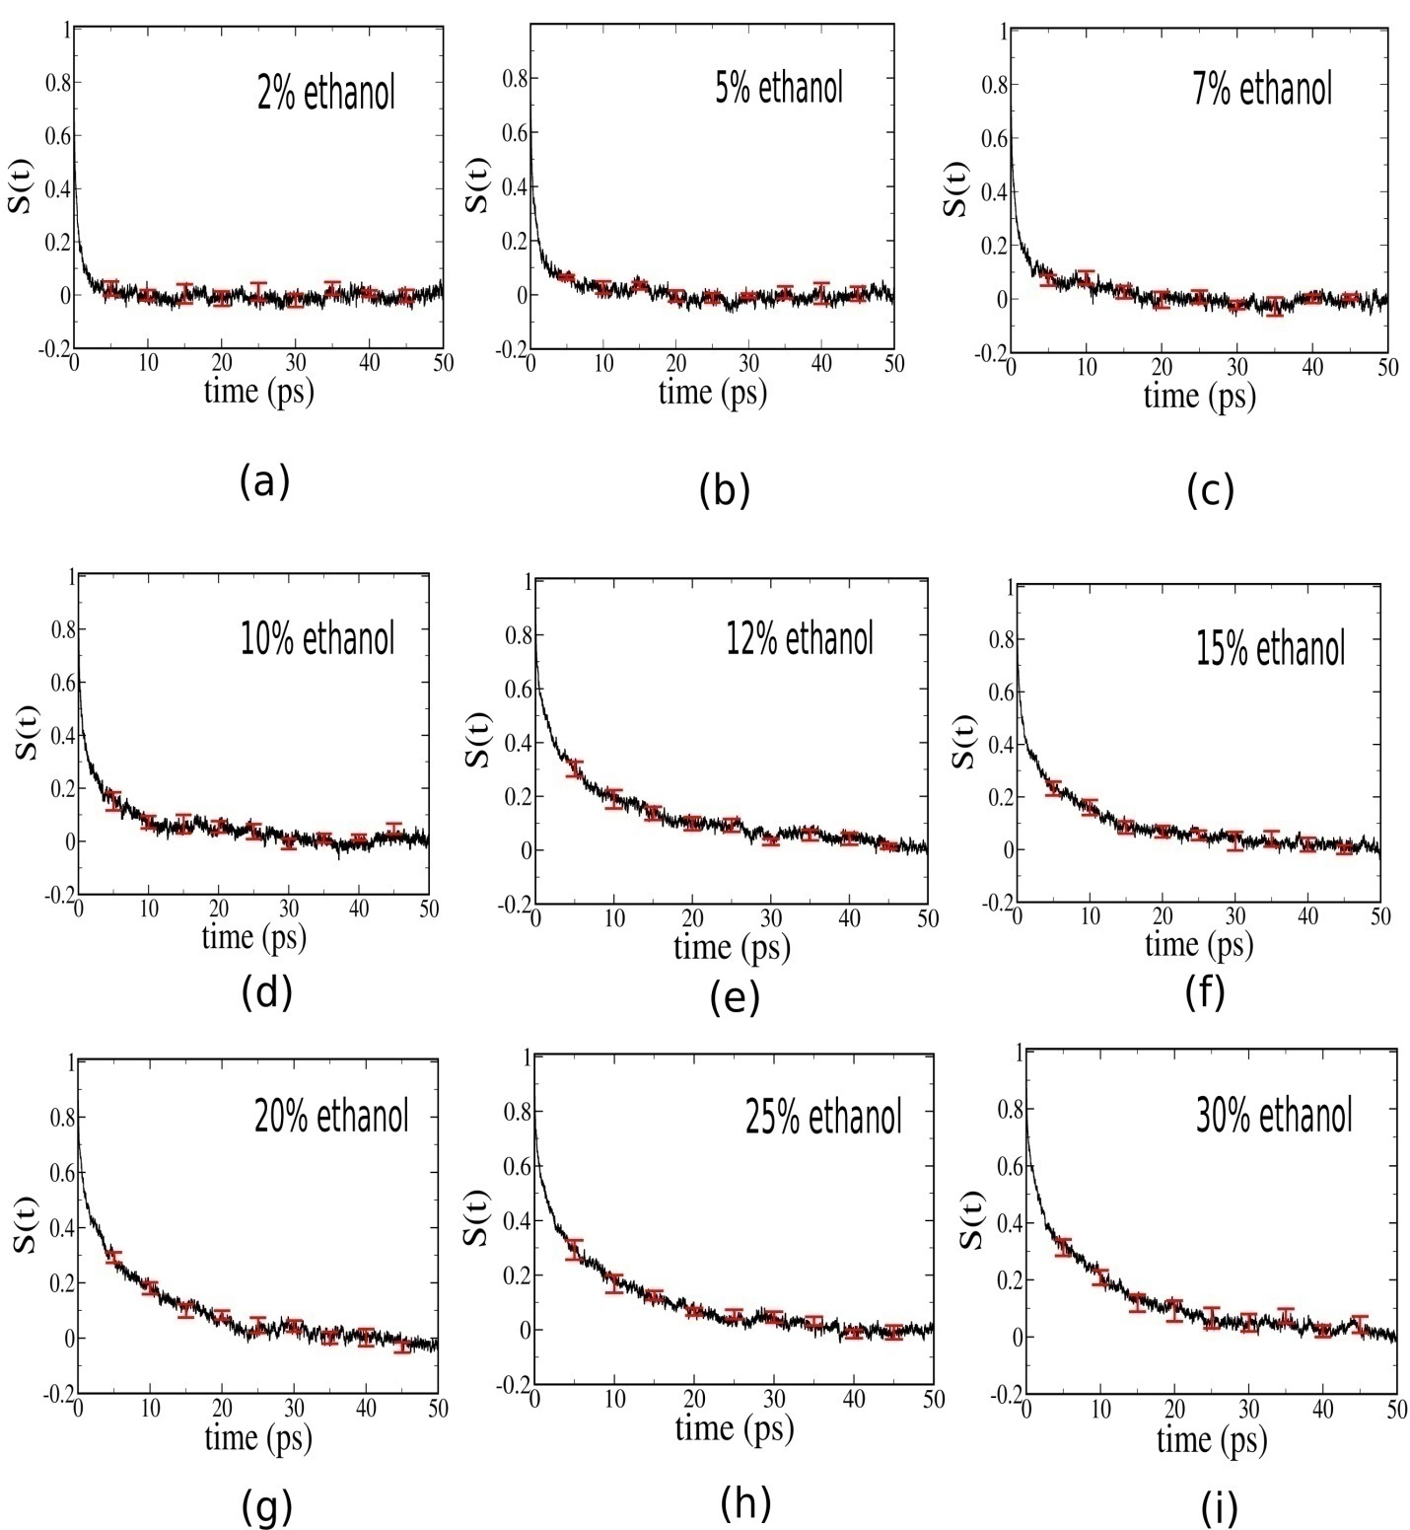

**Figure.SI.3. Statistical uncertainty (Error bars) in non–equilibrium solvent relaxation for several water ethanol binary mixtures for ethanol compositions (a)2% ethanol, (b) 5% ethanol, (c) 7% ethanol, (d) 10% ethanol, (e)12% ethanol, (f)15% ethanol, (g) 20% ethanol, (h) 25% ethanol, (i) 30% ethanol, spanning effectively the low-to-intermediate concentration regime of water-ethanol binary mixture.**

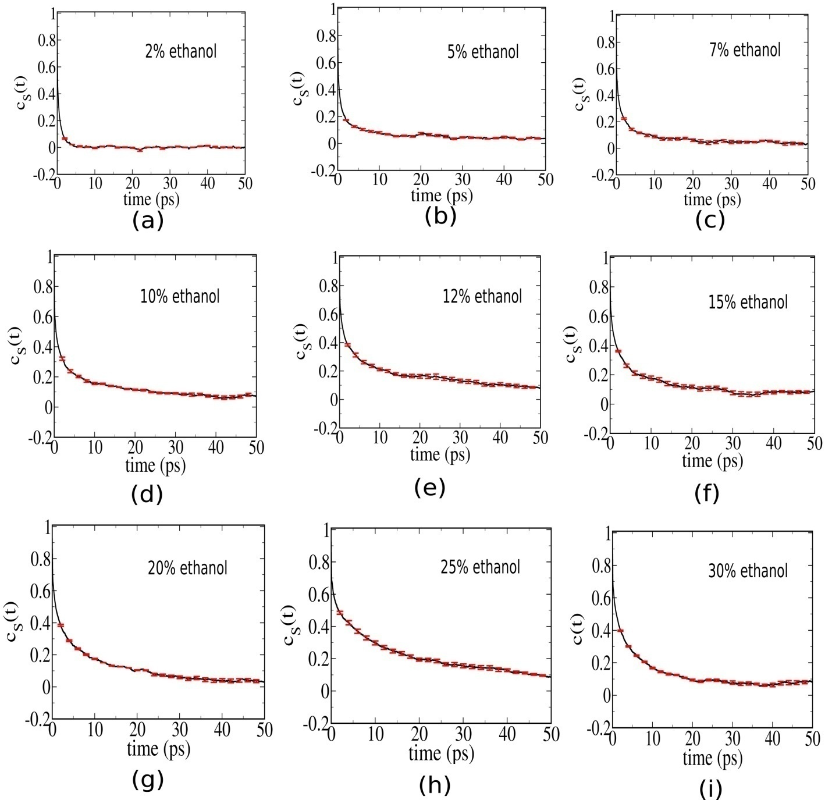

**Figure.SI.4. Statistical uncertainty (Error bars) in equilibrium solvation time correlation functions with ground state probe for ethanol compositions (a)2% ethanol, (b) 5% ethanol, (c) 7% ethanol, (d) 10% ethanol, (e)12% ethanol, (f)15% ethanol, (g) 20% ethanol, (h) 25% ethanol, (i) 30% ethanol, spanning effectively the low-to-intermediate concentration regime of water-ethanol binary mixture. Error bars have been calculated as standard deviation of each of the solvation time correlation function dataset generated from 10 independent equilibrium simulations from the averaged solvation time correlation function.**

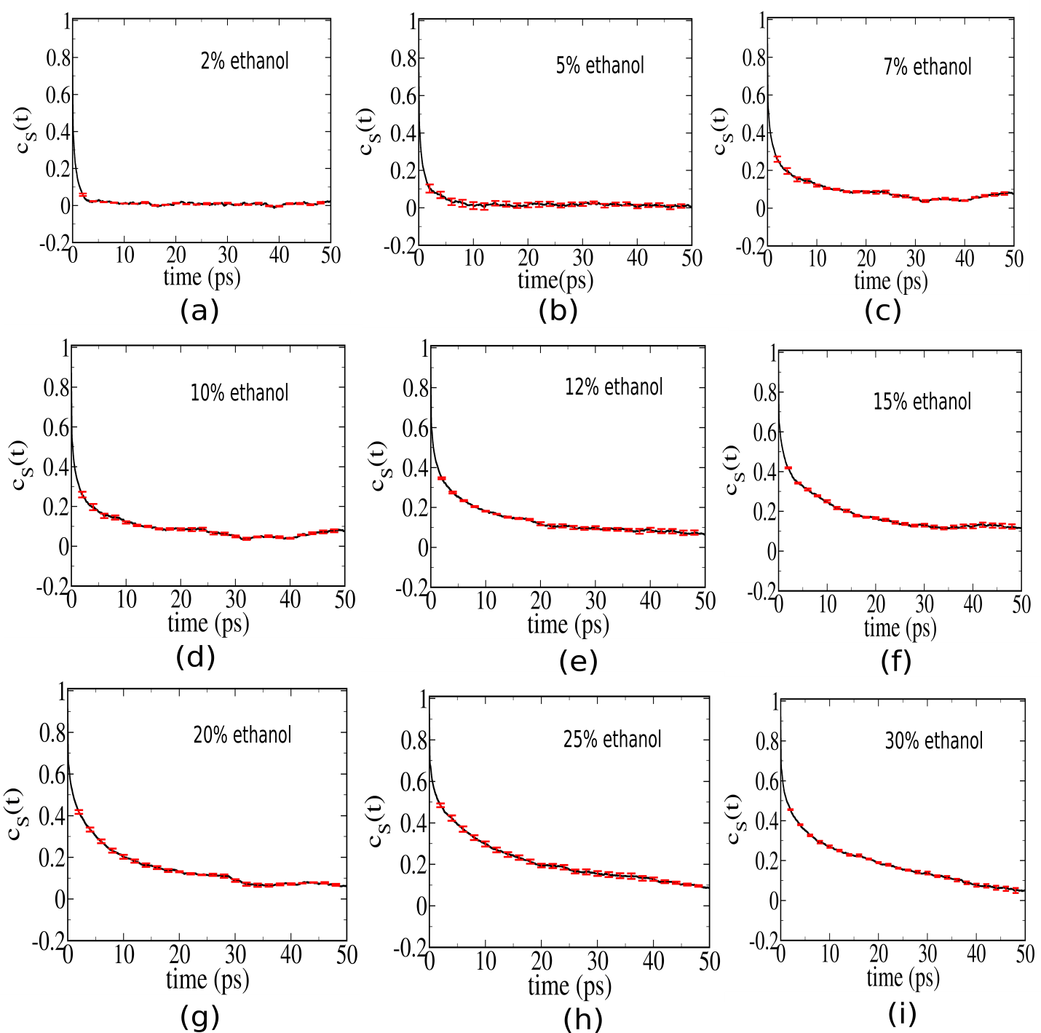

**Figure.SI.5. Statistical uncertainty (Error bars) in equilibrium solvation time correlation functions with excited state probe for ethanol compositions (a)2% ethanol, (b) 5% ethanol, (c) 7% ethanol, (d) 10% ethanol, (e)12% ethanol, (f)15% ethanol, (g) 20% ethanol, (h) 25% ethanol, (i) 30% ethanol, spanning effectively the low-to-intermediate concentration regime of water-ethanol binary mixture. Error bars have been calculated as standard deviation of each of the solvation time correlation function dataset generated from 10 independent equilibrium simulations from the averaged solvation time correlation function.**

**Table.SI.10. Statistical uncertainties (standard deviation from the mean) in fitted parameters for the non-equilibrium solvent response function. Non-equilibrium solvent response is bi-exponential with an additional initial Gaussian component.**

|  |  |  |  |  |  |  |
| --- | --- | --- | --- | --- | --- | --- |
| *x*EtOH | a1 | τ1(ps) | a2 | τ2(ps) | a3 | τ3(ps) |
| 0.0 | 0.27  (±0.03) | 0.022  (±0.006) | 0.58  (±0.01) | 0.23  (±0.04) | 0.15  (±0.02) | 1.55  (±0.07) |
| 0.02 | 0.28 (±0.05) | 0.022 (±0.005) | 0.44  (±0.05) | 0.29  (±0.07) | 0.27  (±0.06) | 1.48  (±0.03) |
| 0.05 | 0.36  (±0.07) | 0.043  (±0.006) | 0.48  (±0.06) | 0.56  (±0.05) | 0.16  (±0.03) | 4.90  (±0.05) |
| 0.07 | 0.30  (±0.04) | 0.021  (±0.005) | 0.50  (±0.06) | 0.53  (±0.04) | 0.20  (±0.02) | 6.50  (±0.12) |
| 0.10 | 0.38  (±0.06) | 0.076  (±0.003) | 0.39  (±0.04) | 1.26  (±0.08) | 0.22  (±0.07) | 11.07  (±0.34) |
| 0.12 | 0.32  (±0.03) | 0.083  (±0.009) | 0.36  (±0.05) | 2.37  (±0.23) | 0.32  (±0.03) | 18.39  (±0.22) |
| 0.15 | 0.32  (±0.07) | 0.07  (±0.01) | 0.34  (±0.05) | 1.23  (±0.12) | 0.34  (±0.04) | 12.98  (±0.18) |
| 0.20 | 0.22  (±0.05) | 0.064  (±0.006) | 0.29  (±0.04) | 0.76  (±0.05) | 0.49  (±0.05) | 9.81  (±0.44) |
| 0.25 | 0.23  (±0.03) | 0.063  (±0.004) | 0.29  (±0.03) | 0.98  (±0.08) | 0.48  (±0.06) | 10.39  (±0.32) |
| 0.30 | 0.23  (±0.05) | 0.074  (±0.007) | 0.31  (±0.07) | 1.28  (±0.09) | 0.45  (±0.02) | 13.21  (±0.28) |

**Table.SI.11. Statistical uncertainties (standard deviation from the mean) in fitted parameters for the equilibrium solvation time correlation function for solute probe in ground state obtained from 10 independent equilibrium simulations. Equilibrium solvent response is bi-exponential with an additional initial Gaussian component.**

|  |  |  |  |  |  |  |
| --- | --- | --- | --- | --- | --- | --- |
| *x*EtOH | a1 | τ1 (ps) | a2 | τ2 (ps) | a3 | τ3 (ps) |
| 0.0 | 0.48  (±0.04) | 0.057  (±0.008) | 0.46  (±0.05) | 0.60  (±0.08) | 0.053  (±0.007) | 2.62  (±0.29) |
| 0.02 | 0.38  (±0.05) | 0.047  (±0.008) | 0.47  (±0.04) | 0.38  (±0.06) | 0.14  (±0.03) | 2.42  (±0.25) |
| 0.05 | 0.61  (±0.08) | 0.11  (±0.02) | 0.30  (±0.07) | 1.95  (±0.31) | 0.094  (±0.008) | 52.03  (±0.18) |
| 0.07 | 0.58  (±0.07) | 0.101  (±0.008) | 0.37  (±0.06) | 3.14  (±0.16) | 0.064  (±0.008) | 140.8  (±0.7) |
| 0.10 | 0.58  (±0.06) | 0.17  (±0.03) | 0.33  (±0.04) | 6.78  (±0.21) | 0.097  (±0.006) | 218.93  (±2.7) |
| 0.12 | 0.64  (±0.08) | 0.36  (±0.04) | 0.31  (±0.06) | 18.3  (±1.5) | 0.054  (±0.003) | 287.31  (±1.7) |
| 0.15 | 0.41  (±0.08) | 0.093  (±0.008) | 0.41  (±0.05) | 2.89  (±0.4) | 0.18  (±0.02) | 52.83  (±2.6) |
| 0.20 | 0.41  (±0.05) | 0.10  (±0.04) | 0.39  (±0.07) | 3.47  (±0.5) | 0.20  (±0.05) | 29.19  (±2.1) |
| 0.25 | 0.46  (±0.03) | 0.16  (±0.05) | 0.30  (±0.03) | 2.9  (±0.3) | 0.24  (±0.04) | 31.25  (±0.5) |
| 0.30 | 0.37  (±0.06) | 0.092  (±0.005) | 0.44  (±0.05) | 3.32  (±0.6) | 0.19  (±0.04) | 39.23  (±0.8) |

**Table.SI.12. Statistical uncertainties (standard deviation from the mean) in fitted parameters for the equilibrium solvation time correlation function for the probe in excited state obtained from 10 independent equilibrium simulations. Equilibrium solvent response is bi-exponential with an additional initial Gaussian component.**

|  |  |  |  |  |  |  |
| --- | --- | --- | --- | --- | --- | --- |
| *x*EtOH | a1 | τ1(ps) | a2 | τ2(ps) | a3 | τ3(ps) |
| 0.0 | 0.56  (±0.07) | 0.053  (±0.007) | 0.41  (±0.05) | 0.63  (±0.09) | 0.034  (±0.008) | 4.09  (±0.4) |
| 0.02 | 0.59  (±0.04) | 0.056  (±0.006) | 0.40  (±0.05) | 0.91  (±0.08) | 0.013  (±0.003) | 66.22  (±2.3) |
| 0.05 | 0.66  (±0.07) | 0.084  (±0.007) | 0.32  (±0.04) | 1.79  (±0.07) | 0.022  (±0.004) | 169.52  (±3.1) |
| 0.07 | 0.64  (±0.06) | 0.11  (±0.02) | 0.32  (±0.06) | 7.1  (±0.3) | 0.041  (±0.002) | 457.02  (±3.6) |
| 0.10 | 0.51  (±0.04) | 0.103  (±0.007) | 0.34  (±0.06) | 6.13  (±0.8) | 0.152  (±0.002) | 201.8  (±0.4) |
| 0.12 | 0.50  (±0.03) | 0.093  (±0.005) | 0.34  (±0.05) | 4.47  (±0.2) | 0.16  (±0.01) | 65.64  (±1.3) |
| 0.15 | 0.44  (±0.04) | 0.092  (±0.003) | 0.36  (±0.04) | 5.5  (±0.1) | 0.20  (±0.02) | 94.93  (±1.5) |
| 0.20 | 0.38  (±0.05) | 0.073  (±0.003) | 0.34  (±0.04) | 2.93  (±0.5) | 0.28  (±0.02) | 27.84  (±1.2) |
| 0.25 | 0.33  (±0.04) | 0.062  (±0.006) | 0.23  (±0.05) | 2.0  (±0.3) | 0.44  (±0.02) | 27.76  (±0.89) |
| 0.30 | 0.39  (±0.03) | 0.085  (±0.007) | 0.19  (±0.04) | 1.85  (±0.3) | 0.42  (±0.02) | 24.3  (±0.2) |

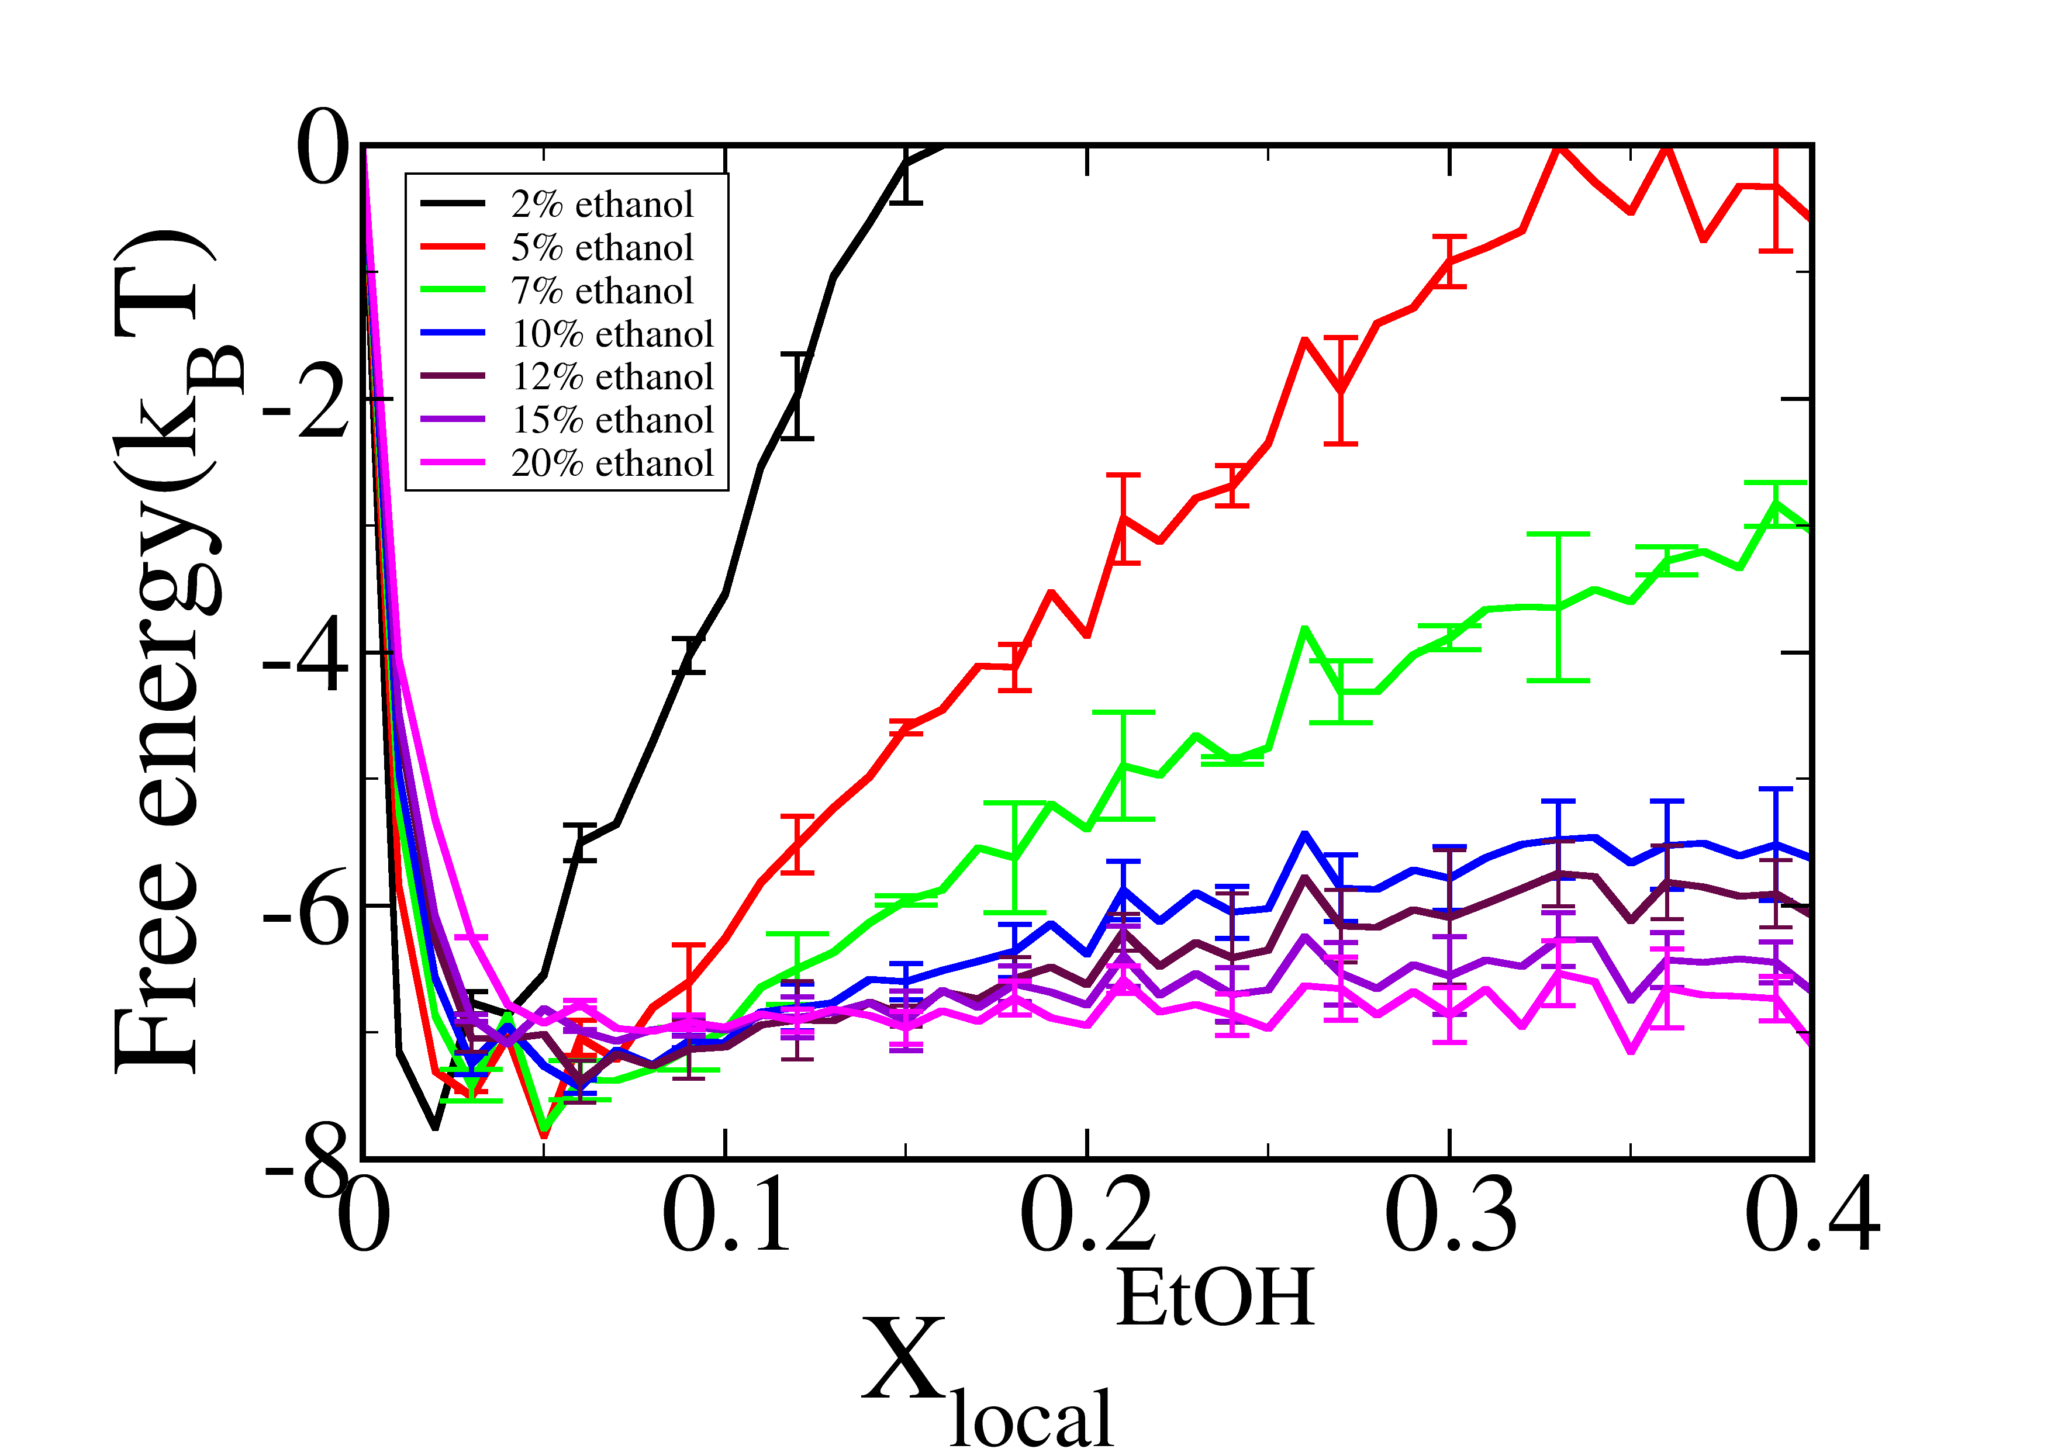

**Figure.SI.6. Error bars for local composition dependent free energy surface for several water ethanol binary mixtures. We observe that up to xEtOH=0.10, flattening of the free energy surface is drastic. Hereafter we observe a gradual softening of the force constant related to the free energy surface.  denotes the mole fraction of ethanol molecules in each of the locally defined grids. This serves as the order parameter.**

In **Figure.SI.7 (a) and (b)**, we show the statistical uncertainties in **Fig.7** of the revised manuscript.

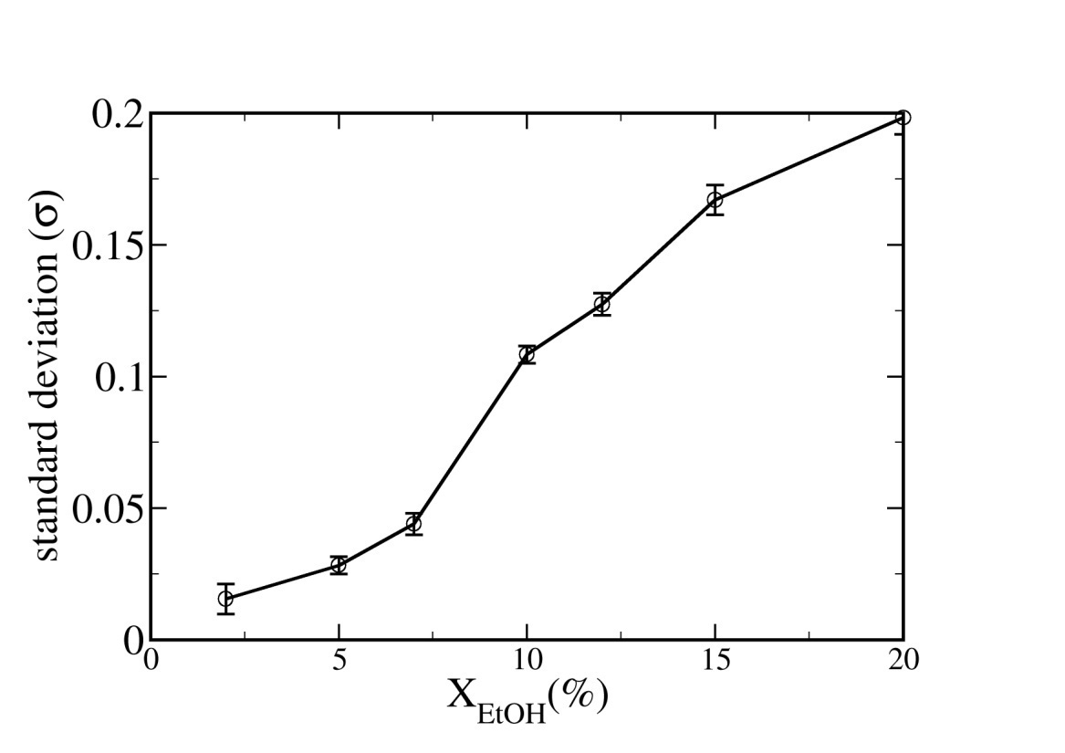

**(a)**

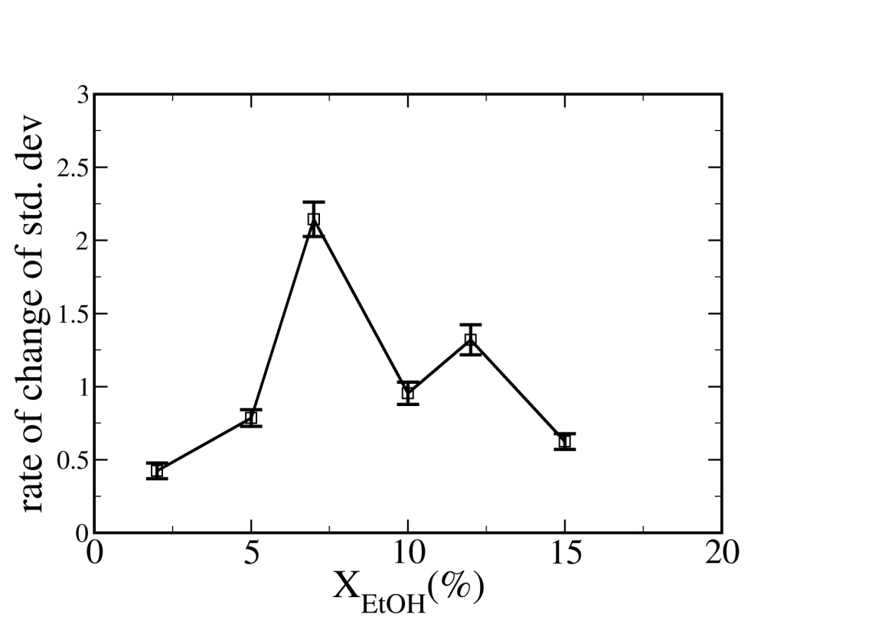

**(b)**

**Figure.SI.7. (a)Error bars for standard deviation of equilibrium probability distribution of local ethanol composition in cubic grids. (b) First derivative of standard deviation which predominantly points out a sudden increase in the concentration regime xEtOH=0.07-0.10.**

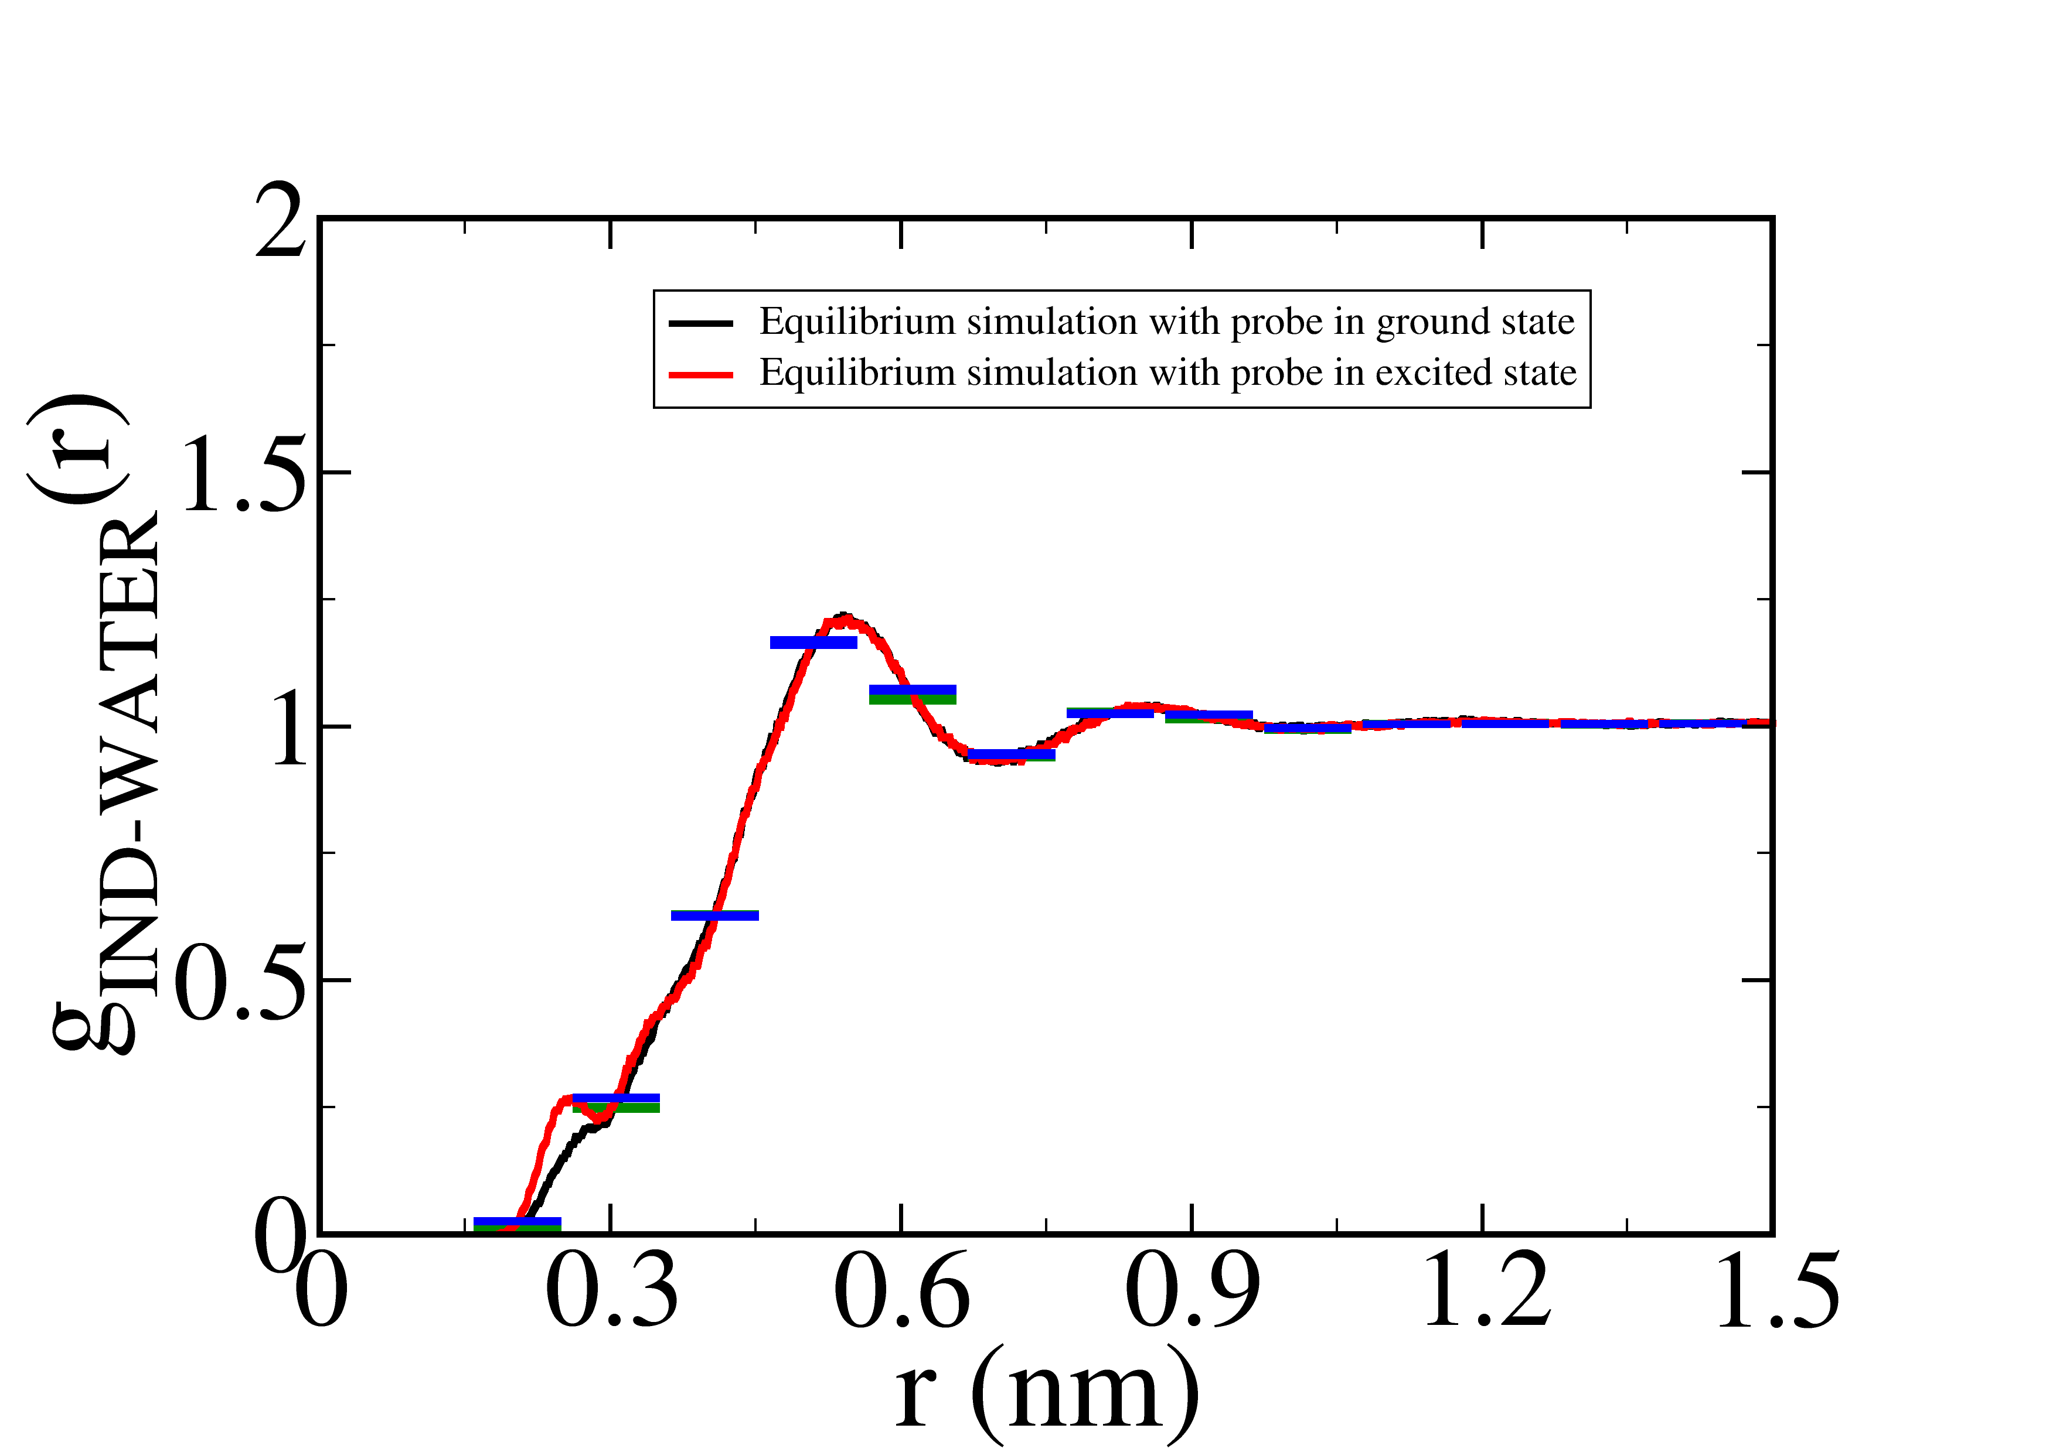

**(a)**

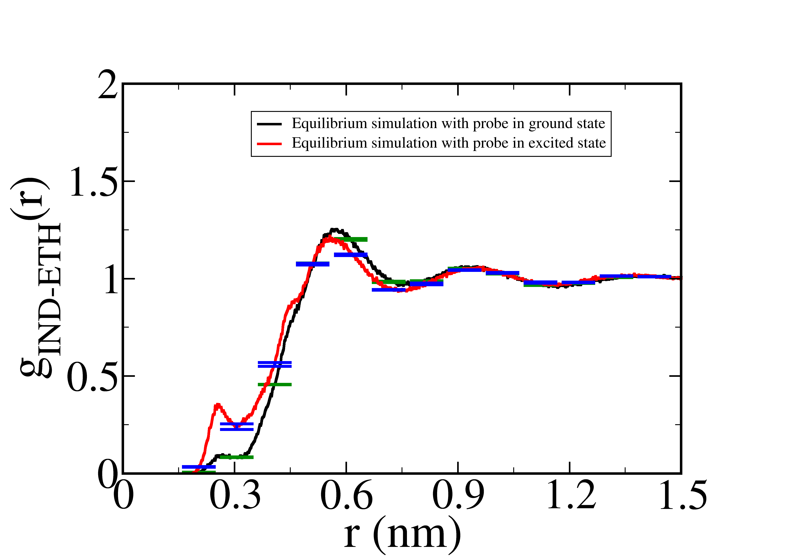

**(b)**

**Figure.SI.8. Error bars for radial distribution of pure solvents around indole in the ground and excited states. Black curve represents the radial distribution function (RDF) around the probe in ground state while the red one represents the RDF around probe in the excited state. (a) RDF of pure water around probe indole in ground and excited states. (b) RDF of pure ethanol around probe indole in ground and excited states. The green error bar lines indicate the errors in RDF for ground state while blue error bar lines indicate the errors in RDF for excited state.**

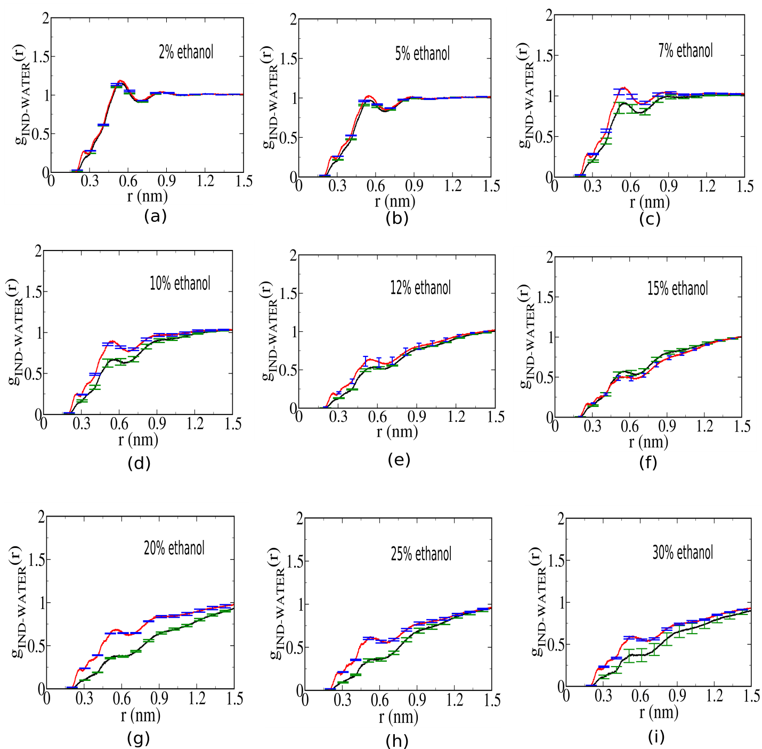

**Figure.SI.9. Error bars for radial distribution function (RDF) for the water component around probe indole for ethanol compositions (a)2% ethanol, (b) 5% ethanol, (c) 7% ethanol, (d) 10% ethanol, (e)12% ethanol, (f)15% ethanol, (g) 20% ethanol, (h) 25% ethanol, (i) 30% ethanol, spanning effectively the low-to-intermediate concentration regime of water-ethanol binary mixture. The green error bar lines indicate the errors in RDF for ground state while blue error bar lines indicate the errors in RDF for excited state.**

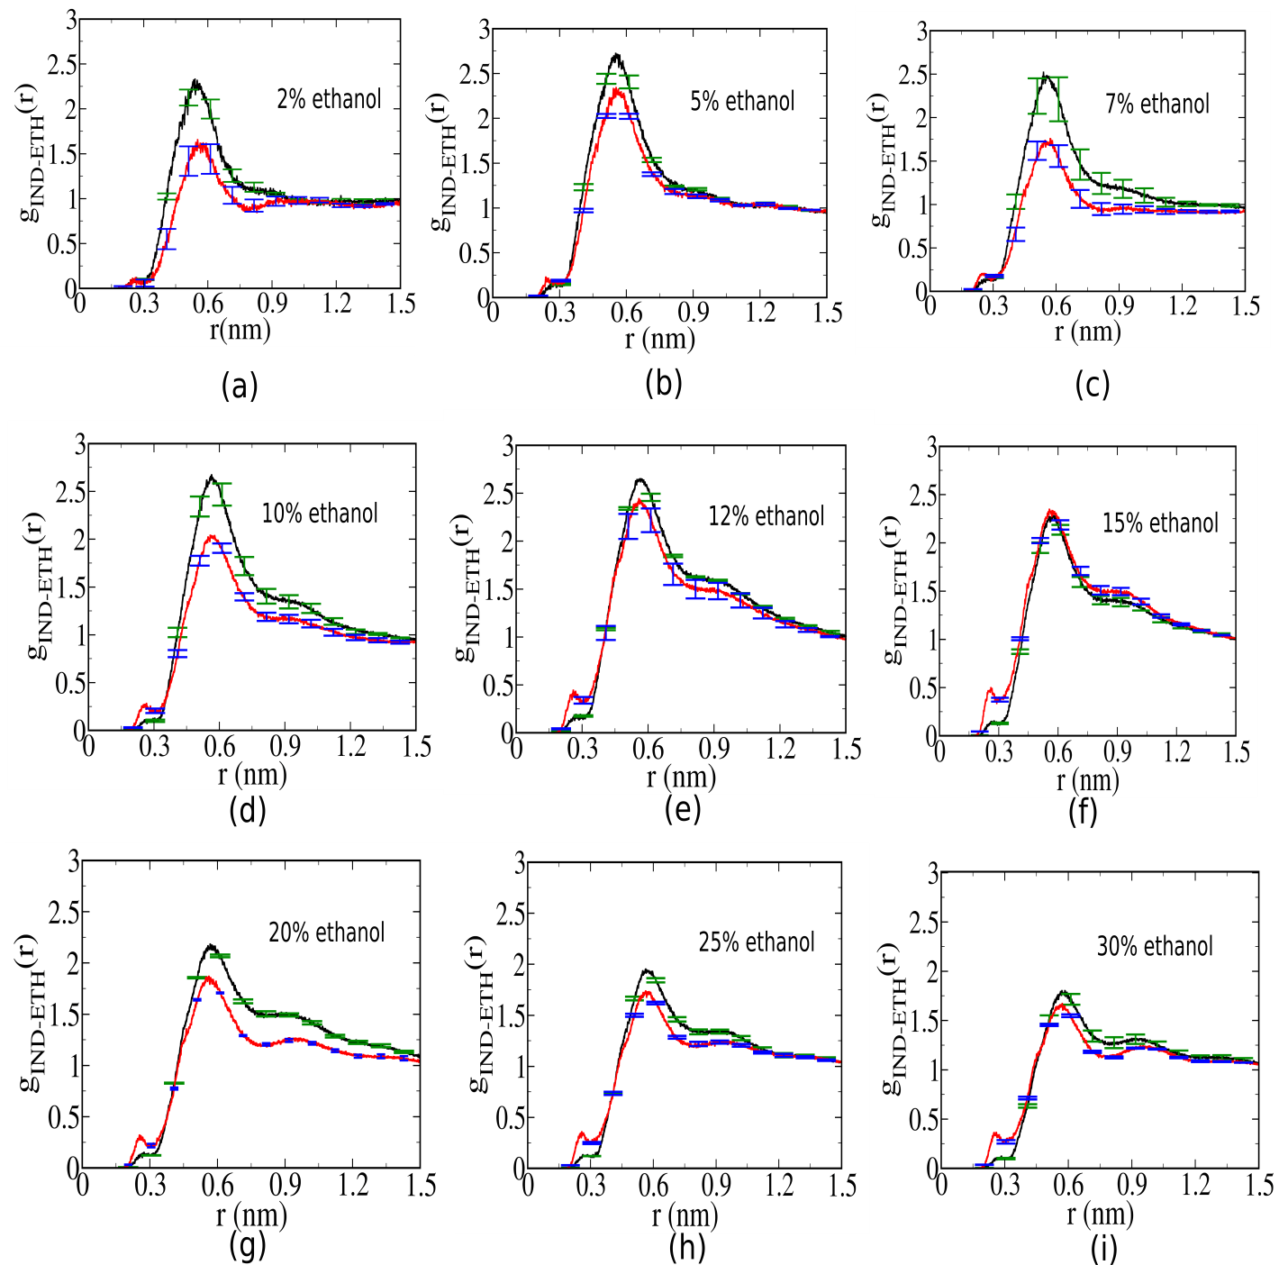

**Figure.SI.10. Error bars for radial distribution function (RDF) for the ethanol component around probe indole for ethanol compositions (a)2% ethanol, (b) 5% ethanol, (c) 7% ethanol, (d) 10% ethanol, (e)12% ethanol, (f)15% ethanol, (g) 20% ethanol, (h) 25% ethanol, (i) 30% ethanol, spanning effectively the low-to-intermediate concentration regime of water-ethanol binary mixture. The green error bar lines indicate the errors in RDF for ground state while blue error bar lines indicate the errors in RDF for excited state.**

1. **Individual solvent response functions for water and ethanol component**

In **Figure.SI.11 and 12,** we present the individual solvent response functions for water and ethanol component for several water-ethanol binary mixtures spanning efficiently the low-to-intermediate ethanol concentration regime.

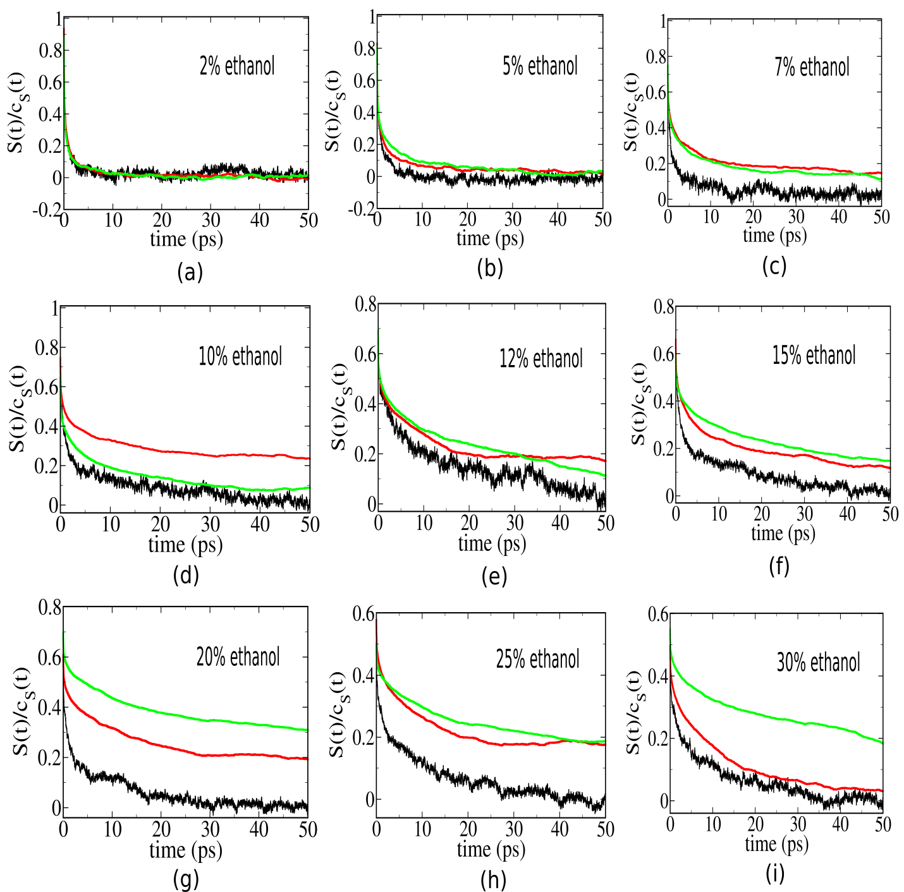

**Figure.SI.11. Individual solvent response functions of water component for ethanol compositions (a)2% ethanol, (b) 5% ethanol, (c) 7% ethanol, (d) 10% ethanol, (e)12% ethanol, (f)15% ethanol, (g) 20% ethanol, (h) 25% ethanol, (i) 30% ethanol, spanning effectively the low-to-intermediate concentration regime of water-ethanol binary mixture.**

Now we have defined the equilibrium solvation time correlation functions as follows,



Where  and ****denotes the indole-water and indole-ethanol salvation energy in a binary mixture.

Non-equilibrium solvent response functions are defined as



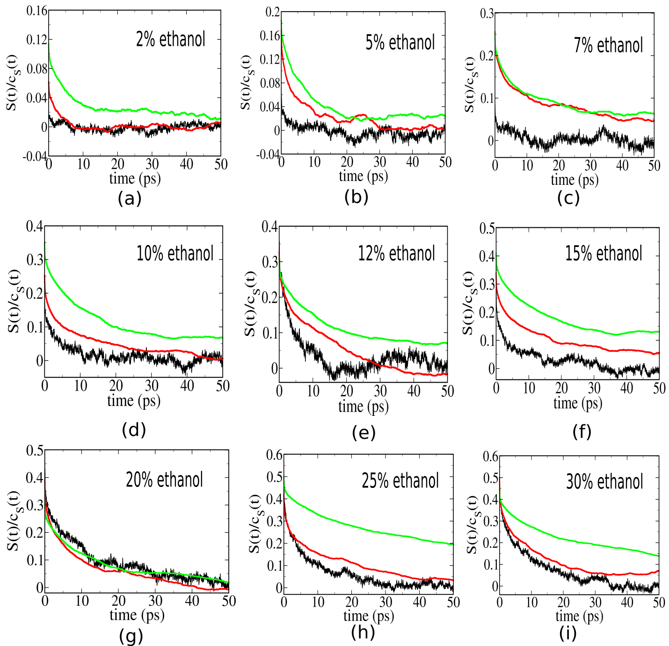

**Figure.SI.12 Individual ethanol contributions to solvent relaxation function ethanol compositions (a)2% ethanol, (b) 5% ethanol, (c) 7% ethanol, (d) 10% ethanol, (e)12% ethanol, (f)15% ethanol, (g) 20% ethanol, (h) 25% ethanol, (i) 30% ethanol, spanning effectively the low-to-intermediate concentration regime of water-ethanol binary mixture.**

1. **Free energy surface as a function of local ethanol composition in the first solvation shell of probe indole in ground and excited state**

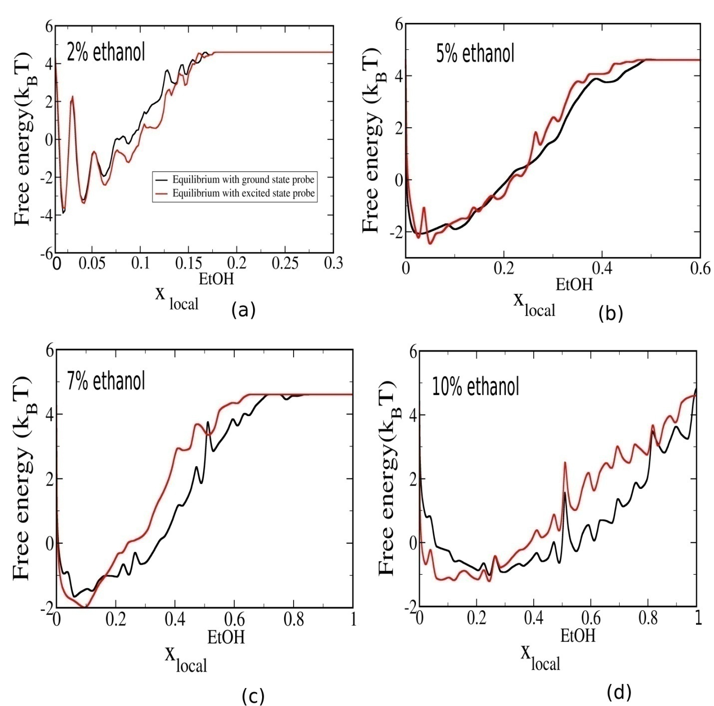

**Figure.SI.13.** **Free energy calculated from the equilibrium probability distribution of local ethanol mole fraction in the first solvation shell of the probe indole in its ground and excited state for ethanol composition (a) 2% ethanol, (b) 5% ethanol, (c) 7% ethanol and (d) 10% ethanol in the low ethanol concentration regime. While the black curve shows the free energy profile for probe in ground state, the red curve shows the same for excited state. We have checked the convergence of the free energy for five independent runs. As there is only one indole in the system, the probability distribution is a little noisy. For all the independent trajectories for a particular ethanol composition, nature of local ethanol composition dependent equilibrium free energy profile remains the same.**

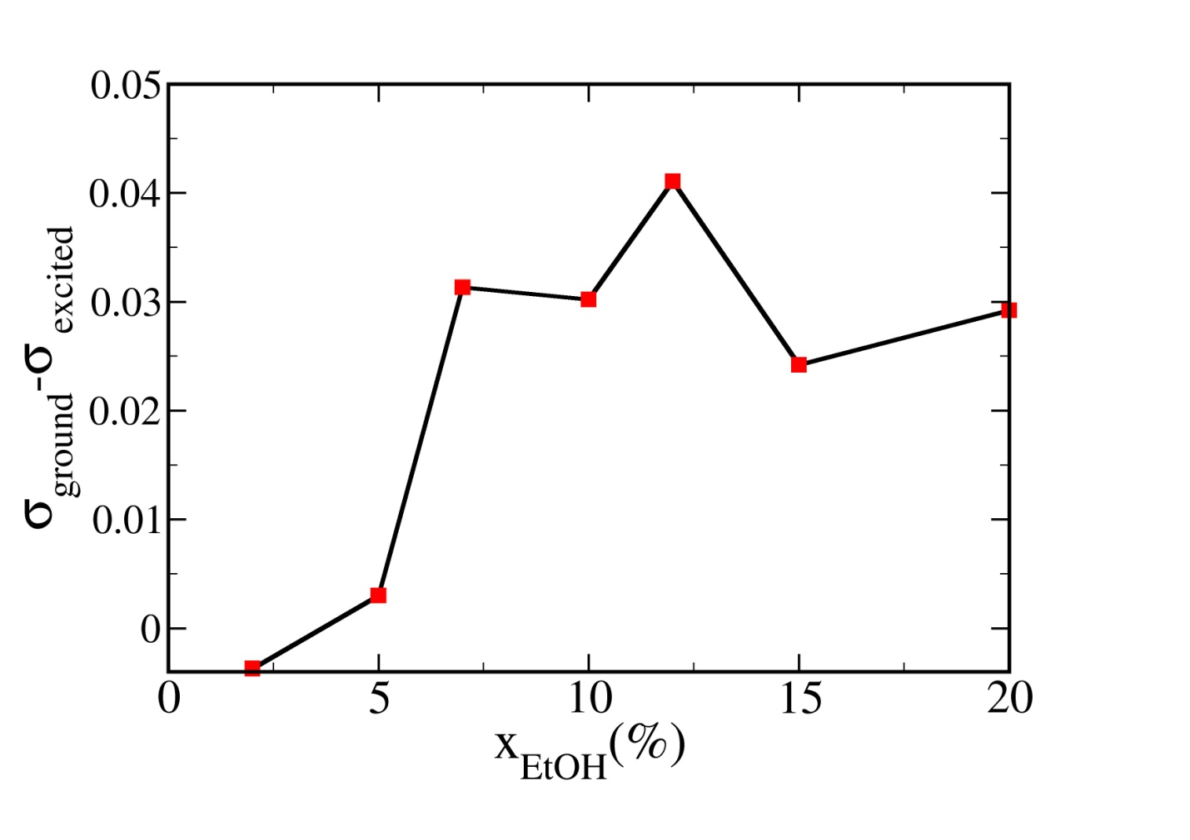

**Figure.SI.14. The difference between the standard deviation of the equilibrium probability distribution of local ethanol mole fraction in the first solvation shell of the probe indole in its ground and excited state which quantifies the difference in anharmonic behaviour between ground and excited state of probe indole as function of ethanol concentration.**