Supporting information

Molybdenum disulfide/reduced graphene oxide hybrids with enhanced electrocatalytic activity: An efficient counter electrode for dye-sensitized solar cells

Fig S1. XRD patterns of MoS₂-rGO composites at different reaction time and keeping the temperature in constant
Fig. S1 clearly shows that the MoS₂-rGO composites with optimal structure and phase crystalline were not obtained until the reaction times were set to be 180°C for 24 h.
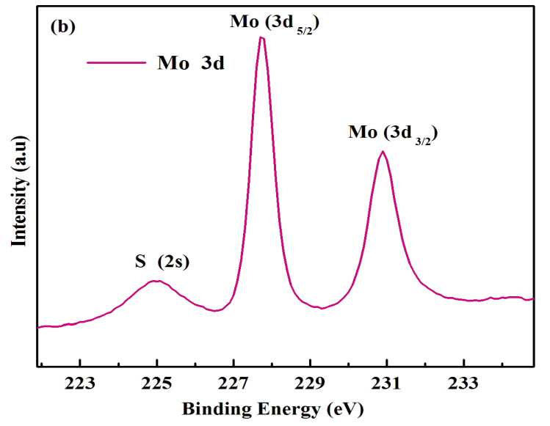
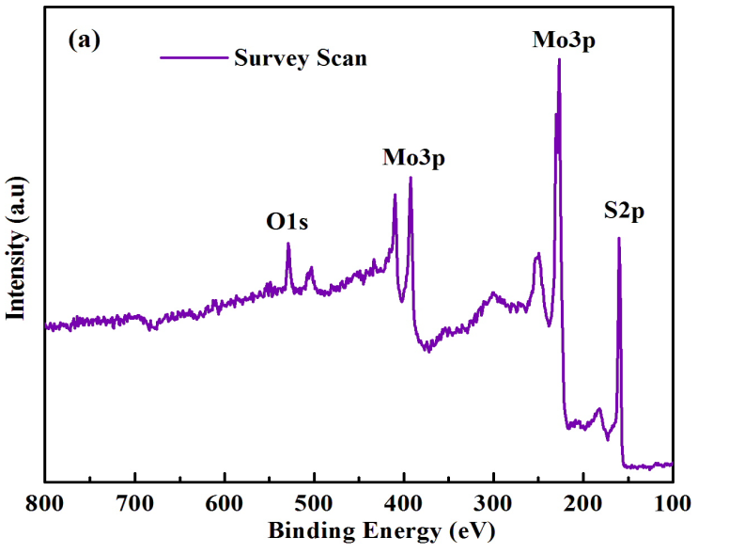

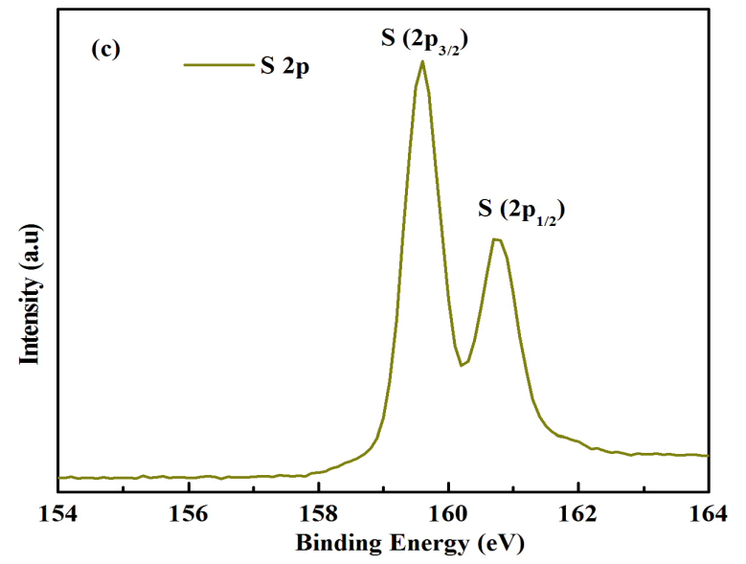

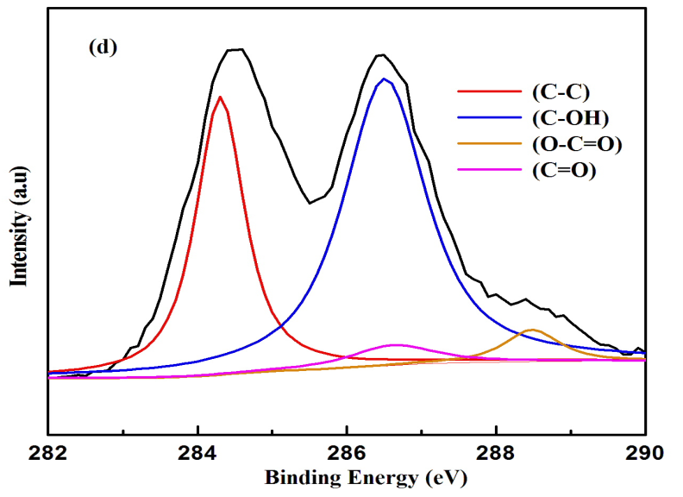

Fig S2. (a) Survey spectra, (b) Mo 3d, (c) S 2p of pristine MoS₂ and (d) GO

The survey spectra indicated that the pristine MoS₂ contains elements Mo, S, and O respectively (Fig. S3 a). The peak with a binding energy of 227.82 eV and 231.04 eV can be assigned to the Mo⁴⁺(3d_{5/2}) and Mo⁴⁺(3d_{3/2}) and the lower energy peak located at 225.20 eV corresponds to S (2s) of MoS₂ as shown in Fig S3 (b). The peak with binding energy revealed at 159.56 eV and 160.90 eV in Fig. S3 (C) can be attributed to the S 2p_{1/2} and S 2p_{3/2}, indicating the existing of S in the pristineMoS₂. Fig. S 2 (d) shows, after deconvolution the peak at 284.2 eV correspond to sp² of GO. The peaks at 286.2 eV (hydroxyl groups), 286.7 eV (carbonyl groups) and 288.5 eV (carboxyl groups) confirms the presence of oxygen functionalities.

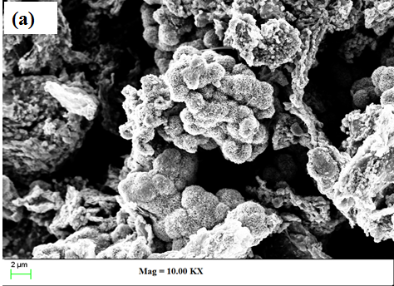

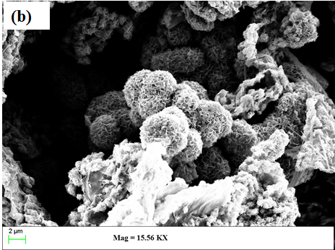

Fig S3. (a) and (b) SEM images of MG-2.5 at different magnifications.

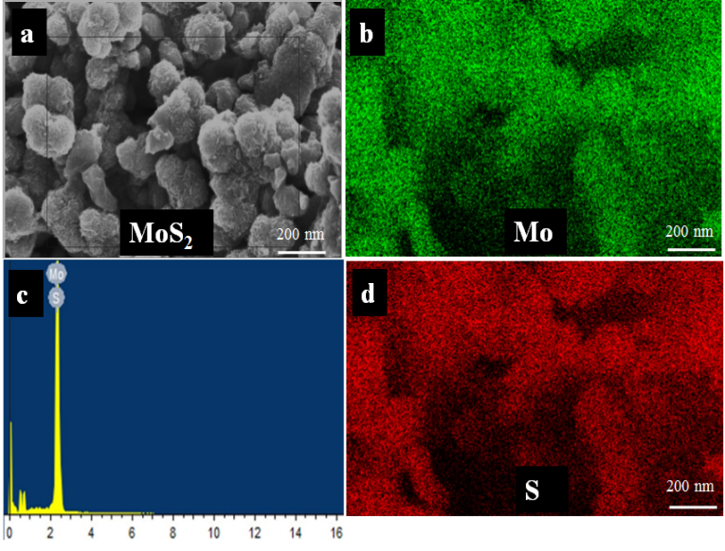

Fig S4. EDS and elemental mapping of pristine MoS₂

